Rhizosphere microbial community structure and diversity in canker-symptomatic and asymptomatic poplars

Jian Zhao¹,Siyu Zhu¹, Yulong Li¹, Mi Zhang¹ & Fangyuan Xu^{1,}*

¹ College of Forestry and Landscape Architecture, Xinjiang Agricultural University, Xinjiang 830052, China
* Correspondence: xufy@xjau.edu.cn; Tel.: +86-156-0991-6913

Supplementary Information
Supplementary Figures S1-S9
Supplementary Tables S1-S9

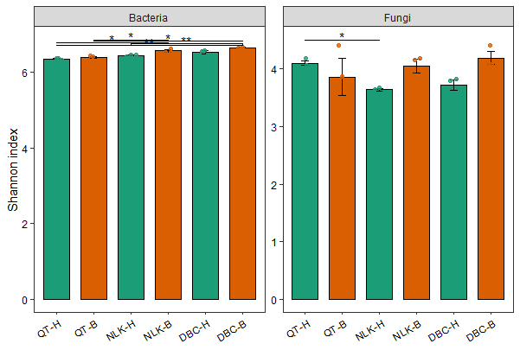
Figure S1. Alpha diversity of bacterial and fungal communities in root-zone soils from asymptomatic and canker-symptomatic P. talassica at Dabancheng, Nileke, and Qitai. Overall status comparisons used exact Wilcoxon rank-sum tests, and within-site comparisons used Welch's t tests. Benjamini-Hochberg correction was applied across related comparisons. No within-site Shannon comparison remained significant after correction; full results are reported in Table S7.

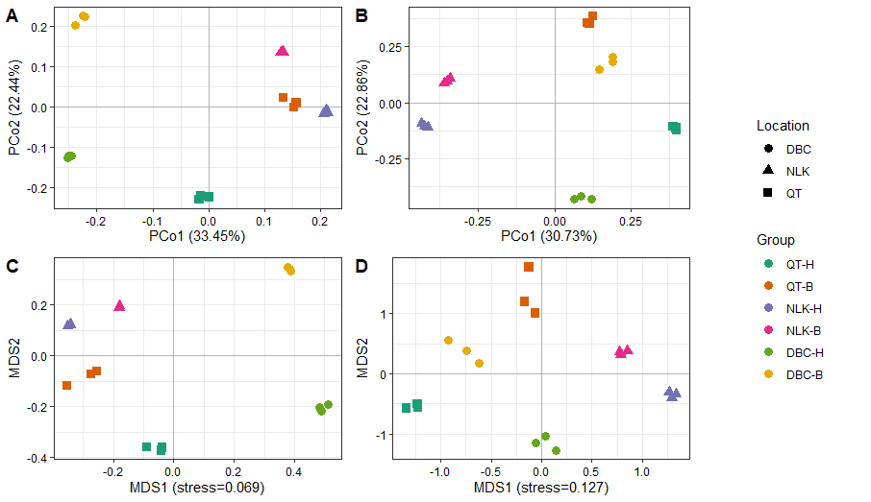
Figure S2. Bray-Curtis beta diversity of bacterial and fungal communities in root-zone soils from asymptomatic and canker-symptomatic P. talassica. (A) Bacterial PCoA, with PCo1 and PCo2 explaining 33.45% and 22.44% of variation; (B) fungal PCoA, with PCo1 and PCo2 explaining 30.73% and 22.86%; (C) bacterial NMDS, stress = 0.069; (D) fungal NMDS, stress = 0.127. Site-by-status PERMANOVA was significant for bacteria (pseudo-F = 16.777, R² = 0.875, P = 0.001) and fungi (pseudo-F = 36.240, R² = 0.938, P = 0.001). Disease status, location, and their interaction were significant for both datasets (all P = 0.001). Status-based dispersion was not significant for either marker, whereas location-based dispersion was significant for 16S (P = 0.002) and ITS1 (P = 0.014). PERMANOVA terms may therefore reflect both centroid and location-related dispersion differences.

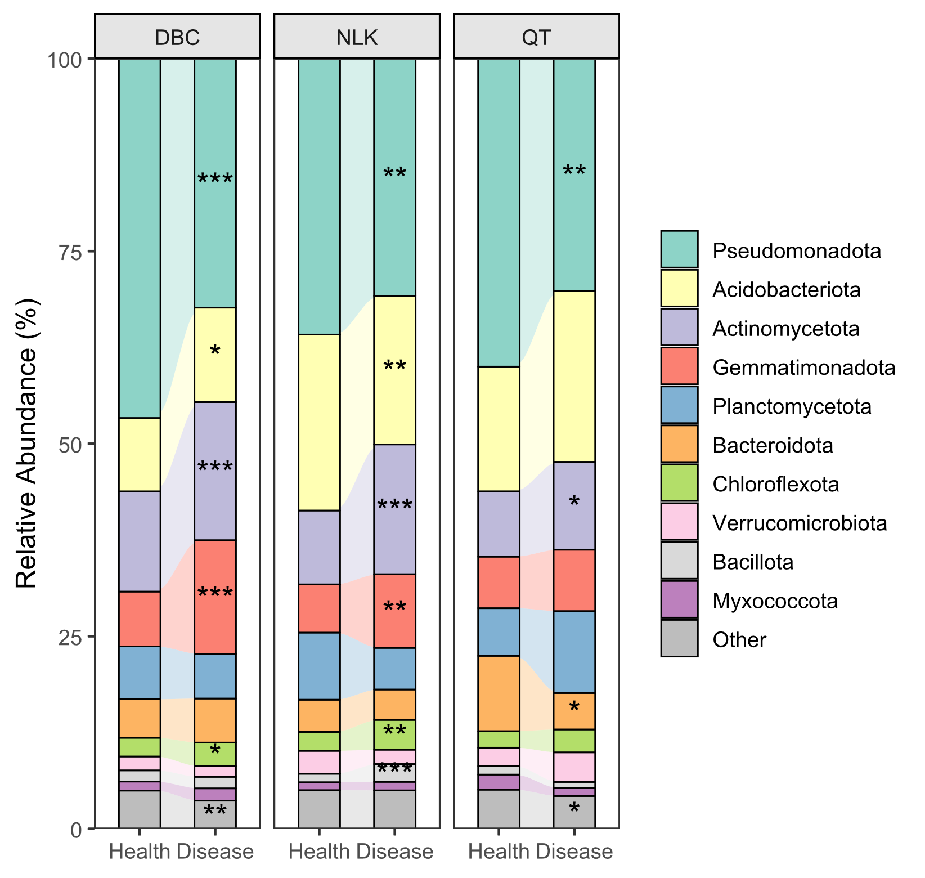
Figure S3. Phylum-level bacterial composition in root-zone soils from asymptomatic and canker-symptomatic P. talassica at three sampling sites. H denotes asymptomatic trees and B denotes canker-symptomatic trees. The parallel genus-level composition requested for the main text is shown in Fig. 2. Each site-by-status group contains three biological composite samples.

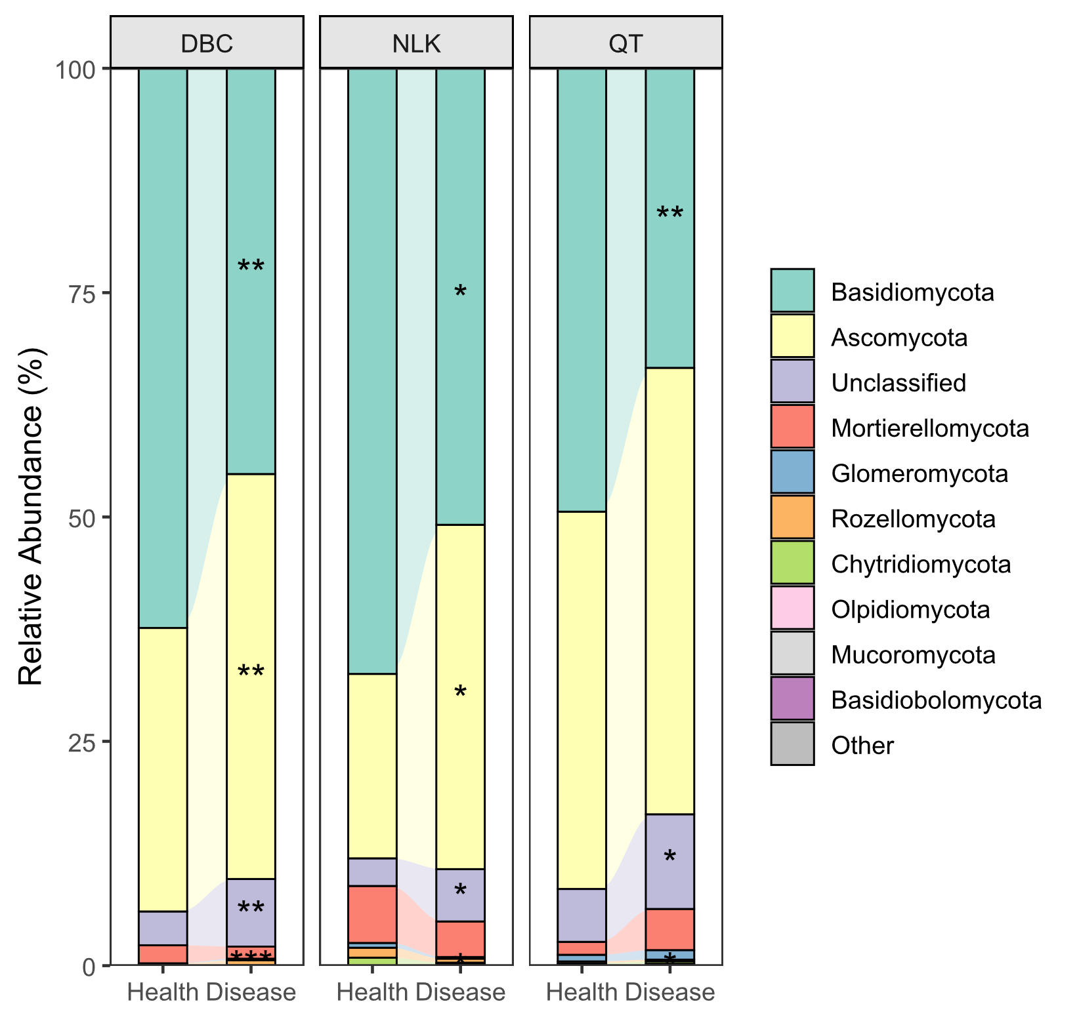
Figure S4. Phylum-level fungal composition in root-zone soils from asymptomatic and canker-symptomatic P. talassica at three sampling sites. H denotes asymptomatic trees and B denotes canker-symptomatic trees. The parallel genus-level composition requested for the main text is shown in Fig. 2. Each site-by-status group contains three biological composite samples.

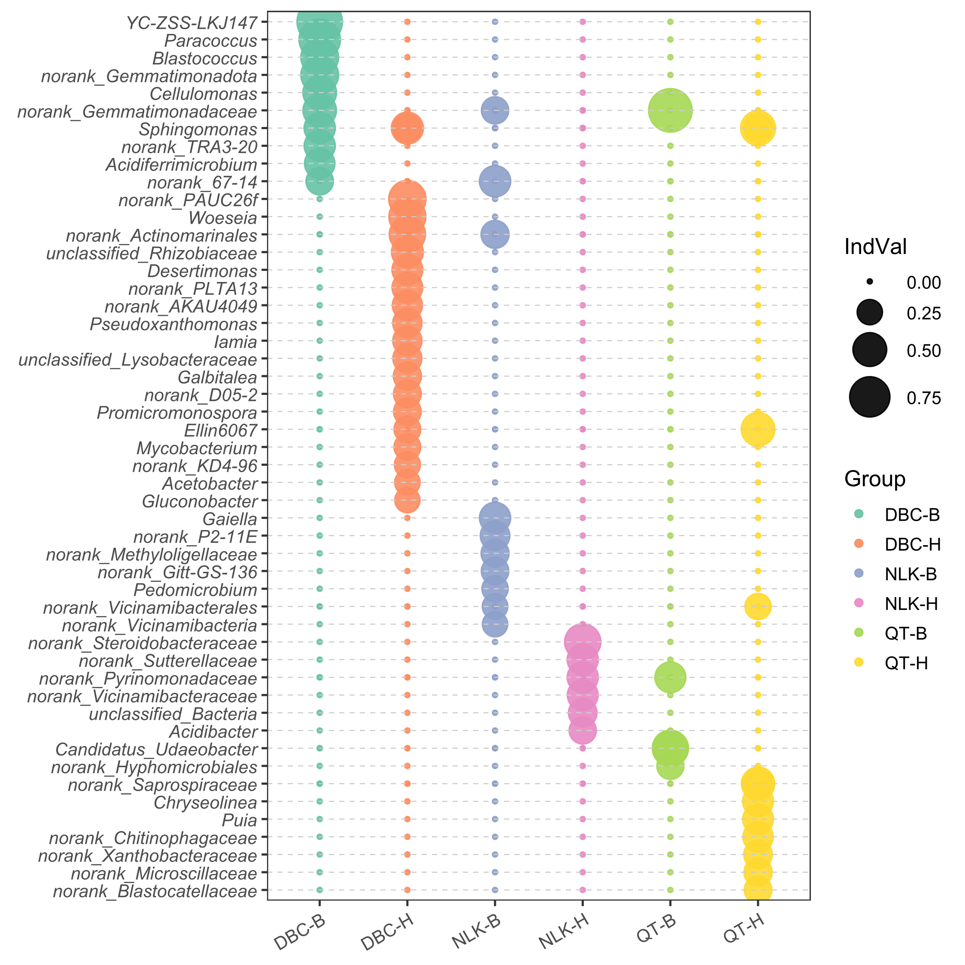
Figure S5. Genus-level bacterial indicator taxa associated with asymptomatic and canker-symptomatic P. talassica rhizospheres at Dabancheng, Nileke, and Qitai. Node size represents mean relative abundance within each site-by-status group. Indicator associations do not establish causality or consistent enrichment across all sites.

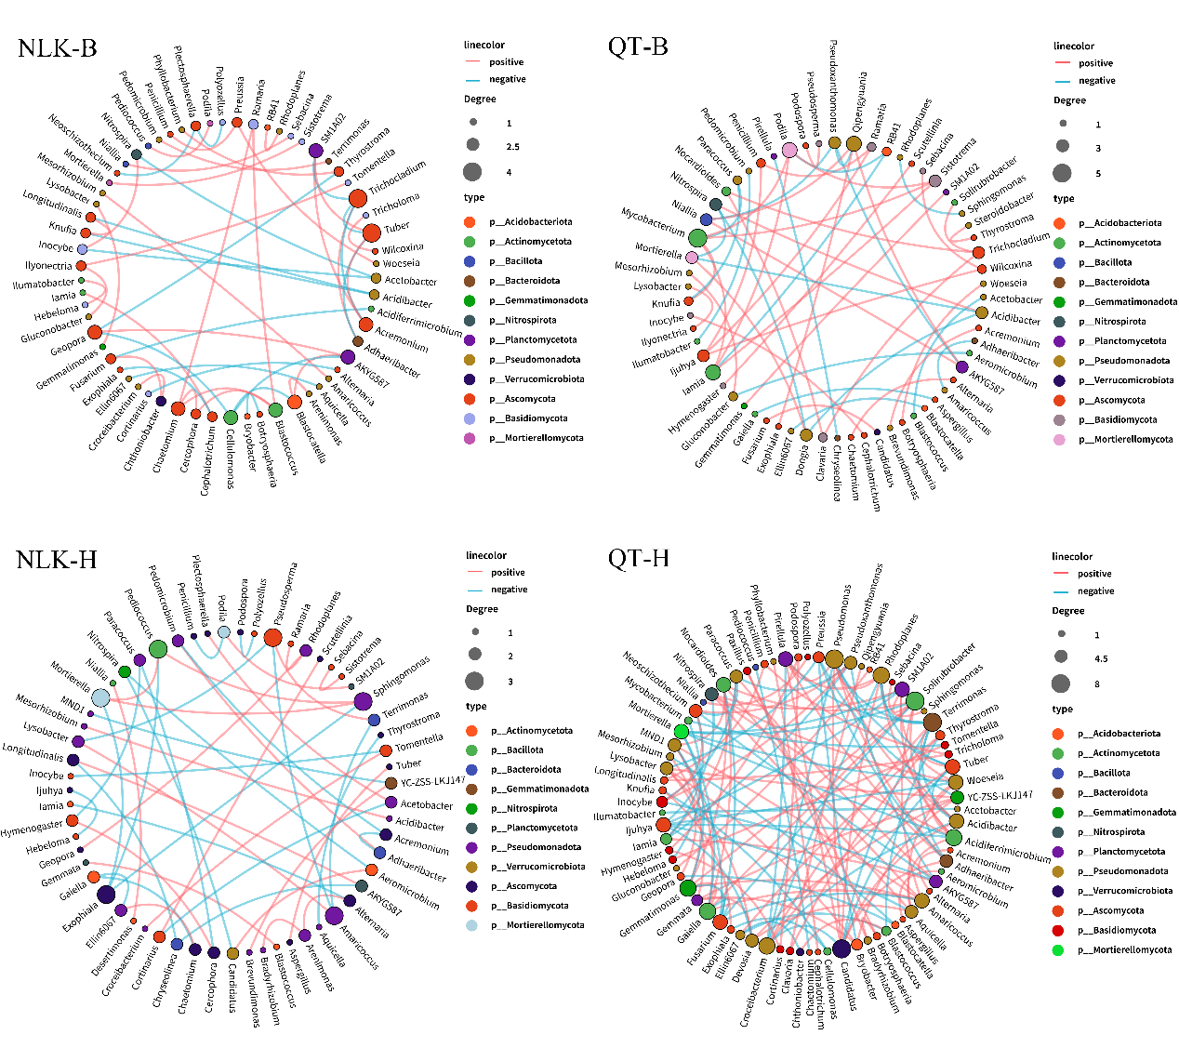
Figure S6. Genus-level co-occurrence networks in root-zone soils from asymptomatic and canker-symptomatic P. talassica at Nileke and Qitai. Separate networks were constructed for each site-by-status group (n = 3) from rarefied OTU data aggregated at genus level. Pearson associations with |r| > 0.6 and P < 0.01 were retained. Node size represents degree, node color denotes phylum, and edge color indicates positive or negative correlation. Edges represent statistical associations rather than direct biological interactions.

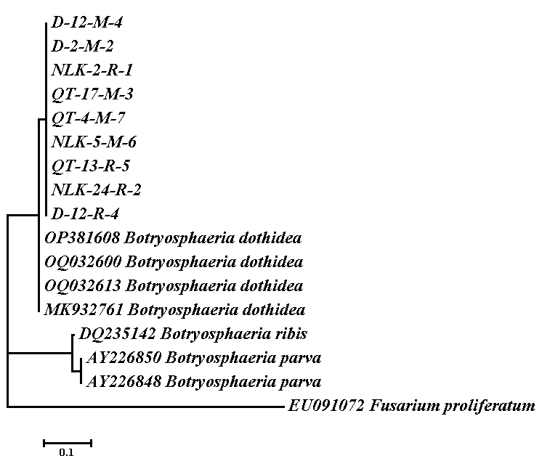
Figure S7. Multilocus phylogenetic identification of independently recovered Botryosphaeria dothidea isolates based on ITS, beta-tubulin, and EF1-alpha sequences. D-12-M-4, D-2-M-2, NLK-2-R-1, QT-17-M-3, QT-4-M-7, NLK-5-M-6, QT-13-R-5, NLK-24-R-2, and D-12-R-4 are independent field isolates recovered from different samples and identified as B. dothidea. XJAU23 denotes the representative isolate used for the pathogenicity and morphological results in Fig. 7; it does not imply that one biological isolate was recovered from all sites.

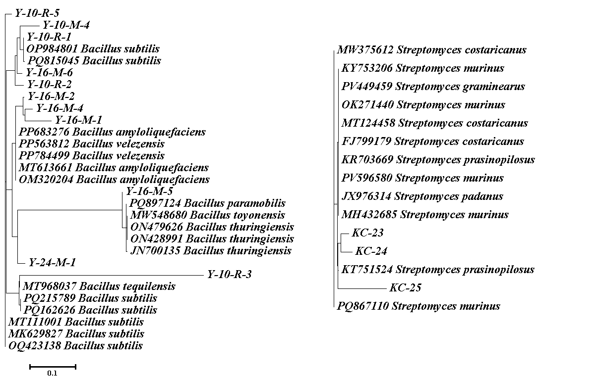
Figure S8. 16S rRNA phylogenetic identification of representative antagonistic bacterial isolates. The left tree shows representative Bacillus isolates and the right tree shows representative Streptomyces isolates. The four Bacillus antagonism-assay isolates D2-19-2, D2-23-7, D2-4-2, and D2-19-1 were identified as Bacillus subtilis. Representative isolates were selected for display, so the tree labels do not include every code used in the antagonism assays.

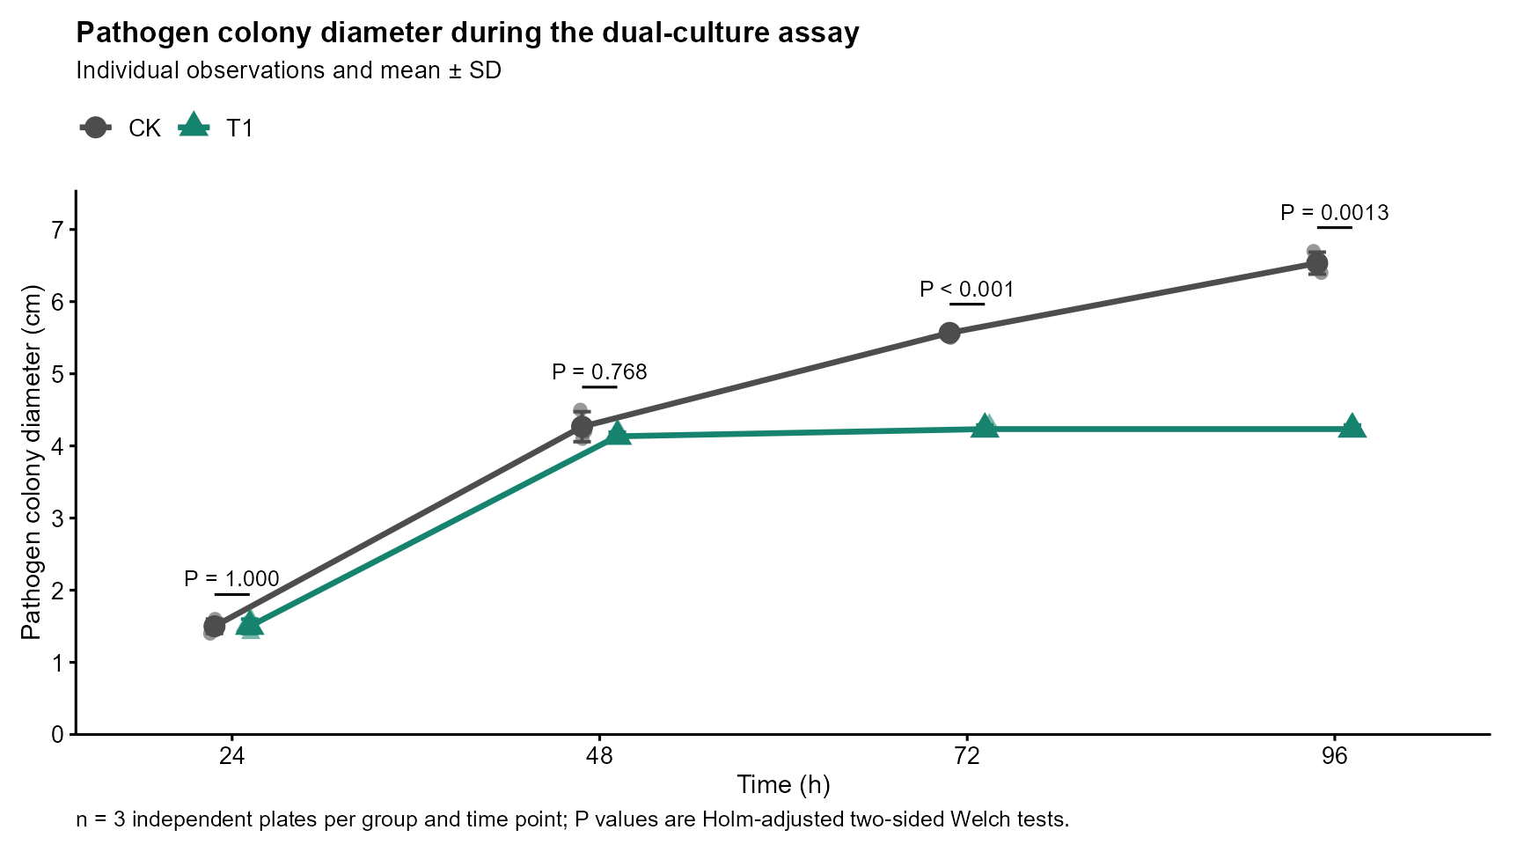
Figure S9. Time course of Botryosphaeria dothidea XJAU23 colony diameter during confrontation with Streptomyces. Individual observations and mean ± SD are shown for the pathogen-only control (CK) and the Streptomyces treatment (T1) at 24, 48, 72, and 96 h (n = 3 plates per group and time point). Two-sided Welch t tests were performed separately at each time point, with Holm correction across the four planned comparisons. Adjusted P values were 1.000, 0.768, 3.72 × 10⁻⁵, and 0.00127, respectively. Representative plates are shown in Fig. 8a,b. The measured outcome is pathogen colony diameter (cm); growth-inhibition values accounting for the 0.8-cm inoculum plug are reported in Table S8.

Table S1 Bacterial data pre-processing statistics and quality control
Sample Name | Clean PE | Raw Tags | Clean Tags | Effective Tags | Effective Ratio (%)
QT-H1 | 72391 | 72239 | 71983 | 71983 | 99.44%
QT-H2 | 63350 | 63295 | 63156 | 63156 | 99.69%
QT-H3 | 58215 | 57885 | 57714 | 57714 | 99.14%
QT-B1 | 61222 | 60714 | 59355 | 59355 | 96.95%
QT-B2 | 84776 | 84642 | 84334 | 84334 | 99.48%
QT-B3 | 52224 | 52134 | 51918 | 51918 | 99.41%
NLK-H1 | 61548 | 61325 | 61109 | 61109 | 99.29%
NLK-H2 | 45745 | 45687 | 45533 | 45533 | 99.54%
NLK-H3 | 73436 | 73090 | 72827 | 72827 | 99.17%
NLK-B1 | 62177 | 62118 | 61851 | 61851 | 99.48%
NLK-B2 | 62758 | 62690 | 48065 | 48065 | 76.59%
NLK-B3 | 54264 | 54144 | 53951 | 53951 | 99.42%
DBC-H1 | 51077 | 50739 | 50627 | 50627 | 99.12%
DBC-H2 | 58246 | 57830 | 57613 | 57613 | 98.91%
DBC-H3 | 66791 | 66787 | 66592 | 66592 | 99.70%
DBC-B1 | 74226 | 74218 | 74021 | 74021 | 99.72%
DBC-B2 | 78752 | 78572 | 78221 | 78221 | 99.33%
DBC-B3 | 62432 | 62009 | 61802 | 61802 | 98.99%

Table S2 Bacteria tags detailed information table
Sample ID | Tags Number | Total length | Max length | Min length | Min length
QT-H1 | 71983 | 29992654 | 462 | 350 | 416.66
QT-H2 | 63156 | 26305630 | 453 | 351 | 416.52
QT-H3 | 57714 | 24046690 | 459 | 350 | 416.65
QT-B1 | 59355 | 24812375 | 467 | 350 | 418.03
QT-B2 | 84334 | 34897188 | 448 | 351 | 413.8
QT-B3 | 51918 | 21704557 | 456 | 350 | 418.05
NLK-H1 | 61109 | 25585864 | 459 | 352 | 418.69
NLK-H2 | 45533 | 19049546 | 459 | 351 | 418.37
NLK-H3 | 72827 | 30506730 | 458 | 350 | 418.89
NLK-B1 | 61851 | 25845242 | 460 | 350 | 417.86
NLK-B2 | 48065 | 20080443 | 454 | 351 | 417.78
NLK-B3 | 53951 | 22550582 | 455 | 350 | 417.98
DBC-H1 | 50627 | 21023580 | 452 | 350 | 415.26
DBC-H2 | 57613 | 23976084 | 452 | 352 | 416.16
DBC-H3 | 66592 | 27662875 | 460 | 350 | 415.41
DBC-B1 | 74021 | 30865664 | 471 | 351 | 416.99
DBC-B2 | 78221 | 32607244 | 462 | 350 | 416.86
DBC-B3 | 61802 | 25749655 | 461 | 350 | 416.65

Table S3 Statistics table of the number of OTUs and tags of different bacterial samples
Sample ID | Total Tags | Unique Tags | Taxon Tags | OTUs
QT-H1 | 71983 | 40503 | 62630 | 2930
QT-H2 | 63156 | 42332 | 53397 | 2817
QT-H3 | 57714 | 33315 | 50237 | 2720
QT-B1 | 59355 | 33236 | 52042 | 2748
QT-B2 | 84334 | 74051 | 59142 | 3080
QT-B3 | 51918 | 28176 | 45777 | 2554
NLK-H1 | 61109 | 35262 | 53645 | 2737
NLK-H2 | 45533 | 27347 | 39876 | 2506
NLK-H3 | 72827 | 44005 | 62956 | 2907
NLK-B1 | 61851 | 36435 | 54621 | 3019
NLK-B2 | 48065 | 28875 | 42419 | 2707
NLK-B3 | 53951 | 34451 | 47153 | 2799
DBC-H1 | 50627 | 26971 | 44343 | 2547
DBC-H2 | 57613 | 31312 | 50439 | 2779
DBC-H3 | 66592 | 36099 | 57880 | 2923
DBC-B1 | 74021 | 45332 | 63891 | 3090
DBC-B2 | 78221 | 49609 | 67755 | 3151
DBC-B3 | 61802 | 34725 | 54784 | 2875

Table S4 Fungal data preprocessing statistics and quality control
Sample Name | Clean PE | Raw Tags | Clean Tags | Effective Tags | Effective Ratio
QT-H1 | 49035 | 49005 | 48954 | 48954 | 99.83%
QT-H2 | 86899 | 86567 | 84333 | 84333 | 97.05%
QT-H3 | 73981 | 72359 | 71780 | 71780 | 97.02%
QT-B1 | 90510 | 89771 | 87996 | 87996 | 97.22%
QT-B2 | 44724 | 44578 | 44382 | 44382 | 99.24%
QT-B3 | 48072 | 47889 | 47858 | 47858 | 99.55%
NLK-H1 | 68287 | 67546 | 66125 | 66125 | 96.83%
NLK-H2 | 46618 | 45879 | 45132 | 45132 | 96.81%
NLK-H3 | 58169 | 57710 | 56549 | 56549 | 97.22%
NLK-B1 | 85885 | 84964 | 83029 | 83029 | 96.67%
NLK-B2 | 76404 | 75913 | 74268 | 74268 | 97.20%
NLK-B3 | 59268 | 58644 | 57709 | 57709 | 97.37%
DBC-H1 | 80188 | 78098 | 76869 | 76869 | 95.86%
DBC-H2 | 82068 | 81286 | 79596 | 79596 | 96.99%
DBC-H3 | 80348 | 79474 | 77695 | 77695 | 96.70%
DBC-B1 | 83388 | 82122 | 80913 | 80913 | 97.03%
DBC-B2 | 55106 | 55104 | 55101 | 55101 | 99.99%
DBC-B3 | 45199 | 45186 | 45152 | 45152 | 99.90%

Table S5 Fungus tags details
Sample ID | Tags Number | Total length | Max length | Min length | Min length
QT-H1 | 48954 | 12258903 | 450 | 100 | 250.42
QT-H2 | 84333 | 21279396 | 446 | 101 | 252.33
QT-H3 | 71780 | 18206811 | 447 | 101 | 253.65
QT-B1 | 87996 | 21241330 | 447 | 105 | 241.39
QT-B2 | 44382 | 11087566 | 451 | 102 | 249.82
QT-B3 | 47858 | 11883162 | 448 | 102 | 248.3
NLK-H1 | 66125 | 17873593 | 451 | 105 | 270.3
NLK-H2 | 45132 | 11992073 | 451 | 112 | 265.71
NLK-H3 | 56549 | 15160402 | 451 | 105 | 268.09
NLK-B1 | 83029 | 20911232 | 449 | 103 | 251.85
NLK-B2 | 74268 | 18802693 | 450 | 105 | 253.17
NLK-B3 | 57709 | 14925126 | 450 | 104 | 258.63
DBC-H1 | 76869 | 21162961 | 451 | 105 | 275.31
DBC-H2 | 79596 | 20494477 | 443 | 112 | 257.48
DBC-H3 | 77695 | 21122352 | 451 | 105 | 271.86
DBC-B1 | 80913 | 20273820 | 450 | 102 | 250.56
DBC-B2 | 55101 | 13264607 | 430 | 102 | 240.73
DBC-B3 | 45152 | 11056480 | 446 | 112 | 244.87

Table S6 Statistics of OTUs and tags of different fungal samples
Sample ID | Total Tags | Unique Tags | Taxon Tags | OTUs
QT-H1 | 48954 | 16639 | 39574 | 961
QT-H2 | 84333 | 28509 | 69422 | 758
QT-H3 | 71780 | 24976 | 59225 | 781
QT-B1 | 87996 | 20694 | 75242 | 752
QT-B2 | 44382 | 17076 | 35922 | 556
QT-B3 | 47858 | 11867 | 42089 | 467
NLK-H1 | 66125 | 21572 | 55153 | 660
NLK-H2 | 45132 | 13533 | 38083 | 582
NLK-H3 | 56549 | 17757 | 47379 | 634
NLK-B1 | 83029 | 25396 | 68942 | 744
NLK-B2 | 74268 | 23106 | 63501 | 743
NLK-B3 | 57709 | 17871 | 50548 | 672
DBC-H1 | 76869 | 25524 | 70459 | 426
DBC-H2 | 79596 | 17340 | 74267 | 572
DBC-H3 | 77695 | 24340 | 71407 | 459
DBC-B1 | 80913 | 25311 | 73781 | 661
DBC-B2 | 55101 | 11177 | 50884 | 522
DBC-B3 | 45152 | 12658 | 41549 | 578

Table S7. Summary of statistical evidence used in the revised manuscript.
Analysis | Comparison | Effect or summary | Test and adjusted evidence
OTU sharing | Group-level shared OTUs; strict all-18-sample OTUs | 16S: 1,466 group-level and 467 strict; ITS1: 247 group-level and 61 strict | Group-level means detected in at least one replicate of every site-by-status group; strict means detected in all 18 samples
Alpha diversity | 16S, pooled H vs B, Shannon | 6.44 ± 0.09 vs 6.54 ± 0.12 | Exact Wilcoxon; raw P = 0.136; BH P = 0.267
Alpha diversity | ITS1, pooled H vs B, Shannon | 3.82 ± 0.23 vs 4.03 ± 0.35 | Exact Wilcoxon; raw P = 0.063; BH P = 0.282
Alpha diversity | Within-site H vs B, Shannon | No bacterial or fungal site comparison remained significant | Welch tests; BH-adjusted P > 0.05
Beta diversity | 16S full Status x Location model | R² = 0.875; pseudo-F = 16.777 | PERMANOVA, 999 permutations; P = 0.001
Beta diversity | ITS1 full Status x Location model | R² = 0.938; pseudo-F = 36.240 | PERMANOVA, 999 permutations; P = 0.001
Beta diversity | 16S adjusted terms | Status R² = 0.190; Location R² = 0.490; interaction R² = 0.195 | PERMANOVA; all P = 0.001
Beta diversity | ITS1 adjusted terms | Status R² = 0.197; Location R² = 0.479; interaction R² = 0.262 | PERMANOVA; all P = 0.001
Dispersion | 16S Status; 16S Location | Status P = 0.198; Location P = 0.002 | vegan::betadisper(type = median), 999 permutations
Dispersion | ITS1 Status; ITS1 Location | Status P = 0.824; Location P = 0.014 | vegan::betadisper(type = median), 999 permutations
Bacterial phylum | Pseudomonadota, QT/NLK/DBC | Disease - Healthy = -9.81/-5.02/-14.33 percentage points | Welch + BH; adjusted P = 0.017/0.009/0.002
Bacterial phylum | Actinomycetota, QT/NLK/DBC | Disease - Healthy = +2.92/+7.26/+4.91 percentage points | Welch + BH; adjusted P = 0.064/<0.001/0.002
Fungal phylum | Basidiomycota, QT/NLK/DBC | Disease - Healthy = -16.03/-16.62/-17.15 percentage points | Welch + BH; adjusted P = 0.080/0.048/0.007
Fungal phylum | Ascomycota, QT/NLK/DBC | Disease - Healthy = +7.71/+17.82/+13.53 percentage points | Welch + BH; adjusted P = 0.124/0.040/0.008
Bacterial genus | Bacillus, QT/NLK/DBC | Low abundance; Disease - Healthy = -0.0025/-0.0012/-0.0037 percentage points | Welch + BH; adjusted P = 0.945/1.000/0.848
Bacterial genus | Streptomyces, QT/NLK/DBC | Direction varied: -0.016/+0.220/+0.156 percentage points | Welch + BH; adjusted P = 0.601/0.056/0.054
FUNGuild trophic mode | DBC Pathotroph and Saprotroph | Pathotroph higher; Saprotroph lower in disease | Welch + BH; adjusted P = 0.034 for both
FUNGuild trophic mode | QT Saprotroph | Higher in disease | Welch + BH; adjusted P = 0.047
FUNGuild guild | Plant Pathogen, QT/NLK/DBC | Disease - Healthy = +4.95/+1.70/+2.06 percentage points | Welch + BH; adjusted P = 0.278/0.044/0.104
PICRUSt2 KEGG | Signaling molecules and interaction, pooled | Healthy 135.98 ± 46.74; disease 363.42 ± 126.85 | Welch + BH; adjusted P = 0.012
PICRUSt2 KEGG | Signaling molecules and interaction, NLK | Disease - Healthy = +250.44 predicted abundance units | Welch + BH; adjusted P = 0.033
H denotes asymptomatic and B denotes canker-symptomatic samples. Each site-by-status cell contains three independent composite samples. Taxonomic and functional claims use Benjamini-Hochberg-adjusted P values. PERMANOVA terms are interpreted together with the dispersion tests.

Table S8. Pathogen colony diameter and growth inhibition during the Streptomyces confrontation assay.
Time (h) | CK diameter (cm) | T1 diameter (cm) | Growth inhibition (%) | Welch P; Holm-adjusted P
24 | 1.50 ± 0.10 | 1.50 ± 0.10 | 0.00 | 1.000; 1.000
48 | 4.27 ± 0.21 | 4.13 ± 0.06 | 3.85 | 0.384; 0.768
72 | 5.57 ± 0.06 | 4.23 ± 0.06 | 27.97 | 9.30 × 10⁻⁶; 3.72 × 10⁻⁵
96 | 6.53 ± 0.15 | 4.23 ± 0.06 | 40.12 | 4.22 × 10⁻⁴; 0.00127
Values are mean ± SD, with n = 3 plates per group and time point. CK is the pathogen-only control and T1 is the Streptomyces treatment. The measured outcome is pathogen colony diameter (cm). Growth inhibition was calculated from unrounded group means as [(mean D_CK - mean D_T1)/(mean D_CK - 0.8)] × 100%, where 0.8 cm is the initial pathogen-plug diameter. Two-sided Welch t tests were performed on the original colony-diameter observations and corrected across the four planned time-point comparisons using the Holm method.

Table S9. Detached-branch lesion outcomes 15 days after inoculation.
Group | Treatment | Visible lesions (n/N) | Lesion diameter, mean ± SD (range), cm | Reduction vs CK1 (%)
CK0 | Sterile agar plug | 0/3 | Not detected | Not applicable
CK1 | XJAU23 only | 3/3 | 4.40 ± 1.28 (3.3–5.8) | Reference
T1 | XJAU23 followed by Streptomyces spp. | 0/3 | Not detected | Not calculated
T2 | XJAU23 followed by Bacillus spp. | 3/3 | 2.43 ± 0.35 (2.1–2.8) | 44.7
For each branch with a visible lesion, two perpendicular lesion diameters were measured and averaged. Individual branch values were 3.3, 5.8, and 4.1 cm for CK1 and 2.4, 2.1, and 2.8 cm for T2. Branches without a visible lesion were reported as not detected and were not assigned a diameter of zero. T2 had a 44.7% lower mean lesion diameter than CK1; the two-sided Welch test was not significant (P = 0.108).

