Tacrolimus attenuates BCL-2/BAX-mediated chondrocyte apoptosis and cartilage matrix degradation in experimental osteoarthritis

Table S1. qPCR Primer Sequences
No. | Gene Name | Species | Forward Sequence (5'→3') | Reverse Sequence (5'→3')
1 | CD86 | mouse | ATATGACCGTTGTGTGTGTTCTGGA | AGGGCCACAGTAACTGAAGCTGTAA
2 | IL-1β | mouse | GCAACTGTTCCTGAACTCAACT | ATCTTTTGGGGTCCGTCAACT
3 | CD206 | mouse | AGCTTCATCTTCGGGCCTTTG | GGTGACCACTCCTGCTGCTTTAG
4 | IL-10 | mouse | GCTCTTACTGACTGGCATGAG | CGCAGCTCTAGGAGCATGTG
5 | Bax | rat | CCAAGAAGCTGAGCGAGTGT | CCAGTTGAAGTTGCCGTCTG
6 | Bcl-2 | rat | GAGTACCTGAACCGGCATCT | GCATCCCAGCCTCCGTTAT
7 | GAPDH | mouse | AGGTCGGTGTGAACGGATTTG | TGTAGACCATGTAGTTGAGGTCA
8 | GAPDH | rat | GGCACAGTCAAGGCTGAGAATG | ATGGTGGTGAAGACGCCAGTA
9 | COL2A1 | rat | CCCCTGCAGTACATGCGG | CTCGACGTCATGCTGTCTCAAG
10 | ACAN | rat | GACAAGGACGAGTTCCCTGG | CTCCGGGGATGTGGCATAAA
11 | MMP13 | rat | GGACAAAGACTATCCCCGCC | GGCATGACTCTCACAATGCG
12 | TNF-α | mouse | GACGTGGAACTGGCAGAAGAG | GCCACAAGCAGGAATGAGAAG
13 | Arg-1 | mouse | CTCCAAGCCAAAGTCCTTAGAG | AGGAGCTGTCATTAGGGACATC

Table S2. Rat Bcl-2 siRNA Sequences
No. | Name | Sense Strand (5'→3') | Antisense Strand (5'→3')
1 | si-Bcl2-1 | GGAUGACUGAGUACCUGAAdTdT | UUCAGGUACUCAGUCAUCCdTdT
2 | si-NC | UUCUCCGAACGUGUCACGUdTdT | ACGUGACACGUUCGGAGAAdTdT

Table S3. Antibody information
Antibody | Application | Manufacturer | Catalogue No. | Working dilution
BCL-2 | WB, IF | Abcam | ab182858 | WB 1/2000; IF 1/150
BAX | WB | Abcam | ab32503 | WB 1/1000
SOX9 | WB | Abcam | ab185966 | WB 1/1000
COL-II | WB, IHC | Abcam | ab34712 | WB 1/1000; IHC 1/200
MMP13 | WB | Abcam | ab39012 | WB 1/3000
TNF-α | IF | Abcam | ab66579 | IF 1/200
Arg-1 | IF | Abcam | ab91279 | IF 1/200
β-actin | WB (loading control) | Abcam | ab8227 | WB 1/10000
Goat Anti-Rabbit IgG H&L (HRP) | WB | Abcam | ab6721 | WB 1/5000
Goat Anti-Mouse IgG H&L (HRP) | WB | Abcam | ab6789 | WB 1/5000
Goat Anti-Rabbit IgG H&L (Alexa Fluor® 488) | IF | Abcam | ab150077 | IF 1/1000
Goat Anti-Mouse IgG H&L (Alexa Fluor® 488) | IF | Abcam | ab150113 | IF 1/1000

Figure S1. Effects of tacrolimus (TAC) on intracellular oxidative stress and macrophage polarization quantified by immunofluorescence staining. (A) Relative fluorescence intensity of intracellular reactive oxygen species (ROS), reflecting the level of cellular oxidative stress. (B) Relative fluorescence intensity of tumor necrosis factor-α (TNF-α), a canonical pro-inflammatory marker of M1-polarized macrophages. (C) Relative fluorescence intensity of arginase-1 (Arg-1), a signature anti-inflammatory marker of M2-polarized macrophages. Four experimental groups were included: Control (normal control group), Blank (untreated model group), TAC-1 (low-dose tacrolimus intervention group), and TAC-2 (high-dose tacrolimus intervention group). Data are presented as mean ± standard deviation. **** indicates P < 0.0001, representing an extremely statistically significant difference between the marked groups. Data are from n = 3 independent experiments.
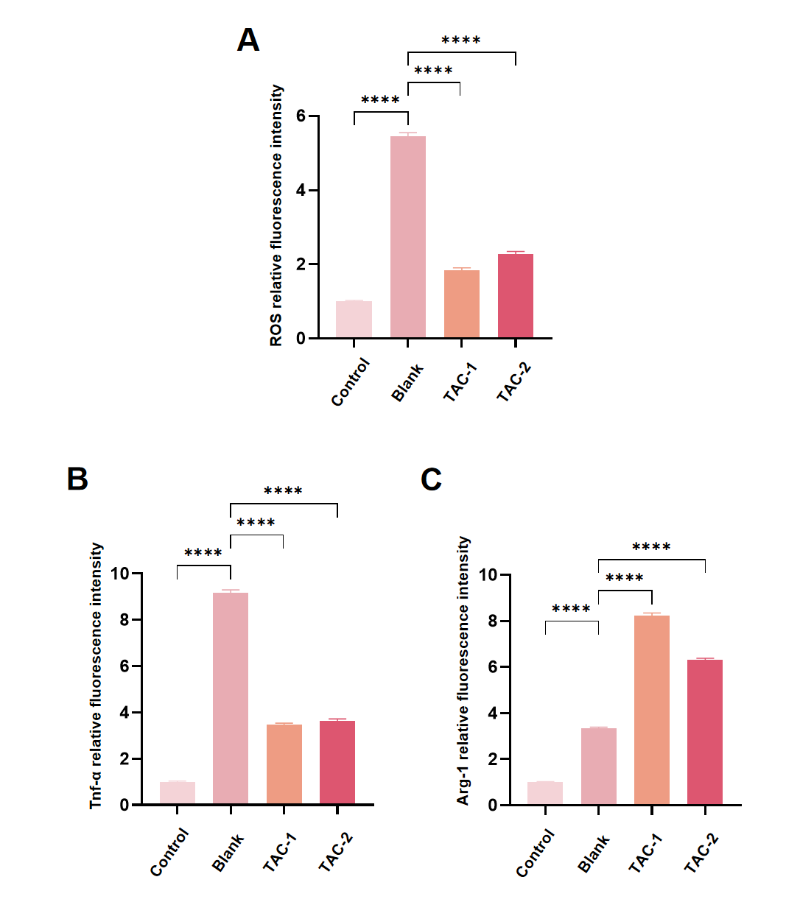
Figure S2. BCL-2 protein expression in chondrocytes. Bar graph shows the mean fluorescence intensity (MFI) of BCL-2 in chondrocytes under different treatments. Chondrocytes were left untreated (Control), stimulated with 10 ng/mL IL-1β alone (Blank), or co-treated with IL-1β and two concentrations of tacrolimus (TAC-1 and TAC-2). Data are presented as mean ± standard deviation (SD). **** p < 0.0001. Data are from n = 3 independent experiments.
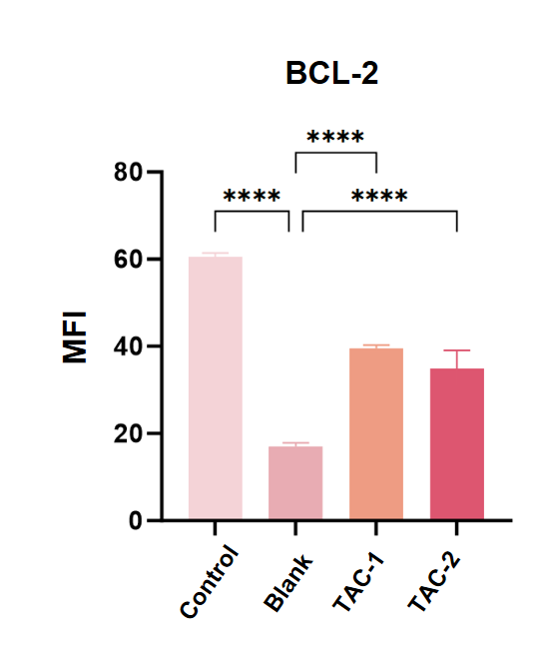
Figure S3. Quantitative histological assessment of cartilage degeneration and synovial inflammation after intra-articular treatment. (A) Quantitative analysis of cartilage degeneration among the Sham, PBS, Dex and TAC groups. (B) Quantitative assessment of synovial inflammation among the four groups. Data are presented as mean ± standard deviation (SD). *p < 0.05, **p < 0.01, ***p < 0.001 and ****p < 0.0001. Each group included n = 6 rats.
