Supplementary Information
Decomposing deep neural network-brain representational similarity reveals distinct sources across the human visual hierarchy
Xiaonai Li, Fangyao Zhang, Yuxuan Zhang
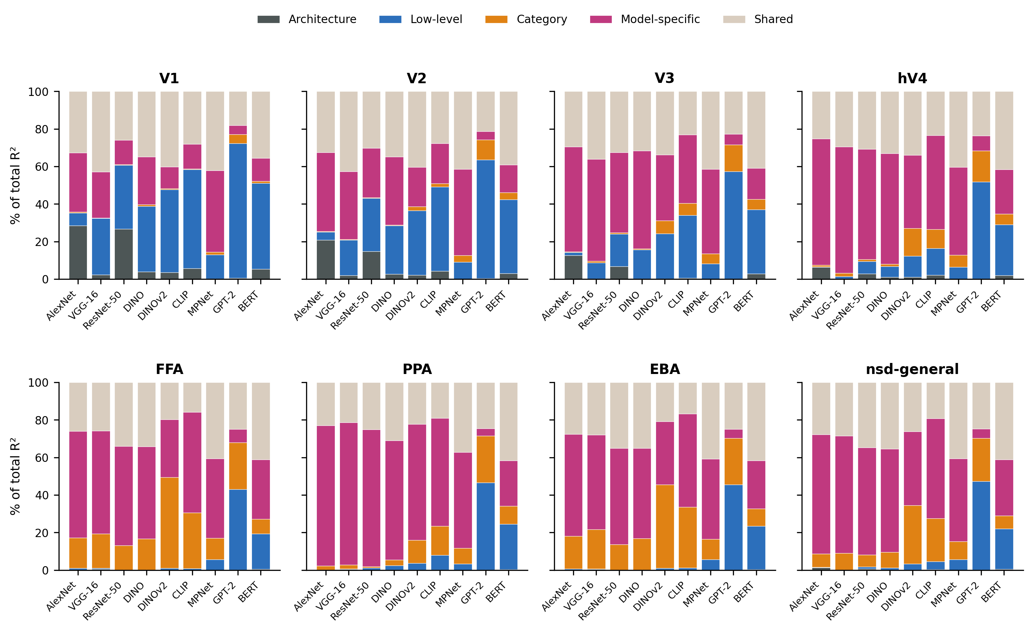
Supplementary Figure S1. Per-model decomposition profiles across the cortical hierarchy. Four-source variance decomposition for each of nine models across all eight ROIs. Each stacked bar shows the proportion of total explained variance (R²). nsdgeneral is included for reference. Group means, n = 8.
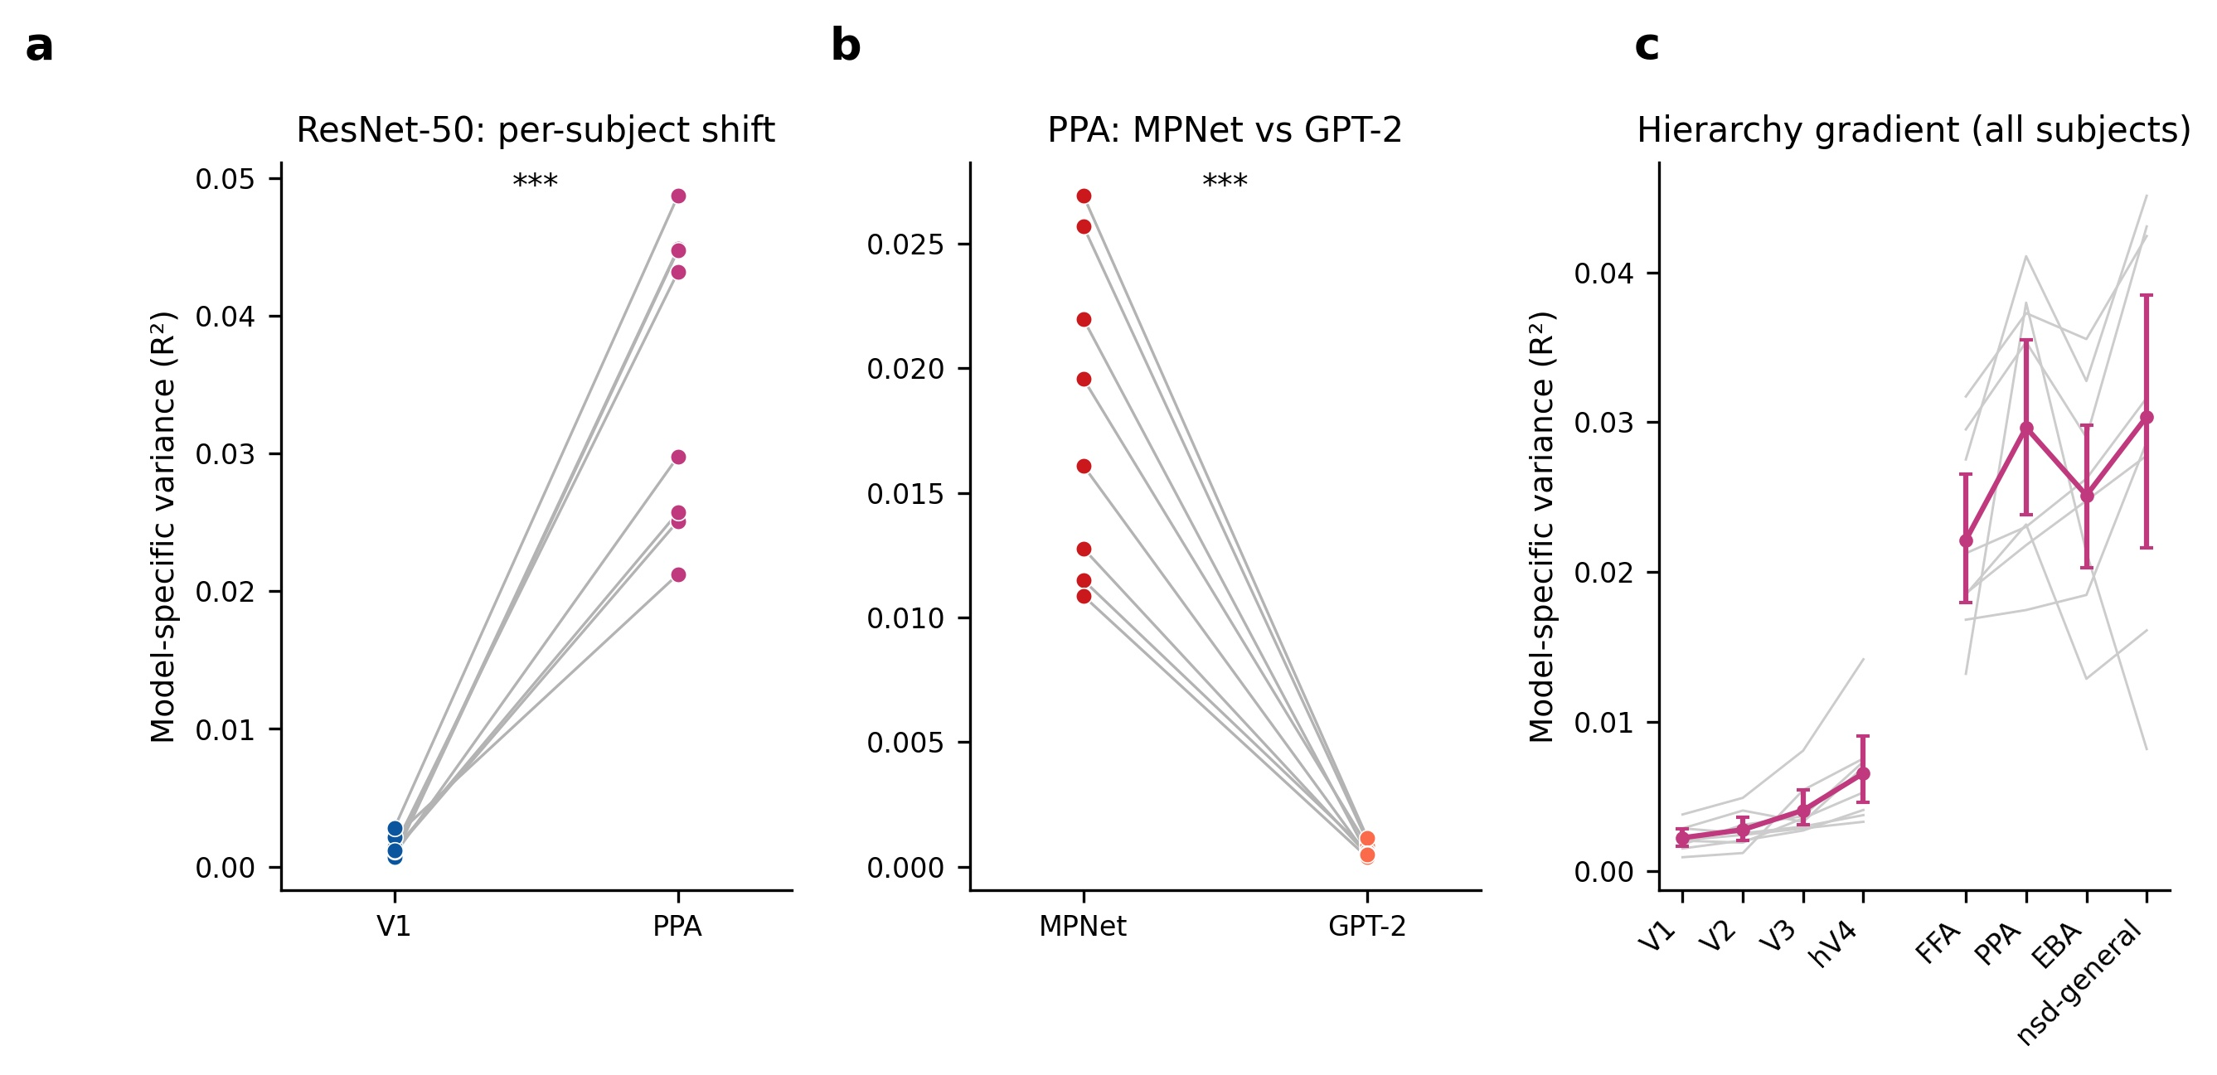
Supplementary Figure S2. Inter-subject consistency. (a) Per-subject V1-to-PPA shift in model-specific variance for ResNet-50; directionally consistent in all eight participants (***p < 0.001). (b) Per-subject MPNet vs GPT-2 model-specific variance in PPA (***p < 0.001, all paired t(7) > 8). (c) Hierarchy gradient of model-specific variance, averaged over the six vision models within each participant. Grey lines show individual participants and pink shows the group mean with its 95% bootstrap confidence interval across participants.
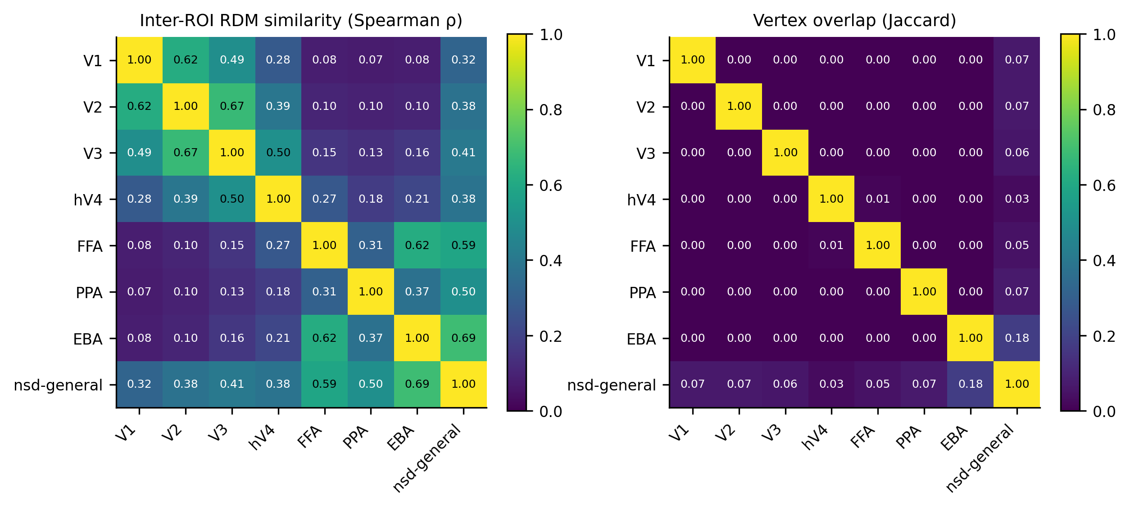
Supplementary Figure S3. Dependence among the eight regions of interest. Left, Spearman correlation between the neural RDMs of each pair of ROIs, computed per participant on the 907 shared stimuli and averaged across participants. Right, pairwise Jaccard overlap of the ROIs' fsaverage vertex sets, averaged across participants.

Supplementary Table S1. Predictor multicollinearity diagnostics. Variance inflation factors (VIF) for each predictor, averaged across eight ROIs and eight participants (maximum in parentheses). All mean VIF values were below 1.27, confirming that multicollinearity does not compromise the variance partitioning.

Model | Architecture | Low-level | Category | Model-specific
AlexNet | 1.068 (1.083) | 1.170 (1.179) | 1.085 (1.091) | 1.208 (1.214)
VGG-16 | 1.163 (1.189) | 1.260 (1.285) | 1.082 (1.087) | 1.223 (1.238)
ResNet-50 | 1.026 (1.040) | 1.082 (1.095) | 1.148 (1.154) | 1.208 (1.215)
DINO | 1.136 (1.146) | 1.181 (1.193) | 1.136 (1.142) | 1.202 (1.208)
DINOv2 | 1.178 (1.260) | 1.211 (1.274) | 1.042 (1.064) | 1.201 (1.338)
CLIP | 1.132 (1.142) | 1.144 (1.154) | 1.025 (1.028) | 1.028 (1.032)
MPNet | 1.002 (1.003) | 1.239 (1.245) | 1.069 (1.072) | 1.219 (1.223)
GPT-2 | 1.013 (1.019) | 1.060 (1.063) | 1.066 (1.074) | 1.011 (1.015)
BERT | 1.054 (1.058) | 1.108 (1.113) | 1.132 (1.139) | 1.156 (1.163)

Supplementary Table S2. Dependence among the eight regions of interest. (a) Spearman correlation between the neural representational dissimilarity matrices of each pair of ROIs, computed per participant on the 907 stimuli shared across all eight participants and averaged across participants; standard deviation across participants in brackets. (b) Proportion of each ROI's fsaverage vertices that lie inside nsdgeneral, averaged across participants. (c) Pairwise Jaccard overlap of vertex sets between all ROIs, averaged across participants. The seven inferential ROIs showed minimal anatomical overlap with one another. nsdgeneral overlaps extensively with them, containing all of V1 to hV4 and most of FFA, PPA and EBA. Its RDM therefore correlates with every other ROI, and it is treated as a reference region rather than an independent ROI.

(a) Inter-ROI RDM similarity, Spearman rho, mean (SD), n = 8
ROI | V1 | V2 | V3 | hV4 | FFA | PPA | EBA | nsd-general
V1 | 1.00 (0.00) | 0.62 (0.07) | 0.49 (0.10) | 0.28 (0.08) | 0.08 (0.02) | 0.07 (0.02) | 0.08 (0.02) | 0.32 (0.03)
V2 | 0.62 (0.07) | 1.00 (0.00) | 0.67 (0.13) | 0.39 (0.10) | 0.10 (0.03) | 0.10 (0.03) | 0.10 (0.03) | 0.38 (0.04)
V3 | 0.49 (0.10) | 0.67 (0.13) | 1.00 (0.00) | 0.50 (0.06) | 0.15 (0.05) | 0.13 (0.04) | 0.16 (0.04) | 0.41 (0.07)
hV4 | 0.28 (0.08) | 0.39 (0.10) | 0.50 (0.06) | 1.00 (0.00) | 0.27 (0.10) | 0.18 (0.05) | 0.21 (0.06) | 0.38 (0.10)
FFA | 0.08 (0.02) | 0.10 (0.03) | 0.15 (0.05) | 0.27 (0.10) | 1.00 (0.00) | 0.31 (0.05) | 0.62 (0.08) | 0.59 (0.15)
PPA | 0.07 (0.02) | 0.10 (0.03) | 0.13 (0.04) | 0.18 (0.05) | 0.31 (0.05) | 1.00 (0.00) | 0.37 (0.07) | 0.50 (0.11)
EBA | 0.08 (0.02) | 0.10 (0.03) | 0.16 (0.04) | 0.21 (0.06) | 0.62 (0.08) | 0.37 (0.07) | 1.00 (0.00) | 0.69 (0.15)
nsd-general | 0.32 (0.03) | 0.38 (0.04) | 0.41 (0.07) | 0.38 (0.10) | 0.59 (0.15) | 0.50 (0.11) | 0.69 (0.15) | 1.00 (0.00)

(b) Proportion of each ROI's vertices inside nsdgeneral, mean over participants
ROI | Proportion inside nsdgeneral
V1 | 1.00
V2 | 1.00
V3 | 1.00
hV4 | 1.00
FFA | 0.86
PPA | 0.78
EBA | 0.79

(c) Pairwise Jaccard overlap of vertex sets, mean over participants
ROI | V1 | V2 | V3 | hV4 | FFA | PPA | EBA | nsd-general
V1 | 1.000 | 0.000 | 0.000 | 0.000 | 0.000 | 0.000 | 0.000 | 0.070
V2 | 0.000 | 1.000 | 0.000 | 0.000 | 0.000 | 0.000 | 0.000 | 0.070
V3 | 0.000 | 0.000 | 1.000 | 0.000 | 0.000 | 0.000 | 0.001 | 0.062
hV4 | 0.000 | 0.000 | 0.000 | 1.000 | 0.012 | 0.000 | 0.001 | 0.028
FFA | 0.000 | 0.000 | 0.000 | 0.012 | 1.000 | 0.001 | 0.002 | 0.048
PPA | 0.000 | 0.000 | 0.000 | 0.000 | 0.001 | 1.000 | 0.000 | 0.074
EBA | 0.000 | 0.000 | 0.001 | 0.001 | 0.002 | 0.000 | 1.000 | 0.183
nsd-general | 0.070 | 0.070 | 0.062 | 0.028 | 0.048 | 0.074 | 0.183 | 1.000

