Supplementary Figure

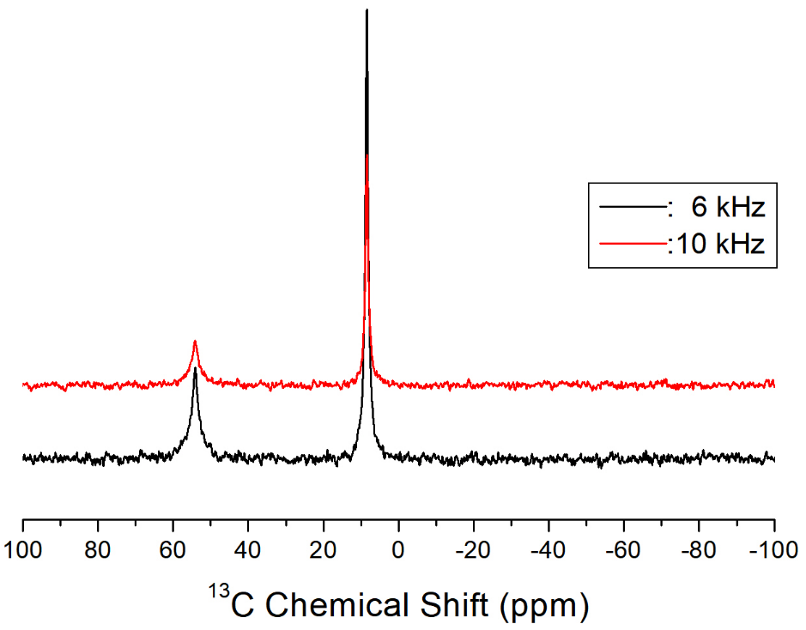

Figure S1. ¹³C NMR chemical shifts in [N(C₂H₅)₄]₂ZnCl₄ measured at spinning speeds of 6 and 10 kHz.

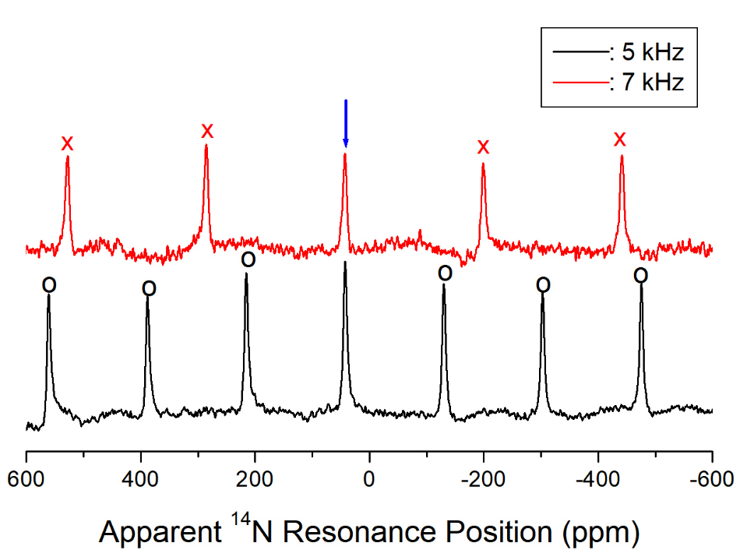
Figure S2. Apparent ¹⁴N resonance positions in [N(C₂H₅)₄]₂ZnCl₄ at spinning speeds of 5 and 7 kHz. The symbols x and o denote the spinning sidebands of the main peaks indicated by the arrows.

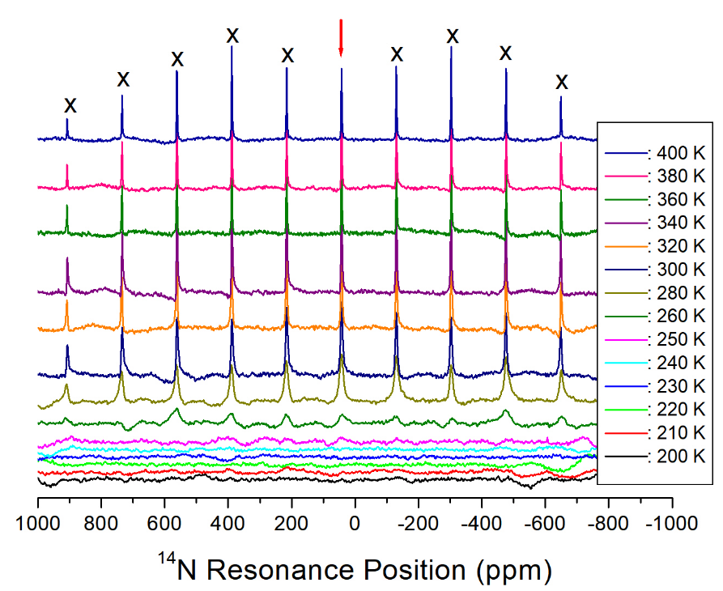
Figure S3. ¹⁴N NMR spectra of [N(C₂H₅)₄]₂ZnCl₄ recorded at a spinning speed of 5 kHz as a function of temperature.

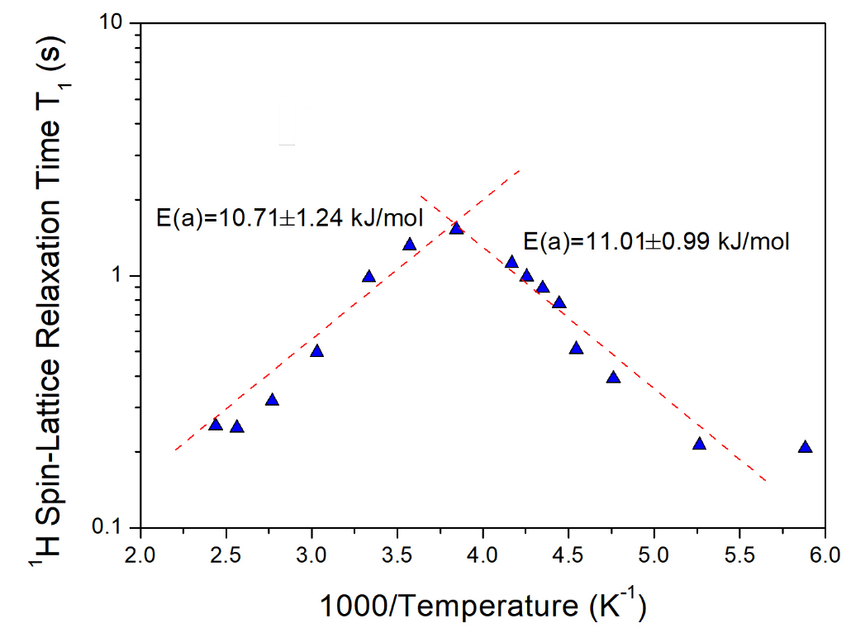
Figure S4. ¹H spin-lattice relaxation time T₁ in [N(C₂H₅)₄]₂ZnCl₄ as a function of inverse temperature. Dot lines represent the activation energies.

Supplementary Table

Table S1. Atomic coordinates (×10⁴) and equivalent isotropic displacement parameters (Å²×10³) for [N(C₂H₅)₄]₂ZnCl₄ at 300 K. U(eq) is defined as one third of the trace of the orthogonalized U_{ij} tensor.

 | x | y | z | U(eq)
Zn(1)  Cl(1) | 2500  2500 | 7500  5478(3) | 7500  6611(2) |  | 66(1)  125(2)
N(1) | 2500 | 2500 | 4149(5) |  | 82(3)
C(1) | 4047(4) | 2500 | 4196(12) |  | 490(40)
C(2) | 4703(18) | 2500 | 5153(10) |  | 143(5)
C(3) | 2500 | 4047(6) | 4096(17) |  | 950(100)
C(4)  H(1A)  H(1B)  H(2A)  H(2B)  H(2C)  H(3A)  H(3B)  H(4A)  H(4B)  H(4C) | 2500  4413  4413  5764  4376  4376  3364  1636  2500  3367  1633 | 4740(30)  3365  1635  2500  3367  1633  4409  4409  5801  4427  4427 | 3149(13)  3883  3883  5119  5466  5466  4412  4412  3198  2831  2831 |  | 190(8)  583  583  214  214  214  1137  1137  286  286  286

Table S2. The bond-lengths (Å) and bond-angles (°) for [N(C₂H₅)₄]₂ZnCl₄ at 300 K.

Zn(1)-Cl(1)#1 | 2.260(3) | C(3)#4-C(1)-C(3) | 89.7(3)
Zn(1)-Cl(1)#2 | 2.260(3) | N(1)-C(1)-H(1A) | 108.4
Zn(1)-Cl(1)#3  Zn(1)-Cl(1) | 2.260(2)  2.260(2) | C(2)-C(1)-H(1A)  C(3)#4-C(1)-H(1A) | 108.4  140.6
N(1)-C(1) | 1.400(4) | C(3)-C(1)-H(1A) | 68.6
N(1)-C(1)#4 | 1.400(4) | N(1)-C(1)-H(1B) | 108.4
N(1)-C(3)#4 | 1.400(5) | C(2)-C(1)-H(1B) | 108.4
N(1)-C(3) | 1.400(5) | C(3)#4-C(1)-H(1B) | 68.6
C(1)-C(2) | 1.550(4) | C(3)-C(1)-H(1B) | 140.6
C(1)-H(1A) | 0.9700 | H(1A)-C(1)-H(1B) | 107.5
C(1)-H(1B) | 0.9700 | C(1)-C(2)-H(2A) | 109.5
C(2)-H(2A) | 0.9600 | C(1)-C(2)-H(2B) | 109.5
C(2)-H(2B) | 0.9600 | H(2A)-C(2)-H(2B) | 109.5
C(2)-H(2C) | 0.9600 | C(1)-C(2)-H(2C) | 109.5
C(3)-C(4) | 1.550(4) | H(2A)-C(2)-H(2C) | 109.5
C(3)-H(3A) | 0.9700 | H(2B)-C(2)-H(2C) | 109.5
C(3)-H(3B) | 0.9700 | N(1)-C(3)-C(4) | 117.1(19)
C(4)-H(4A) | 0.9600 | N(1)-C(3)-C(1) | 44.91(13)
C(4)-H(4B) | 0.9600 | C(4)-C(3)-C(1) | 110.8(14)
C(4)-H(4C) | 0.9600 | N(1)-C(3)-C(1)#4 | 44.91(13)
Cl(1)#1-Zn(1)-Cl(1)#2 | 107.92(17) | C(4)-C(3)-C(1)#4 | 110.8(14)
Cl(1)#1-Zn(1)-Cl(1)#3 | 110.25(9) | C(1)-C(3)-C(1)#4 | 89.7(3)
Cl(1)#2-Zn(1)-Cl(1)#3 | 110.25(9) | N(1)-C(3)-H(3A) | 108.0
Cl(1)#1-Zn(1)-Cl(1) | 110.25(9) | C(4)-C(3)-H(3A) | 108.0
Cl(1)#2-Zn(1)-Cl(1) | 110.25(9) | C(1)-C(3)-H(3A) | 68.5
Cl(1)#3-Zn(1)-Cl(1) | 107.92(17) | C(1)#4-C(3)-H(3A) | 140.2
C(1)-N(1)-C(1)#4 | 174.2(15) | N(1)-C(3)-H(3B) | 108.0
C(1)-N(1)-C(3)#4 | 90.16(7) | C(4)-C(3)-H(3B) | 108.0
C(1)#4-N(1)-C(3)#4 | 90.16(7) | C(1)-C(3)-H(3B) | 140.2
C(1)-N(1)-C(3) | 90.16(7) | C(1)#4-C(3)-H(3B) | 68.5
C(1)#4-N(1)-C(3) | 90.16(7) | H(3A)-C(3)-H(3B) | 107.3
C(3)#4-N(1)-C(3) | 174(2) | C(3)-C(4)-H(4A) | 109.5
N(1)-C(1)-C(2) | 115.4(12) | C(3)-C(4)-H(4B) | 109.5
N(1)-C(1)-C(3)#4 | 44.92(13) | H(4A)-C(4)-H(4B) | 109.5
C(2)-C(1)-C(3)#4 | 109.9(11) | C(3)-C(4)-H(4C) | 109.5
N(1)-C(1)-C(3) | 44.92(13) | H(4A)-C(4)-H(4C) | 109.5
C(2)-C(1)-C(3) | 109.9(11) | H(4B)-C(4)-H(4C) | 109.5
Symmetry transformations used to generate equivalent atoms:
#1 -y+1,x+1/2,-z+3/2 #2 y-1/2,-x+1,-z+3/2 #3 -x+1/2,-y+3/2,z #4 -x+1/2,-y+1/2,z

