Land-Change Trajectories of Brazilian Amazon Wetlands Across Tenure Regimes

Guilherme de Sousa Lobo, Ramon F. Bicudo da Silva, Emilio Moran, Mateus Batistella

Highlights

- Brazilian Amazon wetland human modification accelerated 28.9% over 2015–2024, reaching 6.16% of total area.
- Land tenure regime explains up to 43% of variance in wetland human modification dynamics.
- Public lands and agrarian reform settlements are the deforestation and human modified wetland hotspots
- Tapajós and Xingu basins have transitioned from active deforestation to human land use consolidation in wetlands.
- Negro basin fire intensification is decoupled from deforestation, driven by black-water ecological vulnerability.
Wetland conservation demands tenure regularization in active frontiers and specialized fire management in black-water systems.

SUPPLEMENTARY INFORMATION

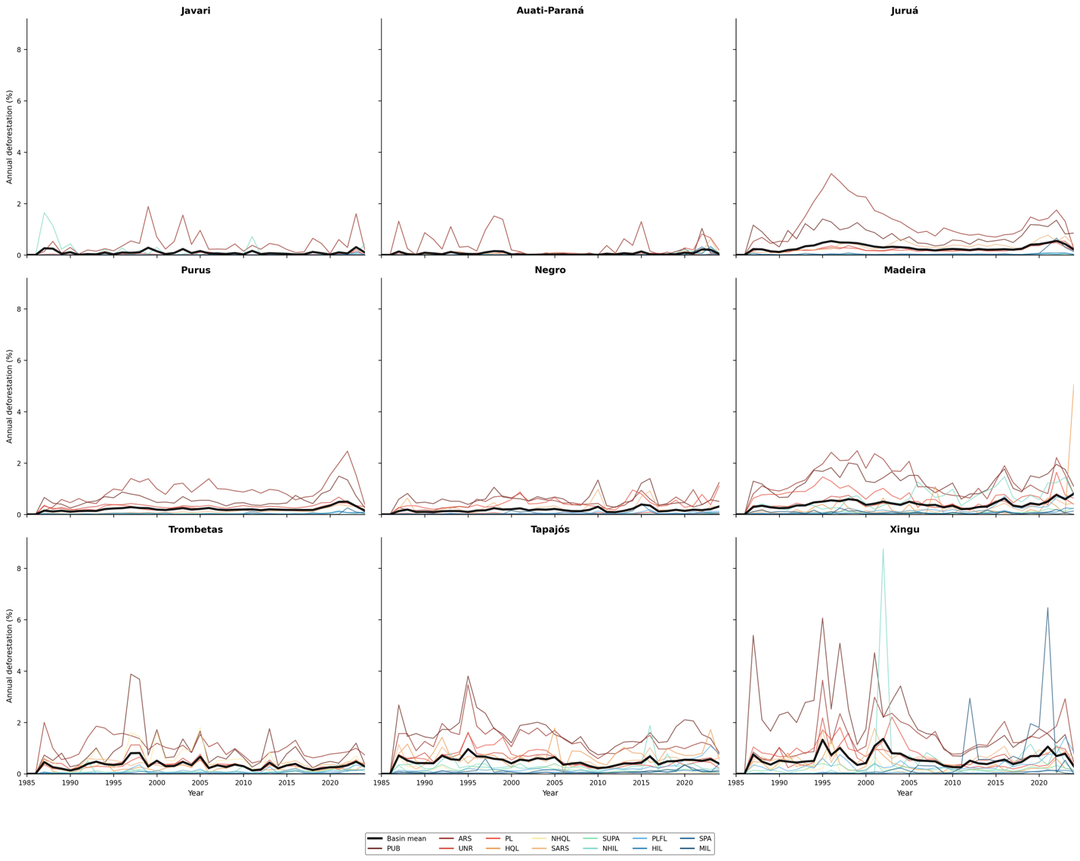
Fig. S1: Annual deforestation rates (%) across major Amazonian wetland sub-basins (1985–2024) disaggregated by land tenure category. The solid black line represents the overall sub-basin mean, while colored lines indicate specific land tenure classes.

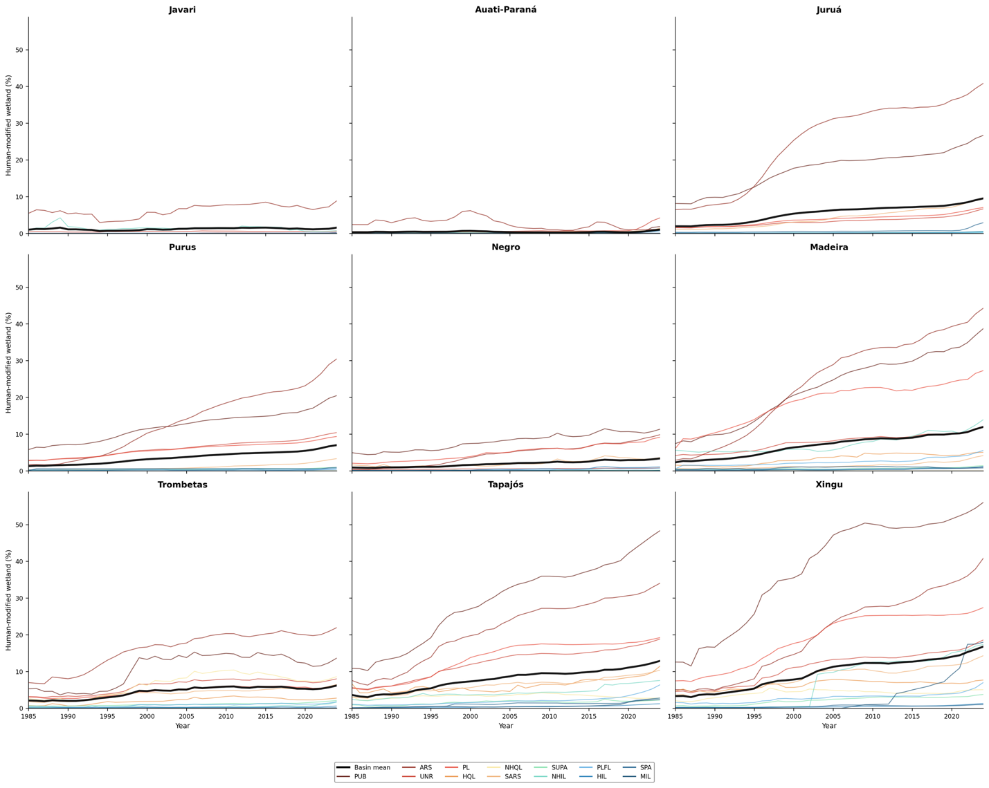
Fig. S2: Human-modified wetland area (%) by land tenure category across Amazonian sub-basins (1985–2024). Black lines denote the weighted mean for each sub-basin.

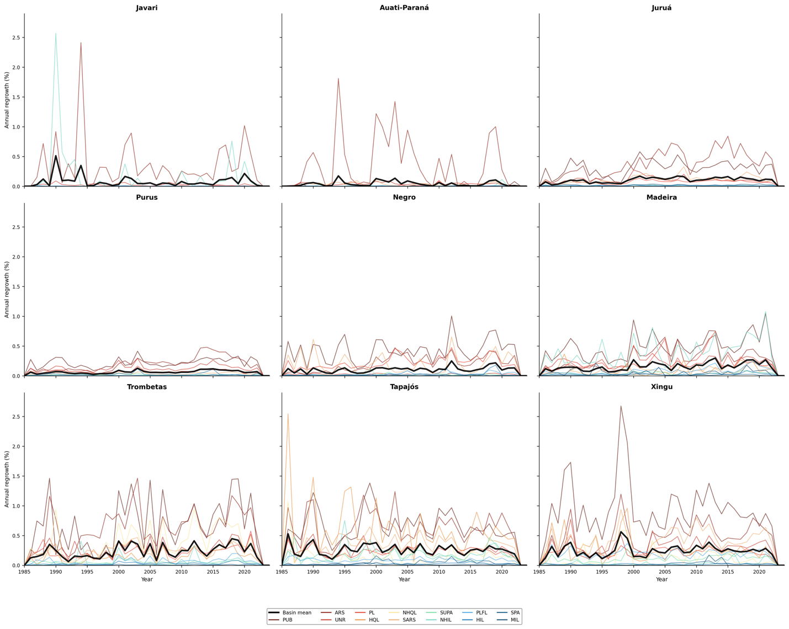
Fig. S3: Annual regrowth rates (%) across major Amazonian wetland sub-basins (1985–2024) disaggregated by land tenure category. The solid black line represents the overall sub-basin mean, while colored lines indicate specific land tenure classes.

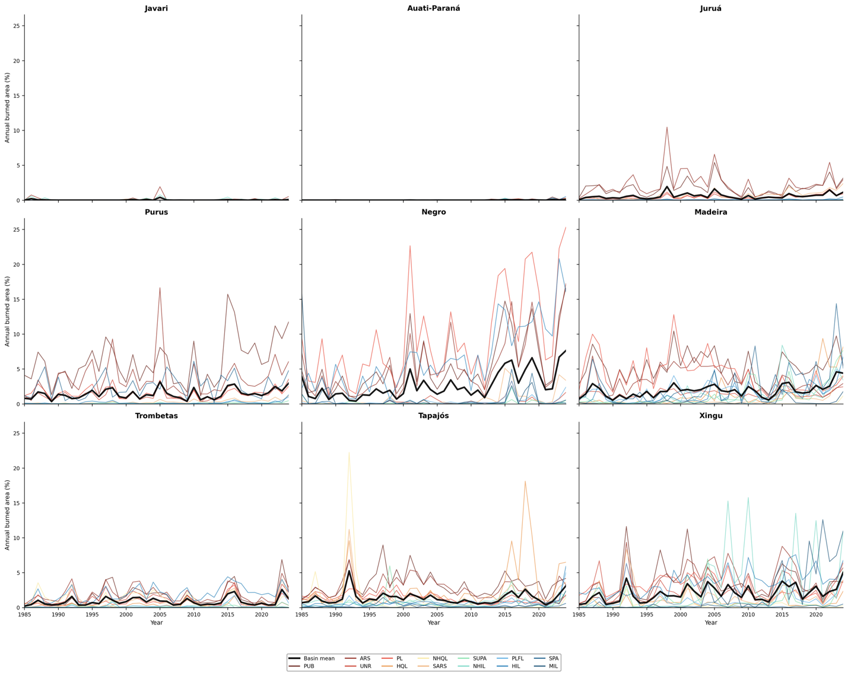
Fig. S4: Annual burned area (%) in Amazonian wetlands by sub-basin and land tenure (1985–2024). The solid black line represents the average fire pressure for each respective basin.

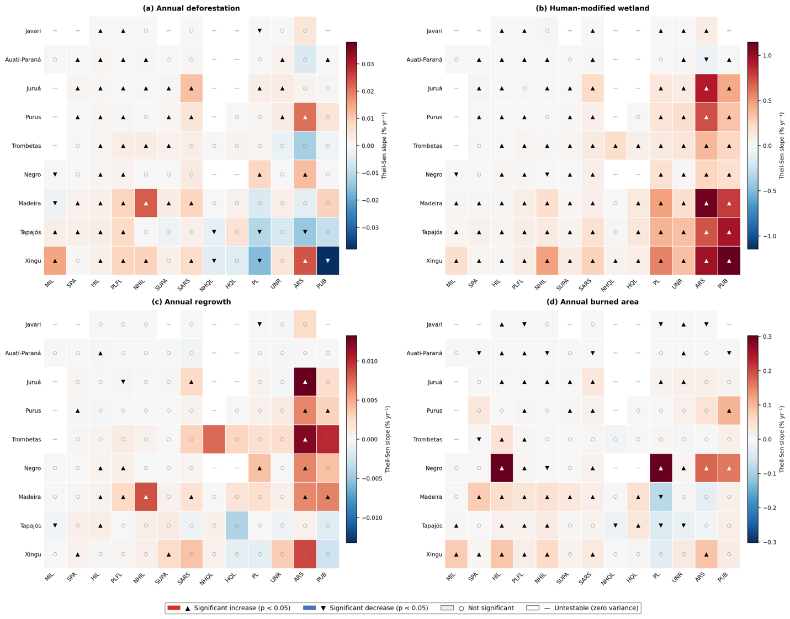
Fig. S5: Mann-Kendall trend analysis of all land tenure category × sub-basin combinations (1985–2024) for (a) Annual deforestation, (b) Human-modified wetland, (c) Annual regrowth, and (d) Annual burned area. Cell color indicates Theil-Sen slope magnitude (% yr⁻¹); diverging scale from blue (decreasing) to red (increasing). ▲ = significant increase (p < 0.05); ▼ = significant decrease; ○ = not significant; — = untestable due to zero variance. Tenure categories are ordered by increasing median pressure (left to right).

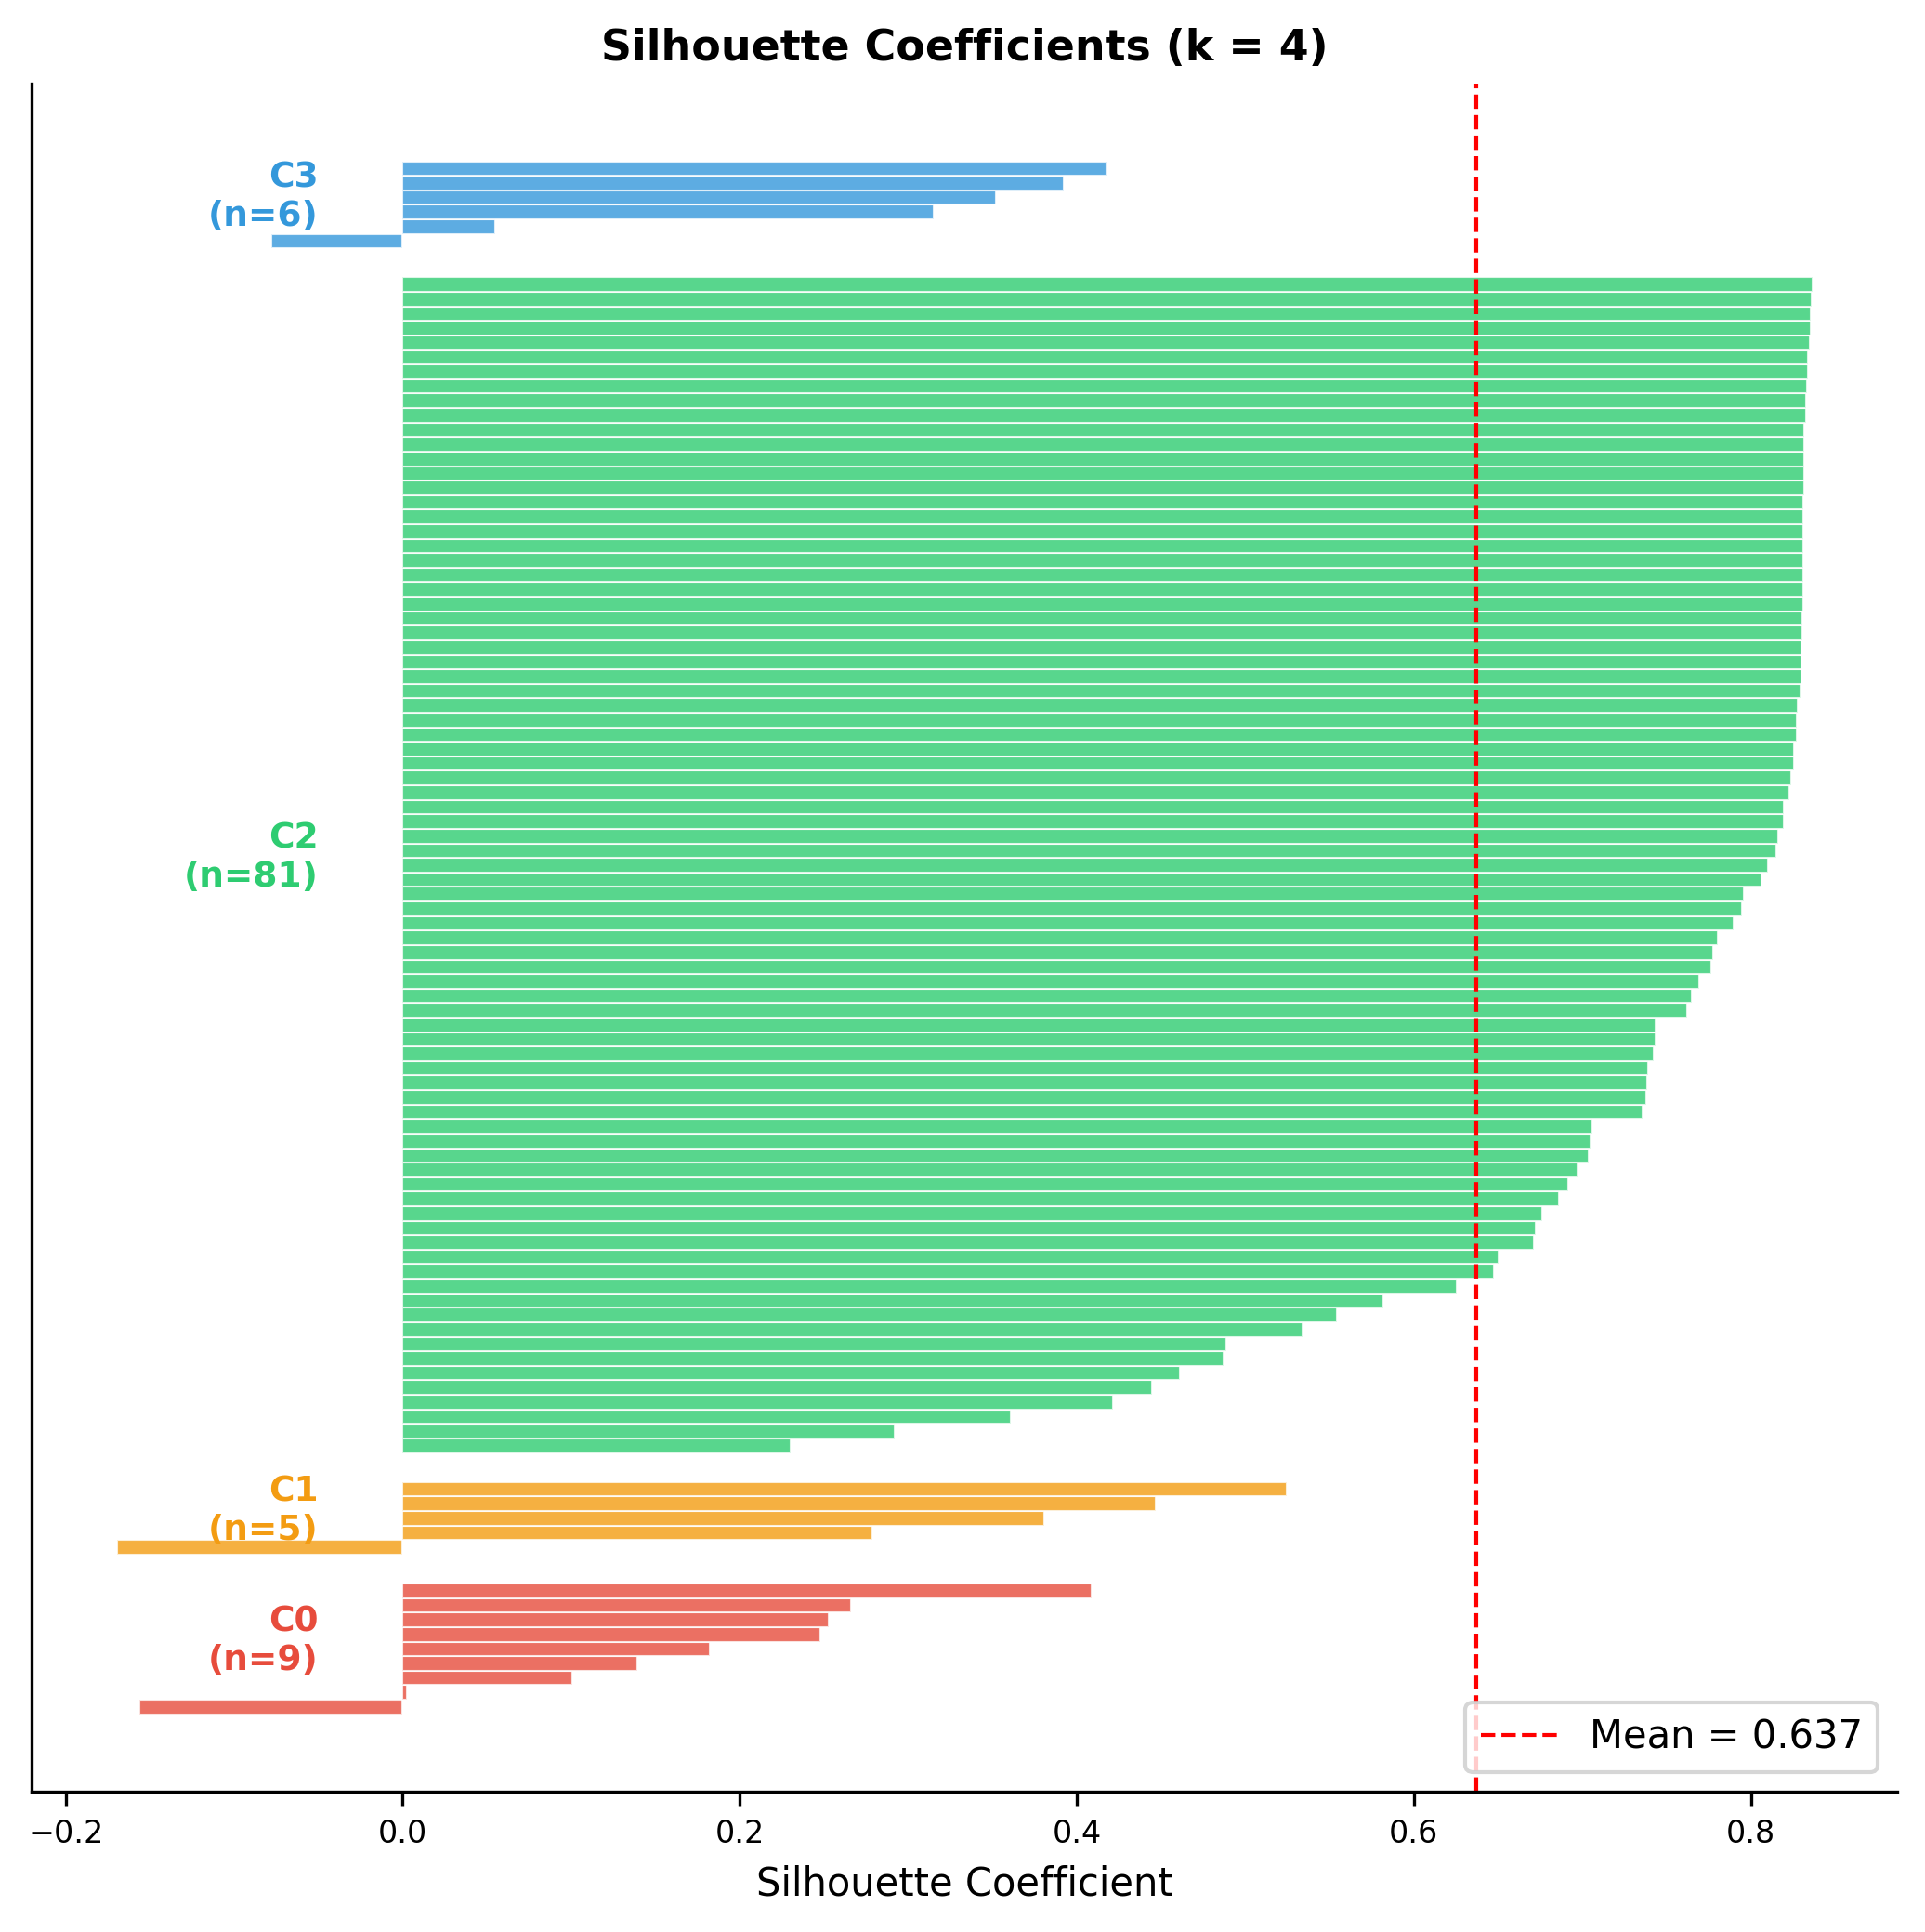
Fig. S6: Silhouette coefficients per combination. C0 (red, n = 9); C1 (orange, n = 5); C2 (green, n = 81), and C3 (blue, n = 6).

Cluster 0 (n = 9, Silhouette = 0.161) is distinguished by an elevated human-modified wetland area trend (Theil-Sen = 0.61% yr⁻¹) while deforestation and burned area remain low. It is composed by Agrarian Reform Settlements (5 of 9 total ARS combinations) and Public Lands (2), with isolated contributions from NHIL (1) and NHQL (1). Geographically, it is concentrated in the Madeira (3) and Trombetas (3) sub-basins, with single combinations in Juruá, Purus, and Xingu.

Cluster 1 (n = 5, Silhouette = 0.292) is distinguished by the highest burned area trend among all groups (Theil-Sen = 0.21% yr⁻¹) while deforestation and human-modified wetland trends remain low. Critically, 4 of 5 tenure combinations belong to the Negro sub-basin. This cluster includes HIL (1), PL (1), PUB (2), and ARS (1).

Cluster 2 (n = 81, Silhouette = 0.740) is characterized by near-zero Theil-Sen slopes across all four indicators (deforestation < 0.01% yr⁻¹, human-modified wetland = 0.06% yr⁻¹, regrowth < 0.01% yr⁻¹, burned area = 0.01% yr⁻¹). This cluster is broadly distributed across all nine sub-basins and encompasses all 13 land tenure categories, with all PLFL (9), SARS (9), and UNR (9) combinations, and the large majority of HIL (8), NHIL (8), SUPA (8), and SPA (8) combinations.

Cluster 3 (n = 6, Silhouette = 0.242) represents a land use consolidation trajectory, uniquely characterized by declining deforestation (Theil-Sen = −0.02% yr⁻¹) and burned area (−0.02% yr⁻¹) alongside the highest human-modified wetland area trend of all clusters (0.70% yr⁻¹), indicating areas where active clearing has slowed but human land use consolidation continues. It is composed exclusively of Private Lands (3), Public Lands (2), and ARS (1), concentrated in the Tapajós (3) and Xingu (2) sub-basins, with one combination in the Madeira.

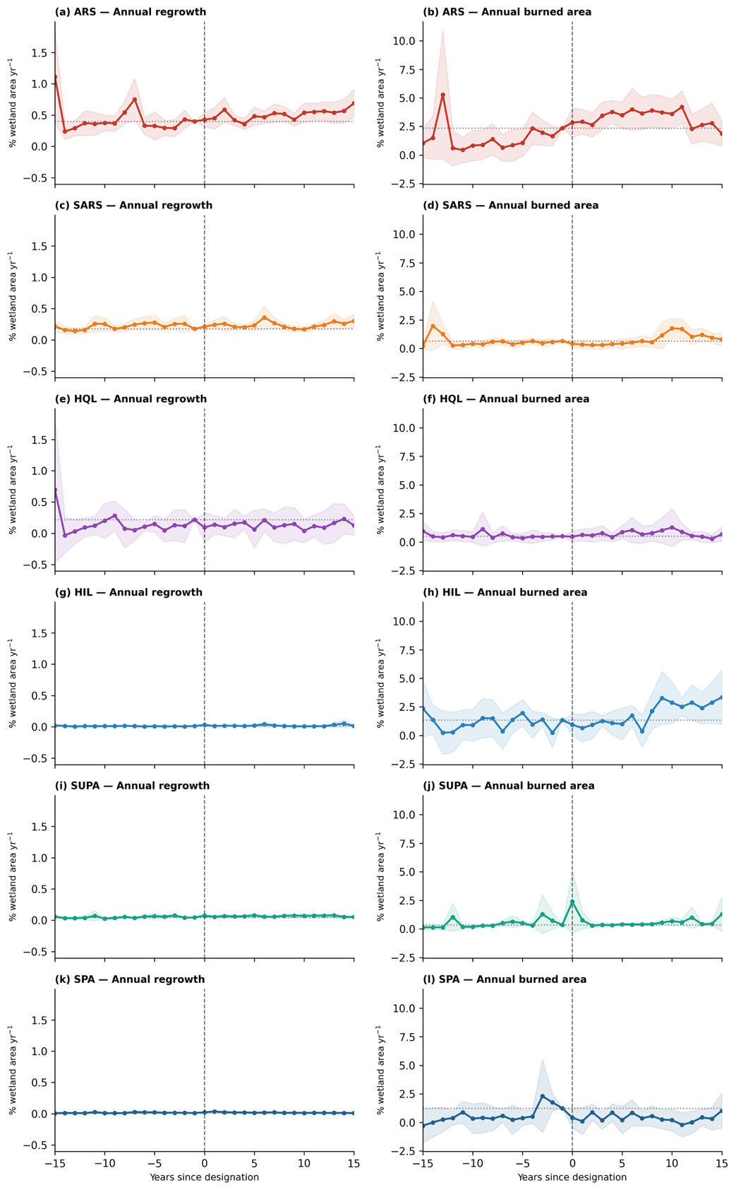

Fig. S7. Wetland land change around tenure designation. Area-weighted, sub-basin-adjusted annual regrowth (left) and annual burned area (right) by event time (15 years before and after designation), for the six tenure classes with a formal designation event: ARS (Agrarian Reform Settlement), SARS (Sustainable Agrarian Reform Settlement, HQL (Homologated Quilombo Land), HIL (Homologated Indigenous Land, SUPA (Sustainable Use Protected Area), SPA (Strict Protected Area). Dashed line, designation year; shaded bands, 95% confidence intervals.

