Supplementary Material

Nanobody-based lateral flow assays for the detection of α-bungarotoxin in Bungarus snake venoms
Suthimon Thumtecho^{1,2*}, Selma B. Belfakir^{1,3},
Tenna V. K. Christensen¹, Esperanza Rivera-de-Torre¹, Nick J. Burlet¹,
Anne Ljungars¹, Georgina M. S. Ross^{3*}, Andreas H. Laustsen^{1*}

¹Department of Biotechnology and Biomedicine, Technical University of Denmark, DK-2800 Kongens Lyngby, Denmark
²Division of Toxicology, Department of Medicine, Chulalongkorn University and King Chulalongkorn Memorial Hospital, the Thai Red Cross Society, 10330 Pathumwan, Bangkok, Thailand
³VenomAid Diagnostics, DK-2800 Kongens Lyngby, Denmark

*Correspondence and requests for materials should be addressed to Suthimon Thumtecho (suthum@dtu.dk), Georgina M. S. Ross (gin@venomaid.com), or Andreas H. Laustsen (ahola@bio.dtu.dk).
Table of contents
Title |  | Page
Table S1 | Overview of phage display campaigns | S1
Table S2 | Determination of affinity measurements by biolayer interferometry | S2
Table S3 | Quantification of V_{H}H immobilization on gold nanoparticles | S3–4
Table S4 | Composition of reaction mixtures for LFIA testing | S5
Table S5 | Preparation of serial dilutions of target toxins/whole venoms | S6
Fig. S1 | Amino acid sequence and structural comparison of α-bungarotoxin and α-cobratoxin | S7
Fig. S2 | Primary screening of V_{H}H clones in dissociation-enhanced lanthanide fluorescence immunoassay against α-bungarotoxin and α-cobratoxin | S8
Fig. S3 | SDS-PAGE analysis of purified V_{H}H_BuTx and V_{H}H_LNTx | S9
Fig. S4 | Binding kinetics of selected V_{H}H clones against biotinylated  α-bungarotoxin by biolayer interferometry | S10
Fig. S5 | Amino acid sequence alignment of V_{H}Hs | S11
Fig. S6 | Epitope binning results by biolayer interferometry | S12
Fig. S7 | UV-Vis spectral characterization and stability of V_{H}H-conjugated gold nanoparticles | S13–14
Fig. S8 | Systematic optimization of LFIA parameters | S15
Fig. S9 | Assessment of V_{H}H recognition in human urine and serum by Western blot and biolayer interferometry | S16–17
Supplementary methods |  | S18–19
References |  | S20

Supplementary Table S1: Overview of phage display campaigns. Summary of phage display selection campaigns with Library C. Target toxins and concentrations are listed for each round, where the output from each selection round (selection output) was used for selection in the subsequent round. "Y/N" indicates the inclusion or exclusion of deselection and/or blocking steps performed using α-cobratoxin to enhance specificity.
Round 1 |  |  |  |  | Round 2 |  |  |  |  | Round 3
Deselection | Blocking | Target, conc.  (nM) | Enrichment | Selection output | Deselection | Blocking | Target, conc.  (nM) | Enrichment | Selection output | Deselection | Blocking | Target, conc.  (nM) | Enrichment | Selection output
Y | Y | α-BuTx, 100 | 2.16 | TPL1170 | N | Y | α-BuTx, 100 | 5,263 | TPL1186 | N | Y | α-BuTx, 100 | 180,000 | TPL1195
Y | Y | α-BuTx, 100 | 2.16 | TPL1170 | N | Y | α-BuTx, 100 | 5,263 | TPL1186 | N | Y | α-BuTx,  10 | 7,800 | TPL1196
Y | Y | α-BuTx, 100 | 2.16 | TPL1170 | N | Y | α-BuTx, 100 | 5,263 | TPL1186 | N | N | α-BuTx, 100 | 442,857 | TPL1197
Y | Y | α-BuTx, 100 | 2.16 | TPL1170 | N | Y | α-BuTx, 100 | 5,263 | TPL1186 | N | N | α-BuTx,  10 | 28,571 | TPL1198
Y | Y | α-BuTx, 100 | 2.16 | TPL1170 | Y | Y | α-BuTx, 100 | 7.5 | TPL1182
Y | Y | α-BuTx, 100 | 2.16 | TPL1170 | Y | N | α-BuTx, 100 | 0.75 | TPL1181
Y | Y | α-BuTx, 100 | 2.16 | TPL1170 | N | N | α-BuTx, 100 | 8,000 | TPL1185
N | N | α-BuTx, 100 | 46 | TPL1171 | N | N | α-BuTx, 100 | 15,000 | TPL1187 | N | N | α-BuTx, 100 | 14,285,714 | TPL1199
N | N | α-BuTx, 100 | 46 | TPL1171 | N | N | α-BuTx, 100 | 15,000 | TPL1187 | N | N | α-BuTx,  10 | 3,571,428 | TPL1200
N | N | α-BuTx, 100 | 46 | TPL1171 | Y | Y | α-BuTx, 100 | 0.5 | TPL1184
N | N | α-BuTx, 100 | 46 | TPL1171 | Y | N | α-BuTx, 100 | 10 | TPL1183
N | N | α-BuTx, 100 | 46 | TPL1171 | N | Y | α-BuTx, 100 | 3,500 | TPL1188
Y | N | α-BuTx, 100 | 2.14 | TPL1169
N | Y | α-BuTx, 100 | 14 | TPL1172
Abbreviation: α-BuTx - α-bungarotoxin; α-CbTx - α-cobratoxin

Supplementary Table S2: Determination of affinity measurement by biolayer interferometry. Affinity measurements of V_{H}Hs binding to α-bungarotoxin and α-cobratoxin using biolayer interferometry (BLI). Empty grey cells indicate the absence of binding signals according to the BLI experimental setup. TPL1198_02_F06 and TPL1158_01_C09 are referred to as V_{H}H_BuTx and V_{H}H_LNTx, respectively.
V_{H}H | Target | K_{D} (M) | K_{D} error | k_{on} (1/Ms) | k_{on} error | k_{off} (1/s) | k_{off} error | R²
TPL1195_01_H02 | α-BuTx | 2.66 × 10⁻⁶ | 1.03 × 10⁻⁷ | 8.75 × 10³ | 3.20 × 10² | 2.33 × 10⁻² | 3.02 × 10⁻⁴ | 0.984
TPL1195_01_H02 | α-CbTx
TPL1195_02_G04 | α-BuTx
TPL1195_02_G04 | α-CbTx
TPL1195_03_C03 | α-BuTx | 5.79 × 10⁻⁵ | 6.93 × 10⁻⁵ | 2.99 × 10³ | 3.58 × 10³ | 1.73 × 10⁻¹ | 1.17 × 10⁻² | 0.968
TPL1195_03_C03 | α-CbTx
TPL1198_01_A05 | α-BuTx | 1.87 × 10⁻⁶ | 4.01 × 10⁻⁸ | 4.6 × 10³ | 9.23 × 10¹ | 8.60 × 10⁻³ | 5.96 × 10⁻⁵ | 0.986
TPL1198_01_A05 | α-CbTx
TPL1198_01_E04 | α-BuTx
TPL1198_01_E04 | α-CbTx
TPL1198_01_E06 | α-BuTx
TPL1198_01_E06 | α-CbTx
TPL1198_02_F06  (V_{H}H_BuTx) | α-BuTx  (toxin coat) | 1.01 × 10⁻⁶ | 4.69 × 10⁻⁹ | 2.43 × 10³ | 1.06 × 10¹ | 2.45 × 10⁻³ | 4.10 × 10⁻⁶ | 0.998
TPL1198_02_F06  (V_{H}H_BuTx) | α-BuTx  (V_{H}H coat) | 8.52 × 10⁻⁸ | 6.51 × 10⁻¹⁰ | 1.64 × 10⁴ | 1.04 × 10² | 1.39 × 10⁻³ | 5.87 × 10⁻⁶ | 0.984
TPL1198_02_F06  (V_{H}H_BuTx) | α-CbTx
TPL1200_01_G12 | α-BuTx | 1.90 × 10⁻⁶ | 1.77 × 10⁻⁸ | 4.06 × 10³ | 3.59 × 10¹ | 7.69 × 10⁻³ | 2.24 × 10⁻⁶ | 0.997
TPL1200_01_G12 | α-CbTx
TPL1200_01_H06 | α-BuTx | 3.30 × 10⁻⁵ | 1.43 × 10⁻⁴ | 6.86 × 10³ | 2.96×10¹ | 2.27×10⁻¹ | 9.26 × 10⁻² | 0.997
TPL1200_01_H06 | α-CbTx
TPL1158_01_C09  (V_{H}H_LNTx) | α-BuTx  (toxin coat) | 1.70 × 10⁻⁸ | 9.73 × 10⁻¹¹ | 4.17 × 10⁴ | 1.75 × 10² | 7.11 × 10⁻⁴ | 2.53 × 10⁻⁶ | 0.997
TPL1158_01_C09  (V_{H}H_LNTx) | α-BuTx  (V_{H}H coat) | 2.68 × 10⁻⁷ | 4.27 × 10⁻⁹ | 7.02 × 10⁴ | 1.06 × 10³ | 1.88 × 10⁻² | 9.18 × 10⁻⁵ | 0.984
TPL1158_01_C09  (V_{H}H_LNTx) | α-CbTx | 1.20 × 10⁻⁹ | 3.62 × 10⁻¹² | 9.27 × 10⁴ | 1.08 × 10² | 1.17 × 10⁻⁴ | 3.27 × 10⁻⁷ | 0.998
Abbreviation: α-BuTx - α-bungarotoxin; α-CbTx - α-cobratoxin
Supplementary Table S3. Quantification of V_{H}H immobilization on gold nanoparticles.
The number of molecules bound per 40 nm gold nanoparticle (AuNP) was calculated based on the theoretical monolayer capacity and experimentally measured mass. The actual number of molecules per nanoparticle ($Ν_{exp}$) was determined using the following equation:
$$Ν_{exp}= \frac{\left(m_{input}-m_{unbound}\right)× N_{A}}{MW_{{V_{H}H}_{ }}× C_{AuNP}× V_{reaction}}$$
Where:
- $m$ is the mass of V_{H}H (g)
- $N_{A}$ is Avogadro’s constant (6.022 $×$ 10²³ mol⁻¹)
- $MW_{{V_{H}H}_{ }}$is the molecular weight of the V_{H}H (g/mol)
- $C_{AuNP}$ is the concentration of 40 nm gold nanoparticles (1.8 $×$ 10¹² particles/mL) calculated from manufacturer’s mass (nanoComposix) concentration (1 mg/mL) for
40 nm spheres
- $V_{reaction}$ is the reaction volume (1 mL)
The theoretical maximum number of V_{H}H molecules that can form a monolayer on a single gold nanoparticle ($Ν_{theory}$) was calculated as:
$$Ν_{theory}= \frac{Α}{σ}$$
Where:
- $Α$ is the surface area of a 40 nm AuNP (5,026.5 nm²) calculated via $4πr^{2}\left(r=20 nm\right)$.
- $σ$ is the estimated cross-sectional area of a single V_{H}H molecule (~10 nm², based on dimensions of ~2.5 $×$ 3.5 nm [1])
The surface saturation (%) was then determined using the following equation:
$$Surface saturation \left(\%\right)=\left(\frac{N_{exp}}{N_{theory}}\right)× 100$$

Conjugated V_{H}H | V_{H}H_BuTx | V_{H}H_LNTx
Initial V_{H}H mass $(m_{input})$ (g) | 0.472 | 0.580
Unbound V_{H}H mass $(m_{unbound})$ (g) | 0.449 | 0.542
Molecular weight ($MW_{{V_{H}H}_{ }})$ (g/mol) | 17,475 | 17,572
Calculated coupling ratio (V_{H}Hs/AuNP) | 448 | 730
Surface saturation (%) | 89.24 | 145.42*
*Values exceeding 100% indicate that experimental conjugation surpasses the theoretical monolayer limit ($Ν_{theory})$. This is likely attributed to the ellipsoidal geometry of V_{H}H, which allows for dense vertical packing, as well as potential multi-layer formation and the inherent surface roughness of the AuNPs.
Supplementary Table S4: Composition of reaction mixtures for LFIA testing. The table details specific volumes of biological matrix, running buffer, gold nanoparticle-conjugated V_{H}Hs, and target analyte combined to achieve a final 100 µL reaction volume/well. "Test" denotes reaction mixtures spiked with the target analyte (purified toxins or whole venoms), whereas "Blank" denotes negative controls without analyte. The designation "other conc." refers to the standard 10-fold serial dilution range from 50,000–0.5 ng/mL. Raw serum was pre-diluted 10-fold (1:10) prior to being added to the final reaction mixture.
Volume (μL)  Buffers | Matrix | Buffer | Gold | Analyte | Total | Matrix ratio (%)
Buffer alone
Test (200,000 ng/mL) | 0 | 85 | 5 | 10 | 100 | 0
Test (100,000 ng/mL) | 0 | 90 | 5 | 5 | 100 | 0
Test (other conc.) | 0 | 92.5 | 5 | 2.5 | 100 | 0
Blank | 0 | 95 | 5 | 0 | 100 | 0
Urine (10:100)
Test (100,000 ng/mL) | 10 | 80 | 5 | 5 | 100 | 10
Test (other conc.) | 10 | 82.5 | 5 | 2.5 | 100 | 10
Blank | 10 | 85 | 5 | 0 | 100 | 10
Urine (50:100)
Test (other conc.) | 50 | 42.5 | 5 | 2.5 | 100 | 50
Blank | 50 | 45 | 5 | 0 | 100 | 50
Serum (1:100) – (prediluted 1:10)
Test (100,000 ng/mL) | 10 | 80 | 5 | 5 | 100 | 1
Test (other conc.) | 10 | 82.5 | 5 | 2.5 | 100 | 1
Blank | 10 | 85 | 5 | 0 | 100 | 1
Serum (5:100) - Dilute serum 1:10
Test (other conc.) | 50 | 42.5 | 5 | 2.5 | 100 | 5
Blank | 50 | 45 | 5 | 0 | 100 | 5

Supplementary Table S5: Preparation of serial dilutions of target toxins/whole venoms. The table outlines the dilution scheme used to prepare the toxin working stocks from an initial 2 mg/mL stock solution. Working stocks were prepared by serial dilution in PBS, where the "Dilution" row indicates the fold-dilution applied to the original stock. To achieve the stated final net concentrations in the assay, varying volumes (2.5, 5, or 10 µL) of the respective working stock were added to the reaction mixtures to reach a final total volume of 100 µL/well.
Dilution (x) | Working stock conc. (µg/mL) | Volume (µL)/well | Net conc. (ng/mL)
100,000 | 0.02 | 2.5 | 0.5
10,000 | 0.2 | 2.5 | 5
1,000 | 2 | 2.5 | 50
100 | 20 | 2.5 | 500
10 | 200 | 2.5 | 5,000
1 | 2,000 | 2.5 | 50,000
1 | 2,000 | 5 | 100,000
1 | 2,000 | 10 | 200,000

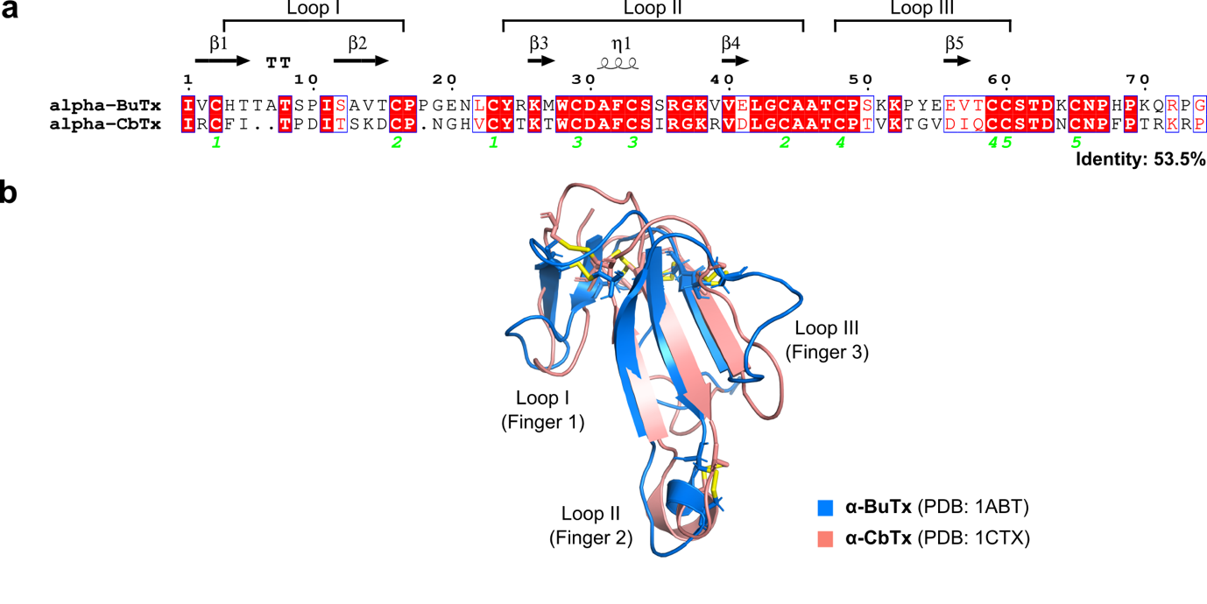
Supplementary Fig. S1. Amino acid sequence and structural comparison of α-bungarotoxin (α-BuTx) and α-cobratoxin (α-CbTx). (a) Amino acid sequence alignment of α-bungarotoxin (α-BuTx; UniProt P60615) and α-cobratoxin (α-CbTx; UniProt P01391) generated using CLUSTAL Omega (version 1.2.4) [2] and rendered with ESPript 3.0 [3] (pairwise identity: 53.5%). Secondary structure elements derived from PDB 1ABT are indicated above the sequences. Strictly identical residues are highlighted in red boxes, and conserved cysteine residues forming invariant disulfide bridges are numbered in green. Canonical three-finger toxin loop boundaries (Loops I–III) are indicated [4]. (b) Sequence-guided structural alignment of α-BuTx (PDB: 1ABT, marine blue) and α-CbTx (PDB: 1CTX, salmon) generated in PyMOL (version 3.0.0, Schrödinger, LLC) [5]. Conserved disulfide bonds stabilizing the structural scaffold are shown as yellow sticks. Visualization was performed using Inkscape (version 1.3; Inkscape Project).

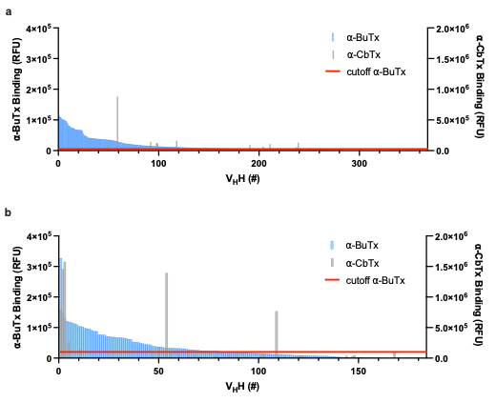
Supplementary Fig. S2: Primary screening of V_{H}H clones in dissociation-enhanced lanthanide fluorescence immunoassay (DELFIA) against α-bungarotoxin (α-BuTx) and α-cobratoxin (α-CbTx). DELFIA binding signals for clones originating from phage display campaign (a) TPL1195 and (b) TPL1198. The α-BuTx cutoff (red line) corresponds to a signal five times above background.
Supplementary Fig. S3: SDS-PAGE analysis of purified V_{H}Hs. Protein purity was assessed by SDS-PAGE with Coomassie Blue staining. (a) Purification of lead candidates V_{H}H_BuTx (TPL1198_02_F06) and V_{H}H_LNTx (TPL1158_01_C09). (b) Purification of additional V_{H}H clones; clones highlighted in pink are from the primary campaign, while TPL1009_01_H05 is from a separate campaign. For each clone, lanes (left to right) show: S, starting supernatant; Wash, fraction collected after resin washing; Dialyzed, final purified protein following elution and dialysis. The expected molecular weight is ~17–20 kDa. Molecular weight marker: PageRuler™ protein ladder (10–180 kDa, Thermo Scientific).
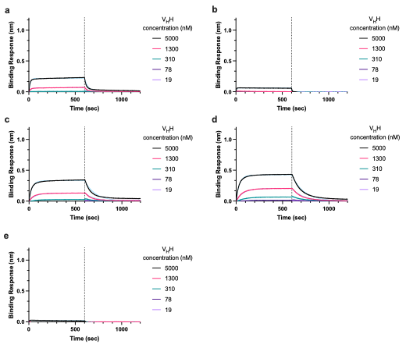
Supplementary Fig. S4: Binding kinetics of selected V_{H}H clones against biotinylated
α-bungarotoxin (α-BuTx) by biolayer interferometry. The binding kinetics of (a) TPL1195_01_H02, (b) TPL1195_03_C03, (c) TPL1198_01_A05, (d) TPL1200_01_G12, (e) TPL1200_01_H06 are shown. Biotinylated α-BuTx was immobilized onto streptavidin-coated sensor tips and exposed to varying concentrations of V_{H}H clones. The dotted line at 600 s marks the transition from association to dissociation. Data were fitted using the 1:1 binding model (blue line).
Supplementary Fig. S5: Amino acid sequence alignment of V_{H}Hs. The amino acid sequences of α-BuTx-specific V_{H}H and LNTx-specific V_{H}H. TPL1198_02_F06 and TPL1158_01_C09 (bold) were selected for subsequent lateral flow immunoassay experiments and are referred to as V_{H}H_BuTx and V_{H}H_LNTx, respectively. The framework regions are labelled in blue, and the complementarity determining regions (CDRs) are labelled in pink. The 3xFLAG and 6xHis-tags at the C-terminal are left unlabelled. The alignment was performed using CLUSTAL Omega (version 1.2.4) and visualized with Inkscape (version 1.3; Inkscape Project).
GenBank accessions:
TPL1195_01_H02 = PZ564802; TPL1195_02_G04 = PZ564805;
TPL1195_03_C03 = PZ564807; TPL1198_01_A05 = PZ564800;
TPL1198_01_E04 = PZ564803; TPL1198_01_E06 = PZ564804;
TPL1198_02_F06 = PZ548132; TPL1200_01_G12 = PZ564801;
TPL1200_01_H06 = PZ564806.
TPL1158_01_C09 (not generated in this study) corresponds to PDB 9GCN (https://www.rcsb.org/structure/9GCN).

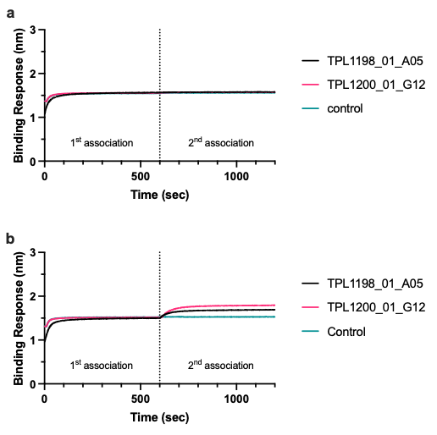
Supplementary Fig. S6: Epitope binning results by biolayer interferometry. Biotinylated α-bungarotoxin was immobilized on streptavidin-coated biosensors and saturated with primary V_{H}H: (a) V_{H}H_BuTx or (b) V_{H}H_LNTx. After 600 seconds (dotted line), the sensors were exposed to the second V_{H}H (TPL1198_01_A05 or TPL1200_01_G12), which was added into a solution containing the first V_{H}H at its saturating concentration. Control traces represent binding signals following saturation of α-BuTx with the first V_{H}H, without addition of a second V_{H}H.
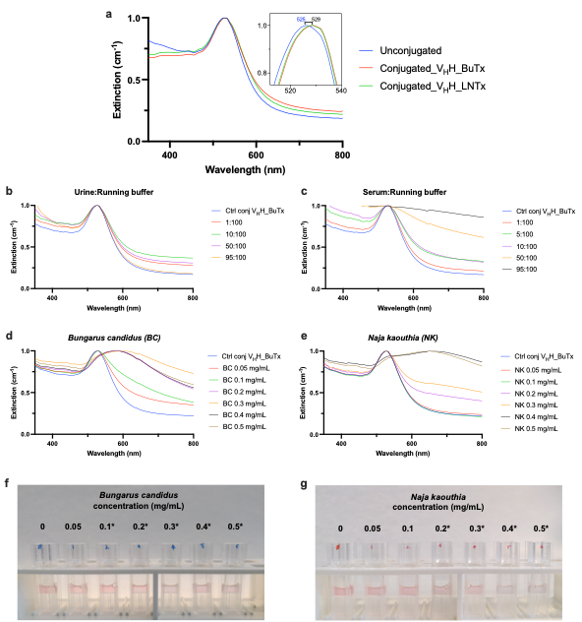Supplementary Fig. S7: UV-Vis spectral characterization and stability of V_{H}H-conjugated gold nanoparticles. (a) Conjugation and colloidal stability: Normalized UV-Vis extinction spectra of bare 40 nm gold nanoparticles (AuNPs) and AuNPs conjugated with V_{H}H_BuTx and V_{H}H_LNTx. The localized surface plasmon resonance (LSPR) peak maximum (λ_{max}) shifted from 525 nm to 529 nm for both V_{H}Hs, confirming successful conjugation while maintaining colloidal stability. (b–c) Matrix stability: UV-Vis spectra of V_{H}H-AuNP conjugates incubated in increasing proportions of (b) urine and (c) serum diluted in running buffer (total volume 100 µL per well). (d–e) Analytical sensitivity: Extinction profiles of the V_{H}H-AuNP biosensor following exposure to increasing concentrations (mg/mL) of (d) Bungarus candidus and (e) Naja kaouthia whole venoms. The absence of significant red-shifting or peak broadening suggests that target binding does not induce nanoparticle aggregation. (f–g) Visual assessment: Representative photographs of V_{H}H-AuNP conjugates at corresponding toxin concentrations for (f) B. candidus and (g) N. kaouthia. Higher concentrations show progressive discoloration, marked by asterisks (*), corresponding to the UV-Vis spectral changes (d–e) indicative of nanoparticle aggregation.
Supplementary Fig. S8: Systematic optimization of LFIA parameters. (a) Evaluation of the test line coating concentrations of V_{H}H_BuTx (0.5–2.0 mg/mL) by Ponceau S staining to assess coating uniformity and signal intensity. (b) Optimization of gold-V_{H}H conjugate loading volume (2–5 µL) using 500 ng/mL α-BuTx, showing signal development at test and control lines. (c) Screening of running buffer composition, including phosphate buffer saline (PBS) with varying concentrations of Tween-20 (0.05–0.5% v/v) and bovine serum albumin (BSA) (0.05–0.5% w/v), to optimize capillary flow and minimize background while maintaining signal intensity. (d–e) Matrix interference assessment and dilution optimization for (d) serum and (e) urine samples, comparing performance in 0.5% versus 2% BSA-containing buffers. The selected conditions–1.0 mg/mL test line coating, 5 µL conjugate volume, and 2% BSA in 0.5% PBST in running buffer–were used in all subsequent assays to ensure optimal signal intensity, low background, and colloidal stability.
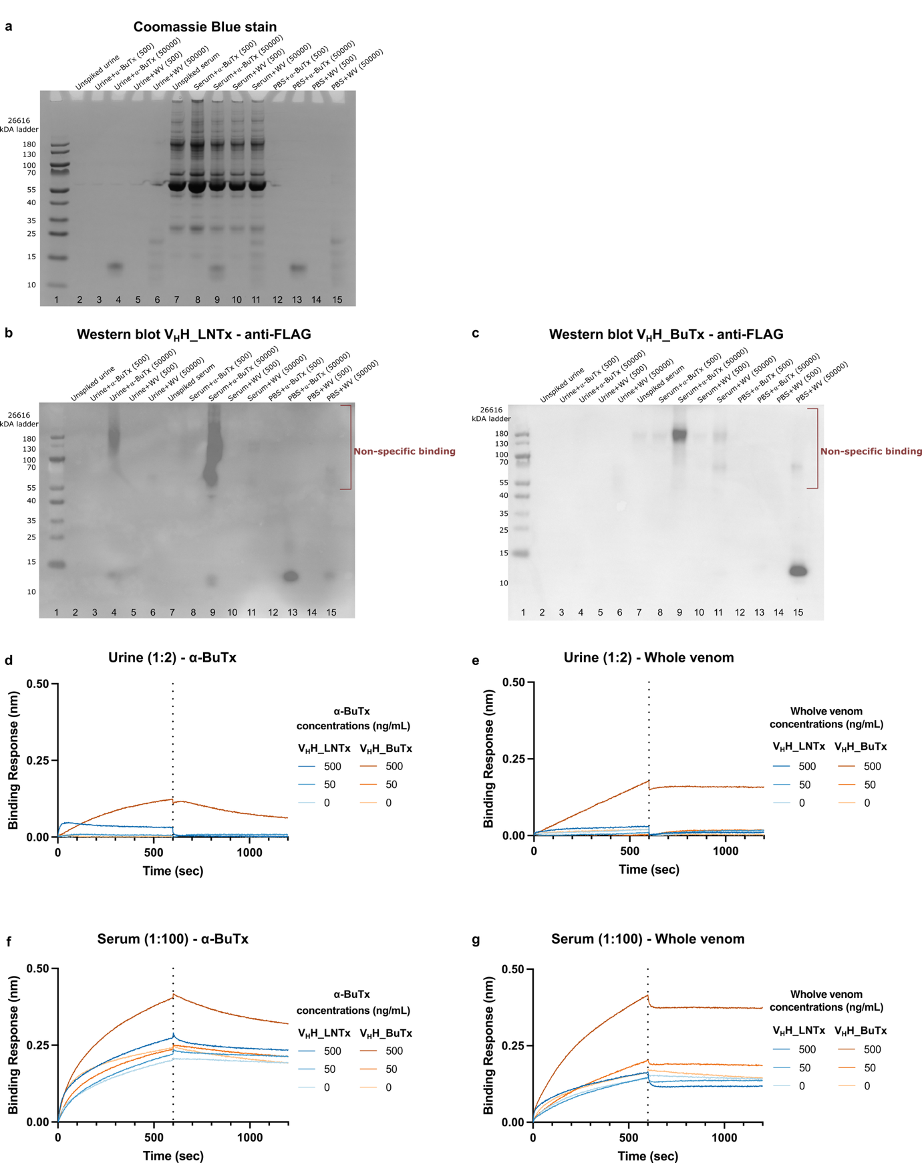
Supplementary Fig. S9: Assessment of V_{H}H recognition in human urine and serum by Western blot and biolayer interferometry. (a) Coomassie blue-stained SDS-PAGE gel and corresponding non-reducing Western blot analyses of (b) V_{H}H_LNTx and (c) V_{H}H_BuTx detected by anti-FLAG-HRP. Samples included purified α-bungarotoxin (α-BuTx) or B. candidus whole venom (WV) at 0, 500, and 50,000 ng/mL in PBS, human urine diluted 1:2 in PBS, and serum diluted 1:100 in PBS. Red brackets indicate areas of possible non-specific binding. (d-g) Biolayer interferometry (BLI) sensorgrams of biotinylated V_{H}Hs immobilized onto streptavidin biosensors and exposed to 0, 5, 50, and 500 ng/mL α-BuTx or B. candidus whole venom spiked into (d, e) human urine (1:2) and (f, g) serum (1:100). Unspiked urine did not exhibit any non-specific binding, whereas unspiked serum produced background binding. Dotted vertical lines indicate the transition between association and dissociation phases.

Supplementary Methods
Evaluation of non-specific binding of V_{H}Hs to biological matrices
Biolayer interferometry (BLI) and Western blot analysis were performed to determine the binding of V_{H}Hs to human serum and urine. BLI experiments were performed using an Octet system (Sartorius) at 25°C with shaking at 1,000 rpm (600 rpm during ligand loading). Assays were conducted in 96-well black flat-bottom microplates (Greiner Bio-One, #655209). Streptavidin-coated biosensors were pre-hydrated in kinetic buffer (KB). Biotinylated V_{H}H_LNTx (120 nM) or V_{H}H_BuTx (80 nM) in KB was loaded onto SA biosensors to a 1.0 nm threshold. Following a 120 s baseline in KB, association was measured for 600 s with α-BuTx or B. candidus whole venom at 0, 5, 50, and 500 ng/mL prepared in human urine diluted 1:2 or human serum diluted 1:100 in KB. Dissociation was subsequently monitored in KB for 600 s. Biosensors were regenerated using glycine buffer (10 mM, pH 2.0) followed by neutralization in KB. Responses from the 0 ng/mL matrix controls were used to account for background interactions associated with the biological matrix.
For Western blot analysis, non-reducing SDS-PAGE and Western blotting were performed by preparing human urine diluted 1:2 in PBS and human serum diluted 1:100 in PBS unspiked or spiked with purified α-BuTx or B. candidus whole venom at 500 and 50,000 ng/mL. Corresponding toxin and venom samples prepared in PBS served as controls. Following electrophoretic separation alongside a prestained protein ladder (Thermo Fisher Scientific, #26616), proteins were transferred onto PVDF membranes using the Trans-Blot Turbo Transfer System (Bio-Rad). Membranes were blocked with 5% (w/v) non-fat dry milk in PBST (0.1% Tween-20 in PBS) for 1 h at room temperature with shaking. Membranes were incubated with purified V_{H}H_LNTx or V_{H}H_BuTx at 2 μg/mL in 5% milk/PBST for 1 h at room temperature, followed by washing with PBST and PBS. V_{H}H binding was detected using monoclonal anti-FLAG M2-peroxidase (HRP) antibody produced in mouse (Sigma-Aldrich, #A8592; 1:1,000 in blocking buffer). Chemiluminescence was developed using ECL reagents (PierceTM, #32109) and captured using a digital imaging system with exposure times ≥120 s.

Reference
1 Saerens, D., Huang, L., Bonroy, K. & Muyldermans, S. Antibody fragments as probe in biosensor development. Sensors 8, 4669-86 (2008).
2 Sievers, F. et al. Fast, scalable generation of high-quality protein multiple sequence alignments using Clustal Omega. Mol. Syst. Biol. 7, 539, 10.1038/msb.2011.75 (2011).
3 Robert, X. & Gouet, P. Deciphering key features in protein structures with the new ENDscript server. Nucleic Acids Res. 42, W320-4, 10.1093/nar/gku316 (2014).
4 Kini, R. M. & Doley, R. Structure, function and evolution of three-finger toxins: mini proteins with multiple targets. Toxicon 56, 855-67, 10.1016/j.toxicon.2010.07.010 (2010).
5 Schrödinger LLC. The PyMOL Molecular Graphics System, Version 3.0.0., (2023).

