Supplementary materials

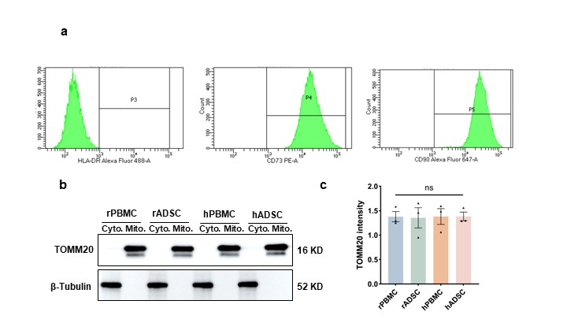
Supplementary Figure 1 Supplementary characterization of isolated mitochondria. a, Additional representative images of flow cytometry detecting hADSCs: HLA-DR, CD73 and CD90. b, Representative images of TOMM20 and β-Tubulin bands in Western Blot. c. TOMM20 intensity adjusted to β-Tubulin. All test were conducted in 3 biological replicates. data was showed in mean±SEM. One-Way ANOVA was applied in the significance determination and multiple comparison. ^{ns}p > 0.05.

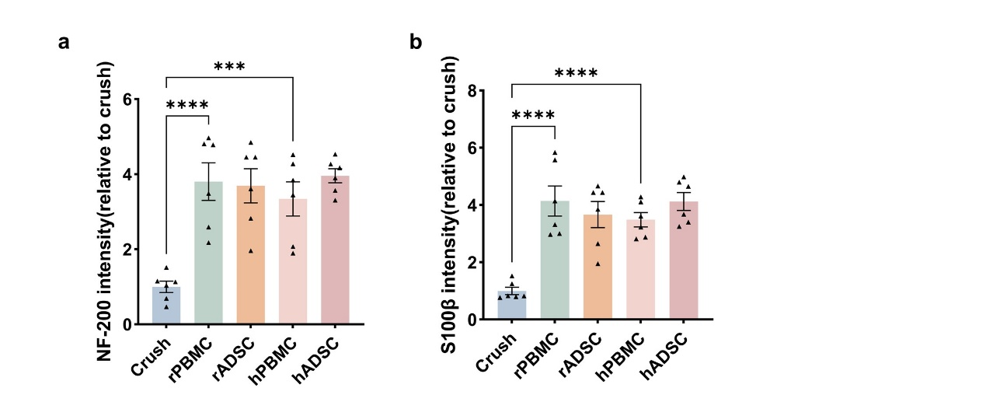
Supplementary Figure. 2 Statistical results of NF-200 and S100β immunofluorescent intensity. a, NF-200 intensity in the transverse section of Figure. 3c. b, S100β intensity in the transverse section of Figure. 3c. All test were conducted in 6 biological replicates, and data was showed in mean±SEM. One-Way ANOVA was applied in the significance determination and multiple comparison. ***p < 0.001, ****p < 0.0001.

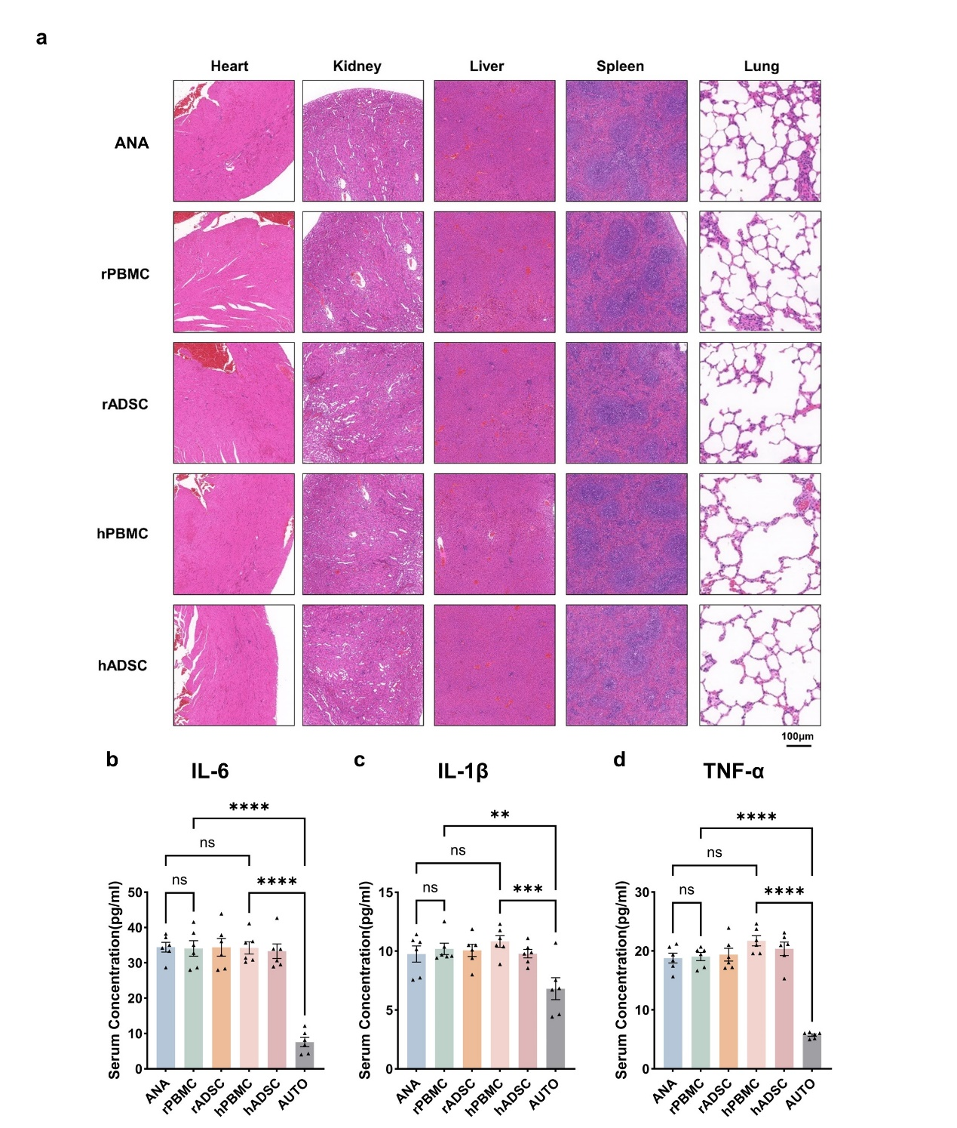
Supplementary Figure 3. Systemic histological and inflammatory evaluation after mitochondrial transplantation. a, Representative H&E-stained sections of major organs, including the heart, kidney, liver, spleen, and lung, from the ANA, rPBMC, rADSC, hPBMC, and hADSC groups. Scale bar = 100 μm. b-d, Serum concentrations of IL-6 (b), IL-1β (c), and TNF-α(d) in the different experimental groups. All test were conducted in 5 biological replicates, and data was showed in mean±SEM. One-Way ANOVA was applied in the significance determination and multiple comparison. **p < 0.01, ***p < 0.001, ****p < 0.0001.

