Supplementary Material
Table S1. Missing Data Imputation Strategy for Clinical Variables
Variable | Imputation method | Imputation value | Missing percentage (%)
Height | Median | 173 | 7.41
SpO₂ | Median | 96 | 6.37
Lactate | Median | 2.6 | 5.08
Weight | Median | 84 | 0.30
Hemoglobin | Median | 8.6 | 0.22
WBC | Median | 16.4 | 0.22
Creatinine | Median | 1 | 0.22
Platelet count | Median | 122 | 0.22
Hematocrit | Median | 26.2 | 0.22
SpO₂, peripheral oxygen saturation; WBC, white blood cell count.

Table S2. ICD Diagnosis and Procedure Code Patterns Used to Identify the Neurocritical Care Subgroup
Category | ICD version | Code pattern or range | Description
Traumatic brain injury | ICD-9-CM | 850–854 | Intracranial injury, including concussion, contusion, laceration, and traumatic intracranial hemorrhage
Traumatic brain injury | ICD-10-CM | S06* | Intracranial injury
Stroke / cerebrovascular disease | ICD-9-CM | 430–439 | Cerebrovascular diseases
Stroke / cerebrovascular disease | ICD-10-CM | I60–I69 | Cerebrovascular diseases
Intracranial hemorrhage | ICD-9-CM | 431* | Intracerebral hemorrhage
Intracranial hemorrhage | ICD-10-CM | I61*; I62* | Intracerebral and other nontraumatic intracranial hemorrhage
Subarachnoid hemorrhage | ICD-9-CM | 430* | Subarachnoid hemorrhage
Subarachnoid hemorrhage | ICD-10-CM | I60* | Nontraumatic subarachnoid hemorrhage
Status epilepticus | ICD-9-CM | 345.3* | Status epilepticus
Status epilepticus | ICD-10-CM | G41* | Status epilepticus
Anoxic brain damage / SQL-labeled cerebral edema | ICD-10-CM | G93.1* | Anoxic brain damage, not elsewhere classified; labeled Cerebral_Edema in the extraction SQL
Cerebral edema | ICD-9-CM | 348.5* | Cerebral edema
Meningitis / encephalitis | ICD-9-CM | 320*; 322* | Bacterial meningitis and meningitis of unspecified cause
Meningitis / encephalitis | ICD-10-CM | G0* | Inflammatory diseases of the central nervous system (G00–G09)
Neurosurgical procedure | ICD-9-CM procedure | 01*; 02*; 03* | Operations on the nervous system
Patients were identified as neurocritical care patients if they had at least one qualifying diagnosis code (ICD-9-CM or ICD-10-CM) or an ICD-9-CM neurosurgical procedure code (01–03) during the index hospitalization. The asterisk (*) denotes any subcode within the specified category and corresponds to the SQL wildcard %. The stroke/cerebrovascular rows overlap with the intracranial and subarachnoid hemorrhage rows because the extraction query used the broader 43* and I6* patterns. G93.1* denotes anoxic brain damage and was labeled Cerebral_Edema in the original extraction SQL; the label does not change the code actually used for subgroup inclusion.
Table S3. Univariable Fine–Gray Associations Between Prespecified Covariates and 28-Day Mortality
Variable | sHR (95% CI) | P value
Age | 1.024 (1.021–1.027) | <0.001
SOFA score | 1.129 (1.118–1.140) | <0.001
Charlson Comorbidity Index | 1.144 (1.129–1.160) | <0.001
Creatinine | 1.178 (1.147–1.209) | <0.001
Hemoglobin | 0.863 (0.842–0.885) | <0.001
Vasopressor use | 1.683 (1.535–1.846) | <0.001
CI, confidence interval; sHR, subdistribution hazard ratio; SOFA, Sequential Organ Failure Assessment. Estimates are reported per one-unit increase for continuous variables and for vasopressor use versus no use.
Table S4. Variance Inflation Factors for Prespecified Covariates in the Overall Cohort
Variable | VIF | Threshold | Result
Age | 1.65 | < 5.00 | Pass
SOFA score | 1.85 | < 5.00 | Pass
Charlson Comorbidity Index | 1.77 | < 5.00 | Pass
Creatinine | 1.36 | < 5.00 | Pass
Hemoglobin | 1.2 | < 5.00 | Pass
Vasopressor use | 1.44 | < 5.00 | Pass
VIF, variance inflation factor. A VIF <5.0 was considered acceptable.
Table S5. Linearity Assessment for the Fine–Gray Models in the Overall Cohort
Term type | Variable | Quadratic-term sHR | P value | Linearity assumption
Exposure | <125 | 0.9999 | 0.549 | Satisfied
Exposure | 125-130 | 1 | 0.836 | Satisfied
Exposure | 130-135 | 1 | 0.615 | Satisfied
Exposure | 135-140 | 1 | 0.616 | Satisfied
Exposure | 140-145 | 1.0001 | 0.021 | Violated
Exposure | 145-150 | 1 | 0.533 | Satisfied
Exposure | 150-155 | 0.9997 | 0.008 | Violated
Exposure | ≥155 | 0.9999 | 0.423 | Satisfied
Covariate | Age | 1.0002 | 0.005 | Violated
Covariate | SOFA score | 0.9997 | 0.813 | Satisfied
Covariate | Charlson Comorbidity Index | 0.9973 | 0.249 | Satisfied
Covariate | Creatinine | 0.9836 | 0.134 | Satisfied
Covariate | Hemoglobin | 1.0025 | 0.65 | Satisfied
Linearity was evaluated by adding a quadratic term to the fully adjusted Fine–Gray model. A P value <0.05 for the quadratic term was interpreted as evidence against linearity. RCS sensitivity analyses were therefore performed for the 140–145 and 150–155 mmol/L serum sodium concentration time-proportion variables, and age was modeled using RCS in the multivariable analyses. RCS, restricted cubic spline; sHR, subdistribution hazard ratio.
Table S6. Time-Varying Coefficient Tests of the Fine–Gray Proportional Subdistribution Hazards Assumption
Serum sodium concentration range (mmol/L) | Model term | Time-interaction coefficient | P value | Interpretation | Global P value
<125 | Time proportion: <125 | -0.01427 | 0.296 | No evidence of non-proportionality | 0.013
<125 | Age RCS basis 1 | -0.00573 | 0.605 | No evidence of non-proportionality
<125 | Age RCS basis 2 | -0.00996 | 0.337 | No evidence of non-proportionality
<125 | Charlson Comorbidity Index | 0.01829 | 0.487 | No evidence of non-proportionality
<125 | SOFA score | 0.00736 | 0.691 | No evidence of non-proportionality
<125 | Creatinine | -0.0229 | 0.653 | No evidence of non-proportionality
<125 | Hemoglobin | -0.0788 | 0.038 | Evidence of non-proportionality
<125 | Vasopressor use | -0.23253 | 0.119 | No evidence of non-proportionality
125–130 | Time proportion: 125–130 | 0.00352 | 0.512 | No evidence of non-proportionality | 0.022
125–130 | Age RCS basis 1 | -0.00575 | 0.604 | No evidence of non-proportionality
125–130 | Age RCS basis 2 | -0.00951 | 0.359 | No evidence of non-proportionality
125–130 | Charlson Comorbidity Index | 0.0169 | 0.522 | No evidence of non-proportionality
125–130 | SOFA score | 0.00768 | 0.678 | No evidence of non-proportionality
125–130 | Creatinine | -0.02745 | 0.594 | No evidence of non-proportionality
125–130 | Hemoglobin | -0.07956 | 0.037 | Evidence of non-proportionality
125–130 | Vasopressor use | -0.23516 | 0.117 | No evidence of non-proportionality
130–135 | Time proportion: 130–135 | -0.00099 | 0.718 | No evidence of non-proportionality | 0.025
130–135 | Age RCS basis 1 | -0.00561 | 0.612 | No evidence of non-proportionality
130–135 | Age RCS basis 2 | -0.00989 | 0.342 | No evidence of non-proportionality
130–135 | Charlson Comorbidity Index | 0.01833 | 0.487 | No evidence of non-proportionality
130–135 | SOFA score | 0.00816 | 0.66 | No evidence of non-proportionality
130–135 | Creatinine | -0.02133 | 0.677 | No evidence of non-proportionality
130–135 | Hemoglobin | -0.07833 | 0.039 | Evidence of non-proportionality
130–135 | Vasopressor use | -0.23049 | 0.123 | No evidence of non-proportionality
135–140 | Time proportion: 135–140 | 0.00113 | 0.61 | No evidence of non-proportionality | 0.019
135–140 | Age RCS basis 1 | -0.00591 | 0.596 | No evidence of non-proportionality
135–140 | Age RCS basis 2 | -0.00942 | 0.364 | No evidence of non-proportionality
135–140 | Charlson Comorbidity Index | 0.01815 | 0.49 | No evidence of non-proportionality
135–140 | SOFA score | 0.00698 | 0.708 | No evidence of non-proportionality
135–140 | Creatinine | -0.02372 | 0.641 | No evidence of non-proportionality
135–140 | Hemoglobin | -0.0793 | 0.037 | Evidence of non-proportionality
135–140 | Vasopressor use | -0.23614 | 0.113 | No evidence of non-proportionality
140–145 | Time proportion: 140–145 | 9e-05 | 0.969 | No evidence of non-proportionality | 0.025
140–145 | Age RCS basis 1 | -0.00561 | 0.613 | No evidence of non-proportionality
140–145 | Age RCS basis 2 | -0.00982 | 0.347 | No evidence of non-proportionality
140–145 | Charlson Comorbidity Index | 0.01751 | 0.508 | No evidence of non-proportionality
140–145 | SOFA score | 0.00768 | 0.678 | No evidence of non-proportionality
140–145 | Creatinine | -0.02435 | 0.635 | No evidence of non-proportionality
140–145 | Hemoglobin | -0.07818 | 0.04 | Evidence of non-proportionality
140–145 | Vasopressor use | -0.23113 | 0.122 | No evidence of non-proportionality
145–150 | Time proportion: 145–150 | 0.00287 | 0.322 | No evidence of non-proportionality | 0.018
145–150 | Age RCS basis 1 | -0.00566 | 0.61 | No evidence of non-proportionality
145–150 | Age RCS basis 2 | -0.00994 | 0.338 | No evidence of non-proportionality
145–150 | Charlson Comorbidity Index | 0.01793 | 0.495 | No evidence of non-proportionality
145–150 | SOFA score | 0.00753 | 0.686 | No evidence of non-proportionality
145–150 | Creatinine | -0.0169 | 0.742 | No evidence of non-proportionality
145–150 | Hemoglobin | -0.07813 | 0.04 | Evidence of non-proportionality
145–150 | Vasopressor use | -0.22808 | 0.125 | No evidence of non-proportionality
150–155 | Time proportion: 150–155 | -0.00563 | 0.256 | No evidence of non-proportionality | 0.014
150–155 | Age RCS basis 1 | -0.00588 | 0.597 | No evidence of non-proportionality
150–155 | Age RCS basis 2 | -0.00966 | 0.352 | No evidence of non-proportionality
150–155 | Charlson Comorbidity Index | 0.01821 | 0.49 | No evidence of non-proportionality
150–155 | SOFA score | 0.00684 | 0.713 | No evidence of non-proportionality
150–155 | Creatinine | -0.02728 | 0.594 | No evidence of non-proportionality
150–155 | Hemoglobin | -0.08024 | 0.034 | Evidence of non-proportionality
150–155 | Vasopressor use | -0.2473 | 0.098 | No evidence of non-proportionality
≥155 | Time proportion: ≥155 | -0.00629 | 0.325 | No evidence of non-proportionality | 0.014
≥155 | Age RCS basis 1 | -0.0062 | 0.573 | No evidence of non-proportionality
≥155 | Age RCS basis 2 | -0.00946 | 0.359 | No evidence of non-proportionality
≥155 | Charlson Comorbidity Index | 0.01942 | 0.463 | No evidence of non-proportionality
≥155 | SOFA score | 0.0064 | 0.731 | No evidence of non-proportionality
≥155 | Creatinine | -0.02794 | 0.584 | No evidence of non-proportionality
≥155 | Hemoglobin | -0.0767 | 0.044 | Evidence of non-proportionality
≥155 | Vasopressor use | -0.2436 | 0.103 | No evidence of non-proportionality
The proportional subdistribution hazards assumption was assessed by testing interactions between each model term and log(time) in the fully adjusted Fine–Gray models. All serum sodium concentration time-proportion terms showed no evidence of non-proportionality (P = 0.256–0.969). Mild time dependence was observed for hemoglobin, and the global tests were statistically significant in all eight models. Global P values represent joint tests across all model terms. RCS, restricted cubic spline; SOFA, Sequential Organ Failure Assessment.

Table S7. Sensitivity Analysis Excluding Patients with ESRD or Renal Replacement Therapy
Serum sodium concentration range (mmol/L) | Overall cohort sHR (95% CI) | P value | After exclusion sHR (95% CI) | P value
<125 | 1.016 (1.006 - 1.026) | 0.002 | 1.016 (1.006-1.027) | 0.002
125-130 | 1.008 (1.004 - 1.011) | <0.001 | 1.007 (1.003-1.012) | <0.001
130-135 | 1.003 (1.000 - 1.005) | 0.017 | 1.002 (1.000-1.004) | 0.032
135-140 | 0.996 (0.994 - 0.997) | <0.001 | 0.996 (0.994-0.997) | <0.001
140-145 | 0.996 (0.994 - 0.998) | <0.001 | 0.996 (0.994-0.998) | <0.001
145-150 | 1.003 (1.001 - 1.005) | 0.015 | 1.002 (1.000-1.004) | 0.04
150-155 | 1.013 (1.009 - 1.018) | <0.001 | 1.013 (1.009-1.017) | <0.001
≥155 | 1.021 (1.017 - 1.026) | <0.001 | 1.021 (1.016-1.026) | <0.001
The sensitivity cohort excluded patients with ESRD (ICD-9-CM 585.6 or ICD-10-CM N18.6) or documented renal replacement therapy during the index ICU admission. Estimates are from fully adjusted Fine–Gray Model 4 and are reported per 1-percentage-point increase in the proportion of monitored time spent within the corresponding serum sodium concentration range. CI, confidence interval; ESRD, end-stage renal disease; sHR, subdistribution hazard ratio.

Table S8. Linearity Assessment for the Fine–Gray Models in the Neurocritical Care Subgroup
Term type | Variable | P value for quadratic term | Linearity assumption
Exposure | <125 | 0.310 | Satisfied
Exposure | 125-130 | 0.434 | Satisfied
Exposure | 130-135 | 0.778 | Satisfied
Exposure | 135-140 | 0.812 | Satisfied
Exposure | 140-145 | 0.114 | Satisfied
Exposure | 145-150 | 0.320 | Satisfied
Exposure | 150-155 | 0.080 | Satisfied
Exposure | ≥155 | 0.409 | Satisfied
Covariate | Age | 0.149 | Satisfied
Covariate | Charlson Comorbidity Index | 0.236 | Satisfied
Covariate | SOFA score | 0.508 | Satisfied
Covariate | Creatinine | 0.019 | Violated
Covariate | Hemoglobin | 0.457 | Satisfied
Linearity was evaluated by adding a quadratic term to the fully adjusted Fine–Gray model. All eight serum sodium concentration time-proportion variables satisfied the linearity assumption. Creatinine showed evidence against linearity and was modeled using RCS in the neurocritical care analysis. RCS, restricted cubic spline.
Figure S1. Patient Selection Flowchart for the Neurocritical Care Subgroup
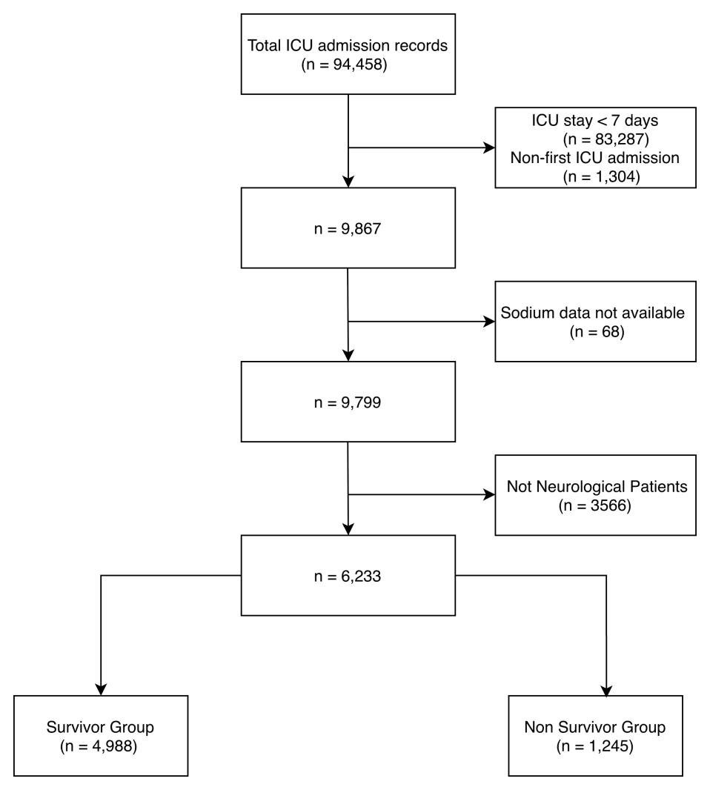
ICU, intensive care unit; MIMIC, Medical Information Mart for Intensive Care.
Figure S2. Restricted Cubic Spline Sensitivity Analysis for Nonlinear Serum Sodium Concentration Time-Proportion Variables
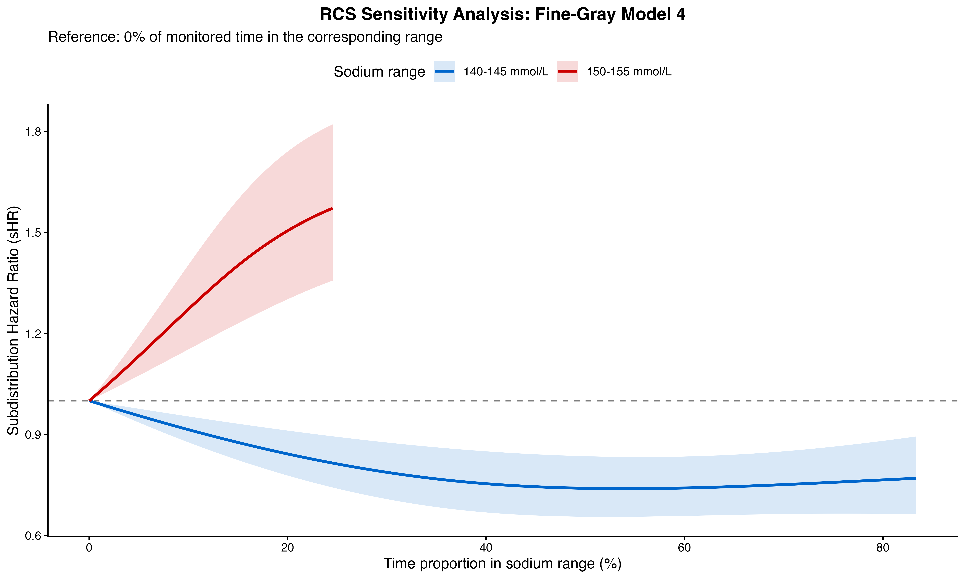
Restricted cubic spline curves from fully adjusted Fine–Gray Model 4 for the 140–145 and 150–155 mmol/L serum sodium concentration ranges. The reference was 0% of monitored time within the corresponding serum sodium concentration range. Solid lines indicate estimated sHRs, and shaded areas indicate 95% confidence intervals. RCS, restricted cubic spline; sHR, subdistribution hazard ratio.

