The pathogen Borrelia burgdorferi sensu lato (s.l.) influences the desiccation resistance of Ixodes ricinus nymphs potentially enhancing its vector role

Frizzera D.¹, Del Fabbro S. ¹, Caracciolo I. ², Bortolomeazzi R. ¹, Trifonova T. ¹, Zanni V. ¹, Annoscia D. ¹, Nazzi F.^{1*}

¹ Dipartimento di Scienze AgroAlimentari, Ambientali e Animali, Università degli studi di Udine, Udine, Italy
² Department of Medical, Surgical and Health Sciences, University of Trieste, Italy

* Corresponding Author
francesco.nazzi@uniud.it

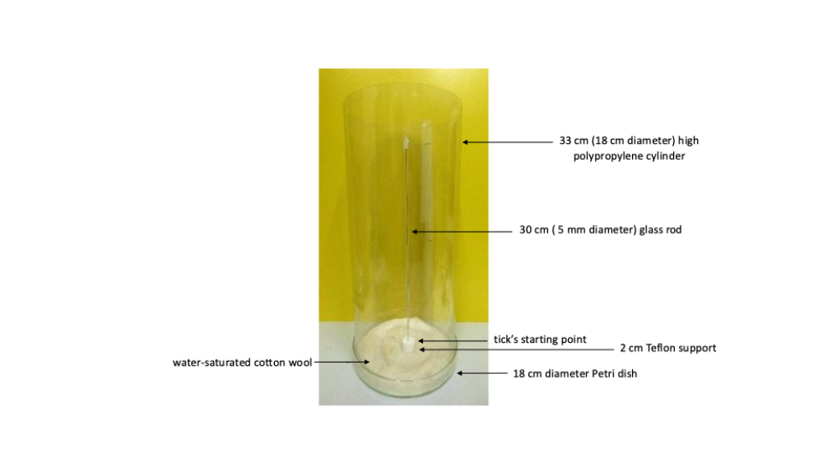
Figure S1. Experimental arena used for the bioassay. A 30 cm glass rod (5 mm diameter) held upright inside a 33 cm high, 18 cm diameter polypropylene cylinder, open at the top and resting on an 18 cm diameter glass Petri dish. The rod was inserted into a central hole in a cylindrical polytetrafluoroethylene (PTFE) support, 2 cm high, placed at the centre of the Petri dish; the support both held the rod upright and raised the starting point of the tick above the water surface. The Petri dish was filled with distilled water and lined with water-saturated cotton wool, which maintained saturation at the base of the arena, while the open top allowed exchange with room air. This generated a stable vertical humidity gradient, from 100% RH at the base to 50% RH at the top of the rod.
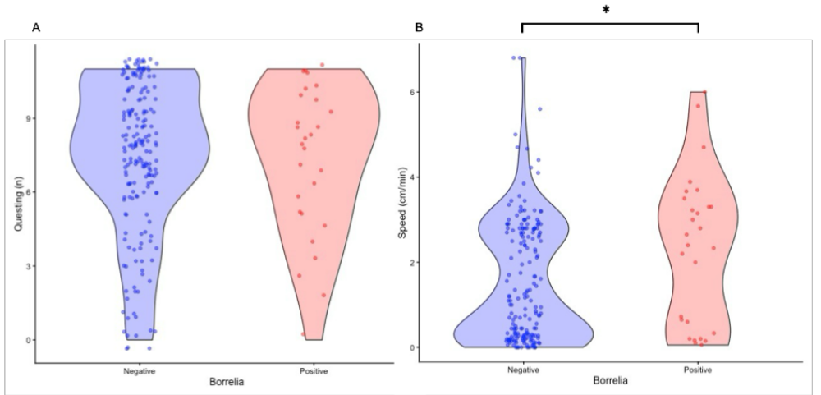

Figure S2. Effect of B. burgdorferi s.l. infection on I. ricinus nymphs behaviour. (A) Number of questing events, (B) average speed (cm/min) in uninfected (negative, blue) and infected (positive, red) ticks. Boxplots show median, interquartile range and data points.

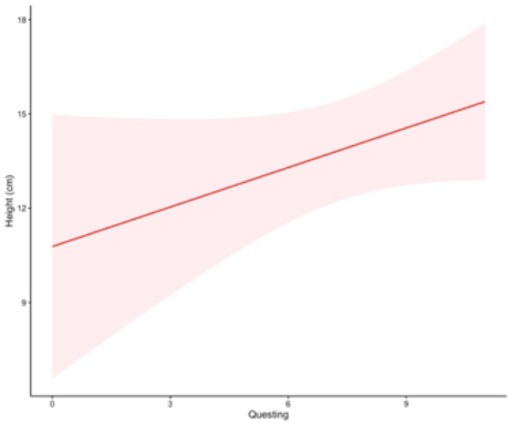
Figure S3. Spearman’s rank correlation coefficient representation of height and question behaviour (meant as number of performed questing behaviour; ρ = 0.150, p-value = 0.027).

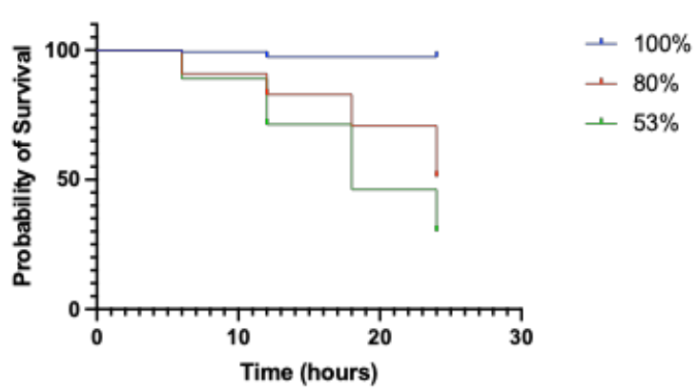
Figure S4. Survival curves of ticks at different humidity conditions (i.e. 100%, 80%, 53% RH). After 12 hours, detrimental differences in survival curves were noted (100 RH vs 80 RH, Log rank test: Chi square = 48.12, df = 1, p-value < 0.001; 100 RH vs 53 RH, Log rank test: Chi square = 81.66, df = 1, p-value < 0.001).

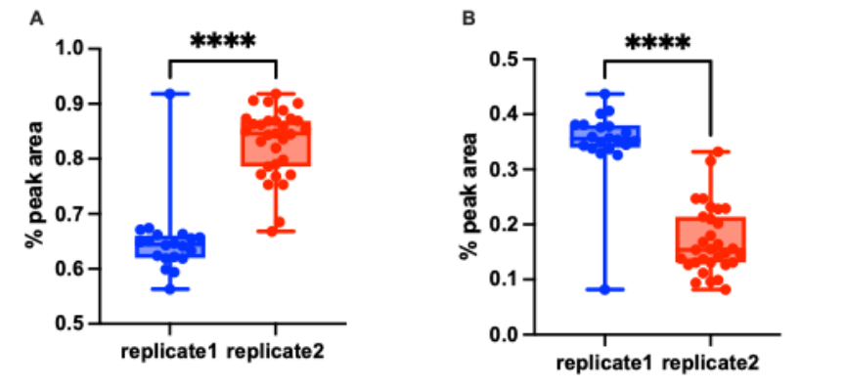
Figure S5. (A) GC-MS analysis of cuticular saturated fatty acids (C12, C14, C16, C18; Mann–Whitney U test: n₁ = 20, n₂ = 31, U = 32.5, p < 0.001). (B) GC-MS analysis of cuticular unsaturated fatty acids (C18:1, C18:2; Mann–Whitney U test: n₁ = 20, n₂ = 31, U = 32.5, p < 0.001).

Table S1. Percentage peak area of the relative FAs
