Percent predicted forced vital capacity–based staging in chronic obstructive pulmonary disease: a prospective, multicenter cohort study

Kazuaki Kojima, Hiroaki Ogata, Kazuya Tsubouchi, Tomotsugu Takano, Katsuyuki Ichiki, Ryo Torii, Shohei Takata, Noriaki Nakagaki, Makoto Yoshida, Yasuhiko Kitasato, Kazunori Tobino, Eiji Harada, Hiroshi Wataya, Hiroshi Ishii, Takashige Maeyama, Masayuki Kawasaki, Masaki Fujita, Kazuhiro Yatera, Tomoaki Hoshino, Yoichi Nakanishi, and Isamu Okamoto

Online Data Supplement.

Table E1. Incremental prognostic value of ppFVC beyond ppFEV₁ and GOLD stage for COPD exacerbation

Base model | Extended model | Population | N | Exacerbations | Competing  deaths | Wald χ² | P value
Incremental prognostic value of ppFVC
ppFEV₁ + covariates | Base model + ppFVC | Overall | 370 | 91 | 27 | 1.73 | 0.19
ppFEV₁ + covariates | Base model + ppFVC | GOLD stages I–II | 194 | 16 | 7 | 0.04 | 0.84
ppFEV₁ + covariates | Base model + ppFVC | GOLD stages III–IV | 176 | 75 | 20 | 2.58 | 0.11
Incremental prognostic value of ppFVC-based stage
GOLD stage + covariates | Base model +  ppFVC-based stage | Overall | 370 | 91 | 27 | 2.56 | 0.11
GOLD stage + covariates | Base model +  ppFVC-based stage | GOLD stages I–II | 194 | 16 | 7 | 0.07 | 0.79
GOLD stage + covariates | Base model +  ppFVC-based stage | GOLD stages III–IV | 176 | 75 | 20 | 2.14 | 0.14

Base and extended Fine–Gray subdistribution hazards models were compared using Wald tests. Covariates included age, sex, body mass index, smoking exposure, use of inhaled corticosteroids, use of long-acting bronchodilators, history of asthma, and C-reactive protein level. ppFVC, percent predicted forced vital capacity; ppFEV₁, percent predicted forced expiratory volume in 1 s; GOLD, Global Initiative for Chronic Obstructive Lung Disease; COPD, chronic obstructive pulmonary disease; Wald χ², Wald chi-square statistic.

Table E2. Incremental prognostic value of ppFVC beyond the ADO index for all-cause mortality

Base model | Extended model | N | Deaths | LR χ² | P value | ΔAIC
ADO index + covariates | Base model + ppFVC | 303 | 47 | 13.62 | < 0.01 | −11.62
ADO index + covariates | Base model + ppFVC-based stage | 303 | 47 | 6.86 | < 0.01 | −4.86

Base and extended multivariable Cox proportional hazards models were compared using likelihood ratio tests. Covariates included sex, body mass index, smoking exposure, use of inhaled corticosteroids, use of long-acting bronchodilators, history of asthma, and C-reactive protein level. Negative ΔAIC values indicate better model fit after the addition of ppFVC or ppFVC-based stage. ppFVC, percent predicted forced vital capacity; ADO, Age, Dyspnea, and airflow Obstruction; LR χ², likelihood ratio chi-square statistic; AIC, Akaike information criterion.

Table E3. Incremental prognostic value of ppFVC beyond the ADO index for COPD exacerbation

Base model | Extended model | N | Exacerbations | Competing  deaths | Wald χ² | P value
ADO index + covariates | Base model + ppFVC | 303 | 79 | 26 | 9.15 | < 0.01
 | Base model +  ppFVC-based stage | 303 | 79 | 26 | 8.72 | < 0.01

Base and extended Fine–Gray subdistribution hazard models were compared using Wald tests. Covariates included sex, body mass index, smoking exposure, use of inhaled corticosteroids, use of long-acting bronchodilators, history of asthma, and C-reactive protein level. ppFVC, percent predicted forced vital capacity; ADO, Age, Dyspnea, and airflow Obstruction; COPD, chronic obstructive pulmonary disease; Wald χ², Wald chi-square statistic.

Figure E1. Patient flow diagram of this study.

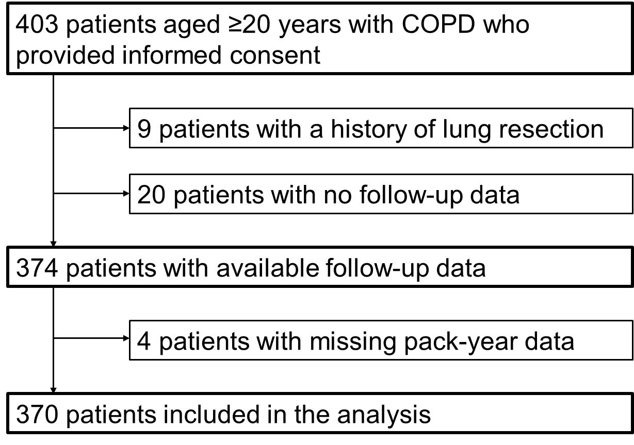

COPD, chronic obstructive pulmonary disease.

Figure E2. Distribution of study participants according to disease severity based on the GOLD and ppFVC-based classifications.

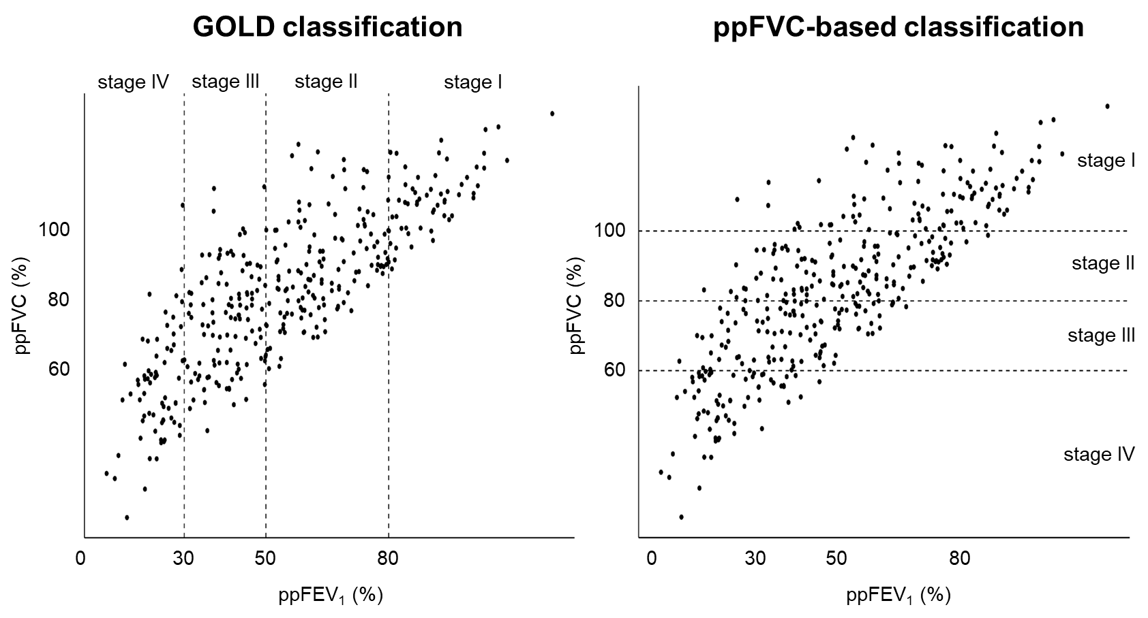

GOLD, Global Initiative for Chronic Obstructive Lung Disease; ppFVC, percent predicted forced vital capacity; ppFEV₁, percent predicted forced expiratory volume in 1 s.

Figure E3. Bangdiwala agreement plot comparing GOLD and ppFVC-based classifications.

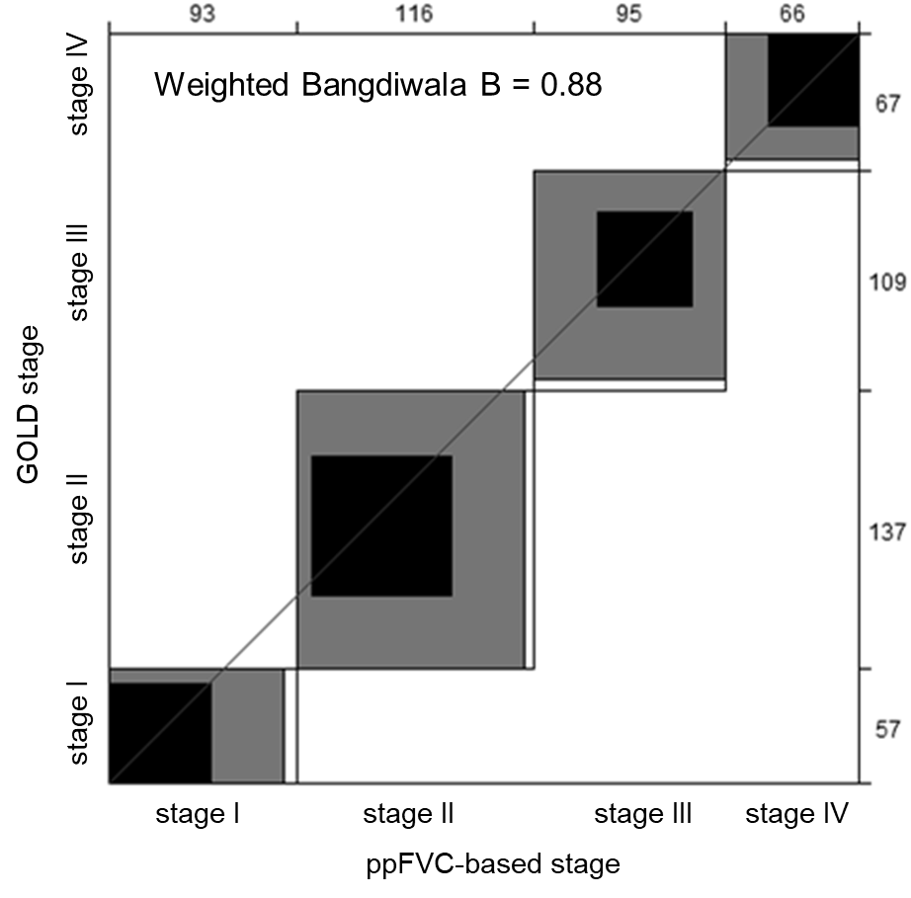

The plot is displayed as an N × N square, where N represents the total sample size. Each large rectangle shows the maximum possible agreement based on the marginal totals, with successive lighter-shaded rectangles representing partial agreement. Each dark rectangle indicates complete agreement, and perfect agreement occurs if all groups form dark squares aligned along a 45° diagonal line. The numbers on the top and right axes indicate the distribution of participants across the ppFVC-based and GOLD stages, respectively.
GOLD, Global Initiative for Chronic Obstructive Lung Disease; ppFVC, percentage predicted forced vital capacity.

Figure E4. Association between ppFVC-based severity stages and all-cause mortality among patients with COPD without a history of asthma.

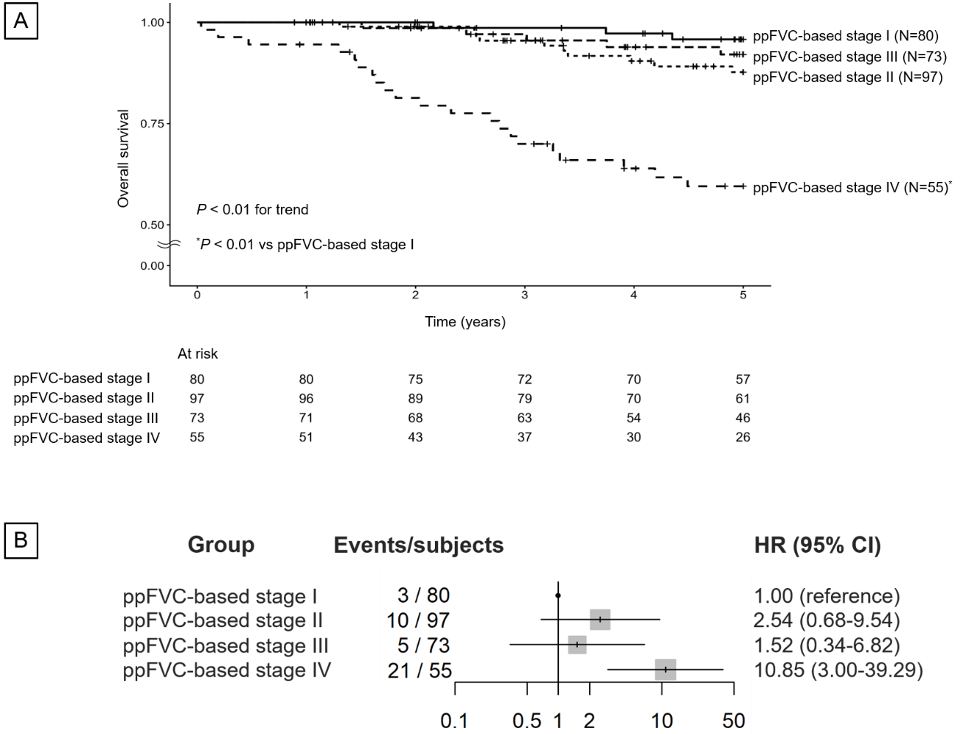

(A) Kaplan–Meier curves of survival probability according to ppFVC-based stages of COPD. (B) Multivariable-adjusted HRs for all-cause mortality across ppFVC-based severity stages. The ppFVC-based staging system classifies COPD severity according to ppFVC as follows: stage I, ppFVC ≥ 100%; stage II, 80% ≤ ppFVC < 100%; stage III, 60% ≤ ppFVC < 80%; and stage IV, ppFVC < 60%. Adjustments were made for age, sex, body mass index, smoking exposure, use of inhaled corticosteroids, use of long-acting bronchodilators, and C-reactive protein level. Because of its skewed distribution, smoking exposure was categorized into three groups: 0 pack-years, 0 < pack-years < 20, and ≥ 20 pack-years. C-reactive protein levels were dichotomized as ≥ 0.30 or < 0.30 mg/dL because of their skewed distribution. ppFVC, percent predicted forced vital capacity; HR, hazard ratio; CI, confidence interval; COPD, chronic obstructive pulmonary disease.

Figure E5. Multivariable-adjusted HRs for all-cause mortality across ppFVC-based severity stages after additional adjustment for dyspnea severity.

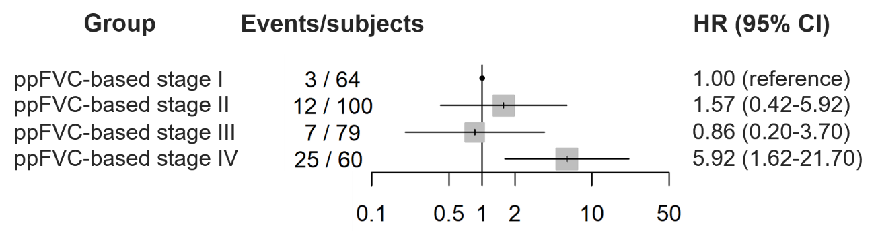

Patients without available modified Medical Research Council dyspnea scale data were excluded from this analysis. The ppFVC-based staging system classifies COPD severity according to ppFVC as follows: stage I, ppFVC ≥ 100%; stage II, 80% ≤ ppFVC < 100%; stage III, 60% ≤ ppFVC < 80%; and stage IV, ppFVC < 60%. Adjustments were made for age, sex, body mass index, smoking exposure, use of inhaled corticosteroids, use of long-acting bronchodilators, history of asthma, C-reactive protein level, and modified Medical Research Council dyspnea scale score. Because of its skewed distribution, smoking exposure was categorized into three groups: 0 pack-years, 0 < pack-years < 20, and ≥ 20 pack-years. C-reactive protein levels were dichotomized as ≥ 0.30 or < 0.30 mg/dL because of their skewed distribution. HR, hazard ratio; ppFVC, percent predicted forced vital capacity; CI, confidence interval; COPD, chronic obstructive pulmonary disease.

Figure E6. Multivariable-adjusted HRs for all-cause mortality across ppFVC-based severity stages after additional adjustment for the ADO index.

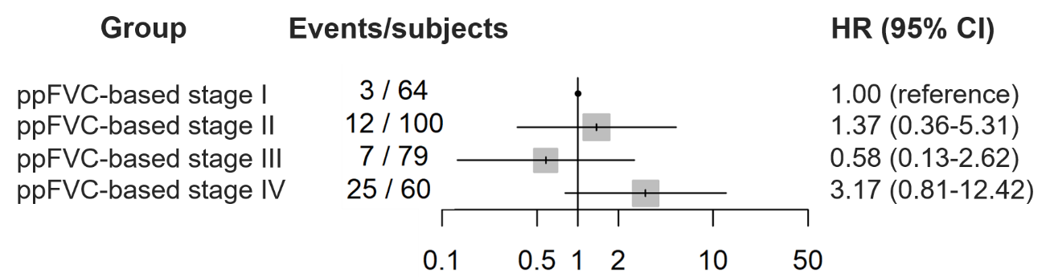

Patients without available modified Medical Research Council dyspnea scale data were excluded from this analysis. The ppFVC-based staging system classifies COPD severity according to ppFVC as follows: stage I, ppFVC ≥ 100%; stage II, 80% ≤ ppFVC < 100%; stage III, 60% ≤ ppFVC < 80%; and stage IV, ppFVC < 60%. Adjustments were made for age, sex, body mass index, smoking exposure, use of inhaled corticosteroids, use of long-acting bronchodilators, history of asthma, C-reactive protein level, and the ADO index. Because of its skewed distribution, smoking exposure was categorized into three groups: 0 pack-years, 0 < pack-years < 20, and ≥ 20 pack-years. C-reactive protein levels were dichotomized as ≥ 0.30 or < 0.30 mg/dL because of their skewed distribution. HR, hazard ratio; ppFVC, percent predicted forced vital capacity; CI, confidence interval; ADO, Age, Dyspnea, and airflow Obstruction; COPD, chronic obstructive pulmonary disease.

Figure E7. Association between ppFVC categories defined using the exact cohort quartiles and all-cause mortality.

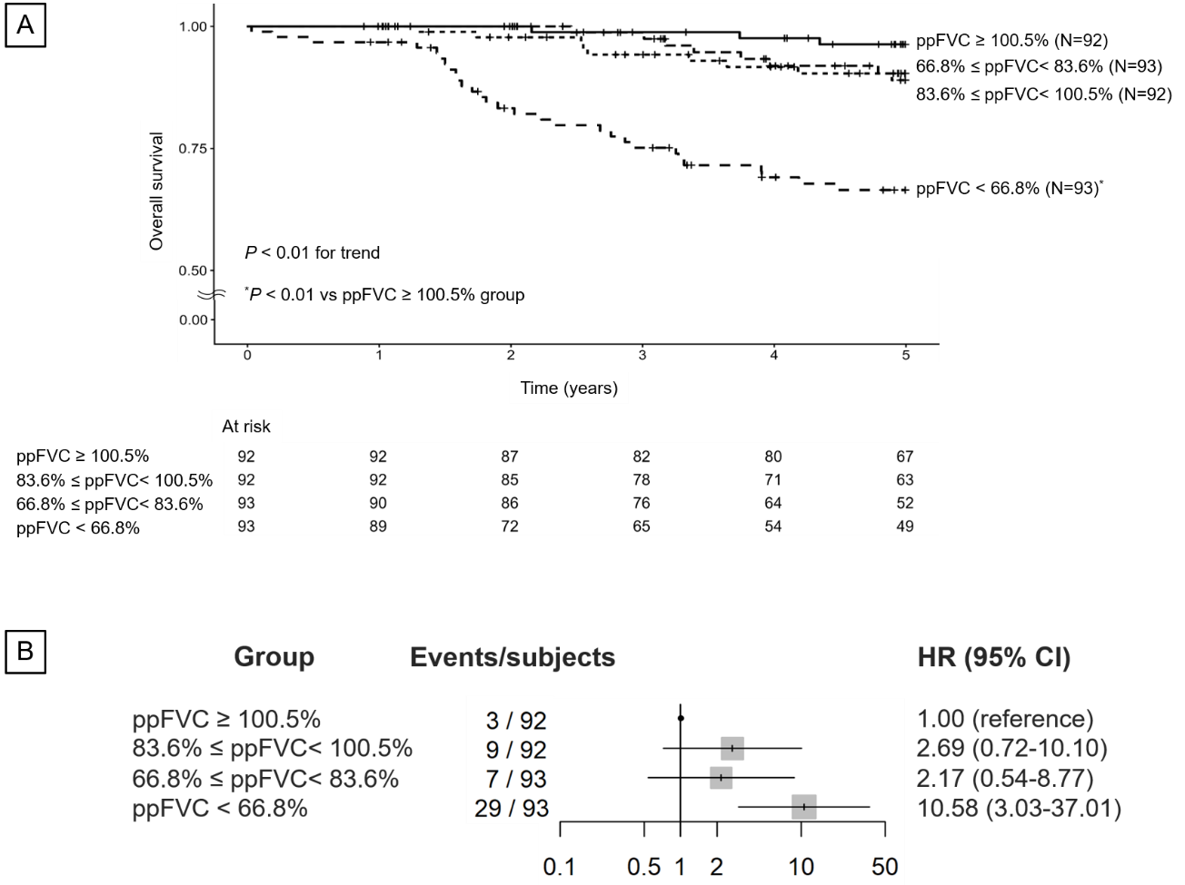

(A) Kaplan–Meier curves of survival probability according to ppFVC categories defined using the exact cohort quartiles. (B) Multivariable-adjusted HRs for all-cause mortality across ppFVC categories defined using the exact cohort quartiles. Patients were categorized according to the exact cohort quartiles of ppFVC as follows: ppFVC ≥ 100.5%, 83.6% ≤ ppFVC < 100.5%, 66.8% ≤ ppFVC < 83.6%, and ppFVC < 66.8%. Adjustments were made for age, sex, body mass index, smoking exposure, use of inhaled corticosteroids, use of long-acting bronchodilators, history of asthma, and C-reactive protein level. Because of its skewed distribution, smoking exposure was categorized into three groups: 0 pack-years, 0 < pack-years < 20, and ≥ 20 pack-years. C-reactive protein levels were dichotomized as ≥ 0.30 or < 0.30 mg/dL because of their skewed distribution. ppFVC, percent predicted forced vital capacity; HR, hazard ratio; CI, confidence interval; COPD, chronic obstructive pulmonary disease.

Figure E8. Association between ppFVC-based severity stages and the risk of COPD exacerbations among patients with COPD without a history of asthma.

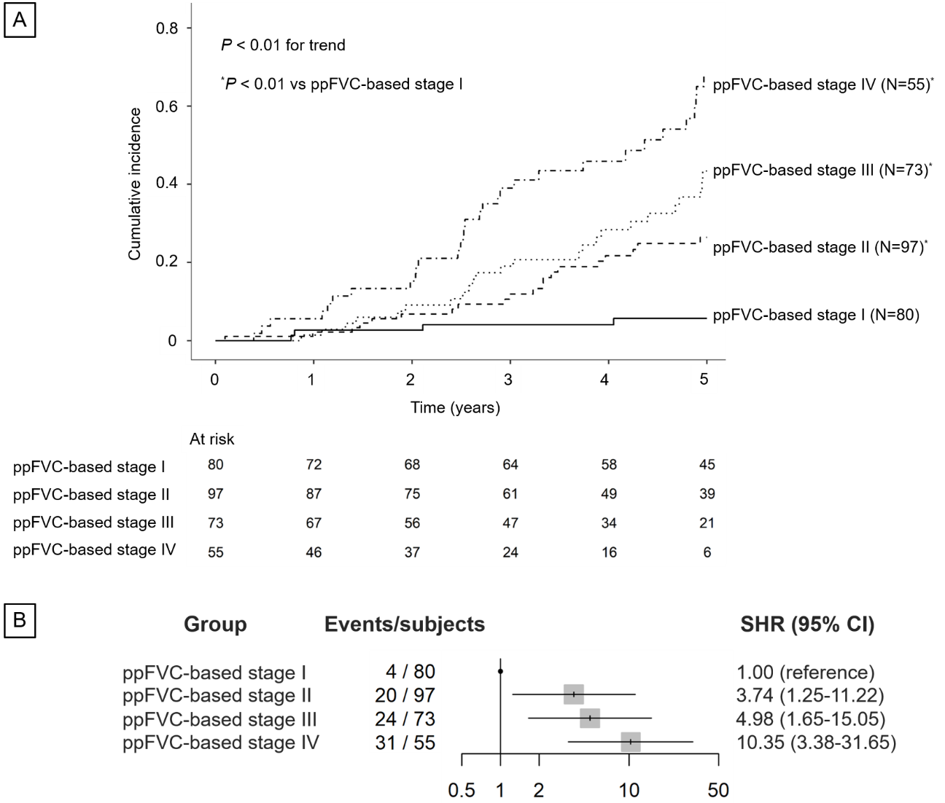

(A) Cumulative incidence function curves for the probability of moderate-to-severe COPD exacerbations according to ppFVC-based stages. (B) Multivariable-adjusted SHRs for first moderate-to-severe COPD exacerbations across ppFVC-based stages. The ppFVC-based staging system classifies COPD severity according to ppFVC as follows: stage I, ppFVC ≥ 100%; stage II, 80% ≤ ppFVC < 100%; stage III, 60% ≤ ppFVC < 80%; and stage IV, ppFVC < 60%. Adjustments were made for age, sex, body mass index, smoking exposure, use of inhaled corticosteroids, use of long-acting bronchodilators, and C-reactive protein level. Because of its skewed distribution, smoking exposure was categorized into three groups: 0 pack-years, 0 < pack-years < 20, and ≥ 20 pack-years. C-reactive protein levels were dichotomized as ≥ 0.30 or < 0.30 mg/dL because of their skewed distribution. ppFVC, percent predicted forced vital capacity; COPD, chronic obstructive pulmonary disease; SHR, subdistribution hazard ratio; CI, confidence interval.

Figure E9. Multivariable-adjusted SHRs for first moderate-to-severe COPD exacerbations across ppFVC-based stages after additional adjustment for dyspnea severity.

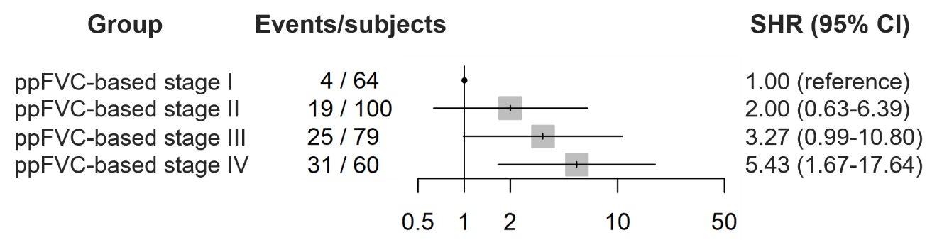

Patients without available modified Medical Research Council dyspnea scale data were excluded from this sensitivity analysis. The ppFVC-based staging system classifies COPD severity according to ppFVC as follows: stage I, ppFVC ≥ 100%; stage II, 80% ≤ ppFVC < 100%; stage III, 60% ≤ ppFVC < 80%; and stage IV, ppFVC < 60%. Adjustments were made for age, sex, body mass index, smoking exposure, use of inhaled corticosteroids, use of long-acting bronchodilators, history of asthma, C-reactive protein level, and modified Medical Research Council dyspnea scale score. Because of its skewed distribution, smoking exposure was categorized into three groups: 0 pack-years, 0 < pack-years < 20, and ≥ 20 pack-years. C-reactive protein levels were dichotomized as ≥ 0.30 or < 0.30 mg/dL because of their skewed distribution. SHR, subdistribution hazard ratio; ppFVC, percent predicted forced vital capacity; COPD, chronic obstructive pulmonary disease; CI, confidence interval.

Figure E10. Multivariable-adjusted SHRs for first moderate-to-severe COPD exacerbations across ppFVC-based stages after additional adjustment for the ADO index.

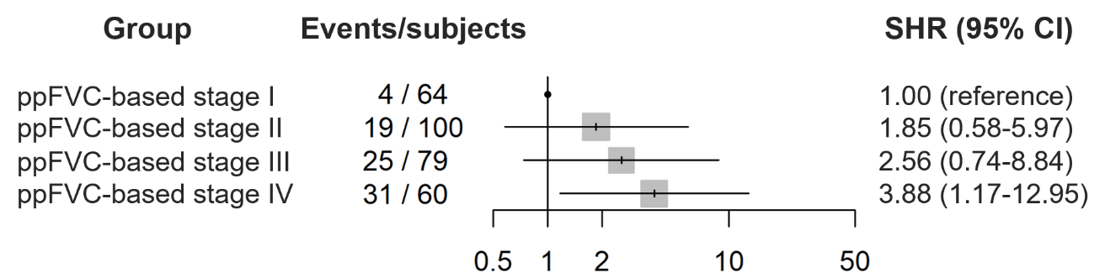

Patients without available modified Medical Research Council dyspnea scale data were excluded from this sensitivity analysis. The ppFVC-based staging system classifies COPD severity according to ppFVC as follows: stage I, ppFVC ≥ 100%; stage II, 80% ≤ ppFVC < 100%; stage III, 60% ≤ ppFVC < 80%; and stage IV, ppFVC < 60%. Adjustments were made for sex, body mass index, smoking exposure, use of inhaled corticosteroids, use of long-acting bronchodilators, history of asthma, C-reactive protein level, and the ADO index. Because of its skewed distribution, smoking exposure was categorized into three groups: 0 pack-years, 0 < pack-years < 20, and ≥ 20 pack-years. C-reactive protein levels were dichotomized as ≥ 0.30 or < 0.30 mg/dL because of their skewed distribution. SHR, subdistribution hazard ratio; CI, confidence interval; ppFVC, percent predicted forced vital capacity; COPD, chronic obstructive pulmonary disease; ADO, Age, Dyspnea, and airflow Obstruction.

Figure E11. Association between ppFVC categories defined using the exact cohort quartiles and the risk of first moderate-to-severe COPD exacerbations.

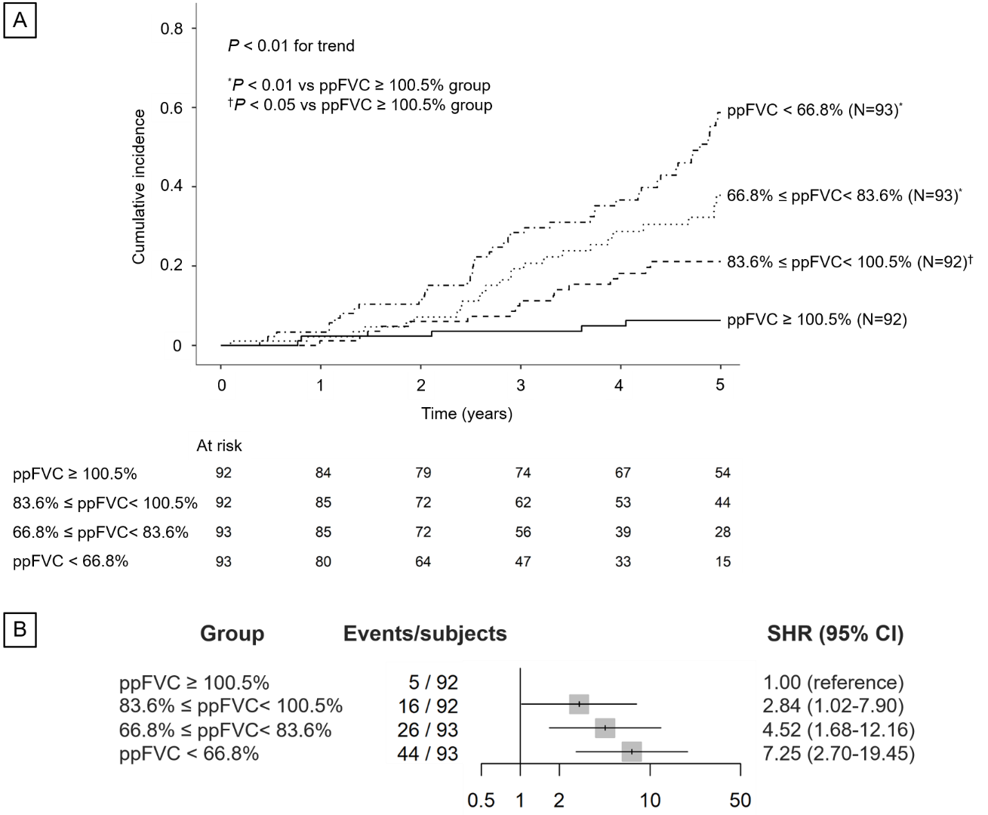

(A) Cumulative incidence function curves for the probability of moderate-to-severe COPD exacerbations according to ppFVC categories defined using the exact cohort quartiles. (B) Multivariable-adjusted SHRs for first moderate-to-severe COPD exacerbations across ppFVC categories defined using the exact cohort quartiles. Patients were categorized according to the exact cohort quartiles of ppFVC as follows: ppFVC ≥ 100.5%, 83.6% ≤ ppFVC < 100.5%, 66.8% ≤ ppFVC < 83.6%, and ppFVC < 66.8%. Adjustments were made for age, sex, body mass index, smoking exposure, use of inhaled corticosteroids, use of long-acting bronchodilators, and C-reactive protein level. Because of its skewed distribution, smoking exposure was categorized into three groups: 0 pack-years, 0 < pack-years < 20, and ≥ 20 pack-years. C-reactive protein levels were dichotomized as ≥ 0.30 or < 0.30 mg/dL because of their skewed distribution. ppFVC, percent predicted forced vital capacity; COPD, chronic obstructive pulmonary disease; SHR, subdistribution hazard ratio; CI, confidence interval.

