Supplementary Information
for
Ultra-dispersed metal oxide nanoparticles on graphitic carbon nitride as functional platforms for electrochemical nitrate valorization

Gian Andrea Rizzi¹, Davide Barreca^{2,*}, Nikša Krstulović³, Oleg I. Lebedev⁴,
Lidia Soldà¹, Andrea Tapparo¹, Chiara Maccato^{1,}* & Alberto Gasparotto¹

¹ Department of Chemical Sciences, Padova University and INSTM, 35131 Padova, Italy.
² CNR-ICMATE and INSTM, Department of Chemical Sciences, Padova University, 35131, Padova, Italy.
³ Centre for Advanced Laser Techniques, Institute of Physics, Bijenicka cesta 46, 10000 Zagreb, Croatia.
⁴ Laboratoire CRISMAT, UMR 6508 Normandie Université, CNRS, ENSICAEN, UNICAEN, 14050 Caen Cedex 4, France.

* Corresponding authors. E-mail: davide.barreca@cnr.it (D.B.); chiara.maccato@unipd.it (C.M.).
Table of Contents
 | Page
§ S-1. Additional experimental details  § S-2. Characterization  § S-2.1 SEM investigation  § S-2.2 XRD analysis  § S-2.3 TEM analysis  § S-2.4 XPS analysis  § S-2.5 REELS analysis  § S-3. Electrochemical functional tests and related data  § S-4. Characterization after electrochemical tests  § S-5. References | S3  S4  S4  S5  S6  S7  S10  S11  S15  S16

§ S-1. Additional experimental details
X-ray diffraction (XRD) measurements were carried out using a Bruker AXS D8 Advance Plus diffractometer equipped with a Göbel mirror and a CuKα X-ray source (λ = 1.54051 Å), powered at 40 kV and 40 mA. Analyses were performed in glancing incidence mode (θ_{i} = 1.0°) with a step size of 0.06° and an acquisition time of 4 s/step.

Metal oxide loading quantification on the electrodes exploited inductively coupled plasma mass spectrometry (ICP-MS) analysis performed on Agilent series 7700x instrument (Agilent Technologies International Japan, Ltd., Tokyo, Japan) using previously reported operating conditions¹. A portion of the electrode was treated with 0.365 mL of 69% nitric acid (Fluka) in ultrasonic bath for 30 min. This solution was diluted to 10 mL with ultrapure water, filtered on 0.2 µm RC membrane (Phenomenex, Phenex 4 mm syringe filter), and analyzed by ICP-MS.

Analyte | Methodology | Calibration range | Retention time | LOD (3σ)
NH₄⁺ | Ion chromatography, Dionex™ IonPac CS12A (2x250 mm) + CG12A (2x50 mm) columns | 0.05-10 mg×L⁻¹ | 6.85 min | 3 µg×L⁻¹
NO₂⁻ | Ion chromatography, Dionex™ IonPac AS11-HC (2x250 mm) + AG11-HC (2x50 mm) columns | 0.1-10 mg×L⁻¹ | 4.85 min | 5 µg×L⁻¹
Table S1. Performance parameters of the ion chromatographic procedure used for the determination of ammonium and nitrite in the analyzed aqueous solutions. For the validation of the adopted analytical procedure, the reader is referred to previous references^{2,3} regarding the use of ion chromatography in environmental analyses.

Mott–Schottky analysis was performed in the 10⁵÷10^{–1} Hz frequency range, with 1/C_{P}² calculated at 3 KHz according to the formula:
$\frac{1}{C_{P}^{2}}={\left[\frac{\left(-Z^{''2}+{\left(Z^{'}-R_{s}\right)}^{2}\right)∙ω}{-Z^{''}}\right]}^{2}$
where C_{p} is the depletion layer capacity, Z’ and Z” are respectively the real and imaginary parts of the impedance, ω is the frequency and R_{s} is the cell resistance.

§ S-2. Characterization
§ S-2.1 SEM investigation
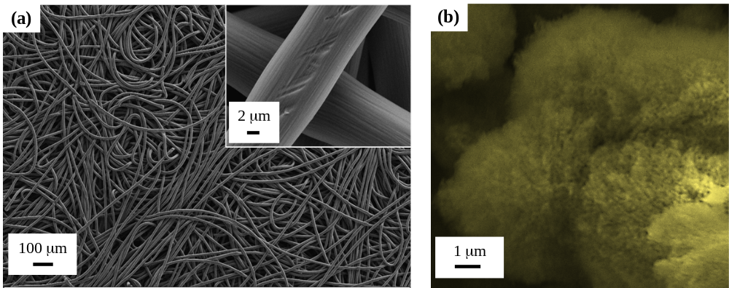
Figure S1. SEM image of the bare CC substrate showing interwoven carbon fibres. Inset: higher magnification micrograph. (b) SEM image of gCN powders.

§ S-2.2 XRD analysis
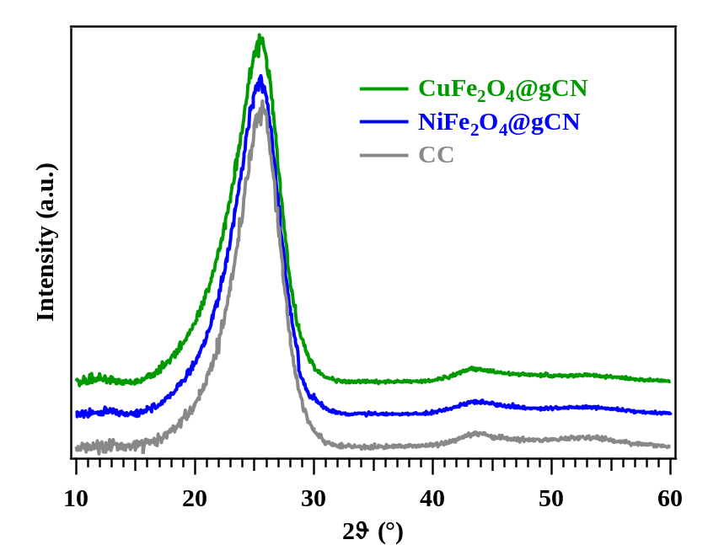
Figure S2. XRD patterns for two representative oxide@gCN specimens and for the bare carbon cloth (CC). In all cases, only signals attributable to the CC support could be observed.

§ S-2.3 TEM analysis
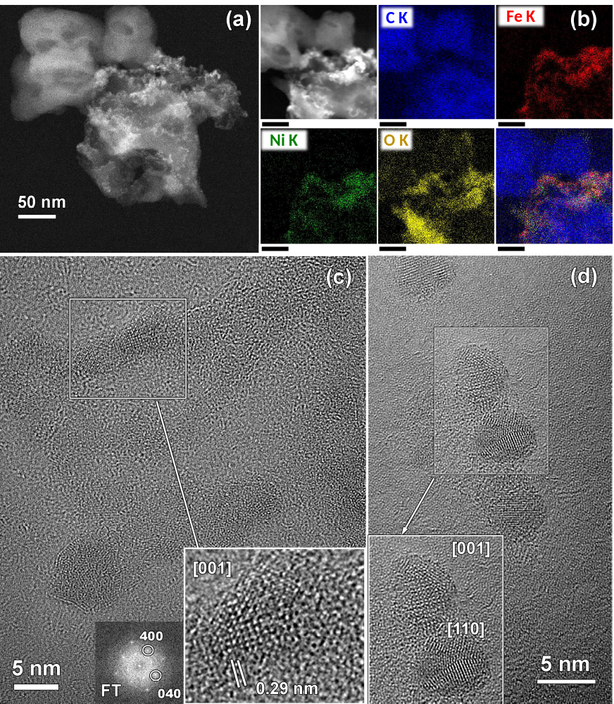
Figure S3. (a) Low magnification HAADF-STEM image of the NiFe₂O₄@gCN sample. (b) HAADF-STEM image and simultaneously acquired EDXS elemental maps for C, Fe, Ni and O, along with an overlayed color image. Scale bar: 30 nm. (c-d) BF-HRTEM images of NiFe₂O₄ NPs on gCN. The magnified images framed by white boxes show nanoparticles oriented along main [001] and [110] crystallographic zone axes of the cubic NiFe₂O₄ structure⁴. The FT pattern is also given as inset in (c).

§ S-2.4 XPS analysis
The main photoelectron peaks for a bare gCN specimen supported on CC are displayed in Figure S3. For the C 1s peak (Figure S4a), spectral deconvolution evidenced four main components. The intense one, at 284.8 eV, was due to adventitious contamination and C-C bonds from the substrate. The band at 285.9 eV was related to C atoms bonded to gCN amino groups, whereas the peak centered at 288.4 eV was ascribed to both N-C=N moieties from gCN and carbonyl groups from the carbon cloth. The signal located at 289.3 eV was traced back to carboxylate/ester groups from the substrate⁵⁻⁸. The weaker signal at ≈292.5 eV was due to collective π-electron excitations^{9,10}. For the N 1s signal (Figure S4b), the component at 398.9 eV was assigned to nitrogen belonging to C=N–C moieties in gCN, whereas the ones located at 399.7 eV and 401.0 eV were due to gCN three-coordinated N atoms and uncondensed amino groups, respectively. The weak feature at 404.8 eV is due to the excitation of π electrons⁵⁻⁸. The O 1s peak (Figure S4c) included two contributions at 531.9 eV and 533.3 eV: the former arose from –OH surface groups and carbonyl/carboxylate/ester ones from the CC substrate, whereas the latter was due to adsorbed H₂O⁵⁻⁷.

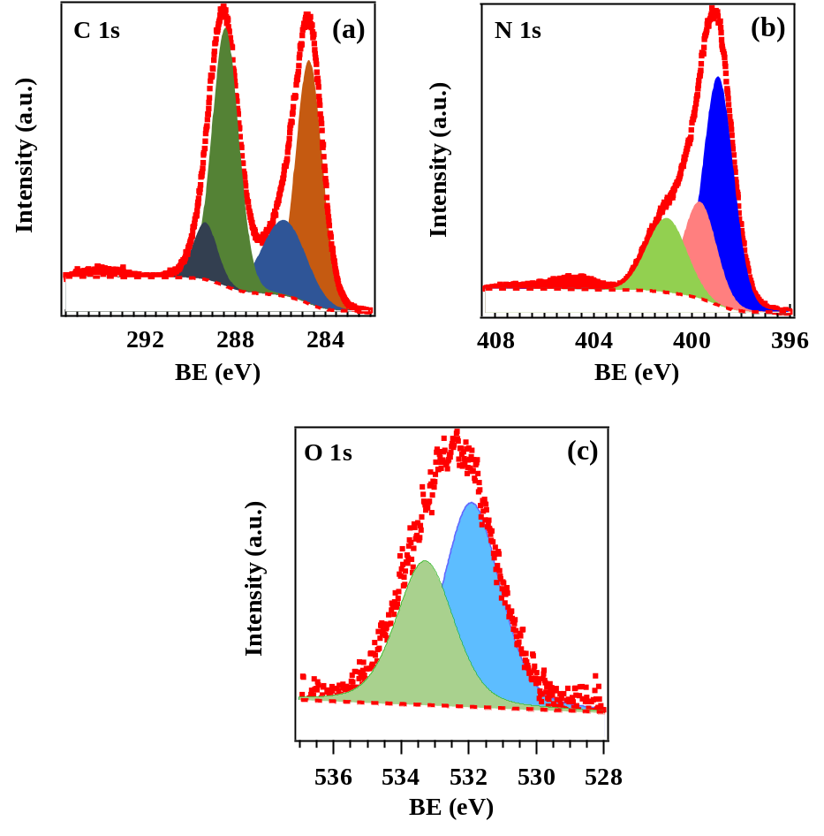
Figure S4. (a) C 1s, (b) N 1s and (c) O 1s photoelectron signals for the bare gCN specimen grown on CC substrate. Elemental quantification yielded the following atomic percentages: C = 58.2 at.%; N = 38.3 at.%; O = 3.5 at.%.

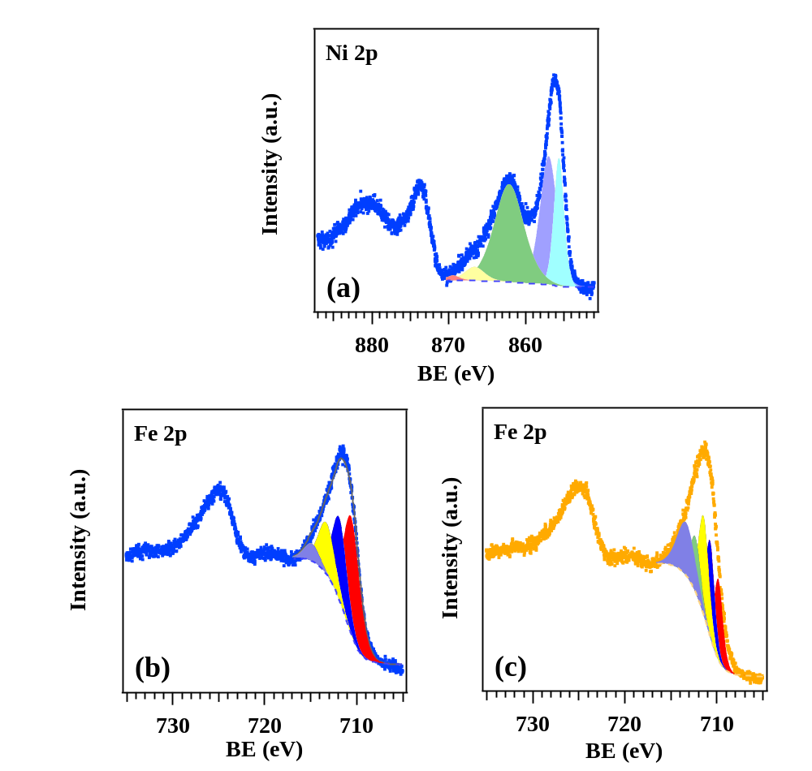
Figure S5. (a) Ni 2p and (b) Fe 2p photoelectron signals for the NiFe₂O₄@gCN sample. (c) Fe 2p signal for the Fe₂O₃@gCN specimen. For the target peaks, the fitting was carried out according to Biesinger et al.¹¹, yielding results well supporting the occurrence of NiFe₂O₄ (a,b) and Fe₂O₃ (c), along with the presence of Ni(II) and Fe(III) centers. For NiFe₂O₄@gCN, deconvolution of the Ni 2p_{3/2} signal and its shake-up satellite involved five components centered at 855.0, 856.3, 861.4, 865.9 and 868.7 eV, whereas fitting of the Fe 2p_{3/2} peak was carried out with four contributions at 710.0, 711.3, 712.7 and 714.3 eV. As far as the Fe 2p_{3/2} signal of Fe₂O₃@gCN is concerned, spectral deconvolution involved five components at 709.8, 710.7, 711.4, 712.3 and 713.3 eV.

§ S-2.5 REELS analysis
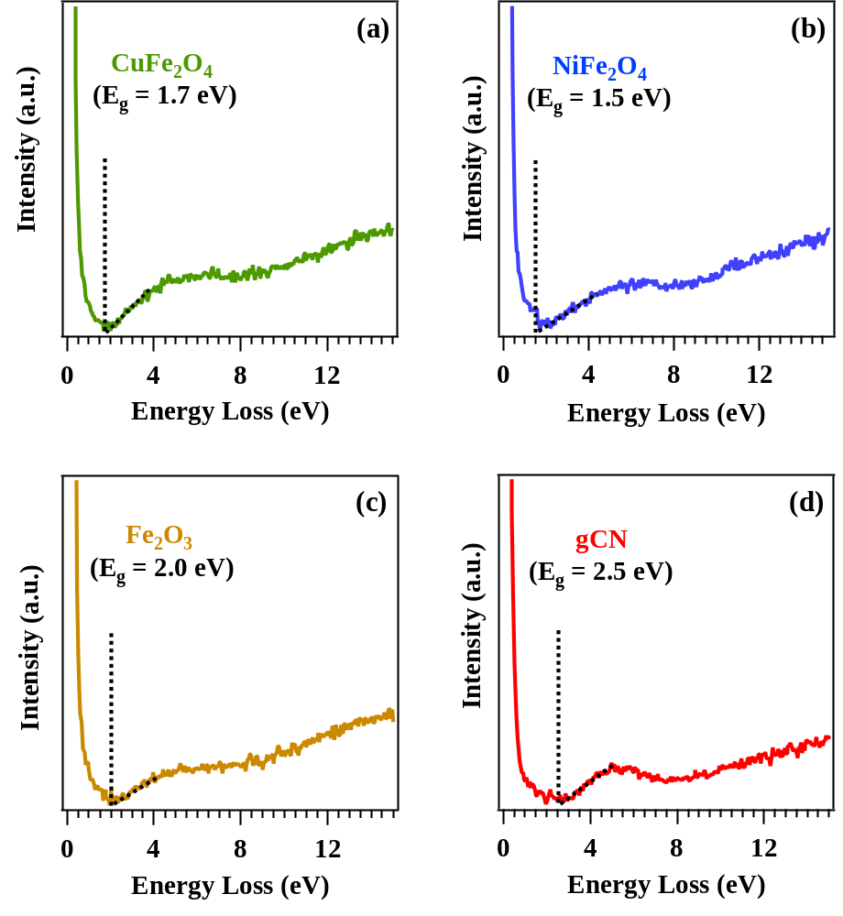
Figure S6. REELS spectra for bare CuFe₂O₄, NiFe₂O₄, Fe₂O₃ and gCN specimens. The corresponding band gap values are consistent with literature data¹²⁻¹⁷.

§ S-3. Electrochemical functional tests and related data
Material | Electrolyte | j (mA/cm²) | j (mA/mg) | Faradaic efficiency (%) | Ref.
CuFe₂O₄@gCN  (this work) | 0.05 M Na₂SO₄ + 0.1 M NaNO₃ | 17 | 10430 ª | 21 | This work
Fe₂O₃ | 1 M KOH +  0.3 M KNO₃ | 260 | 130 | 63.0 | ¹⁸
Cu₂O | 0.1 M Na₂SO₄ + 8 mM NaNO₃ | 1.5 | 30 | 85 | ¹⁹
NiFe₂O₄/CC | 0.1 M phosphate + 0.1 M NaNO₃ | 160 | 89 | 96.6 | ²⁰
Fe₂O₃@CC | 0.5 M Na₂SO₄ + 500 mg/L NaNO₃ | 17 | 30 | 80.4 | ²¹
Cu/Fe rGO | 1 M KOH +  0.1 M KNO₃ | 100 | 25 | 92.5 | ²²
NiCo₂O₄/CC | 0.5 M Na₂SO₄ + 0.5 M NaNO₃ | 44 | 19 | 65 | ²³
FeNC-Fe₃O₄/CC | 0.25 M Na₂SO₄ + 0.1 M KNO₃ | 50 | 10 | 65 | ²⁴
NiCo₂O₄/CC | 1 M NaOH +  0.3 M NaNO₃ | 56.2 | n.a. | 80 | ²⁵
CoFe₂O₄/CC | 0.1 M K₂SO₄ + 0.1 M KNO₃ | 40 | 133 | n.a. | ²⁶
NiFe₂O₄/CC | 0.1 M K₂SO₄ + 0.1 M KNO₃ | 35 | 116 | n.a. | ²⁶
NiFe₂O₄/Carbon paper | 0.1 M Na₂SO₄ + 0.1 M KNO₃ | 4 | 0.8 | 70 | ²⁷
Fe₂O₃/Carbon paper | 0.1 M Na₂SO₄ + 0.1 M KNO₃ | 4 | 0.8 | 65 | ²⁷
Table S2. Summary of functional performances in e-NO₃RR of selected electrocatalysts based on carbonaceous materials/metal oxides. n.a. = data not available. CC = carbon cloth; rGO = reduced graphene oxide. ª normalization uses only the oxide mass of sputtered CuFe₂O₄.
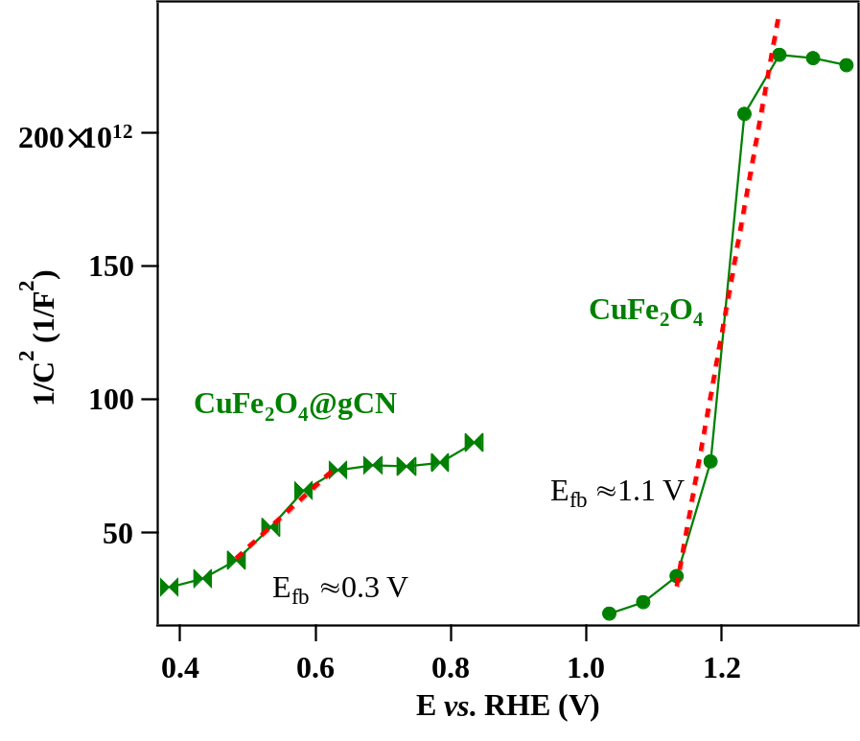
Figure S7. Mott-Schottky plots as a function of the applied potential obtained at 3 kHz for specimens CuFe₂O₄@gCN and CuFe₂O₄. The obtained values of the flat band potential (E_{fb}) are in good agreement with UPS measurements and confirm a charge transfer from gCN to CuFe₂O₄ after E_{f} alignment.

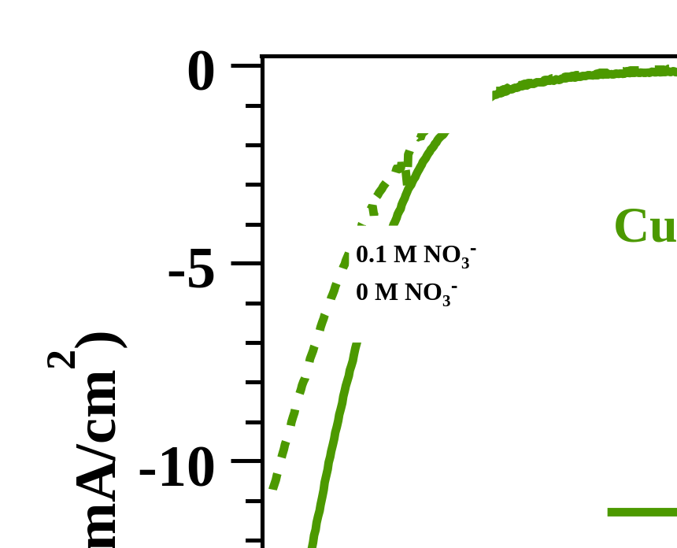
Figure S8. LSV scans obtained from CuFe₂O₄@gCN electrode in nitrate-free and 0.1 M NO₃⁻ solutions.

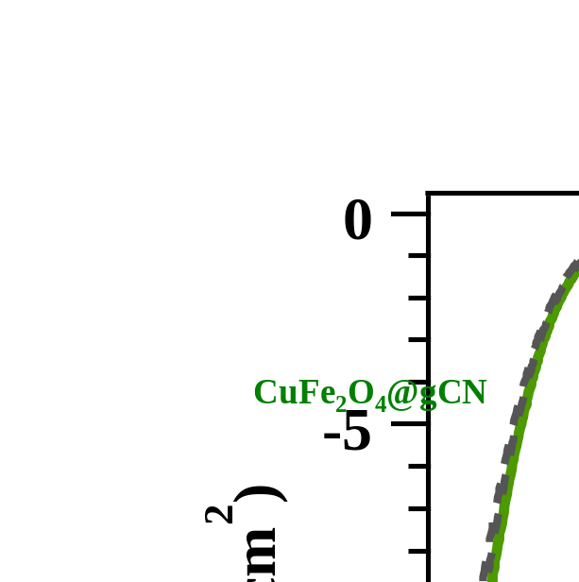
Figure S9. LSV curves recorded in 0.1 M NO₃⁻ aqueous solutions on the pristine CuFe₂O₄@gCN sample (solid green line) and every 90 days for 6 months upon specimen storage under ambient conditions (grey dashed lines).

§ S-4. Characterization after electrochemical tests
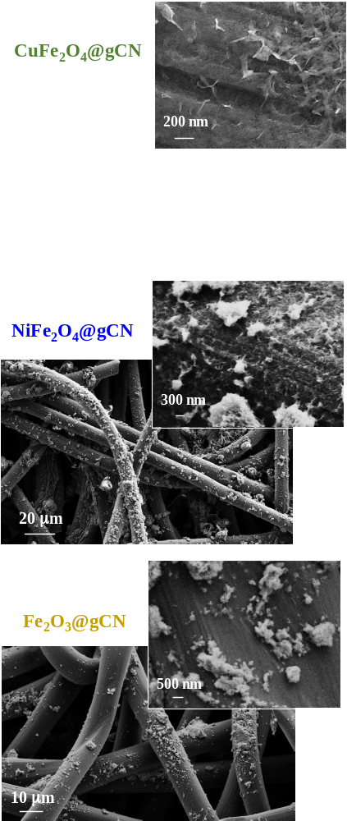
Figure S10. Representative SEM micrographs of the target systems after the completion of electrochemical tests indicated in the caption to Fig. S9.
§ S-5. References

1 Di Marco, V. et al. Metal ion release from fine particulate matter sampled in the Po valley to an aqueous solution mimicking fog water: kinetics and solubility. Aerosol Air Qual. Res. 20, 720-729, https://doi.org/10.4209/aaqr.2019.10.0498 (2020).
2 APHA, AWWA, WEF (2012). Method 4110: Determination of Anions by Ion Chromatography. In Standard Methods for the Examination of Water and Wastewater, 22nd Ed., Washington DC: American Public Health Association.
3 US EPA, 1999. Particulate Matter (PM2.5) Speciation Guidance, final draft. Washington, DC: United States Environmental Protection Agency.
4 ICSD card N°73676.
5 Scattolin, E. et al. Graphitic carbon nitride structures on carbon cloth containing ultra- and nano-dispersed NiO for photoactivated oxygen evolution. ChemSusChem 17, e202400948, https://doi.org/10.1002/cssc.202400948 (2024).
6 Moulder, J. F., Stickle, W. F., Sobol, P. E. & Bomben, K. D. Handbook of X-ray photoelectron spectroscopy. (Physical Electronics Division, Perkin-Elmer Corporation, 1992).
7 Sturaro, T. et al. Nano- and ultra-dispersed ZnO and ZnFe₂O₄ on graphitic carbon nitride as photoelectrocatalysts for the ethanol oxidation reaction. Mater. Adv. 6, 963-968, https://doi.org/10.1039/d4ma01114g (2025).
8 Benedet, M. et al. Functionalization of graphitic carbon nitride systems by cobalt and cobalt-iron oxides boosts solar water oxidation performances. Appl. Surf. Sci. 618, 156652, https://doi.org/10.1016/j.apsusc.2023.156652 (2023).
9 Bertóti, I., Mohai, M. & László, K. Surface modification of graphene and graphite by nitrogen plasma: Determination of chemical state alterations and assignments by quantitative X-ray photoelectron spectroscopy. Carbon 84, 185-196, https://doi.org/10.1016/j.carbon.2014.11.056 (2015).
10 Scattolin, E. et al. Graphitic carbon nitride functionalized with NiO nanoaggregates: An X-ray photoelectron spectroscopy investigation. Surf. Sci. Spectra 31, 024001, https://doi.org/10.1116/6.0003732 (2024).
11 Biesinger, M. C. et al. Resolving surface chemical states in XPS analysis of first row transition metals, oxides and hydroxides: Cr, Mn, Fe, Co and Ni. Appl. Surf. Sci. 257, 2717-2730, https://doi.org/10.1016/j.apsusc.2010.10.051 (2011).
12 Zander, J., Fink, M. F., Attia, M., Roth, C. & Marschall, R. Selective optimisation of catalytic activity by tuning the structural composition in nanoparticulate CuFe₂O₄. Sustain. Energy Fuels 8, 4848-4863, https://doi.org/10.1039/d4se00968a (2024).
13 Vergari, M. et al. Photoelectrochemical performance and charge dynamics of supersonic cluster beam deposited CuFe₂O₄ thin films. Appl. Surf. Sci. Adv. 34, 100999, https://doi.org/10.1016/j.apsadv.2026.100999 (2026).
14 Meinert, M. & Reiss, G. Electronic structure and optical band gap determination of NiFe₂O₄. J. Phys. Condens. Matter 26, 115503, https://doi.org./10.1088/0953-8984/26/11/115503 (2014).
15 Carraro, G. et al. Enhanced hydrogen production by photoreforming of renewable oxygenates through nanostructured Fe₂O₃ polymorphs. Adv. Funct. Mater. 24, 372-378, https://doi.org/10.1002/adfm.201302043 (2014).
16 Hong, I. et al. Band alignment modulation of g-C₃N₄ by tuning structural defects for selective ammonia photosynthesis from nitrate reduction under visible light irradiation. Chem. Eng. J. 484, 149506, https://doi.org/10.1016/j.cej.2024.149506 (2024).
17 Alaghmandfard, A. & Ghandi, K. A comprehensive review of graphitic carbon nitride (g-C₃N₄)–metal oxide-based nanocomposites: potential for photocatalysis and sensing. Nanomaterials 12, 294, https://doi.org/10.3390/nano12020294 (2022).
18 Wu, Q. et al. Screening of transition metal oxides for electrocatalytic nitrate reduction to ammonia at large currents. Nano Res. 17, 3902-3910, https://doi.org/10.1007/s12274-023-6379-2 (2024).
19 Bai, L. et al. Electrocatalytic nitrate and nitrite reduction toward ammonia using Cu₂O nanocubes: active species and reaction mechanisms. J. Am. Chem. Soc. 146, 9665-9678, https://doi.org/10.1021/jacs.3c13288 (2024).
20 Xie, L. et al. High-performance electrochemical nitrate reduction to ammonia under ambient conditions using NiFe₂O₄ nanosheet arrays. Inorg. Chem. Front. 9, 3392-3397, https://doi.org/10.1039/d2qi00827k (2022).
21 Li, R., Liu, J., Fan, J. & Zhang, W.-x. A comparative study of the electrocatalytic performance of iron and iron oxide for nitrate reduction. J. Environ. Chem. Eng. 13, 119945, https://doi.org/10.1016/j.jece.2025.119945 (2025).
22 Zhang, S. et al. Fe/Cu diatomic catalysts for electrochemical nitrate reduction to ammonia. Nat. Commun. 14, 3634, https://doi.org/10.1038/s41467-023-39366-9 (2023).
23 Dhanaraman, E., Bhanuse, G. B., Kumar, S. & Fu, Y.-P. Mo-doped spinel NiCo₂O₄ as a bifunctional electrocatalyst for highly efficient nitrate reduction to ammonia and oxygen evolution reaction. J. Mater. Chem. A 14, 25222-25239, https://doi.org.10.1039/d6ta02168a (2026).
24 Wei, J. et al. Coupling iron oxide with iron single-atom catalyst promotes neutral electrochemical nitrate reduction from water. Water Res. 289, 124936, https://doi.org/10.1016/j.watres.2025.124936 (2026).
25 Liu, Q. et al. Ambient ammonia synthesis via electrochemical reduction of nitrate enabled by NiCo₂O₄ nanowire array. Small 18, 2106961, https://doi.org/10.1002/smll.202106961 (2022).
26 Ding, J. et al. Coupling nitrate-to-ammonia conversion and sulfion oxidation reaction over hierarchical porous spinel MFe₂O₄ (M=Ni, Co, Fe, Mn) in wastewater. Small 21, 2411317, https://doi.org/10.1002/smll.202411317 (2025).
27 Yang, B. et al. Highly efficient electrochemical nitrate reduction to ammonia over a Fe₂O₃/NiFe₂O₄ heterostructured catalyst. ACS Sustainable Chem. Eng. 14, 4148-4157, https://doi.org/10.1021/acssuschemeng.5c13093 (2026).

