Prevalence and associated factors of basic activities of daily living impairment in Chinese patients with comorbid T2DM and hypertension
Ziling Feng^{1†}, Wenduo Yu^{1†}, Hongying Liu², Wenyan Zhang¹, Ni Xiong¹, Leyao Tang¹, Hua Zhong^{3*}, Wenjie Dai^{1*}
1 Department of Epidemiology and Health Statistics, Xiangya School of Public Health, Central South University, Changsha, Hunan, China
2 Case Room, Medical Department, Hunan Prevention and Treatment Institute for Occupational Diseases, Affiliated Prevention and Treatment Institute for Occupational Diseases of University of South China, Changsha, Hunan, China
3 Department of Cardiology, National Clinical Research Center for Geriatric Disorders, Xiangya Hospital, Central South University, Changsha, Hunan, China
†These authors contributed equally to the work.
*Corresponding authors: Hua Zhong, Email: zhonghua960@163.com; Wenjie Dai, Email: m18673965791@163.com; Address: No. 172 Tongzipo Road, Yuelu District, Changsha, Hunan, China

Supplementary Information
Supplementary Table S1 Prevalence of individual T2DM-related complications among participants
T2DM-related complications | Total (N=475) | BADL impairment (n=83) | No BADL impairment (n=392) | P value
Diabetic nephropathy | 138 (29.1%) | 29 (34.9%) | 109 (27.8%) | 0.193
Diabetic retinopathy | 233 (49.1%) | 36 (43.4%) | 197 (50.3%) | 0.255
Diabetic foot | 15 (3.2%) | 6 (7.2%) | 9 (2.3%) | 0.020
Diabetic ketosis | 30 (6.3%) | 4 (4.8%) | 26 (6.6%) | 0.537
Diabetic peripheral neuropathy | 321 (67.6%) | 58 (69.9%) | 263 (67.1%) | 0.622
Diabetic peripheral vasculopathy | 22 (4.6%) | 8 (9.6%) | 14 (3.6%) | 0.017
Number of T2DM-related complications, median (IQR) | 2 (0–2) | 2 (1–3) | 2 (0–2) | 0.403

Supplementary Table S2 Prevalence of other chronic conditions among the study participants
Other chronic conditions | Total (N=475) | BADL impairment (n=83) | No BADL impairment (n=392) | P value
Stroke | 81 (17.1%) | 35 (42.2%) | 46 (11.7%) | <0.001
Hyperlipidemia | 161 (33.9%) | 15 (18.1%) | 146 (37.2%) | 0.001
Coronary heart disease | 221 (46.5%) | 51 (61.4%) | 170 (43.4%) | 0.003
Chronic kidney disease | 48 (10.1%) | 14 (16.9%) | 34 (8.7%) | 0.024
Fatty liver | 99 (20.8%) | 8 (9.6%) | 91 (23.2%) | 0.006
Carotid atherosclerosis | 136 (28.6%) | 18 (21.7%) | 118 (30.1%) | 0.123
Carotid plaque formation | 108 (22.7%) | 17 (20.5%) | 91 (23.2%) | 0.590
Number of other chronic conditions, median (IQR) | 2 (1–3) | 2 (1–3) | 2 (1–3) | 0.265

Supplementary Table S3 Distribution of responses for each BADL item
BADL item | No difficulty at all | Need help | Unable to perform at all
Bathing | 392 (82.5%) | 45 (9.5%) | 38 (8.0%)
Dressing | 398 (83.8%) | 41 (8.6%) | 36 (7.6%)
Toileting | 418 (88.0%) | 36 (7.6%) | 21 (4.4%)
Transferring | 444 (93.5%) | 28 (5.9%) | 3 (0.6%)
Continence | 465 (97.9%) | 7 (1.5%) | 3 (0.6%)
Feeding | 468 (98.5%) | 4 (0.8%) | 3 (0.6%)

Supplementary Table S4 Variance inflation factor (VIF) values for covariates in the multivariable model
Variable | VIF
Age (years) | 1.28
Sex | 2.73
Educational level | 1.99
Monthly per capita household income (yuan) | 1.81
Living arrangement | 1.02
Current smoking | 2.63
Course of hypertension (years) | 1.08
T2DM-related complications | 1.06
Presence of other chronic conditions | 1.06

Supplementary Table S5 Sensitivity analysis using Firth's penalized logistic regression for factors associated with BADL impairment
Variables | Main analysis |  | Firth-corrected
Variables | OR (95% CI) | P value | OR (95% CI) | P value
Age (years)
50–69 | 1
≥70 | 3.49 (1.83–6.66) | <0.001 | 3.32 (1.80–6.42) | <0.001
Sex
Male | 1
Female | 1.36 (0.54–3.45) | 0.519 | 1.32 (0.54–3.39) | 0.550
Educational level
Primary School or below | 1
Middle school | 0.56 (0.27–1.17) | 0.124 | 0.58 (0.28–1.17) | 0.127
High school or above | 0.16 (0.04–0.62) | 0.008 | 0.18 (0.05–0.61) | 0.005
Monthly per capita household income (yuan)
≤3,000 | 1
>3,000 | 1.32 (0.61–2.84) | 0.476 | 1.32 (0.62–2.79) | 0.471
Living arrangement
Living with others | 1
Living alone | 0.10 (0.01–0.75) | 0.025 | 0.15 (0.02–0.59) | 0.004
Current smoking
No | 1
Yes | 0.76 (0.29–1.95) | 0.565 | 0.75 (0.30–1.94) | 0.554
Course of hypertension (years)
<10 | 1
≥10 | 1.80 (0.97–3.34) | 0.061 | 1.75 (0.97–3.28) | 0.062
T2DM-related complications
No | 1
Yes | 1.23 (0.67–2.25) | 0.501 | 1.21 (0.68–2.22) | 0.527
Presence of other chronic conditions
No | 1
Yes | 3.00 (1.12–8.03) | 0.029 | 2.72 (1.14–7.79) | 0.022

Supplementary Table S6 Sensitivity analysis by treating age as a continuous variable
Variables | Main analysis  (categorical age) |  | Sensitivity analysis  (age as continuous)
Variables | OR (95% CI) | P value | OR (95% CI) | P value
Age (years)
50–69 | 1
≥70 | 3.49 (1.83–6.66) | <0.001
Age (per year increase) |  |  | 1.13 (1.09–1.18) | <0.001
Sex
Male | 1 |  | 1
Female | 1.36 (0.54–3.45) | 0.519 | 1.64 (0.61–4.39) | 0.326
Educational level
Primary School or below | 1 |  | 1
Middle school | 0.56 (0.27–1.17) | 0.124 | 0.88 (0.40–1.91) | 0.742
High school or above | 0.16 (0.04–0.62) | 0.008 | 0.30 (0.07–1.23) | 0.093
Monthly per capita household income (yuan)
≤3,000 | 1 |  | 1
>3,000 | 1.32 (0.61–2.84) | 0.476 | 0.90 (0.40–2.03) | 0.791
Living arrangement
Living with others | 1 |  | 1
Living alone | 0.10 (0.01–0.75) | 0.025 | 0.10 (0.01–0.76) | 0.026
Current smoking
No | 1 |  | 1
Yes | 0.76 (0.29–1.95) | 0.565 | 0.97 (0.35–2.66) | 0.953
Course of hypertension (years)
<10 | 1 |  | 1
≥10 | 1.80 (0.97–3.34) | 0.061 | 1.39 (0.73–2.66) | 0.316
T2DM-related complications
No | 1 |  | 1
Yes | 1.23 (0.67–2.25) | 0.501 | 1.50 (0.79–2.83) | 0.215
Presence of other chronic conditions
No | 1 |  | 1
Yes | 3.00 (1.12–8.03) | 0.029 | 2.94 (1.06–8.13) | 0.038

Supplementary Table S7 Sensitivity analyses by including each of other chronic conditions separately
Model | OR (95% CI) | P value
Stroke | 5.43 (3.00–9.85) | <0.001
Hyperlipidaemia | 0.43 (0.23–0.82) | 0.010
Coronary heart disease | 1.49 (0.87–2.56) | 0.147
Chronic kidney disease | 2.34 (1.10–4.97) | 0.027
Fatty liver disease | 0.40 (0.18–0.50) | <0.001
Carotid atherosclerosis | 0.69 (0.38–1.27) | 0.230
Carotid plaque formation | 0.95 (0.51–1.77) | 0.865

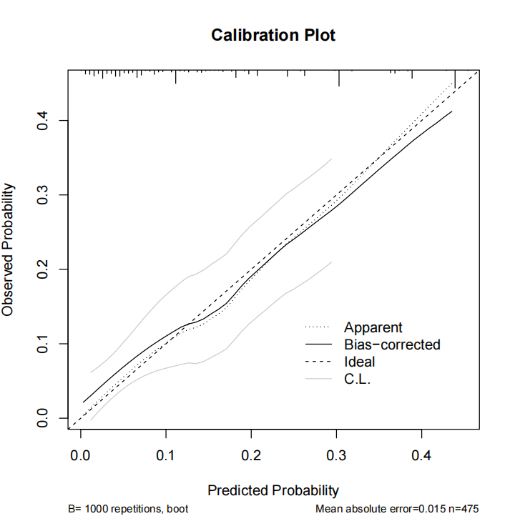
Supplementary Figure S1. Calibration plot of the multivariable logistic regression model
Note: The plot shows the agreement between predicted probabilities and observed outcomes. The dashed diagonal line represents perfect calibration. The apparent curve (dashed line) and bias-corrected curve (solid line) were estimated using 1000 bootstrap resamples. The mean absolute error was 0.015, indicating good calibration.

Supplementary File 1 Structured questionnaire for the assessment of socio-demographic and clinical characteristics

Part One: Socio-demographic characteristics
1. Age: ______ years
2. Sex:
□ Male □ Female
3. Marital status:
□ Married □ Unmarried / Divorced / Widowed
4. Educational level:
□ Primary school or below □ Middle school □ High school or above
5. Monthly per capita household income:
□ ≤3,000 yuan □ >3,000 yuan
6. Living arrangement:
□ Living with others □ Living alone
7. Current smoking (smoking >6 months or ≥1 cigarette per day in the past year):
□ No □ Yes
8. Current alcohol consumption (alcohol consumption >1 time per month in the past year):
□ No □ Yes

Part Two: Clinical characteristics
9. Course of type 2 diabetes mellitus (T2DM): ______ years
10. Course of hypertension: ______ years
11. Family history of T2DM:
□ No □ Yes
12. Family history of hypertension:
□ No □ Yes
13. T2DM-related complications (multiple choices allowed):
□ Diabetic nephropathy
□ Diabetic retinopathy
□ Diabetic foot
□ Diabetic ketosis
□ Diabetic peripheral neuropathy
□ Diabetic peripheral vasculopathy
□ None of the above
14. Other chronic conditions (multiple choices allowed):
□ Stroke
□ Hyperlipidemia
□ Coronary heart disease
□ Chronic kidney disease
□ Fatty liver
□ Carotid atherosclerosis
□ Carotid plaque formation
□ None of the above

Part Three: Katz Activities of Daily Living (ADL) Scale
Instructions: Please select the option that best describes your actual situation for each of the following activities.
1. Bathing (sponge, shower, or tub bath)
□ No difficulty at all
□ Need help
□ Unable to perform at all
2. Dressing (getting clothes from closets and drawers, putting on clothes, managing fasteners)
□ No difficulty at all
□ Need help
□ Unable to perform at all
3. Toileting (going to the toilet, managing clothes, cleaning self after elimination)
□ No difficulty at all
□ Need help
□ Unable to perform at all
4. Transferring (moving in and out of bed, moving in and out of a chair)
□ No difficulty at all
□ Need help
□ Unable to perform at all
5. Continence (urination and defecation control)
□ No difficulty at all
□ Need help
□ Unable to perform at all
6. Feeding (getting food from plate into mouth)
□ No difficulty at all
□ Need help
□ Unable to perform at all

