Supplementary Figure S1. Multimodal Model Architecture

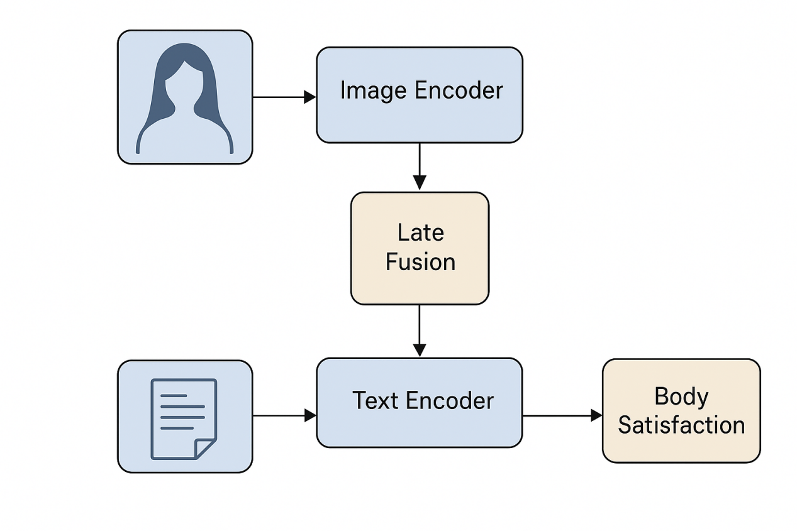

Supplementary Figure S1 illustrates the overall architecture of the proposed multimodal prediction framework. The model consists of two parallel encoding streams for visual and textual data, followed by a late fusion module and a prediction head.

The image encoder is implemented using convolutional neural networks (ResNet-50 and EfficientNet-B0 pretrained on ImageNet), which extract high-level visual representations capturing facial expressions, body posture, and image composition features. Input images are resized to 224 × 224 pixels and normalized prior to feature extraction.

The text encoder employs multilingual BERT to generate contextualized embeddings from captions, posts, and open-ended self-descriptions. Text inputs are tokenized and truncated to a maximum length of 128 tokens to ensure consistency across samples.

In the late fusion stage, visual and textual embeddings are concatenated into a joint multimodal representation. This fused feature vector is then passed to a fully connected prediction head, which outputs either continuous body satisfaction scores (regression) or discrete satisfaction categories (classification), depending on the task setting.

This architecture enables the model to integrate complementary information from visual and linguistic self-presentation while preserving modality-specific representations, facilitating both predictive performance and interpretability.

Supplementary Analysis 1. Robustness Checks
To assess the robustness of the multimodal prediction framework, we conducted additional analyses using alternative data partitioning strategies. Specifically, models were retrained and evaluated using a 60/20/20 train–validation–test split, while preserving stratification by cultural group and gender.

Across all evaluated metrics, the multimodal model consistently outperformed single-modality baselines (CNN-only and BERT-only models) under the alternative split configuration. Regression performance, measured by Root Mean Square Error (RMSE), showed minimal variation compared to the primary 70/15/15 split, with differences remaining within ±0.03 RMSE units. Classification performance metrics (accuracy and F1-score) similarly exhibited stable results across splits.

Importantly, cross-cultural performance patterns remained consistent under the alternative partitioning strategy. Visual features continued to contribute more strongly to predictions among Western participants, whereas linguistic and contextual features retained greater relative importance among East Asian participants. These findings indicate that observed cultural differences in feature importance were not driven by sampling variability or a specific train–test configuration.

Together, these robustness checks provide additional support for the stability and generalizability of the multimodal modeling results reported in the main text.

