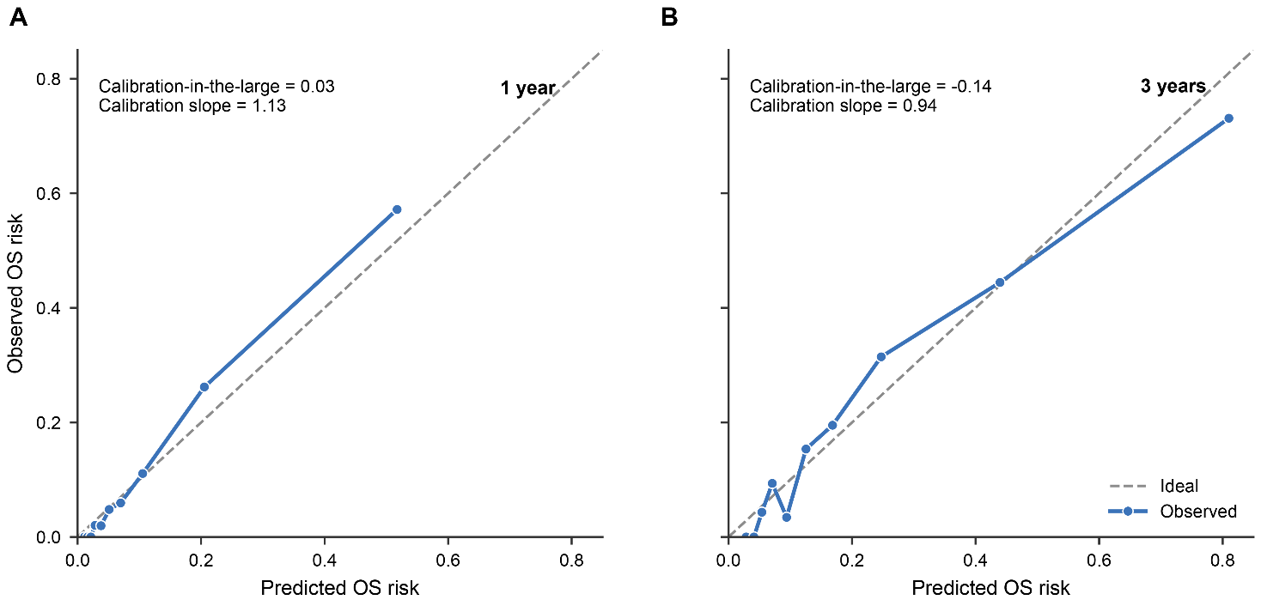
Supplementary Figure S1. Time-specific calibration of the locked postdiagnostic pretreatment OS model in the 2016–2021 temporal validation cohort. Calibration is shown at (A) 1 year and (B) 3 years after diagnosis. The diagonal line represents perfect calibration. Calibration-in-the-large and the time-specific calibration slope are reported within each panel. Because the proportional-hazards assumption for the Cox calibration layer was not supported, absolute-risk calibration was interpreted at the prespecified 1- and 3-year horizons.
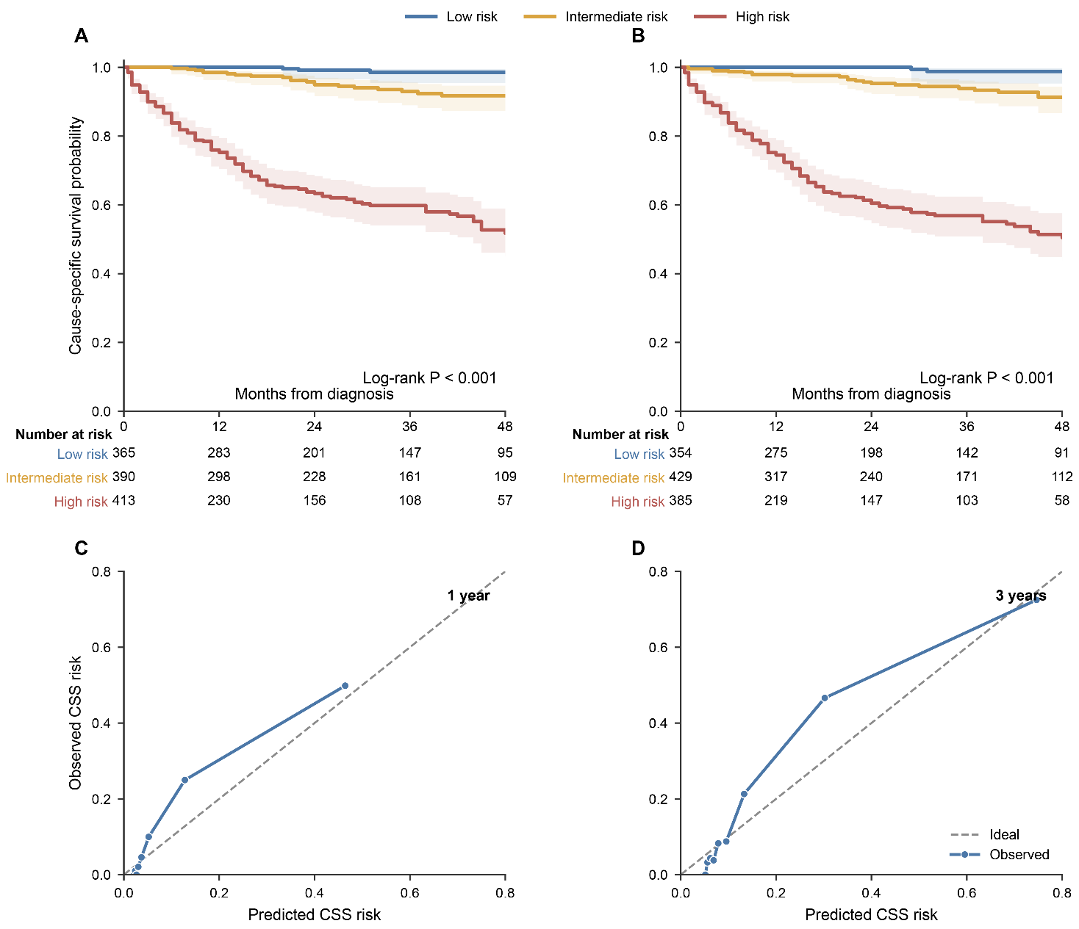
Supplementary Figure S2. Supporting cause-specific chondrosarcoma survival analyses. (A) Cause-specific chondrosarcoma survival within the OS-model-derived low-, intermediate-, and high-risk groups. (B) Cause-specific chondrosarcoma survival according to risk groups derived from the separately fitted CSS-specific model. In panels A and B, deaths from causes other than chondrosarcoma were treated as censored observations; shaded bands indicate 95% confidence intervals. Panels C and D show calibration of the CSS-specific model at 1 and 3 years, respectively. The diagonal line represents perfect calibration.
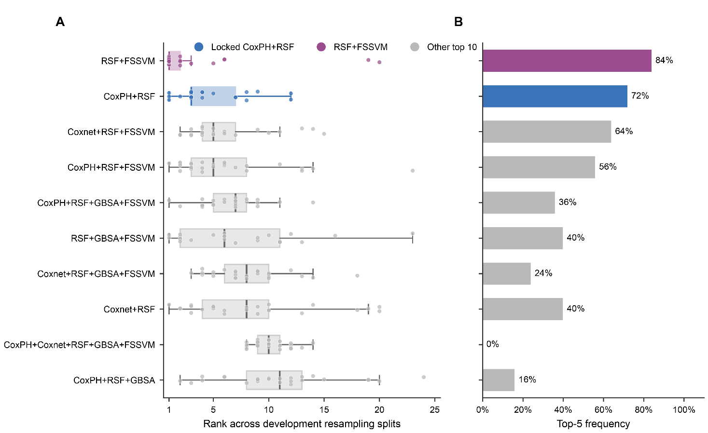
Supplementary Figure S3. Development-only repeated cross-validation assessment of postdiagnostic pretreatment model-configuration stability. Thirty-one postdiagnostic pretreatment configurations were evaluated using fivefold cross-validation repeated five times, yielding 25 development-only resampling splits. (A) Distribution of model ranks across the 25 resampling splits for the ten configurations with the highest mean cross-validated C-index, displayed in order of mean rank. Each point represents the rank observed in one split, and boxplots summarize the median and interquartile range; lower ranks indicate better performance. (B) Percentage of resampling splits in which each configuration ranked among the five highest-performing models. The independent 2016–2021 temporal validation cohort was not used for model reselection.
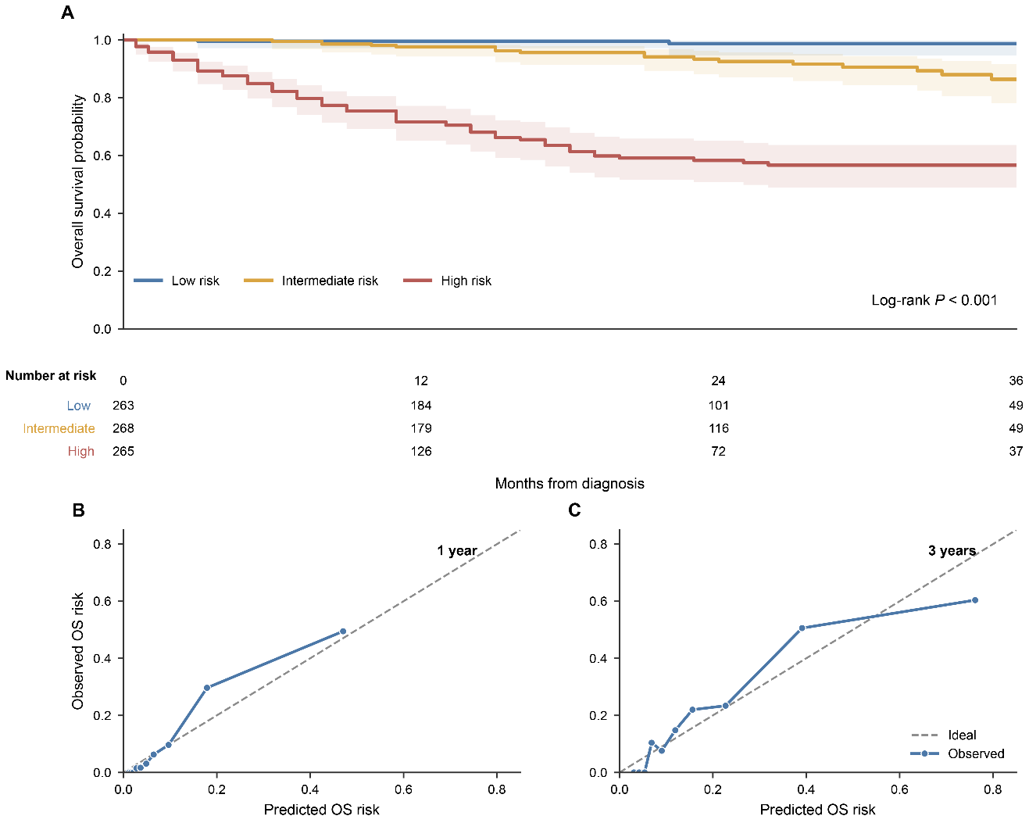
Supplementary Figure S4. Recent-period temporal-split sensitivity analysis using patients diagnosed during 2018–2021 as the validation cohort. (A) Kaplan–Meier estimates of overall survival according to the model-derived low-, intermediate-, and high-risk groups through 36 months after diagnosis; shaded bands indicate 95% confidence intervals. Panels B and C show calibration at 1 and 3 years, respectively. The 36-month display was chosen because no patients remained at risk at 48 months in this recent-period validation subset.

