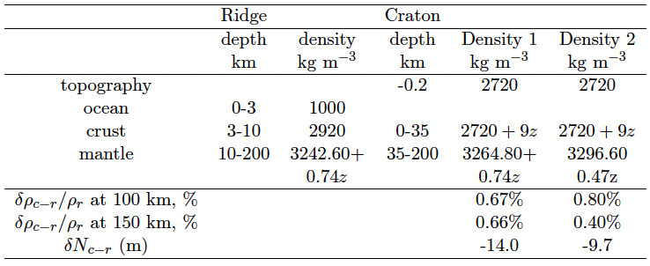
Table S1: Typical density profiles under a ridge or a 200 km thick craton. These profiles are in exact isostatic equilibrium. The excess density of the craton lithosphere is either uniform to a depth of 200 km depth (Density 1), or decreases linearly with depth (Density 2). At a depth of 118 km the density of the craton is 0.66% denser than the adiabat for the two models, at 200 km depth the density of the last model (Density 2) becomes adiabatic. Only the profile of Density 2 is consistent with gravity considerations.

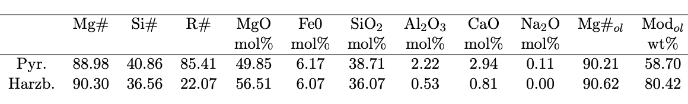
Table S2: The Mg#, Si# and R# of pyrolite and harzburgite and their molar composition⁵¹. The last two columns show Mg#_{ol} in the olivine component and the modal proportion of olivine, Mod_{ol} , in wt% computed at 125 km depth, along the geotherm of a craton. Because the low partitioning of Fe between olivine and pyroxene, Mg# and Mg#_{ol} are to first order similar.

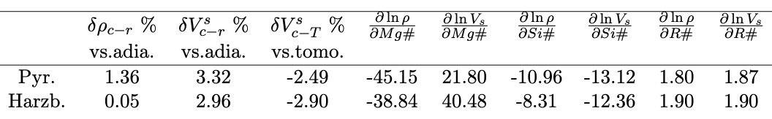
Table S3: Excess density and excess S-wave velocity at 125 km depth compared to the adiabat (columns 1 and 2). Along its cold geotherm, a pyrolitic craton is 1.36% denser than along an adiabat, and 3.32% faster (${δρ}_{c-r}$ and $δV_{c-r}^{s}$). This fast S-velocity is still 2.49 slower than typical tomographic observations ($δV_{c-T}^{s}$, third column). Although harzburgite is less dense it is even slower than pyrolite. The other columns express the change in density and velocity (in %) when the three mineralogical parameters are varied).

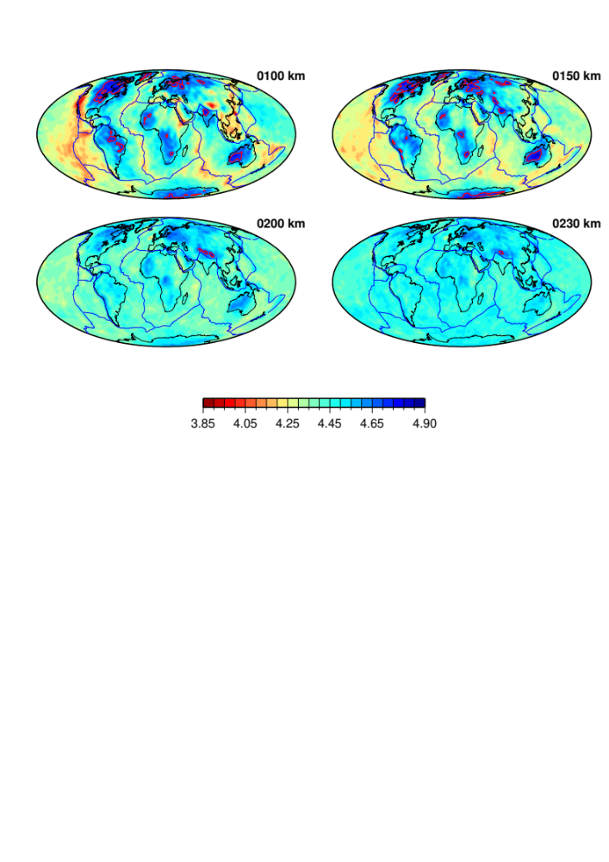

Fig. S1: 3DLGL-TPESvoigt Vs tomographic model¹ version 2022-11 at different depths in the upper mantle. Absolute velocities are shown in km s⁻¹. The red contour lines underline regions where velocities are higher than 4.7 km s⁻¹.

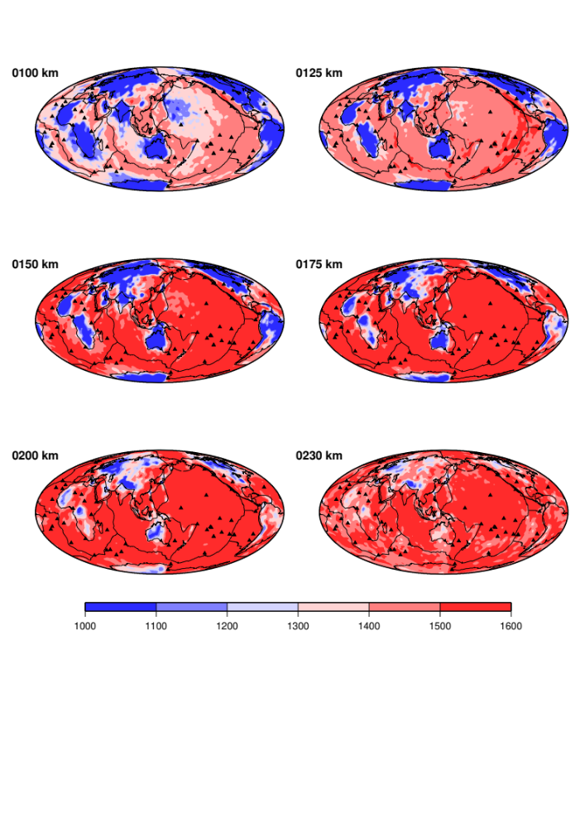
Fig. S2: Temperature predicted by our seismic model, assuming a pyrolitic composition⁵¹. Temperatures are in °C. These predictions are used to define the LAB at each geographical point (see Fig. S3).

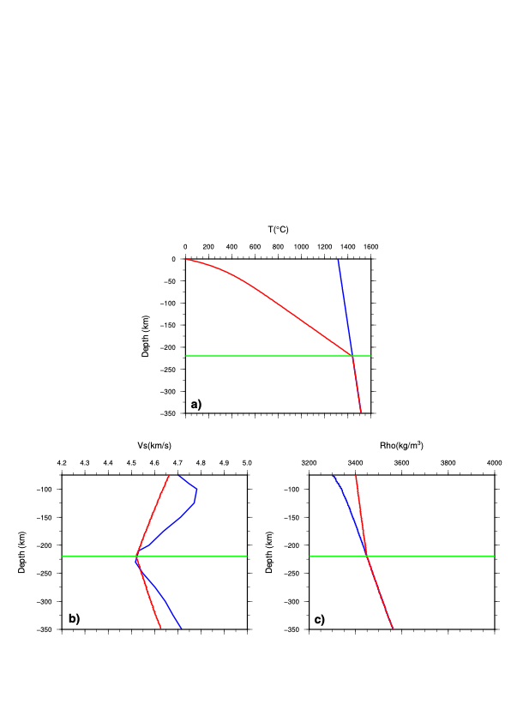

Fig. S3: Examples of typical geotherms under cratons and ridges, 1D Vs and density vertical profiles.
We selected a location beneath the North America craton, where the thickness of the craton is 220 km, equal to the global average thickness of Precambrian regions in our model. The LAB thickness (green line) is estimated as the depth at which the temperature derived from tomography (Fig. S2) is closest to the adiabat. In the craton lithosphere, we estimate the geotherm by solving the time-dependent diffusive heat equation with radiogenic sources¹¹. The cratonic geotherm at this location is shown in panel (a) (red line) alongside the adiabatic geotherm (blue line). Below the LAB, the temperature is adiabatic. Using Perple X, we compute the mineralogical velocity along the cratonic geotherm, assuming a pyrolitic composition (red line in panel (b)). The velocity of the tomographic model (blue line in panel (b)) is closest from the red line at the LAB depth. We also compute the density in the cold lithospheric craton (red line in panel (c)) which we compare to that along the adiabat (blue line in panel (c)). The pyrolitic density at this location (red line in panel (c)) is too high while the Vs velocity (red line panel (b)) is significantly slower than that indicated by seismology (blue lines in panels (c) and (b)).

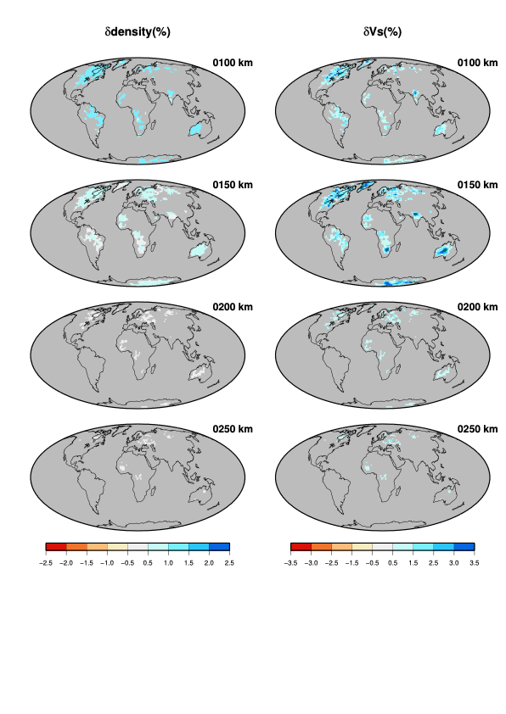

Fig. S4: Density and velocity differences in cratonic lithospheric roots, for a pyrolitic composition. Density anomalies (left column) are differences between predictions along the cratonic geotherm at each geographical point and the density required to explain the geoid and achieve isostatic equilibrium with a ridge. Shear velocity anomalies (right column) are differences between tomographic and predicted velocities around a cratonic geotherm. Average difference in % for densities and velocities are respectively: 1.1 and 1.4 at 100 km, 0.4 and 2.3 at 150 km, 0.1 and 1.2 at 200 km and 0.1 and 0.9 at 250 km.

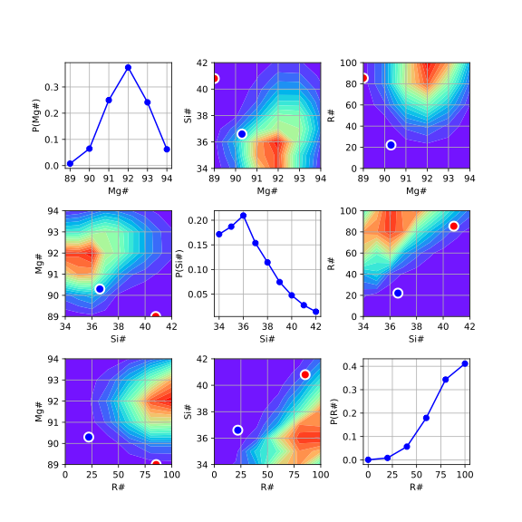
Fig. S5: Probability density function of the parameters Mg#, Si# and R# calculated at a depth of 125 km in a 220 km thick cratonic lithosphere, leading to an appropriate density and observed seismic S wave velocity. Neither the pyrolite (red dot), nor the harzburgite (blue dot) can explain the data. Compositions with Mg#≈92, Si#<37 and R#>75 are suggested.

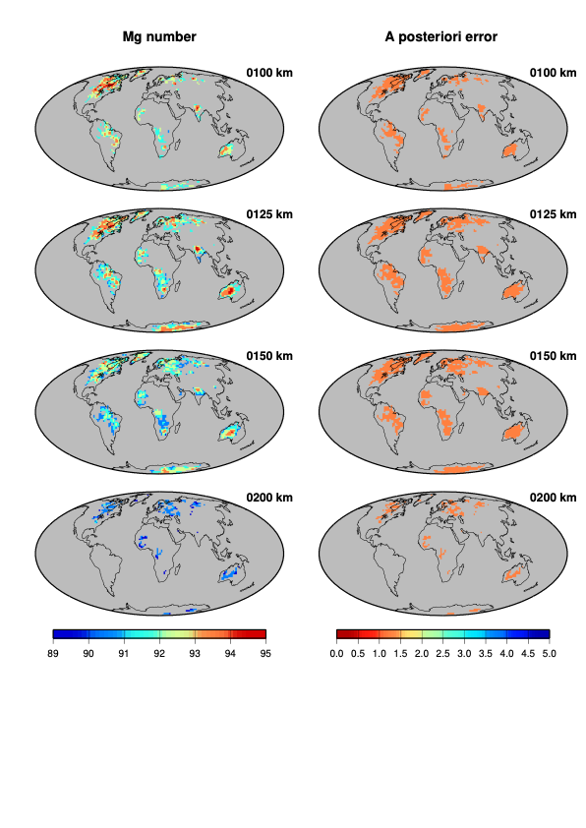

Fig. S6: Maps of Mg# number (left column, same as Fig. 2) and their a posteriori error (right column) inferred from the least square inversion. The a posteriori error is small and close to 1 everywhere, indicating that Mg# is well resolved (the a posteriori error would be close to 5, the value of the a priori error, if there was no resolution).

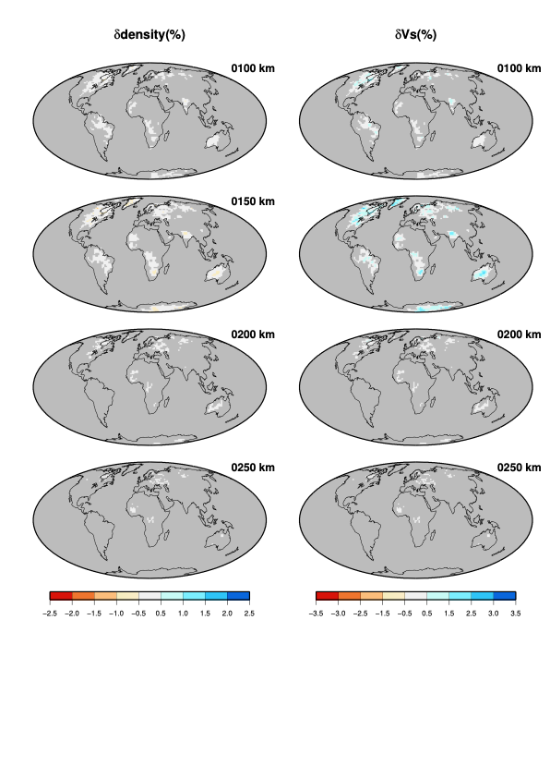

Fig. S7: Difference in % at different depths in cratonic lithospheric roots, between observed and predicted densities (left) and velocities (right) after inversion. The starting model is a pyrolitic composition. Density anomalies (left column) are differences between predictions after inversion and the density required to explain the geoid and achieve isostatic equilibrium with a ridge. Predicted densities are within 0.5% of that required by isostasy and gravity. Shear velocity anomalies (right column) are differences between observed and predicted velocities after inversion. Predicted velocities are too slow by up to 3.5% at 150 km depth.

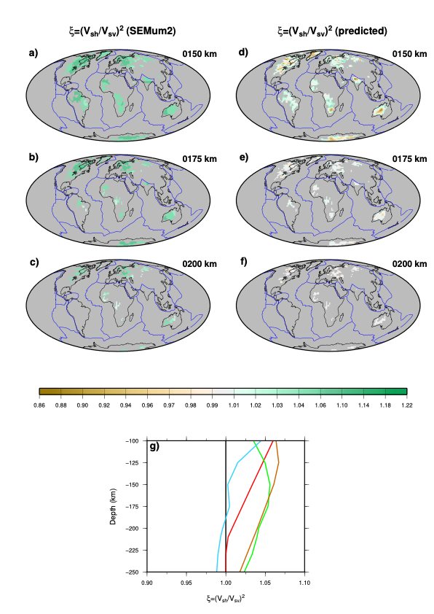
Fig. S8: Radial anisotropy (displayed with parameter ξ=(Vsh/Vsv)²) required to explain the misfit in Fig. 4. Panels a-c (left): Radial anisotropy maps at different depths in the upper mantle according to the SEMUM2²¹ model. Panels d-f (right): ξ maps obtained by attributing the misfit in Figure S4 to radial anisotropy. The obtained ξ values are smaller than 1 (Vsh<Vsv) under most cratons, in contradiction with SEMUM2 and most recent ξ models²⁴. Panel g : mean values over cratonic regions of the required ξ (light blue curve) compared with the ξ of PREM (red curve), SEMUM2 (green curve) and S362ANI²³ (brown curve).

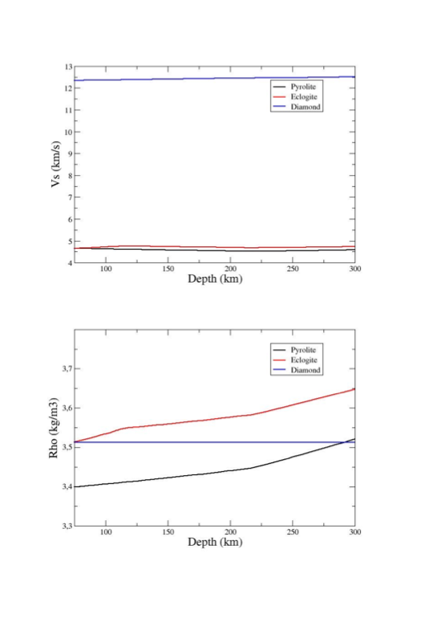

Fig. S9: Velocity (top) and density (bottom) profiles for pyrolite, eclogite and diamond along the craton geotherm of Fig. S3a.

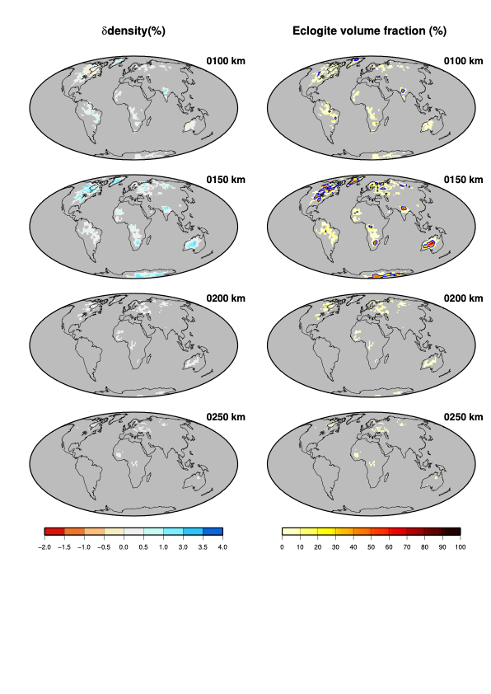

Fig. S10: Density anomalies and eclogite volume fraction required to explain observed seismic velocities at different depths in cratonic lithospheric roots. Volume fraction of eclogite in percent is indicated with warm colour from ivory (0%) to brown (100%). Density differences are in % between predictions and the density profile required to explain the geoid and achieve isostatic equilibrium with a ridge. The blue contour line highlights regions where eclogite volume fractions exceed 20%). The corresponding maximum increases in density reach 4.7% at 150 km and 1.0% at 200 km depth.

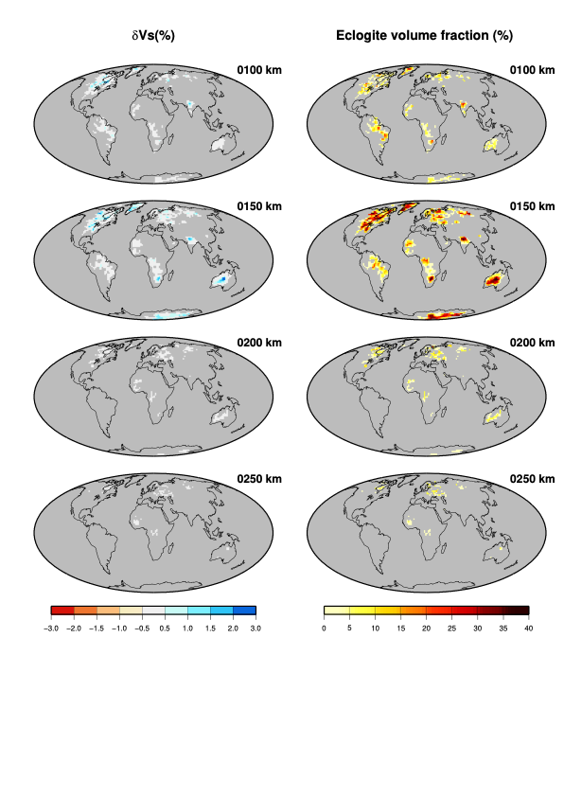

Fig. S11: Vs misfit and maximum eclogite volume fraction allowed for increasing density by no more 1% relative to a density profile in isostatic equilibrium with that under a ridge. Shear velocity anomalies (left column) are differences between observed and predicted velocities after adding eclogite. Predicted velocities are too slow by up to 3% at 150 km depth. Volume fraction of eclogite (right column) in percent is indicated with warm colour from ivory (0%) to brown (40%). The maxima of 40% is reached at 150 km depth.

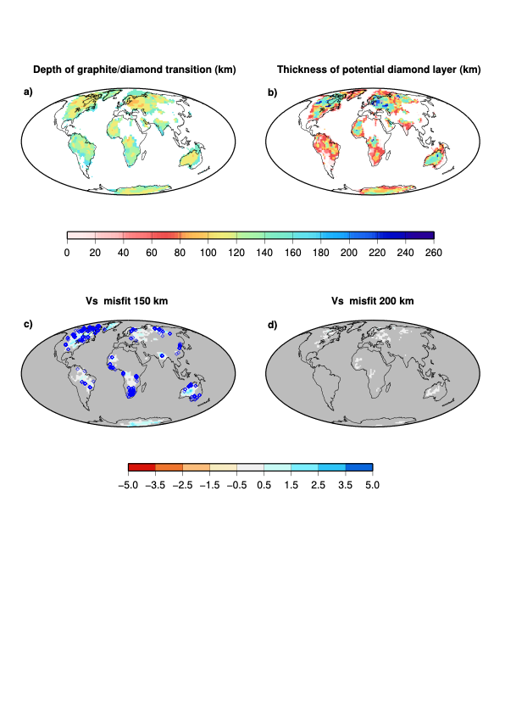

Fig. S12: Depth of the graphite diamond transition, thickness of the potential diamond layer and misfit maps at 150 and 200 km. Panel a): depth of the graphite-diamond transition³⁵. Panel b): Thickness of the potential diamond layer (difference between the depth of the LAB and that of the graphite-diamond transition). Panels c) and d): difference in % between observed and predicted velocities after inversion at 150 and 200 km. Blue diamonds on the map at 150 km indicate where diamonds have been found at the surface⁵⁸.

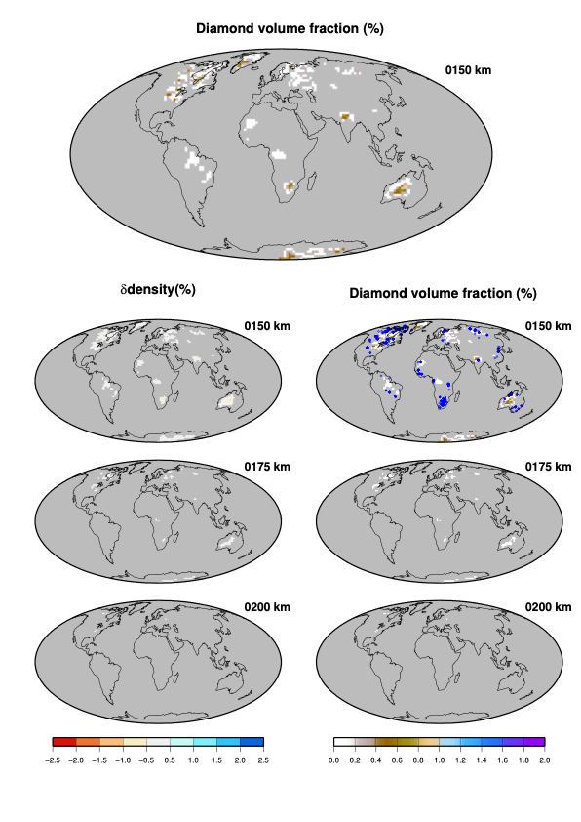

Fig. S13: Same as Fig. 5, but the density anomalies and diamond volume fraction are computed after increasing the lithosphere thickness by 50 km beneath cratons. The maximum amount of diamond reaches 1.4% at 150 km depth, 0.2% at 175 km depth and 0.1% at 200 km depth.

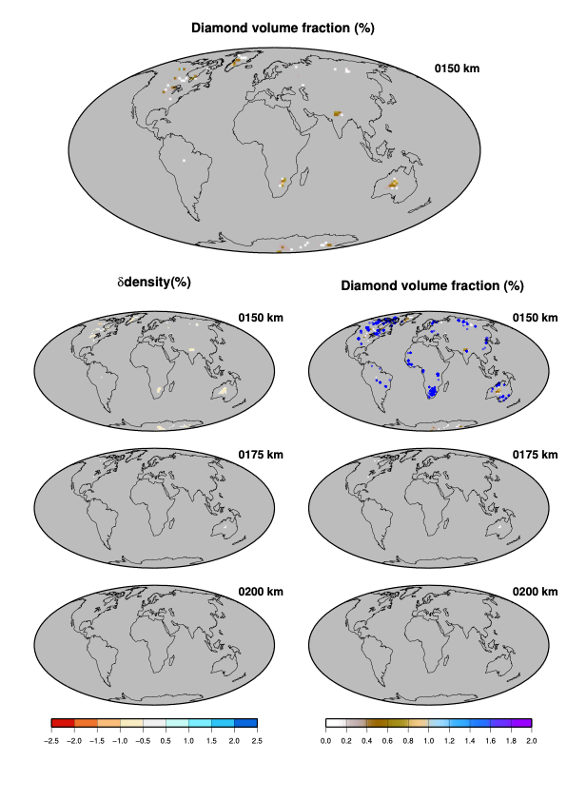

Fig. S14: Same as Fig. 5, but the density anomalies and diamond volume fraction are computed assuming that Vs observations are reduced by 1%. The probability that it happens is around 0.15. The maximum amount of diamond reaches 1.3% at 150 km depth, and 0.11% at 175 km depth while diamond is not required at 200 km depth.

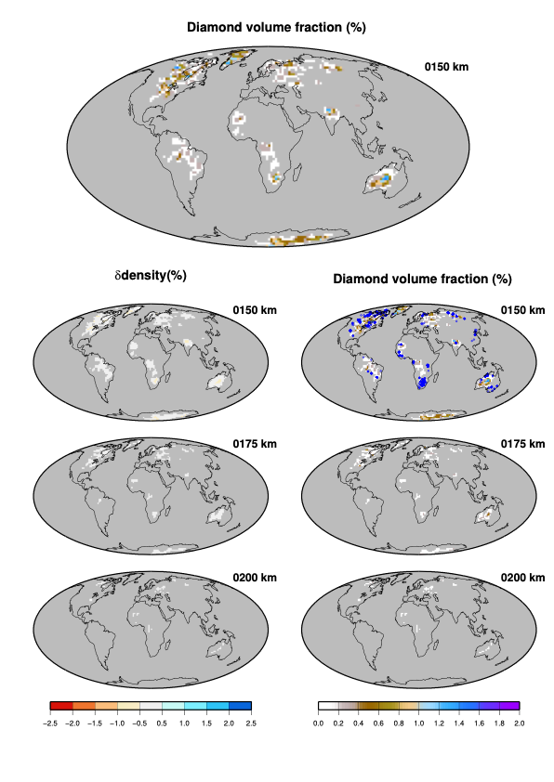

Fig. S15: Same as Fig. 5, but the density anomalies and diamond volume fraction are computed using the thermodynamic database of Holland and Powell. The maximum amount of diamond reaches 1.9% at 150 km depth, 0.6% at 175 km depth and 0.3% at 200 km depth.

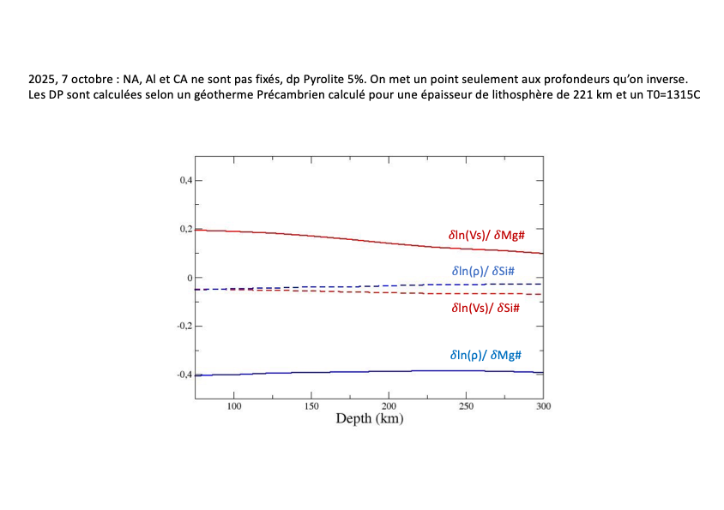

Fig. S16: Partial derivatives of the velocity and density with respect to the inverted parameters, Mg#, and Si#. Relative partial derivatives are shown as a function of depth. We invert for Mg#= Mg/(Mg+Fe) and Si#= Si/(Si+Mg+Fe) and then derive the modal olivine content from a simple relationship (see Methods).

