Recovery of genomic and transcriptomic profiles from decades-old FFPE brain tissues

Caroline Robinson Christiansen^{1,2,3*}, Emily Hansen Firoozfard^{1,2*}, Nikolay Oskolkov⁴, M. Thomas P. Gilbert^{2,5}, Sarah S. T. Mak², Martin Wirenfeldt^{6,7,8}, Christina Kjær^{1†}, Emilio Mármol-Sánchez^{2†}
¹Department of Technology, Faculty of Health and Technology, University College Copenhagen, Copenhagen, Denmark. ²Center for Evolutionary Hologenomics, GLOBE Institute, University of Copenhagen. ³Department of Pathology, Rigshospitalet, The Capital Region of Denmark, Copenhagen, Denmark. ⁴Metabolic Research Group, Latvian Institute of Organic Synthesis, Riga, Latvia. ⁵University Museum, NTNU, Trondheim, Norway. ⁶Department of Pathology, Esbjerg Hospital, University Hospital of Southern Denmark, Esbjerg, Denmark. ⁷Department of Regional Health Research, University of Southern Denmark, Odense, Denmark. ⁸BRIDGE (Brain Research - Inter Disciplinary Guided Excellence), Department of Clinical Research, University of Southern Denmark, Odense, Denmark.

*Shared first authorship
†These authors contributed equally

*Corresponding authors:
Emilio Mármol-Sánchez (emilio.marmol.sanchez@gmail.com)
Christina Kjær (chkj@kp.dk)

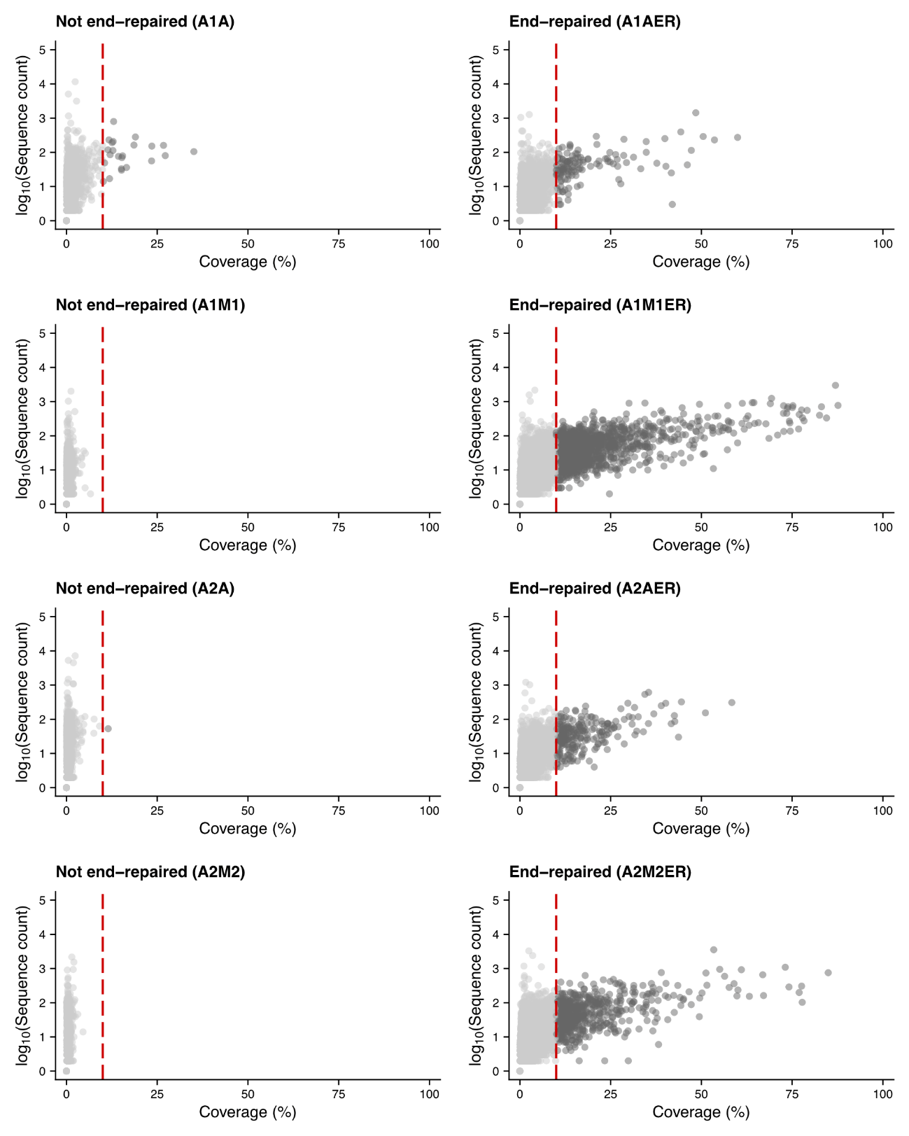

Supplementary Figure 1: Per-sample sequence count vs. transcript coverage for protein-coding mRNA loci. Comparison between libraries prepared from FFPE tissues with and without end-repair treatment in patient A. Each dot represents a protein-coding mRNA gene. The x-axis shows the percentage of the transcript length covered by mapped RNA fragments, while the y-axis shows the log₁₀-transformed sequence count. The red dashed line marks a 10% coverage threshold, defined as the lower limit to consider any given protein-coding mRNA gene as successfully profiled.

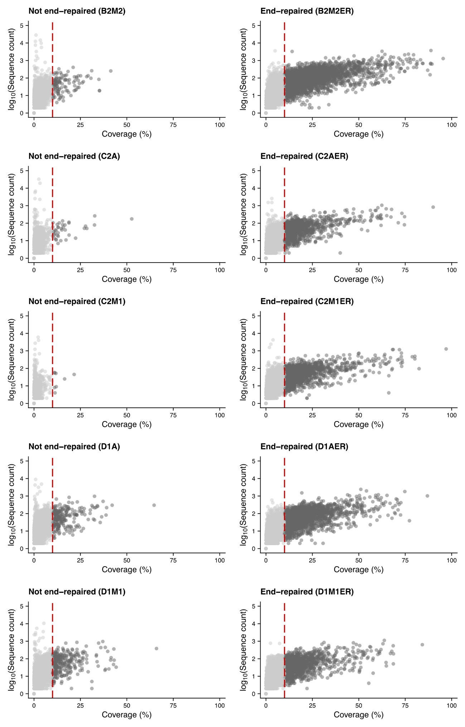

Supplementary Figure 2: Per-sample sequence count vs. transcript coverage for protein-coding mRNA loci. Comparison between libraries prepared from FFPE tissues with and without end-repair treatment in patients B, C & D. Each dot represents a protein-coding mRNA gene. The x-axis shows the percentage of the transcript length covered by mapped RNA fragments, while the y-axis shows the log₁₀-transformed sequence count. The red dashed line marks a 10% coverage threshold, defined as the lower limit to consider any given protein-coding mRNA gene as successfully profiled.

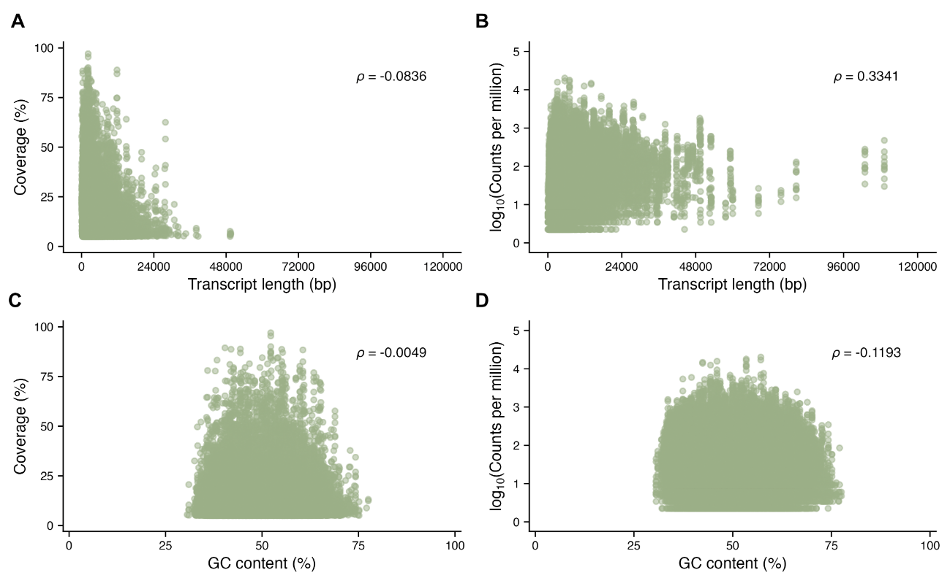
Supplementary Figure 3: Association between gene features and FFPE mRNA recovery. Per-gene transcript coverage (%) and abundance expresed in counts per million and log₁₀-transformed plotted against transcript length (A, B) and transcript GC content (C, D), pooled across the ten end-repaired FFPE libraries. Only genes with transcript-wide coverage >10% and at least one log₁₀ count per million are considered. Spearman’s rank correlation coefficient (ρ) between the two plotted variables is shown in each panel.

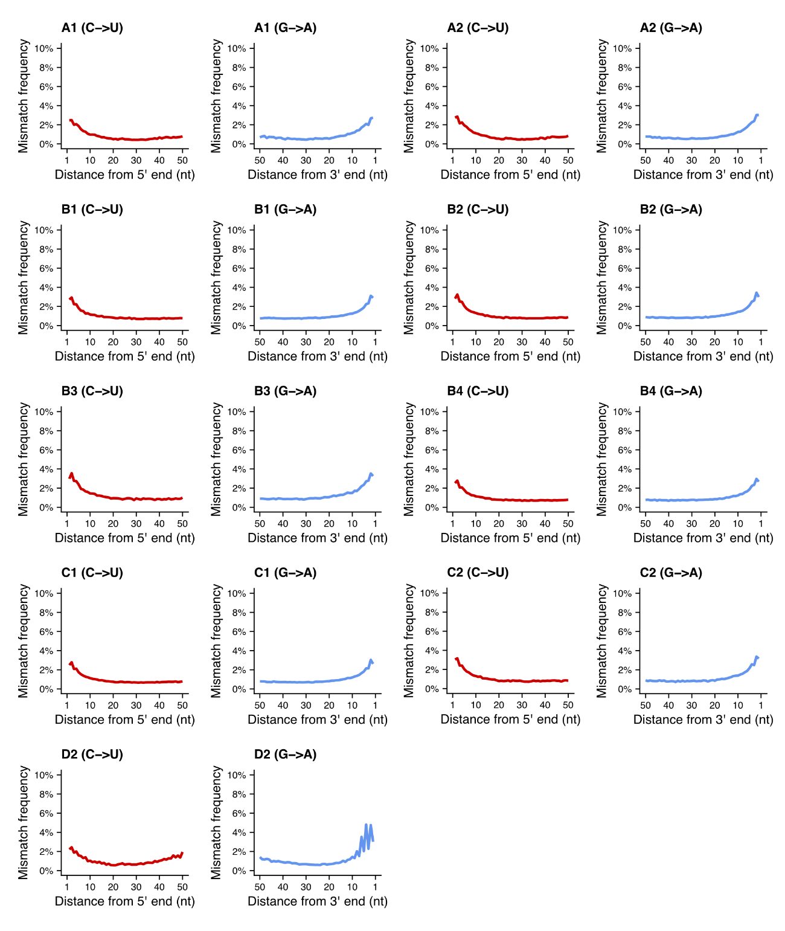

Supplementary Figure 4: Cytosine deamination damage profiling of DNA sequencing data from FFPE brain samples. G>A mismatches are considered as C>U deamination events for DNA sequences mapped to the negative strand. All 33 samples are included and damage profiles averaged according to individual and brain tissue (see Table 1).

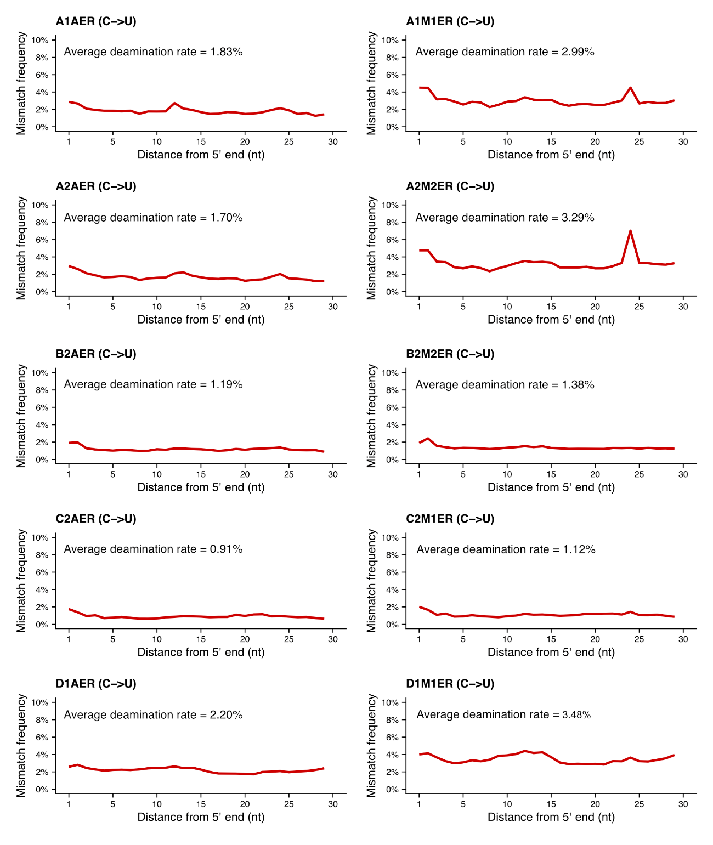

Supplementary Figure 5: Cytosine deamination damage profiling of RNA sequencing data from FFPE brain samples after end-repair treatment. The average C>U deamination rate is reported for each sample (n = 10).

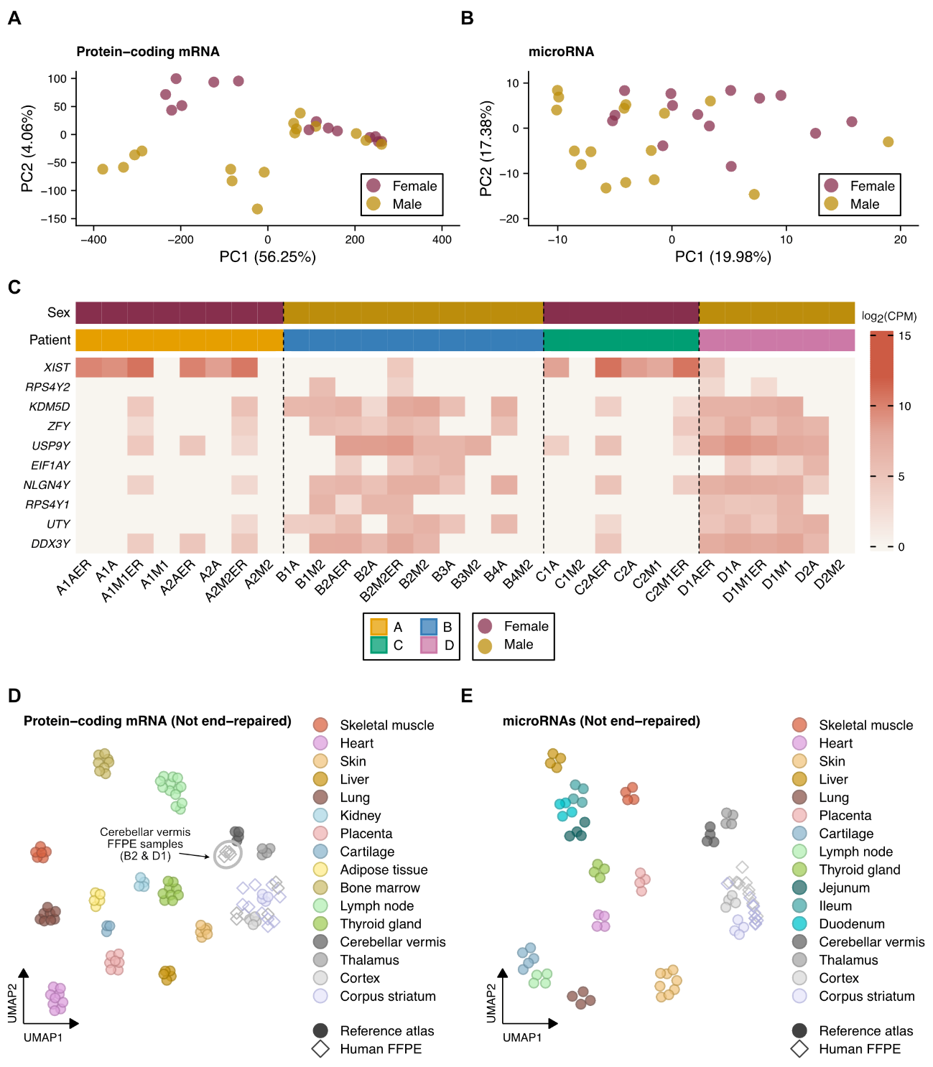

Supplementary Figure 6: Sex-based PCA and heatmap, and multi-tissue UMAP projections for FFPE samples prepared without end-repair treatment. (A) PCA of protein-coding mRNA expression across all 30 FFPE brain samples colored by sex. (B) PCA of microRNA expression across all 30 FFPE brain samples colored by sex. (C) Heatmap depicting sex-specific expression patterns of nine chromosome Y-linked marker genes and the lncRNA XIST across all RNA libraries from the four patients considered in this study. Intensity values for each gene are represented in log₂-scaled counts per million (CPM) from normalized expression values using the trimmed mean of M-values (TMM) method. Each cell represents one individual RNA library. Dashed lines separate each of the four individual patients used in this pilot study. (D) UMAP embedding of protein-coding mRNA expression from FFPE brain samples without end-repair treatment projected onto a human multi-tissue RNA-seq reference atlas. (E) UMAP embedding of microRNA expression from FFPE brain samples without end-repair treatment projected onto a human multi-tissue small RNA-seq reference atlas.

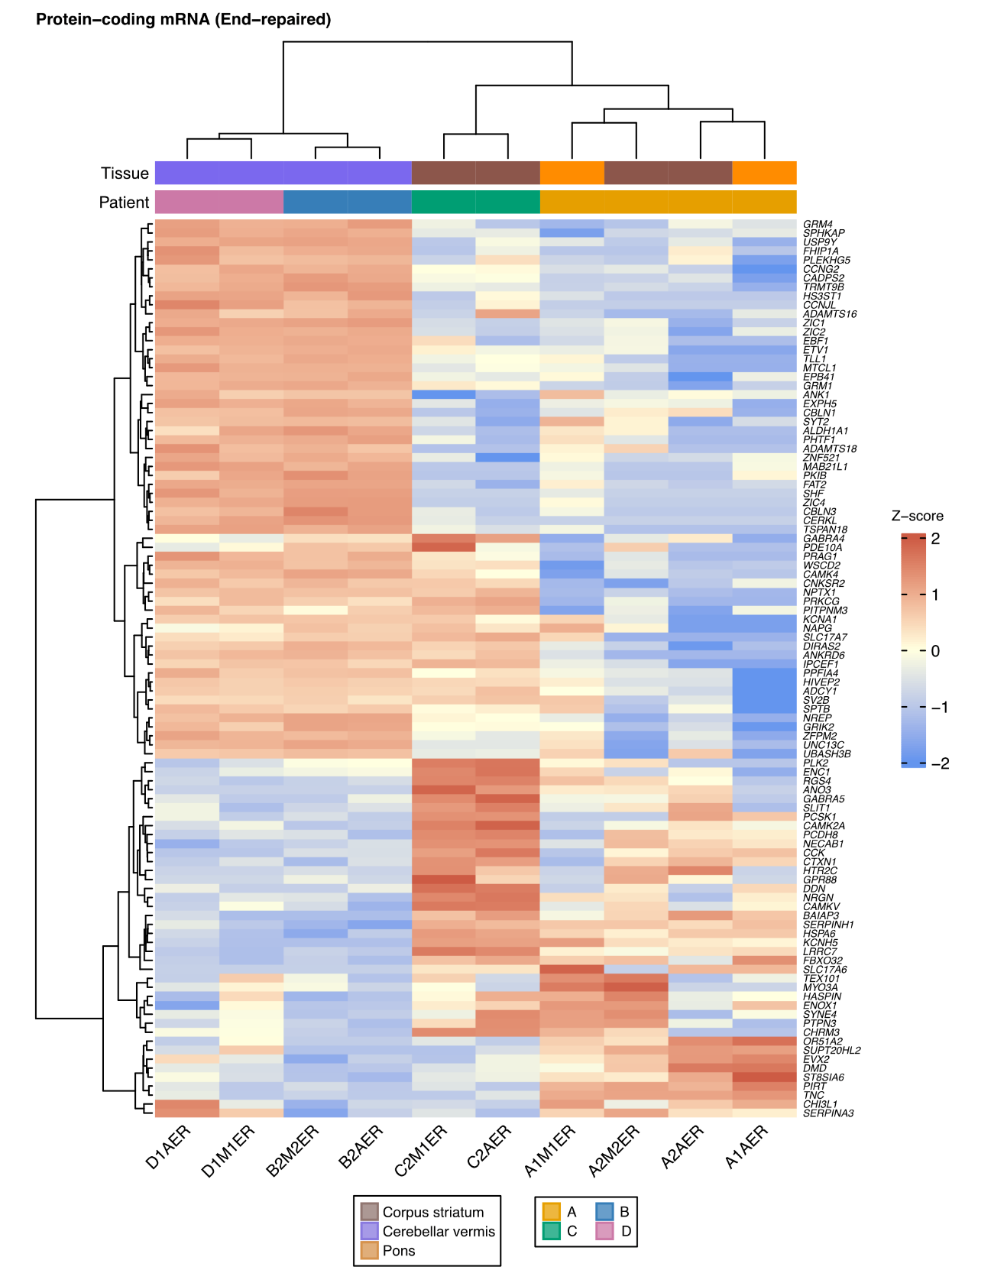

Supplementary Figure 7: Hierarchical clustering of the top 100 most variable protein-coding mRNAs across end-repaired FFPE brain samples. Expression values across samples (n = 10) are shown as row-wise z-scores computed on TMM-normalized log₂ counts per million. Rows (genes) and columns (samples) are clustered using Ward's method with Euclidean distance.

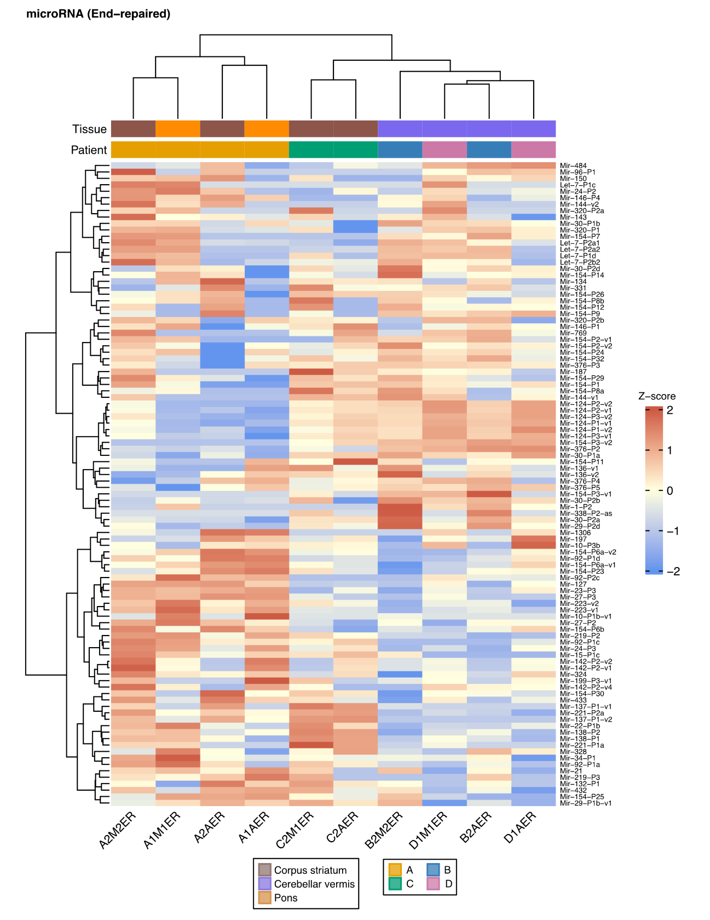

Supplementary Figure 8: Hierarchical clustering of the top 100 most variable microRNAs across end-repaired FFPE samples. Expression values across samples (n = 10) are shown as row-wise z-scores computed on TMM-normalized log₂ counts per million. Rows (genes) and columns (samples) are clustered using Ward's method with Euclidean distance.

