Supplementary Material
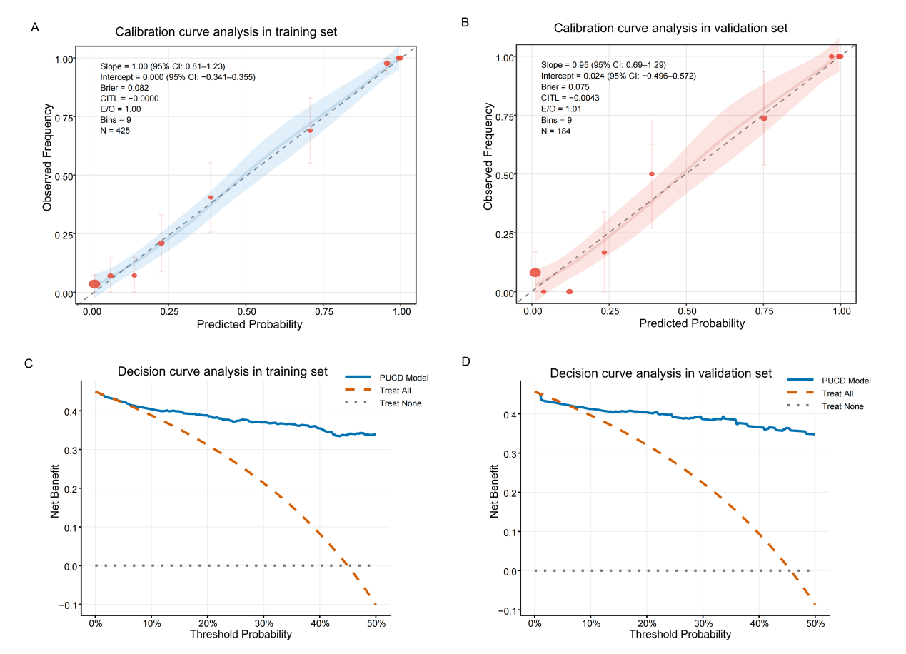
Fig. S1 The calibration and decision curve analysis for pan-urinary cancer detection (PUCD) model. (A) The calibration curve analysis for PUCD model in training set. (B) The calibration curve analysis for PUCD model in validation set. (C) The decision curve analysis for PUCD model in training set. (D) The decision curve analysis for PUCD model in validation set.
Fig. S2 Performance of pan-urinary cancer detection (PUCD) model across different cancer types and stages. (A) The sensitivity of the panel for all cancers in the training (blue) and validation (yellow) sets. (B) The sensitivity of the panel for bladder cancer. (C) The sensitivity of the panel for ureteral cancer. (D) The sensitivity of the panel for renal pelvis cancer. (E) The sensitivity of the panel for kidney cancer. (F) The sensitivity of the panel for prostate cancer. Within each cancer type, sensitivity is further broken down by pathological stage (I, II, III, IV). The number of patients in each subgroup is indicated at the base of the corresponding bar. Error bars represent 95% confidence intervals.

Fig. S3 Diagnostic performance for urothelial carcinoma of the methylation panel. (A) Receiver operating characteristic (ROC) curves for pan-urinary cancer detection (PUCD) model and four genes in the training set. (B) ROC curves for PUCD model and four genes in validation set. (C) The distribution of the PUCD score for cancer stages in the training set. (D) The distribution of the PUCD score for cancer stages in validation set. (E) Sensitivity and specificity of PUCD model for urothelial carcinoma in the training and validation sets. (F) Sensitivity of PUCD model in urothelial carcinoma patients with different tumor stage. Error bars represent 95% confidence intervals. Statistical significance versus the non-cancer group was determined by Wilcoxon Test (*p < 0.05, **p < 0.01, ***p < 0.001, ****p < 0.0001).

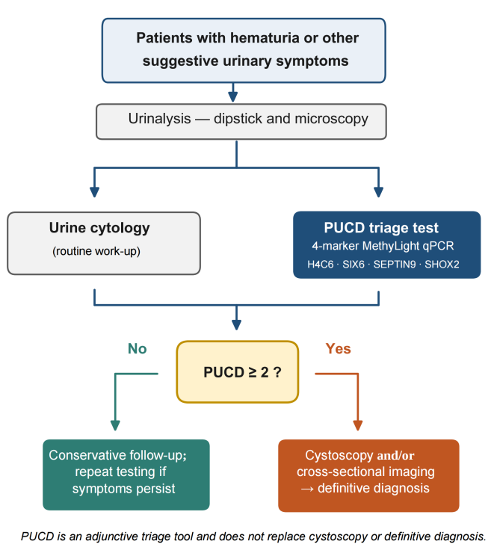
Fig. S4 Proposed diagnostic pathway incorporating the pan-urinary cancer detection (PUCD) assay. In patients presenting with hematuria or other suggestive urinary symptoms, urinalysis/cytology and the PUCD triage test are performed. A positive PUCD result (PUCD ≥ 2) prompts cystoscopy and/or cross-sectional imaging; a negative result supports conservative follow-up with repeat testing if symptoms persist. The assay is intended as an adjunctive triage tool, not a replacement for definitive diagnosis.

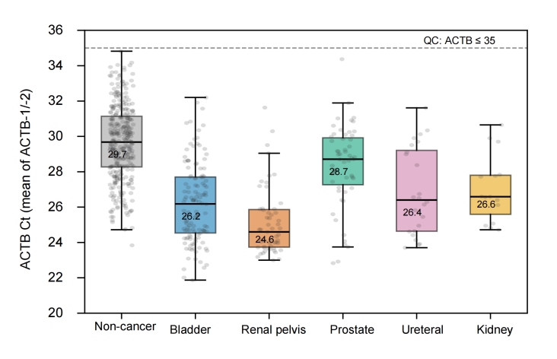
Fig. S5 ACTB internal-control Ct (mean of ACTB-1/-2) by diagnostic group. dashed line = prespecified QC threshold (ACTB ≤ 35).

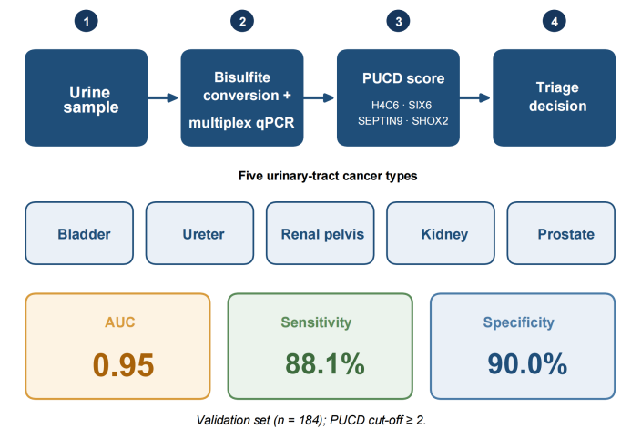
Fig. S6 Graphical abstract. Summary of the four-step workflow (urine sample → bisulfite conversion and multiplex qPCR → pan-urinary cancer detection (PUCD) score from four methylation markers → triage decision), the five covered cancer types, and the headline validation performance (AUC 0.95; sensitivity 88.1%; specificity 90.0%). AUC, area under the receiver operating characteristic curve.

Table S1. Pre-analytical stability of urine DNA methylation measurements during room-temperature storage.
Eight urine samples (S1–S6, non-cancer controls; S7–S8, bladder cancer) were each divided into three 10–15 mL parallel aliquots and stored at room temperature for 0, 3, or 7 days before DNA extraction, bisulfite conversion, and qPCR. ACTB served as the internal-reference control (gate: ACTB Ct ≤ 35). The PUCD call was defined as positive when the composite score P ≥ 2 and negative when P < 2.
Sample ID | Clinical group | ACTB Ct CV across 0/3/7 d (%) | PUCD call (Day 0 / 3 / 7) | Call stable?
S1 | Non-cancer | <5 | Negative / Negative / Negative | Yes
S2 | Non-cancer | <5 | Negative / Negative / Negative | Yes
S3 | Non-cancer | <5 | Negative / Negative / Negative | Yes
S4 | Non-cancer | <5 | Negative / Negative / Negative | Yes
S5 | Non-cancer | <5 | Negative / Negative / Negative | Yes
S6 | Non-cancer | <5 | Negative / Negative / Negative | Yes
S7 | Bladder cancer | <5 | Positive / Positive / Positive | Yes
S8 | Bladder cancer | <5 | Positive / Positive / Positive | Yes
Across all eight samples the ACTB internal-control Ct values showed a coefficient of variation below 5% at 0, 3, and 7 days of room-temperature storage, and the PUCD call was identical at the three time points (all six non-cancer samples negative; both bladder-cancer samples positive). This indicates that urine DNA methylation measurements are stable under room-temperature storage for at least 7 days, well beyond the 72-hour processing window used in the present study.

Table S2. Comparison of Methylation Quantification Methods for the Four-Gene Panel
Method | Training AUC  (95% CI) | Validation AUC  (95% CI) | Sensitivity  (95% CI) | Specificity  (95% CI)
Raw delta  (50 - Ct) | 0.949  (0.929-0.970) | 0.950  (0.913-0.987) | 88.1%  (79.5-93.4%) | 90.0%  (82.6-94.5%)
delta Ct  (flipped) | 0.937  (0.913-0.961) | 0.924  (0.880-0.968) | 76.2%  (66.1-84.0%) | 94.0%  (87.5-97.2%)
Two alternative methylation quantification approaches were compared using the same four-gene panel (H4C6, SIX6, SEPTIN9, SHOX2) and logistic regression framework. The raw delta method (50 - Ct) demonstrated the higher AUC and was retained for all analyses. delta Ct (flipped) = target Ct - ACTB Ct. Because input DNA was delivered by fixed volume rather than fixed mass, the reduction in AUC under ACTB normalisation (delta Ct: validation AUC 0.924) relative to the raw delta method (0.950) is consistent with part of the apparent signal reflecting DNA-input differences rather than cancer-specific methylation alone; the ACTB-normalised estimate is therefore presented as a conservative lower bound on performance.

Table S3. ACTB Ct Value Distribution and Quality Control Metrics
ACTB-1 served as the internal reference for H4C6 and SIX6 (Tube 1); ACTB-2 served as the internal reference for SEPTIN9 and SHOX2 (Tube 2). The QC acceptance criterion was ACTB Ct <= 35 for both reference assays.
A. Overall ACTB Ct Distribution
Metric | ACTB-1 (H4C6/SIX6 Ref) | ACTB-2 (SEPTIN9/SHOX2 Ref)
N | 609 | 609
Mean | 28.26 | 28.21
SD | 2.75 | 2.74
Median | 28.48 | 28.51
Q1 | 26.24 | 26.15
Q3 | 30.32 | 30.21
Min | 21.89 | 21.85
Max | 34.89 | 34.75
Samples with Ct <= 35 | 609 (100.0%) | 609 (100.0%)

B. ACTB Ct by Dataset and Cancer Status
Subgroup | N | ACTB-1 Median (IQR) | ACTB-1 Range | ACTB-2 Median (IQR) | ACTB-2 Range
Training Set | 425 | 28.56 (26.40-30.40) | 21.89-34.70 | 28.58 (26.25-30.23) | 21.85-34.58
Validation Set | 184 | 28.38 (25.63-30.29) | 22.03-34.89 | 28.38 (25.61-30.12) | 22.0-34.75
Cancer | 275 | 26.42 (24.51-28.43) | 21.89-34.04 | 26.29 (24.55-28.49) | 21.85-34.70
Non-cancer | 334 | 29.68 (28.30-31.13) | 23.85-34.89 | 29.63 (28.18-31.18) | 23.83-34.75

C. ACTB Ct Decile Distribution
Percentile | ACTB-1 | ACTB-2
Min | 21.89 | 21.85
10% | 24.29 | 24.33
20% | 25.58 | 25.55
30% | 26.62 | 26.63
40% | 27.64 | 27.60
50% | 28.48 | 28.51
60% | 29.25 | 29.20
70% | 29.93 | 29.88
80% | 30.73 | 30.63
90% | 31.78 | 31.67
Max | 34.89 | 34.75
QC protocol: In addition to ACTB as the internal control, each analytical run included a positive control (fully methylated human DNA), a negative control (unmethylated human DNA), and a no-template control (NTC). Bisulfite conversion efficiency was consistently >99% as assessed by the ACTB assay. All controls were required to meet pre-specified acceptance criteria before sample results were reported.

Table S4. Conversion Between PUCD Score and Predicted Cancer Probability
The PUCD score is computed as PUCD = 0.4619 x Logit + 2.2056, where Logit is the linear predictor from the logistic regression model. The predicted cancer probability is obtained via the inverse logit transformation: Probability = 1 / (1 + exp(-Logit)). The PUCD >= 2 cutoff corresponds to a predicted probability of 39.1%.

PUCD Score | Logit Value | Predicted Cancer Probability
0.0 | -4.7751 | 0.8%
0.5 | -3.6926 | 2.4%
1.0 | -2.6101 | 6.8%
1.5 | -1.5276 | 17.8%
2.0 | -0.4451 | 39.1%
2.5 | 0.6374 | 65.4%
3.0 | 1.7199 | 84.8%
3.5 | 2.8023 | 94.3%
4.0 | 3.8848 | 98.0%
4.5 | 4.9673 | 99.3%
5.0 | 6.0498 | 99.8%
5.5 | 7.1323 | 99.9%
6.0 | 8.2148 | 100.0%
Note: The PUCD >= 2 cutoff (Logit = -0.4451) corresponds to a predicted cancer probability of 39.1%. The relationship between PUCD and Logit is strictly monotonic, so the rank order of risk is preserved.

Table S5. Non-Cancer Control Population Breakdown and PUCD Specificity by Diagnostic Category
All non-cancer controls were patients presenting at the urology clinic for clinical evaluation. Cancer-free status was confirmed through clinical evaluation, imaging (ultrasound/CT), cystoscopy where clinically indicated, and histopathological confirmation where applicable. As individuals could present with multiple concurrent benign conditions, diagnostic categories were tallied with repeated counting; therefore, the sum of category sample sizes exceeds the total number of controls. 95% confidence intervals for specificity were computed using the Wilson score method. Categories with fewer than 10 individuals were merged into "Other Benign Conditions."
Diagnostic Category | N | % of Controls | TN (n) | FP (n) | Specificity (95% CI)
No Specific Abnormal Finding | 189 | 56.6% | 174 | 15 | 92.1% (87.3%-95.1%)
Renal Crystals | 85 | 25.4% | 78 | 7 | 91.8% (84.0%-96.0%)
Prostatic Calcification/Cyst | 45 | 13.5% | 39 | 6 | 86.7% (73.8%-93.7%)
Gynecological Conditions | 45 | 13.5% | 41 | 4 | 91.1% (79.3%-96.5%)
Renal Cysts | 31 | 9.3% | 29 | 2 | 93.5% (79.3%-98.2%)
Benign Prostatic Hyperplasia | 18 | 5.4% | 13 | 5 | 72.2% (49.1%-87.5%)
Urinary Tract Stones | 16 | 4.8% | 14 | 2 | 87.5% (64.0%-96.5%)
Other Benign Conditions | 20 | 6.0% | 20 | 0 | 100.0% (83.9%-100.0%)
OVERALL | 334 | 100.0% | 301 | 33 | 90.1% (86.4%-92.9%)
Demographics of non-cancer controls: median age 53 years (range: 25-79); 59.3% male (198/334), 40.7% female (136/334). Cancer group demographics: median age 66 years (range: 30-80); 83.3% male (229/275), 16.7% female (46/275).

Table S6. Alternative clinically meaningful operating points of the PUCD score (validation set).
Operating point | PUCD score threshold | Sensitivity (%) (95% CI) | Specificity (%) (95% CI) | PPV (%) (95% CI) | NPV (%) (95% CI)
Primary (Youden, PUCD ≥ 2.00) | 2.00 | 88.1 (79.5–93.4) | 90.0 (82.6–94.5) | 88.1 (79.5–93.4) | 90.0 (82.6–94.5)
Sensitivity-priority (PUCD ≥ 1.72) | 1.72 | 94.0 (86.8–97.4) | 80.0 (71.1–86.7) | 79.8 (70.8–86.5) | 94.1 (87.0–97.5)
Specificity-priority (PUCD ≥ 2.28) | 2.28 | 81.0 (71.3–87.9) | 95.0 (88.8–97.8) | 93.2 (84.9–97.0) | 85.6 (77.9–90.9)
Operating points were defined on the PUCD score in the training set (n = 425; 191 cancers / 234 controls): Primary = cutoff maximizing Youden’s index; Sensitivity-priority = highest-sensitivity cutoff with training specificity ≥ 80%; Specificity-priority = highest-specificity cutoff with training sensitivity ≥ 80%. Performance is reported on the held-out validation set (n = 184; 84 cancers / 100 controls).

Table S7. Stage-Specific Sensitivity of the PUCD Assay by Cancer Type in the Validation Set
Cancer Type | Stage | N | Detected (n) | Sensitivity (%) | 95% CI Lower | 95% CI Upper
Bladder cancer | I | 24 | 22 | 91.7% | 74.2% | 97.7%
Bladder cancer | II | 12 | 12 | 100.0% | 75.8% | 100.0%
Bladder cancer | III | 1 | 1 | 100.0% | 20.7% | 100.0%
Bladder cancer | IV | 1 | 0 | 0.0% | 0.0% | 79.3%
Prostate cancer | I | 8 | 6 | 75.0% | 40.9% | 92.9%
Prostate cancer | II | 7 | 5 | 71.4% | 35.9% | 91.8%
Prostate cancer | III | 1 | 0 | 0.0% | 0.0% | 79.3%
Prostate cancer | IV | 1 | 1 | 100.0% | 20.7% | 100.0%
Renal pelvis cancer | I | 4 | 3 | 75.0% | 30.1% | 95.4%
Renal pelvis cancer | II | 5 | 5 | 100.0% | 56.6% | 100.0%
Renal pelvis cancer | III | 6 | 6 | 100.0% | 61.0% | 100.0%
Renal pelvis cancer | IV | 2 | 2 | 100.0% | 34.2% | 100.0%
Ureteral cancer | I | 2 | 2 | 100.0% | 34.2% | 100.0%
Ureteral cancer | II | 2 | 2 | 100.0% | 34.2% | 100.0%
Ureteral cancer | III | 1 | 1 | 100.0% | 20.7% | 100.0%
Ureteral cancer | IV | 2 | 2 | 100.0% | 34.2% | 100.0%
Kidney cancer | I | 3 | 3 | 100.0% | 43.9% | 100.0%
Kidney cancer | II | 1 | 0 | 0.0% | 0.0% | 79.3%
Kidney cancer | III | 1 | 1 | 100.0% | 20.7% | 100.0%
Pooled I/II (Early) | I+II | 68 | 60 | 88.2% | 78.5% | 93.9%
Pooled III/IV (Advanced) | III+IV | 16 | 14 | 87.5% | 64.0% | 96.5%
Note: Sensitivity was calculated using the predefined PUCD >= 2 cutoff derived from the training set. 95% confidence intervals were computed using the Wilson score method. Cancer type-specific and stage-specific estimates should be interpreted with caution due to limited sample sizes, particularly for ureteral cancer (n=7 total), kidney cancer (n=5 total), and individual stage subgroups with small n.

Table S8. Calibration detail for the training and validation sets (logistic calibration)
In the training set, slope = 1.00 (95% CI: 0.81–1.23), intercept = −0.00 (95% CI: −0.341–0.355); in the held-out validation set, slope = 0.95 (95% CI: 0.69–1.29), intercept = 0.024 (95% CI: −0.496–0.572). A slope near 1.0 and intercept near 0 indicate minimal average miscalibration in both sets.
Set | Decile | n | Mean predicted probability | Observed event fraction | Wilson 95% CI for observed
Training | 1 | 42 | 0.008 | 0.024 | 0.004–0.123
Training | 2 | 43 | 0.014 | 0.047 | 0.013–0.155
Training | 3 | 42 | 0.061 | 0.071 | 0.025–0.190
Training | 4 | 43 | 0.139 | 0.070 | 0.024–0.186
Training | 5 | 42 | 0.226 | 0.214 | 0.117–0.359
Training | 6 | 43 | 0.385 | 0.395 | 0.264–0.544
Training | 7 | 42 | 0.708 | 0.690 | 0.540–0.809
Training | 8 | 43 | 0.956 | 0.977 | 0.879–0.996
Training | 9 | 42 | 0.993 | 1.000 | 0.916–1.0
Training | 10 | 43 | 0.998 | 1.000 | 0.918–1.0
Validation | 1 | 18 | 0.008 | 0.000 | 0.0–0.176
Validation | 2 | 18 | 0.012 | 0.167 | 0.058–0.392
Validation | 3 | 19 | 0.037 | 0.000 | 0.0–0.168
Validation | 4 | 18 | 0.120 | 0.000 | 0.0–0.176
Validation | 5 | 19 | 0.230 | 0.158 | 0.055–0.376
Validation | 6 | 18 | 0.388 | 0.500 | 0.290–0.710
Validation | 7 | 18 | 0.743 | 0.722 | 0.491–0.875
Validation | 8 | 19 | 0.967 | 1.000 | 0.832–1.0
Validation | 9 | 18 | 0.994 | 1.000 | 0.824–1.0
Validation | 10 | 19 | 0.998 | 1.000 | 0.832–1.0

Table S9. Projected Diagnostic Consequences of the PUCD Assay Across Selected Hypothetical Cancer Prevalence Scenarios
Prevalence | TP per 1,000 | FN per 1,000 | FP per 1,000 | TN / potentially deferred per 1,000 (range) | PPV (95% CI) | NPV (95% CI)
5% | 44 | 6 | 95 | 855 (785-898) | 31.7% (19.4%-47.2%) | 99.3% (98.7%-99.6%)
10% | 88 | 12 | 90 | 810 (743-850) | 49.5% (33.6%-65.3%) | 98.6% (97.3%-99.2%)
20% | 176 | 24 | 80 | 720 (661-756) | 68.8% (53.3%-80.9%) | 96.8% (94.1%-98.3%)
30% | 264 | 36 | 70 | 630 (578-661) | 79.1% (66.1%-87.9%) | 94.6% (90.4%-97.1%)
Note: Because the observed case-mix over-represents cancer relative to real-world practice, these estimates are illustrative and require confirmation in prospective, consecutively recruited populations. Values are hypothetical arithmetic projections for cohorts of 1,000 symptomatic patients and were calculated using the sensitivity of 88.1% (74/84; 95% CI, 79.5%-93.4%) and specificity of 90.0% (90/100; 95% CI, 82.6%-94.5%) observed in the internal hold-out validation set. The scenario assumes that all patients would otherwise undergo further cancer-directed diagnostic evaluation and, hypothetically, that only PUCD-positive patients would proceed. Potentially deferred procedures were calculated as (1 - assumed prevalence) x specificity x 1,000; test-negative cancers were calculated as assumed prevalence x (1 - sensitivity) x 1,000. Confidence intervals for PPV and NPV were calculated by propagating the Wilson confidence limits for sensitivity and specificity. Counts were rounded to the nearest whole patient. TP, true positive; FN, false negative; FP, false positive; TN, true negative; PPV, positive predictive value; NPV, negative predictive value; CI, confidence interval.

Table S10. Adjustment for Age and Sex Confounding: Multivariable Regression, Propensity Score Matching, and Stratified Analysis
Part A. Multivariable Logistic Regression: Adjusted Odds Ratios
Dataset | PUCD Adjusted OR (95% CI) | p value | Age OR (95% CI) | Sex (Male) OR (95% CI)
Training | 7.65 (4.95-13.07) | 1.27e-16 | 1.16 (1.10-1.22) | 5.89 (2.15-17.90)
Validation | 6.24 (3.49-13.86) | 1.14e-07 | 1.10 (1.04-1.18) | 5.79 (1.54-26.75)
Pooled | 7.07 (4.95-10.82) | 6.50e-23 | 1.14 (1.10-1.18) | 5.78 (2.58-13.88)
Part B. Propensity Score-Matched Analysis (1:1 Matching on Age and Sex)
Dataset | Matched Pairs (N) | AUC (95% CI) | Sensitivity (95% CI) | Specificity (95% CI)
Training | 191 | 0.946 (0.924-0.967) | 88.0% (82.6-91.8%) | 88.5% (83.2-92.3%)
Validation | 84 | 0.948 (0.910-0.986) | 88.1% (79.5-93.4%) | 89.3% (80.9-94.3%)
Part C. Stratified Diagnostic Performance by Age and Sex
Dataset | Subgroup | N (Cancer/Total) | AUC (95% CI) | Sensitivity (95% CI) | Specificity (95% CI)
Training | Age <60 | 42/230 | 0.936 (0.876-0.995) | 90.5% (77.9-96.2%) | 92.0% (87.3-95.1%)
Training | Age >=60 | 149/195 | 0.931 (0.896-0.967) | 87.2% (80.9-91.7%) | 82.6% (69.3-90.9%)
Training | Male | 158/303 | 0.937 (0.911-0.963) | 85.4% (79.1-90.1%) | 88.3% (82.0-92.5%)
Training | Female | 33/122 | 0.998 (0.994-1.000) | 100.0% (89.6-100.0%) | 93.3% (86.1-96.9%)
Validation | Age <60 | 16/99 | 0.916 (0.807-1.000) | 81.2% (57.0-93.4%) | 91.6% (83.6-95.9%)
Validation | Age >=60 | 68/85 | 0.943 (0.893-0.993) | 89.7% (80.2-94.9%) | 82.4% (59.0-93.8%)
Validation | Male | 71/124 | 0.947 (0.904-0.990) | 87.3% (77.6-93.2%) | 90.6% (79.7-95.9%)
Validation | Female | 13/60 | 0.985 (0.958-1.000) | 92.3% (66.7-98.6%) | 89.4% (77.4-95.4%)
Note: OR, odds ratio; CI, confidence interval; AUC, area under the receiver operating characteristic curve; PSM, propensity score matching. Multivariable logistic regression included PUCD score, age, and sex as independent variables. PSM was performed using 1:1 nearest-neighbor matching with caliper = 0.2 SD of the propensity score. Stratified analyses were performed within each age (<60 vs. >=60 years) and sex subgroup. All 95% CIs for sensitivity and specificity were calculated using the Wilson score method.

Table S11. Prostate Cancer Subgroup Analysis: Sensitivity by Stage and Urinalysis Status, with Urothelial Cancer Comparison
Subgroup | N | Detected (n) | Sensitivity | 95% CI
Overall prostate cancer | 55 | 37 | 67.3% | 54.1%-78.2%
Stage I | 19 | 14 | 73.7% | 51.2%-88.2%
Stage II | 21 | 13 | 61.9% | 40.9%-79.2%
Stage III | 7 | 5 | 71.4% | 35.9%-91.8%
Stage IV | 8 | 5 | 62.5% | 30.6%-86.3%
Hematuria positive (OB+) | 20 | 16 | 80.0% | 58.4%-91.9%
Hematuria negative (OB-) | 34 | 20 | 58.8% | 42.2%-73.6%
Proteinuria positive (PRO+) | 11 | 8 | 72.7% | 43.4%-90.3%
Proteinuria negative (PRO-) | 43 | 28 | 65.1% | 50.2%-77.6%
Urothelial cancer (Overall) | 205 | 194 | 94.6% | 90.6%-97.0%
Stage I | 117 | 109 | 93.2% | 87.1%-96.5%
Stage II | 56 | 56 | 100.0% | 93.6%-100.0%
Stage III | 21 | 19 | 90.5% | 71.1%-97.3%
Stage IV | 11 | 10 | 90.9% | 62.3%-98.4%
Note: Urinalysis results were missing for one of the 55 prostate cancer cases; therefore, the hematuria and proteinuria subgroup denominators sum to 54. Sensitivity was calculated as the proportion of cases correctly classified as cancer by the PUCD assay. 95% confidence intervals were calculated using the Wilson score method. Urine samples were collected as first-void urine without prior digital rectal examination or prostate massage. Urothelial cancers include bladder, renal pelvis and ureteral. OB = urine occult blood; PRO = urine protein.

Table S12. Diagnostic Performance of the PUCD Assay Within Low and High Grade Urothelial Carcinoma
Dataset | Tumor Grade | N | Positive_N | Sensitivity | CI_lower | CI_upper
Combined | High-grade | 98 | 96 | 0.980 | 0.929 | 0.994
Combined | Low-grade | 37 | 32 | 0.865 | 0.720 | 0.941
Training | High-grade | 65 | 63 | 0.969 | 0.895 | 0.992
Training | Low-grade | 29 | 25 | 0.862 | 0.694 | 0.945
Validation | High-grade | 33 | 33 | 1.000 | 0.896 | 1.000
Validation | Low-grade | 8 | 7 | 0.875 | 0.529 | 0.978
Note: Tumor-grade information was available for 135 of the 205 patients with urothelial carcinoma. The remaining 70 patients were excluded from the grade-stratified analysis because grade information was unavailable.

Table S13. Diagnostic Performance of the PUCD Assay Within Urinalysis Subgroups
Diagnostic performance metrics were calculated using the predefined PUCD >= 2 cutoff. 95% confidence intervals for sensitivity, specificity, PPV, and NPV were computed using the Wilson score method. LR+, positive likelihood ratio; LR-, negative likelihood ratio. OB, urine occult blood; PRO, urine protein.
Subgroup | N | Cancer (n) | Control (n) | Sensitivity (95% CI) | Specificity (95% CI) | AUC (95% CI) | PPV (95% CI) | NPV (95% CI) | LR+ | LR-
Overall | 596 | 271 | 325 | 87.8% (83.4%-91.2%) | 90.2% (86.4%-92.9%) | 0.949 (0.930-0.967) | 88.1% (83.7%-91.5%) | 89.9% (86.1%-92.7%) | 8.92 | 0.14
OB Positive | 212 | 187 | 25 | 94.1% (89.8%-96.7%) | 84.0% (65.3%-93.6%) | 0.975 (0.954-0.996) | 97.8% (94.4%-99.1%) | 65.6% (48.3%-79.6%) | 5.88 | 0.07
OB Negative | 384 | 84 | 300 | 73.8% (63.5%-82.0%) | 90.7% (86.8%-93.5%) | 0.881 (0.832-0.930) | 68.9% (58.7%-77.5%) | 92.5% (88.9%-95.0%) | 7.91 | 0.29
PRO Positive | 156 | 139 | 17 | 96.4% (91.9%-98.5%) | 100.0% (81.6%-100.0%) | 0.991 (0.977-1.000) | 100.0% (97.2%-100.0%) | 77.3% (56.6%-89.9%) | Inf | 0.04
PRO Negative | 440 | 132 | 308 | 78.8% (71.1%-84.9%) | 89.6% (85.7%-92.5%) | 0.913 (0.880-0.946) | 76.5% (68.7%-82.8%) | 90.8% (87.0%-93.6%) | 7.58 | 0.24
Both Positive | 123 | 120 | 3 | 96.7% (91.7%-98.7%) | 100.0% (43.9%-100.0%) | 0.986 (0.965-1.000) | 100.0% (96.8%-100.0%) | 42.9% (15.8%-75.0%) | Inf | 0.03
Both Negative | 351 | 65 | 286 | 67.7% (55.6%-77.8%) | 90.2% (86.2%-93.1%) | 0.850 (0.789-0.910) | 61.1% (49.6%-71.5%) | 92.5% (88.8%-95.0%) | 6.91 | 0.36
OB+ / PRO- | 89 | 67 | 22 | 89.6% (80.0%-94.8%) | 81.8% (61.5%-92.7%) | 0.968 (0.937-1.000) | 93.8% (85.0%-97.5%) | 72.0% (52.4%-85.7%) | 4.93 | 0.13
OB- / PRO+ | 33 | 19 | 14 | 94.7% (75.4%-99.1%) | 100.0% (78.5%-100.0%) | 1.000 (1.000-1.000) | 100.0% (82.4%-100.0%) | 93.3% (70.2%-98.8%) | Inf | 0.05
Interaction tests: Occult blood status, chi-squared = 4.38, p = 0.037; Urine protein status, chi-squared = 11.85, p < 0.001. Note:PPV and NPV in this table reflect the sampled case-control composition of each subgroup and are not directly transferable to screening, referral, or other intended-use populations.

Table S14. Comparison of published urine-based methylation / urinary assays with the PUCD panel
Assay (reference) | Biomarker(s) | Cancer scope | Sample | Reported performance
This study (PUCD) | H4C6, SIX6, SEPTIN9, SHOX2 | Bladder, ureter, renal pelvis, kidney, prostate | Urine | AUC 0.95; Sens 88.1%, Spec 90.0% (val.)
Chen et al., 2020 [18] | Multiple (bladder) | Bladder | Urine | High sensitivity for bladder cancer
Beijert et al., 2024 (GHSR/MAL) [20] | GHSR/MAL | Bladder | Urine | Bladder-cancer detection/validation
TAGMe (Yang et al., 2024) [17] | TAGMe | Universal / urothelial | Urine | Universal-cancer methylation marker
TWIST1 (Wan et al., 2024) [12] | TWIST1 | Bladder | Urine | Bladder urothelial carcinoma
Cxbladder (Lotan et al., 2023) [29] | RNA (FGFR3/TERT + others) | Urothelial | Urine | Sens 97%, Spec 90% (urothelial)
Bladder EpiCheck (Witjes et al., 2018) [30] | Methylation | Bladder | Urine | Sens 68.2%, Spec 88.0%
UroVysion (FISH) [28] | Chromosomal probes | Urothelial | Urine (cells) | Sens 72%, Spec 83%
NMP22 BladderChek [31] | Protein | Bladder | Urine | Pooled Sens 56%, Spec 88%
The distinguishing feature of PUCD is simultaneous coverage of five urinary-tract malignancies rather than bladder-centric scope. Cross-study comparison is limited by differing populations and designs; a head-to-head comparison in the same cohort is a stated priority for future validation.

