Full unedited immunoblotting membranes for: “MITOCHONDRIAL SMN1-ANTICORRELATED GENE INVESTIGATION UNCOVERS EARLY GLYCINERGIC IMPAIRMENTS IN SPINAL MUSCULAR ATROPHY”
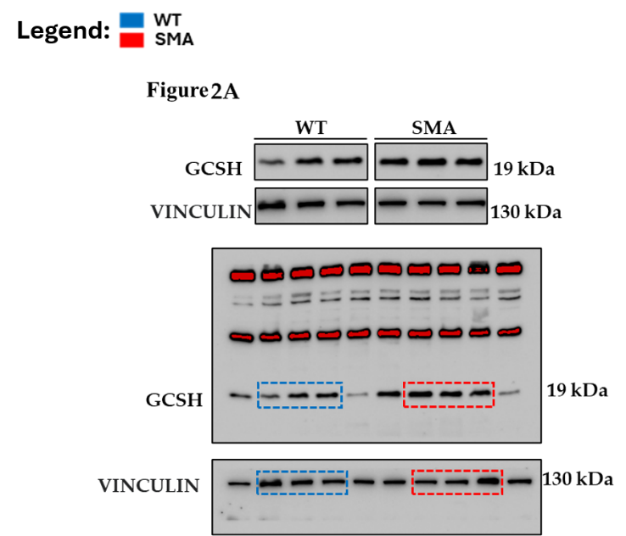
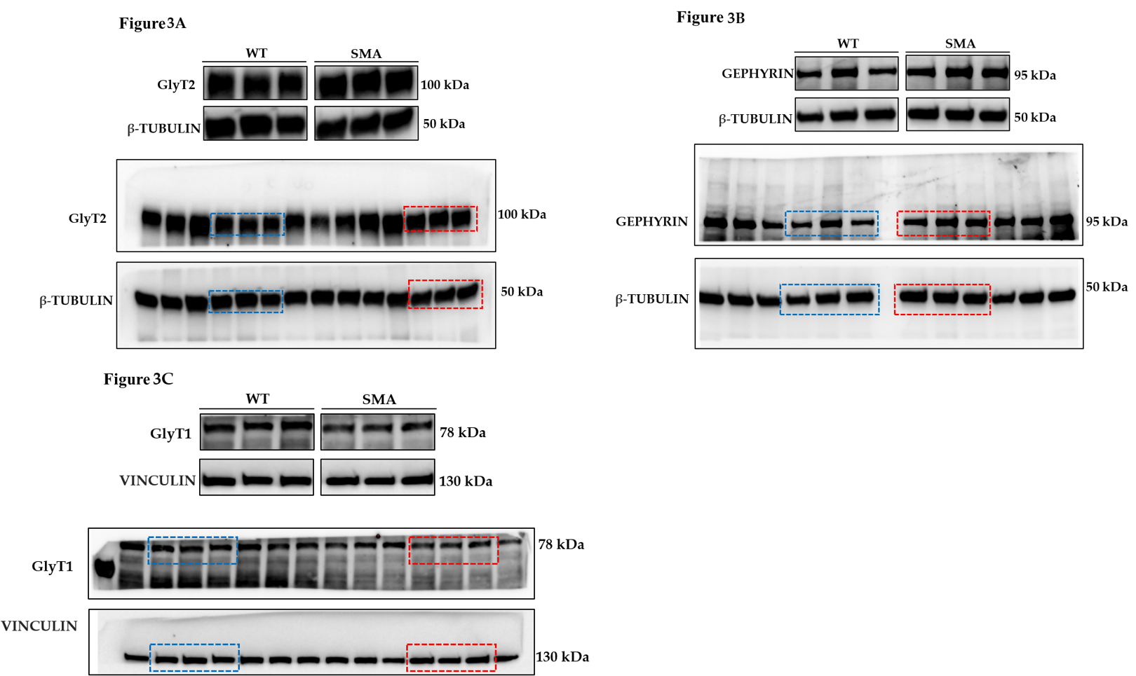
Caretto et al.

