Supplementary Material
WebXR-Based Mobile Point Cloud Rendering and Semantic Segmentation Using Depth Data and Voxel Fusion

Ming-Der Yang^{1,2}, Chun-Wei Yeh^{2,⸸}, and Hui Ping Tsai^{1,2,*,⸸}
¹Department of Civil Engineering and Innovation and Development Center of Sustainable Agriculture, National Chung Hsing University, Taichung 402, Taiwan
²Smart Sustainable New Agriculture Research Center (SMARTer), National Chung Hsing University, Taichung 402, Taiwan
*huiping.tsai@nchu.edu.tw (H. P. Tsai)

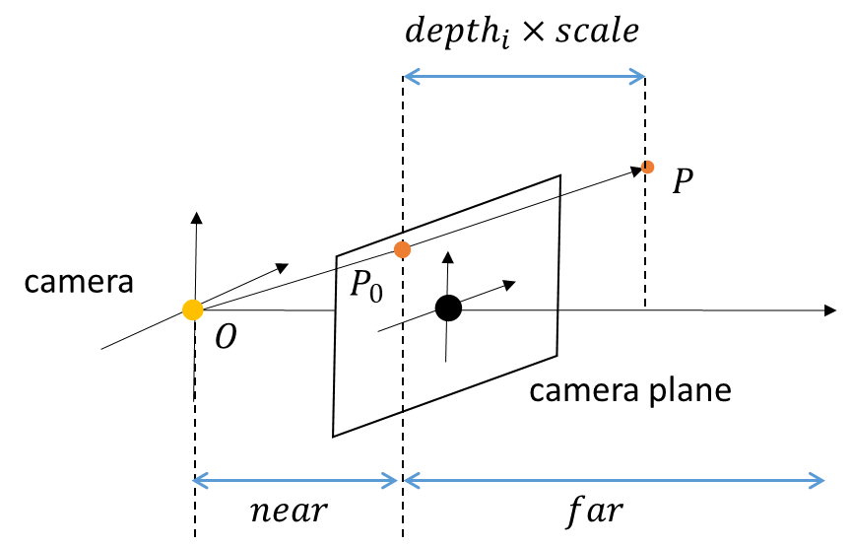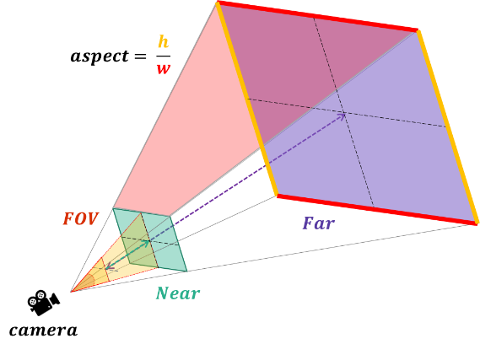
(b)
(a)
Figure S1. (a) Viewing frustum (b) Camera depth.
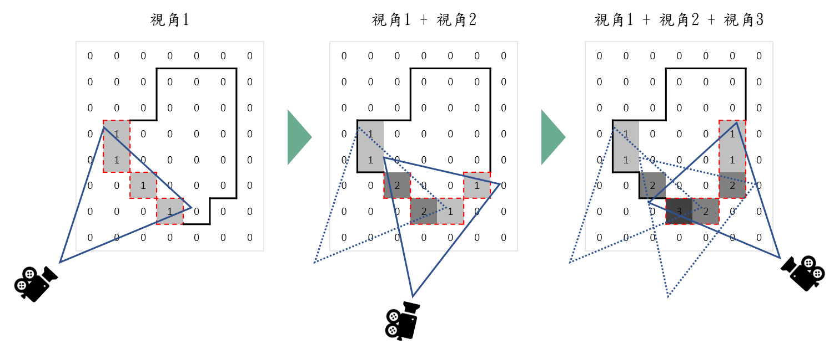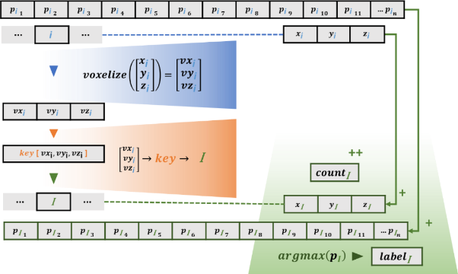
(b)
(a)
Figure S2. (a) Updating voxel data (b) Point cloud merging (Voxel fusion).
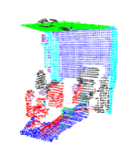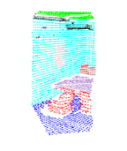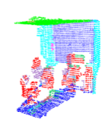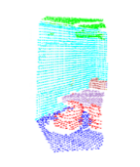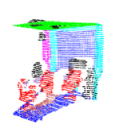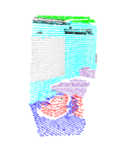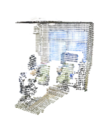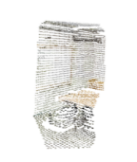
RGB
Local
Ground Truth (GT)
Global
A
B
C
D
Figure S3. Single-viewpoint point cloud test results for global and local features.

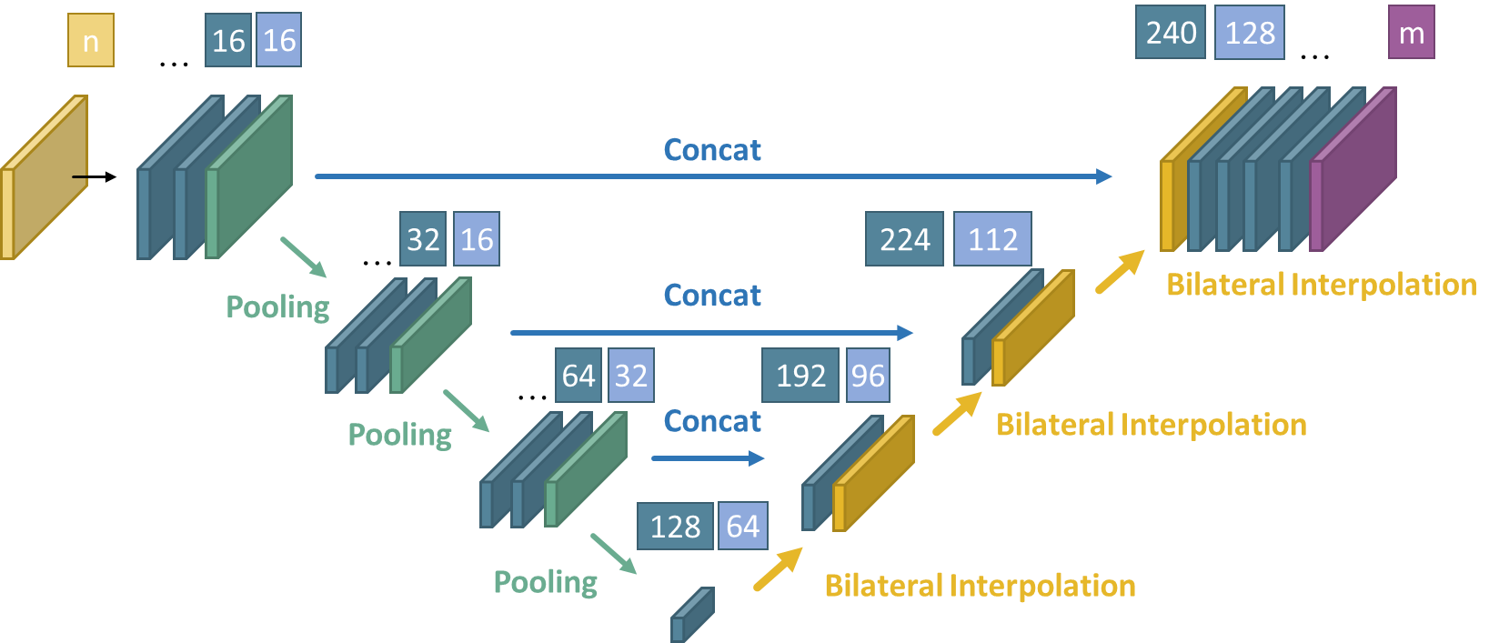
Figure S4. Encoder–Decoder architecture.

Table S1. Buffer array attributes.
Count | No. of points currently contained in each voxel
Label | Classification label argmax (p) for each voxel
Cumulative position (xyz) | Cumulative sum of point positions within each voxel
Cumulative probability (P) | Cumulative probability of classification within each voxel

Table S2. Hardware specifications of the Google Pixel 6 Pro.
FOV | 70.95°
Aspect | 2.165
Near | 0.10 m
Far | 1000.00 m
System | Android 14
Processor | Google Tensor (5 nm)
CPU | Octa-core (2x2.80 GHz Cortex-X1 & 2x2.25 GHz Cortex-A76 & 4x1.80 GHz Cortex-A55)
GPU | Mali-G78 MP20

Table S3. PointNet training parameters.
EPOCH | 25 / 10
Optimizer | ADAM
Learning rate | 0.001
Batch size | 32

Table S4. Single-viewpoint point cloud test results.
Architecture |  | PointNet
No. of parameters |  | 879,630
Input | Global (256, 9) |  | Local (256, 9)
Accuracy |  | 0.7791 |  | 0.7960
meanIOU |  | 0.5214 |  | 0.4849

Table S5. WebXR dataset training parameters.
EPOCH | 50
Optimizer | ADAM
Learning rate | 0.001
Batch size | 8

Table S6. WebXR dataset test results. (E-D: Encoder–Decoder; E-D-T: Encoder–Decoder-Thin)
 | E-D | E-D-T | E-D | E-D-T | E-D | E-D-T
Input | RGB |  | RGBD |  | RGBXYZ
No. of parameters | 265,278 | 56,542 | 265,422 | 56,686 | 265,710 | 56,974
Accuracy | 0.7137 | 0.7065 | 0.7674 | 0.7626 | 0.7704 | 0.7696
meanIOU | 0.4547 | 0.4491 | 0.5236 | 0.5219 | 0.5383 | 0.5335

Table S7. Average multiviewpoint segmentation results (unit: percentage). (E-D: Encoder–Decoder; E-D-T: Encoder–Decoder-Thin)
 | E-D |  | E-D-T |  | E-D |  | E-D-T |  | E-D |  | E-D-T
Input | RGB |  |  |  | RGBD |  |  |  | RGBXYZ
Accuracy | 71.37 |  | 68.06 |  | 76.74 |  | 76.18 |  | 77.04 |  | 76.52
meanIOU | 40.76 |  | 37.42 |  | 46.33 |  | 46.95 |  | 49.31 |  | 48.38
Accuracy_fused | 76.14 | +4.76 | 73.36 | +5.30 | 80.54 | +3.80 | 79.60 | +3.41 | 79.76 | +2.72 | 78.88 | +2.36
meanIOU_fused | 51.04 | +10.29 | 47.93 | +10.50 | 54.16 | +7.83 | 53.31 | +6.36 | 55.56 | +6.25 | 54.36 | +5.98

Table S8. Average multiviewpoint voxel recognition results (unit: percentage).
 | Model | RGB | RGBD | RGBXYZ | PointNet-G | PointNet-L
Encoder–Decoder | Accuracy | 62.92 | 68.91 | 69.13 | 71.65 | 64.54
Encoder–Decoder | meanIOU | 41.32 | 45.81 | 47.56 | 50.74 | 43.08
Encoder–Decoder-Thin | Accuracy | 66.06 | 69.43 | 70.19 | 71.65 | 64.54
Encoder–Decoder-Thin | meanIOU | 43.91 | 45.72 | 48.75 | 50.74 | 43.08

Table S9. Real-world scene dataset training parameters.
EPOCH | 50
Optimizer | ADAM
Learning rate | 0.001
Batch size | 8

Table S10. Real-world scene testing results.
Input | RGB | RGBD | RGBXYZ
No. of parameters | 56,284 | 56,428 | 56,716
Accuracy | 0.8897 | 0.8983 | 0.8981
meanIOU | 0.7423 | 0.7608 | 0.7854

