Supplementary Figures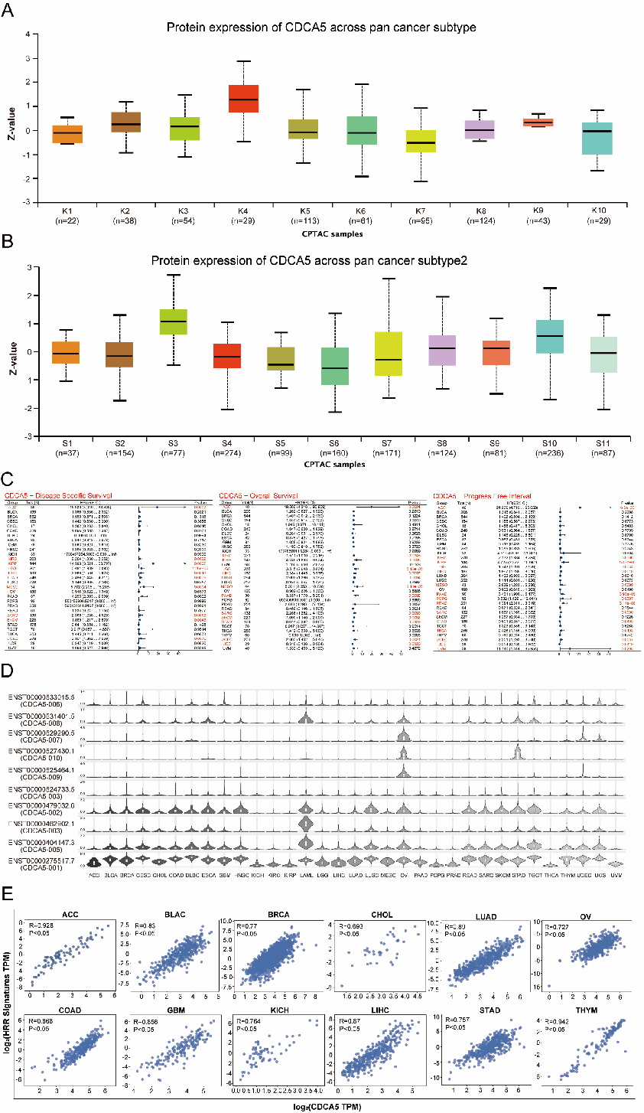

Fig. S1 The expression of CDCA5 in pan-cancer, prognosis and correlation with DNA damage.
A,B. We identifiedand 11 aneuploidy-driven subtypes (S1-S11)(A) and 10 structural alteration-driven subtypes (K1-K10)(B) across 14 cancer types, using proteomic data from 2002 primary tumors.
C.The prognostic significance of CDCA5 in overall survival (OS), progression-free interval (PFI), and disease-specific survival (DSS) across multiple cancer types.
D. The expression of 10 CDCA5 isoforms in 32 cancer types was analyzed.
E. Across 12 tumor types, CDCA5 was positively correlated with HRR characteristics,
Data are expressed as the mean ± SD of at least three independent experiments.
*P < 0.05, **P < 0.01, ***P < 0.001, ****P < 0.0001.

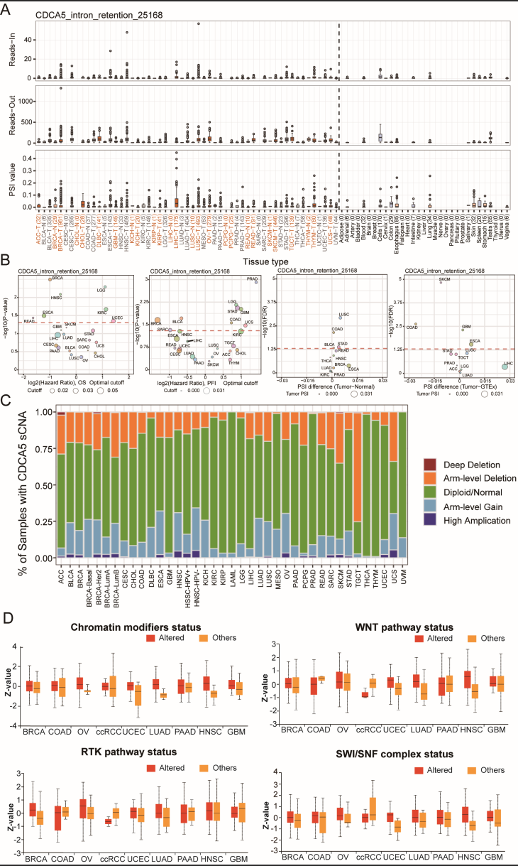
Fig. S2 Variable Splicing Events of CDCA5 and Its Association with Immune and Carcinogenic Pathways.
A Reads-in, reads-out, and PSI values CDCA5_intron_retention_25168 in pan-cancers, adjacent samples, and healthy tissue samples.Color-coded labels indicate tumors and their adjacent tissues, while non-tumor tissues are marked in black. B PSI differences when comparing tumors and corresponding healthy or adjacent tissues and the association between CDCA5_intron_retention_25168 events and prognosis. C Box plots comparing the expression of CDCA5 in 9 cancers based on the presence or absence of somatic alterations in the indicated pathways as assessed with the UALCAN tool. D The TCGA public gene database analyzed the correlation between CDCA5 and immune infiltration, presenting the results in a heat map format. Statistical significance indicated as *P < 0.05, **P < 0.01, ***P < 0.001.
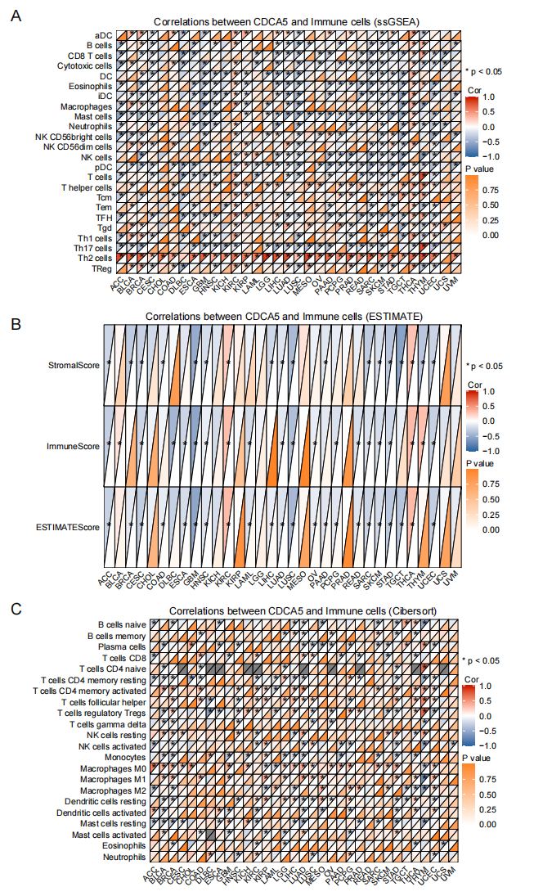Fig. S3 Correlation between CDCA5 expression and immune infiltration profiles across TCGA pan-cancer cohorts evaluated by three independent algorithms
A Correlations between CDCA5 expression and immune cell infiltration levels calculated by ssGSEA. B Correlations between CDCA5 expression and ESTIMATE-derived StromalScore, ImmuneScore and ESTIMATEScore. C Correlations between CDCA5 expression and immune cell subset abundance estimated by CIBERSORT.
The color gradient represents Spearman correlation coefficients; statistically significant correlations are marked with asterisks (p < 0.05).
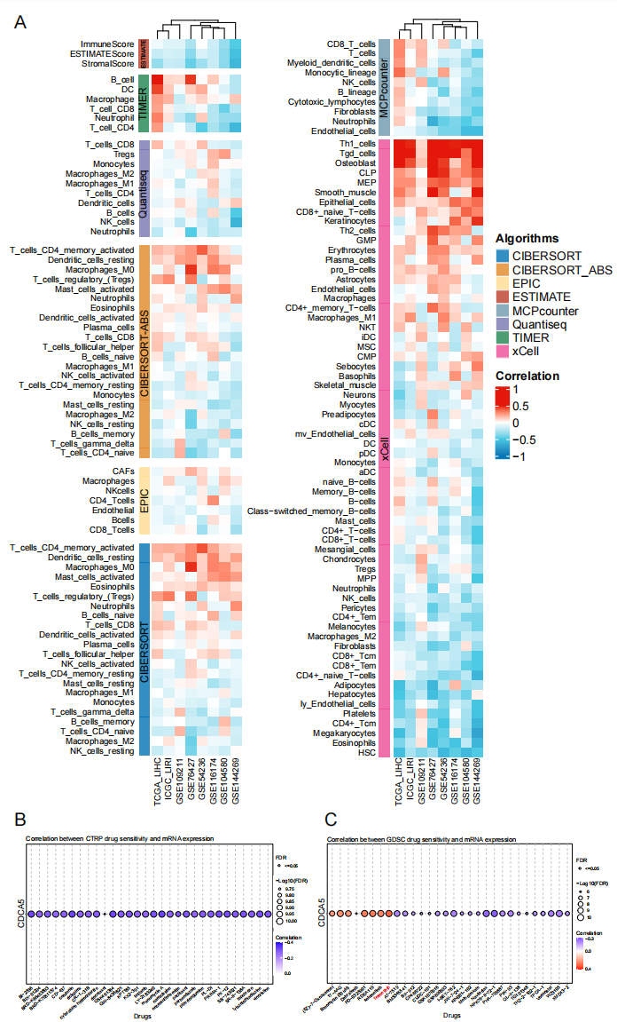
Fig. S4 Correlation between CDCA5 expression and immune infiltration profiles across TCGA pan-cancer cohorts evaluated by three independent algorithms
A Correlations between CDCA5 expression and immune cell infiltration levels calculated by ssGSEA. B Correlations between CDCA5 expression and ESTIMATE-derived StromalScore, ImmuneScore and ESTIMATEScore. C Correlations between CDCA5 expression and immune cell subset abundance estimated by CIBERSORT.
The color gradient represents Spearman correlation coefficients; statistically significant correlations are marked with asterisks (p < 0.05).

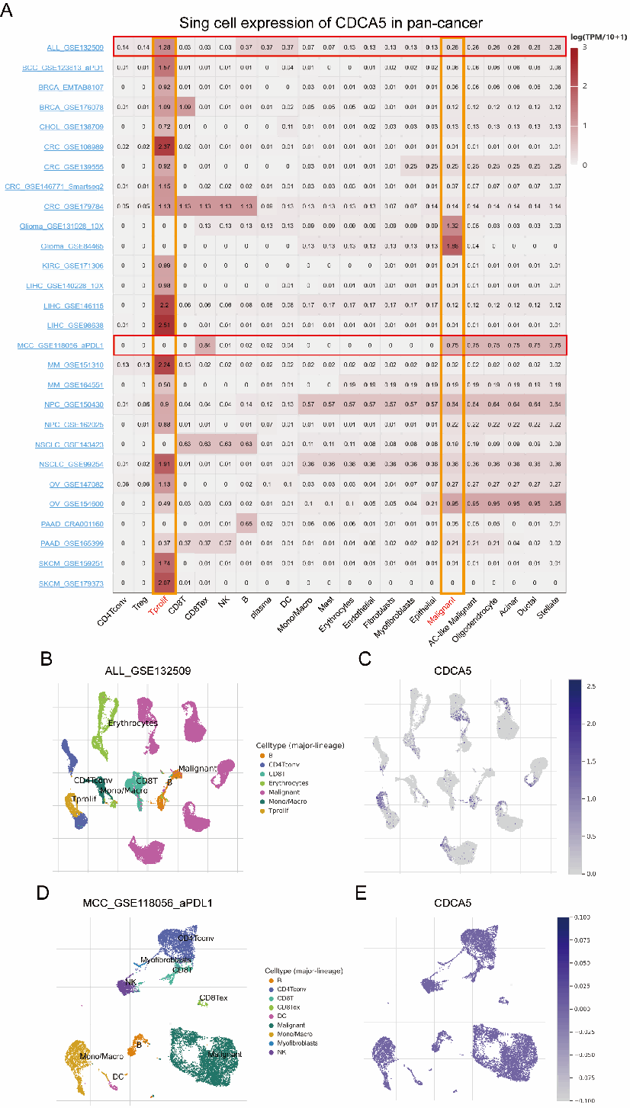

Fig. S5 Sing-cell expression of CDCA5 in pan-cancer
- Summary of CDCA5 expression of 22 cell types in 28 single cell datasets.
- Scatter plot showed the distributions of 7 different cell types of the GSE132509 ALL dataset.
- Scatter plot showed the CDCA5 expression levels of cells in the GSE132509 dataset.
- Scatter plot showed the distributions of 9 different cell types of the GSE118056_aPDL1 MCC dataset.
- Scatter plot showed the CDCA5 expression levels of cells in the GSE118056_aPDL1 MCC dataset
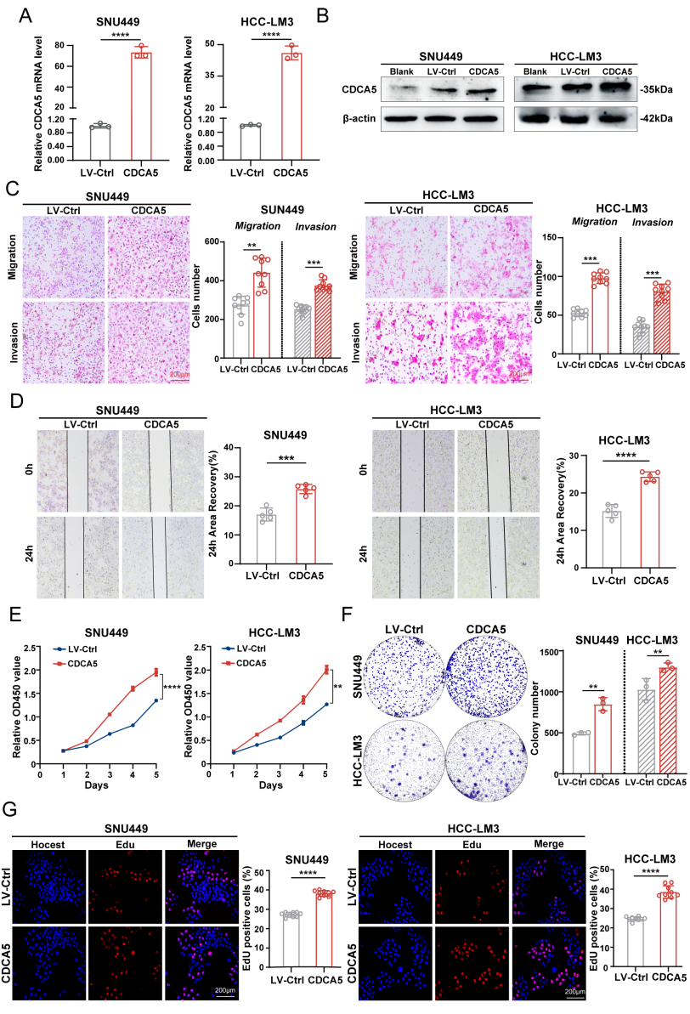
Fig S6 Overexpression of CDCA5 promotes HCC progression.
A, B. Evaluation of CDCA5 overexpression efficiency at the mRNA (A) and protein levels (B).
C, D. CDCA5 overexpression significantly promoted HCC cell migration and invasion. n = 3 independent experiments. Scale bar, 200 μm.
E.CCK-8 assay results indicating that CDCA5 overexpression significantly enhanced the proliferation of SNU449 and HCC-LM3 cells.
F.Increased clonogenic formation of HCC cells upon CDCA5 overexpression. n = 3 independent experiments.
G.CDCA5 overexpression significantly promoted the proliferation of SNU449 and HCC-LM3 cells, as analyzed by the EdU assay. The EdU positive rate is presented as the mean ± SD. n=3 independent experiments. Scale bar, 200μm.
Data are presented as the mean ± SD of at least three independent experiments. Statistical significance indicated as *P < 0.05, **P < 0.01, ***P < 0.001.

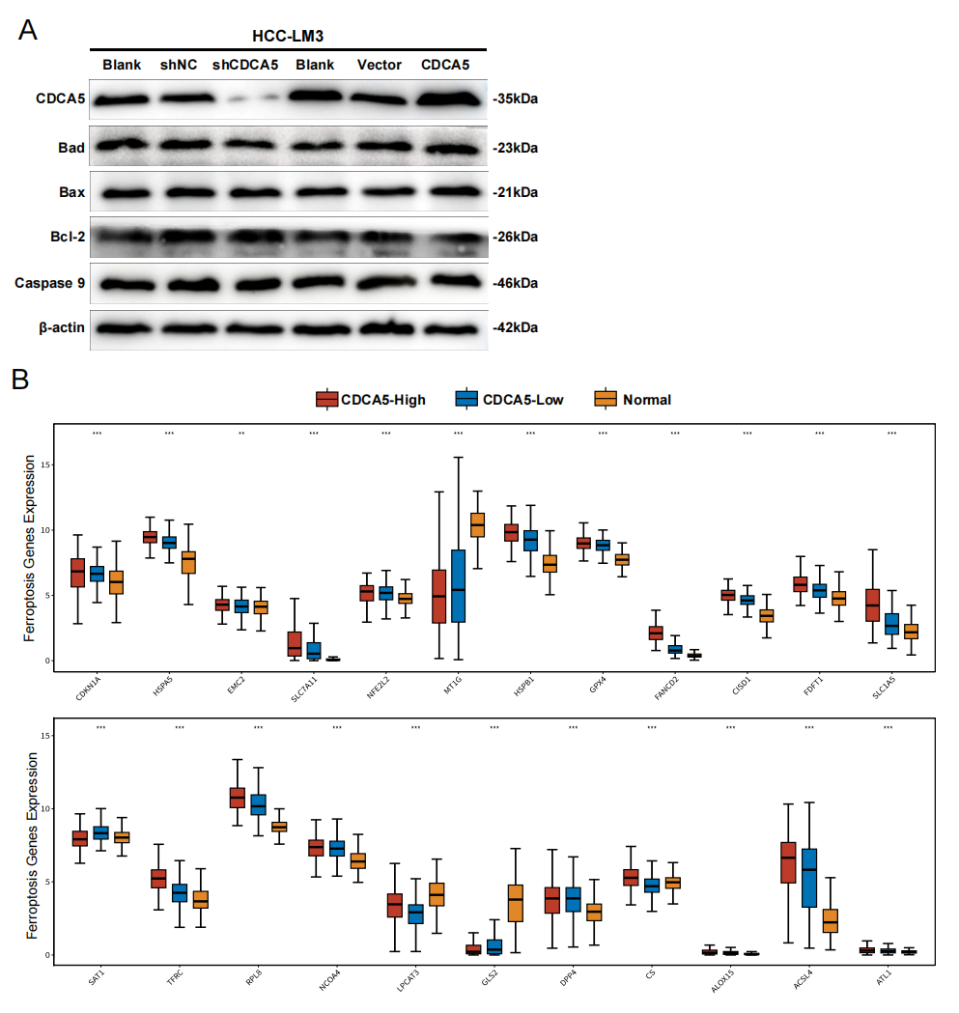
Fig S7 CDCA5 can specifically regulate ferroptosis over apoptosis
A. CDCA5 knockdown and overexpression did not affect apoptosis, as assessed by WB. n= 3 independent experiments.
B Analysis of the correlation between CDCA5 and ferroptosis-related proteins using the TCGA-LIHC database.
Statistical significance indicated as *P < 0.05, **P < 0.01, ***P < 0.001.
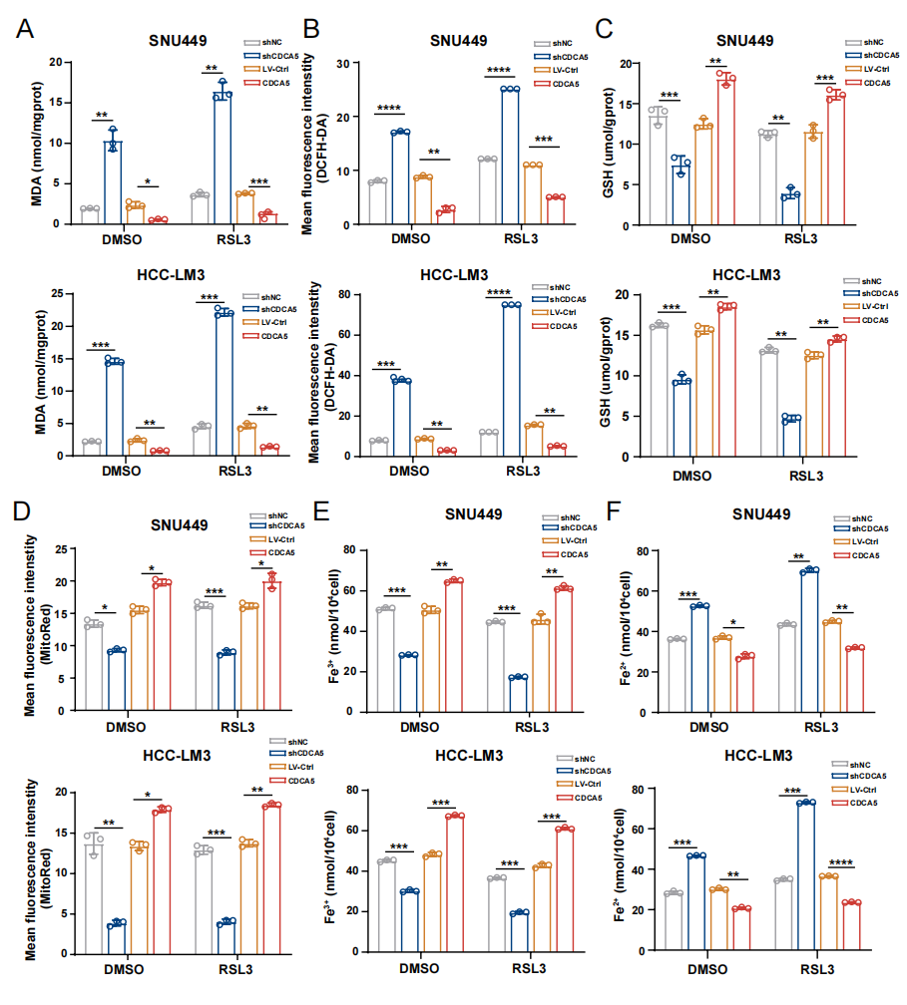
Fig S8 CDCA5 can specifically regulate ferroptosis in HCC
A-F. In SNU449 and HCC-LM3 with CDCA5 knockdown or overexpression, intracellular MDA content (A), ROS level (B), GSH content (C), mitochondrial activity (D), Fe²⁺ content (E), and Fe³⁺ content (F) were measured. n = 3 independent experiments.Data are presented as the mean ± SD of at least three independent experiments.
Statistical significance indicated as *P < 0.05, **P < 0.01, ***P < 0.001.

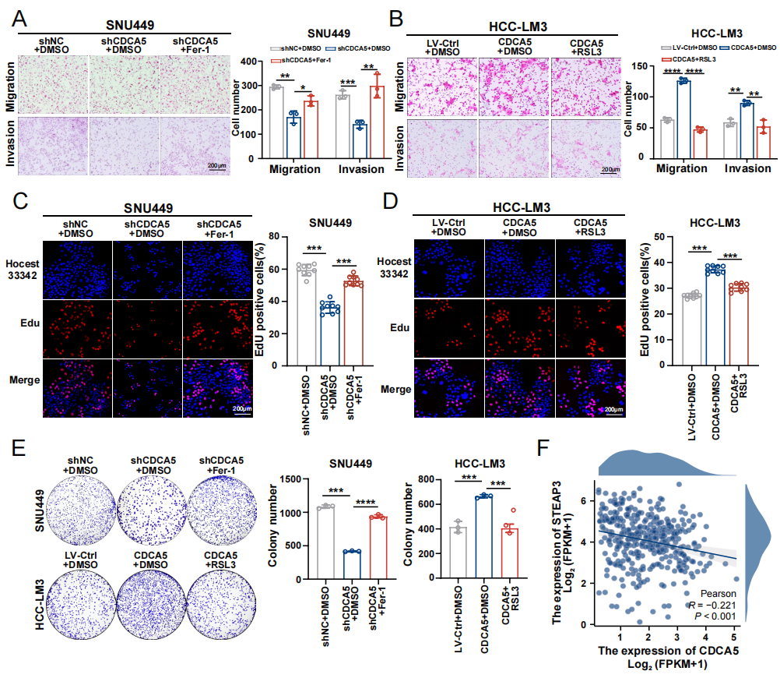
Fig S9 CDCA5 affects HCC progression by regulating ferroptosis.
A,B. Migration and invasion assay results were partially rescued in SNU449 shCDCA5 cells treated with Fer-1 (A) and HCC-LM3 CDCA5 overexpression cells treated with RSL3(B). n = 3 independent experiments.Scale bar, 200μm.
- E. The proliferative capacity of HCC cells was similarly restored. n = 3 independent experiments.Scale bar, 200μm.
F.The correlation between CDCA5 and STEAP3 was analyzed in TCGA-LIHC database.
Data are presented as the mean ± SD of at least three independent experiments. Statistical significance indicated as *P < 0.05, **P < 0.01, ***P < 0.001.

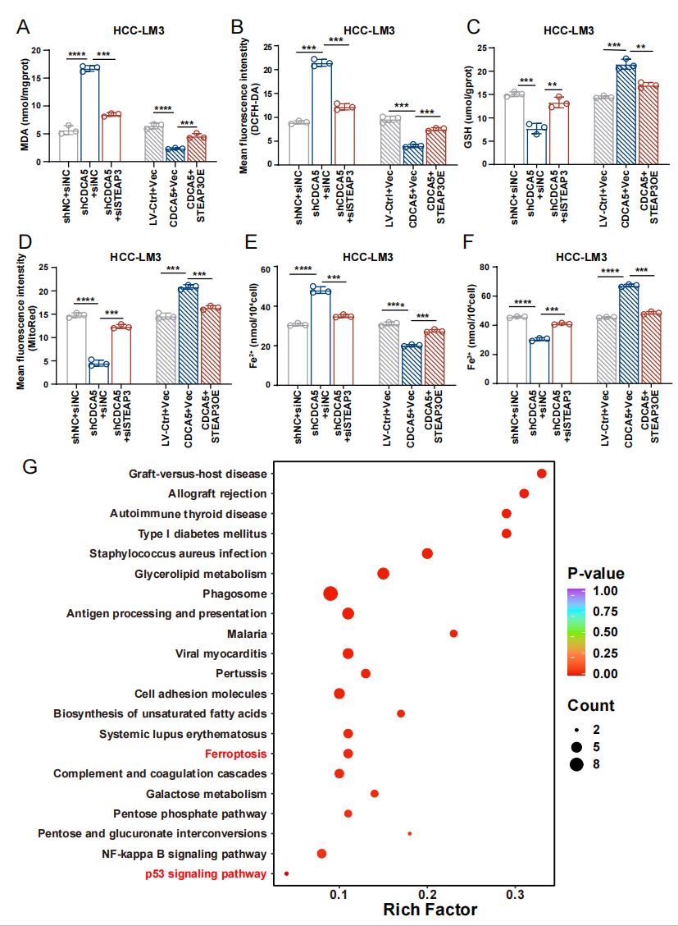
Fig S10 Restoration of ferroptosis-related indicators in CDCA5-STEAP3 double transgenic cells.
A-F. In HCC-LM3 shCDCA5 cells with further knockdown of STEAP3 and CDCA5 cells overexpressing STEAP3, changes in MDA content (A), ROS levels (B), GSH levels (C), mitochondrial activity (D), as well as Fe²⁺ (E) and Fe³⁺ content (F) were partially rescued. n = 3 independent experiments.
G. LV-Ctrl and CDCA5OE were subjected to protein profiling, and the resulting differential proteins underwent KEGG enrichment analysis.
Data are presented as the mean ± SD of at least three independent experiments. Statistical significance indicated as *P < 0.05, **P < 0.01, ***P < 0.001.

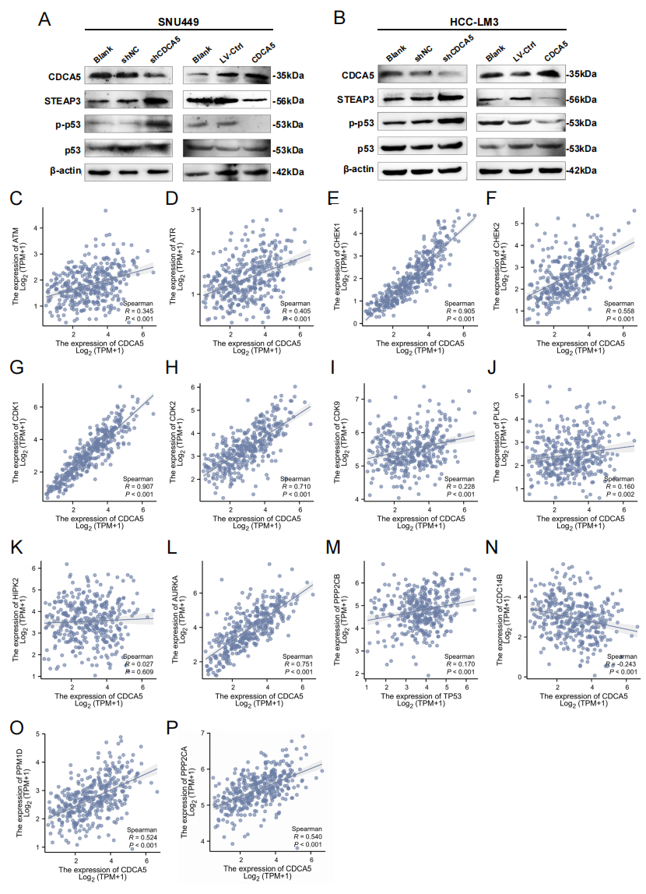

Fig S11 CDCA5 negatively suppresses ferroptosis by regulating STEAP3 through p53.
A,B. WB analysis revealed that changes in CDCA5, STEAP3, p53 and p-p53 were observed after addition of p53 agonist and inhibitor. n = 3 independent experiments.
C-P. The correlation between CDCA5 and p53 protein kinase and phosphatase was analyzed in the TCGA database.
Data are presented as the mean ± SD of at least three independent experiments. Statistical significance indicated as *P < 0.05, **P < 0.01, ***P < 0.001.

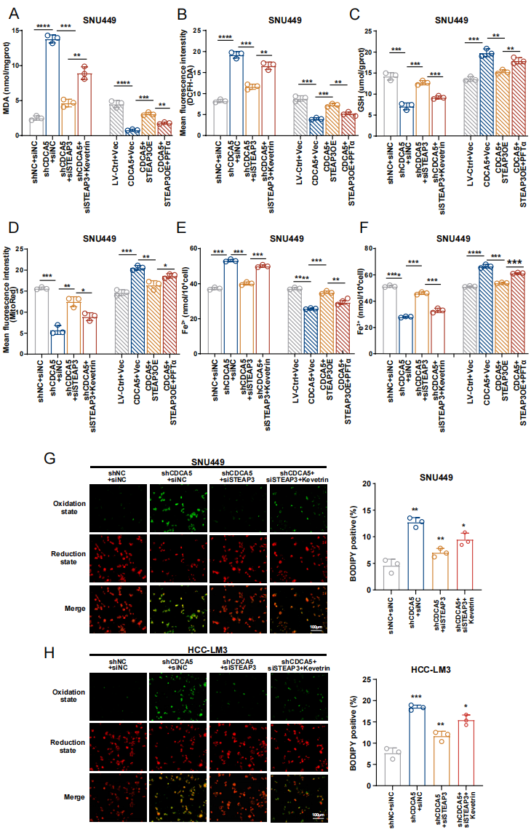
Fig S12 CDCA5 negatively suppresses ferroptosis by regulating STEAP3.
A-F. In CDCA5-STEAP3 duplex transgenic cells, inhibitors and activators of p53 were added, and intracellular MDA content (A), ROS level (B), GSH content (C), mitochondrial activity (D), Fe2+ content (E), and Fe3+ content (F) were measured. Results represent n = 3 independent experiments.
G,H Representative BODIPY C11 staining and quantitative analysis of lipid peroxidation in SNU449 (G) and HCC-LM3 (H) cells. Results represent n = 3 independent experiments.
Data are presented as the mean ± SD of at least three independent experiments.
Statistical significance indicated as *P < 0.05, **P < 0.01, ***P < 0.001, ****P < 0.0001.
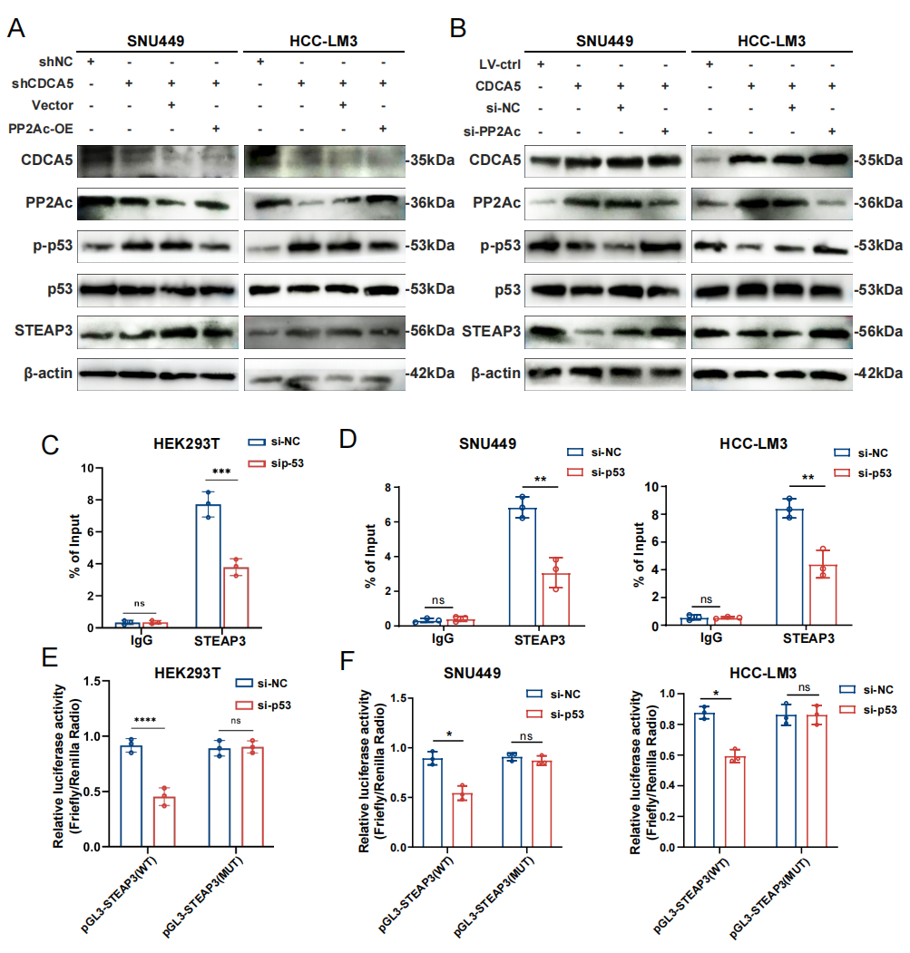
Fig S13 CDCA5 regulates STEAP3 transcription through the PP2Ac/p53 axis.
A,B Western blot detection of CDCA5, PP2Ac, p-p53, total p53 and STEAP3 protein levels in SNU449 and HCC-LM3 cells. (A) CDCA5-knockdown cells with or without PP2Ac overexpression. (B) CDCA5-overexpressing cells with or without PP2Ac knockdown. Results represent n = 3 independent experiments.
C,D. ChIP-qPCR analysis of p53 binding to the STEAP3 promoter in HEK293T (C), SNU449 and HCC-LM3 (D) cells transfected with si-NC or si-p53. IgG served as the negative control.ChIP-qPCR analysis of p53 binding to the STEAP3 promoter in HEK293T (C), SNU449 and HCC-LM3 (D) cells transfected with si-NC or si-p53. IgG served as the negative control.
E,F. Dual-luciferase reporter assays verifying the transcriptional regulation of wild-type (WT) or mutant (MUT) STEAP3 promoter by p53 in HEK293T (E), SNU449 and HCC-LM3 (F) cells.Dual-luciferase reporter experiments showed that P53 binds to the promoter region of STEAP3.
Data are presented as the mean ± SD of at least three independent experiments.
Statistical significance indicated as *P < 0.05, **P < 0.01, ***P < 0.001, ****P < 0.0001

Supplementary table S1
CDCA5 lentiviral vector
Name |  | Target sequences
shCDCA5  shRNA NC |  | CAGAGACTTGGAAATGTCTAAGAAA  TTCTCCGAACGTGTCACGTAA

Supplementary table S2
Quantitative real-time PCR Primer sequences
Name |  | Sequences（5'-3'）
CDCA5 | Forward primer | CCACCACCCGAGAAACAGAA
CDCA5 | Reverse primer | GGTGGCTATGTACAGGACAGG
GAPDH | Forward Primer | GGTCTCCTCTGACTTCAACA
GAPDH | Reverse Primer: | GTGAGGGTCTCTCTCTTCCT

Supplementary table S3
Antibodies used to Western blot and immunohistochemistry
Name | Firm
Anti-CDCA5 antibody | Abcam(ab192237)
β-actin Antibody | Abmart(P30002)
Ki67 Antibody | Abcam(ab16667)
Bad Antibody | Abmart(T40052)
Bax Antibody | Abmart(T40051)
Bcl-2 Antibody | Abmart(T40056)
Caspase 9 (Cleaved-Asp353) Antibody | Abmart(TP74722)
Polyclonal STEAP3 antibody | Abcam(ab126068)
Anti-p53 antibody | Abcam(ab26)
Polyclonal PP2A-alpha antibody | Abcam(ab106262)
Phospho-p53 (Ser15) Antibody | Cell Singling Technology(#9284)
Supplementary table S4
CDCA5 clinical-relevant AS events on OncoSplicing.
Gene_Symbol | Splice_Type | Splice_Event | Project
CDCA5 | RI | CDCA5_RI_16747 | SpliceSeq
CDCA5 | A3 | alt_3prime_48428 | SpIAdder
CDCA5 | A5 | alt_5prime_34932 | SpIAdder
CDCA5 | IR | intron_retention_25165 | SpIAdder
CDCA5 | IR | intron_retention_25166 | SpIAdder
CDCA5 | IR | intron_retention_25167 | SpIAdder
CDCA5 | IR | intron_retention_25168 | SpIAdder
CDCA5 | IR | intron_retention_25172 | SpIAdder

Supplementary table S5
The TP53 mutational status of the HCC cell lines used.
Cell line | TP53 stauts | Mutation
JHH-7 | Wild-type | None
HCC-LM3 | Mutant | p.R249S
SNU-449 | Mutant | p.A161T
SNU-398 | Null | Homozygous deletion
Huh7 | Mutant | p.Y220C

Supplementary table S6
H-score comparison of CDCA5, Ki-67 and STEAP3 in 30 pairs of HCC tumor and adjacent non-tumor tissues.
Protein | Tumor tissues (n=30) Median (P25, P75) |  | Adjacent non-tumor tissues (n=30) Median (P25, P75) | Z value | P value
CDCA5 |  | 168.5 (139.5, 190.0) | 95.5 (82.5, 109.0) | −4.782 | < 0.001
Ki-67 |  | 200.0 (166.5, 223.0) | 87.5 (77.0, 100.5) | −4.782 | < 0.001
Note: The Wilcoxon signed-rank test was applied for paired comparison. H-score ranges from 0 to 300. P25: 25th percentile; P75: 75th percentile.
Supplementary table S7
Univariate and multivariate regression analysis (DSS) of prognostic factors in patients with HCC.
Characteristics | Total(N) | Univariate analysis |  |  | Multivariate analysis
Characteristics | Total(N) | Hazard ratio (95% CI) | P value |  | Hazard ratio (95% CI) | P value
CDCA5 | 365
Low | 183 | Reference |  |  | Reference
High | 182 | 2.261 (1.425 - 3.586) | < 0.001 |  | 1.434 (0.628 - 3.274) | 0.393
Pathologic N stage | 253
N0 | 249 | Reference
N1 | 4 | 3.612 (0.870 - 14.991) | 0.077
Pathologic M stage | 268
M0 | 265 | Reference |  |  | Reference
M1 | 3 | 5.166 (1.246 - 21.430) | 0.024 |  | 6.111 (0.993 - 37.586) | 0.051
Pathologic stage | 341
Stage I&Stage II | 254 | Reference |  |  | Reference
Stage III&Stage IV | 87 | 3.803 (2.342 - 6.176) | < 0.001 |  | 0.305 (0.029 - 3.232) | 0.324
Tumor status | 354
Tumor free | 202 | Reference |  |  | Reference
With tumor | 152 | 775790759.3892 (0.000 - Inf) | 0.994 |  | 1005869810.4246 (0.000 - Inf) | 0.996
Residual tumor | 337
R0 | 320 | Reference
R1&R2 | 17 | 1.678 (0.728 - 3.870) | 0.224
Histologic grade | 360
G1&G2 | 227 | Reference
G3&G4 | 133 | 1.086 (0.683 - 1.728) | 0.726
Child-Pugh grade | 235
A | 214 | Reference |  |  | Reference
B&C | 21 | 2.560 (1.123 - 5.834) | 0.025 |  | 7.250 (2.057 - 25.552) | 0.002
Vascular invasion | 309
No | 204 | Reference
Yes | 105 | 1.277 (0.707 - 2.306) | 0.418
Female | 118 | Reference
Male | 247 | 0.813 (0.516 - 1.281) | 0.373
Age | 365
<= 60 | 174 | Reference
> 60 | 191 | 0.846 (0.543 - 1.317) | 0.458
Weight | 338
<= 70 | 182 | Reference
> 70 | 156 | 1.000 (0.630 - 1.589) | 0.999
BMI | 329
<= 25 | 175 | Reference
> 25 | 154 | 0.826 (0.512 - 1.330) | 0.431
AFP(ng/ml) | 275
<= 400 | 214 | Reference
> 400 | 61 | 0.867 (0.450 - 1.668) | 0.668
Fibrosis ishak score | 210
0&1/2 | 104 | Reference
3/4&5&6 | 106 | 0.660 (0.340 - 1.279) | 0.218
Note: * has statistical significance for differences, P < 0.05.

Supplementary table S8
Univariate and multivariate regression analysis (PFI) of prognostic factors in patients with HCC.
Characteristics | Total(N) | Univariate analysis |  |  | Multivariate analysis
Characteristics | Total(N) | Hazard ratio (95% CI) | P value |  | Hazard ratio (95% CI) | P value
CDCA5 | 373
Low | 187 | Reference |  |  | Reference
High | 186 | 1.716 (1.280 - 2.300) | < 0.001 |  | 1.361 (0.910 - 2.034) | 0.133
Pathologic T stage | 370
T1&T2 | 277 | Reference |  |  | Reference
T3&T4 | 93 | 2.177 (1.590 - 2.980) | < 0.001 |  | 1.426 (0.883 - 2.303) | 0.147
Pathologic N stage | 258
N0 | 254 | Reference
N1 | 4 | 1.370 (0.338 - 5.552) | 0.659
Pathologic M stage | 272
M0 | 268 | Reference |  |  | Reference
M1 | 4 | 3.476 (1.091 - 11.076) | 0.035 |  | 2.134 (0.630 - 7.229) | 0.223
Tumor status | 354
Tumor free | 202 | Reference |  |  | Reference
With tumor | 152 | 11.342 (7.567 - 17.000) | < 0.001 |  | 14.161 (8.354 - 24.003) | < 0.001
Residual tumor | 344
R0 | 326 | Reference
R1&R2 | 18 | 1.513 (0.840 - 2.726) | 0.168
Histologic grade | 368
G1&G2 | 233 | Reference
G3&G4 | 135 | 1.152 (0.853 - 1.557) | 0.355
Child-Pugh grade | 240
A | 218 | Reference
B&C | 22 | 1.395 (0.765 - 2.545) | 0.277
Adjacent hepatic tissue inflammation | 236
None | 118 | Reference
Mild&Severe | 118 | 1.238 (0.867 - 1.768) | 0.241
Vascular invasion | 317
No | 208 | Reference |  |  | Reference
Yes | 109 | 1.676 (1.196 - 2.348) | 0.003 |  | 1.502 (0.987 - 2.286) | 0.058
Gender | 373
Female | 121 | Reference
Male | 252 | 0.982 (0.721 - 1.338) | 0.909
Age | 373
<= 60 | 177 | Reference
> 60 | 196 | 0.960 (0.718 - 1.284) | 0.783
Weight | 345
<= 70 | 184 | Reference
> 70 | 161 | 1.016 (0.750 - 1.375) | 0.920
BMI | 336
<= 25 | 177 | Reference
> 25 | 159 | 0.936 (0.689 - 1.272) | 0.673
AFP(ng/ml) | 279
<= 400 | 215 | Reference
> 400 | 64 | 1.045 (0.698 - 1.563) | 0.832
Fibrosis ishak score | 214
0&1/2 | 106 | Reference
3/4&5&6 | 108 | 1.209 (0.835 - 1.750) | 0.315
Note: * has statistical significance for differences, P < 0.05.

