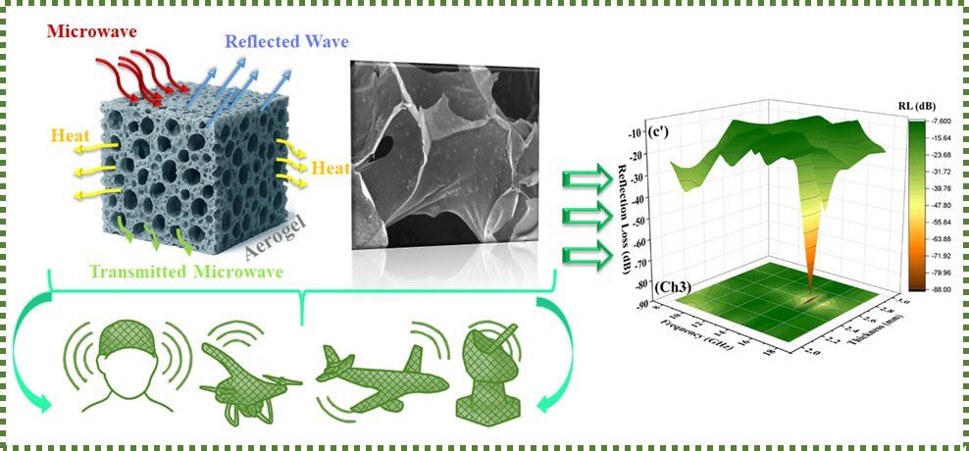
Fig1. Graphic Abstract of the MoSe₂/AC/MMT-Chitosan aerogel.
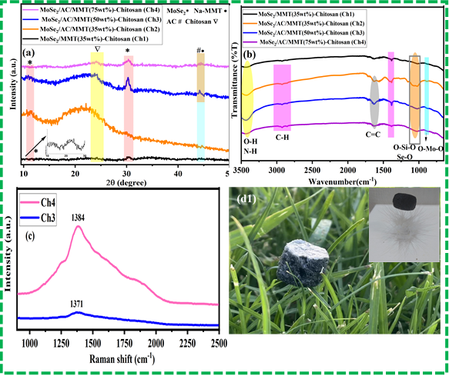
Fig. 2. XRD (a), FTIR (b), Raman (c) and macroscopic image (d1) of the MoSe₂/AC/MMT–Chitosan aerogel.
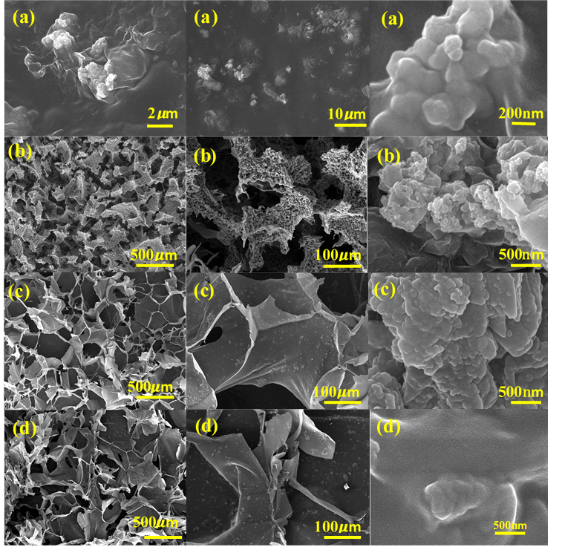
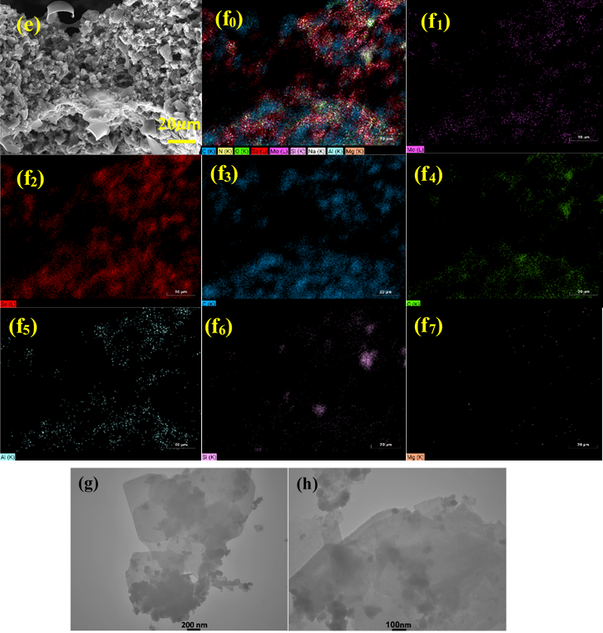
Fig. 3. FE-SEM images of MoSe₂/MMT–Chitosan (a), MoSe₂/AC/MMT–Chitosan (35, 50, 75 wt%, b–d) with
elemental mapping of the 50 wt% sample (e, f₀–f₇) and TEM images of MoSe₂/MMT/AC (g-h).

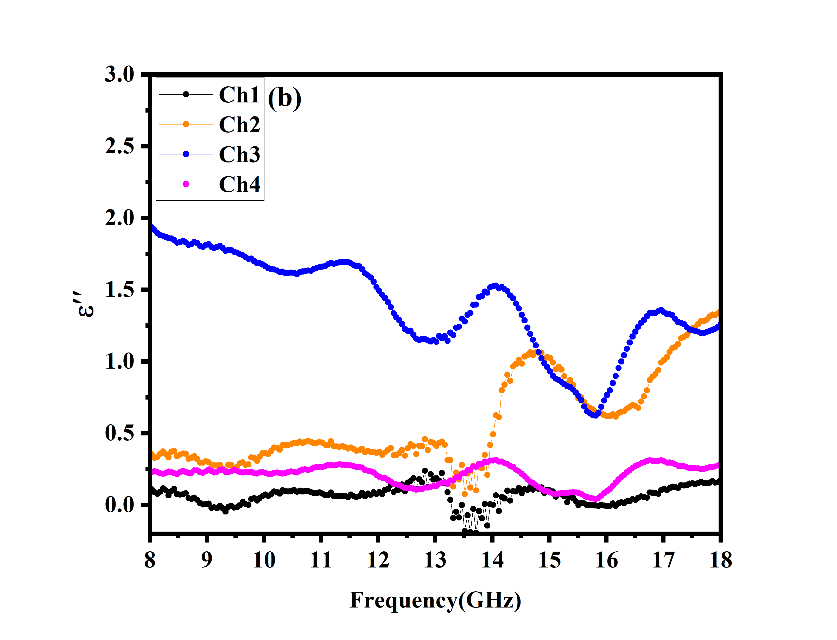
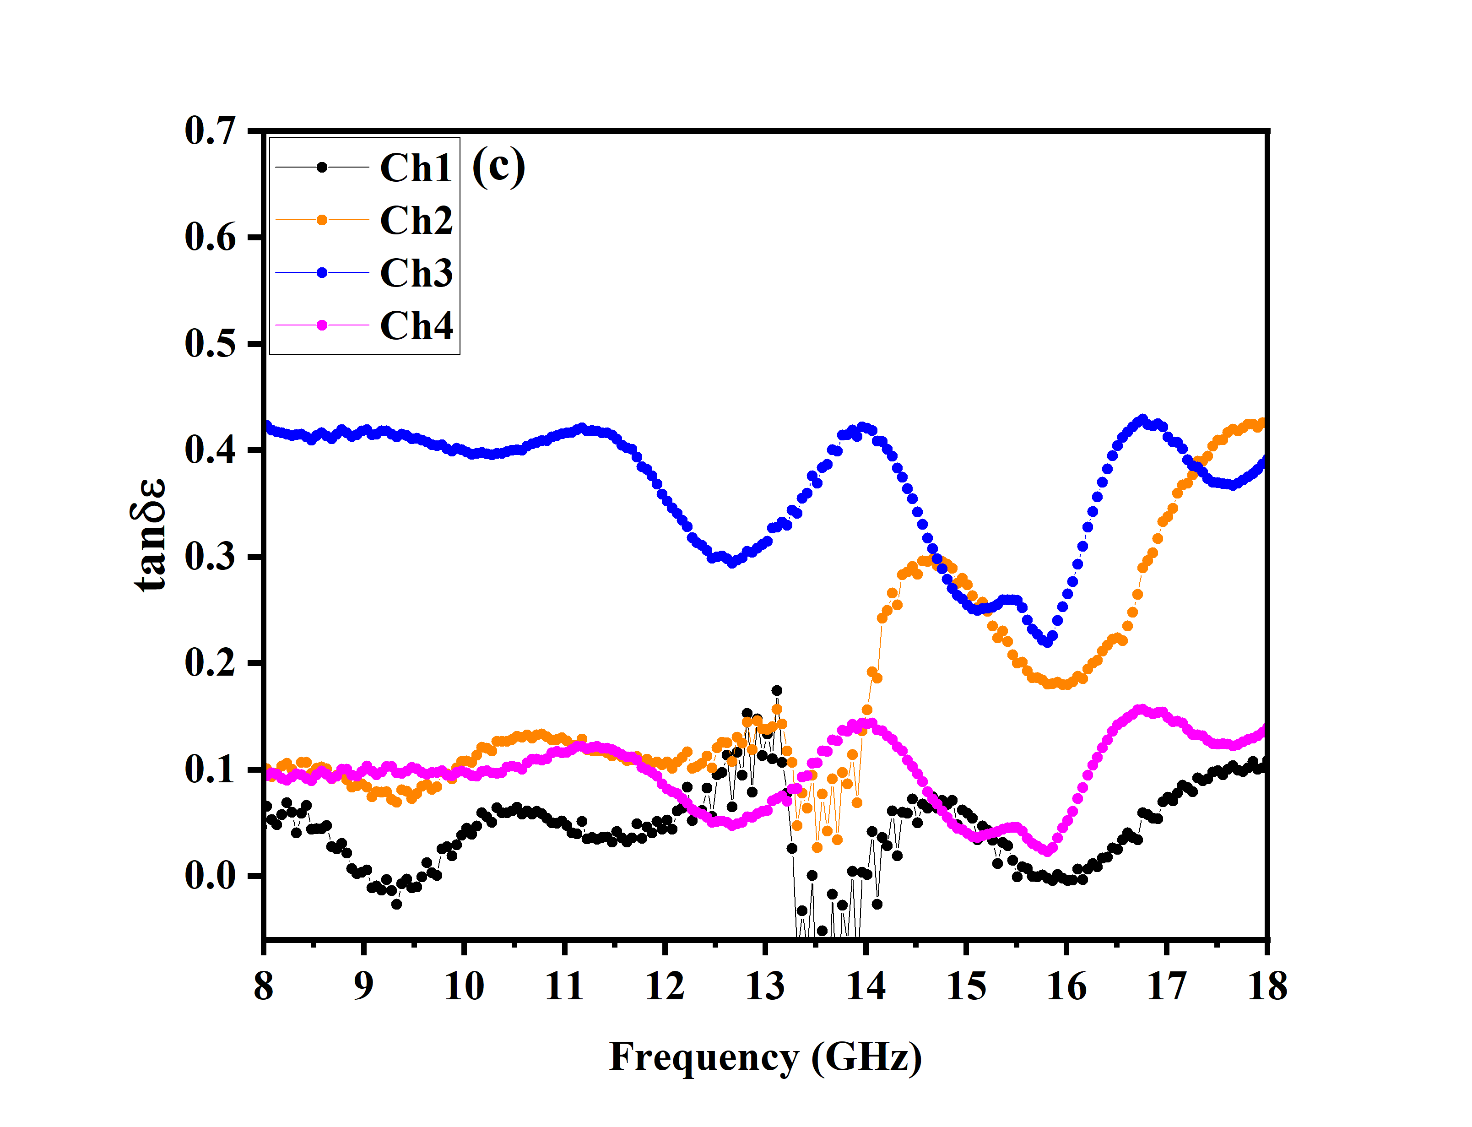
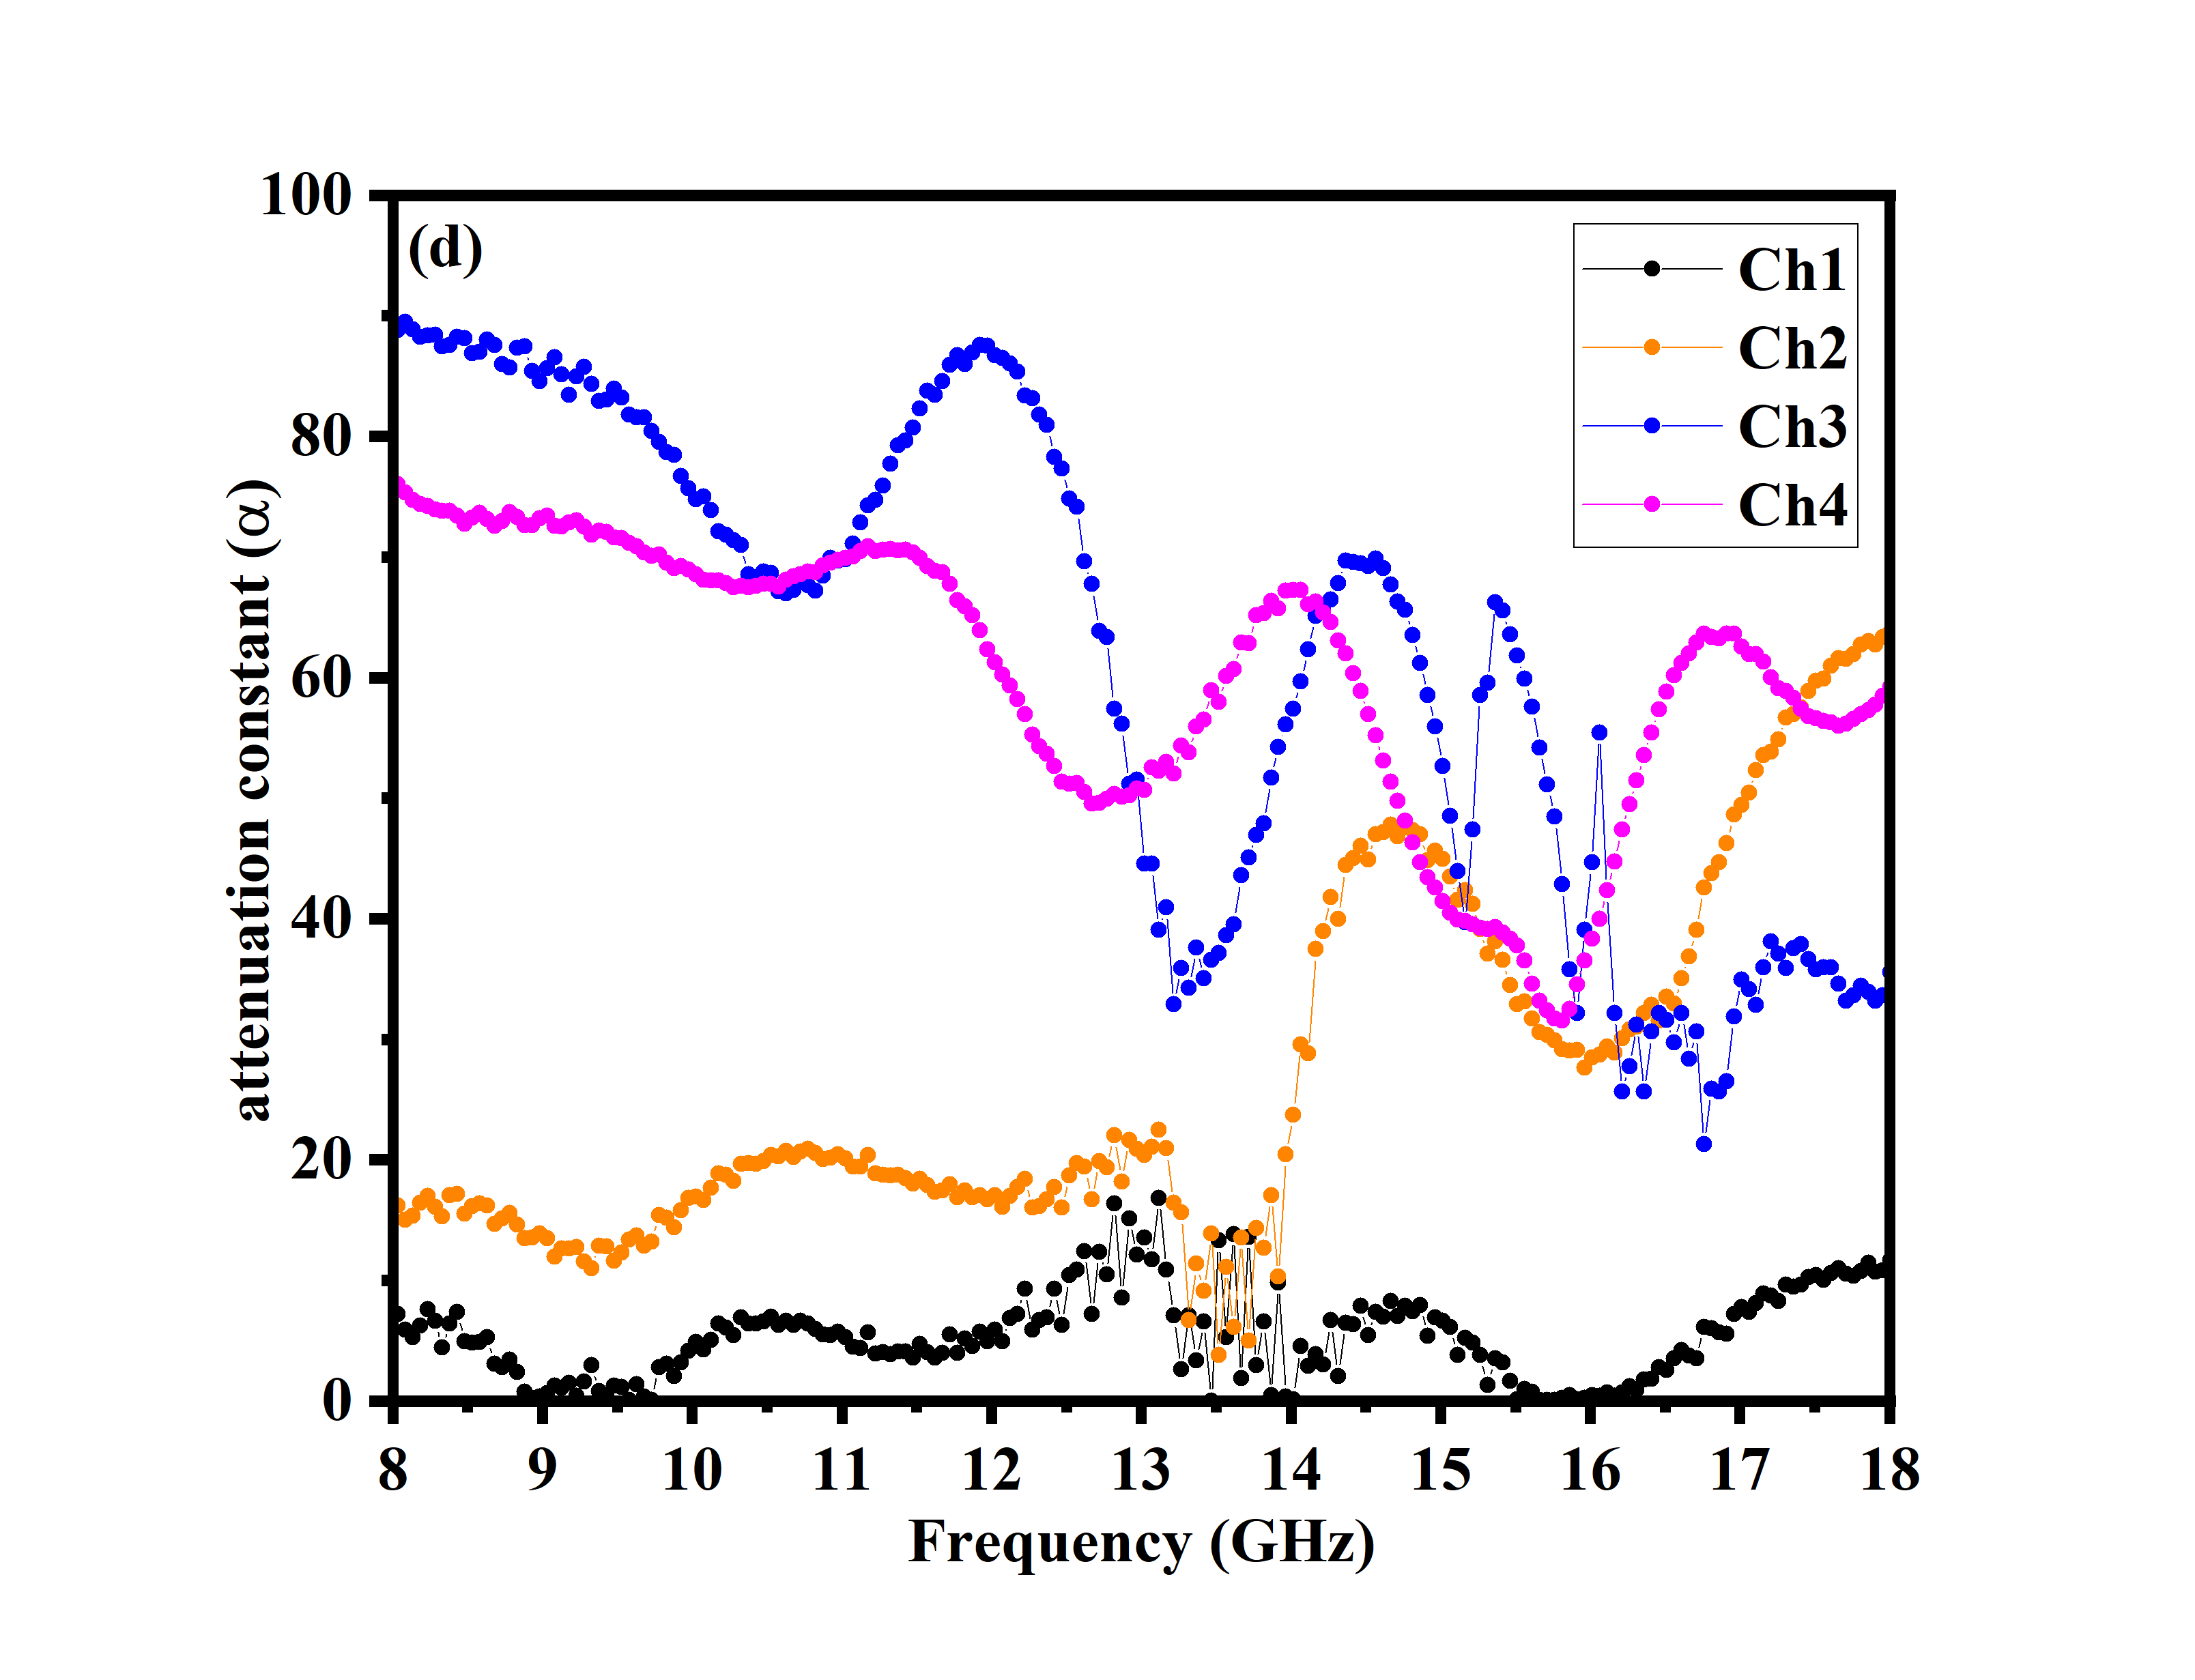
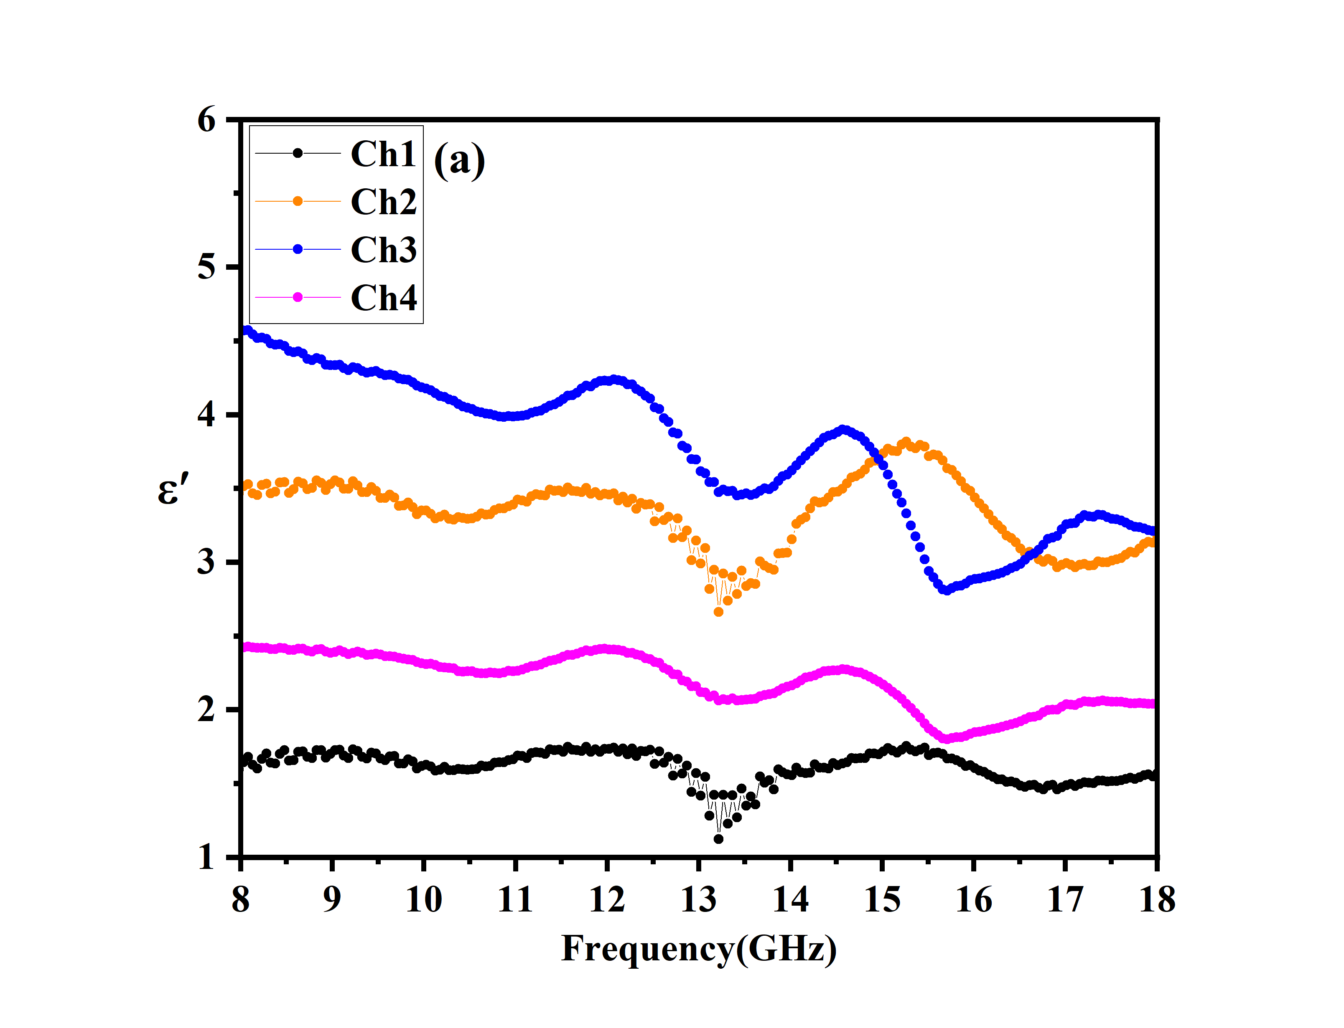
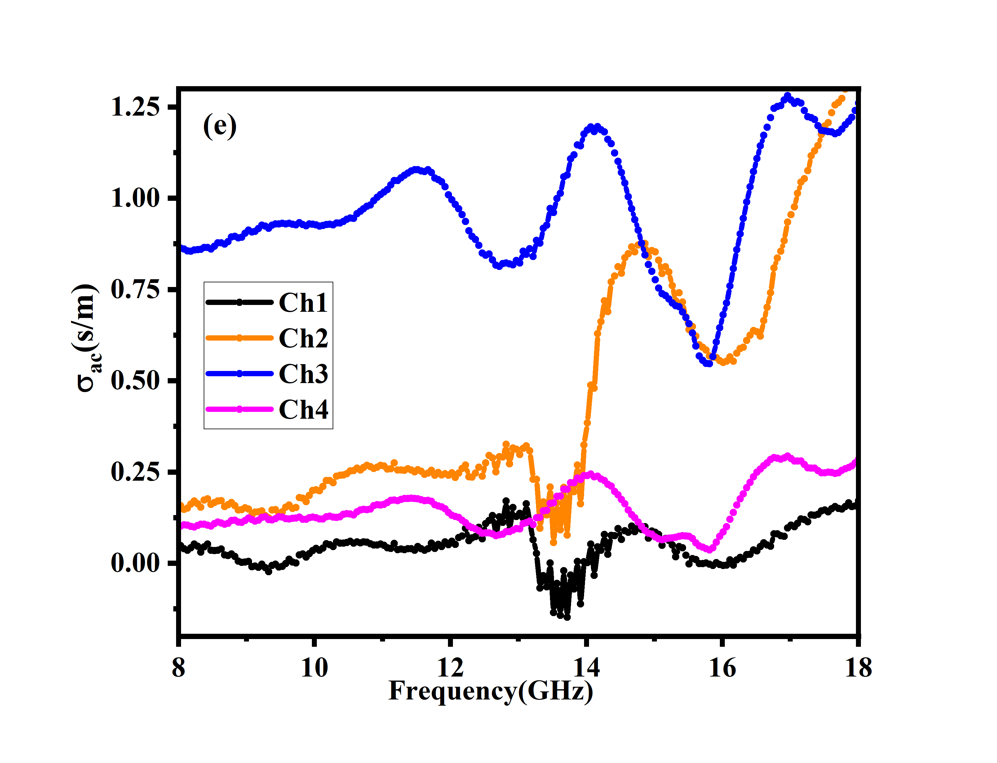
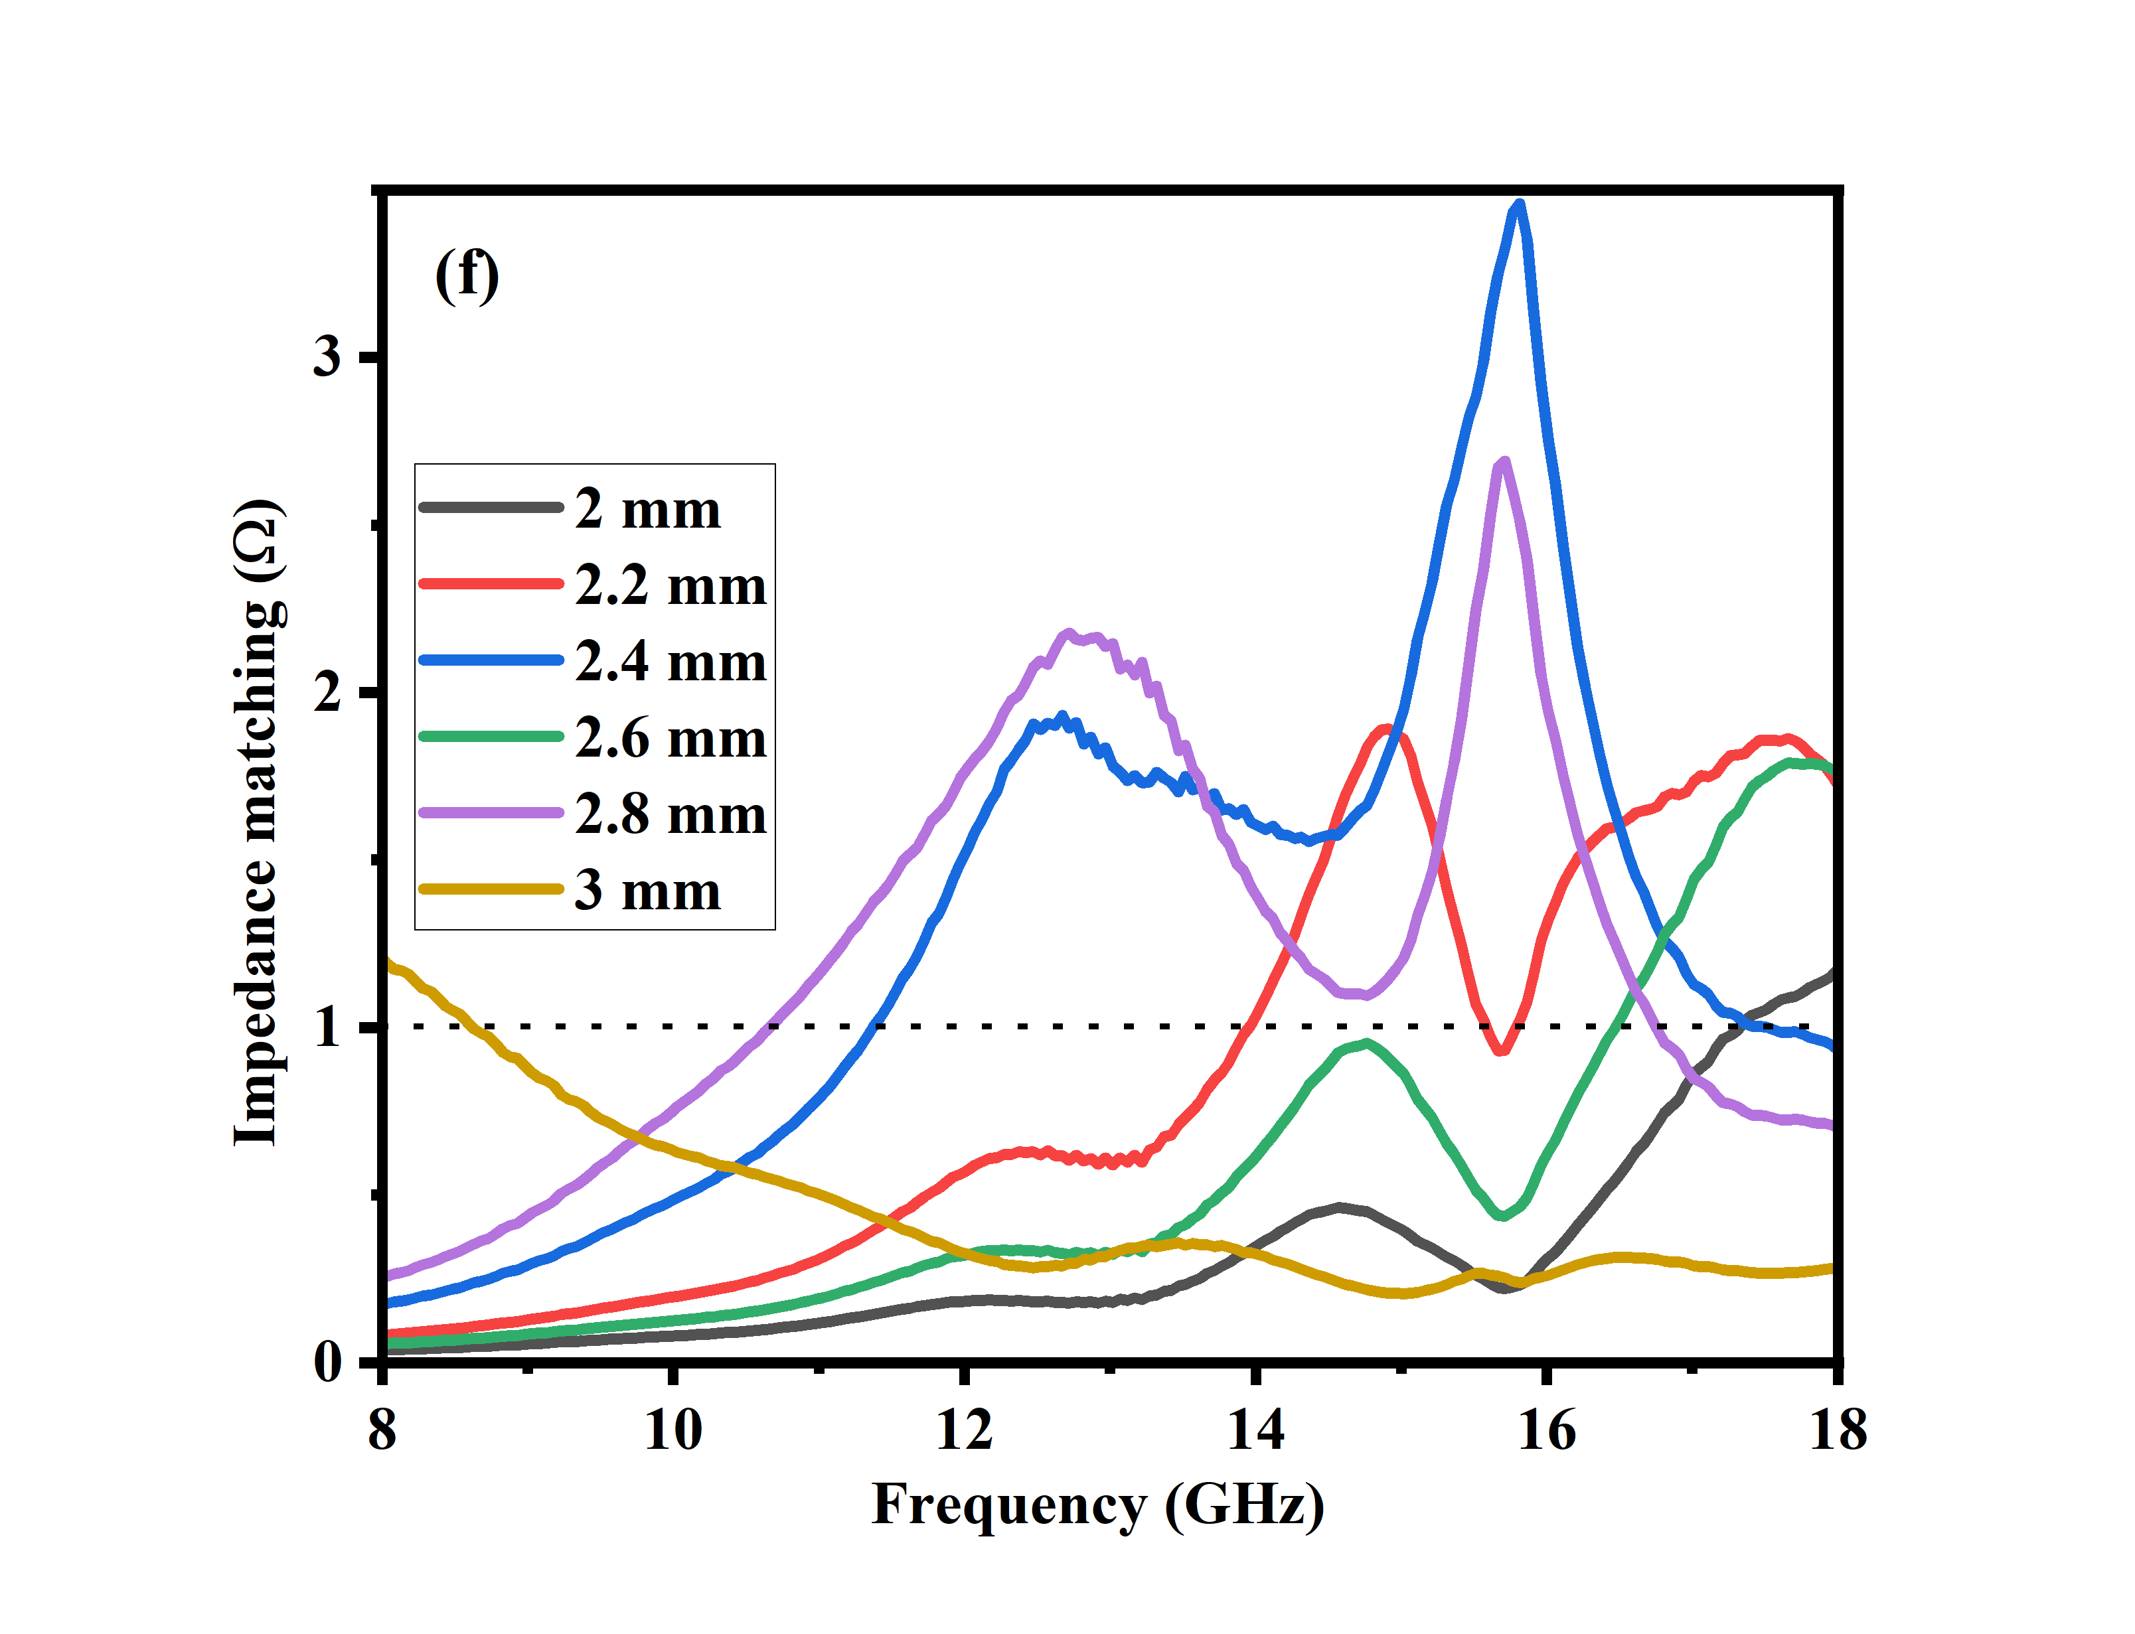

Fig. 4 Permittivity (ε′, ε″, (a, b)), dielectric loss tangent (tan δₑ,(c)), attenuation constant (d) AC conductivity spectra
(e) Impedance matching (f) of MoSe₂/MMT–Chitosan and MoSe₂/AC/MMT–Chitosan aerogels with 35, 50, and 75 wt% filler content.

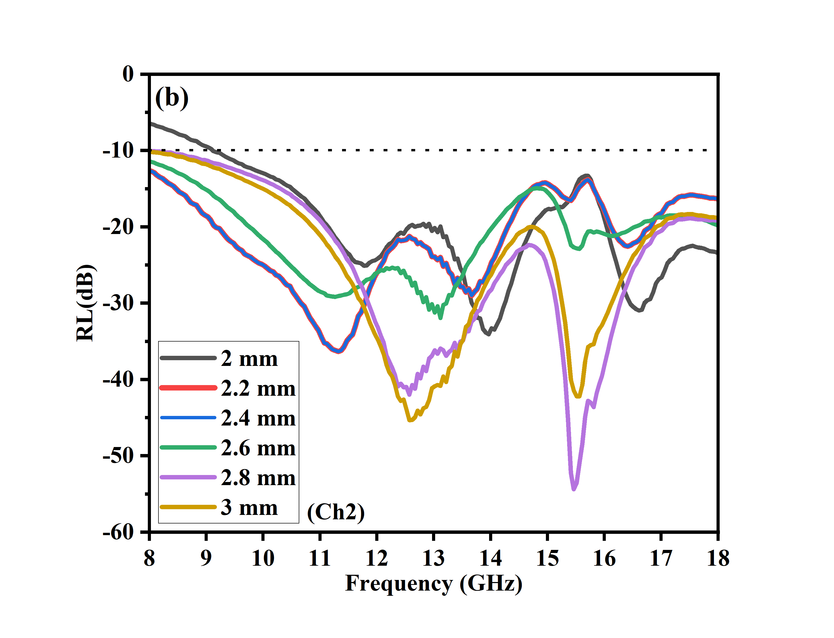
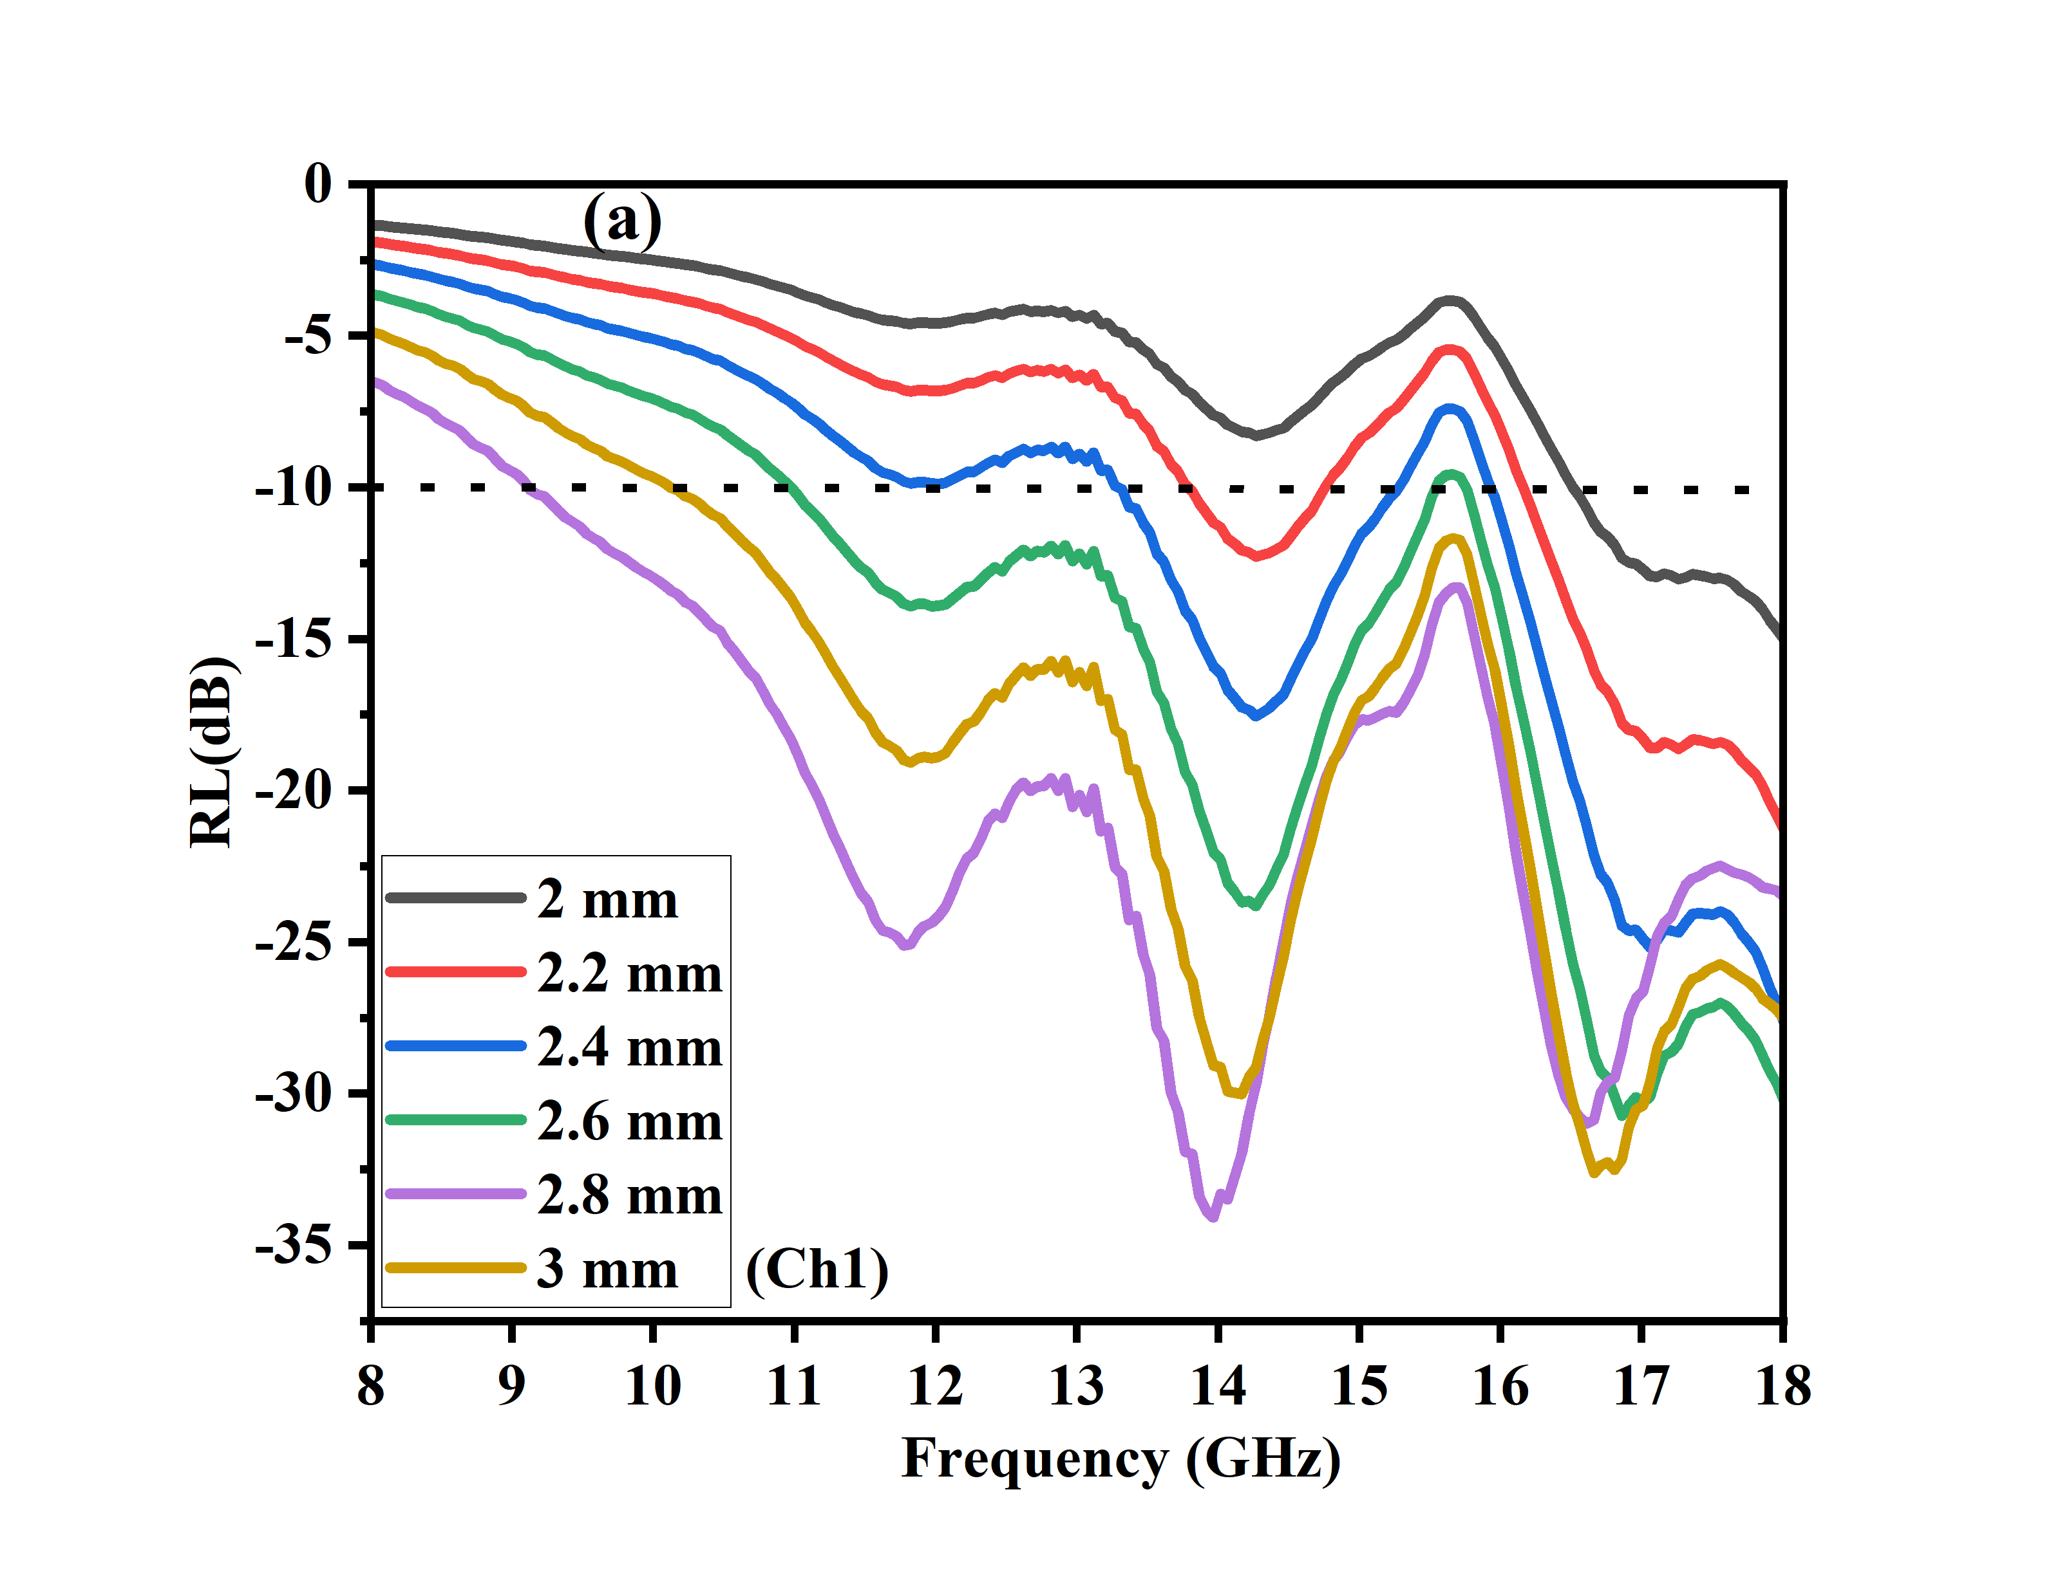
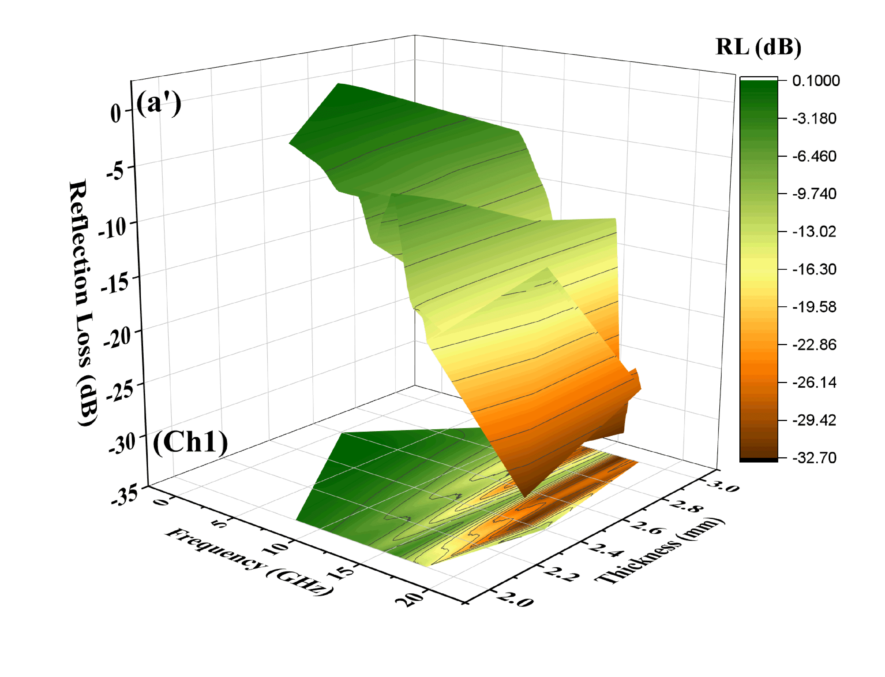
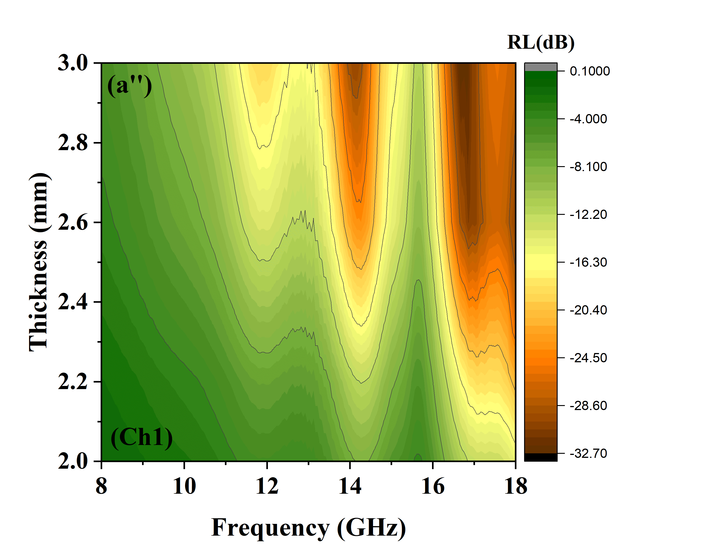
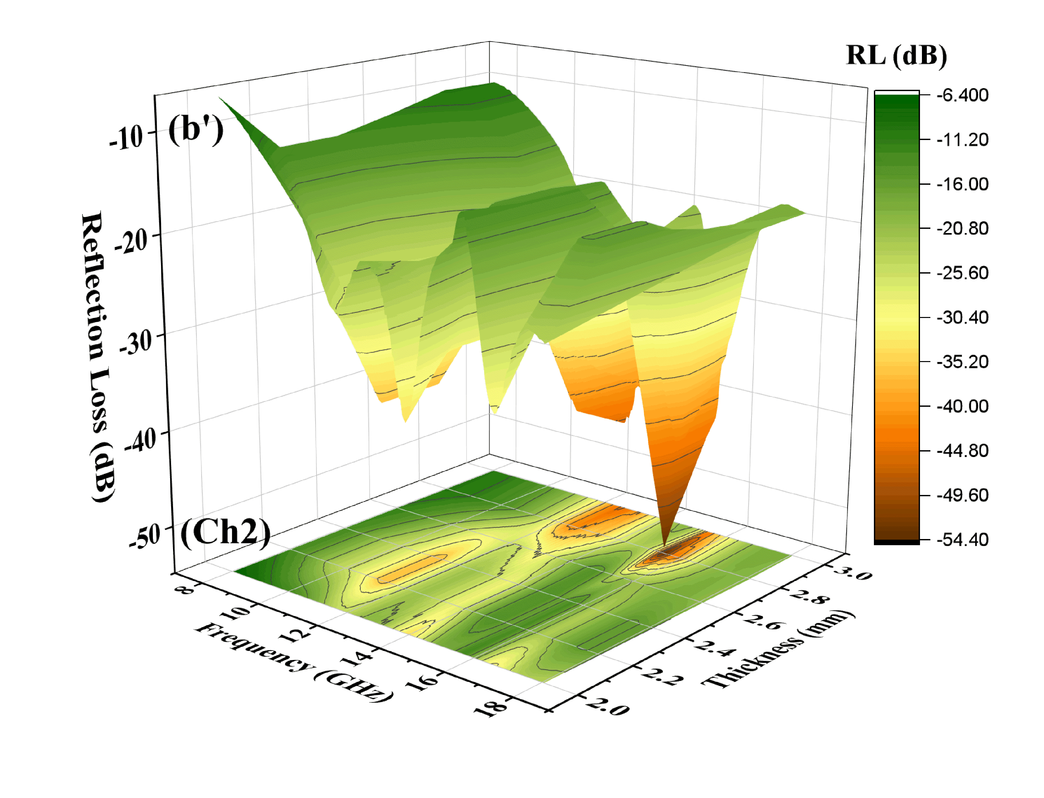
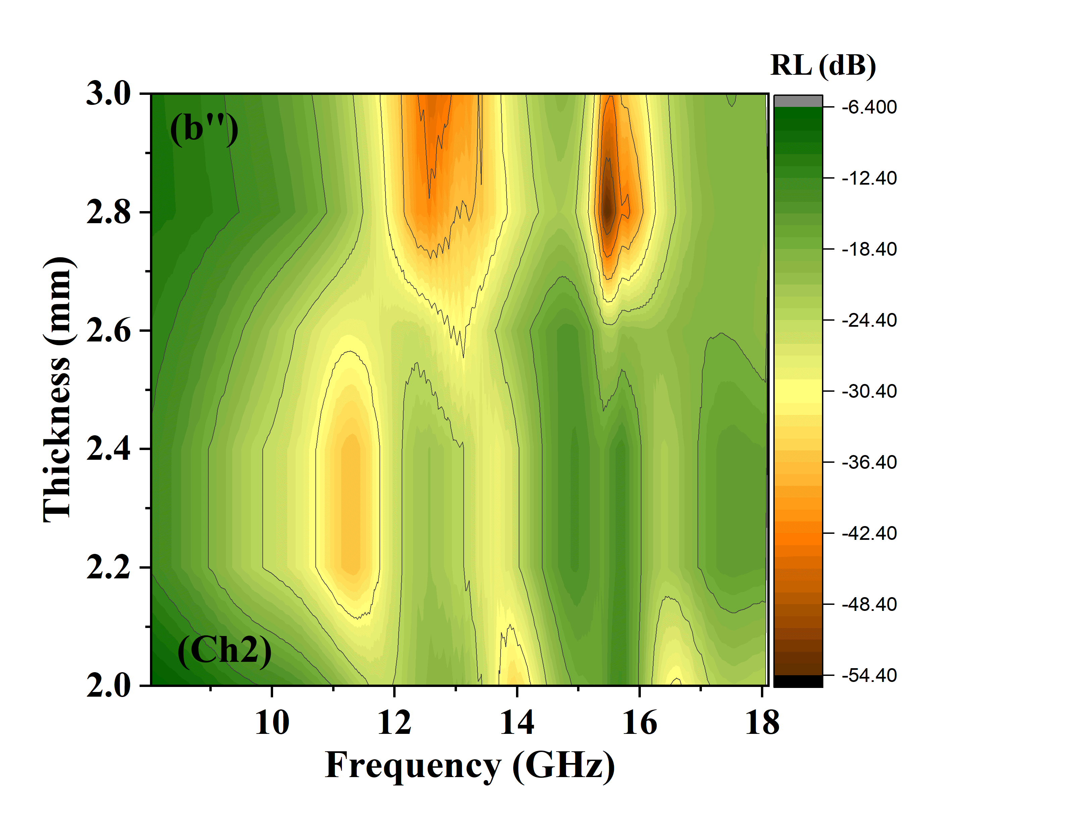
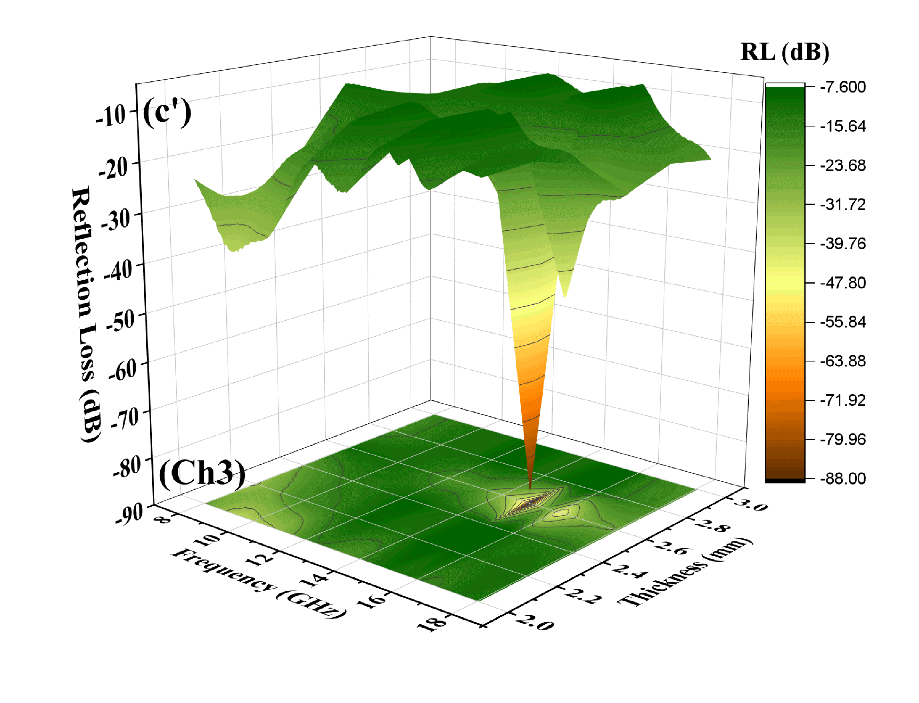
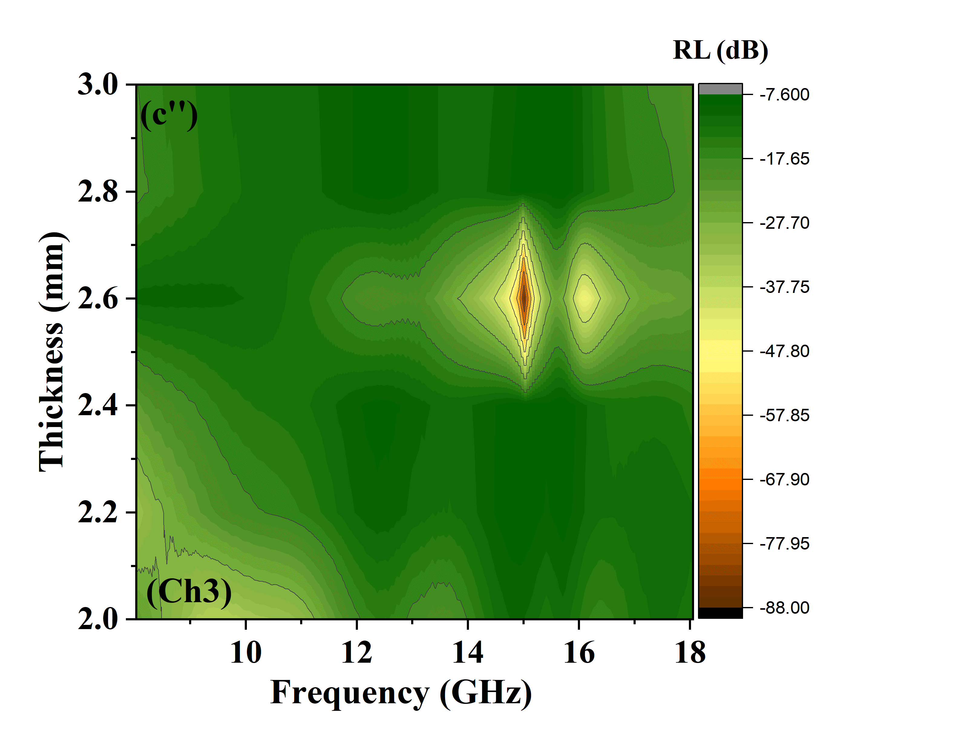
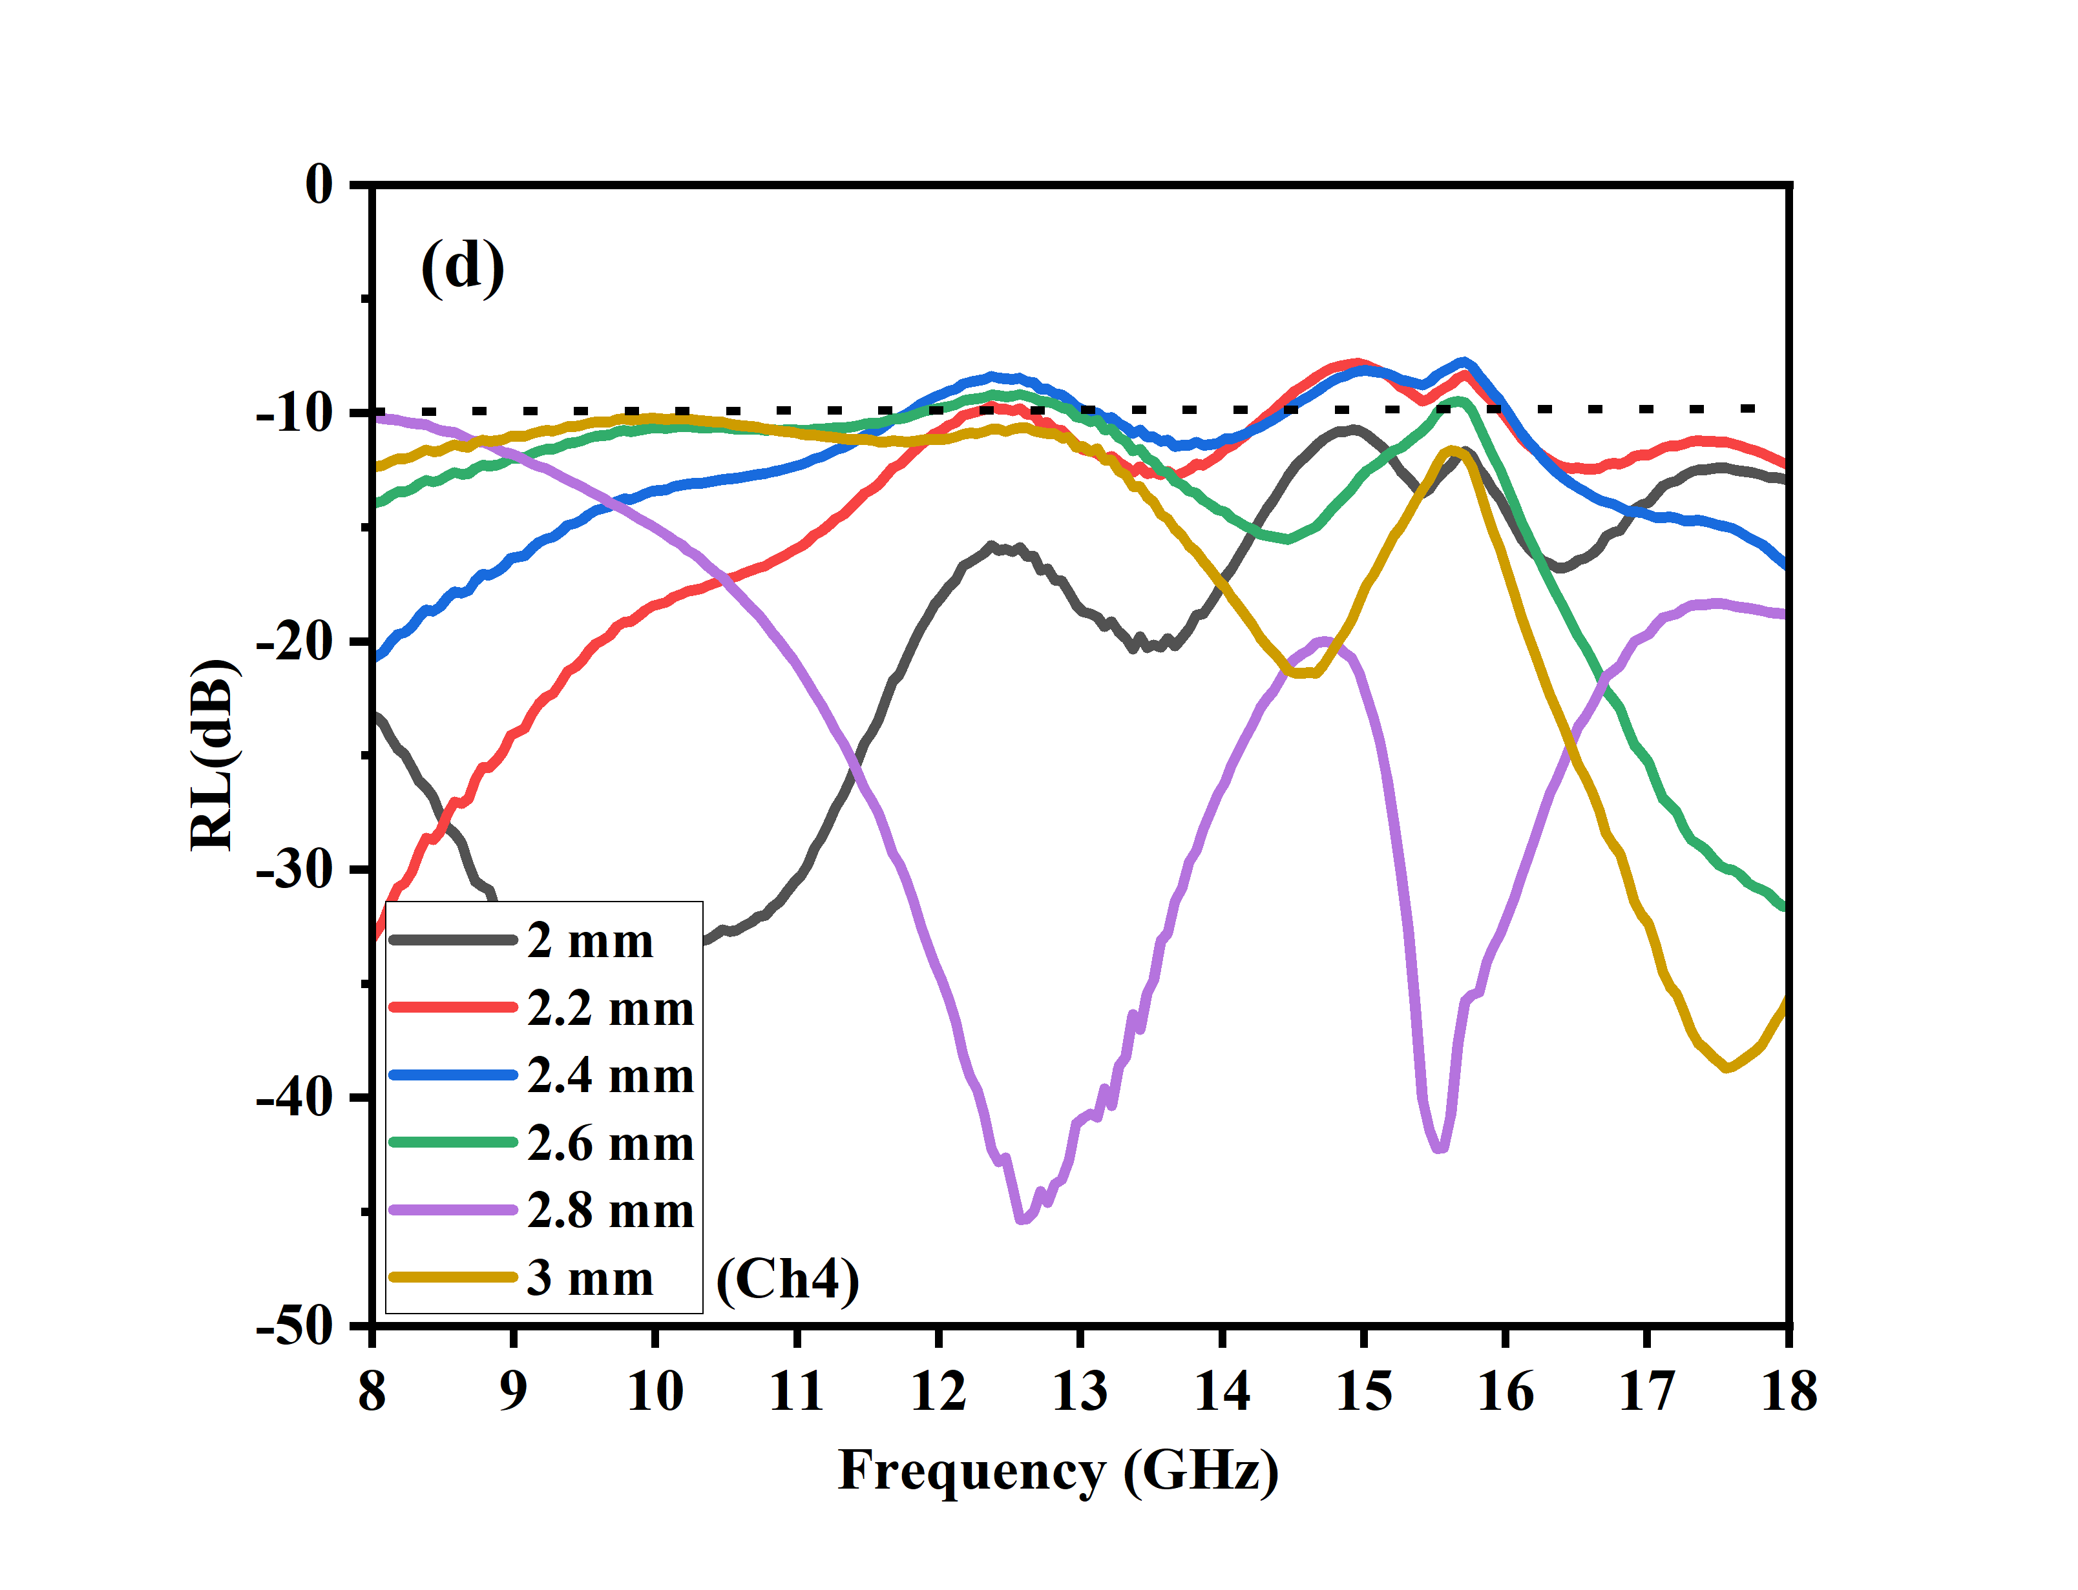
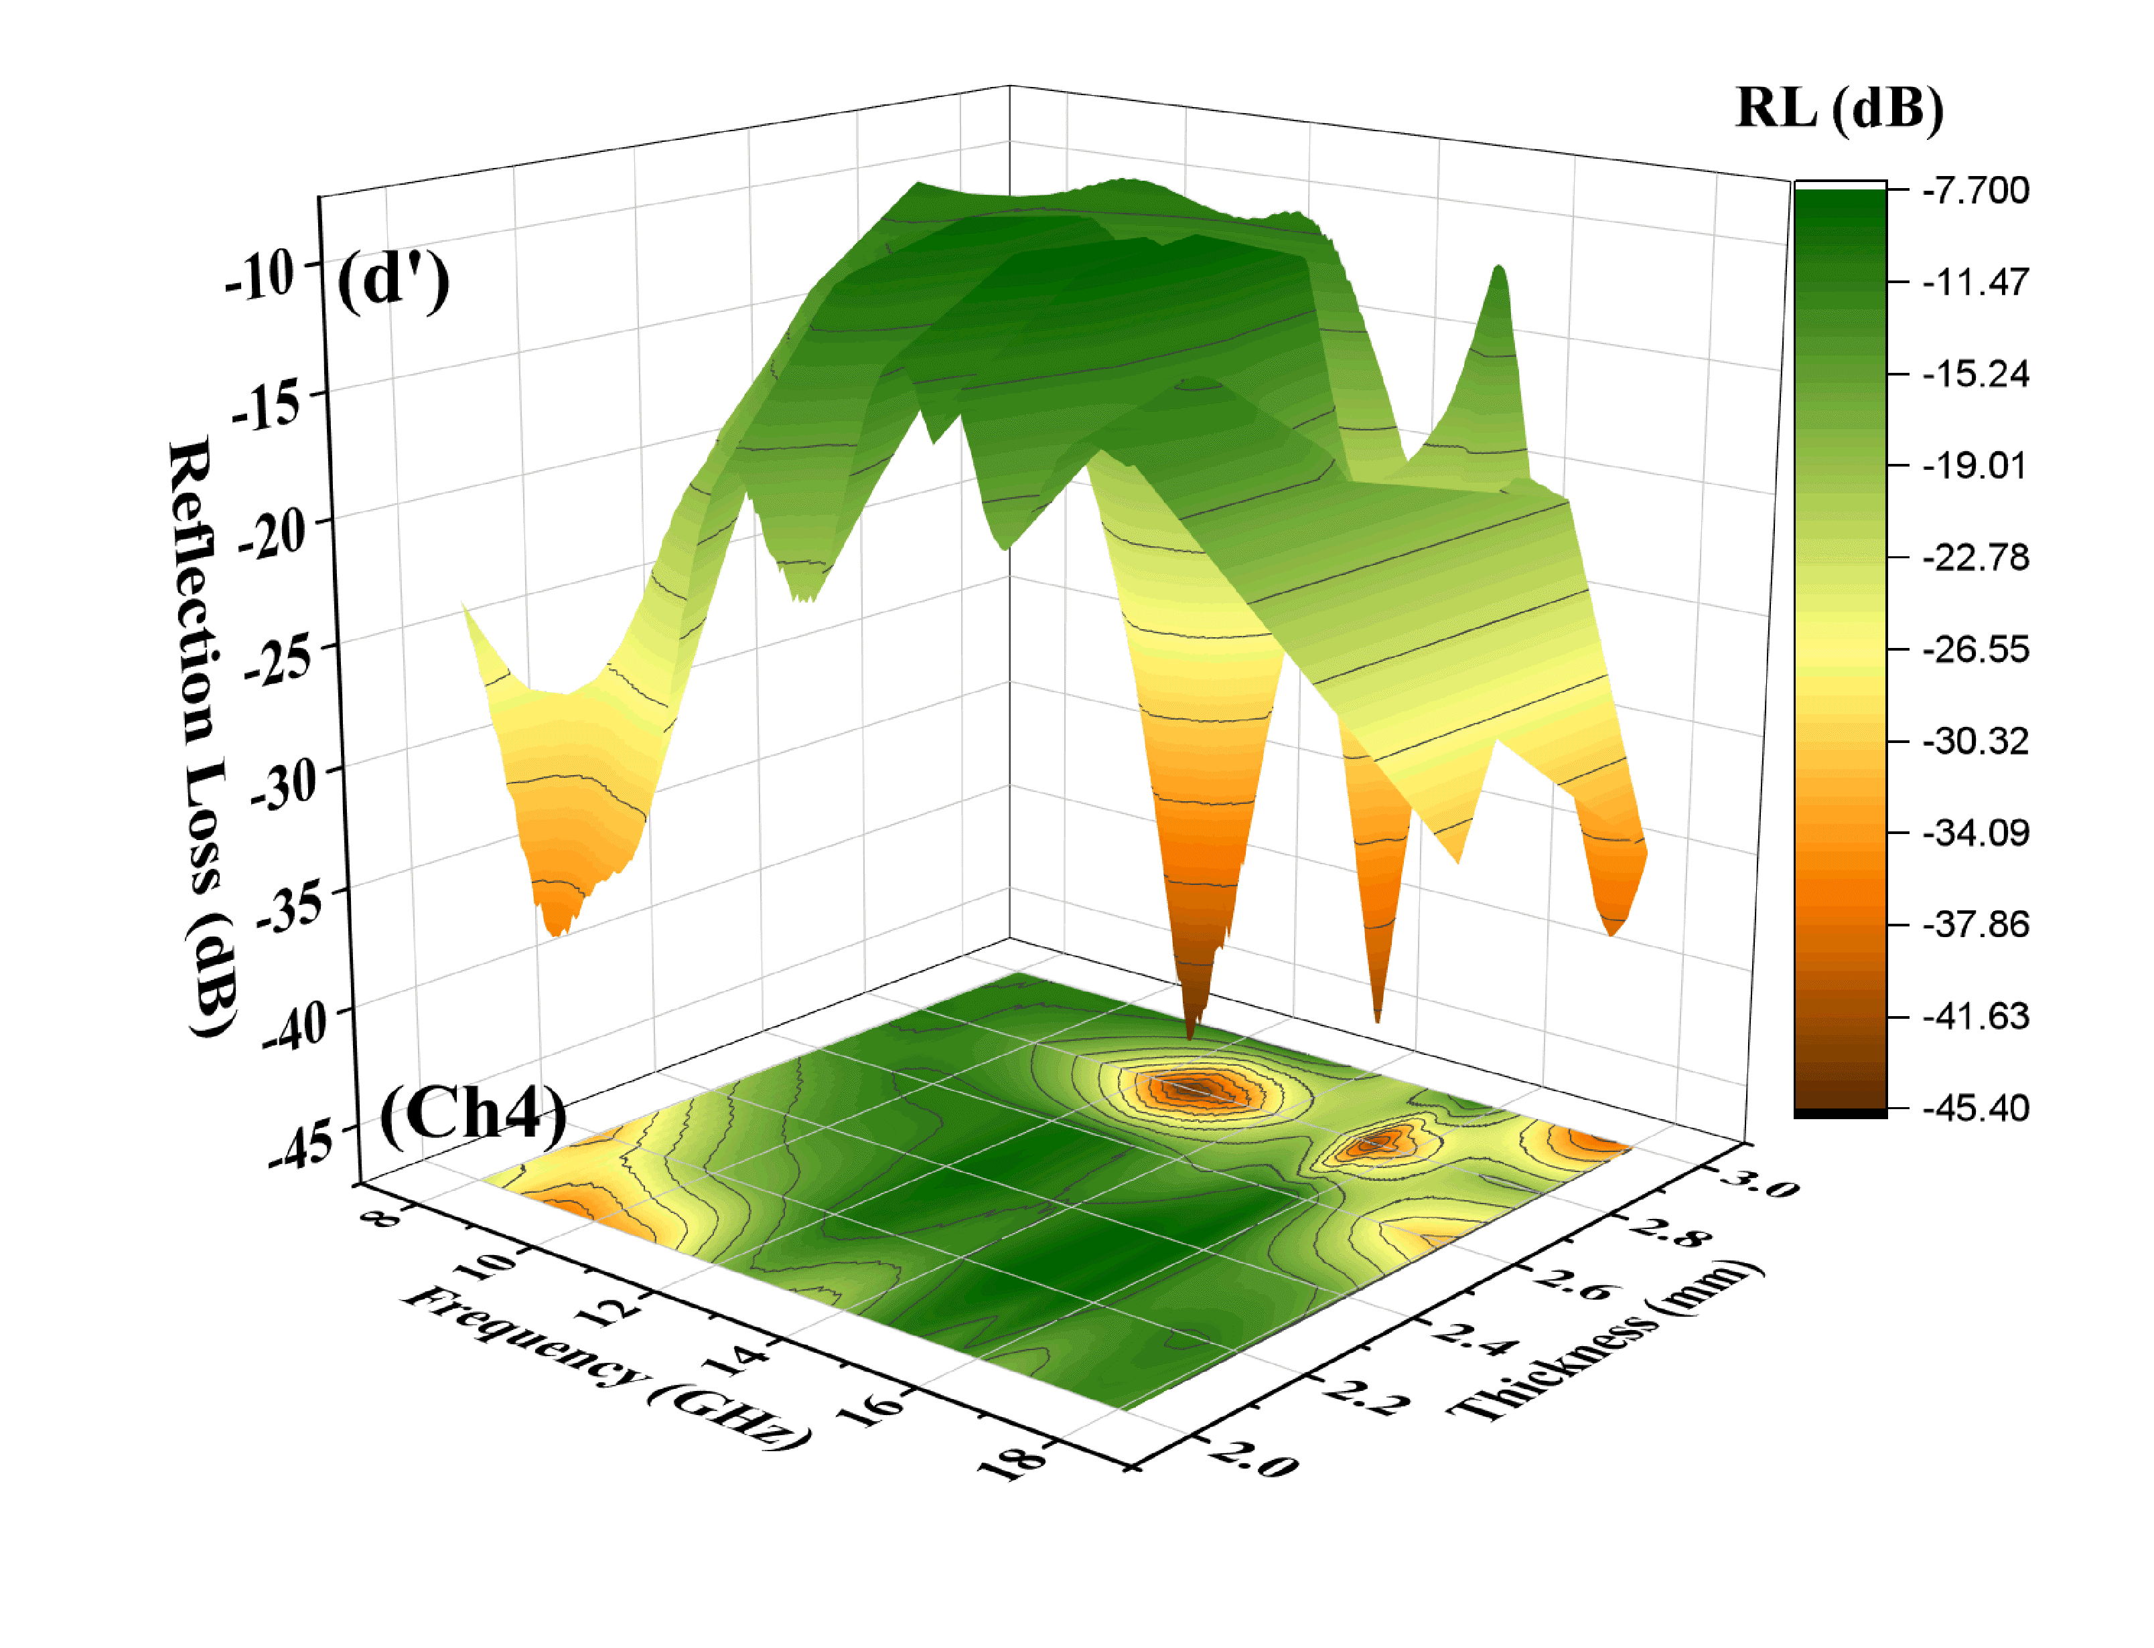
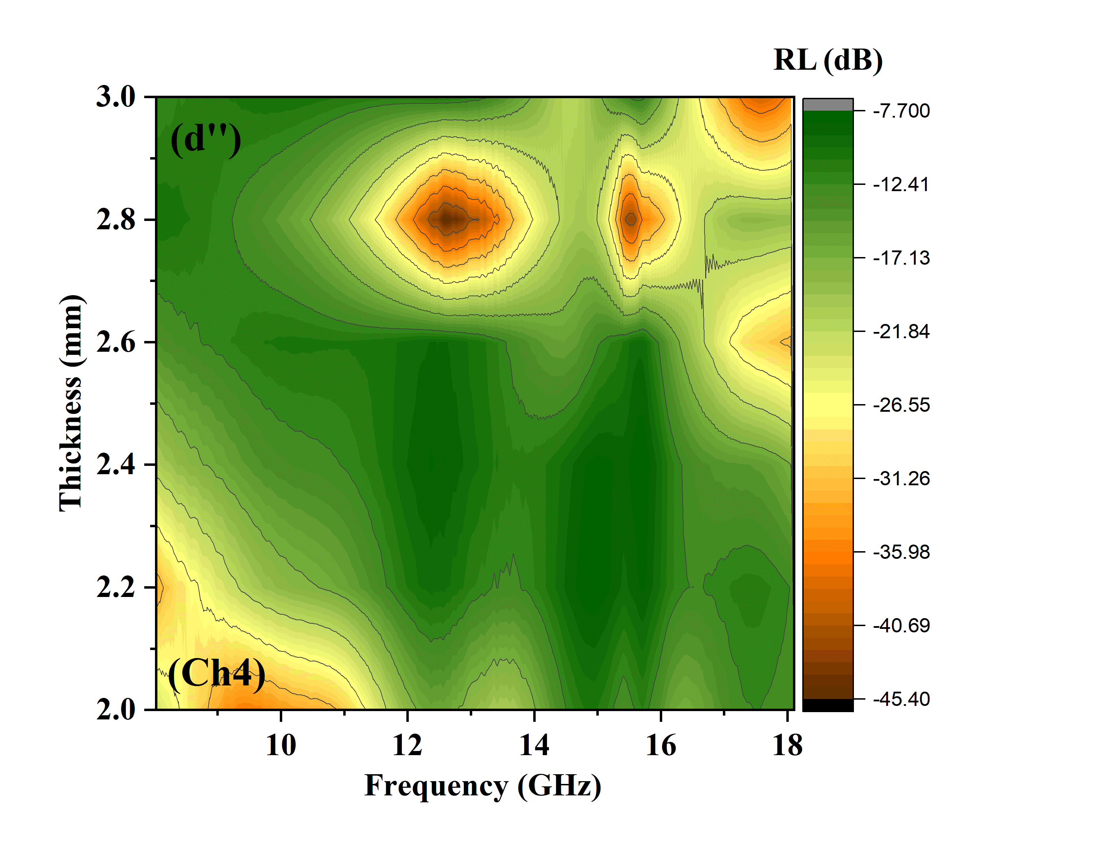
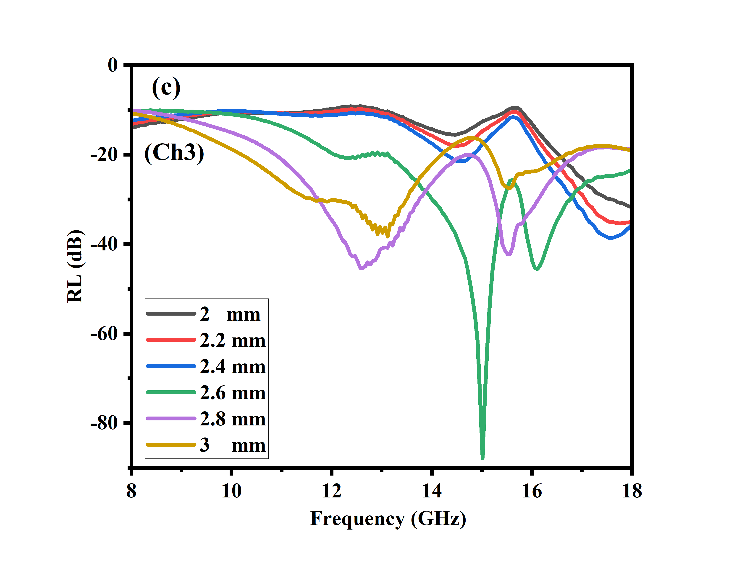

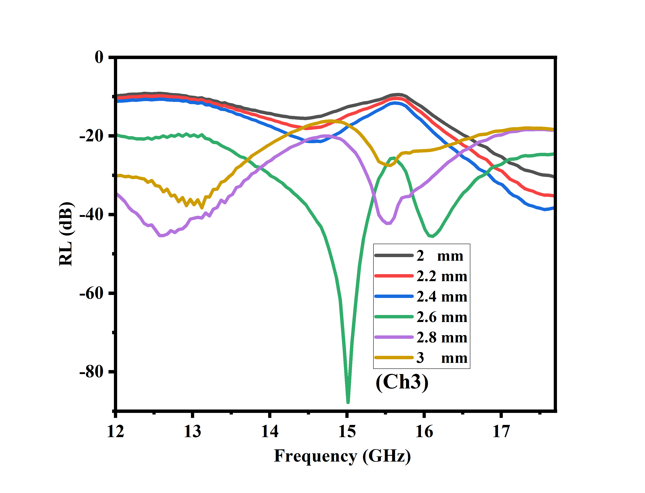
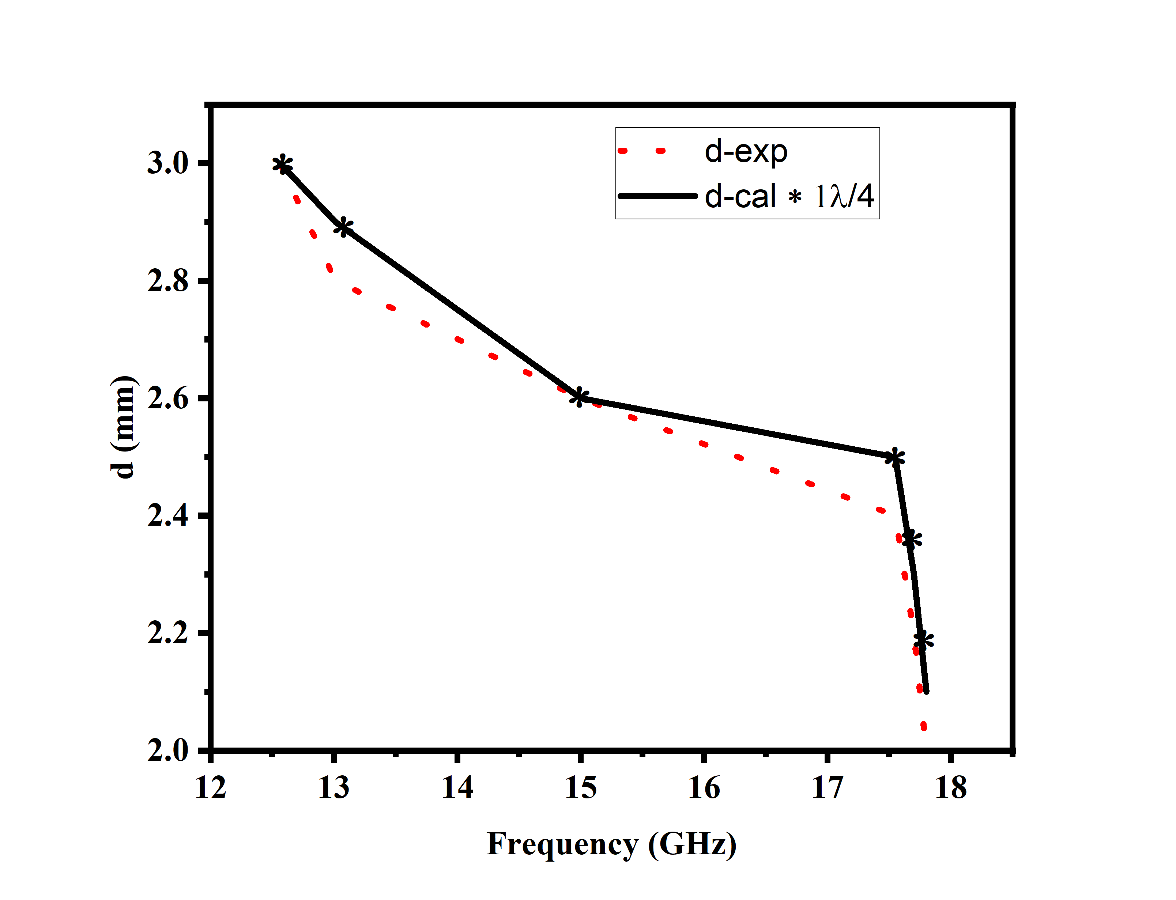

Fig. 5. 2D (a–d), 3D (a′–d′), contour (a″–d″) plots of frequency-dependent reflection loss for MoSe₂/MMT–Chitosan and MoSe₂/AC/MMT–Chitosan composites with different composite contents at various thicknesses and RL versus frequency at different absorber thicknesses (experimental and simulated) (e).

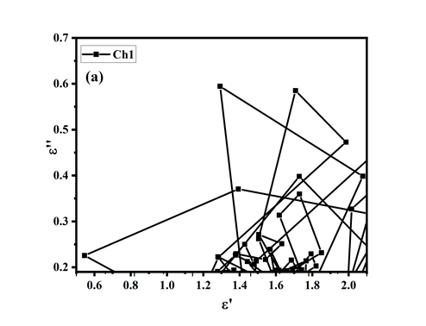
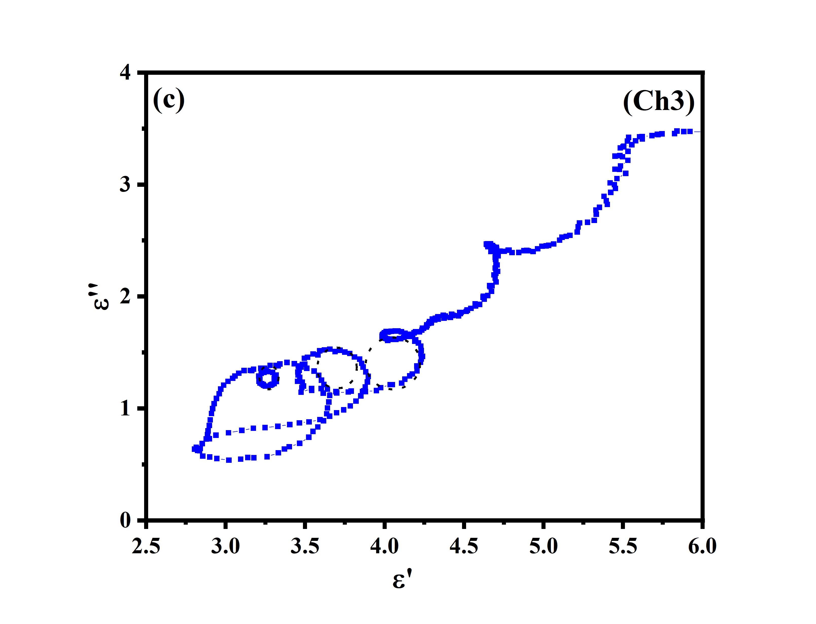
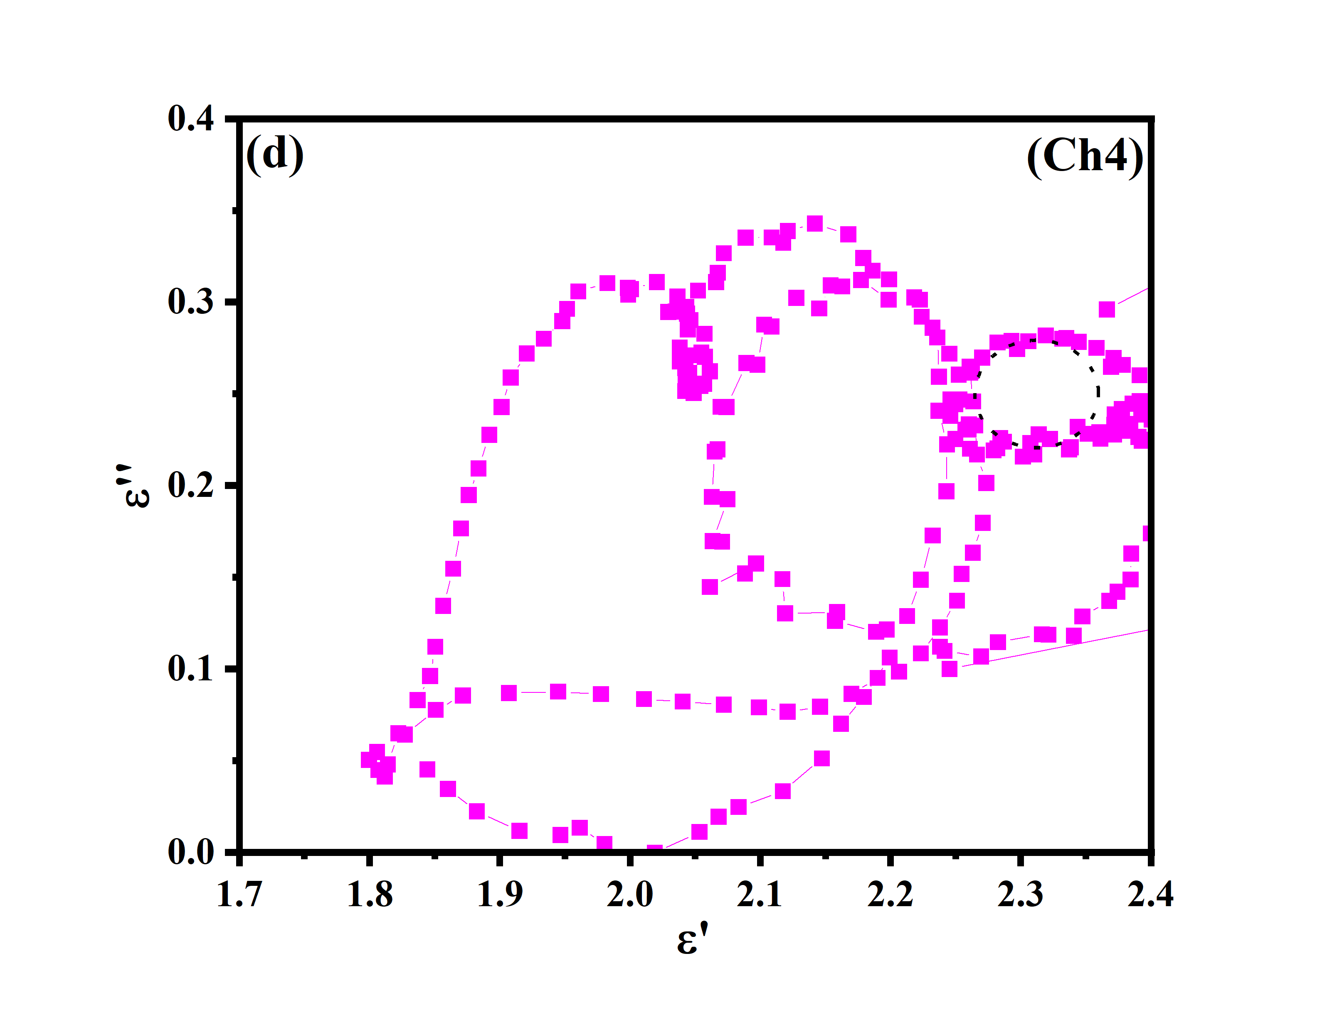
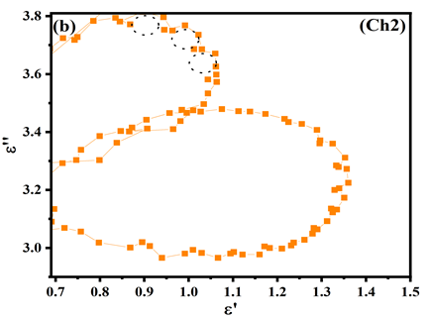

Fig. 6. Cole–Cole analysis of dielectric properties of MoSe₂/AC/MMT–Chitosan Aerogels.
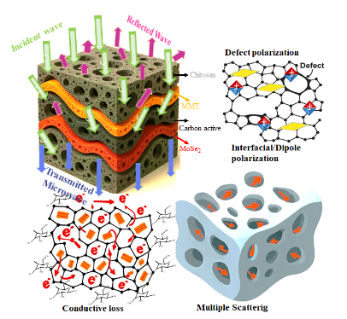

Fig. 7. Representation of the mechanisms underlying electromagnetic wave attenuation in the MoSe₂/AC/MMT-Chitosan Aerogel.
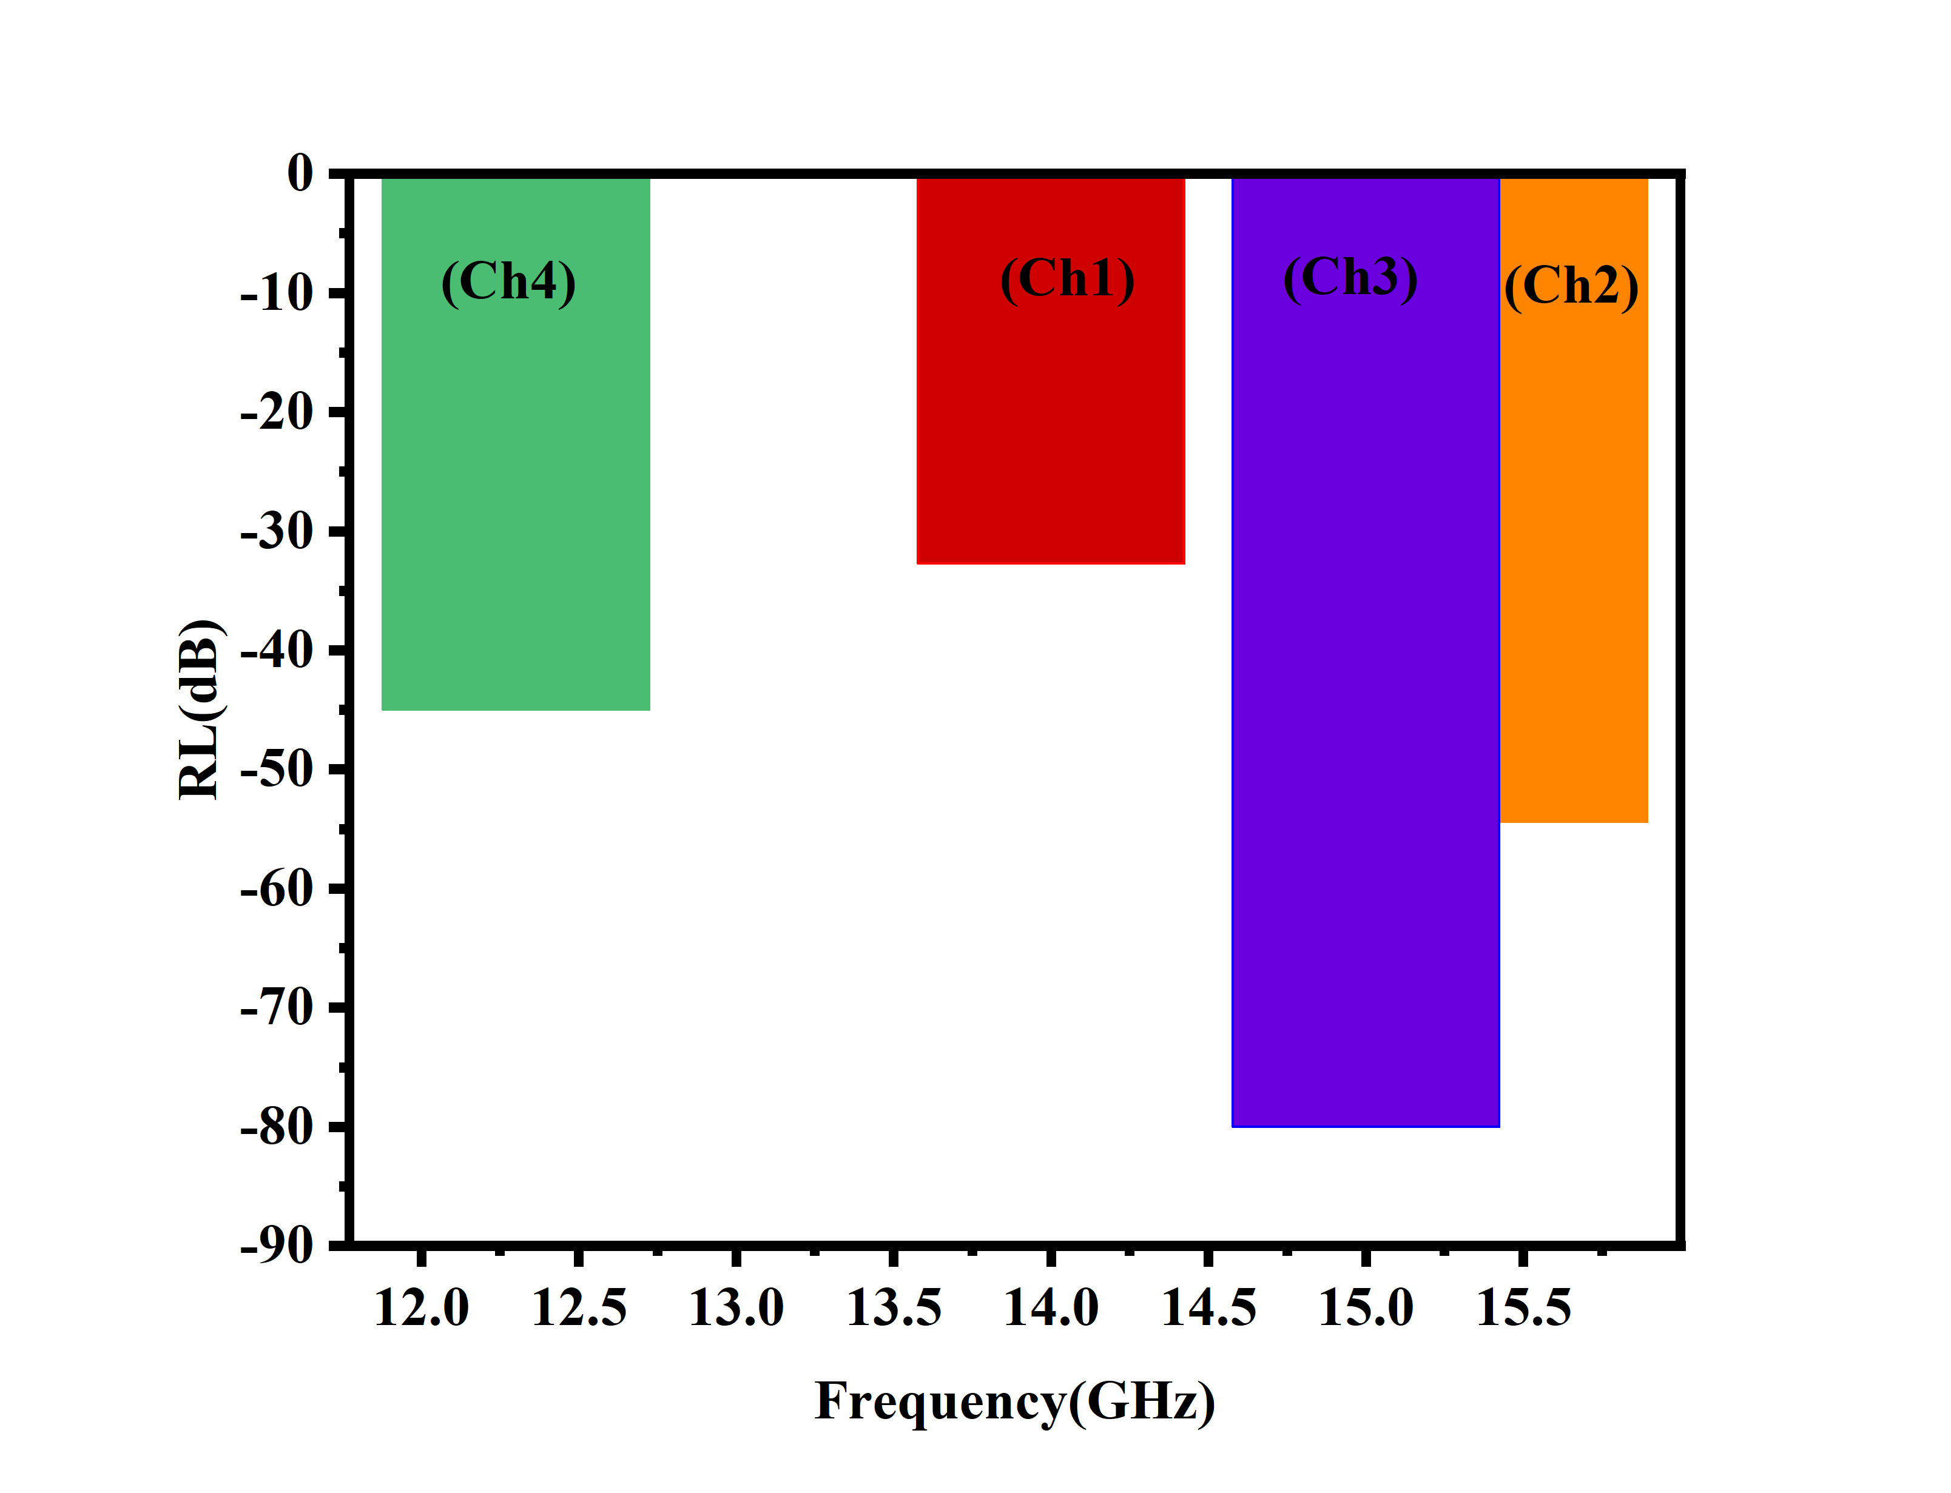
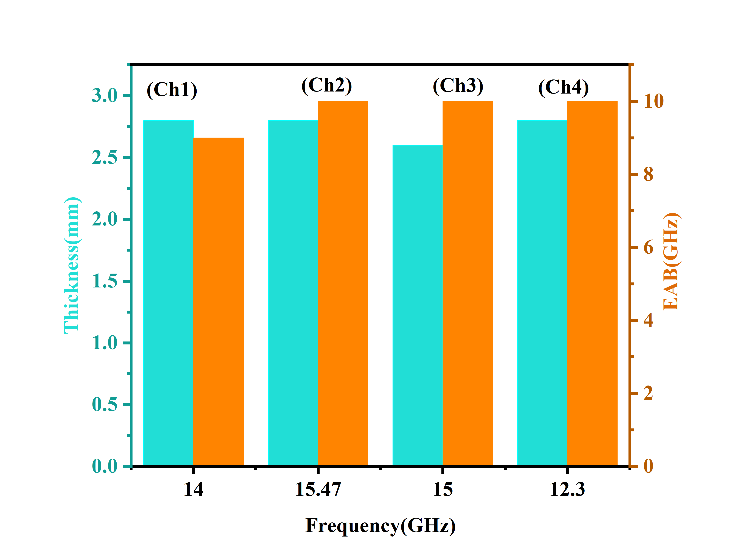
(a)
(b)

Fig. 8. (a) Comparison of reflection loss versus frequency for MoSe₂/AC/MMT–Chitosan with different filler contents, and (b) thickness and bandwidth versus frequency.
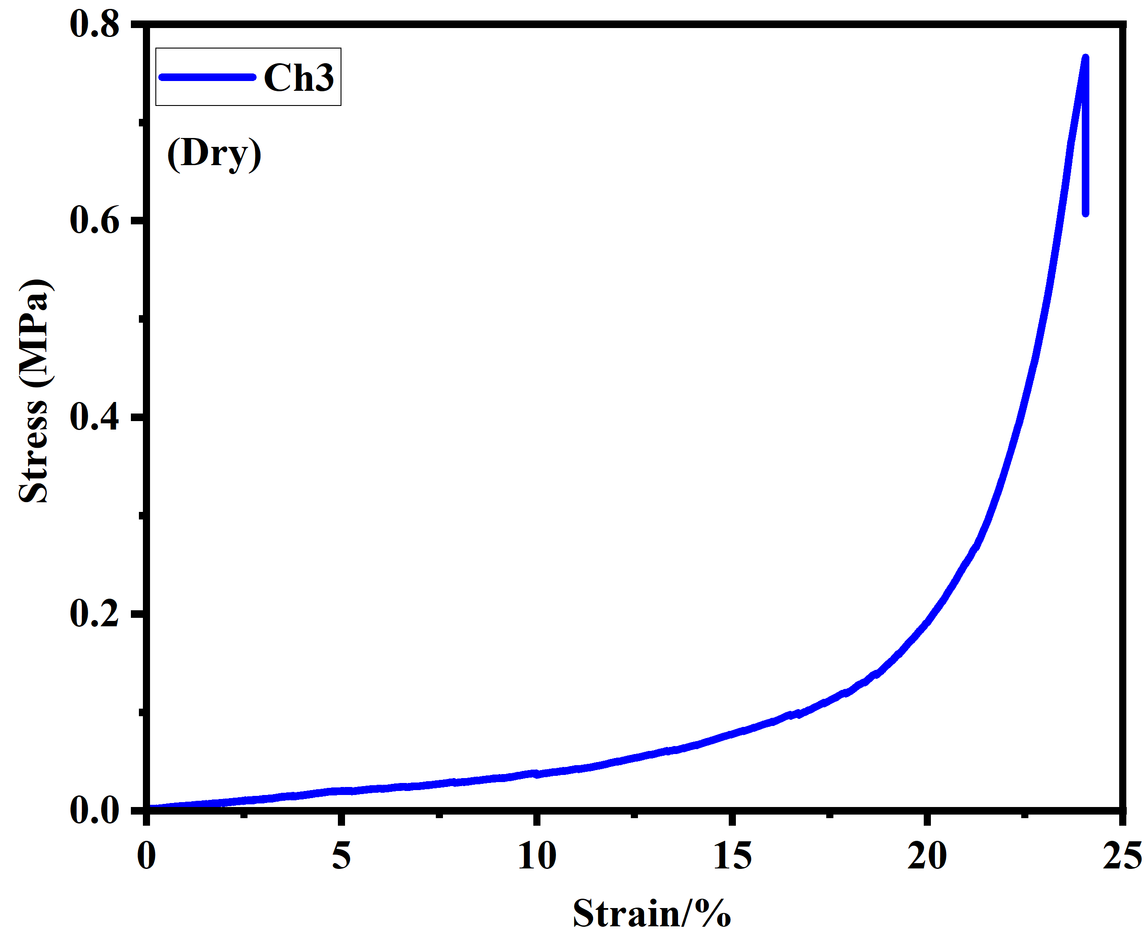

Figure.9. Stress-strain curves of chitosan and MoSe₂/AC/MMT(50 wt%)–Chitosan Aerogels.

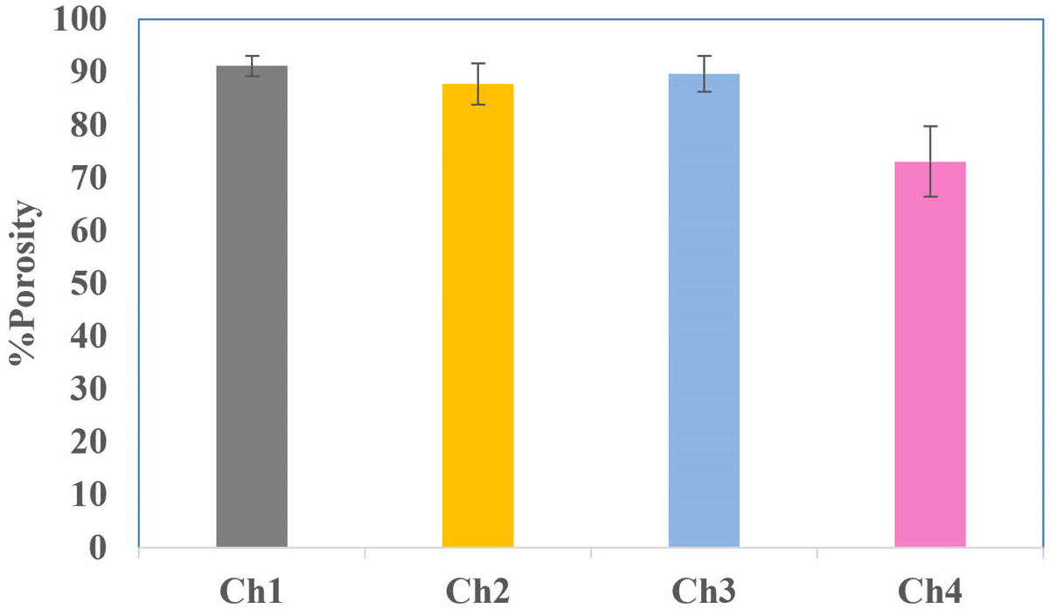

Figure10. % Porosity of Ch1,Ch2,Ch3 and Ch4.
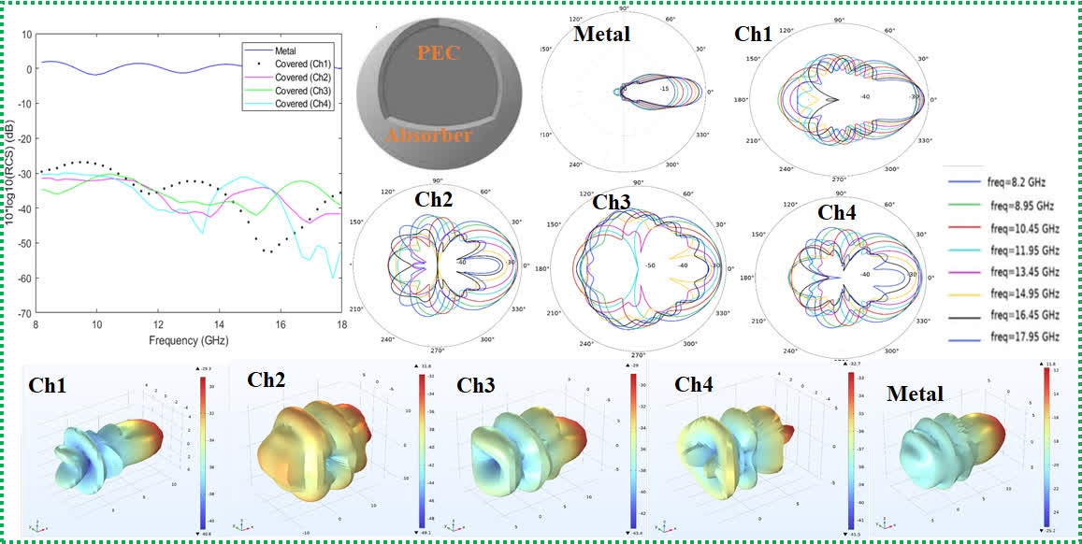
Fig. 11. RCS response and far-field scattering pattern of the coated metal sphere (Ch1–Ch4) at 14.95 GHz.

