Appendix S

Table S1: Performance comparison of machine learning models trained with different synthetic sampling techniques in Stage 2. Results are reported using imbalance-aware evaluation metrics on the independent testing set to assess generalization under synthetic data augmentation.
 | Metrics | DT | RF | SVM | LR | GB | LightGBM | CatBoost | AdaBoost | XGB | MLP
SMOTE | Accuracy | 0.6538 | 0.8076 | 0.7692 | 0.5576 | 0.7884 | 0.7307 | 0.8461 | 0.7884 | 0.6538 | 0.7115
SMOTE | Precision | 0.7075 | 0.8005 | 0.7951 | 0.6257 | 0.8197 | 0.7284 | 0.819 | 0.842 | 0.736 | 0.7325
SMOTE | Recall | 0.6538 | 0.8076 | 0.7692 | 0.5576 | 0.7884 | 0.7307 | 0.8461 | 0.7884 | 0.6538 | 0.7115
SMOTE | F1-score | 0.6758 | 0.8034 | 0.7547 | 0.5713 | 0.7709 | 0.7204 | 0.851 | 0.7819 | 0.6801 | 0.7179
SMOTE | MCC | 0.4911 | 0.6993 | 0.6372 | 0.3667 | 0.6775 | 0.5921 | 0.7584 | 0.6819 | 0.5134 | 0.5617
SMOTE-Bagging | Accuracy | 0.7307 | 0.7692 | 0.7115 | 0.5384 | 0.7884 | 0.7692 | 0.7623 | 0.7692 | 0.7115 | 0.7307
SMOTE-Bagging | Precision | 0.7627 | 0.7692 | 0.7519 | 0.6477 | 0.8327 | 0.7815 | 0.7335 | 0.8039 | 0.7378 | 0.7842
SMOTE-Bagging | Recall | 0.7307 | 0.7692 | 0.7115 | 0.5384 | 0.7884 | 0.7692 | 0.7623 | 0.7692 | 0.7115 | 0.7307
SMOTE-Bagging | F1-score | 0.7361 | 0.7686 | 0.704 | 0.5665 | 0.7768 | 0.7624 | 0.7596 | 0.7745 | 0.7144 | 0.7271
SMOTE-Bagging | MCC | 0.6 | 0.643 | 0.5489 | 0.3645 | 0.6809 | 0.6521 | 0.632 | 0.6496 | 0.5706 | 0.59

 | Metrics | RF-GB-SVM | SVM-RF-XGB | RF-DT-SVM-GB | RF-GB-SVM-MLP | RF-XGB-DT-LR | GB-RF-SVM-DT-CatBoost | RF-GB-SVM-DT-RF
SMOTE-Stacking | Accuracy | 0.8076 | 0.7115 | 0.7307 | 0.8076 | 0.7692 | 0.75 | 0.75
SMOTE-Stacking | Precision | 0.8198 | 0.6485 | 0.7638 | 0.8147 | 0.7334 | 0.748 | 0.7935
SMOTE-Stacking | Recall | 0.8076 | 0.7115 | 0.7308 | 0.8076 | 0.7692 | 0.75 | 0.75
SMOTE-Stacking | F1-score | 0.7852 | 0.6766 | 0.7206 | 0.7818 | 0.7488 | 0.7354 | 0.7418
SMOTE-Stacking | MCC | 0.6989 | 0.5439 | 0.5753 | 0.699 | 0.633 | 0.6124 | 0.6139

 |  | Metrics |  | DT | RF |  | SVM |  | LR |  | GB | LightGBM |  | CatBoost |  | AdaBoost |  | XGB | MLP
ADASYN |  | Accuracy |  | 0.6923 | 0.75 |  | 0.7692 |  | 0.5961 |  | 0.75 | 0.7692 |  | 0.8076 |  | 0.7115 |  | 0.75 | 0.6346
 |  | Precision |  | 0.7347 | 0.7693 |  | 0.8198 |  | 0.6706 |  | 0.7689 | 0.7722 |  | 0.8272 |  | 0.7759 |  | 0.7745 | 0.6525
 |  | Recall |  | 0.6923 | 0.75 |  | 0.7692 |  | 0.5961 |  | 0.75 | 0.7692 |  | 0.8076 |  | 0.7115 |  | 0.75 | 0.6346
 |  | F1-score |  | 0.6939 | 0.7523 |  | 0.767 |  | 0.6284 |  | 0.7401 | 0.767 |  | 0.8098 |  | 0.7246 |  | 0.7568 | 0.6318
 |  | MCC |  | 0.5421 | 0.6229 |  | 0.6448 |  | 0.4221 |  | 0.6244 | 0.6483 |  | 0.7113 |  | 0.5809 |  | 0.6218 | 0.449
ADASYN-Bagging |  | Accuracy |  | 0.6538 | 0.7115 |  | 0.7307 |  | 0.5769 |  | 0.7692 | 0.7692 |  | 0.7884 |  | 0.7115 |  | 0.7115 | 0.673
 |  | Precision |  | 0.6913 | 0.7338 |  | 0.77 |  | 0.6614 |  | 0.7755 | 0.7924 |  | 0.7983 |  | 0.7916 |  | 0.7361 | 0.7245
 |  | Recall |  | 0.6538 | 0.7115 |  | 0.7307 |  | 0.5769 |  | 0.7692 | 0.7692 |  | 0.7884 |  | 0.7115 |  | 0.7115 | 0.673
 |  | F1-score |  | 0.6677 | 0.7186 |  | 0.7234 |  | 0.611 |  | 0.765 | 0.77 |  | 0.7892 |  | 0.7412 |  | 0.7156 | 0.6879
 |  | MCC |  | 0.4897 | 0.565 |  | 0.5794 |  | 0.4029 |  | 0.6424 | 0.6519 |  | 0.6762 |  | 0.5871 |  | 0.5653 | 0.5122
 | Metrics |  | RF-GB-SVM |  |  | SVM-RF-XGB |  | RF-DT-SVM-GB |  | RF-GB-SVM-MLP |  |  | RF-XGB-DT-LR |  | GB-RF-SVM-DT-CatBoost |  | RF-GB-SVM-DT-RF
ADASYN-Stacking | Accuracy |  | 0.7692 |  |  | 0.8076 |  | 0.7692 |  | 0.75 |  |  | 0.75 |  | 0.7307 |  | 0.7884
ADASYN-Stacking | Precision |  | 0.7882 |  |  | 0.8452 |  | 0.7923 |  | 0.7761 |  |  | 0.7473 |  | 0.7159 |  | 0.8042
ADASYN-Stacking | Recall |  | 0.7692 |  |  | 0.8076 |  | 0.7692 |  | 0.75 |  |  | 0.75 |  | 0.7307 |  | 0.7884
ADASYN-Stacking | F1-score |  | 0.7438 |  |  | 0.799 |  | 0.7526 |  | 0.7361 |  |  | 0.7381 |  | 0.7142 |  | 0.7659
ADASYN-Stacking | MCC |  | 0.6442 |  |  | 0.7021 |  | 0.6376 |  | 0.6057 |  |  | 0.6119 |  | 0.5757 |  | 0.6701

 | Metrics | DT | RF | SVM | LR | GB | LightGBM | CatBoost | AdaBoost | XGB | MLP
Tomek | Accuracy | 0.6346 | 0.8076 | 0.7307 | 0.5384 | 0.8269 | 0.7692 | 0.7692 | 0.75 | 0.7307 | 0.7115
Tomek | Precision | 0.744 | 0.8005 | 0.7715 | 0.6487 | 0.8542 | 0.8423 | 0.7515 | 0.846 | 0.7484 | 0.7343
Tomek | Recall | 0.6346 | 0.8076 | 0.7307 | 0.5384 | 0.8269 | 0.7692 | 0.7692 | 0.75 | 0.7307 | 0.7115
Tomek | F1-score | 0.6806 | 0.8034 | 0.7229 | 0.5691 | 0.8081 | 0.7696 | 0.76 | 0.7659 | 0.7299 | 0.7137
Tomek | MCC | 0.4892 | 0.6993 | 0.5803 | 0.3712 | 0.7371 | 0.6618 | 0.639 | 0.633 | 0.5839 | 0.5579
Tomek-Bagging | Accuracy | 0.7884 | 0.75 | 0.6923 | 0.5384 | 0.75 | 0.7307 | 0.8269 | 0.7115 | 0.7307 | 0.7115
Tomek-Bagging | Precision | 0.7984 | 0.7743 | 0.7344 | 0.6502 | 0.7891 | 0.8147 | 0.8671 | 0.7346 | 0.7435 | 0.7438
Tomek-Bagging | Recall | 0.7884 | 0.75 | 0.6923 | 0.5384 | 0.75 | 0.7307 | 0.8269 | 0.7115 | 0.7307 | 0.7115
Tomek-Bagging | F1-score | 0.7884 | 0.7585 | 0.6852 | 0.5762 | 0.7393 | 0.7399 | 0.8179 | 0.7211 | 0.7332 | 0.713
Tomek-Bagging | MCC | 0.6788 | 0.6261 | 0.519 | 0.3625 | 0.6156 | 0.6328 | 0.7355 | 0.5588 | 0.5866 | 0.5634

 | Metrics | RF-GB-SVM | SVM-RF-XGB | RF-DT-SVM-GB | RF-GB-SVM-MLP | RF-XGB-DT-LR | GB-RF-SVM-DT-CatBoost | RF-GB-SVM-DT-RF
Tomek-Stacking | Accuracy | 0.75 | 0.6923 | 0.7115 | 0.75 | 0.7115 | 0.8076 | 0.7692
Tomek-Stacking | Precision | 0.768 | 0.6844 | 0.6385 | 0.78 | 0.7047 | 0.8036 | 0.7556
Tomek-Stacking | Recall | 0.75 | 0.6923 | 0.7115 | 0.75 | 0.7115 | 0.8076 | 0.7692
Tomek-Stacking | F1-score | 0.728 | 0.6808 | 0.6722 | 0.7421 | 0.7059 | 0.7928 | 0.7327
Tomek-Stacking | MCC | 0.6089 | 0.5163 | 0.5386 | 0.6101 | 0.5501 | 0.7078 | 0.6293

 | Metrics | DT | RF | SVM | LR | GB | LightGBM | CatBoost | AdaBoost | XGB | MLP
BL1 | Accuracy | 0.5 | 0.7884 | 0.673 | 0.5576 | 0.7884 | 0.75 | 0.7307 | 0.7692 | 0.6346 | 0.6346
BL1 | Precision | 0.5121 | 0.7829 | 0.7551 | 0.6158 | 0.8106 | 0.7791 | 0.7976 | 0.8403 | 0.6399 | 0.6941
BL1 | Recall | 0.5 | 0.7884 | 0.673 | 0.5576 | 0.7884 | 0.75 | 0.7307 | 0.7692 | 0.6346 | 0.6346
BL1 | F1-score | 0.4899 | 0.7804 | 0.687 | 0.574 | 0.7674 | 0.7321 | 0.7269 | 0.7661 | 0.6327 | 0.6563
BL1 | MCC | 0.2505 | 0.671 | 0.5006 | 0.3652 | 0.6738 | 0.6158 | 0.6042 | 0.6646 | 0.4375 | 0.4521
BL1-Bagging | Accuracy | 0.6153 | 0.6923 | 0.7307 | 0.5576 | 0.7884 | 0.6923 | 0.8076 | 0.75 | 0.673 | 0.673
BL1-Bagging | Precision | 0.627 | 0.6998 | 0.7768 | 0.6158 | 0.8106 | 0.7634 | 0.8211 | 0.8189 | 0.7254 | 0.736
BL1-Bagging | Recall | 0.6153 | 0.6923 | 0.7307 | 0.5576 | 0.7692 | 0.6923 | 0.8076 | 0.75 | 0.673 | 0.673
BL1-Bagging | F1-score | 0.6131 | 0.69 | 0.7217 | 0.574 | 0.7674 | 0.6894 | 0.8035 | 0.7471 | 0.6848 | 0.6787
BL1-Bagging | MCC | 0.4216 | 0.5322 | 0.5841 | 0.3652 | 0.6738 | 0.5465 | 0.7108 | 0.6339 | 0.5192 | 0.4939

 | Metrics | RF-GB-SVM | SVM-RF-XGB | RF-DT-SVM-GB | RF-GB-SVM-MLP | RF-XGB-DT-LR | GB-RF-SVM-DT-CatBoost | RF-GB-SVM-DT-RF
BL1-Stacking | Accuracy | 0.7115 | 0.6538 | 0.7115 | 0.7884 | 0.75 | 0.7115 | 0.7884
BL1-Stacking | Precision | 0.7283 | 0.6575 | 0.6905 | 0.8163 | 0.7523 | 0.7511 | 0.8209
BL1-Stacking | Recall | 0.7115 | 0.6538 | 0.7115 | 0.7884 | 0.75 | 0.7115 | 0.7884
BL1-Stacking | F1-score | 0.6915 | 0.6541 | 0.695 | 0.7701 | 0.7234 | 0.7024 | 0.7685
BL1-Stacking | MCC | 0.5413 | 0.4693 | 0.5455 | 0.6736 | 0.5986 | 0.5512 | 0.6791

 | Metrics | DT | RF | SVM | LR | GB | LightGBM | CatBoost | AdaBoost | XGB | MLP
BL2 | Accuracy | 0.6538 | 0.8269 | 0.75 | 0.5961 | 0.8269 | 0.8076 | 0.8269 | 0.7307 | 0.7115 | 0.75
BL2 | Precision | 0.6405 | 0.8023 | 0.8312 | 0.674 | 0.8313 | 0.8347 | 0.8382 | 0.7659 | 0.7312 | 0.7452
BL2 | Recall | 0.6538 | 0.8269 | 0.75 | 0.5961 | 0.8269 | 0.8076 | 0.8269 | 0.7307 | 0.7115 | 0.75
BL2 | F1-score | 0.644 | 0.8137 | 0.762 | 0.6117 | 0.8148 | 0.8007 | 0.804 | 0.7345 | 0.7189 | 0.7388
BL2 | MCC | 0.4646 | 0.7269 | 0.622 | 0.4389 | 0.7281 | 0.7091 | 0.7298 | 0.6036 | 0.5599 | 0.6098
BL2-Bagging | Accuracy | 0.6923 | 0.7884 | 0.7884 | 0.5769 | 0.7884 | 0.7692 | 0.8076 | 0.75 | 0.75 | 0.7115
BL2-Bagging | Precision | 0.728 | 0.774 | 0.8384 | 0.6666 | 0.8166 | 0.7653 | 0.8035 | 0.7719 | 0.7779 | 0.7918
BL2-Bagging | Recall | 0.6923 | 0.7884 | 0.7884 | 0.5769 | 0.7884 | 0.7692 | 0.8076 | 0.75 | 0.75 | 0.7115
BL2-Bagging | F1-score | 0.7003 | 0.7803 | 0.7852 | 0.597 | 0.7701 | 0.7613 | 0.7995 | 0.7487 | 0.7549 | 0.7231
BL2-Bagging | MCC | 0.5462 | 0.6696 | 0.6757 | 0.4187 | 0.6765 | 0.6411 | 0.7021 | 0.6267 | 0.6225 | 0.566

 | Metrics | RF-GB-SVM | SVM-RF-XGB | RF-DT-SVM-GB | RF-GB-SVM-MLP | RF-XGB-DT-LR | GB-RF-SVM-DT-CatBoost | RF-GB-SVM-DT-RF
BL2-Stacking | Accuracy | 0.8076 | 0.75 | 0.6346 | 0.8269 | 0.8076 | 0.6923 | 0.7884
BL2-Stacking | Precision | 0.7875 | 0.7039 | 0.6404 | 0.8593 | 0.7678 | 0.6777 | 0.7491
BL2-Stacking | Recall | 0.8076 | 0.75 | 0.6346 | 0.8269 | 0.8076 | 0.6923 | 0.7884
BL2-Stacking | F1-score | 0.7887 | 0.7181 | 0.6346 | 0.8124 | 0.7766 | 0.6779 | 0.7588
BL2-Stacking | MCC | 0.6998 | 0.5975 | 0.4364 | 0.7357 | 0.6945 | 0.5113 | 0.6611

 | Metrics | DT | RF | SVM | LR | GB | LightGBM | CatBoost | AdaBoost | XGB | MLP
ENN | Accuracy | 0.5 | 0.5769 | 0.6538 | 0.5 | 0.5384 | 0.5576 | 0.5961 | 0.6153 | 0.5384 | 0.5769
ENN | Precision | 0.6577 | 0.7309 | 0.7254 | 0.5597 | 0.6729 | 0.6397 | 0.6823 | 0.7468 | 0.6899 | 0.6475
ENN | Recall | 0.5 | 0.5769 | 0.6538 | 0.5 | 0.5384 | 0.5576 | 0.5961 | 0.6153 | 0.5384 | 0.5769
ENN | F1-score | 0.5549 | 0.6038 | 0.6805 | 0.5195 | 0.5633 | 0.5812 | 0.6209 | 0.6592 | 0.5803 | 0.5987
ENN | MCC | 0.3289 | 0.4198 | 0.5026 | 0.2846 | 0.373 | 0.3849 | 0.4378 | 0.479 | 0.3768 | 0.387
ENN-Bagging | Accuracy | 0.5384 | 0.5384 | 0.6346 | 0.5 | 0.5192 | 0.5576 | 0.6153 | 0.6346 | 0.5192 | 0.5576
ENN-Bagging | Precision | 0.6716 | 0.7112 | 0.703 | 0.5727 | 0.6484 | 0.6758 | 0.692 | 0.7357 | 0.6823 | 0.6794
ENN-Bagging | Recall | 0.5384 | 0.5384 | 0.6346 | 0.5 | 0.5192 | 0.5576 | 0.6153 | 0.6346 | 0.5192 | 0.5576
ENN-Bagging | F1-score | 0.5811 | 0.5758 | 0.6598 | 0.525 | 0.5514 | 0.5865 | 0.6391 | 0.6729 | 0.5594 | 0.5981
ENN-Bagging | MCC | 0.3737 | 0.3689 | 0.4726 | 0.2927 | 0.3564 | 0.3988 | 0.4583 | 0.4868 | 0.3573 | 0.3896

 | Metrics | RF-GB-SVM | SVM-RF-XGB | RF-DT-SVM-GB | RF-GB-SVM-MLP | RF-XGB-DT-LR | GB-RF-SVM-DT-CatBoost | RF-GB-SVM-DT-RF
ENN-Stacking | Accuracy | 0.5961 | 0.6153 | 0.5 | 0.5961 | 0.5769 | 0.673 | 0.5576
ENN-Stacking | Precision | 0.661 | 0.6429 | 0.5982 | 0.6643 | 0.6614 | 7393 | 0.663
ENN-Stacking | Recall | 0.5962 | 0.6154 | 0.5 | 0.5962 | 0.5769 | 0.673 | 0.5576
ENN-Stacking | F1-score | 0.6032 | 0.6239 | 0.518 | 0.6115 | 0.5925 | 0.6838 | 0.5852
ENN-Stacking | MCC | 0.4158 | 0.4237 | 0.3023 | 0.4243 | 0.4036 | 0.5399 | 0.382

 | Metrics | DT | RF | SVM | LR | GB | LightGBM | CatBoost | AdaBoost | XGB | MLP
SVM | Accuracy | 0.5576 | 0.7884 | 0.75 | 0.5769 | 0.7692 | 0.7307 | 0.7884 | 0.75 | 0.7115 | 0.6346
SVM | Precision | 0.6252 | 0.7736 | 0.7768 | 0.6331 | 0.8044 | 0.7674 | 0.7884 | 0.8037 | 0.6952 | 0.6738
SVM | Recall | 0.5576 | 0.7884 | 0.75 | 0.5769 | 0.7692 | 0.7307 | 0.7884 | 0.75 | 0.7115 | 0.6346
SVM | F1-score | 0.5823 | 0.7712 | 0.7365 | 0.594 | 0.7578 | 0.7371 | 0.7878 | 0.757 | 0.6963 | 0.6246
SVM | MCC | 0.3652 | 0.671 | 0.6057 | 0.386 | 0.6423 | 0.5987 | 0.6728 | 0.6348 | 0.5422 | 0.4226

SVM-Bagging | Accuracy | 0.7115 | 0.7307 | 0.7115 | 0.5769 | 0.75 | 0.7692 | 0.75 | 0.7115 | 0.7115 | 0.7115
SVM-Bagging | Precision | 0.7784 | 0.7115 | 0.7408 | 0.6296 | 0.8002 | 0.8245 | 0.7469 | 0.7579 | 0.7228 | 0.7167
SVM-Bagging | Recall | 0.7115 | 0.7307 | 0.7115 | 0.5769 | 0.75 | 0.7692 | 0.75 | 0.7115 | 0.7115 | 0.7115
SVM-Bagging | F1-score | 0.7127 | 0.7131 | 0.6994 | 0.5918 | 0.7463 | 0.7653 | 0.7445 | 0.726 | 0.7087 | 0.7061
SVM-Bagging | MCC | 0.5677 | 0.574 | 0.544 | 0.353 | 0.6161 | 0.6509 | 0.6148 | 0.5721 | 0.5641 | 0.5521

 | Metrics | RF-GB-SVM | SVM-RF-XGB | RF-DT-SVM-GB | RF-GB-SVM-MLP | RF-XGB-DT-LR | GB-RF-SVM-DT-CatBoost | RF-GB-SVM-DT-RF
SVM-Stacking | Accuracy | 0.7692 | 0.7692 | 0.673 | 0.75 | 0.75 | 0.7307 | 0.75
SVM-Stacking | Precision | 0.8104 | 0.7952 | 0.7091 | 0.7731 | 0.7377 | 0.7679 | 0.7308
SVM-Stacking | Recall | 0.7692 | 0.7692 | 0.673 | 0.75 | 0.75 | 0.7307 | 0.75
SVM-Stacking | F1-score | 0.7544 | 0.7547 | 0.6639 | 0.7334 | 0.715 | 0.7129 | 0.7324
SVM-Stacking | MCC | 0.6524 | 0.6372 | 0.4834 | 0.6065 | 0.596 | 0.5904 | 0.6049

 | Metrics | DT | RF | SVM | LR | GB | LightGBM | CatBoost | AdaBoost | XGB | MLP
K-mean | Accuracy | 0.5192 | 0.6923 | 0.7115 | 0.5192 | 0.8076 | 0.7307 | 0.8461 | 0.75 | 0.7115 | 0.7692
K-mean | Precision | 0.508 | 0.6938 | 0.7428 | 0.5751 | 0.8099 | 0.7133 | 0.8385 | 0.8108 | 0.7317 | 0.804
K-mean | Recall | 0.5192 | 0.6923 | 0.7115 | 0.5192 | 0.8076 | 0.7307 | 0.8461 | 0.75 | 0.7115 | 0.7692
K-mean | F1-score | 0.5101 | 0.691 | 0.6998 | 0.5352 | 0.7797 | 0.7183 | 0.8323 | 0.7614 | 0.7082 | 0.7574
K-mean | MCC | 0.2596 | 0.5244 | 0.5451 | 0.3011 | 0.6974 | 0.5804 | 0.764 | 0.6228 | 0.5652 | 0.6424
K-mean-Bagging | Accuracy | 0.6538 | 0.6538 | 0.6923 | 0.5 | 0.7692 | 0.7115 | 0.7884 | 0.7692 | 0.6923 | 0.75
K-mean-Bagging | Precision | 0.6401 | 0.6765 | 0.7235 | 0.5657 | 0.7971 | 0.75 | 0.779 | 0.7997 | 0.7275 | 0.7957
K-mean-Bagging | Recall | 0.6538 | 0.6538 | 0.6923 | 0.5 | 0.7692 | 0.7115 | 0.7885 | 0.7692 | 0.6923 | 0.75
K-mean-Bagging | F1-score | 0.6446 | 0.6634 | 0.6811 | 0.5179 | 0.7526 | 0.7028 | 0.7805 | 0.7745 | 0.6982 | 0.7431
K-mean-Bagging | MCC | 0.4605 | 0.4753 | 0.5134 | 0.2821 | 0.6423 | 0.5494 | 0.6715 | 0.6489 | 0.5428 | 0.6158

 | Metrics | RF-GB-SVM | SVM-RF-XGB | RF-DT-SVM-GB | RF-GB-SVM-MLP | RF-XGB-DT-LR | GB-RF-SVM-DT-CatBoost | RF-GB-SVM-DT-RF
K-mean-Stacking | Accuracy | 0.7884 | 0.7692 | 0.75 | 0.7884 | 0.7692 | 0.75 | 0.8269
K-mean-Stacking | Precision | 0.7695 | 0.7539 | 0.6853 | 0.7797 | 0.7365 | 0.7167 | 0.8255
K-mean-Stacking | Recall | 0.7884 | 0.7692 | 0.75 | 0.7884 | 0.7692 | 0.75 | 0.8269
K-mean-Stacking | F1-score | 0.7704 | 0.7504 | 0.7139 | 0.7722 | 0.7449 | 0.7245 | 0.7965
K-mean-Stacking | MCC | 0.669 | 0.636 | 0.5982 | 0.6752 | 0.6319 | 0.6012 | 0.7281

Table S2: Performance comparison of selected top-performing models under different class-weight adjustment strategies (ICF, ISRF, ENS, and CW) applied to synthetically augmented datasets. Results are reported using imbalance-aware evaluation metrics on the independent testing set to assess the effectiveness of class-weight transfer in improving generalization.
Best Models | Original weight
Best Models | Accuracy | Precision |  | Recall |  | F1-score |  | MCC |  | MCC OVR |  |  | AUC-M |  |  | AUC-W
CatBoost-SMOTE | 0.8461 | 0.851 |  | 0.8461 |  | 0.819 |  | 0.7584 |  | 0.6935 |  |  | 0.8871 |  |  | 0.9097
CatBoost-Tomek-Bagging | 0.8269 | 0.8671 |  | 0.8269 |  | 0.8179 |  | 0.7355 |  | 0.7 |  |  | 0.8651 |  |  | 0.8884
Gb-Tomek | 0.8269 | 0.8542 |  | 0.8269 |  | 0.8081 |  | 0.7371 |  | 0.5403 |  |  | 0.8661 |  |  | 0.8913
RF-BL2 | 0.8269 | 0.8023 |  | 0.8269 |  | 0.8137 |  | 0.7269 |  | 0.4747 |  |  | 0.8518 |  |  | 0.8915
Gb-BL2 | 0.8269 | 0.8313 |  | 0.8269 |  | 0.8148 |  | 0.7281 |  | 0.5007 |  |  | 0.8804 |  |  | 0.8984
CatBoost-BL2 | 0.8269 | 0.8382 |  | 0.8269 |  | 0.804 |  | 0.7298 |  | 0.5115 |  |  | 0.9075 |  |  | 0.8914
CatBoost-Kmean | 0.8461 | 0.8385 |  | 0.8461 |  | 0.8323 |  | 0.764 |  | 0.7362 |  |  | 0.8814 |  |  | 0.903
RF-Gb-SVM-MLP-BL2 | 0.8269 | 0.8593 |  | 0.8269 |  | 0.8124 |  | 0.7357 |  | 0.736 |  |  | 0.8673 |  |  | 0.8994
RF-Gb-SVM-DT-RF-Kmean | 0.8269 | 0.8255 |  | 0.8269 |  | 0.7965 |  | 0.7281 |  | 0.532 |  |  | 0.8688 |  |  | 0.899
Best Models | ICF -weight
Best Models | Accuracy | Precision |  | Recall |  | F1-score |  | MCC |  | MCC OVR |  |  | AUC-M |  |  | AUC-W
CatBoost-SMOTE | 0.8461 | 0.8918 |  | 0.8461 |  | 0.8363 |  | 0.7702 |  | 0.7482 |  |  | 0.8759 |  |  | 0.9084
CatBoost-Tomek-Bagging | 0.8461 | 0.8807 |  | 0.8461 |  | 0.832 |  | 0.7669 |  | 0.7525 |  |  | 0.8691 |  |  | 0.8917
Gb-Tomek | 0.8269 | 0.8062 |  | 0.8269 |  | 0.8081 |  | 0.7301 |  | 0.4877 |  |  | 0.8592 |  |  | 0.8933
RF-BL2 | 0.7884 | 0.774 |  | 0.7884 |  | 0.7803 |  | 0.6696 |  | 0.4395 |  |  | 0.8345 |  |  | 0.8851
Gb-BL2 | 0.7884 | 0.8044 |  | 0.7884 |  | 0.7653 |  | 0.672 |  | 0.5127 |  |  | 0.8809 |  |  | 0.9022
CatBoost-BL2 | 0.7884 | 0.7912 |  | 0.7884 |  | 0.7789 |  | 0.6829 |  | 0.4796 |  |  | 0.903 |  |  | 0.9102
CatBoost-Kmean | 0.7884 | 0.7969 |  | 0.7884 |  | 0.7836 |  | 0.6817 |  | 0.6754 |  |  | 0.8838 |  |  | 0.9066
RF-Gb-SVM-MLP-BL2 | 0.7884 | 0.8199 |  | 0.7884 |  | 0.7759 |  | 0.6715 |  | 0.6719 |  |  | 0.8721 |  |  | 0.881
RF-Gb-SVM-DT-RF-Kmean | 0.8461 | 0.8166 |  | 0.8461 |  | 0.8215 |  | 0.761 |  | 0.5436 |  |  | 0.9271 |  |  | 0.934
Best Models | ISRF -weight
Best Models | Accuracy |  | Precision |  | Recall |  | F1-score |  | MCC |  | MCC OVR |  |  |  | AUC-M |  |  | AUC-W
CatBoost-SMOTE | 0.8269 |  | 0.8064 |  | 0.8269 |  | 0.8095 |  | 0.7273 |  | 0.6432 |  |  |  | 0.8888 |  |  | 0.911
CatBoost-Tomek-Bagging | 0.8076 |  | 0.8496 |  | 0.8076 |  | 0.7996 |  | 0.7055 |  | 0.6844 |  |  |  | 0.8651 |  |  | 0.8886
Gb-Tomek | 0.7692 |  | 0.7953 |  | 0.7692 |  | 0.753 |  | 0.6412 |  | 0.4612 |  |  |  | 0.8577 |  |  | 0.8867
RF-BL2 | 0.8076 |  | 0.7855 |  | 0.8076 |  | 0.7953 |  | 0.697 |  | 0.4594 |  |  |  | 0.846 |  |  | 0.8891
Gb-BL2 | 0.8076 |  | 0.8089 |  | 0.8076 |  | 0.8039 |  | 0.701 |  | 0.4646 |  |  |  | 0.8721 |  |  | 0.8936
CatBoost-BL2 | 0.8461 |  | 0.86 |  | 0.8461 |  | 0.8222 |  | 0.7637 |  | 0.56 |  |  |  | 0.8991 |  |  | 0.9102
CatBoost-Kmean | 0.7884 |  | 0.8369 |  | 0.7884 |  | 0.7789 |  | 0.6817 |  | 0.7015 |  |  |  | 0.8878 |  |  | 0.9044
RF-Gb-SVM-MLP-BL2 | 0.8653 |  | 0.8968 |  | 0.8653 |  | 0.8504 |  | 0.7961 |  | 0.7676 |  |  |  | 0.8917 |  |  | 0.9174
RF-Gb-SVM-DT-RF-Kmean | 0.8461 |  | 0.8497 |  | 0.8461 |  | 0.8184 |  | 0.7608 |  | 0.5675 |  |  |  | 0.8891 |  |  | 0.9136
Best Models | ENS -weight
Best Models | Accuracy | Precision |  | Recall |  | F1-score |  | MCC |  | MCC OVR |  |  | AUC-M |  |  | AUC-W
CatBoost-SMOTE | 0.8461 | 0.8557 |  | 0.8461 |  | 0.8234 |  | 0.7587 |  | 0.6828 |  |  | 0.8863 |  |  | 0.9095
CatBoost-Tomek-Bagging | 0.8461 | 0.8624 |  | 0.8461 |  | 0.8405 |  | 0.7606 |  | 0.7539 |  |  | 0.867 |  |  | 0.8888
Gb-Tomek | 0.8461 | 0.8295 |  | 0.8461 |  | 0.8266 |  | 0.764 |  | 0.5366 |  |  | 0.8654 |  |  | 0.8917
RF-BL2 | 0.8269 | 0.8023 |  | 0.8269 |  | 0.8137 |  | 0.7269 |  | 0.4747 |  |  | 0.8439 |  |  | 0.8902
Gb-BL2 | 0.8461 | 0.8708 |  | 0.8461 |  | 0.8395 |  | 0.7677 |  | 0.5846 |  |  | 0.8767 |  |  | 0.8991
CatBoost-BL2 | 0.8653 | 0.8658 |  | 0.8653 |  | 0.8499 |  | 0.7912 |  | 0.6115 |  |  | 0.911 |  |  | 0.9197
CatBoost-Kmean | 0.8653 | 0.8874 |  | 0.8653 |  | 0.8471 |  | 0.7936 |  | 0.7751 |  |  | 0.89 |  |  | 0.9035
RF-Gb-SVM-MLP-BL2 | 0.8461 | 0.843 |  | 0.8161 |  | 0.8362 |  | 0.7629 |  | 0.6953 |  |  | 0.9229 |  |  | 0.9317
RF-Gb-SVM-DT-RF-Kmean | 0.8653 | 0.8673 |  | 0.8653 |  | 0.8368 |  | 0.7918 |  | 0.5831 |  |  | 0.8615 |  |  | 0.8951
Best Models | CW -weight
Best Models | Accuracy | Precision |  | Recall |  | F1-score |  | MCC |  |  |  | MCC OVR |  | AUC-M |  |  | AUC-W
CatBoost-SMOTE | 0.8846 | 0.9034 |  | 0.8846 |  | 0.8651 |  | 0.8236 |  |  |  | 0.7904 |  | 0.8928 |  |  | 0.9154
CatBoost-Tomek-Bagging | 0.8461 | 0.8807 |  | 0.8461 |  | 0.832 |  | 0.7669 |  |  |  | 0.7525 |  | 0.8901 |  |  | 0.8901
Gb-Tomek | 0.8269 | 0.8542 |  | 0.8269 |  | 0.8081 |  | 0.7371 |  |  |  | 0.5403 |  | 0.8742 |  |  | 0.8951
RF-BL2 | 0.8461 | 0.828 |  | 0.8461 |  | 0.832 |  | 0.7586 |  |  |  | 0.5424 |  | 0.8518 |  |  | 0.8956
Gb-BL2 | 0.8461 | 0.8708 |  | 0.8461 |  | 0.8395 |  | 0.7677 |  |  |  | 0.5846 |  | 0.8678 |  |  | 0.894
CatBoost-BL2 | 0.8269 | 0.8374 |  | 0.8269 |  | 0.8171 |  | 0.7307 |  |  |  | 0.5402 |  | 0.9242 |  |  | 0.9048
CatBoost-Kmean | 0.8269 | 0.8192 |  | 0.8269 |  | 0.8182 |  | 0.7345 |  |  |  | 0.7125 |  | 0.8702 |  |  | 0.893
RF-Gb-SVM-MLP-BL2 | 0.8076 | 0.8367 |  | 0.8076 |  | 0.7943 |  | 0.7015 |  |  |  | 0.6872 |  | 0.8576 |  |  | 0.8839
RF-Gb-SVM-DT-RF-Kmean | 0.8653 | 0.8361 |  | 0.8653 |  | 0.8413 |  | 0.7912 |  |  |  | 0.5593 |  | 0.8775 |  |  | 0.909

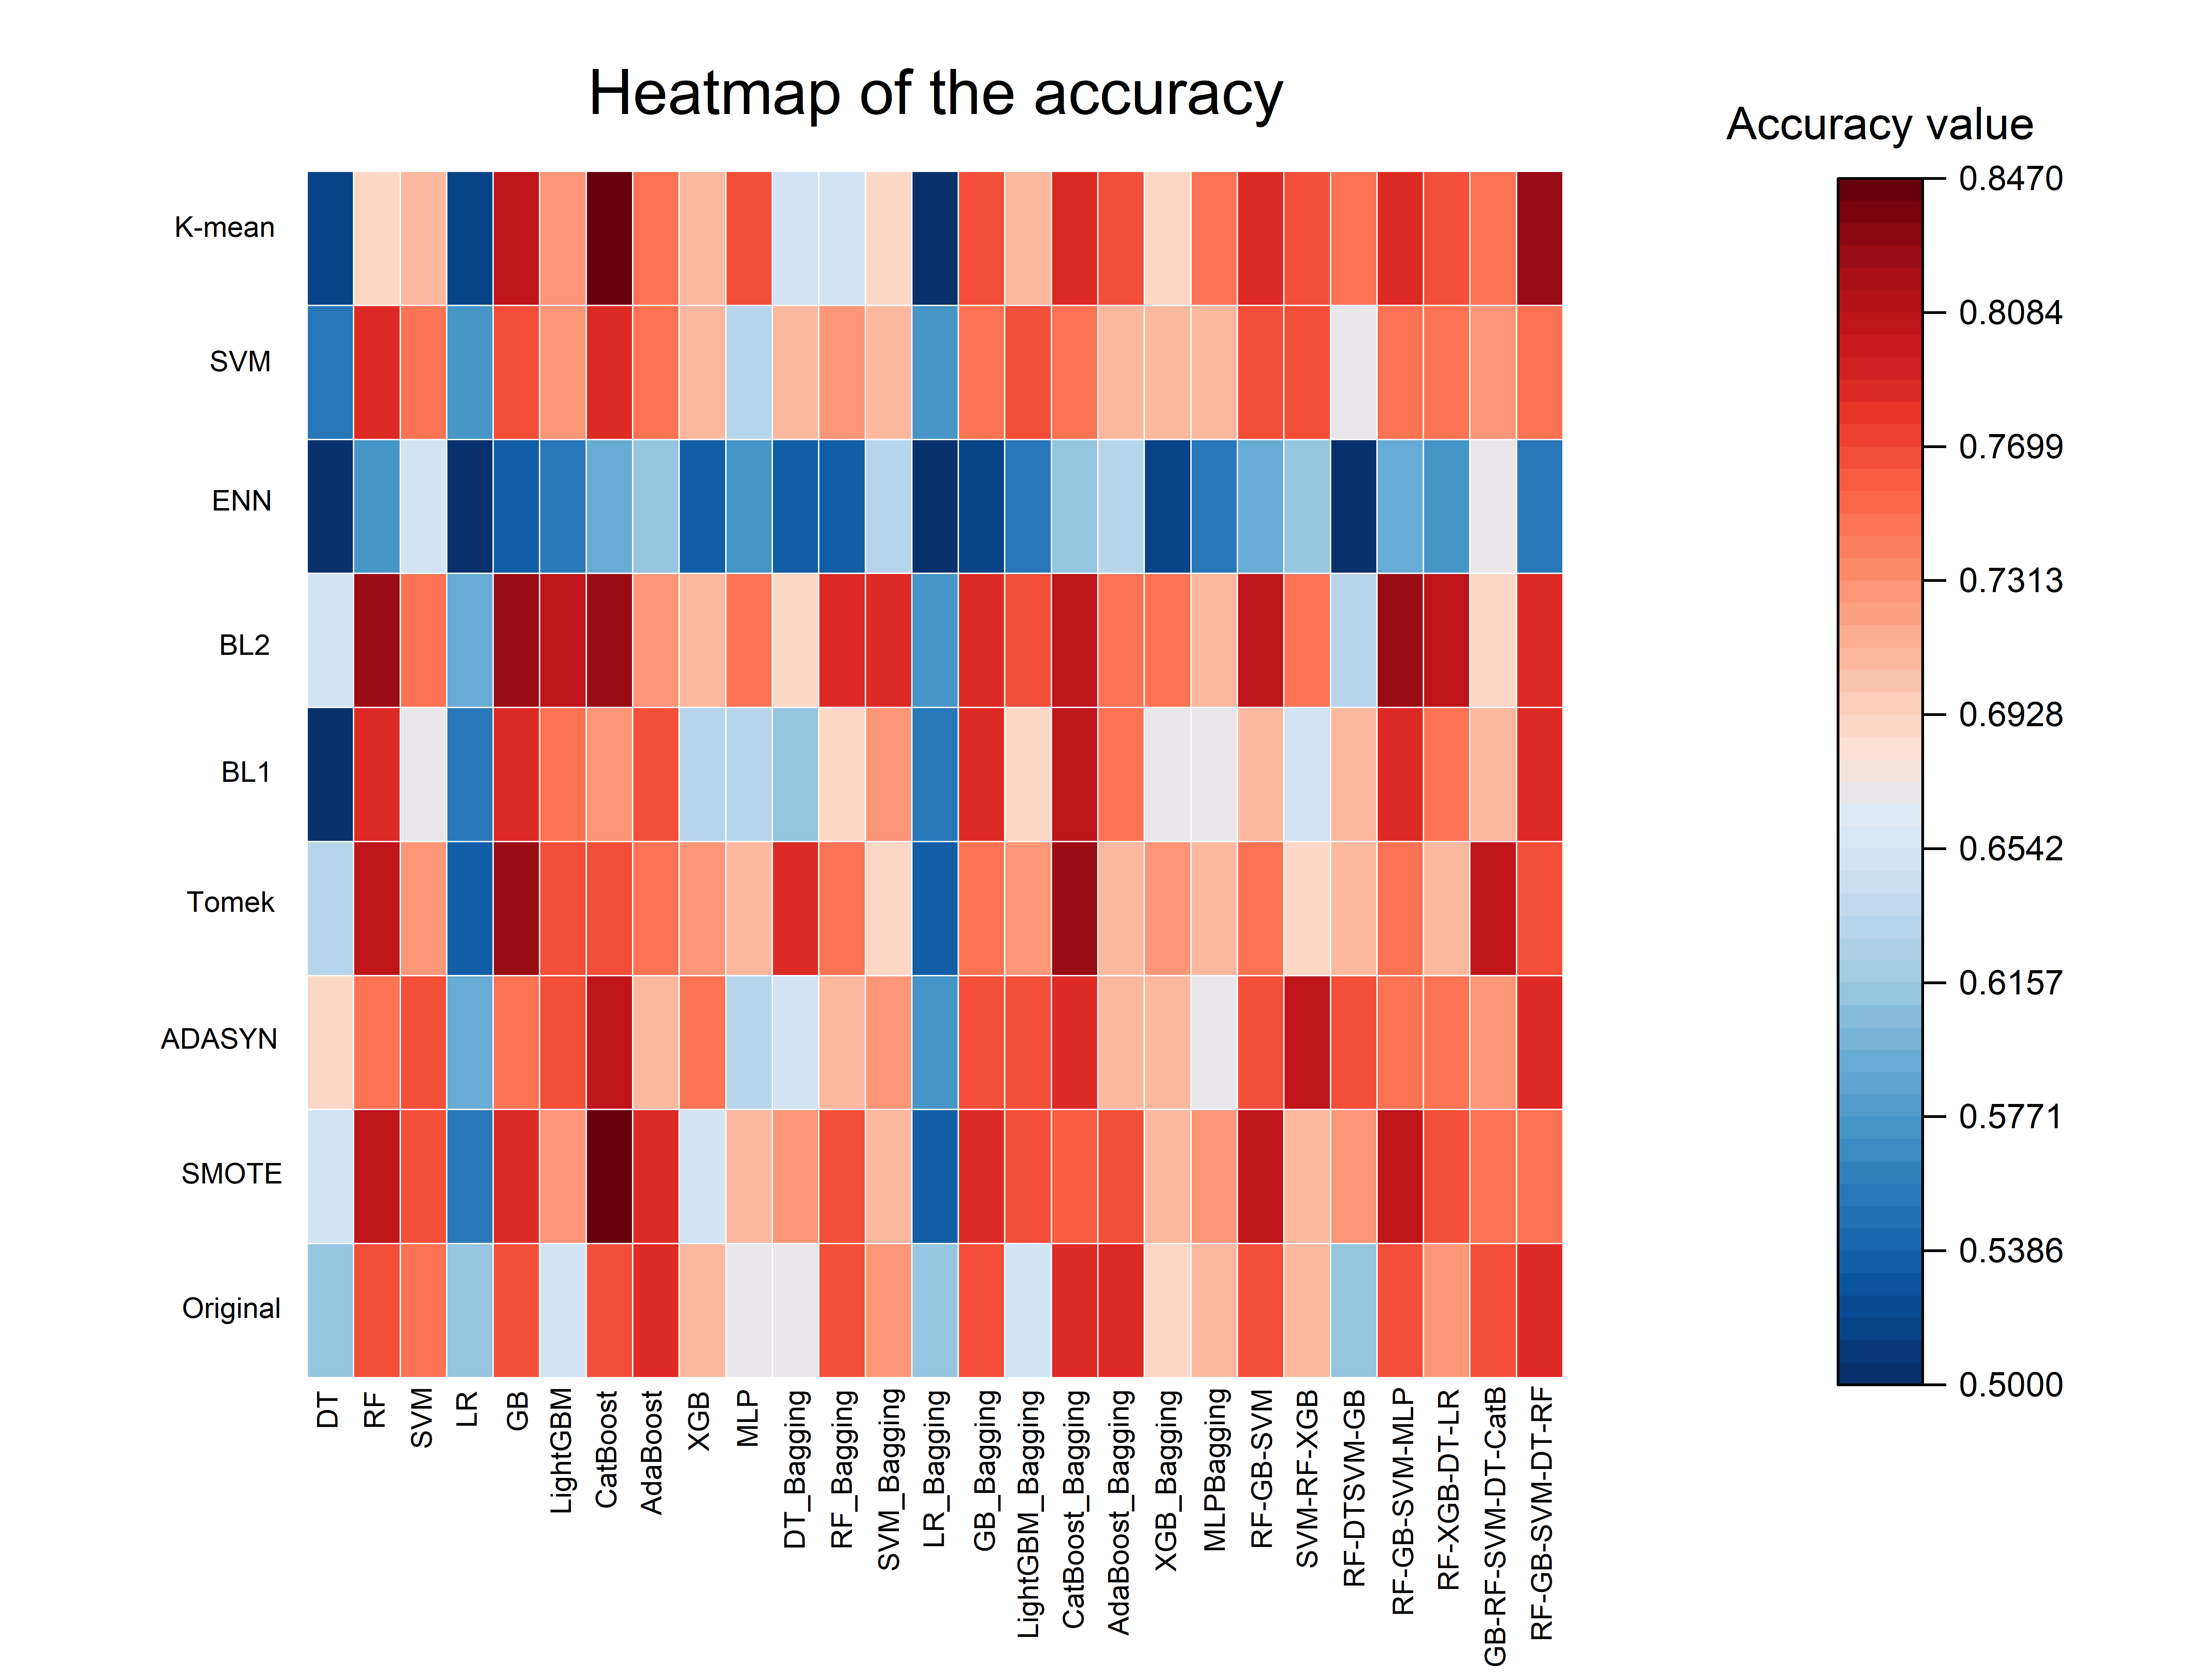 | 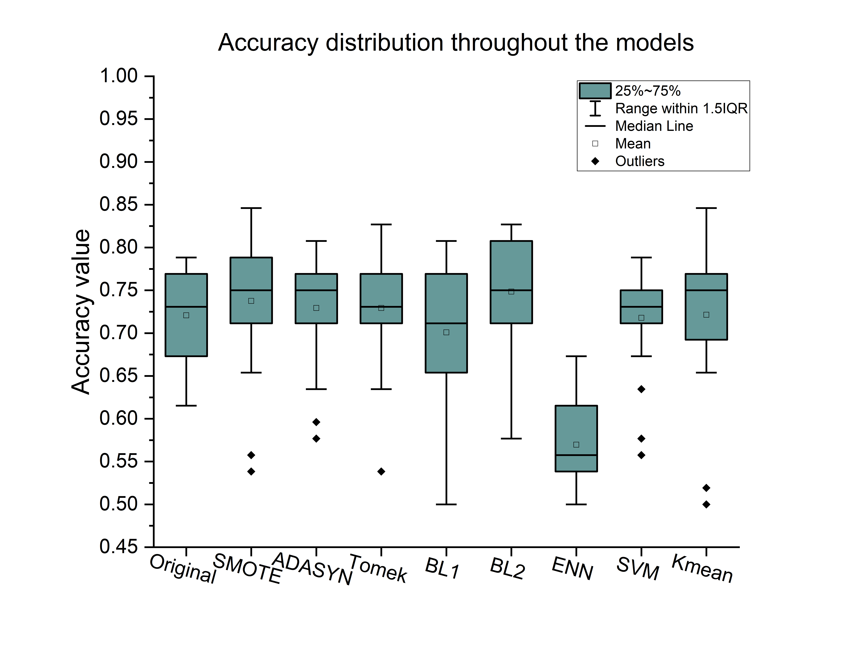
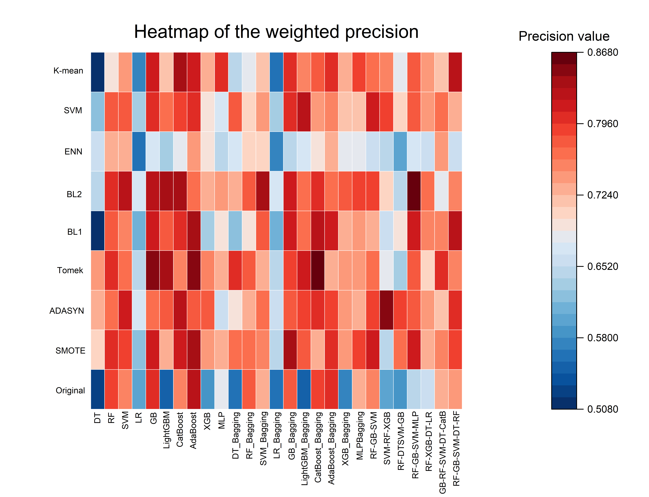 | 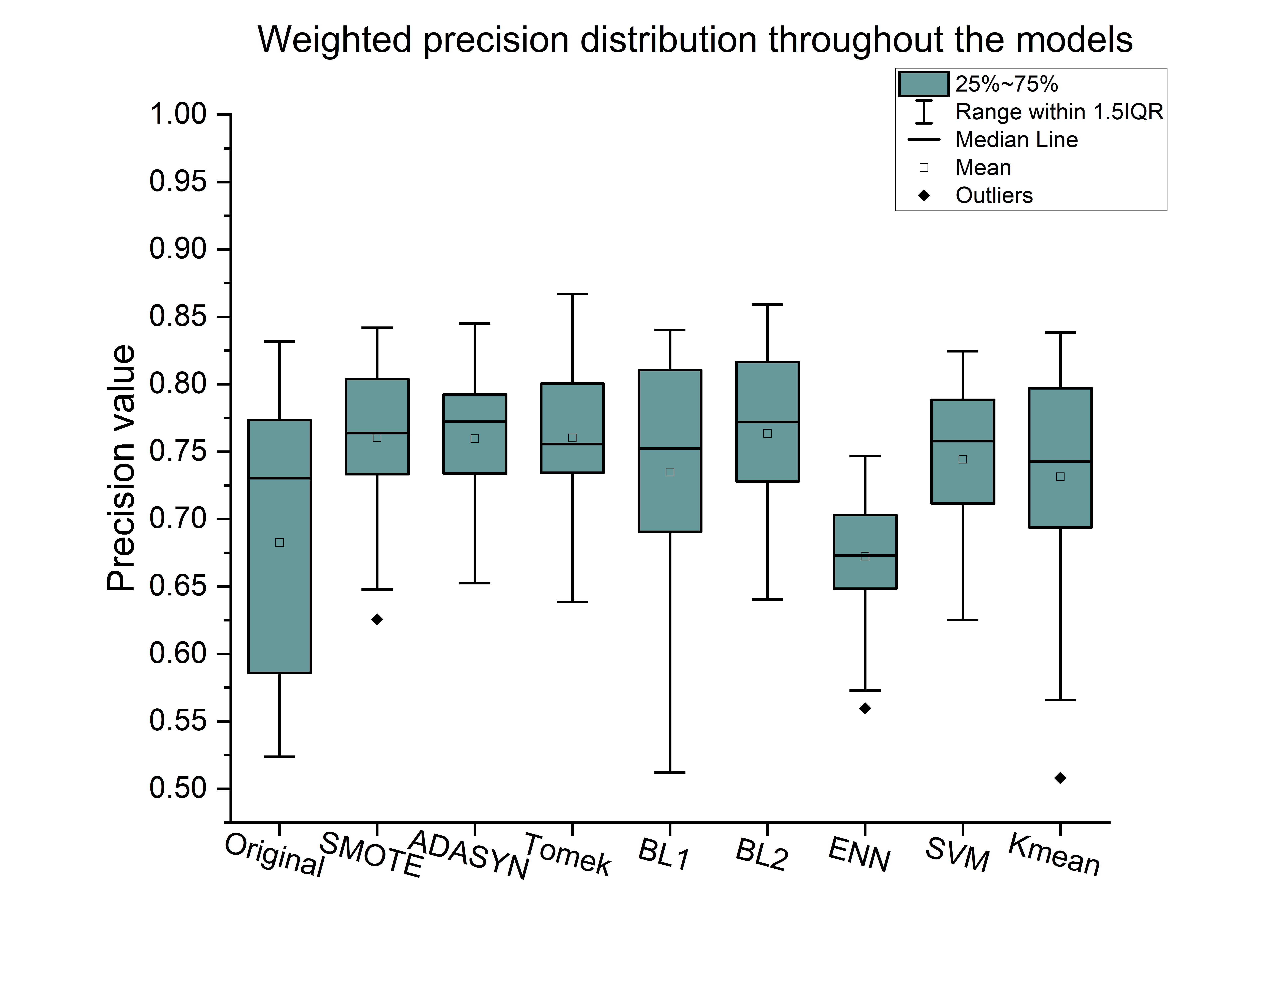
 | 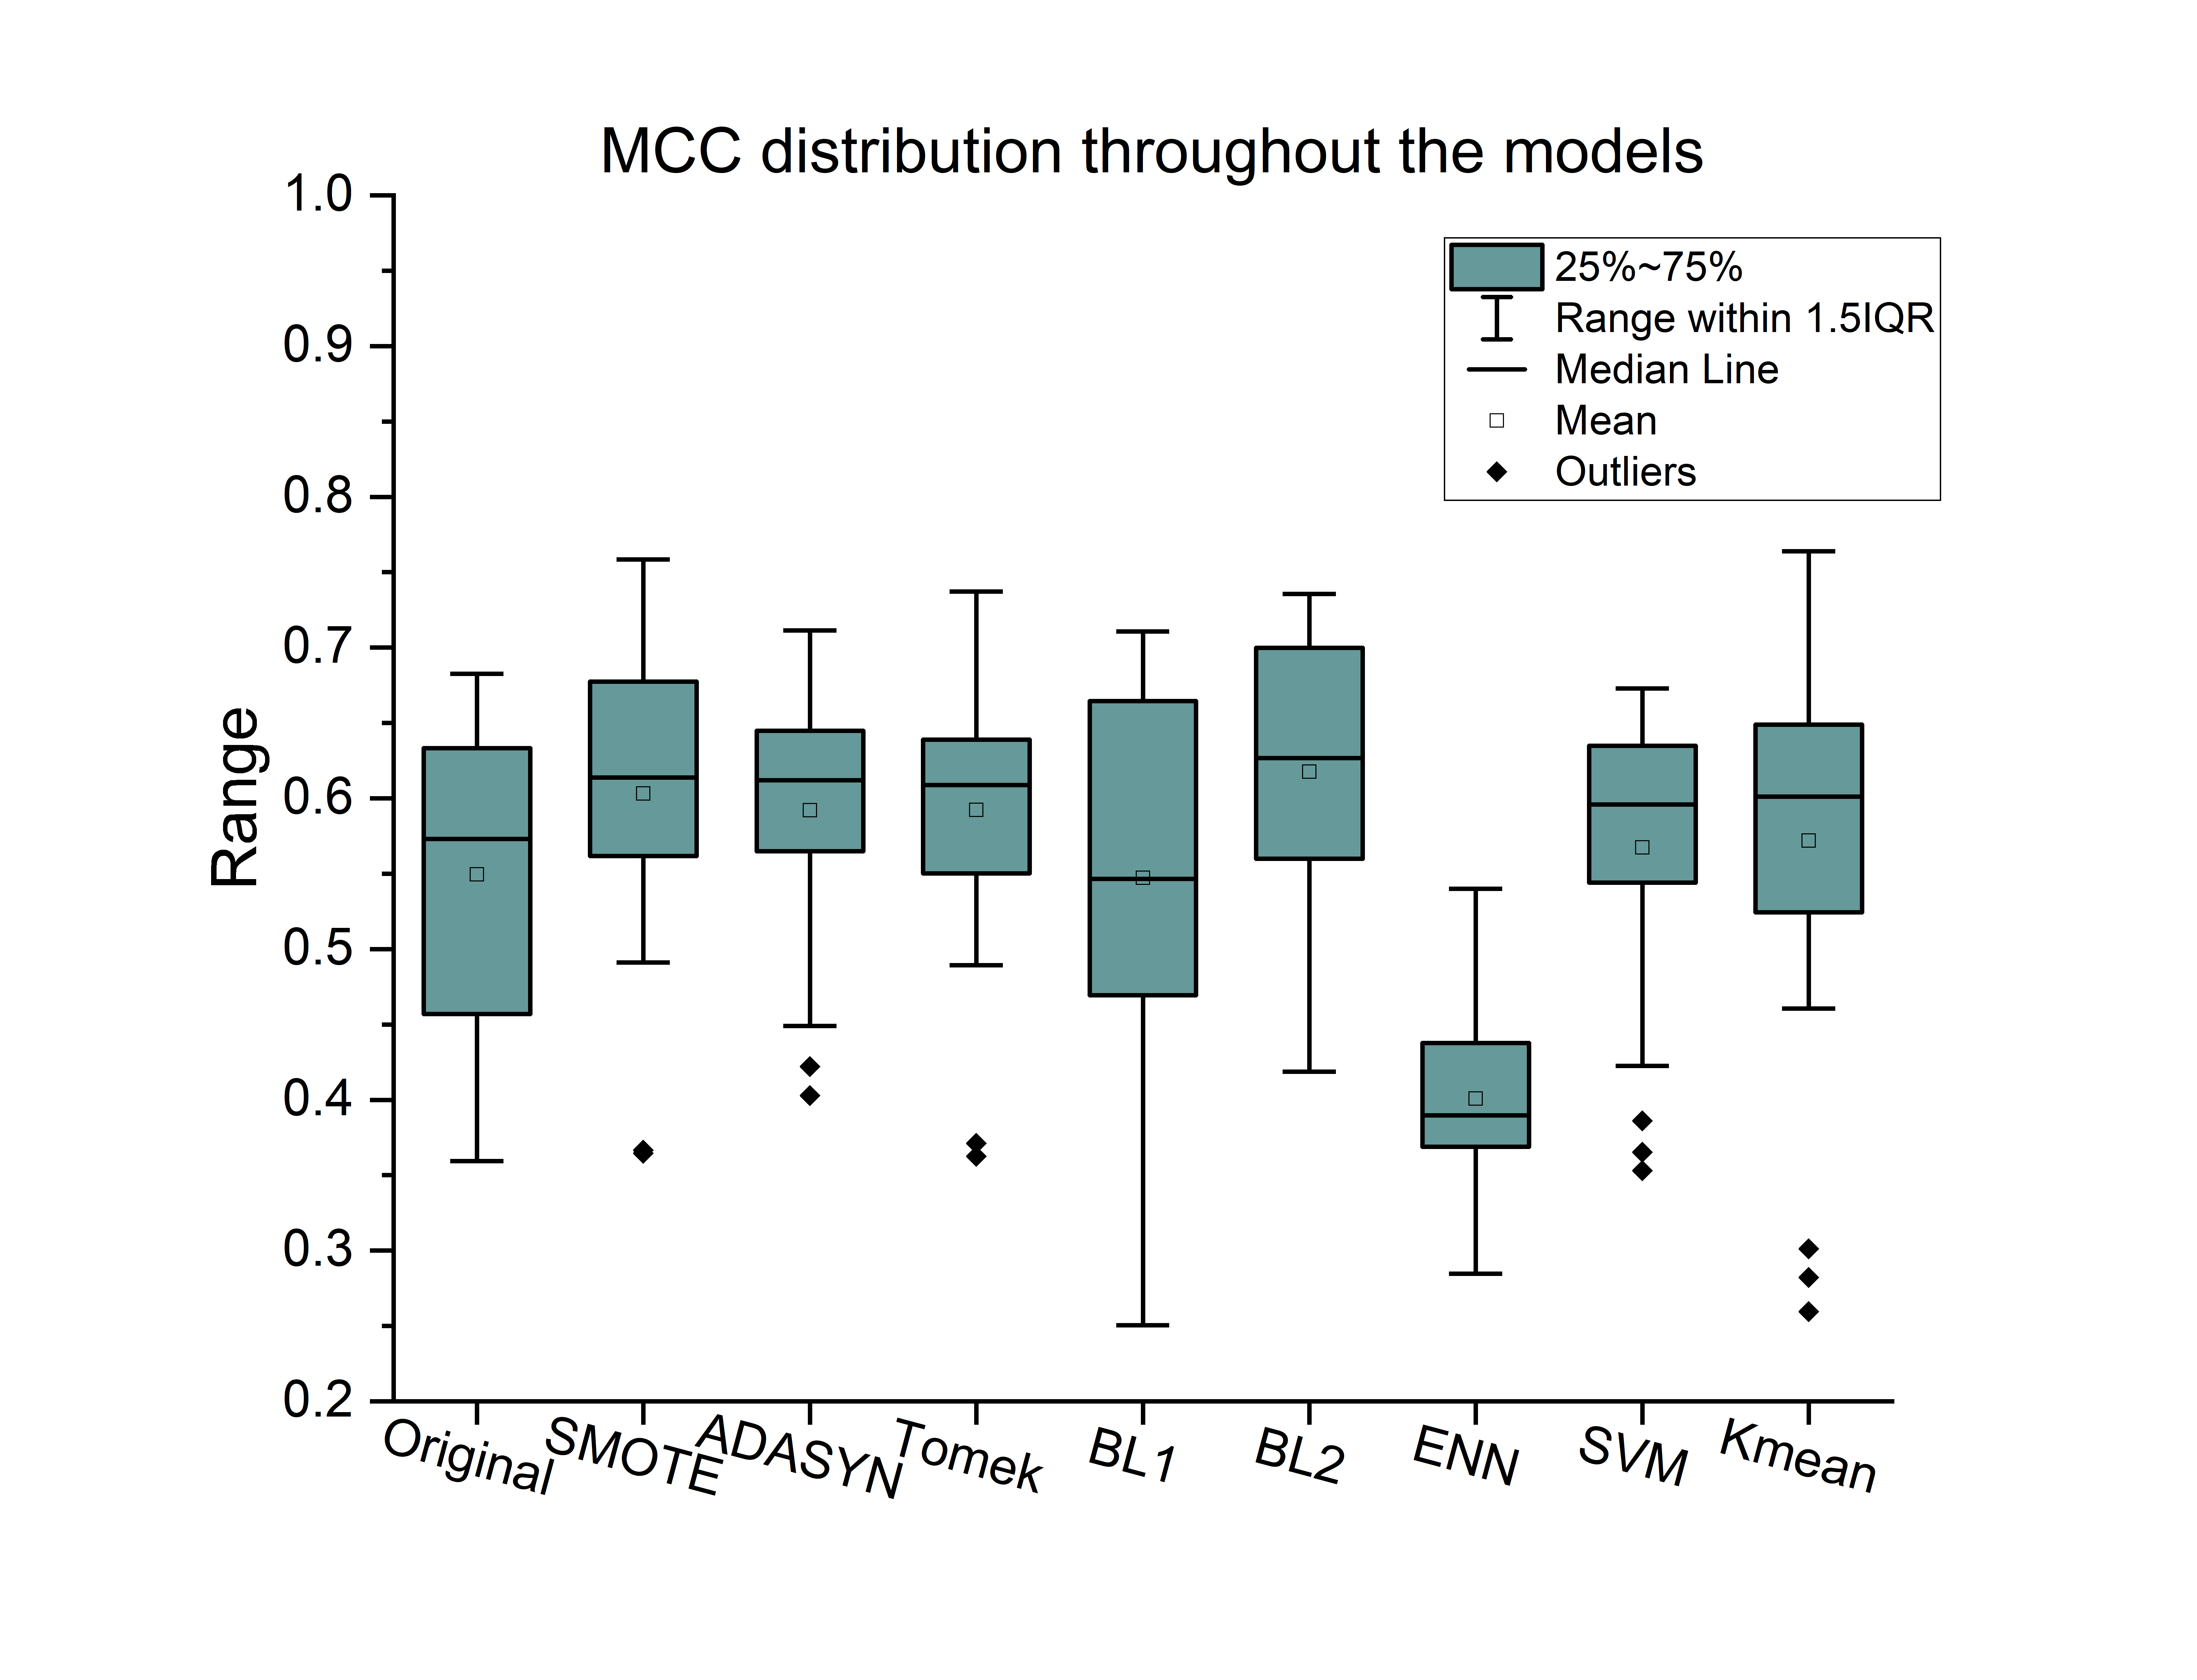
Figure S1: Comparative visualization of MCC performance across machine learning models and synthetic sampling techniques in Stage 2. The figure highlights the impact of oversampling strategies (e.g., SMOTE, Borderline-SMOTE-2, K-Means SMOTE) and ensemble configurations (Bagging and Stacking) on classification robustness under imbalanced multiclass conditions.

 |  | Original | ICF-weight | ISRF-weight | ENS-weight | CW-weight
 | CatBoost-SMOTE | 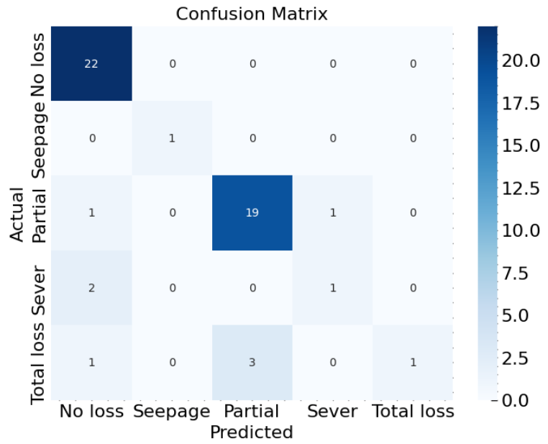 | 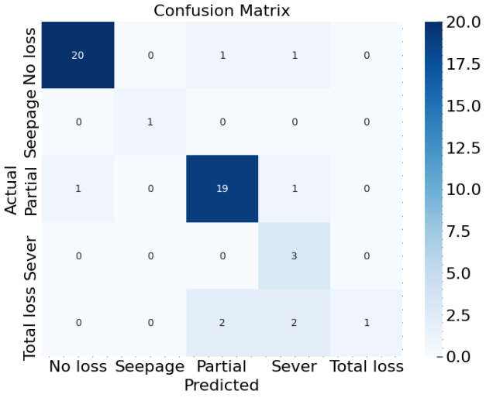 | 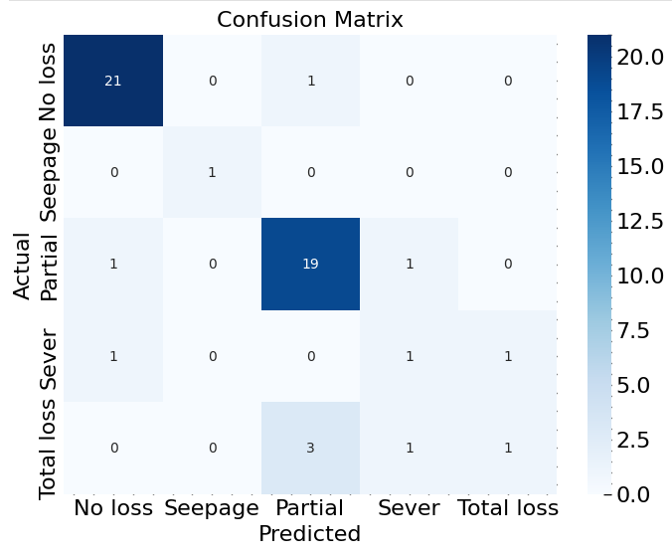 | 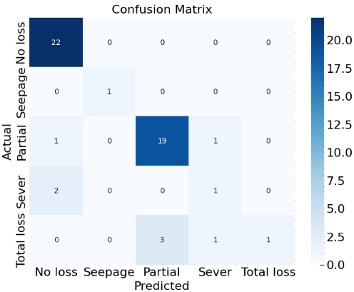 | 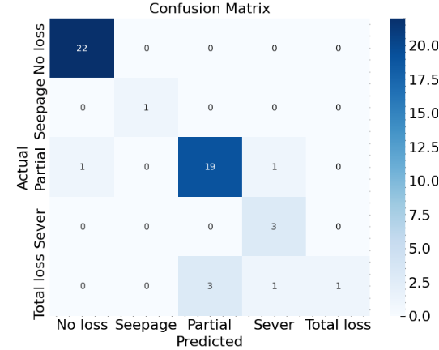
 | CatBoost-Tomek-Bagging | 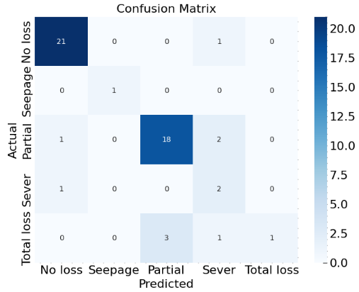 | 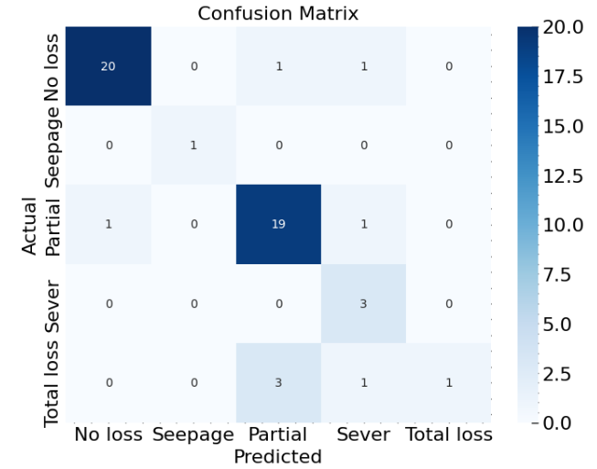 | 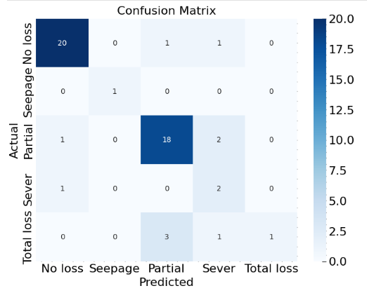 | 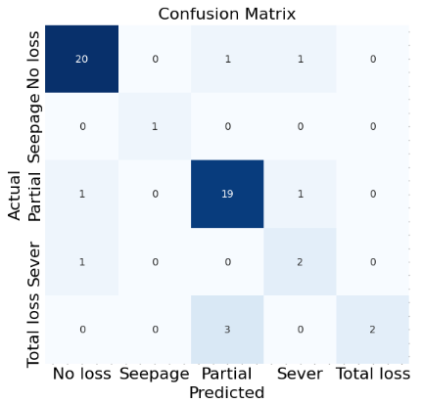 | 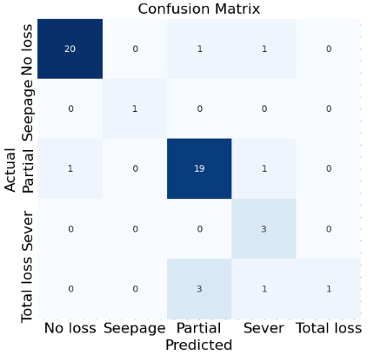
 | Gb-Tomek | 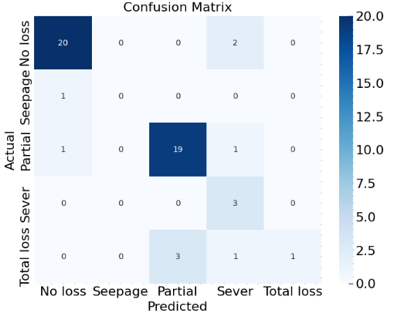 | 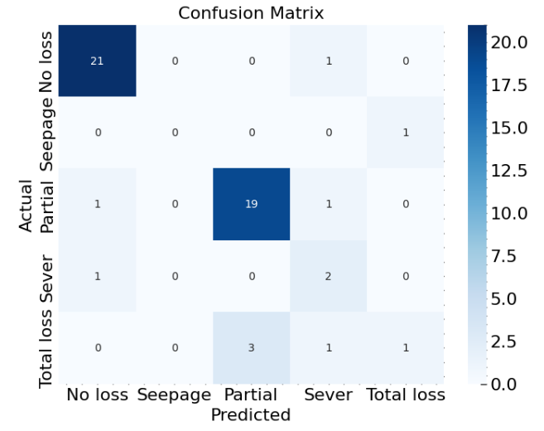 | 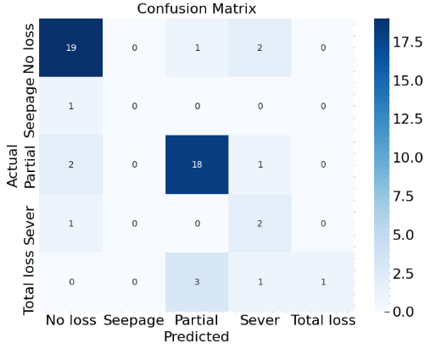 | 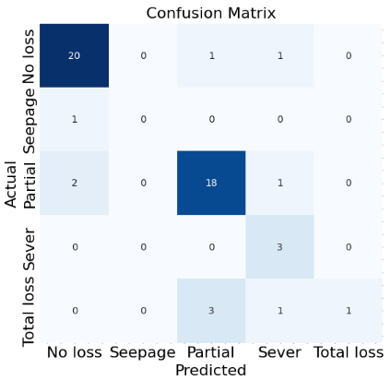 | 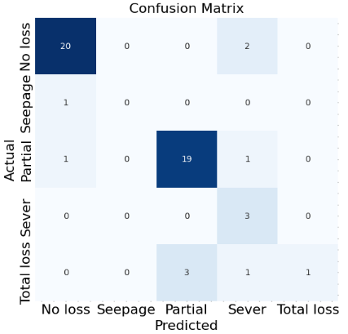
 | RF-BL2 | 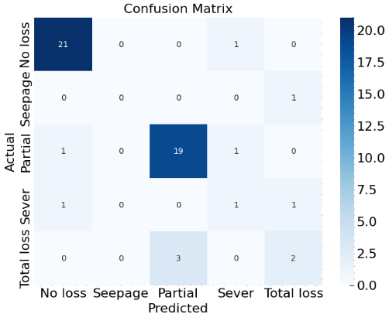 | 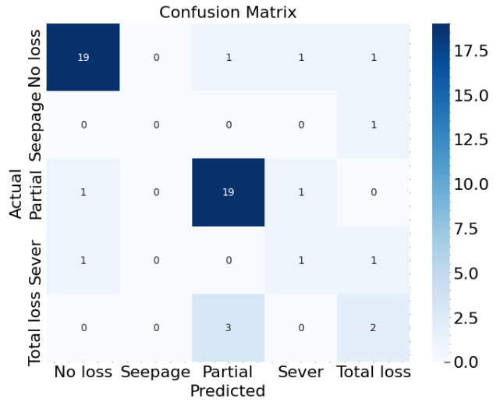 | 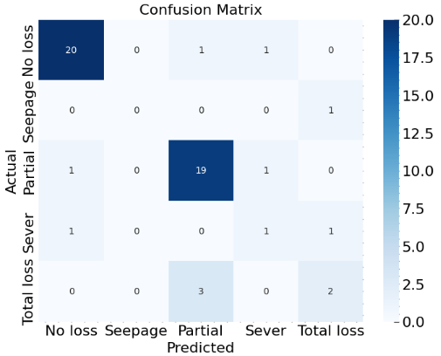 | 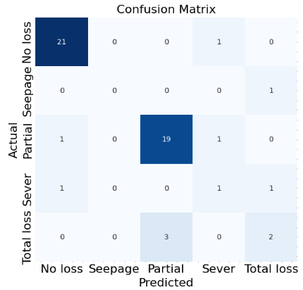 | 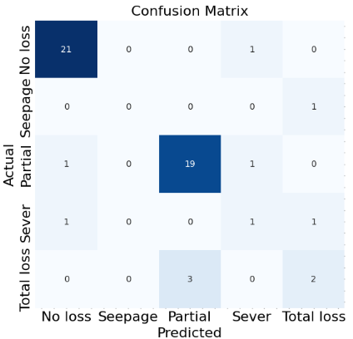
 | Gb-BL2 | 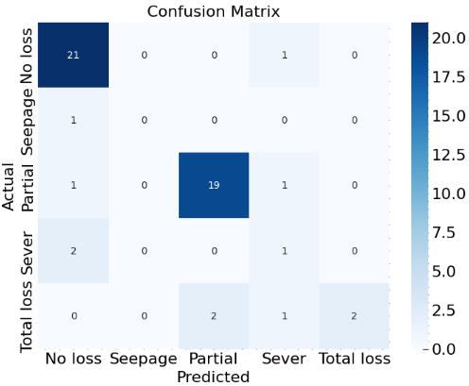 | 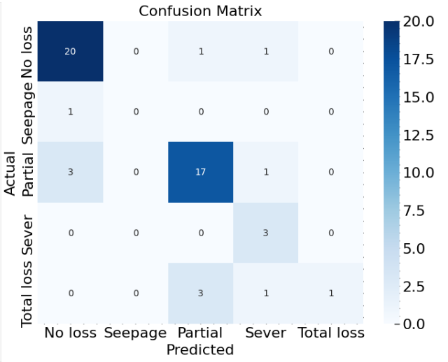 | 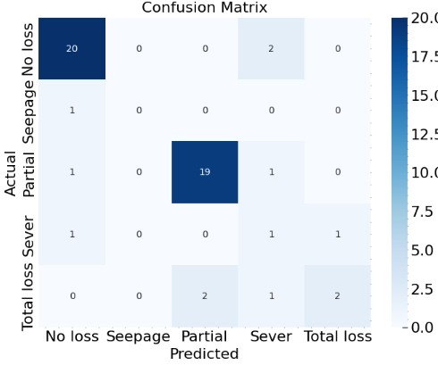 | 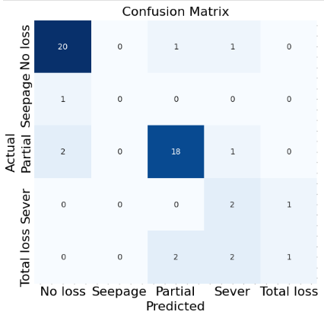 | 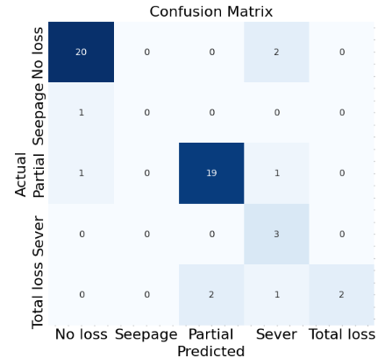
 | CatBoost-BL2 | 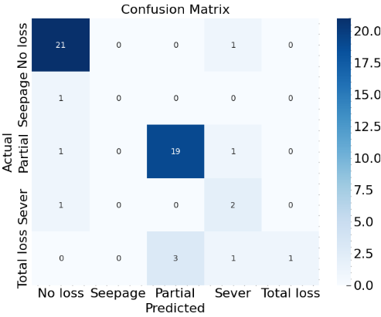 | 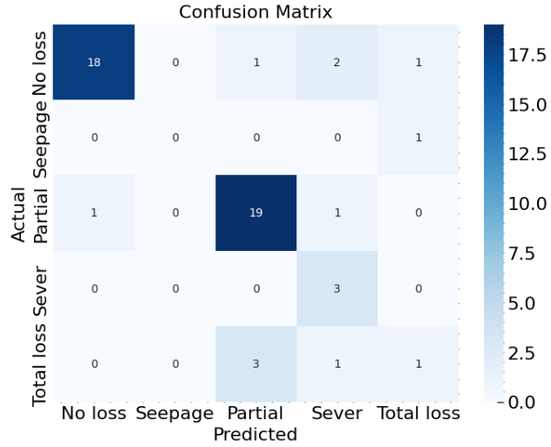 | 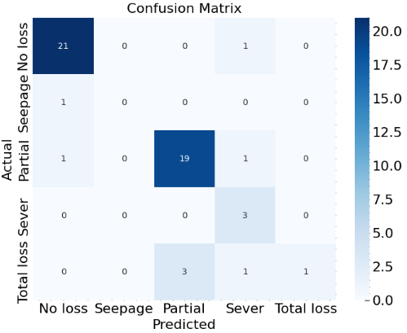 | 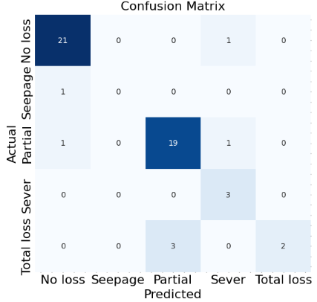 | 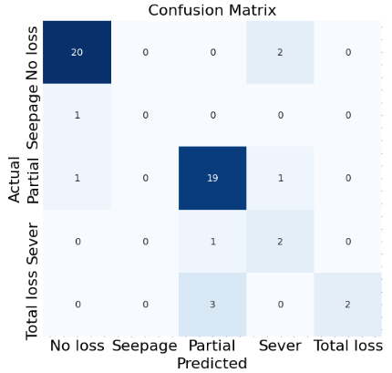
 | CatBoost-Kmean | 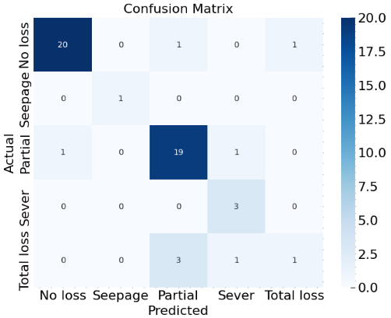 | 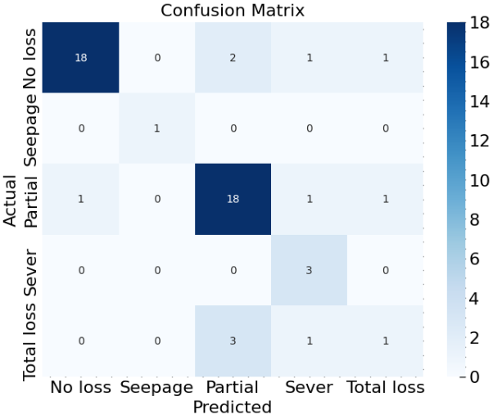 | 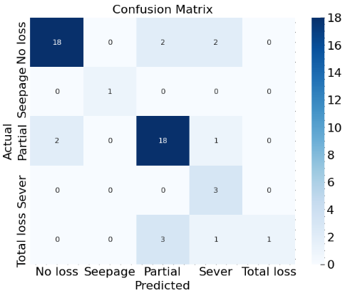 | 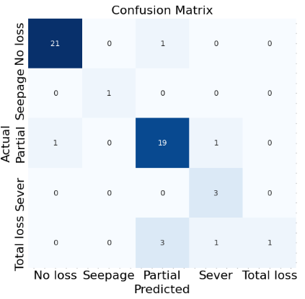 | 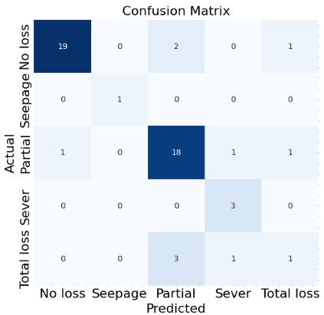
 | RF-Gb-SVM-MLP-BL2 | 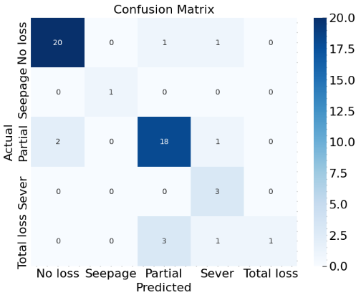 | 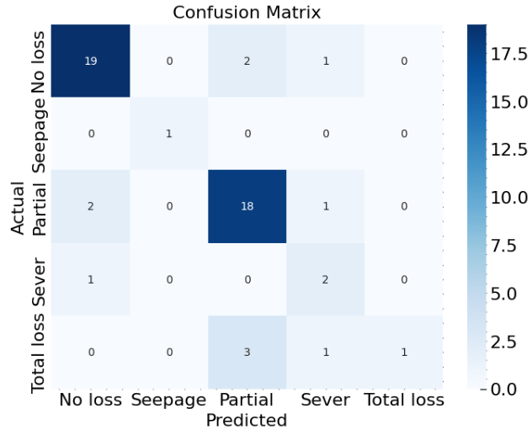 | 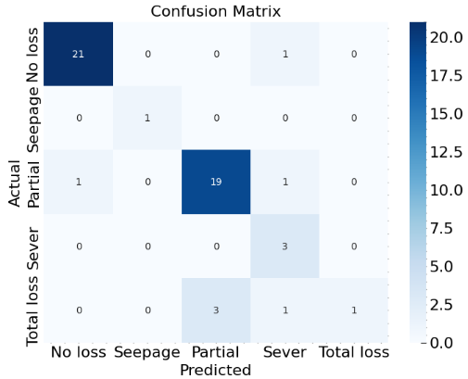 | 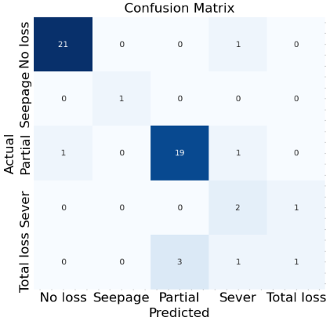 | 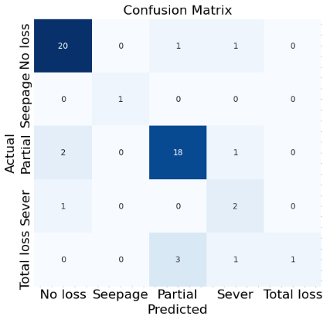
 | -  RF-GB-SVM-DT-RF-kmean | 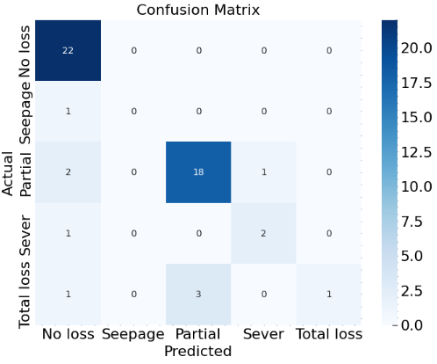 | 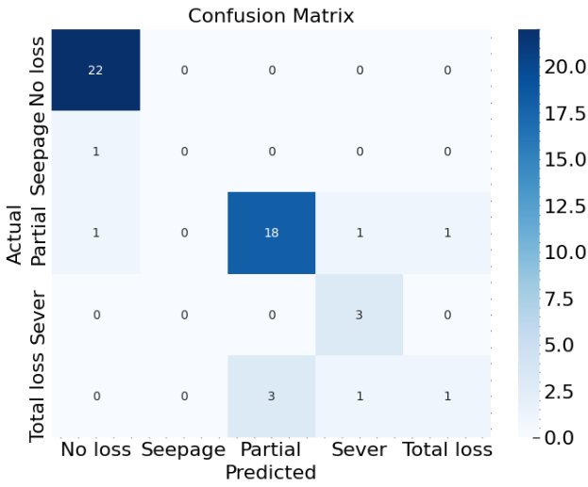 | 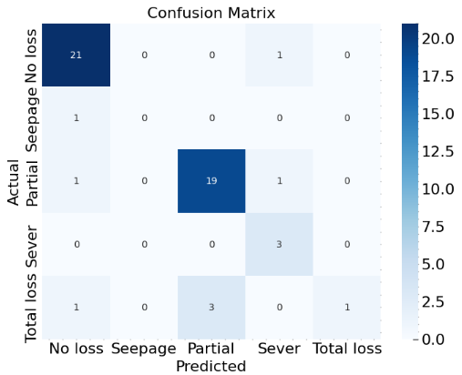 | 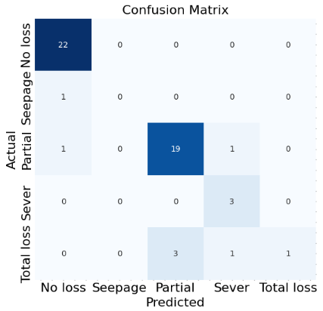 | 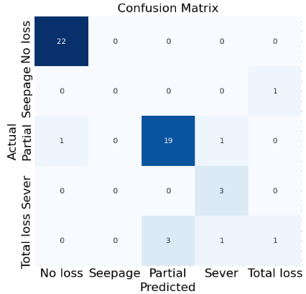
Figure S2: Confusion matrices of selected top-performing models under different class-weight strategies. Diagonal elements represent correct classifications, while off-diagonal elements indicate misclassifications across lost circulation severity classes.

 | Original | ICF | ISRF | ENS | CW
CatBoost-SMOTE | 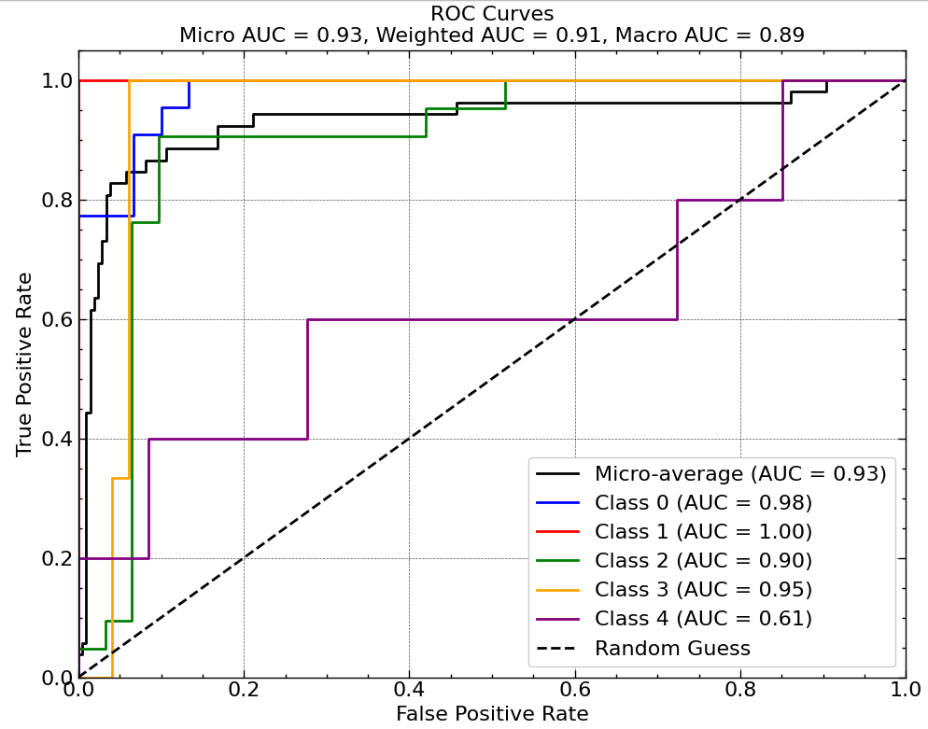 | 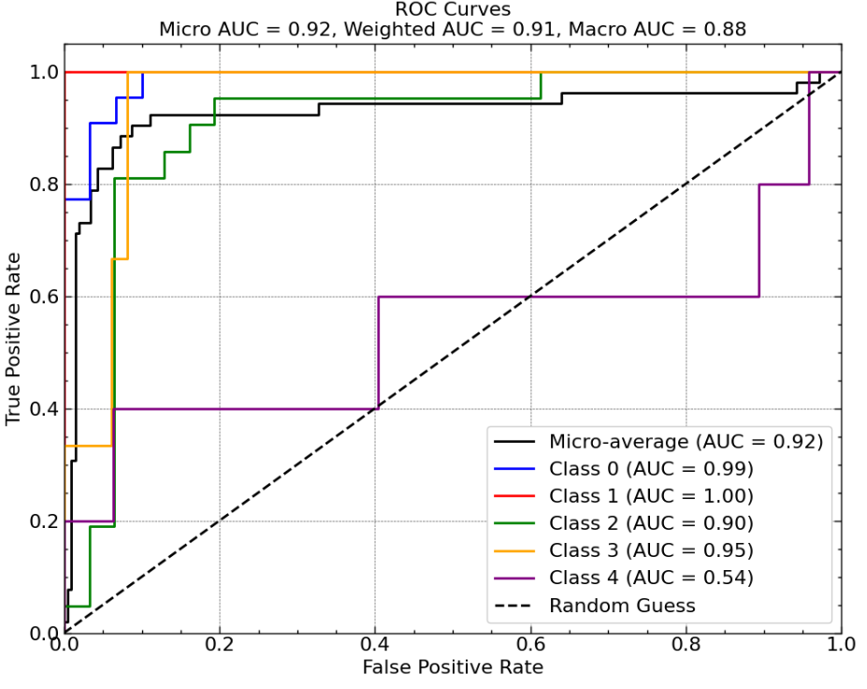 | 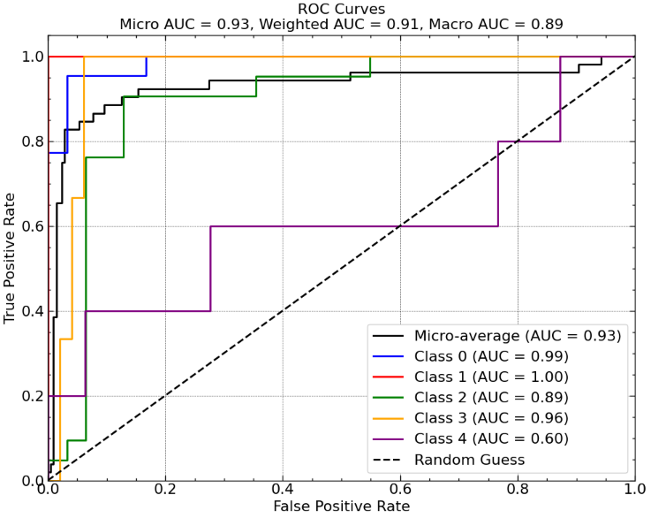 | 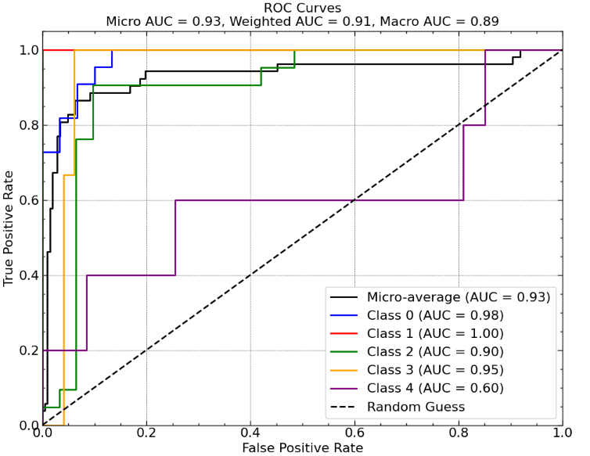 | 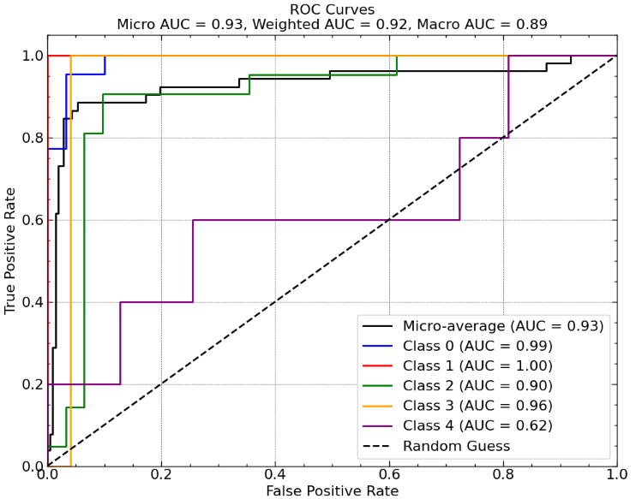
CatBoost-Tomek-Bagging | 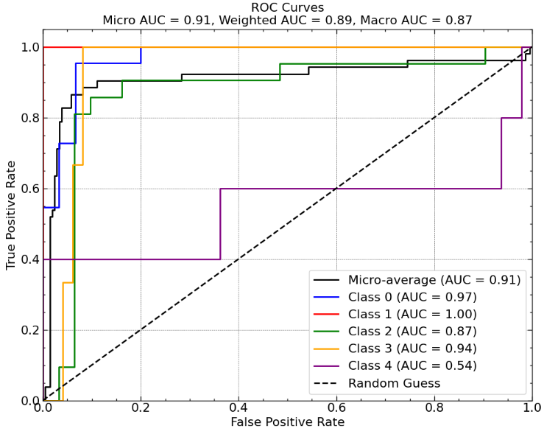 | 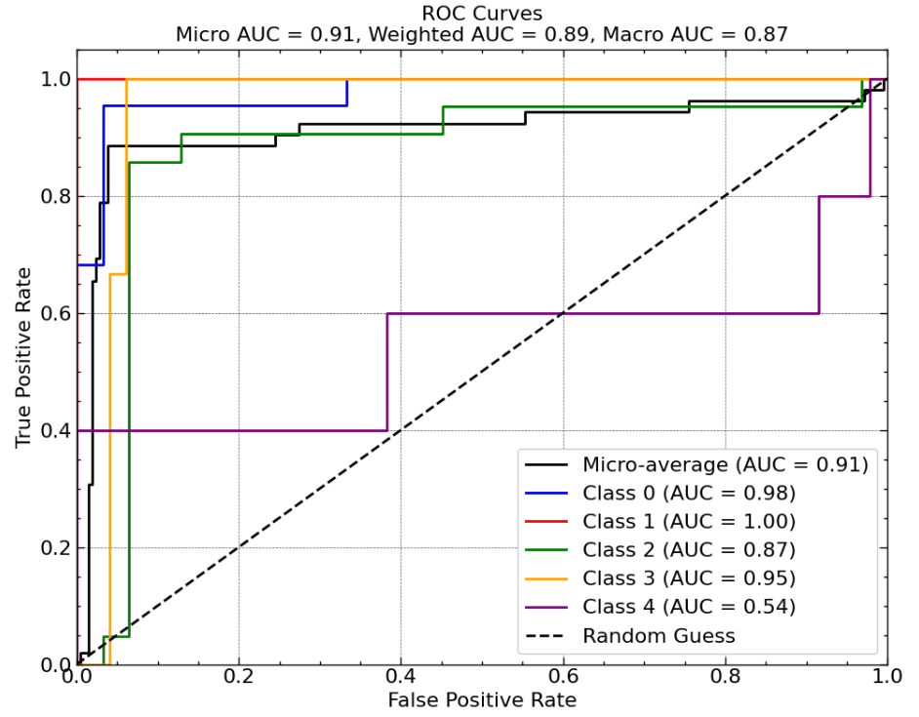 | 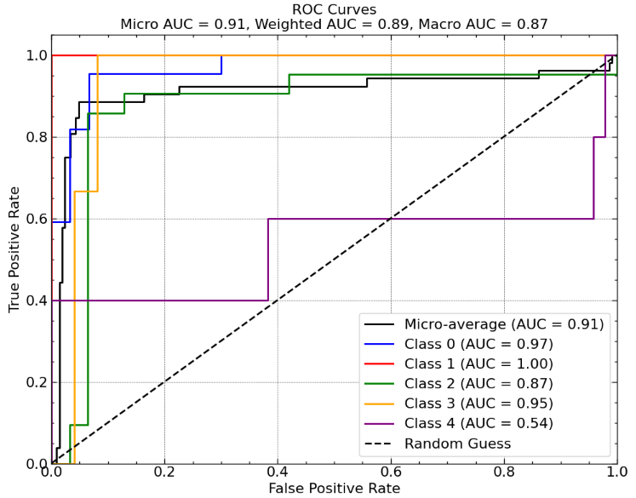 | 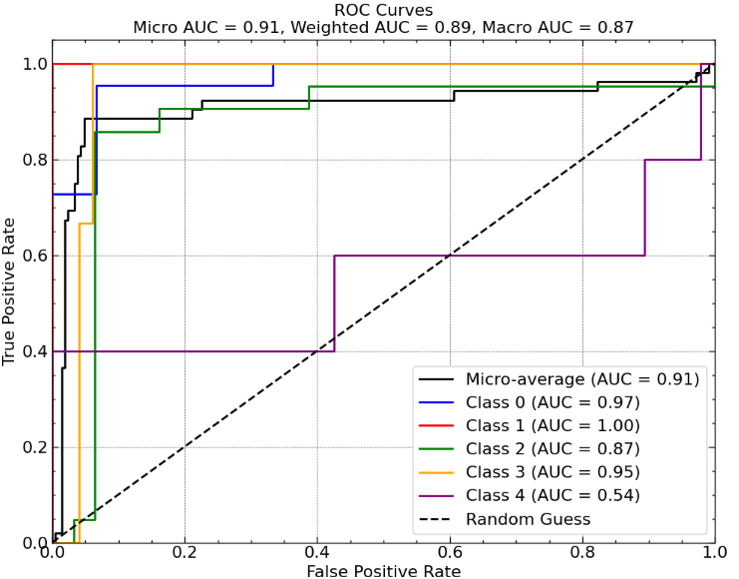 | 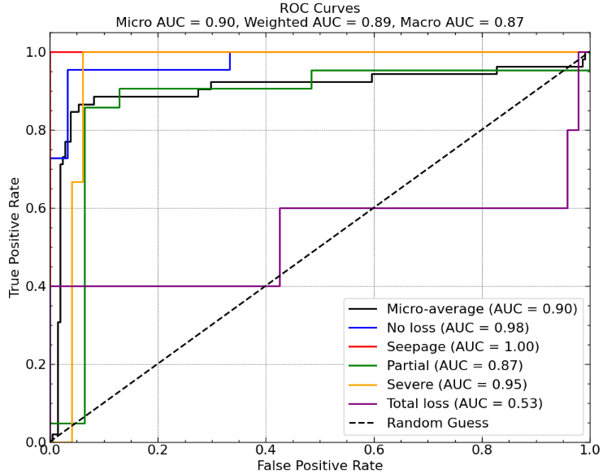
Gb-Tomek | 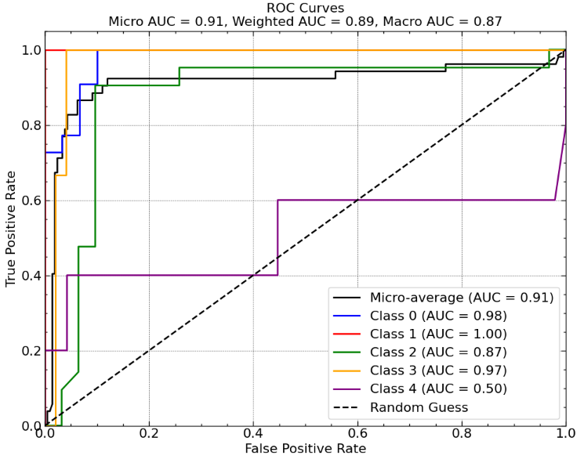 | 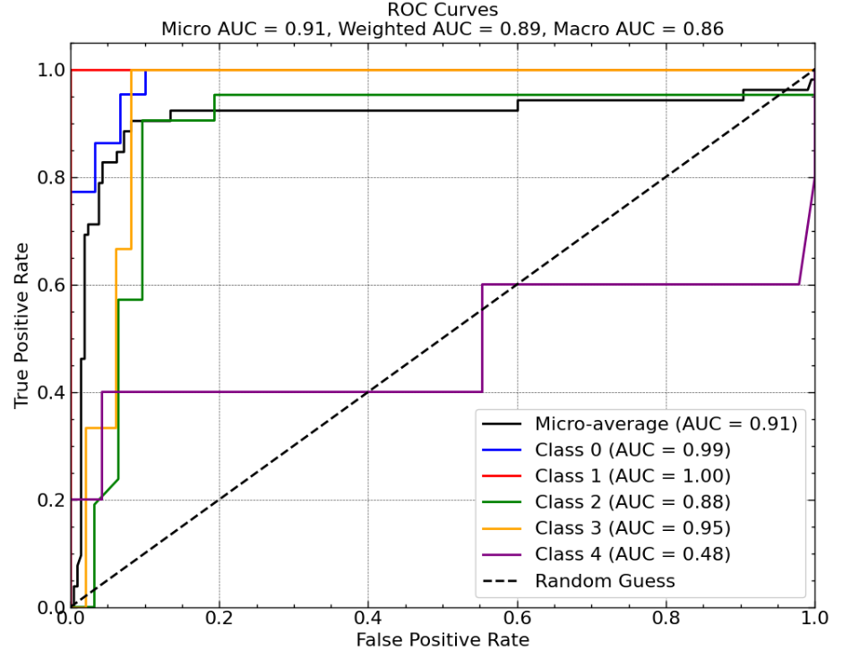 | 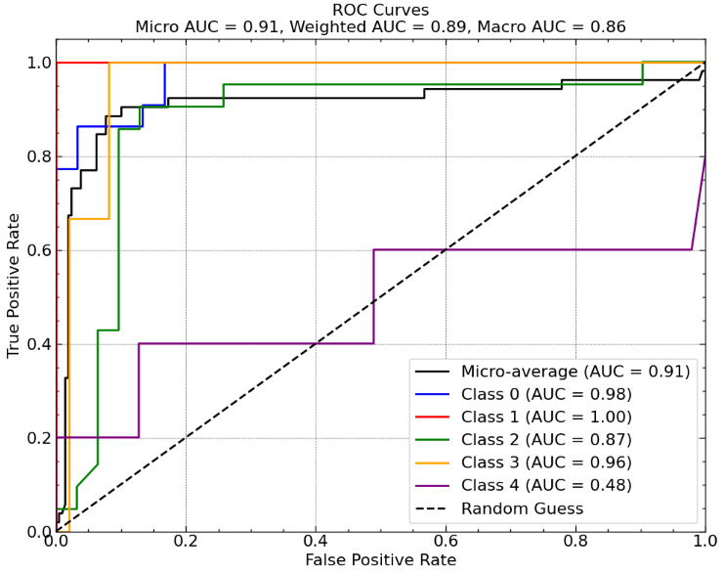 | 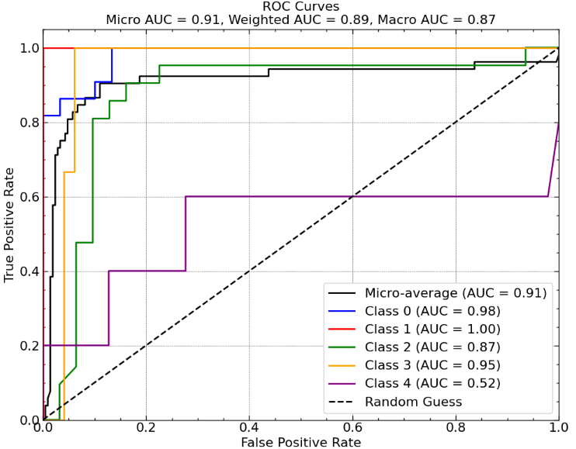 | 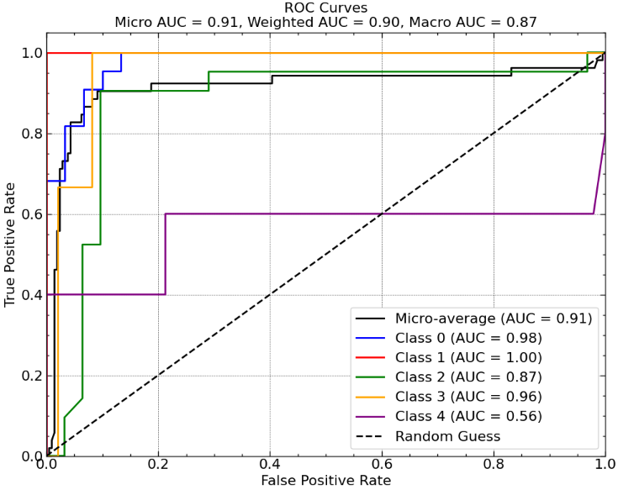
RF-BL2 | 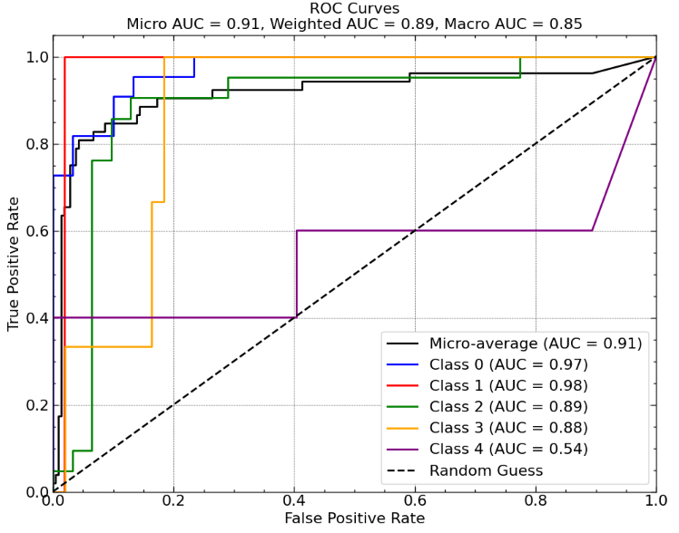 | 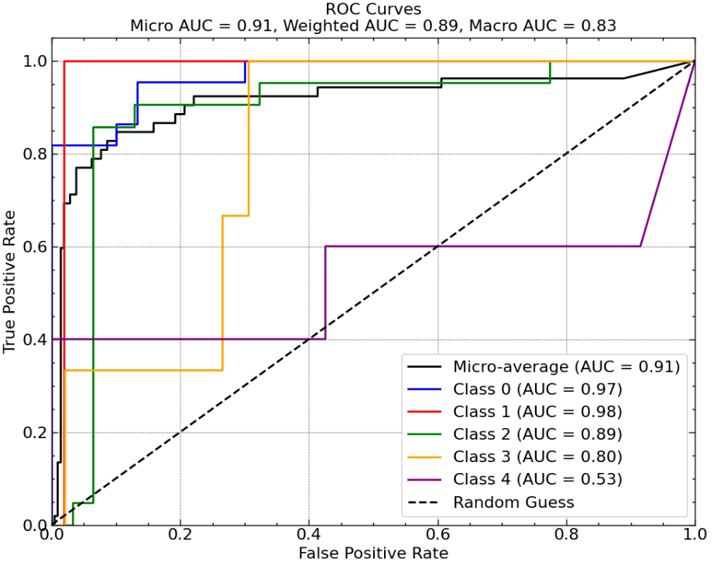 | 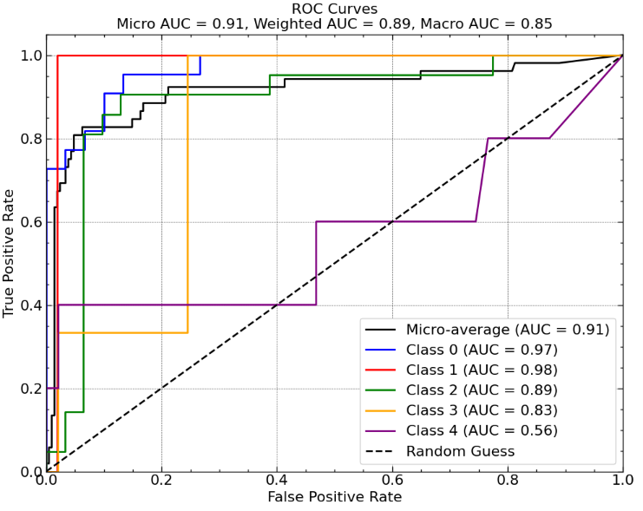 | 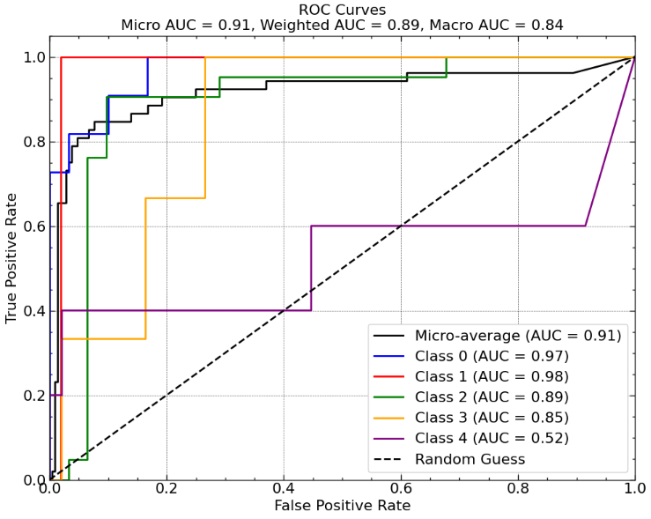 | 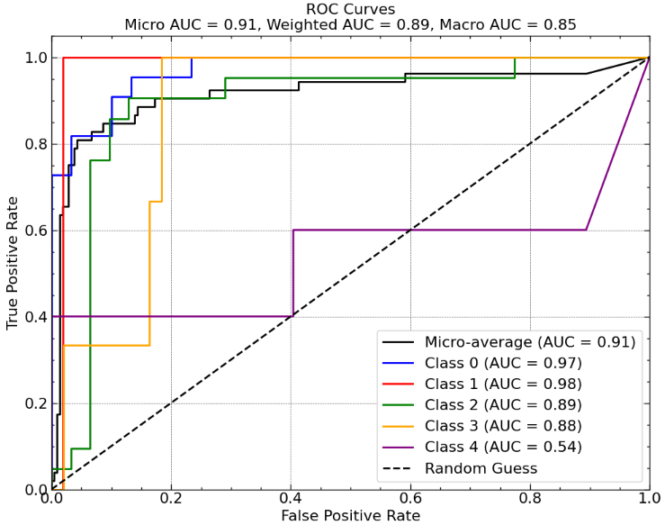
Gb-BL2 | 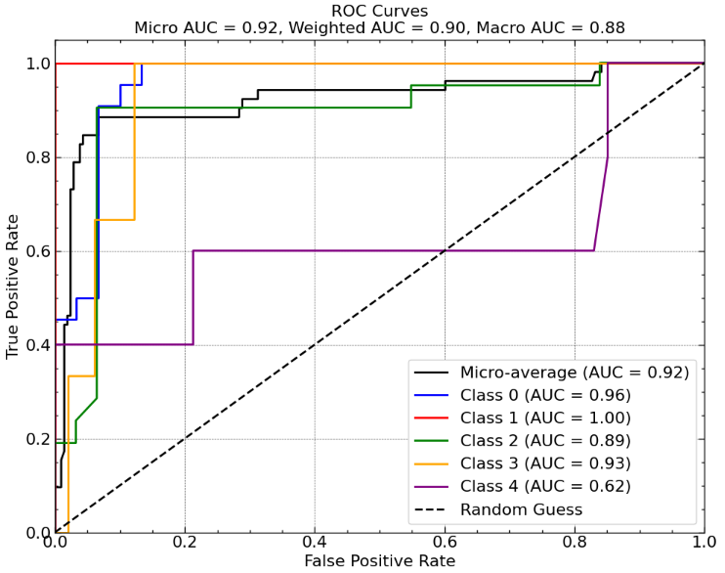 | 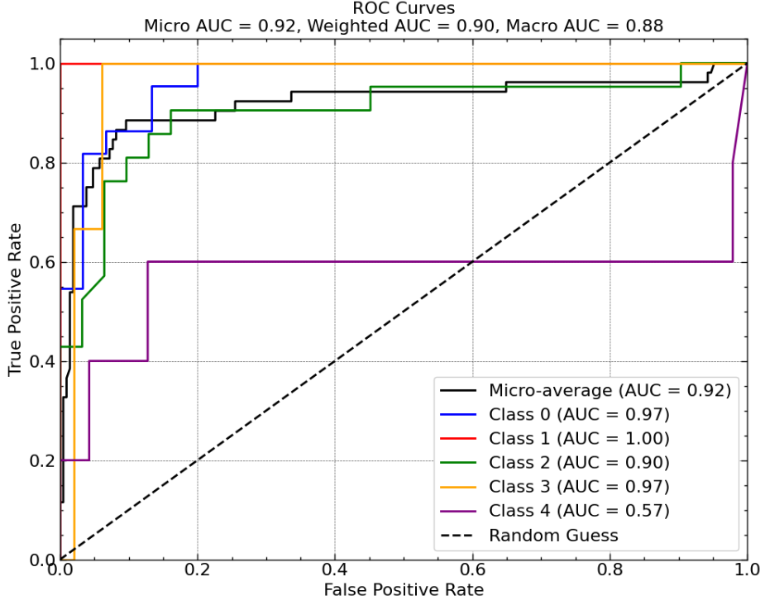 | 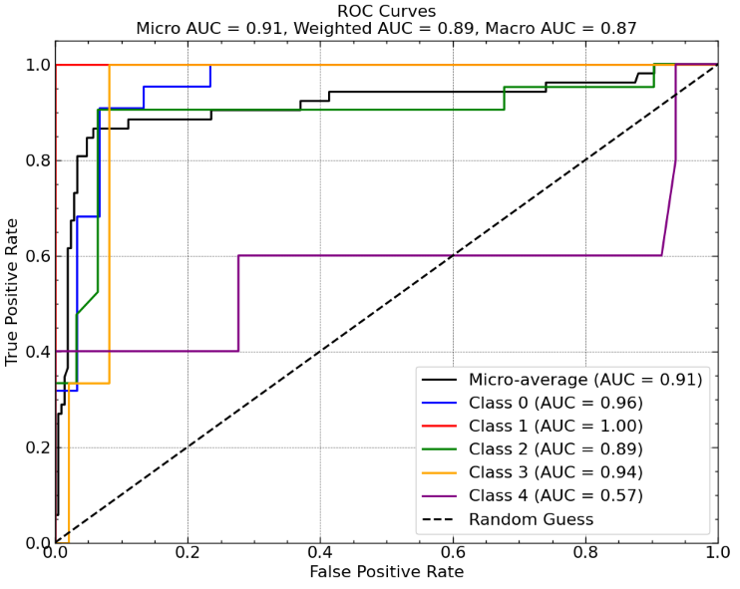 | 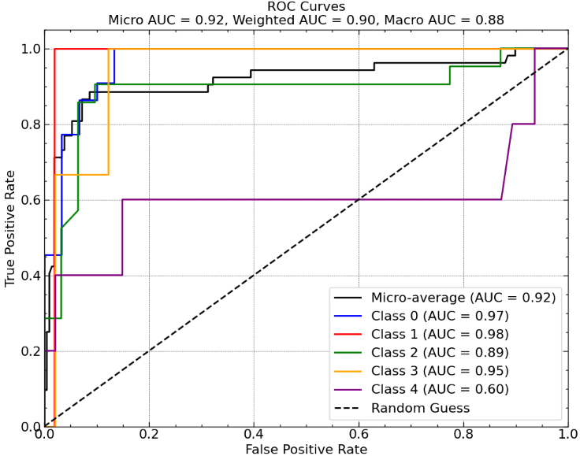 | 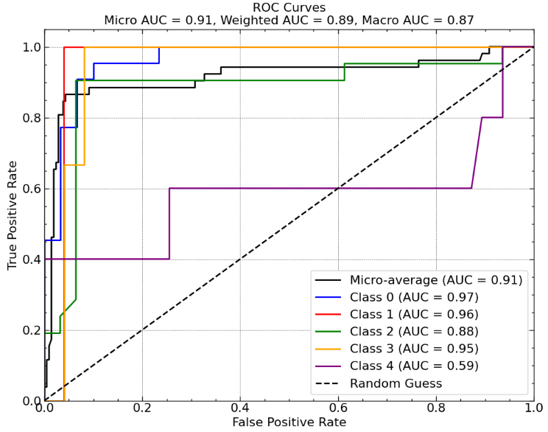
CatBoost-BL2 | 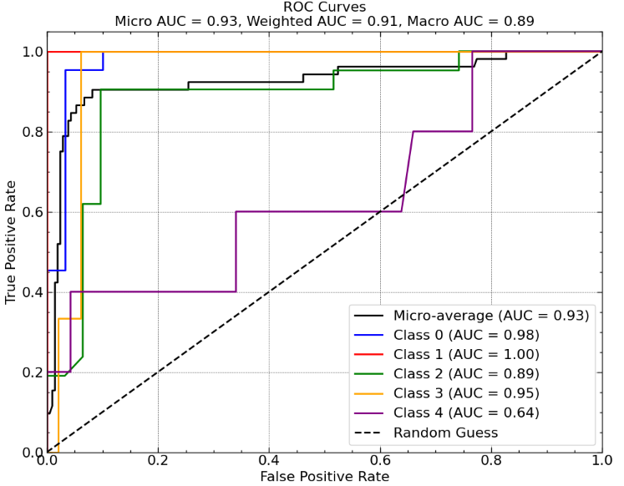 | 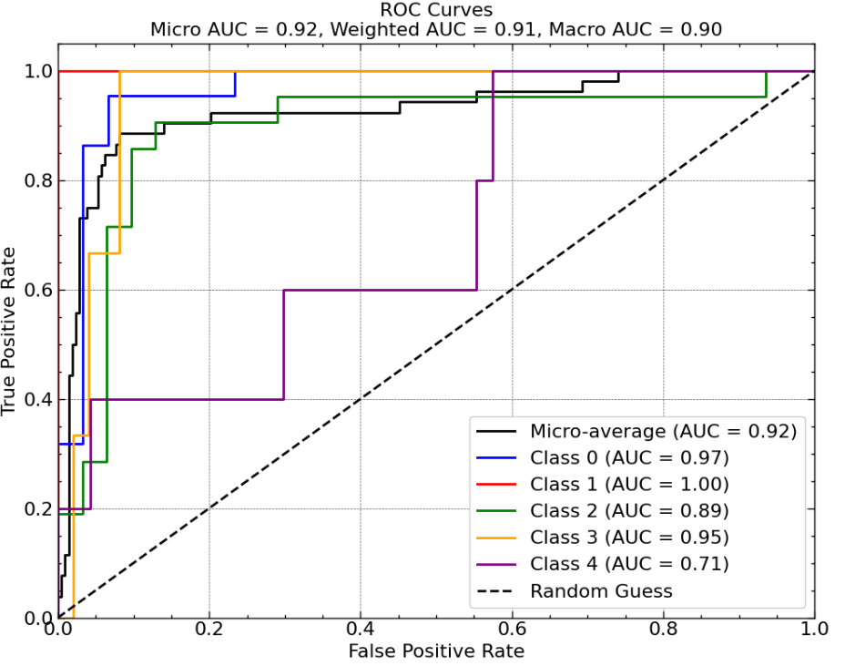 | 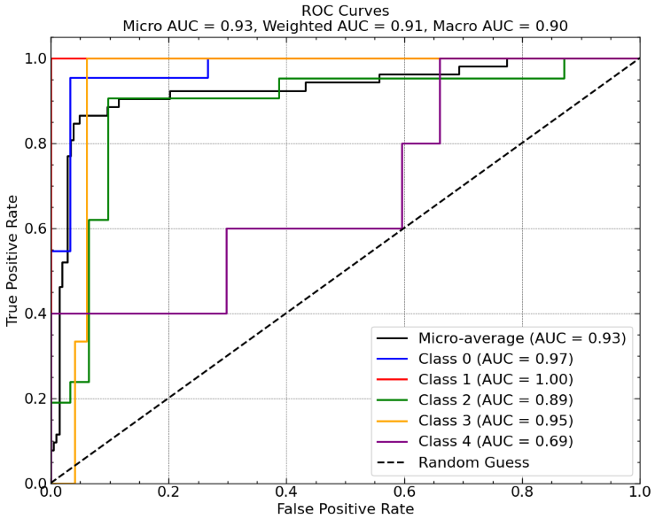 | 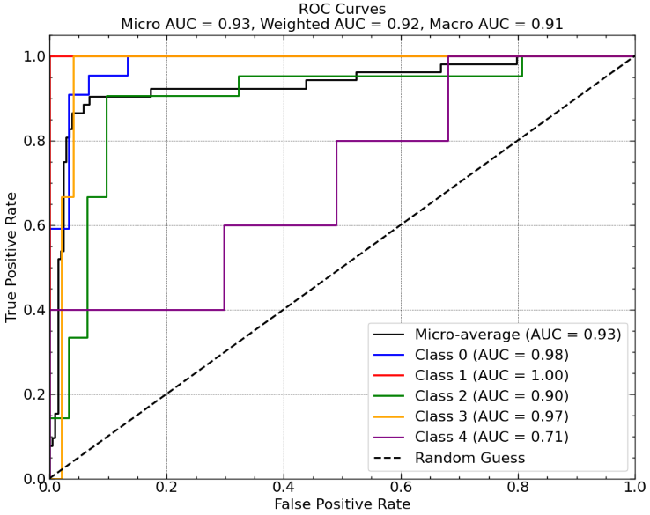 | 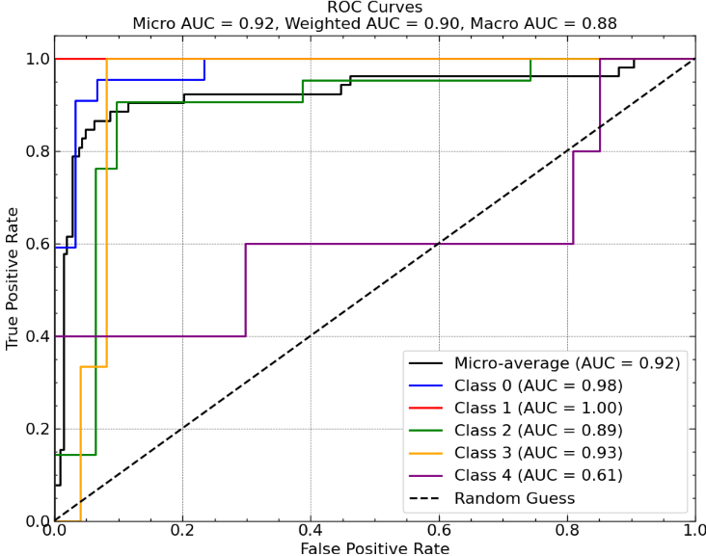
CatBoost-Kmean | 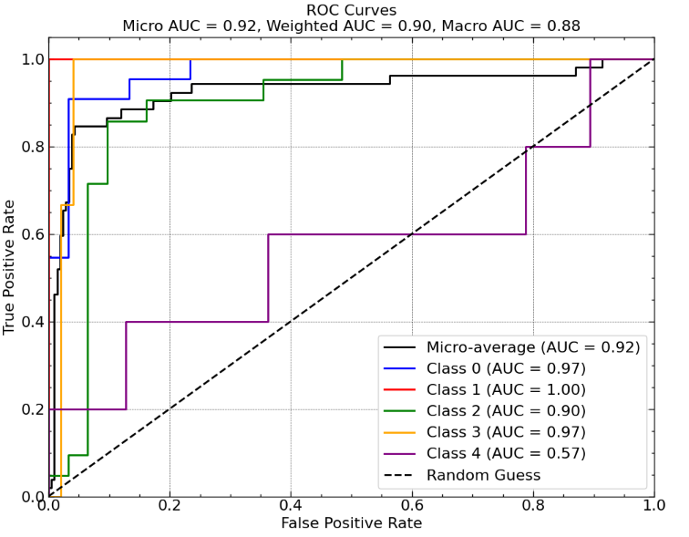 | 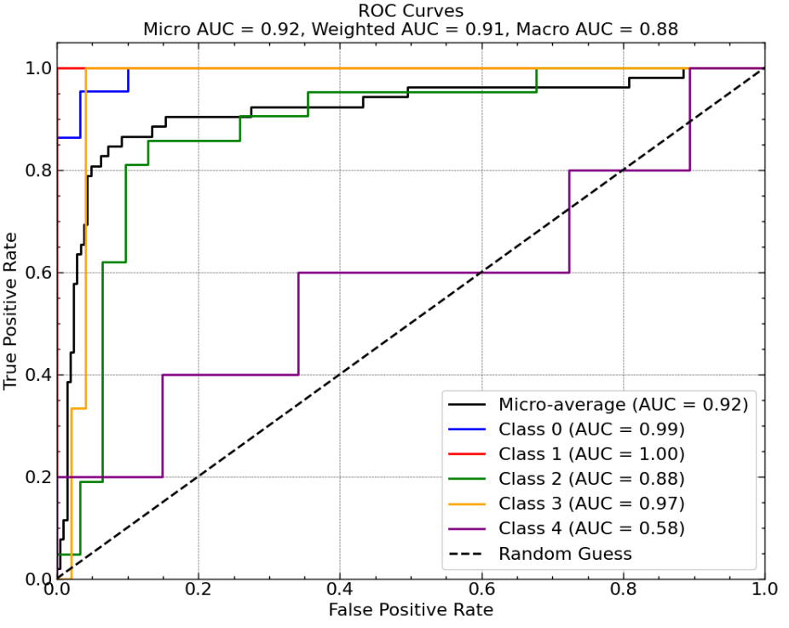 | 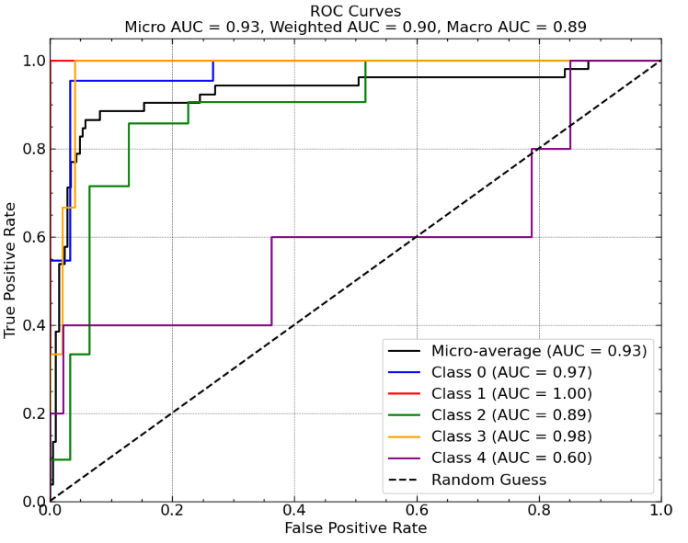 | 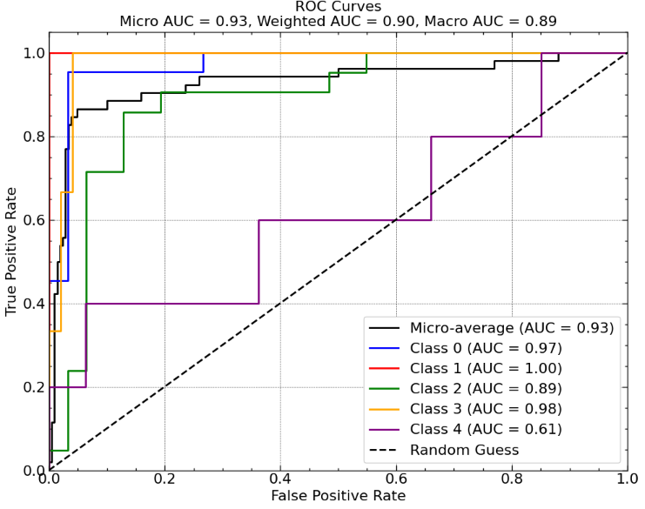 | 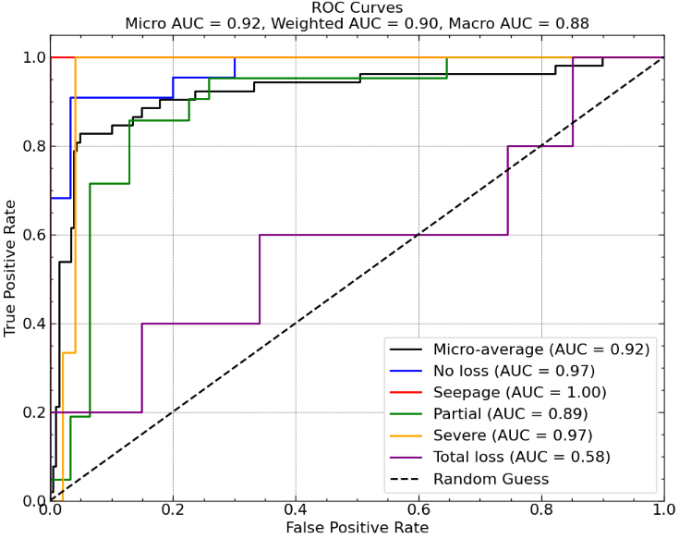
RF-Gb-SVM-MLP-BL2 | 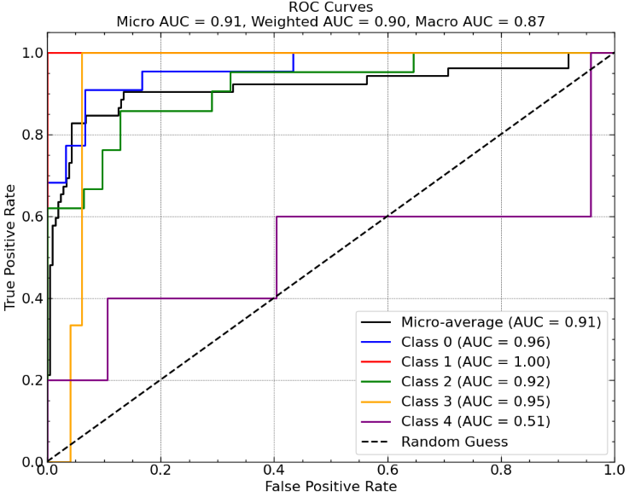 | 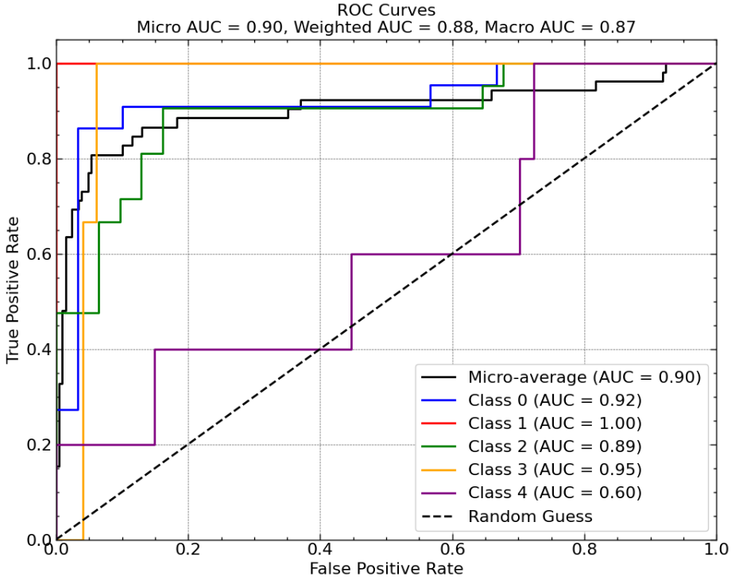 | 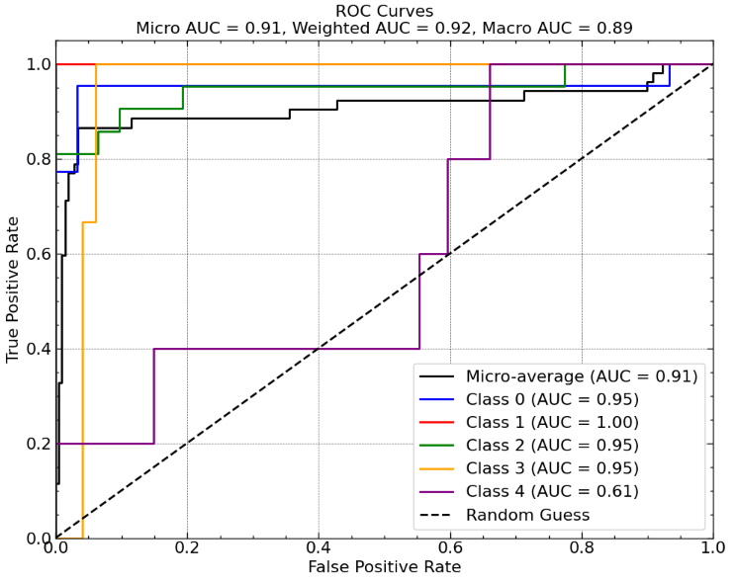 | 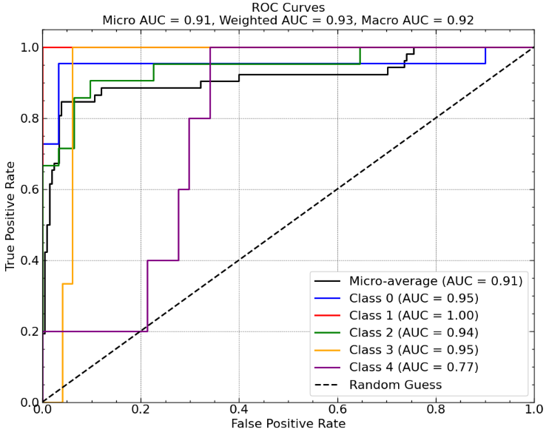 | 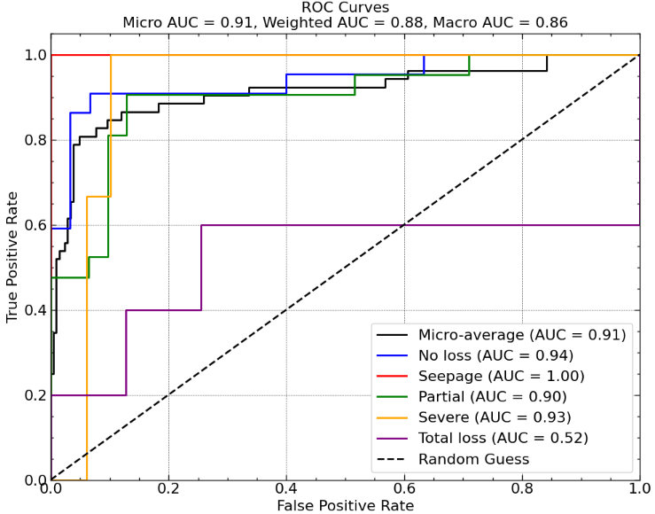
-  RF-GB-SVM-DT-RF-kmean | 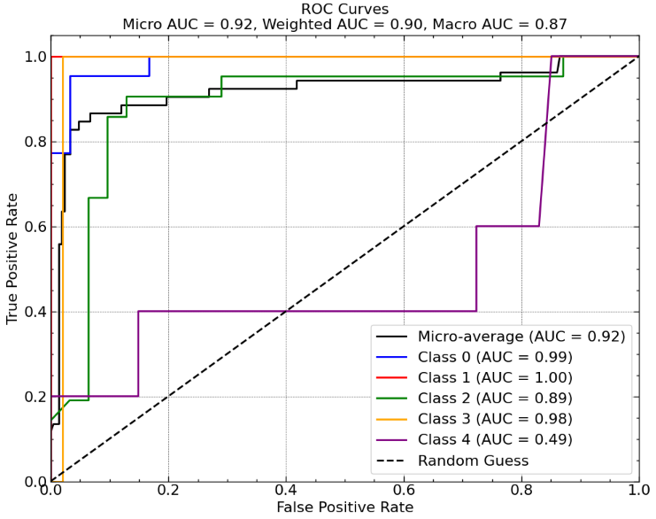 | 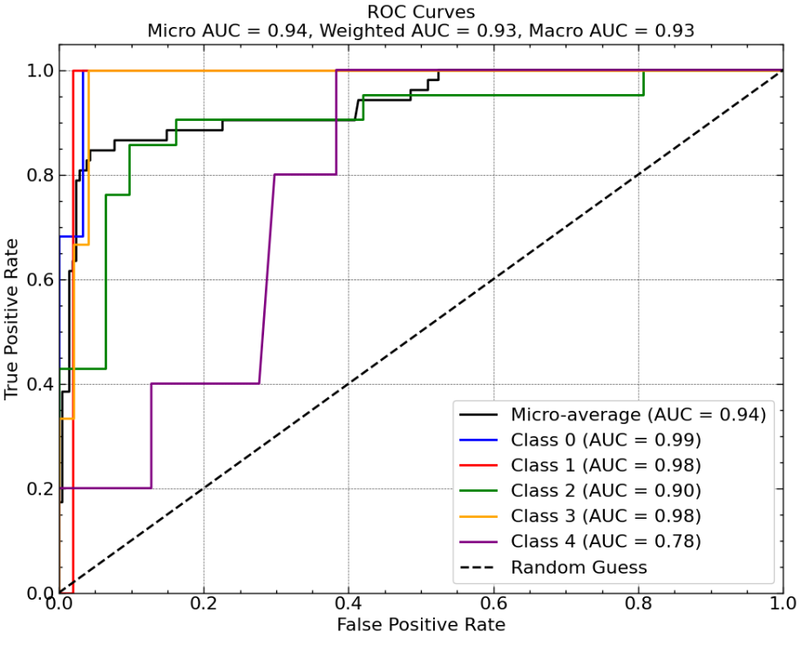 | 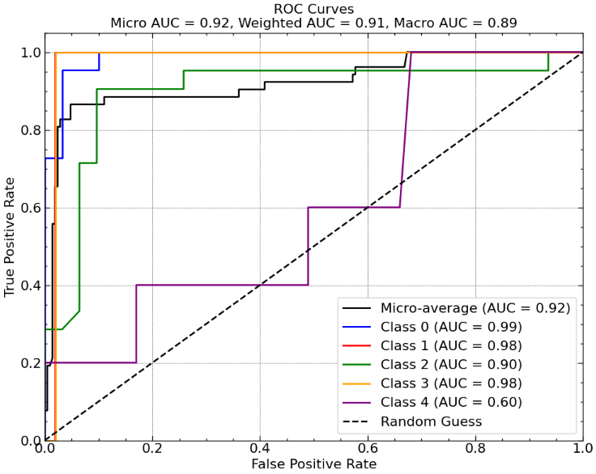 | 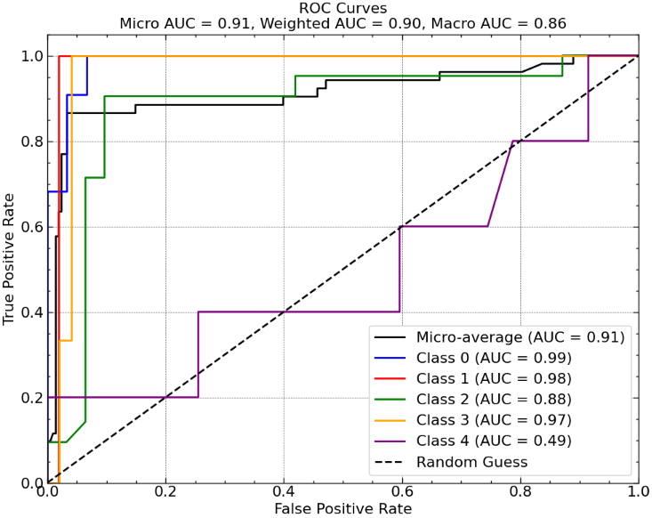 | 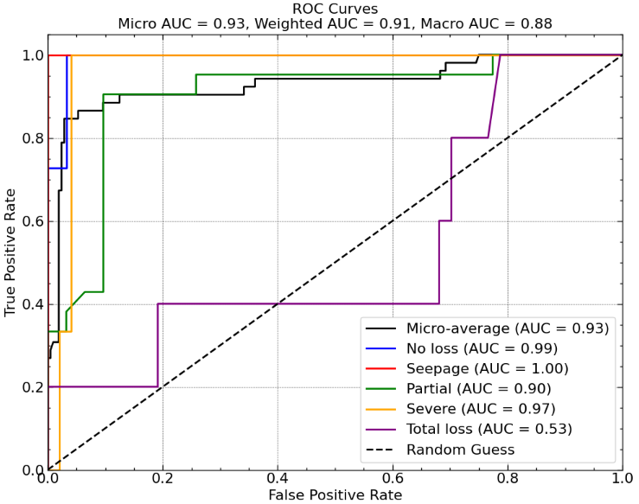
Figure S3: Receiver Operating Characteristic (ROC) curves for selected top models under optimized class-weight configurations. The curves illustrate the trade-off between True Positive Rate and False Positive Rate across thresholds, with AUC values summarizing discrimination performance.

