Supplementary Materials

Supplementary Figure S1. Independent synovial expression validation
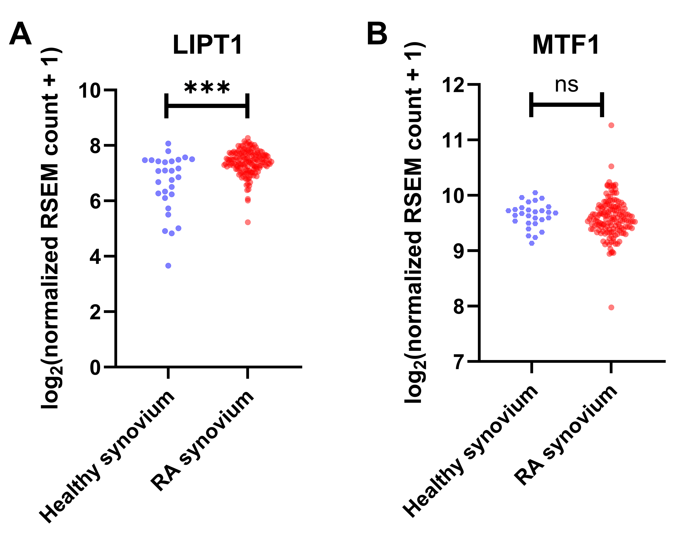
Expression of (A) LIPT1 and (B) MTF1 in healthy synovial biopsies (n = 28) and rheumatoid arthritis (RA) synovial biopsies (n = 152) from GSE89408. Each point represents one participant. RNA-Seq by Expectation-Maximization (RSEM) feature counts were normalized using median-of-ratios sample size factors and displayed as log2(normalized count + 1). Comparisons used two-sided Mann–Whitney U tests with Benjamini–Hochberg adjustment across the two genes. LIPT1: U = 3140.0, P = 6.55 × 10⁻⁵, adjusted P = 1.31 × 10⁻⁴; MTF1: U = 1833.0, P = 0.245, adjusted P = 0.245. Significance symbols refer to adjusted P values: ***P < 0.001; ns, not significant.

Supplementary Figure S2. Western blot source images
(A) Source images corresponding to main Figure 5G. Lanes 1–3, healthy controls (HCs); lanes 4–6, rheumatoid arthritis (RA).
β-actin  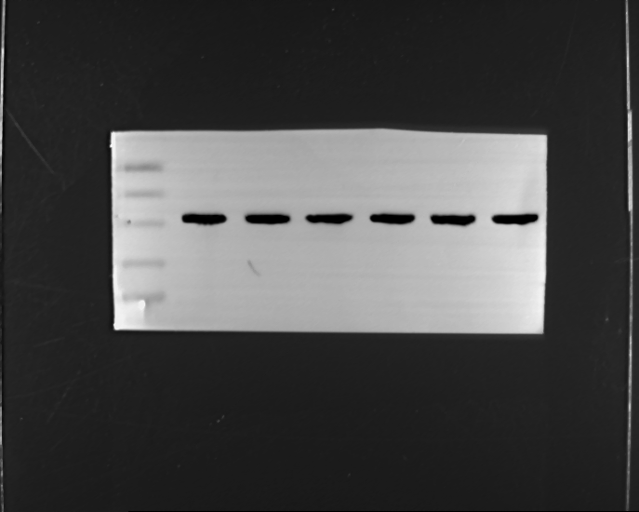 | LIPT1  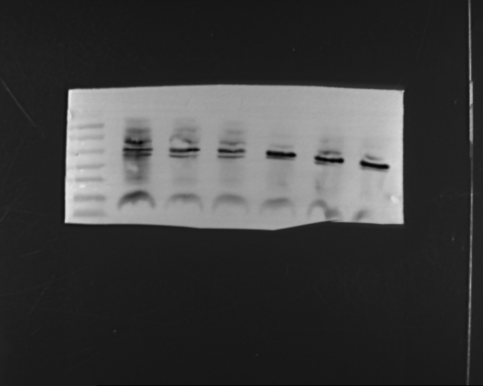 | MTF1  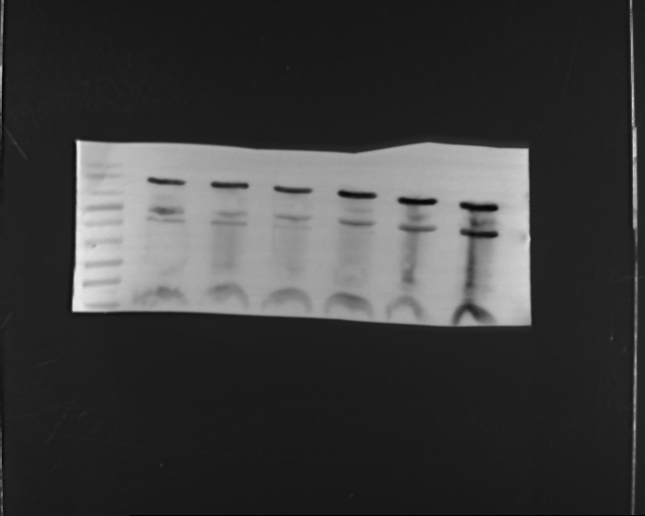
(B) Source images corresponding to main Figure 6H. Lanes 1–4, FLS, RA-FLS, RA-FLS + si-LIPT1, and RA-FLS + si-NC, respectively.
β-actin  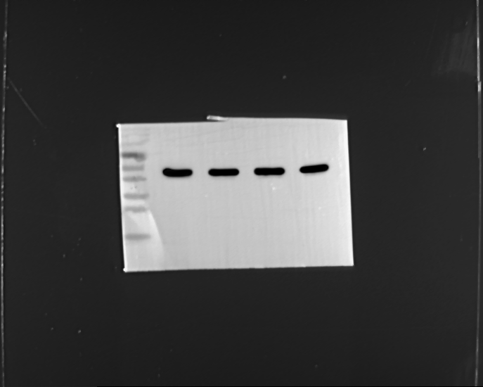 | LIPT1  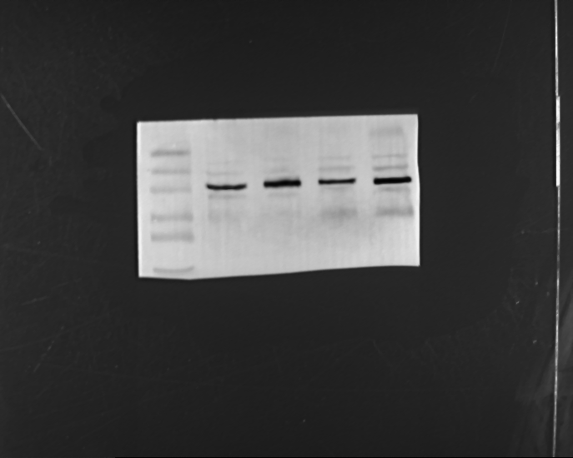
Wnt-5  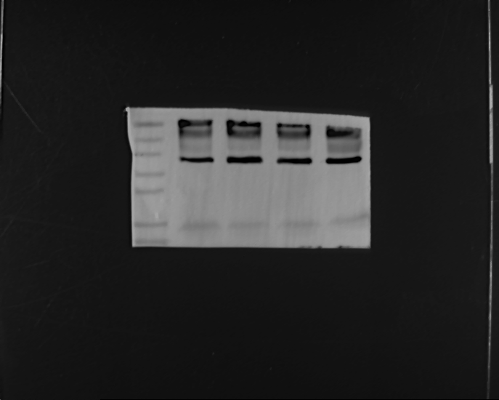 | β-catenin  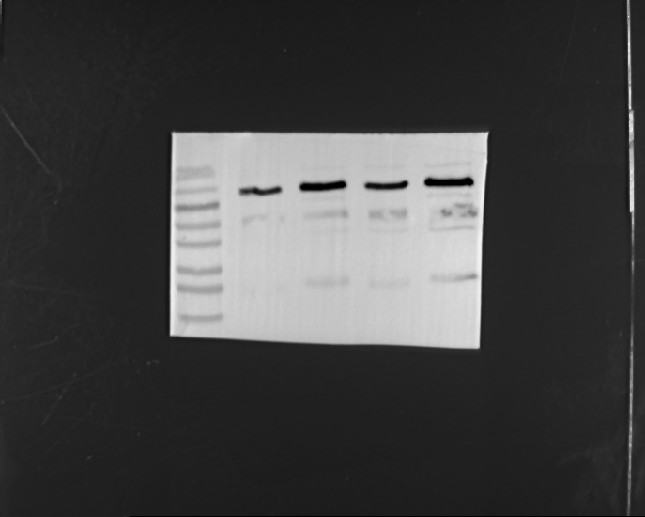
FLS, fibroblast-like synoviocytes; si-NC, non-targeting scrambled siRNA control. Panel C continues on the following page.

Supplementary Figure S2. Western blot source images (continued)
(C) Source images corresponding to main Figure 8H. Lanes 1–3, RA-FLS + si-NC; lanes 4–6, RA-FLS + si-LIPT1; lanes 7–9, RA-FLS + si-LIPT1 + SKL2001.
β-actin  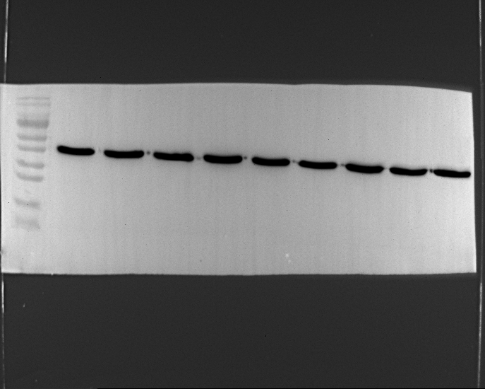 | LIPT1  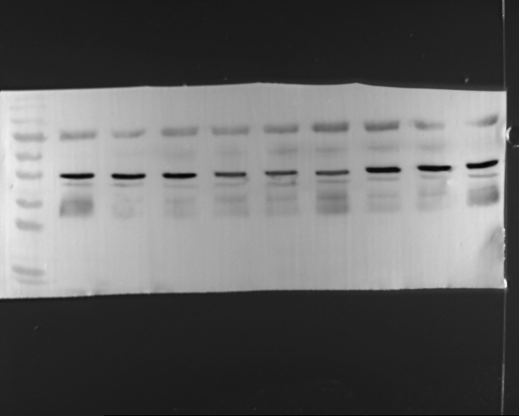
Wnt-5  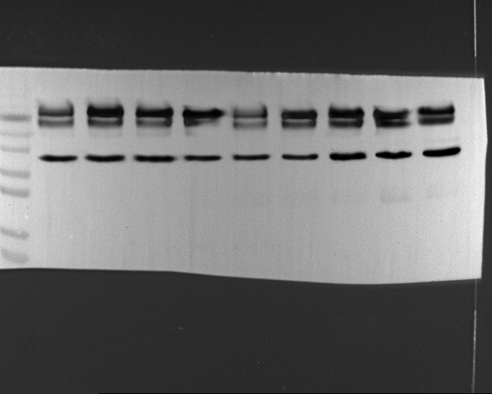 | β-catenin  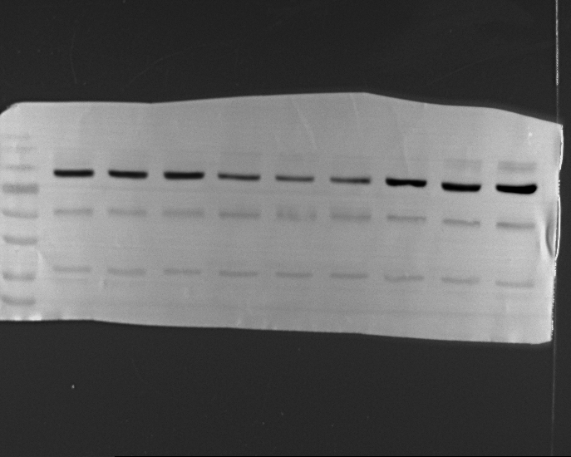
Panels A–C show the complete available image frames corresponding to main Figures 5G, 6H, and 8H. No additional cropping or lane removal was applied. Images were converted uniformly from 16-bit to 8-bit grayscale for presentation. Wnt-5 denotes the immunoblot signal detected by the WNT5A/B-reactive antibody; WNT5A denotes the transcript measured by reverse transcription quantitative polymerase chain reaction (RT-qPCR).

Supplementary Figure S3. Annexin V-FITC/PI staining after LIPT1 depletion
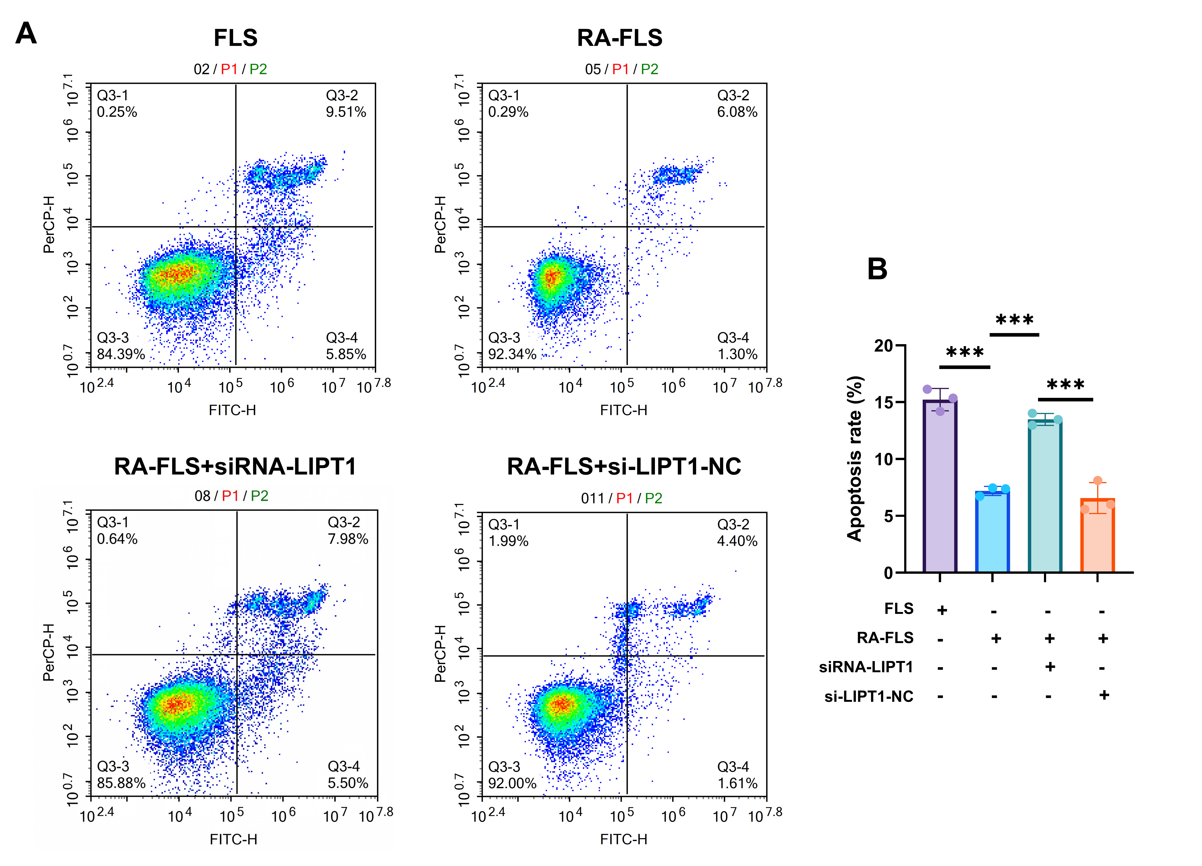
(A) Representative Annexin V-FITC/PI plots for FLS, RA-FLS, RA-FLS + si-LIPT1, and RA-FLS + si-NC. Cells were collected 48 h after siRNA transfection. (B) Total Annexin V-positive fractions. Annexin V-FITC and PI fluorescence are displayed on the FITC-H and PerCP-H axes, respectively. The total Annexin V-positive fraction is the sum of the upper-right (Q3-2) and lower-right (Q3-4) populations within the displayed parent gate. Each point represents one independently cultured and treated sample (n = 3 per group). Values are mean ± standard deviation (SD). Comparisons used one-way ANOVA followed by Tukey’s HSD test. ***P < 0.001 for the indicated comparisons. The figure labels siRNA-LIPT1 and si-LIPT1-NC denote si-LIPT1 and the non-targeting control si-NC, respectively. The axis label “Apoptosis rate” denotes the total Annexin V-positive fraction, an apoptosis-associated readout. FLS, fibroblast-like synoviocytes; RA, rheumatoid arthritis; FITC, fluorescein isothiocyanate; PI, propidium iodide. Individual values are provided in Supplementary Table S3.

Supplementary Figure S4. Annexin V-FITC/PI staining after SKL2001 treatment
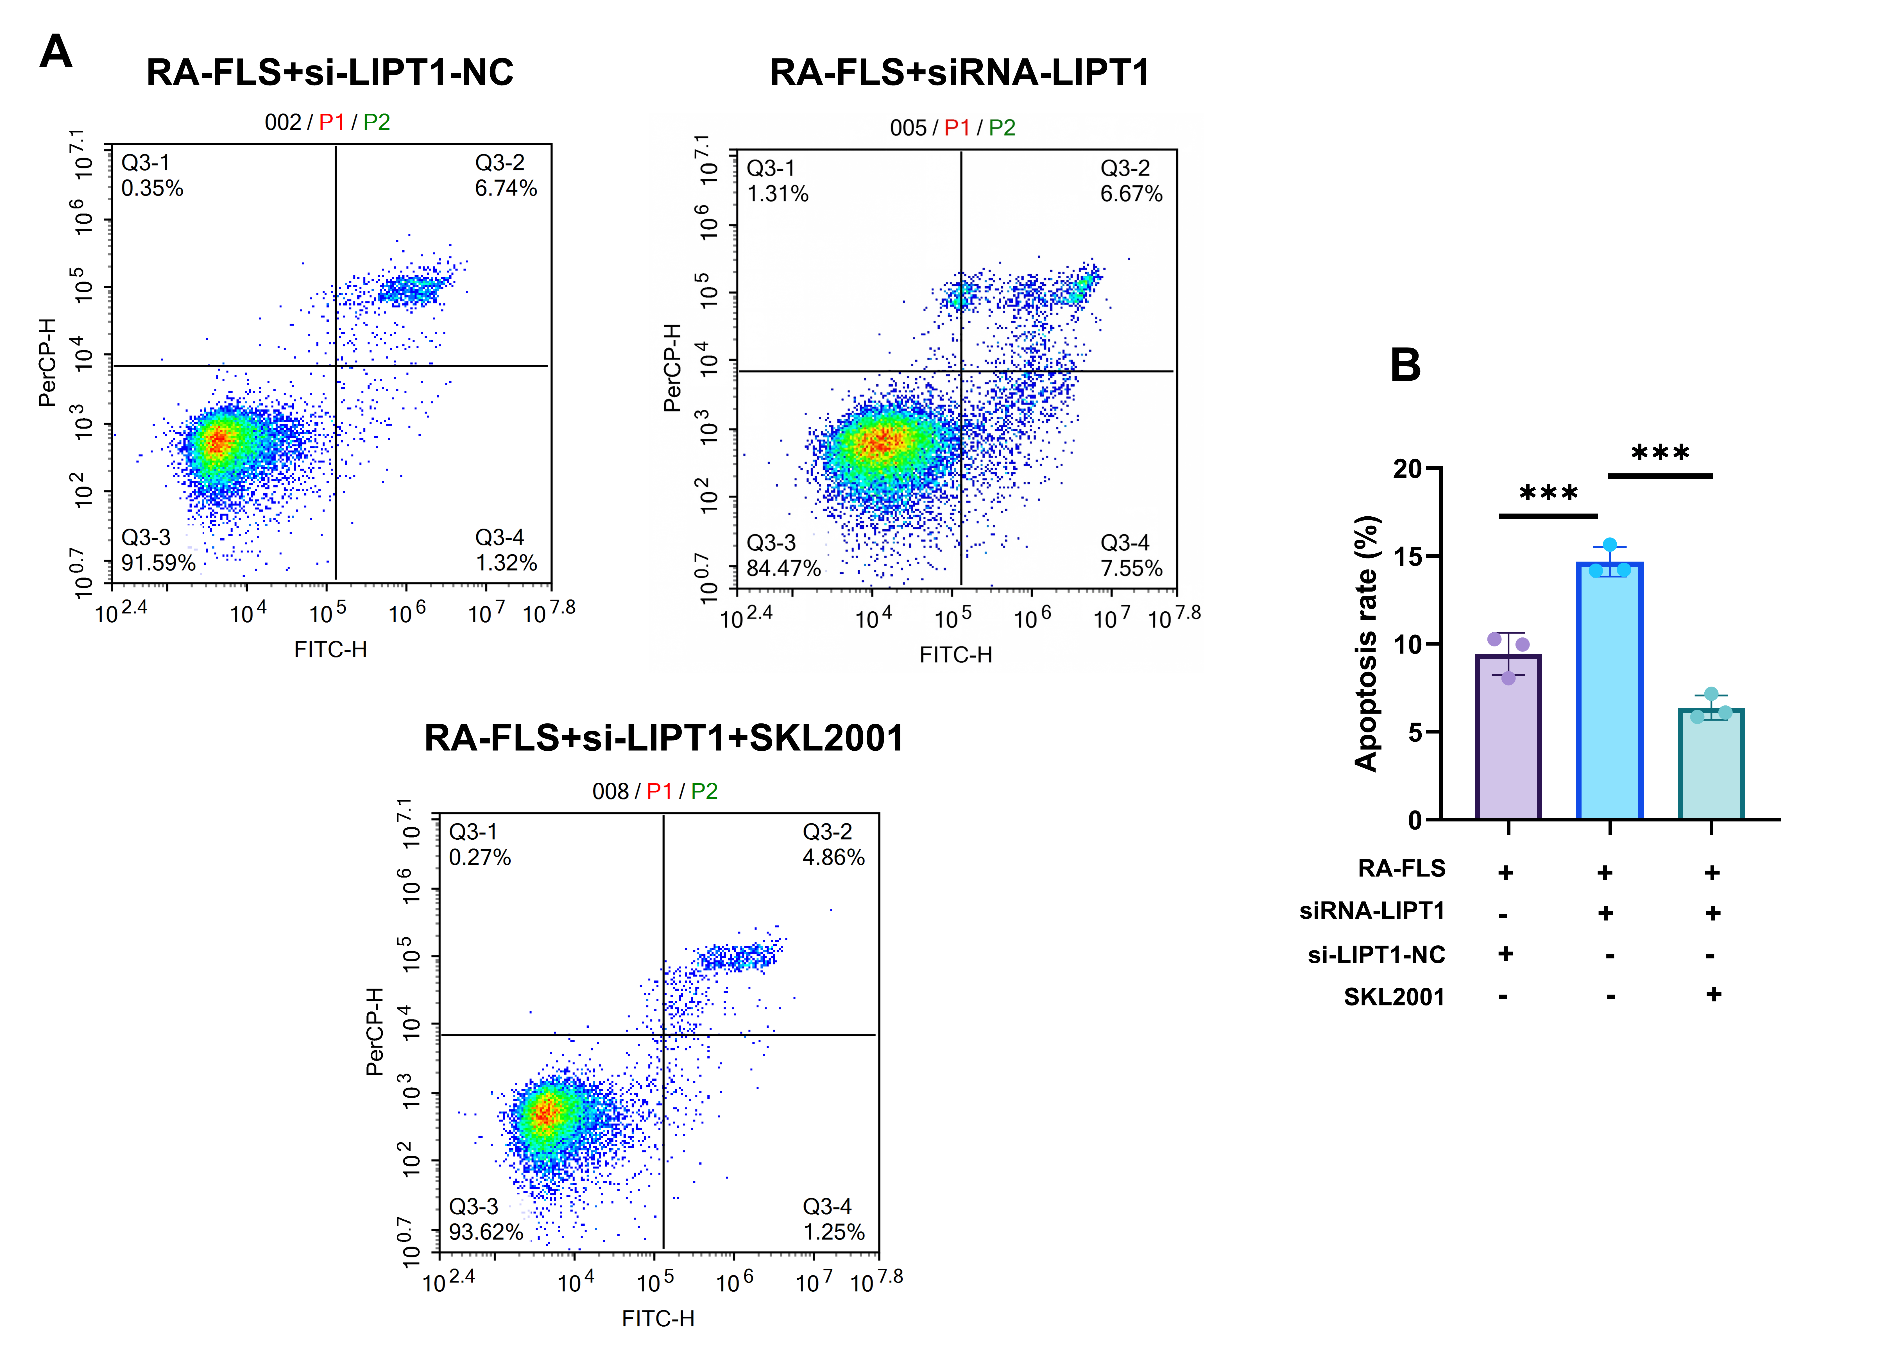
(A) Representative Annexin V-FITC/PI plots for RA-FLS + si-NC, RA-FLS + si-LIPT1, and RA-FLS + si-LIPT1 + SKL2001. For the rescue treatment, 20 μM SKL2001 was added after 6 h of siRNA transfection and maintained for a further 48 h. (B) Total Annexin V-positive fractions. Annexin V-FITC and PI fluorescence are displayed on the FITC-H and PerCP-H axes, respectively. The total Annexin V-positive fraction is the sum of the upper-right (Q3-2) and lower-right (Q3-4) populations within the displayed parent gate. Each point represents one independently cultured and treated sample (n = 3 per group). Values are mean ± standard deviation (SD). Comparisons used one-way ANOVA followed by Fisher’s LSD test. ***P < 0.001 for the indicated comparisons. The figure labels siRNA-LIPT1 and si-LIPT1-NC denote si-LIPT1 and the non-targeting control si-NC, respectively. The axis label “Apoptosis rate” denotes the total Annexin V-positive fraction, an apoptosis-associated readout. This experiment was analyzed separately from the knockdown comparison in Supplementary Fig. S3. RA-FLS, rheumatoid arthritis fibroblast-like synoviocytes; FITC, fluorescein isothiocyanate; PI, propidium iodide. Individual values are provided in Supplementary Table S3.

Supplementary Table S1. Cuproptosis-related candidate genes
Gene | Role or provenance
FDX1 | Positive regulator in foundational mechanistic screen
LIAS | Positive regulator in foundational mechanistic screen
LIPT1 | Positive regulator in foundational mechanistic screen
DLD | Positive regulator in foundational mechanistic screen
DLAT | Positive regulator in foundational mechanistic screen
PDHA1 | Positive regulator in foundational mechanistic screen
PDHB | Positive regulator in foundational mechanistic screen
MTF1 | Negative regulator in foundational mechanistic screen
GLS | Negative regulator in foundational mechanistic screen
CDKN2A | Negative regulator in foundational mechanistic screen
SLC25A3 | GeneCards-derived candidate identified in the module-intersection analysis
The candidate set comprises ten regulators identified in the foundational cuproptosis screen and SLC25A3, a GeneCards-derived candidate included in the module-intersection analysis. LIPT1 and MTF1 overlap the blue weighted gene co-expression network analysis (WGCNA) module, whereas SLC25A3 overlaps the green module.
Source: Tsvetkov, P. et al. Copper induces cell death by targeting lipoylated TCA cycle proteins. Science 375, 1254–1261 (2022). https://doi.org/10.1126/science.abf0529

Supplementary Table S2. RT-qPCR primers, targeting siRNAs, and controls
(A) RT-qPCR primers
Target | Amplicon  (bp) | Forward primer (5′–3′) | Reverse primer (5′–3′)
β-actin | 96 | CCCTGGAGAAGAGCTACGAG | GGAAGGAAGGCTGGAAGAGT
LIPT1 | 181 | TGGATGTGCAGGCTACCAAA | GCATTGCTCCTGATCCCTTG
MTF1 | 130 | TTCCACAAACAAGGCTGCTC | GCAATGGCTCAGAGAACAGG
WNT5A | 126 | TCATACCTTGAGCACGACGA | TGGAGGTTGGAGACAAAGGG
β-catenin | 100 | ATGTCTGAGGACAAGCCACA | CAGCAGTCTCATTCCAAGCC
(B) LIPT1-targeting siRNA duplexes
siRNA | Sense strand (5′–3′) | Antisense strand (5′–3′)
LIPT1-380 (si1) | GAGAAGAAGUGGAGGAGGATT | UCCUCCUCCACUUCUUCUCTT
LIPT1-892 (si2) | GGGAGUGGAUAUAUGGCAATT | UUGCCAUAUAUCCACUCCCTT
LIPT1-1049 (si3) | GGAAAUACGUGACAAAUUATT | UAAUUUGUCACGUAUUUCCTT
si-LIPT1-380 (si1) was selected for the functional experiments. The sequences shown include the terminal TT residues.
(C) Negative controls and group terminology
Label | Treatment and use
SC | Silencer Select Negative Control No. 1 siRNA (Invitrogen, Thermo Fisher Scientific; catalogue no. 4390843), delivered using Lipo8000. This commercial non-targeting control is labeled si-NC in main Figures 6–9 and Supplementary Figs. S3 and S4.
NC (mock) | Lipo8000 alone, with no siRNA. This control was used in the siRNA screen (main Figure 5C), not in the subsequent functional comparisons.
Targeting and non-targeting siRNAs were used at a final concentration of 50 nM. All screening groups followed the same transfection and medium-change schedule.

Supplementary Table S3. Individual flow-cytometry measurements
Values are total Annexin V-positive fractions (%) calculated as Q3-2 + Q3-4 within the displayed parent population. Baseline, knockdown, and rescue comparisons were conducted and analyzed separately; their controls were not pooled. The knockdown and rescue comparisons are shown in Supplementary Figs. S3 and S4, respectively. Samples 1–3 follow the order in the source data. SD, standard deviation.
Comparison | Group | Sample 1  (%) | Sample 2  (%) | Sample 3  (%) | Mean ± SD  (%)
Baseline | FLS | 15.30 | 16.05 | 14.79 | 15.38 ± 0.63
Baseline | RA-FLS | 6.72 | 7.93 | 8.52 | 7.72 ± 0.92
Knockdown | FLS | 14.19 | 15.36 | 16.14 | 15.23 ± 0.98
Knockdown | RA-FLS | 6.73 | 7.38 | 7.45 | 7.19 ± 0.40
Knockdown | RA-FLS + si-LIPT1 | 14.02 | 13.48 | 12.97 | 13.49 ± 0.53
Knockdown | RA-FLS + si-NC | 5.57 | 6.01 | 8.11 | 6.56 ± 1.36
Rescue | RA-FLS + si-NC | 9.97 | 8.06 | 10.28 | 9.44 ± 1.20
Rescue | RA-FLS + si-LIPT1 | 14.18 | 14.22 | 15.66 | 14.69 ± 0.84
Rescue | RA-FLS + si-LIPT1 + SKL2001 | 5.86 | 6.11 | 7.17 | 6.38 ± 0.70

Supplementary Methods

Independent synovial expression validation
GSE89408 was used solely for independent expression validation and did not contribute to discovery, WGCNA construction, module selection, or candidate prioritization. The GEO-supplied matrix contains RSEM feature counts. Genes with positive counts in all samples were used to calculate median-of-ratios sample size factors, and counts were divided by the corresponding sample factor. LIPT1 and MTF1 expression was compared between healthy synovium (n = 28) and RA synovium (n = 152) using two-sided Mann–Whitney U tests. P values were adjusted across the two genes using the Benjamini–Hochberg procedure. Normalized counts were displayed as log2(normalized count + 1).

Computational analysis materials
The Zenodo deposit contains archived computational inputs and outputs, together with verification, reconstruction, and independent-validation scripts. The archived ssGSEA matrix contains 66 samples; two outliers were excluded before WGCNA module–trait analysis. Supplementary Data 1 contains the 28 ssGSEA immune-signature definitions and the retained EPIC and xCell numerical outputs for the same 66 discovery samples. EPIC and xCell were used descriptively and did not determine candidate selection. Supplementary Table S1 lists the candidate genes. Independent validation assesses candidate expression, not preservation of the discovery network.

Experimental replication and statistical analysis
PBMC measurements represent individual participants and were compared using two-sided Mann–Whitney U tests. Cell RT-qPCR, immunoblotting, and biochemical assays used separately treated samples, as specified in the main Methods and figure legends. Wound-healing measurements came from separate wells, and each Transwell count came from one field in a different insert. CCK-8 wells and PCR wells in optimization assays were technical replicates and were summarized descriptively. For the 13 four-group outcomes, Shapiro–Wilk tests of within-group model residuals returned P > 0.05. Mean-centered Levene testing identified unequal variances for the LIPT1 and β-catenin RT-qPCR outcomes in main Figure 6B and D. These outcomes used Welch ANOVA followed by pairwise Welch t tests with Bonferroni adjustment across all six comparisons per outcome. Other four-group outcomes used one-way ANOVA followed by Tukey’s HSD test. Analyses retained the source-workbook normalization and displayed measurement scale. Three-group rescue comparisons used one-way ANOVA followed by Fisher’s LSD test. Flow cytometry included 27 independently cultured and treated samples across three separate comparisons, with three samples per condition. Knockdown samples were collected 48 h after transfection. Rescue samples received 20 μM SKL2001 after 6 h of transfection, followed by a further 48 h of drug exposure. Annexin V positivity was calculated as Q3-2 + Q3-4. The four-group knockdown and three-group rescue comparisons were analyzed separately. Individual values and mean ± SD are provided in Supplementary Table S3.

Data and code access
The discovery datasets GSE77298, GSE55457, and GSE55235 and the independent validation dataset GSE89408 are available in GEO (https://www.ncbi.nlm.nih.gov/geo/). Computational inputs, outputs, and code are available in Zenodo (https://doi.org/10.5281/zenodo.22824236). The deposit also includes Supplementary Data 1, which contains the ssGSEA signature definitions and discovery-cohort EPIC/xCell outputs. Individual flow-cytometry measurements are provided in Supplementary Table S3. Additional experimental data, including raw Flow Cytometry Standard (FCS) files, are available from the corresponding author on reasonable request.

