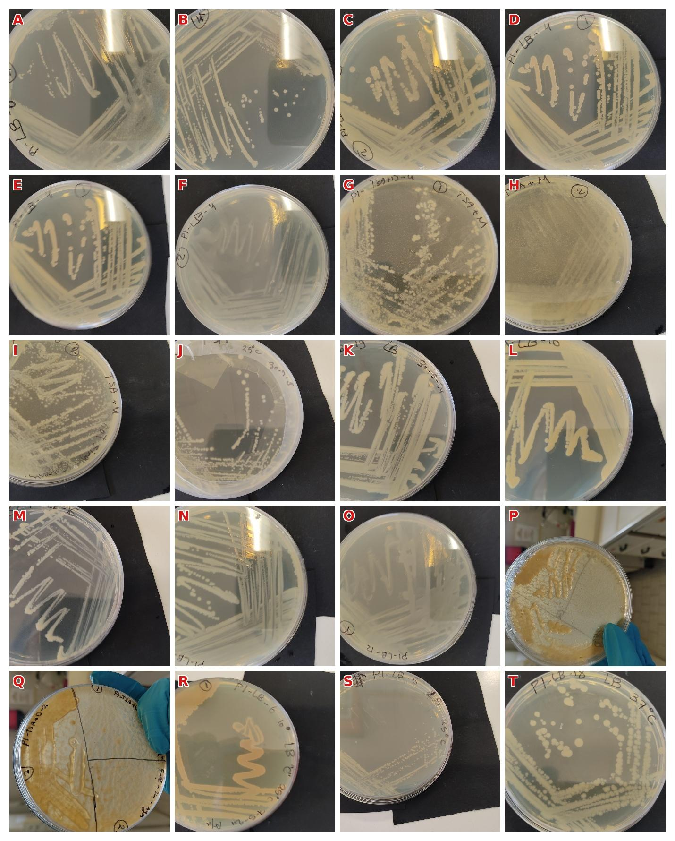
Figure S2: Representative bacterial colonies isolated from Bactrocera oleae midgut homogenates plated on five culture media following serial dilution. The full colony list and details of the growth conditions for each colony are presented in Table S1. Panels A-T show morphologically distinct colony types selected for downstream 16S rRNA gene amplification and identification. (A: LB-6-2; B: LB-6-4-1; C: LB-3-2; D-E: LB-4-1; F: LB-4-2; G: TSA-D-4; H: TSA-D-2-2; I: TSA-D-6-2; K: LB-19; L: LB-16; M: LB-16-2; N: LB-18; O: LB-12; P-Q: TSA-D-2; R:LB-6-1; S: LB-6-4-2; T: LB-18).

