Supplementary Information

Mitigation of Bacterial Spot Disease of Pepper (Capsicum annuum L.) by the Diseased Plant-Recruited Microorganisms Differentiating Rhizosphere Microbiota

Hyung-Geun Song^{1†}, Seo-Yeon Yang^{1†}, Yu-Sung Cho¹, Minju Choi¹, Hyun-Joo Yang², Min-Kyoung Seo², Ji-Hoon Lee^{1,3*}

†Equal contribution; *Corresponding author

Contents

Tables
Table S1 – Table S6

Figures
Figure S1 – Figure S11

Table S1. Experimental treatments for the bacterial inoculations performed to alleviate pepper bacterial spot disease
Group | Bacterial composition
Negative control (NC) | No bacterial inoculation
Positive control (PC) | Xanthomonas euvesicatoria KACC 18722
Treatment 1 (T1) | Xanthomonas euvesicatoria KACC 18722  Arachidicoccus terrestris KACC 18014
Treatment 2 (T2) | Xanthomonas euvesicatoria KACC 18722  Rhodanobacter terrae KACC 11761
Treatment 3 (T3) | Xanthomonas euvesicatoria KACC 18722  Arachidicoccus terrestris KACC 18014  Rhodanobacter terrae KACC 11761
Treatment 4 (T4) | Xanthomonas euvesicatoria KACC 18722  Arachidicoccus terrestris KACC 18014  Rhodanobacter terrae KACC 11761  Bacillus thuringiensis KCTC 3452  Pantoea agglomerans KACC 10055

Table S2. Chlorophyll contents of the pepper leaves (unit: mg g⁻¹)
Group | Chlorophyll-a | Chlorophyll-b | Total Chlorophyll
PAC | 1.96±0.16 ª | 0.82±0.10 ª | 2.78±0.23 ª
PAD | 1.09±0.21 ^{c} | 0.51±0.10 ^{b} | 1.60±0.30 ^{c}
PBC | 1.50±0.33 ^{b} | 0.74±0.13 ª | 2.24±0.45 ^{b}
PBD | 0.79±0.34 ^{c} | 0.38±0.13 ^{b} | 1.17±0.47 ^{c}
Values are Mean±SD. Different superscript letters within a column indicate statistically significant differences determined by ANOVA with Tukey's HSD post hoc test (p<0.05).

Table S3. Alpha diversity of the rhizosphere soil microbiota (Mean±SD)
Group | Sample | Quality-filtered read number | Normalized no. of sequence | Good's coverage | observed species (OTUs) | Richness | Diversity
 |  |  |  |  |  | Chao1 | Shannon | Inverse Simpson
PAC | PAC1 | 101,953 | 50,453 | 0.924±0.001 | 6366.4±40.0 | 16647.0±474.9 | 6.94±0.01 | 272.4±3.1
PAC | PAC2 | 71,056 | 50,453 | 0.926±0.001 | 6309.5±31.1 | 15910.9±365.1 | 6.95±0.01 | 269.5±2.1
PAC | PAC3 | 122,933 | 50,453 | 0.920±0.001 | 6852.3±45.7 | 16918.9±461.1 | 7.14±0.01 | 340.1±4.0
PAD | PAD1 | 72,605 | 50,453 | 0.933±0.001 | 5549.1±30.6 | 14676.4±395.6 | 6.50±0.01 | 116.5±1.1
PAD | PAD2 | 84,016 | 50,453 | 0.930±0.001 | 5707.1±34.5 | 15647.7±424.7 | 6.56±0.01 | 168.2±1.6
PAD | PAD3 | 98,132 | 50,453 | 0.930±0.001 | 5955.4±38.7 | 15529.0±421.0 | 6.82±0.01 | 239.1±2.4
PBC | PBC1 | 100,298 | 50,453 | 0.924±0.001 | 6494.6±38.9 | 16797.6±464.8 | 7.10±0.01 | 383.0±3.5
PBC | PBC2 | 50,453 | 50,453ª | 0.928 | 6465 | 14835.2 | 7.13 | 411.9
PBC | PBC3 | 123,034 | 50,453 | 0.922±0.001 | 6607.1±43.6 | 17092.4±472.4 | 7.10±0.01 | 376.3±3.6
PBD | PBD1 | 63,812 | 50,453 | 0.930±0.001 | 6080.2±26.0 | 15217.7±332.0 | 6.93±0.00 | 296.1±1.9
PBD | PBD2 | 82,712 | 50,453 | 0.927±0.001 | 6243.6±35.5 | 16043.9±417.1 | 6.95±0.01 | 269.2±2.6
PBD | PBD3 | 103,914 | 50,453 | 0.931±0.001 | 5868.3±39.7 | 15478.5±463.4 | 6.86±0.01 | 302.4±2.6

ª Normalized to 50,453 to be compared at the same number

Table S4. Alpha diversity of the rhizosphere microbiota of the inoculation experimental treatments (Mean±SD)
Group | Sample | Quality-filtered read number | Normalized no. of sequence | Good’s coverage | observed species (OTUs) | Richness | Diversity
 |  |  |  |  |  | Chao1 | Shannon | Inverse Simpson
Negative control | NC01 | 52,526 | 47,210 | 0.974±0.000 | 2387±11 | 5304±138 | 5.61±0.00 | 84.8±0.4
Negative control | NC02 | 70,409 | 47,210 | 0.969±0.001 | 2997±21 | 6226±206 | 6.06±0.00 | 153.3±1.0
Negative control | NC03 | 79,756 | 47,210 | 0.971±0.001 | 2470±22 | 6111±264 | 5.68±0.01 | 101.9±0.8
Positive control | PC01 | 56,516 | 47,210 | 0.972±0.000 | 2654±14 | 6012±192 | 5.89±0.00 | 87.6±0.6
Positive control | PC02 | 66,856 | 47,210 | 0.974±0.000 | 2641±18 | 5344±179 | 6.07±0.00 | 143.9±1.1
Positive control | PC03 | 62,389 | 47,210 | 0.969±0.000 | 2972±18 | 6330±194 | 6.12±0.00 | 125.4±1.0
Treatment 1 | T101 | 68,862 | 47,210 | 0.967±0.001 | 3203±22 | 6708±218 | 6.29±0.00 | 184.5±1.3
Treatment 1 | T102 | 73,917 | 47,210 | 0.968±0.001 | 3209±23 | 6472±204 | 6.28±0.01 | 159.5±1.4
Treatment 1 | T103 | 67,158 | 47,210 | 0.969±0.000 | 2980±20 | 6487±222 | 6.27±0.00 | 194.1±1.6
Treatment 2 | T201 | 47,210 | 47,210 | 0.967 | 3210 | 6810 | 6.36 | 223.1
Treatment 2 | T202 | 60,964 | 47,210 | 0.969±0.000 | 2994±17 | 6497±200 | 6.26±0.00 | 205.1±1.1
Treatment 2 | T203 | 70,380 | 47,210 | 0.967±0.001 | 3176±22 | 6668±210 | 6.30±0.00 | 194.1±1.4
Treatment 3 | T301 | 79,334 | 47,210 | 0.969±0.001 | 2959±23 | 6364±224 | 6.12±0.01 | 161.9±1.3
Treatment 3 | T302 | 54,587 | 47,210 | 0.970±0.000 | 2890±13 | 6179±163 | 6.06±0.00 | 136.1±0.6
Treatment 3 | T303 | 63,154 | 47,210 | 0.963±0.000 | 3527±20 | 7502±211 | 6.40±0.00 | 189.0±1.4
Treatment 4 | T401 | 72,185 | 47,210 | 0.971±0.000 | 2635±21 | 5865±219 | 5.67±0.01 | 91.7±0.6
Treatment 4 | T402 | 59,393 | 47,210 | 0.968±0.000 | 2986±17 | 6458±188 | 6.10±0.00 | 144.4±0.9
Treatment 4 | T403 | 64,127 | 47,210 | 0.967±0.000 | 3194±19 | 6554±193 | 6.22±0.00 | 142.9±1.2

Table S5. Pairwise PERMANOVA post-hoc comparisons of rhizosphere microbial communities among treatments, using the ThetaYC distance metric with Bonferroni correction. R² values represent the proportion of variance explained by the group differentiation. p-values indicate the raw significance level, while p_adj denotes the p-values adjusted by the Bonferroni method. NC, negative control; PC, positive control (X. euvesicatoria KACC18722); T1–T4, microbial treatments (n=3). Note that with n=3 per group the minimum attainable raw p-value is 0.1 and no comparison is significant after Bonferroni correction. Therefore, R² values are provided as descriptive measures of the magnitude of separation.
Comparison | R² | p value | p_adj
NC vs PC | 0.51857 | 0.1 | 0.3
NC vs T1 | 0.596297 | 0.1 | 0.3
NC vs T2 | 0.626085 | 0.1 | 0.3
NC vs T3 | 0.673084 | 0.1 | 0.3
NC vs T4 | 0.433421 | 0.1 | 0.3
PC vs T1 | 0.208764 | 0.4 | 0.576923
PC vs T2 | 0.292713 | 0.4 | 0.576923
PC vs T3 | 0.31969 | 0.3 | 0.576923
PC vs T4 | 0.219837 | 0.3 | 0.576923
T1 vs T2 | 0.180031 | 0.6 | 0.642857
T1 vs T3 | 0.189083 | 0.5 | 0.576923
T1 vs T4 | 0.223083 | 0.5 | 0.576923
T2 vs T3 | 0.188656 | 0.7 | 0.7
T2 vs T4 | 0.194546 | 0.5 | 0.576923
T3 vs T4 | 0.198255 | 0.4 | 0.576923

Table S6. Topological properties of the top 30 hub OTUs in co-occurrence network analysis
Rank | OTU | Degree | Betweenness | Closeness | Phylum | Genus
1 | Otu00118 | 14 | 631.86 | 0.00280 | Acidobacteriota | Gp6
2 | Otu00157 | 20 | 621.97 | 0.00293 | Bacteria_unclassified | Bacteria_unclassified
3 | Otu00038 | 8 | 559.78 | 0.00234 | Verrucomicrobiota | Opitutaceae_unclassified
4 | Otu00086 | 16 | 523.61 | 0.00279 | Bacteroidota | Cytophagales_unclassified
5 | Otu00068 | 10 | 501.75 | 0.00271 | Actinomycetota | Jatrophihabitans
6 | Otu00133 | 8 | 496.28 | 0.00235 | Pseudomonadota | Rhodospirillaceae_unclassified
7 | Otu00032 | 7 | 493.50 | 0.00247 | Pseudomonadota | Dongia
8 | Otu00110 | 22 | 470.29 | 0.00304 | Pseudomonadota | Acidibacter
9 | Otu00116 | 9 | 450.62 | 0.00251 | Actinomycetota | Baekduia
10 | Otu00009 | 12 | 434.97 | 0.00270 | Actinomycetota | Jatrophihabitans
11 | Otu00060 | 5 | 434.06 | 0.00242 | Pseudomonadota | Bradyrhizobiaceae_unclassified
12 | Otu00005 | 6 | 426.84 | 0.00256 | Bacteroidota | Mucilaginibacter
13 | Otu00058 | 8 | 418.52 | 0.00238 | Acidobacteriota | Gp3
14 | Otu00041 | 8 | 407.33 | 0.00236 | Pseudomonadota | Micropepsaceae_unclassified
15 | Otu00054 | 4 | 362.13 | 0.00207 | Actinomycetota | Jatrophihabitans
16 | Otu00061 | 8 | 361.90 | 0.00227 | Bacteria_unclassified | Bacteria_unclassified
17 | Otu00052 | 8 | 354.36 | 0.00220 | Actinomycetota | Gaiella
18 | Otu00107 | 16 | 349.28 | 0.00270 | Acidobacteriota | Gp3
19 | Otu00033 | 10 | 348.60 | 0.00273 | Actinomycetota | Thermoleophilia_unclassified
20 | Otu00101 | 7 | 342.18 | 0.00242 | Bacteria_unclassified | Bacteria_unclassified
21 | Otu00124 | 14 | 332.00 | 0.00287 | Chloroflexota | Caldilineaceae_unclassified
22 | Otu00050 | 3 | 328.87 | 0.00254 | Verrucomicrobiota | Subdivision3_genera_incertae_sedis
23 | Otu00128 | 18 | 326.56 | 0.00301 | Pseudomonadota | Hyphomicrobiales_unclassified
24 | Otu00091 | 3 | 323.27 | 0.00238 | Planctomycetota | Tepidisphaera
25 | Otu00102 | 6 | 320.66 | 0.00270 | Bacteroidota | Chitinophagaceae_unclassified
26 | Otu00077 | 5 | 316.83 | 0.00247 | Pseudomonadota | Sphingomonadales_unclassified
27 | Otu00119 | 15 | 314.45 | 0.00276 | Verrucomicrobiota | Subdivision3_genera_incertae_sedis
28 | Otu00156 | 10 | 302.68 | 0.00263 | Pseudomonadota | Reyranella
29 | Otu00106 | 8 | 301.83 | 0.00235 | Planctomycetota | Singulisphaera
30 | Otu00144 | 13 | 288.26 | 0.00282 | Bacteroidota | Chitinophagaceae_unclassified

Figure S1. Schematic of the two pot experiments. (A) Experiment 1 (infection experiment) used a 2 × 2 design combining soil pathogen history (A soil, no pathogen; B soil, inoculated with X. euvesicatoria KACC 18722 and aged 14 d) with plant-level pathogen challenge (control, diseased), yielding four groups (PAC, PBC, PAD, PBD; n = 3 each). (B) Experiment 2 (inoculation experiment) comprised 6 groups grown in A soil: a non-inoculated negative control (NC), a pathogen-only positive control (PC), and four microbial treatments (T1-T4) differing in inoculant composition (Table S3); n = 3 per group.
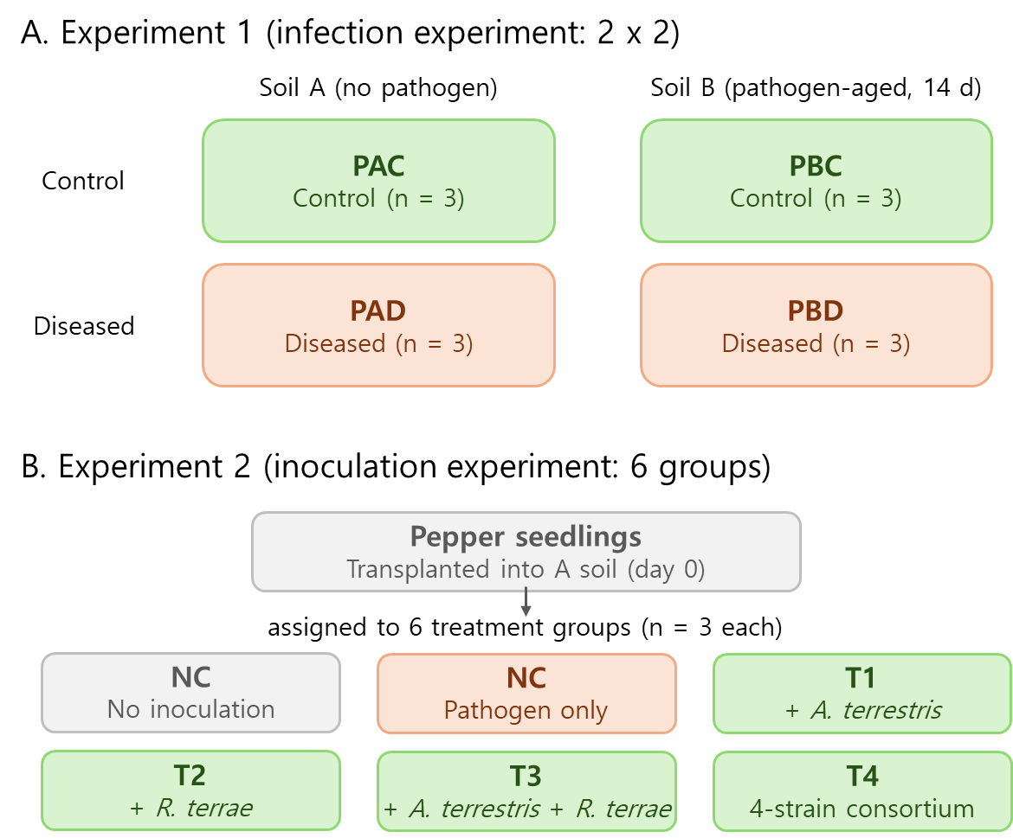

Figure S2. PCR amplification using the Xanthomonas-specific primer pair of Bs-XeF and Bs-XeR for detection of X. euvesicatoria. Ladder: 100 bp ladder, Xeu: X. euvesicatoria.
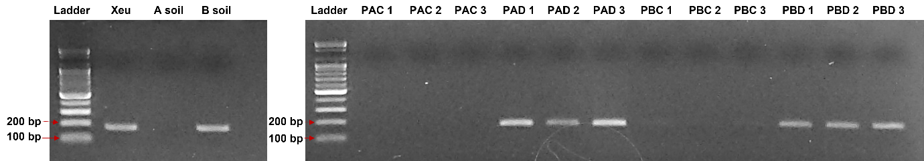

Figure S3. Alpha diversity comparing between Control groups (PAC and PBC) and Disease groups (PAD and PBD). A, B, C and D show the number of OTUs, Chao1, Shannon, and inverse Simpson values, respectively. Error bars represent the standard deviation of the mean, and asterisks indicate significant differences determined by t-test: *** (p<0.001), ** (p<0.01), * (p<0.05).

Figure S4. Relative sequence abundances of the red pepper rhizosphere bacterial communities at phylum (A) and genus (B) levels. Top 30 genera were presented among the total 743 genera (B).
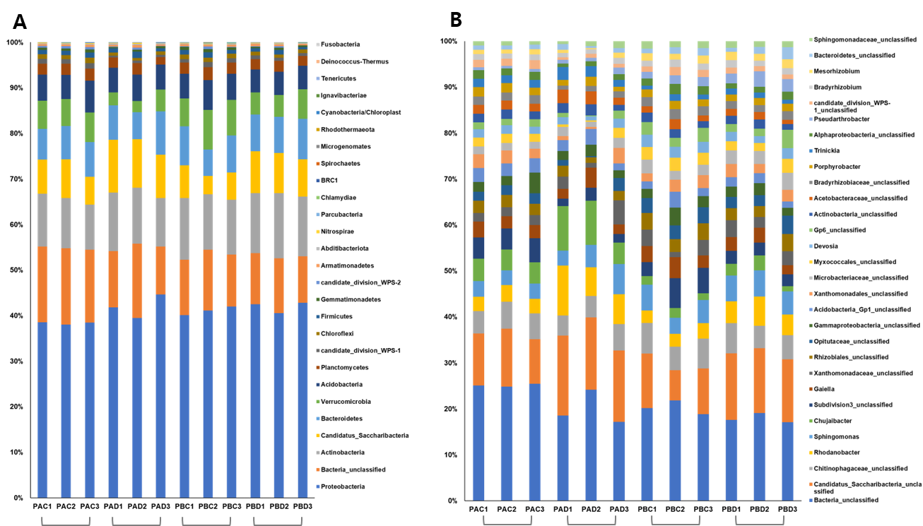

Figure S5. Heatmaps representing relative sequence abundance at phylum (A) and genus (B) levels. Vertical and horizontal dendrograms based on Bray-Curtis dissimilarity distance. Only top 30 (in abundance) genera among the total 743 included.
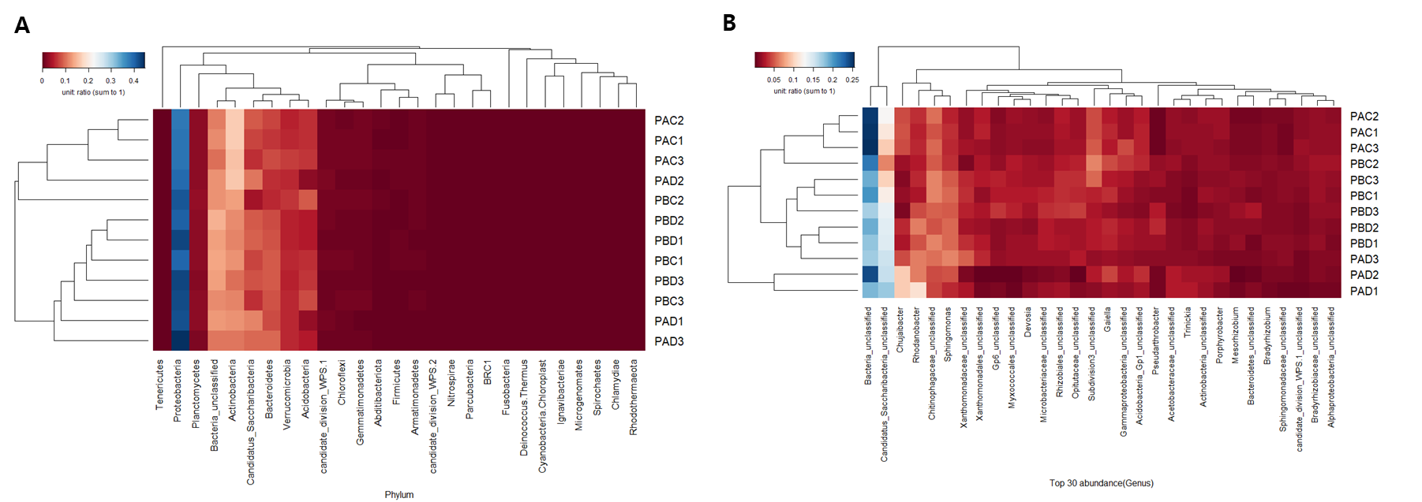

Figure S6. Inoculation experiment for pepper bacterial spot disease. NC at 29 days and PC and treatments (T1-T4) at 43 days.
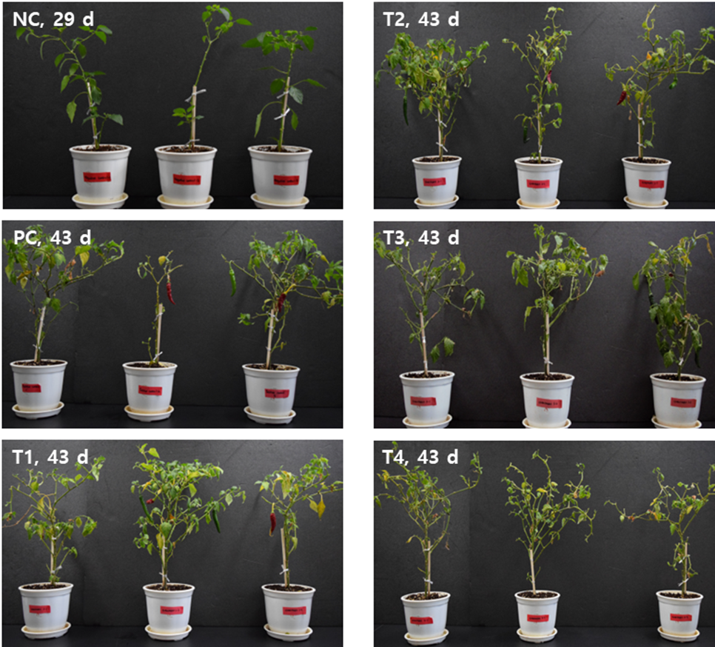

Figure S7. Inoculation experiment for pepper bacterial spot disease. (A) Counts of leaf numbers. (B) Shoot lengths of the pepper plants. (C) Root lengths and surface areas.
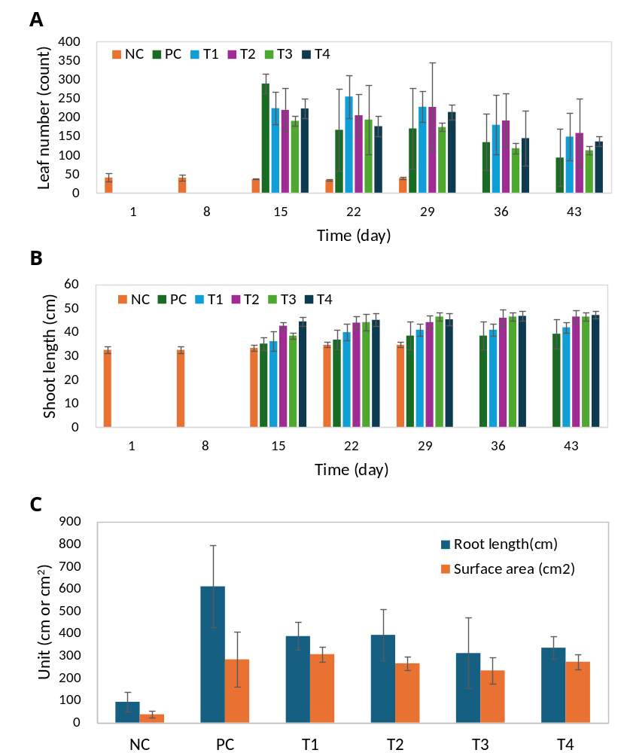

Figure S8. Root scan images of the inoculation experiment at the end of incubation.
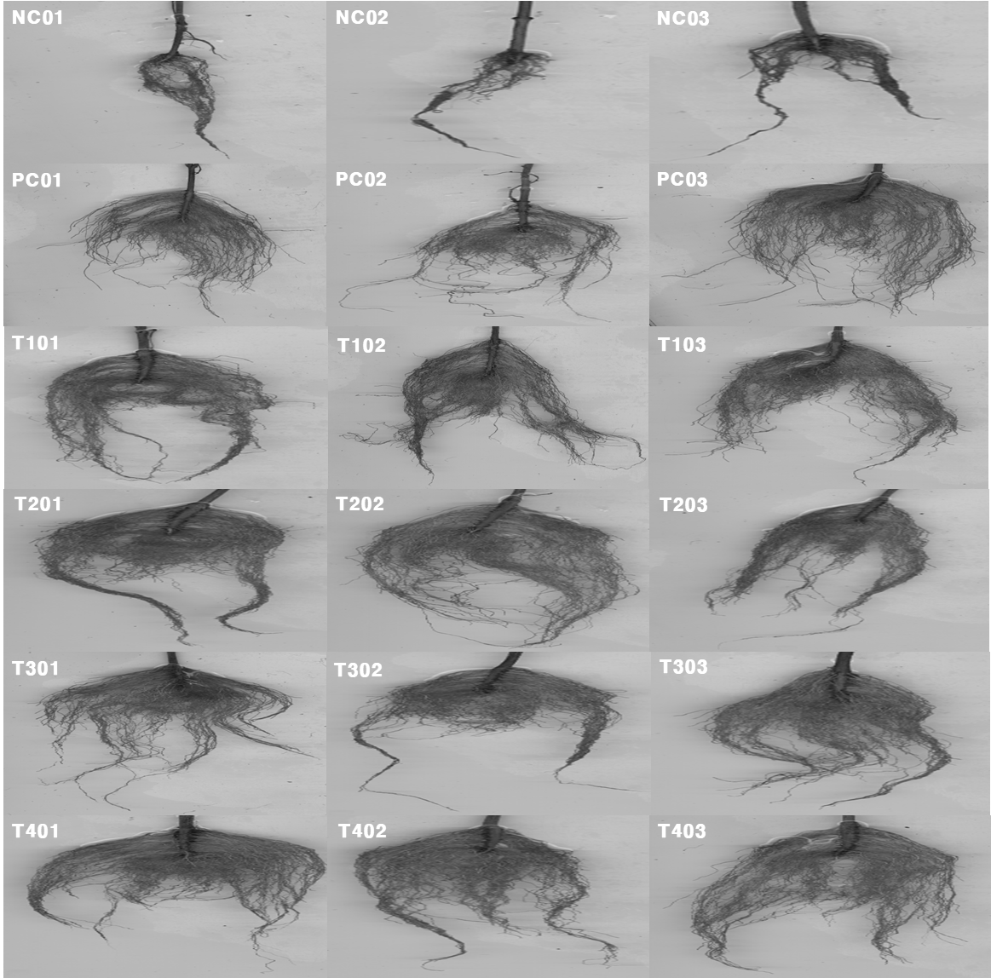

Figure S9. Relative sequence abundances of the inoculation experiment at phylum (A) and genus (B) levels. Genera less than 0.5% in total were pooled into “Others” (from total 652 genera).
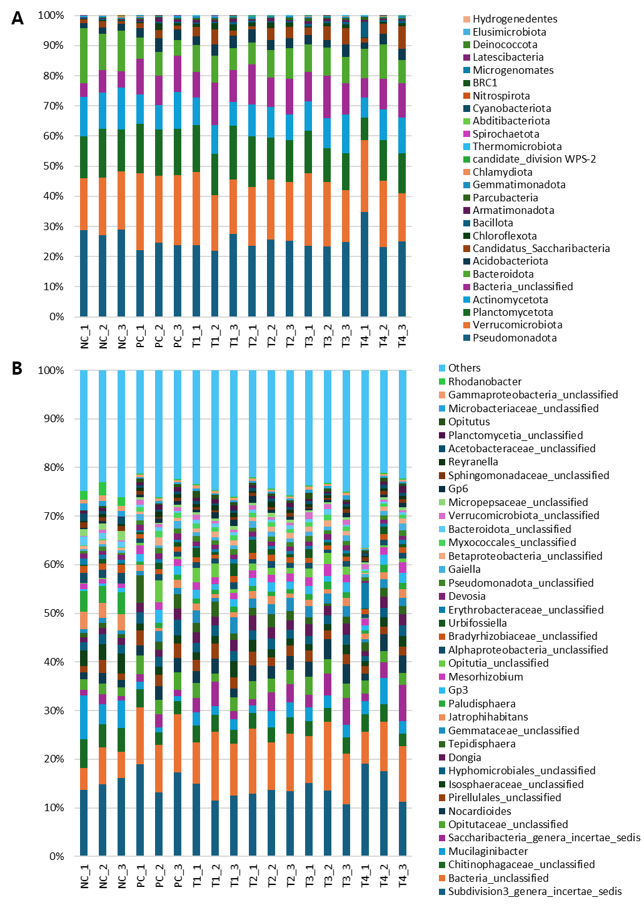
Figure S10. Heatmaps representing relative sequence abundance at phylum (A) and genus (B) levels. Vertical and horizontal dendrograms based on Bray-Curtis dissimilarity distance. Genera less than 0.5% in total were pooled into “Others” (from total 652 genera).

Figure S11. Ordination analysis of NMDS (A) and PCoA (B) using ThetaYC distance metric and group beta-dispersion analysis, represented as PCoA (C) and boxplot of distance to centroid (D). No significant difference in beta-dispersion among the treatment groups (F=0.2748, p=0.928), indicating the significant community shifts identified by PERMANOVA primarily driven by changes in community composition rather than differences in within-group variance.
