Supplementary material
Part A: Sensitivity analysis of the SCCI coupling parameters
This appendix presents a benchmark experiment designed to assess the sensitivity of the SCCI inversion procedure to the three coupling parameters $a$, $b$, and $c$. The analysis is structured around a series of controlled perturbations in which two parameters are held constant while the third is systematically varied. For each tested parameter value, five SCCI iterations were performed. Every figure in this appendix is composed of three panels: (a) the ERT inversion result, (b) the SRT inversion result, and (c) an inset summarizing the evolution of SCCI constraint weights and data misfits. The scenarios tested in this section are based on Fig. S1, present in the main text of this work
The inset displays the range of constraint weights applied during each SCCI iteration, with method 0 corresponding to ERT and method 1 to SRT, along with the χ² misfit evolution for both ERT and SRT across the same iterations. This multi-parameter exploration provides a systematic evaluation of how the coupling responds to variations in each parameter and allows identification of stable versus unstable regions of the parameter space.
- Sensitivity to parameter $a$
To evaluate the role of parameter $a$, which governs the strength of the cross-gradient constraint, it was varied while maintaining $b=0.1$ and $c=1$. Four scenarios were considered, covering $a=0.1$ (the baseline configuration used in the main analysis), $a=0.01$, $a=0.001$, and $a=0.5$. The corresponding Figs. S1 – S4 illustrate how adjustments to $a$ modify the balance between structural coupling and individual data-fit objectives. Across these cases, the three-panel figure layout reveals how strongly the imposed cross-gradient influences the evolution of both resistivity and velocity models, as well as the degree to which the constraint weights shift during iterative coupling. Together, these results offer insight into the sensitivity of the SCCI workflow to strengthening or weakening the primary coupling parameter.
- Sensitivity to parameter $b$
The effect of parameter $b$, which regulates the structural weighting applied within the coupling constraint, was assessed by fixing $a=0.1$ and $c=1$and evaluating three scenarios with $b=0.01$, $b=0.3$, and $b=0.5$. Figs. S5 – S7 document how increasing $b$alters the distribution of constraint weights and how the ERT and SRT models adapt to a stronger or weaker emphasis on structural similarity. These cases demonstrate how modifications to $b$influence the stability and convergence of the SCCI process, highlighting where structural coherence becomes dominant and where decoupling effects may appear. The three-panel format again provides a clear comparison of model behaviour and misfit evolution across the five SCCI iterations.
- Sensitivity to parameter $c$
The influence of the scaling parameter $c$, which adjusts the relative magnitude of the coupling term when applied to the model gradients, was explored by fixing $a=0.1$ and $b=0.1$ and testing $c=0.5$, $c=2$, and $c=3$. Figs. S8 – S10 present the outcomes of these configurations, illustrating how modifying the scale factor amplifies or moderates the effect of the coupling operator. The three-component figure layout shows how the inversion models respond to changes in $c$, and how the constraint weights and χ² misfits evolve during the five SCCI iterations. This set of experiments identifies the parameter ranges where the coupling strength is appropriately balanced, and where excessive amplification or under-scaling leads to less coherent joint inversion behavior.
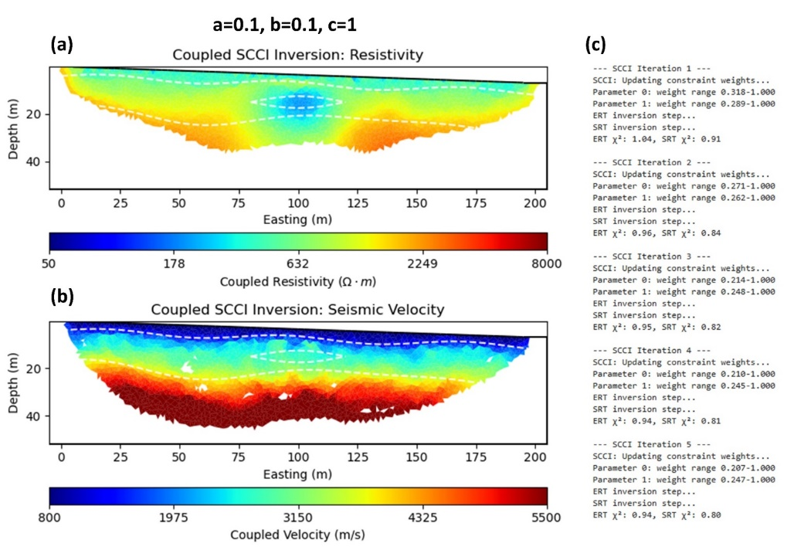
Fig. S1. Sensitivity test for parameter $a=0.1$ (baseline configuration), with $b=0.1$ and $c=1$ held constant. Panels show: (a) final ERT model, (b) final SRT model, and (c) evolution of constraint weights and χ² data misfits for ERT (method 0) and SRT (method 1) across the five SCCI iterations.
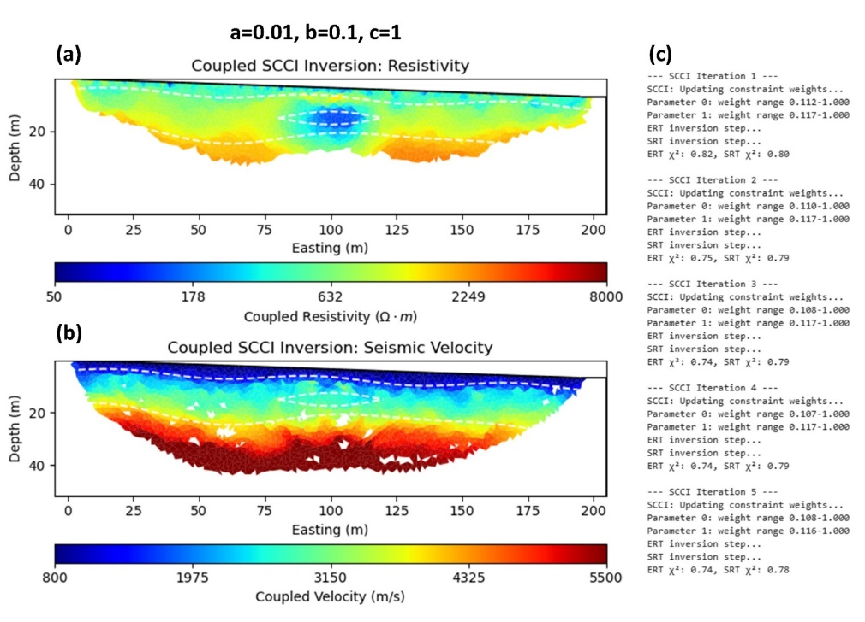
Fig. S2. Sensitivity test for parameter $a=0.01$, with $b=0.1$ and $c=1$ fixed. Panels illustrate: (a) ERT model, (b) SRT model, and (c) changes in constraint weighting and χ² misfits through the SCCI iterations, showing the effect of reducing the cross-gradient strength.
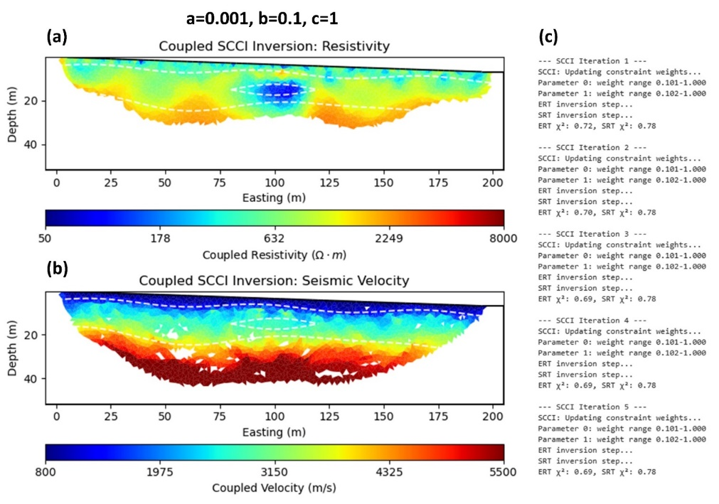
Fig. S3. Sensitivity test for parameter $a=0.001$, while $b=0.1$and $c=1$ remain constant. Panels present: (a) ERT model, (b) SRT model, and (c) constraint-weight trajectories and χ² evolution, highlighting the behaviour of the inversion under a very weak cross-gradient coupling.
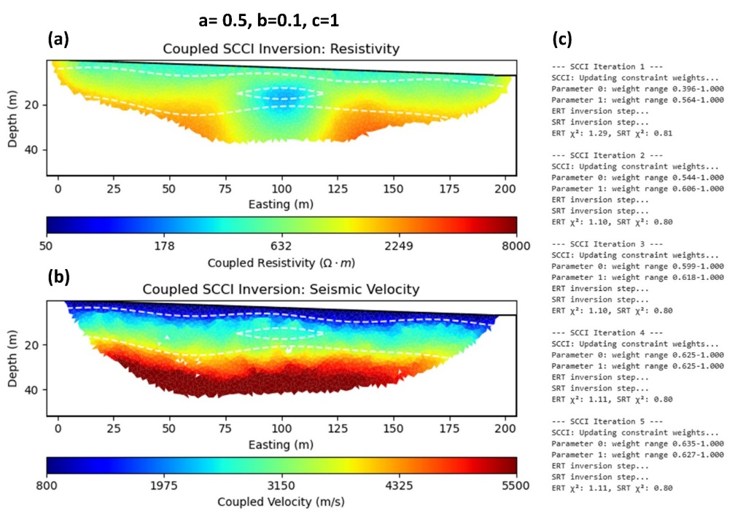
Fig. S4. Sensitivity test for parameter $a=0.5$, with $b=0.1$ and $c=1$ fixed. Panels include: (a) ERT model, (b) SRT model, and (c) iteration-by-iteration constraint weights and χ² trends, illustrating the impact of imposing a stronger cross-gradient constraint.
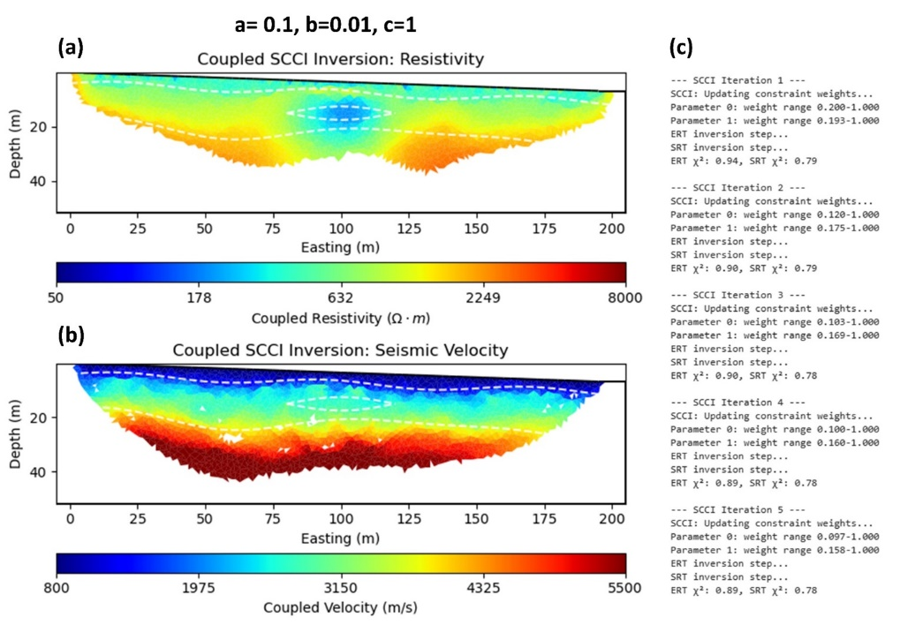
Fig. S5. Sensitivity test for parameter $b=0.01$, with $a=0.1$ and $c=1$ held constant. Panels show: (a) final ERT model, (b) final SRT model, and (c) evolution of constraint weights and χ² misfits, capturing the effect of a weak structural-weighting term.
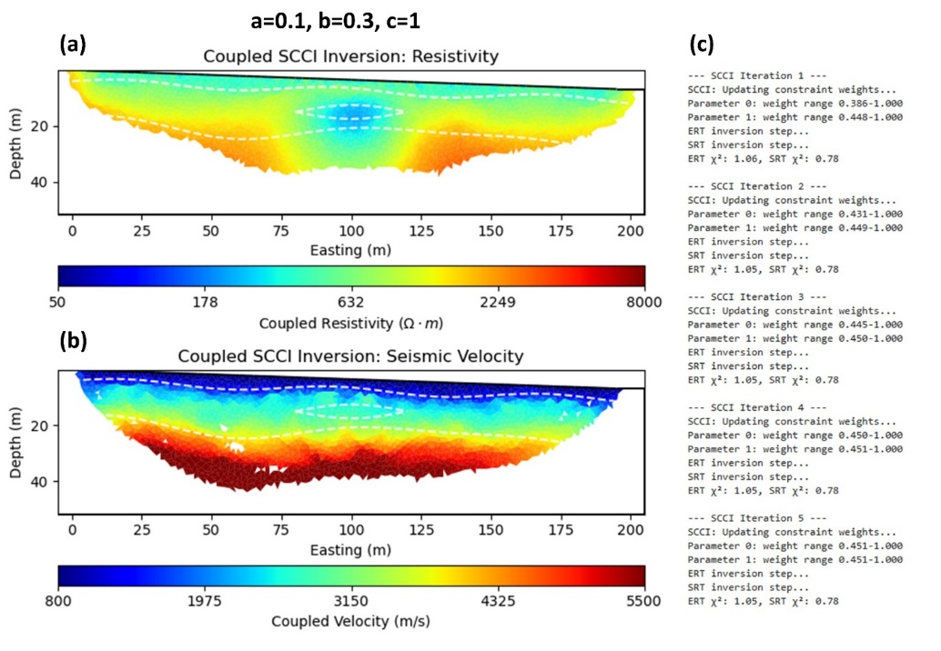
Fig. S6. Sensitivity test for parameter $b=0.3$, with $a=0.1$ and $c=1$ fixed. Panels illustrate: (a) ERT model, (b) SRT model, and (c) changes in constraint weights and χ² across iterations, documenting the response to an intermediate structural-weighting value.
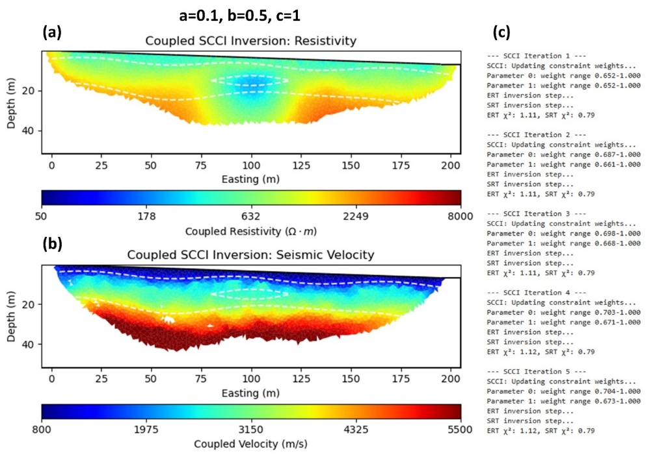
Fig. S7. Sensitivity test for parameter $b=0.5$, while $a=0.1$ and $c=1$ remain constant. Panels present: (a) ERT model, (b) SRT model, and (c) the evolution of constraint weights and χ² misfits, showing the influence of a stronger structural-coupling contribution.
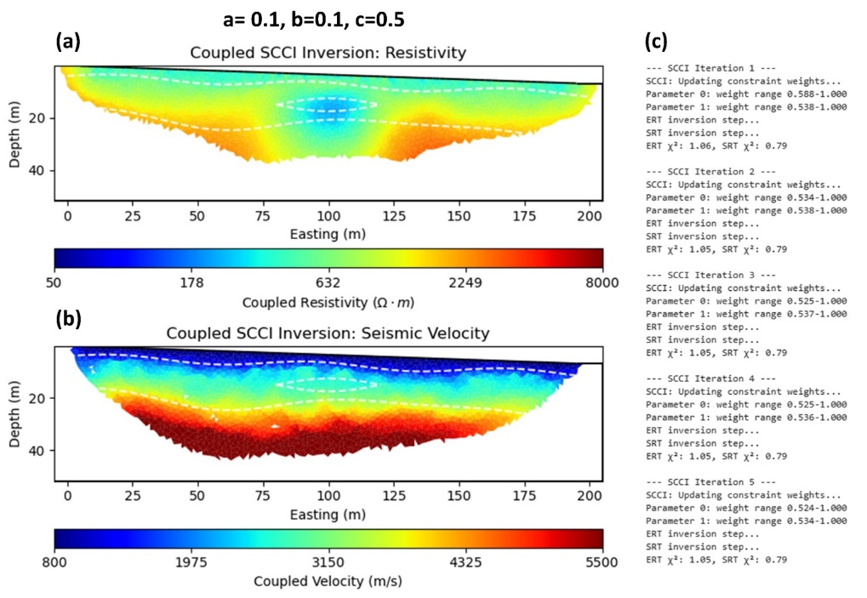
Fig. S8. Sensitivity test for parameter $c=0.5$, with $a=0.1$ and $b=0.1$ fixed. Panels show: (a) ERT model, (b) SRT model, and (c) iteration-wise constraint weights and χ² misfit evolution, illustrating the effect of reducing the scaling applied to the coupling operator.
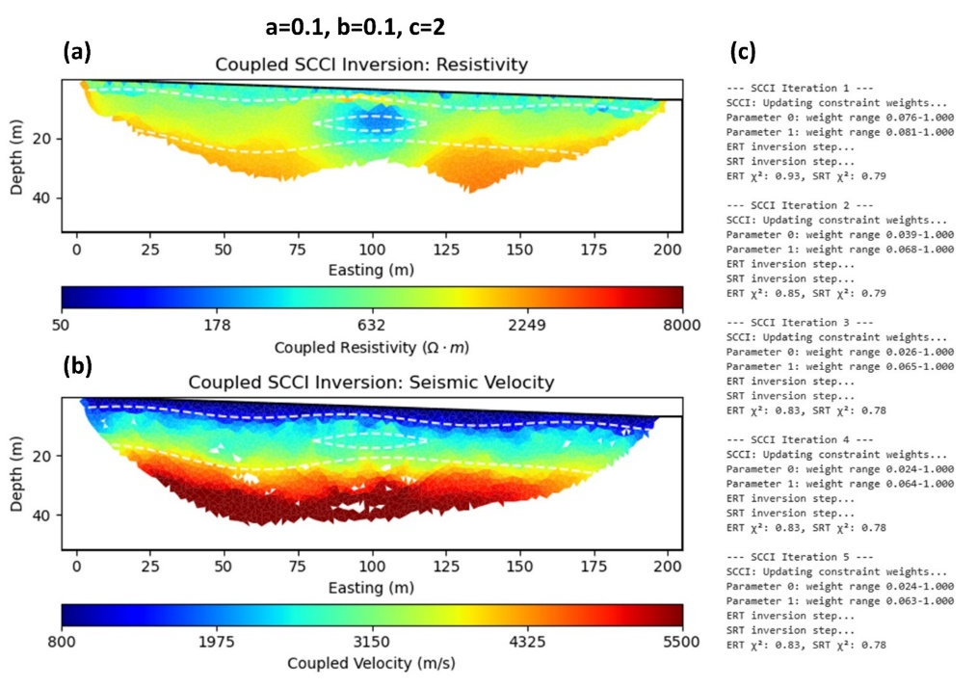
Fig. S9. Sensitivity test for parameter $c=2$, with $a=0.1$ and $b=0.1$ unchanged. Panels include: (a) ERT model, (b) SRT model, and (c) the behavior of constraint weights and χ² values across the SCCI iterations as the coupling term is amplified.
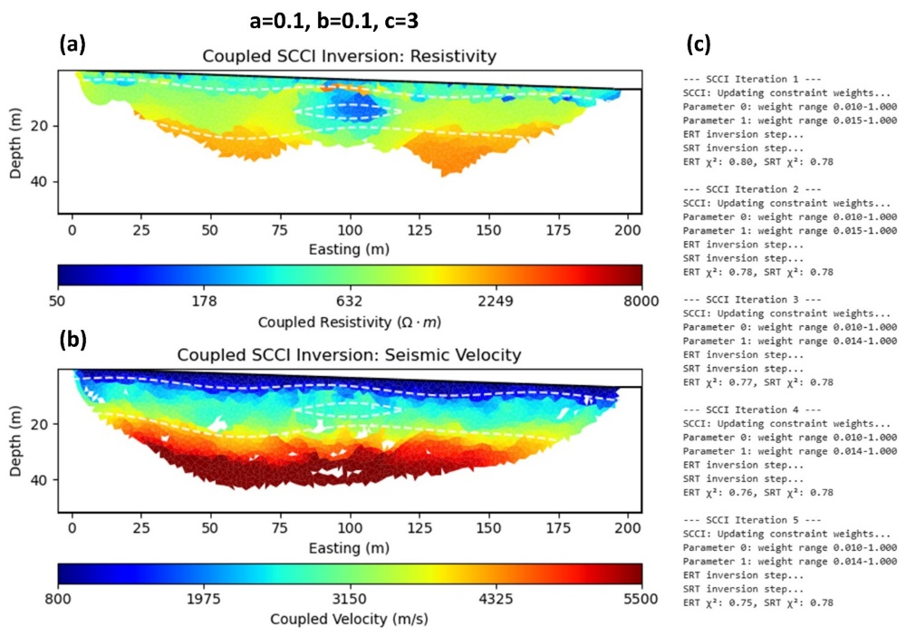
Fig. S10. Sensitivity test for parameter $c=3$, with $a=0.1$ and $b=0.1$ fixed. Panels present: (a) ERT model, (b) SRT model, and (c) evolution of constraint weighting and χ² misfits, highlighting the inversion response under a strongly scaled coupling factor.

Part B: Effect of structural coupling for both synthetic and real field data
The spatial distribution of relative changes in the inverted synthetic models induced by the structural coupling process are illustrated in Fig. S11. Fig. S11a displays the resistivity model, where colors indicate the percentage of change from the individually inverted model to the structurally coupled model. Similarly, Fig. S11b shows the velocity model, also colored by the percentage of change resulting from the coupling. These visualizations highlight which areas of the subsurface experienced the most significant adjustments due to the incorporation of structural constraints between the two geophysical methods.
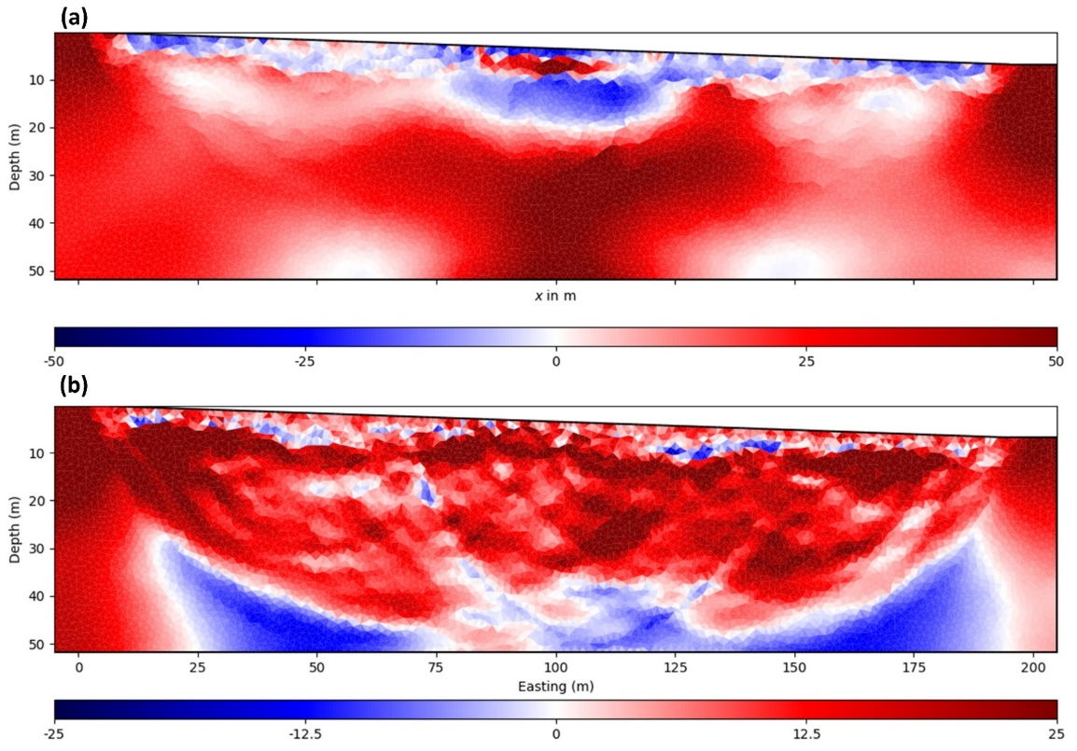
Fig. S11. Spatial distribution of relative changes induced by structural coupling. (a) Resistivity model (ERT) and (b) velocity model (SRT) colored by percentage of change during the coupling process.

Fig. S12 provides a comparative assessment of structural similarity between the individually inverted and structurally coupled synthetic models. Fig. S12a presents a one-dimensional profile extracted at a fixed horizon of 100 m from the 2D electrical resistivity and seismic velocity models, illustrating the results from both individual inversions and the coupled inversion. This cross-section allows for a direct visual comparison of how structural coupling influences the recovery of subsurface interfaces along a specific transect. Fig. S12b further quantifies this structural similarity by plotting the relationship between structural similarity metrics and boundary gradients. The inclusion of a 1:1 reference line signifies perfect boundary matching, enabling an evaluation of how closely the coupled inversion results align with the true structural boundaries compared to the individually inverted models.

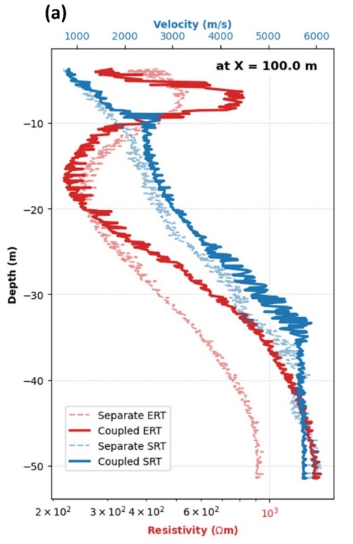 | 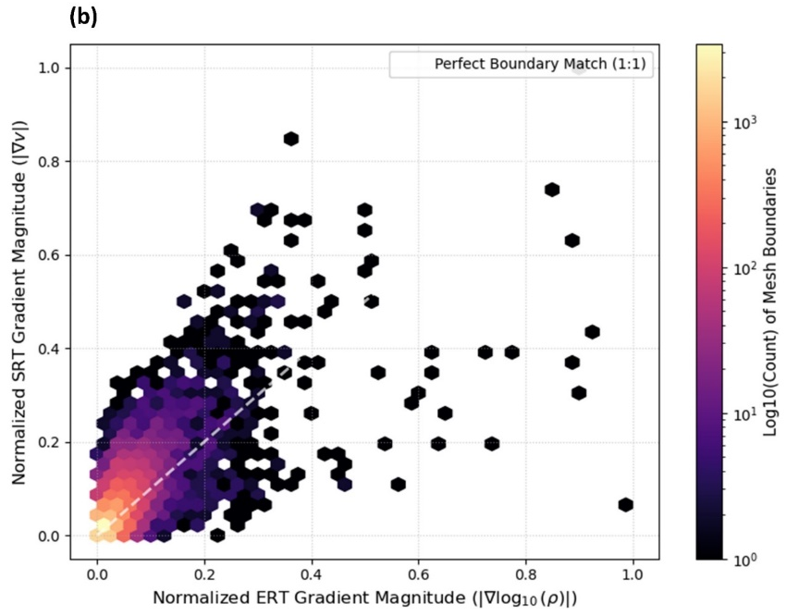
Fig. S12. Comparative assessment of structural similarity. (a) One-dimensional profile extracted from 2D models at a fixed X-position, showing individual and coupled ERT and SRT results. (b) Plot of structural similarity and boundary gradient relationship with a 1:1 reference line indicating perfect boundary match.

Fig. S13 illustrates the spatial patterns of parameter changes resulting from structural coupling in the field case. Fig. S13a shows the relative change in the resistivity model, while Fig. S13b displays the relative change in the velocity model. These maps highlight the areas where the SCCI has induced the most significant modifications to the individual inversion results, indicating zones where the coupled inversion process had a stronger influence on refining the subsurface parameters.

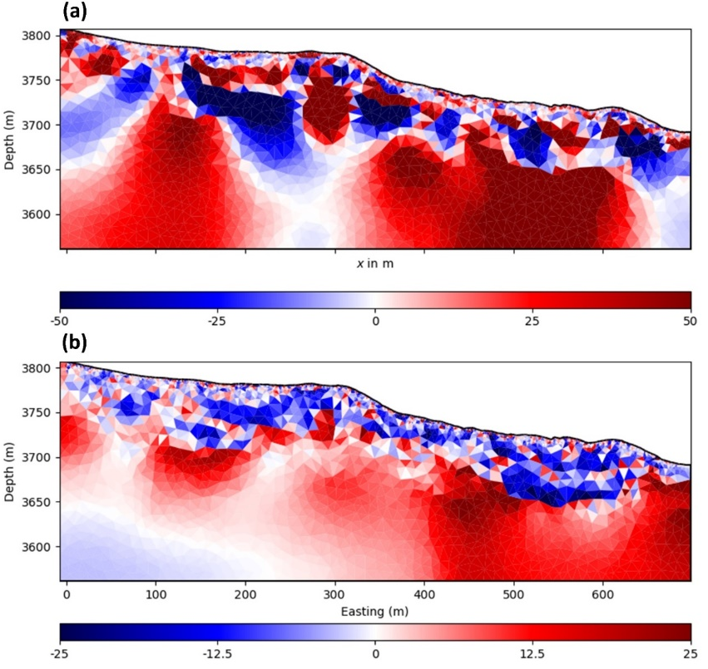
Fig. S13. Spatial pattern of parameter changes induced by structural coupling in the field case. (a) Resistivity model (ERT) and (b) velocity model (SRT) colored by relative change.

A detailed comparative structural assessment of the field models is provided in Fig. S14, evaluating the impact of structural coupling. Fig. S14a presents one-dimensional profiles extracted from both the 2D ERT and SRT models, comparing the results from individual inversions against those obtained via SCCI. The weak correlation between ERT and SRT models is evident here. Fig. S14b quantifies the structural similarity and boundary gradient between the coupled and individual models, referencing a 1:1 line to denote a perfect match. This panel is crucial for assessing how well the coupled inversion preserves or alters the structural elements identified independently. Fig. S14c offers a zoomed-in view, specifically illustrating the coupling intensity along cell boundaries. This detailed perspective allows for a precise examination of how the SCCI influences the interfaces between different geological units, revealing the extent to which structural information is transferred and enforced across these boundaries during the inversion process. Despite these advantages, operational limitations of SCCI include its higher computational cost relative to independent runs, requiring twice the iteration count to achieve full gradient convergence, as well as the ongoing challenge of optimizing SCCI parameters across different case studies.

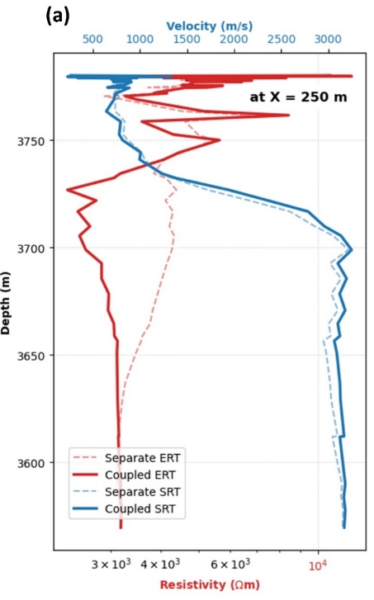 |  | 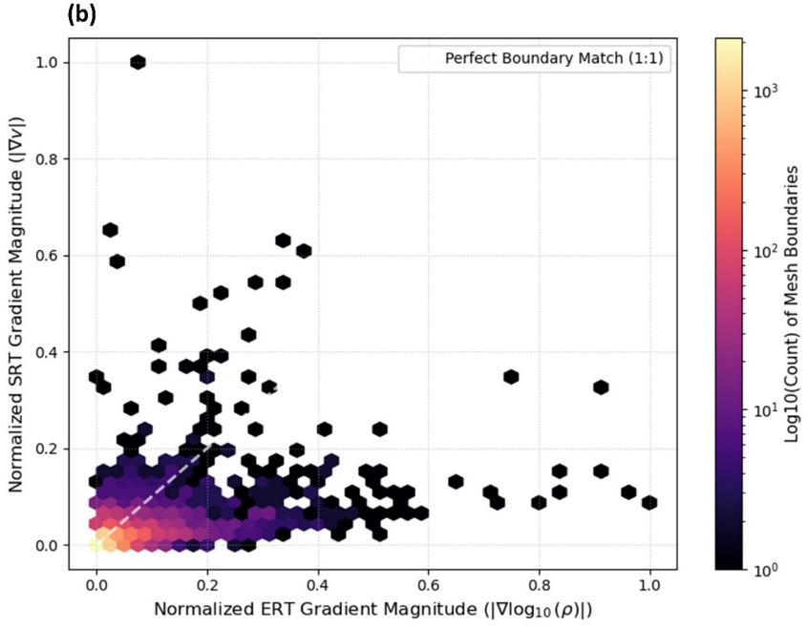
 | 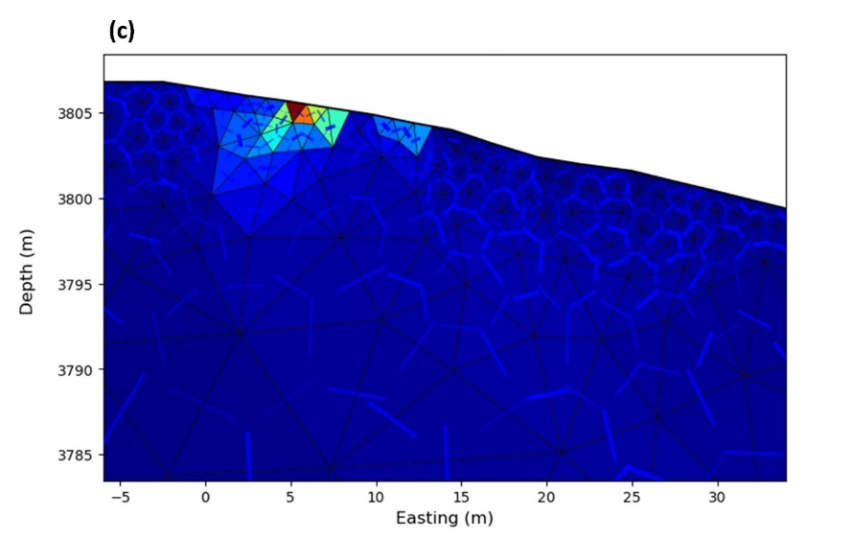
Fig. S14. Comparative structural assessment and coupling effect for the field models. (a) One-dimensional profile extracted from 2D ERT and SRT models (individual and coupled). (b) Structural similarity and boundary gradient plot with 1:1 reference line representing perfect match. (c) Zoomed view illustrating coupling intensity along cell boundaries.

