SUPPLEMENTARY FIGURES & TABLES
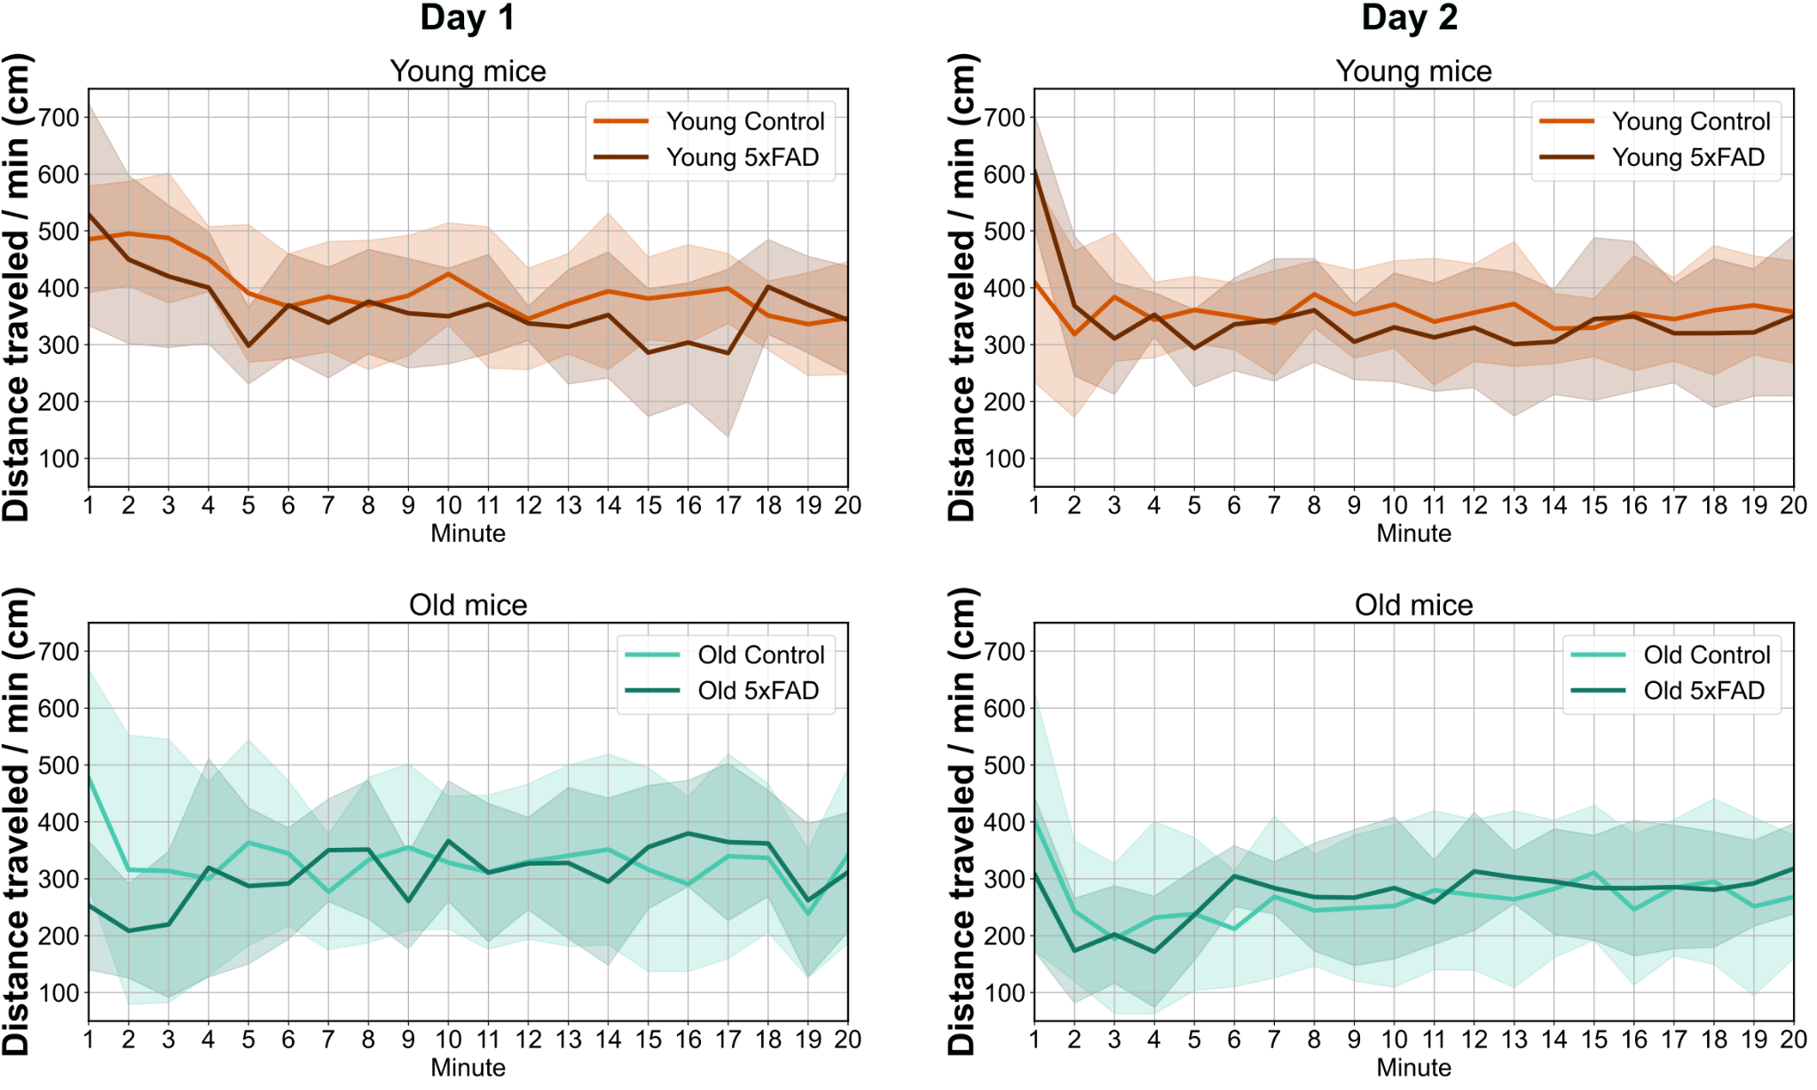
Supplementary Figure 1. Distance traveled per minute during the 20-minute OFT. Each column represents a separate testing day (day 1 and day 2). Lines represent the mean across mice, and shaded regions indicate ±1 SD.
Supplementary Table1. Minimum detectable effect sizes for the sample sizes used, assuming 80% statistical power at α = 0.05 vs. observed effect sizes.
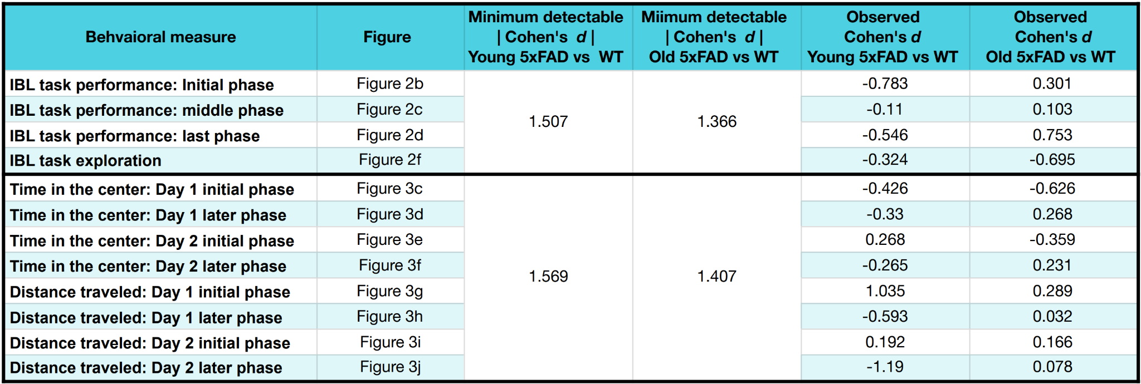
Supplementary Table 2. Correlation between age-adjusted cortical plaque burden and age-adjusted behavioral measures. Values highlighted in red remain statistically significant after false discovery rate correction using the Benjamini–Hochberg procedure (q < 0.05).
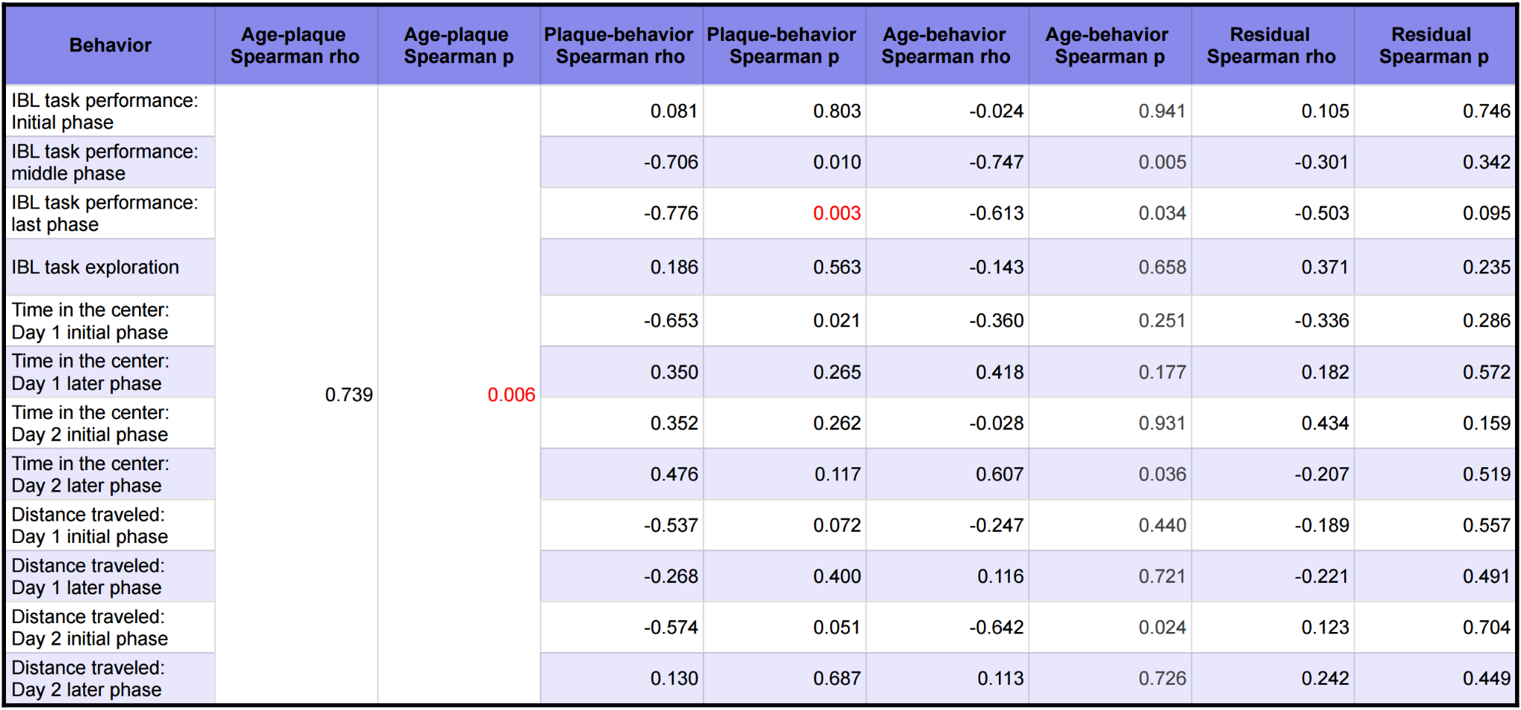
Supplementary Table 3. Summary of multiple linear regression analyses with cortical plaque burden and age as predictors of behavioral measures. No regression coefficients remained statistically significant after false discovery rate correction using the Benjamini–Hochberg procedure (q < 0.05).
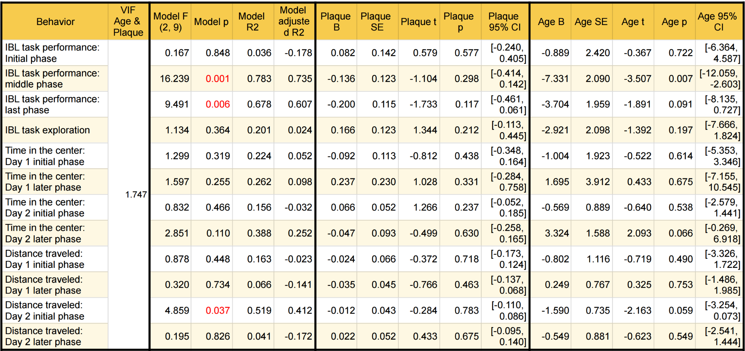
Supplementary Table 4. Correlation between age-adjusted hippocampal plaque burden and age-adjusted behavioral measures. Values highlighted in red remain statistically significant after false discovery rate correction using the Benjamini–Hochberg procedure (q < 0.05).
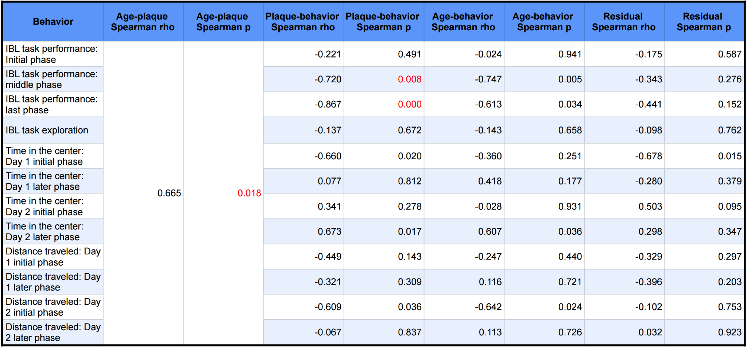
Supplementary Table 5. Summary of multiple linear regression analyses with hippocampal plaque burden and age as predictors of behavioral measures. No regression coefficients remained statistically significant after false discovery rate correction using the Benjamini–Hochberg procedure (q < 0.05).
