design of experiments in the present research
Needle Foot Pressure (N) | Needle Thread Tension (N) | Stitch Density (SPI) | Number of Layers in MLI | Sample Code
16.28 | 4.43 | 8 | 2 | E1
16.28 | 4.43 | 5 | 2 | E2
16.28 | 13.52 | 8 | 2 | E3
16.28 | 13.52 | 5 | 2 | E4
49.00 | 4.43 | 8 | 2 | E5
49.00 | 4.43 | 5 | 2 | E6
49.00 | 13.52 | 8 | 2 | E7
49.00 | 13.52 | 5 | 2 | E8
16.28 | 4.43 | 8 | 6 | B1
16.28 | 4.43 | 5 | 6 | B2
16.28 | 13.52 | 8 | 6 | B3
16.28 | 13.52 | 5 | 6 | B4
49.00 | 4.43 | 8 | 6 | B5
49.00 | 4.43 | 5 | 6 | B6
49.00 | 13.52 | 8 | 6 | B7
49.00 | 13.52 | 5 | 6 | B8
16.28 | 4.43 | 8 | 12 | D1
16.28 | 4.43 | 5 | 12 | D2
16.28 | 13.52 | 8 | 12 | D3
16.28 | 13.52 | 5 | 12 | D4
49.00 | 4.43 | 8 | 12 | D5
49.00 | 4.43 | 5 | 12 | D6
49.00 | 13.52 | 8 | 12 | D7
49.00 | 13.52 | 5 | 12 | D8
16.28 | 4.43 | 8 | 24 | F1
16.28 | 4.43 | 5 | 24 | F2
16.28 | 13.52 | 8 | 24 | F3
16.28 | 13.52 | 5 | 24 | F4
49.00 | 4.43 | 8 | 24 | F5
49.00 | 4.43 | 5 | 24 | F6
49.00 | 13.52 | 8 | 24 | F7
49.00 | 13.52 | 5 | 24 | F8

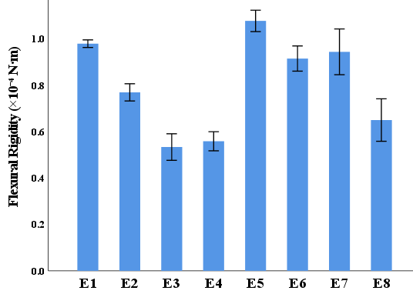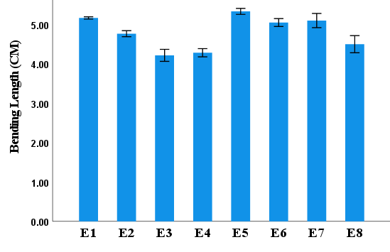
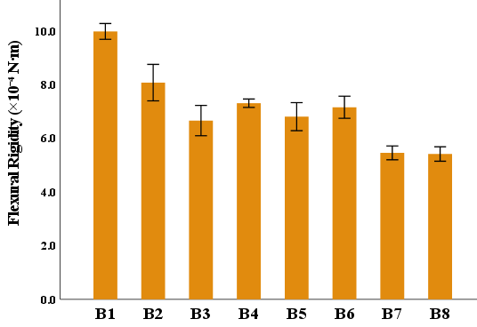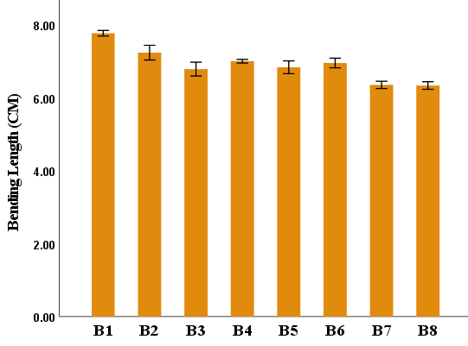
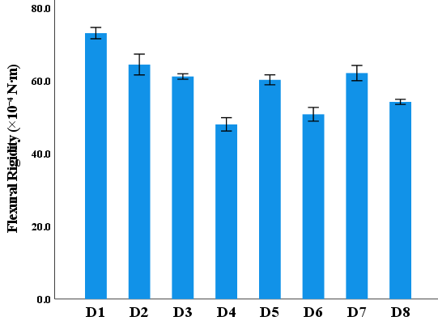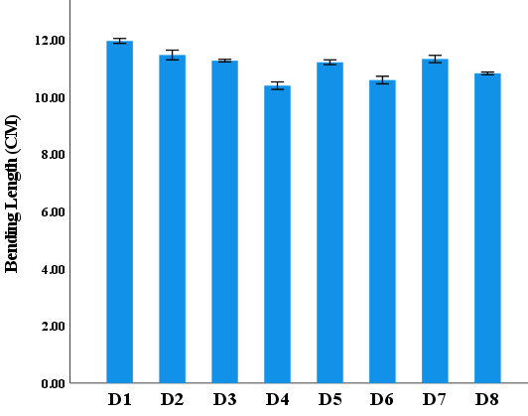
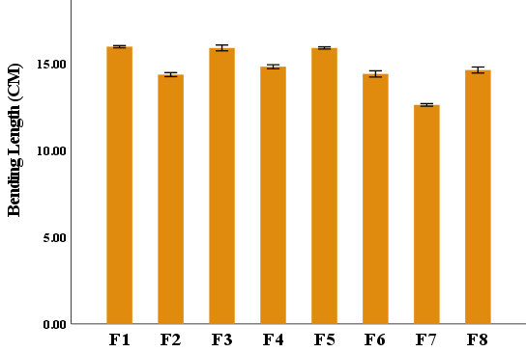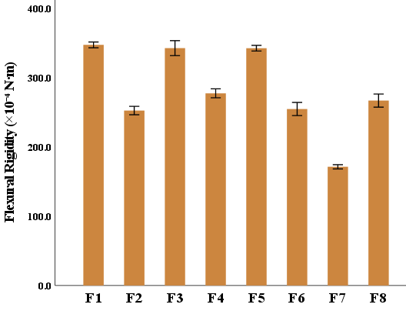
supplementary Fig. Mean values and standard deviations of bending length and flexural rigidity for all experimental runs.

