Supplementary information
SI Results and Discussion
Supplementary Tables and Figures

Microhabitats are associated with bacterial and archaeal community structure in acid mine drainage from an abandoned mine

Minji Kim^{1§}, So-Jeong Kim^{2§}, and Soo-Je Park¹*

¹Department of Biology, Jeju National University, 102 Jejudaehak-ro, Jeju 63243, South Korea
²Geo-Environment Research Division, Korea Institute of Geoscience and Mineral Resources, Daejeon 34132, South Korea

*Corresponding author: Soo-Je Park (Tel: +82-64-753-3524, Fax: +82-64-756-3541, Email: sjpark@jejunu.ac.kr)

§These authors made an equal contribution.

Running title: Microhabitats structure AMD prokaryotic communities

Keywords: acid mine drainage, microhabitats, amplicon, biofilm, acidophile, 16S rRNA gene
SI Results and Discussion
Sequence similarity of the dominant Unclassified Gammaproteobacteria ASVs
ASV_1 was the most abundant ASV in the pooled dataset (139,268 reads; 19.43%) and exactly matched a 253-bp V4 sequence in the SILVA release 144 training set annotated as Ferrovum (Supplementary Figure S9). However, DADA2 assigned ASV_1 only through Gammaproteobacteria, with genus-level bootstrap support of 46%, below minBoot = 80; it is therefore reported as Unclassified Gammaproteobacteria (see also Supplementary Table S8, and Figures S7). The short V4 sequence does not support definitive assignment to Ferrovum Group II, Group III, or any other genome-defined lineage. Any group-level sequence-similarity result should be labeled provisional and accompanied by an explicit alignment, reference-sequence set, tree-building method, support values, and corresponding legend. The genus Ferrovum was previously divided into six phylogenetic groups (Groups I–VI) by Ullrich et al. ¹. However, genome sequences are currently available only for a limited number of lineages, and no genomes have yet been reported for Groups II and III ². It should be noted that the “Group 2” designation used in earlier studies corresponds to Group VI in the updated classification scheme (recently published SILVA Release 144 database) and includes strains such as Ferrovum sp. JA12 and Ferrovum sp. PN-J185 ³. Consequently, the dominant Ferrovum populations identified in the present study belong to phylogenetic groups that remain genomically uncharacterized, making it difficult to infer their ecological functions based on currently available genomic information.
The dominant Unclassified Gammaproteobacteria ASVs showed different relative sequence-abundance patterns among the sampled water and biofilm categories. Because the V4 amplicons did not receive supported genus-level assignments, published genome traits of Ferrovum lineages cannot be transferred to these ASVs. Genome-resolved recovery and direct functional measurements would be required to test their identity and function.

SI References
1 Ullrich, S. R. et al. Comparative genomics underlines the functional and taxonomic diversity of novel “Ferrovum” related iron oxidizing bacteria. Advanced Materials Research 1130, 15–18 (2015).
2 Grettenberger, C. L., Havig, J. R. & Hamilton, T. L. Metabolic diversity and co-occurrence of multiple Ferrovum species at an acid mine drainage site. BMC Microbiol 20, 119, doi:10.1186/s12866-020-01768-w (2020).
3 Ullrich, S. R. et al. Gene Loss and Horizontal Gene Transfer Contributed to the Genome Evolution of the Extreme Acidophile "Ferrovum". Front Microbiol 7, 797, doi:10.3389/fmicb.2016.00797 (2016).

Supplementary Tables and Figures
Supplementary Table S1. Physicochemical profiles for the three spatial Groups and community-sample mapping. Measurements are Group-level profiles and are reported descriptively; they are not used for inferential community–environment association.

Supplementary Table S2. Per-sample read tracking through the DADA2 workflow. The table reports read-pair counts and retention at primer trimming, quality filtering, merging, chimera removal, and final length filtering, with denominators stated explicitly for each retention percentage.

Supplementary Table S3. Continuous genus-level Levins’ niche breadth and aggregation sensitivity across three microhabitat Types. Equal-weighted Type means are the primary calculation; pooled counts within Type are the sensitivity calculation. No categorical generalist or specialist calls were assigned.

Supplementary Table S4. Sample metadata, sequencing identifiers, microhabitat Type, spatial Group, and Group-level physicochemical profiles. The table maps ‘seq_ID’ and ‘analysis_name’ to the seven community samples and to the three spatial Groups. Physicochemical measurements are Group-level profiles and are reported descriptively; they are not used for inferential community–environment association.

Supplementary Table S5. CPCoA and PERMDISP summary. The primary CPCoA used square-root-transformed Bray–Curtis dissimilarities calculated after rarefaction to 88,397 reads per sample. The Type-constrained analysis is exploratory, with 5,039 enumerated nonidentity unrestricted sample permutations for CPCoA and 999 requested permutations for PERMDISP; physicochemical variables were not used as constraints.

Supplementary Table S6. Domain-level composition of Archaea and Bacteria per sample, reaggregated from the final ASV count table with canonical SILVA r144 taxonomy.

Supplementary Table S7. Phylum-level relative abundance per sample. Formal values were reaggregated by exact ASV sequence join to the canonical SILVA r144 taxonomy table using DADA2 assignTaxonomy with minBoot = 80.

Supplementary Table S8. Formal SILVA r144 taxonomy and rank-specific bootstrap diagnostics for the 30 most abundant ASVs. Formal rank labels use DADA2 assignTaxonomy with minBoot = 80; adjacent bootstrap columns are diagnostic and do not replace the formal taxonomy.

Supplementary Figure S1. Continuous genus-level standardized Levins’ niche breadth across the three microhabitat Types. (a) Standardized Levins’ niche breadth (B_A) is plotted against mean relative sequence abundance across seven samples for all 129 named genera. (b) B_A is shown for the 15 named genera with the greatest mean relative sequence abundance. Genus-level relative sequence abundances were calculated within each sample and then averaged within AMD precipitate-associated biofilm, wall-attached biofilm, and water, giving every sample equal weight. For each genus, B = 1/Σp_i² and B_A = (B − 1)/(3 − 1), where p_i is the proportional representation among three Type-level mean abundances. Teal identifies the 15 most abundant named genera and gray the remaining named genera. Higher B_A indicates a more even relative sequence-abundance distribution among the three sampled Types. Values are continuous descriptive summaries; no generalist, intermediate, or specialist threshold was applied, and the figure does not measure physiological niche breadth or environmental tolerance.
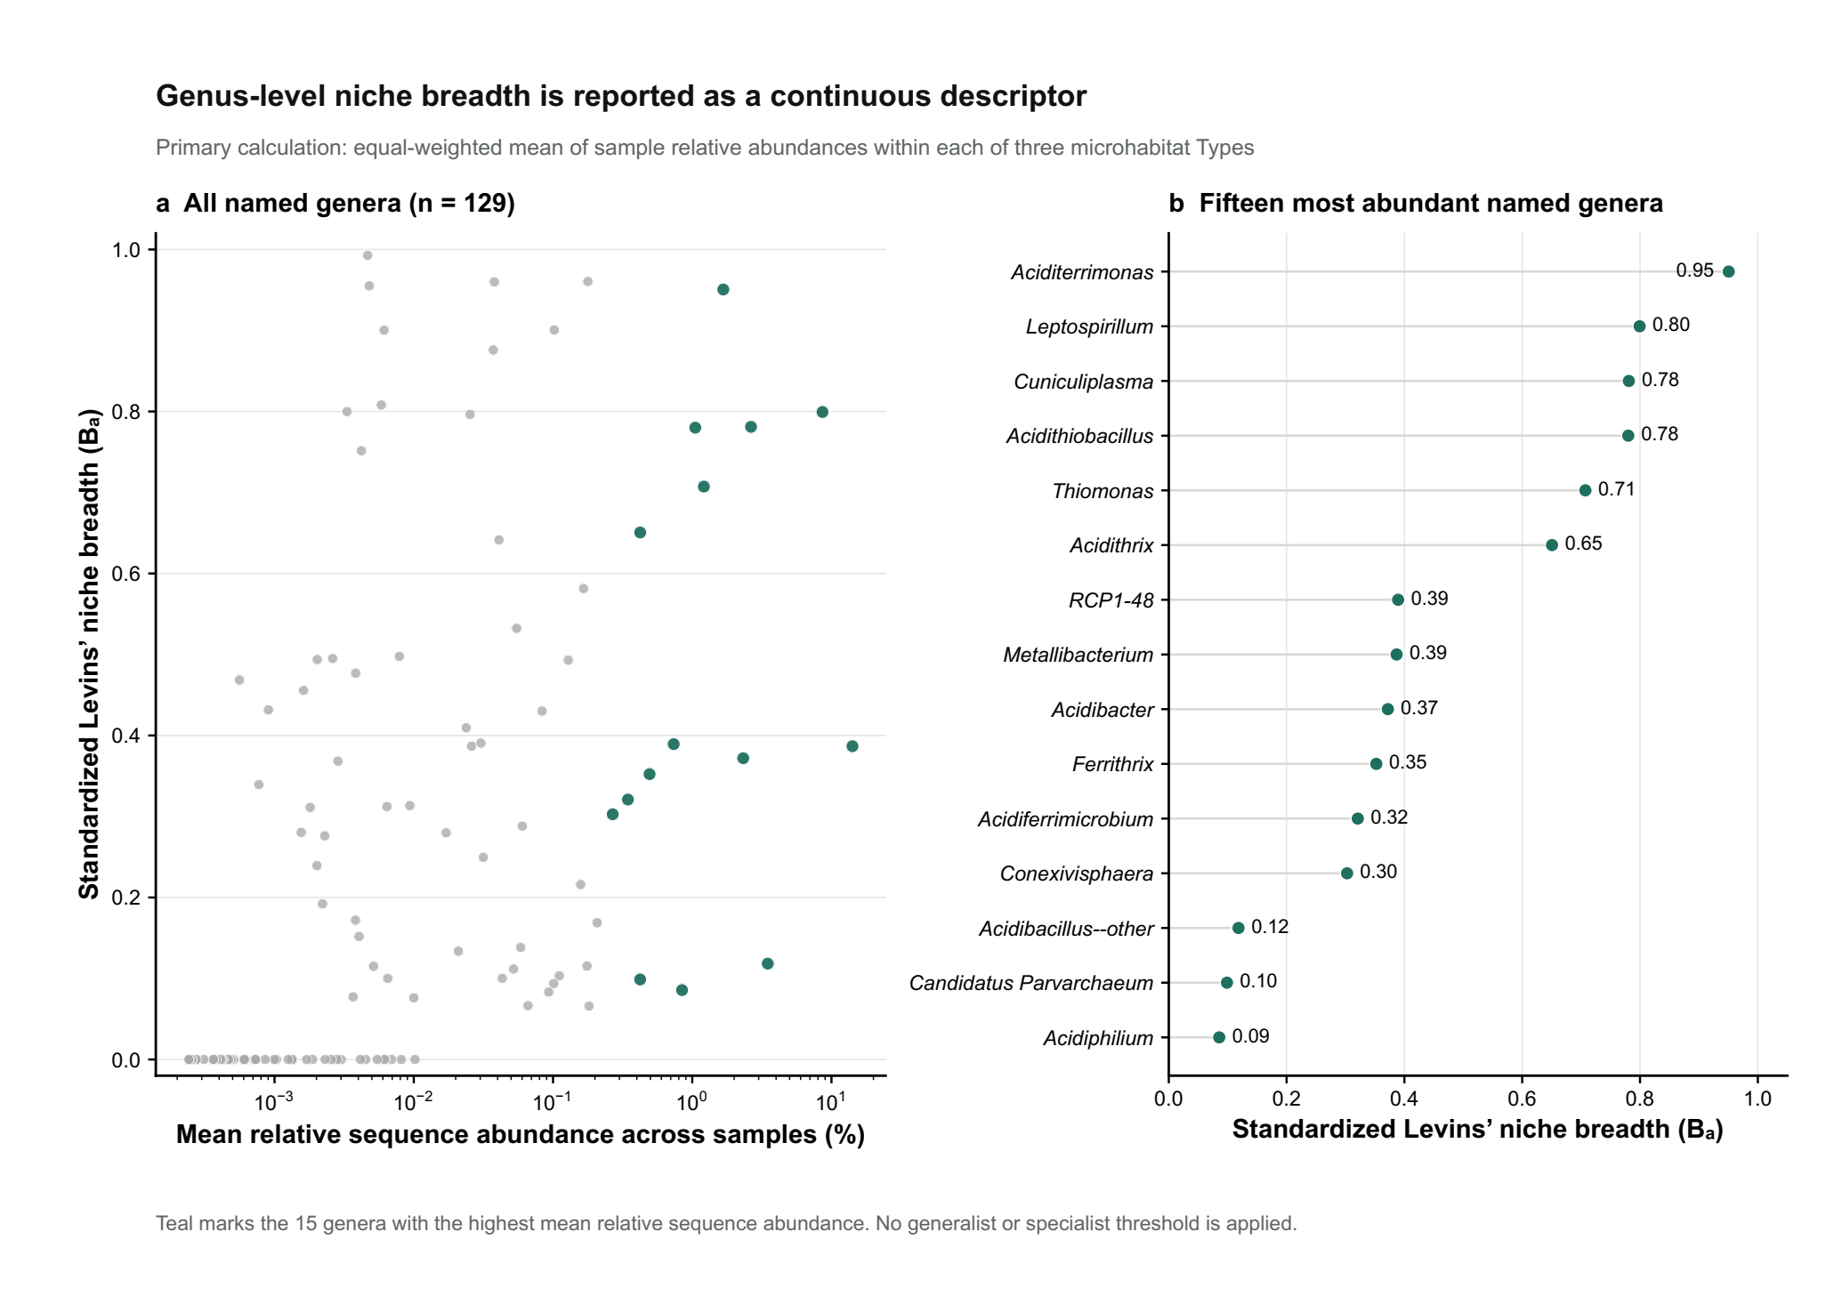

Supplementary Figure S2. Sensitivity of continuous genus-level standardized Levins’ niche breadth to Type aggregation. Each point represents one of 129 named genera. The x-axis shows B_A calculated from equal-weighted Type means of sample relative sequence abundances (primary analysis); the y-axis shows B_A calculated after pooling genus counts within each Type (sensitivity analysis). The dashed line denotes equal values. Teal identifies the 15 named genera with the greatest mean relative sequence abundance; gray identifies the remaining genera. The median absolute difference in B_A was 0.022 and the maximum was 0.199. Pooled-read aggregation gives greater weight to Types represented by more samples and to samples with greater read depth. This sensitivity analysis is not an independent validation or a basis for categorical generalist or specialist assignment.
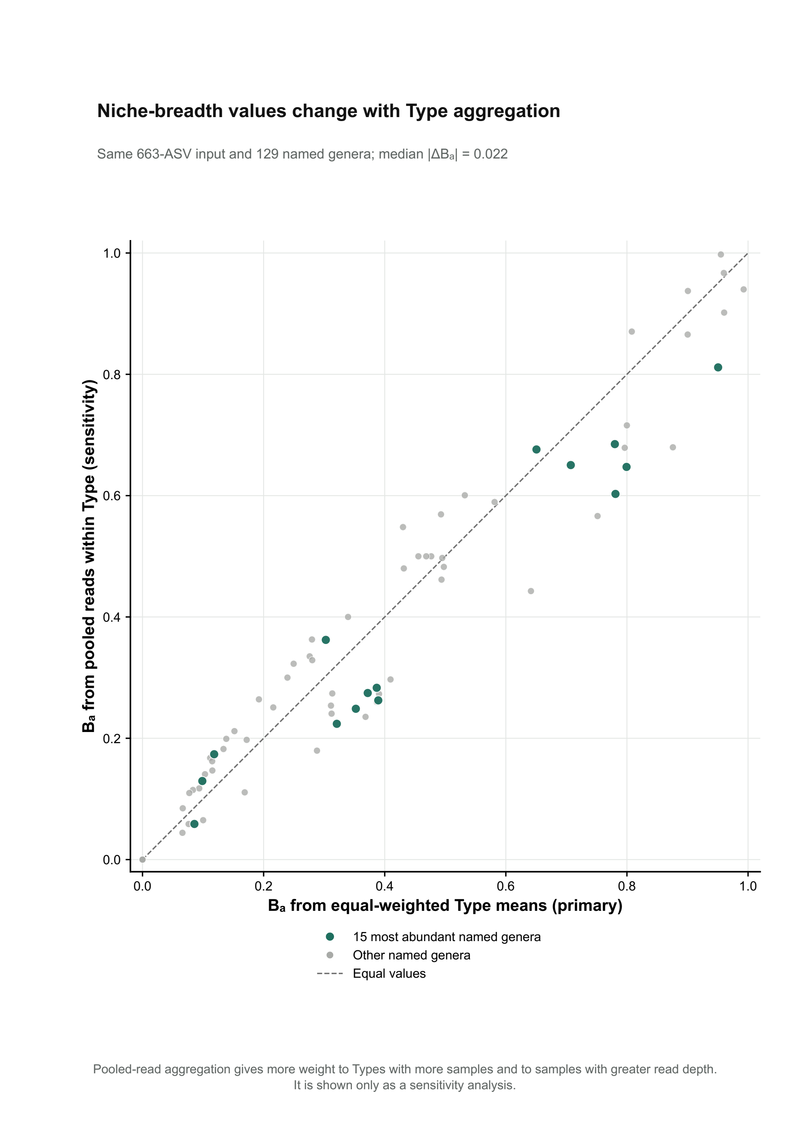
Supplementary Figure S3. Alpha diversity across Ilgwang AMD microhabitat Types. Alpha-diversity metrics were calculated from the DADA2 ASV table rarefied to 88,397 reads per sample. Points represent individual samples and horizontal segments show the Type median; sample sizes are displayed with the Type labels. Observed ASVs, Chao1, and ACE describe richness; Shannon diversity, Simpson diversity (1 − D), inverse Simpson diversity, and Pielou’s evenness describe diversity or evenness. Colors and symbols identify AMD precipitate-associated biofilm (P_biofilm; n = 2), wall-attached biofilm (W_biofilm; n = 3), and water (n = 2). Kruskal–Wallis comparisons are shown as exploratory descriptive patterns because Type sizes are small and unbalanced.
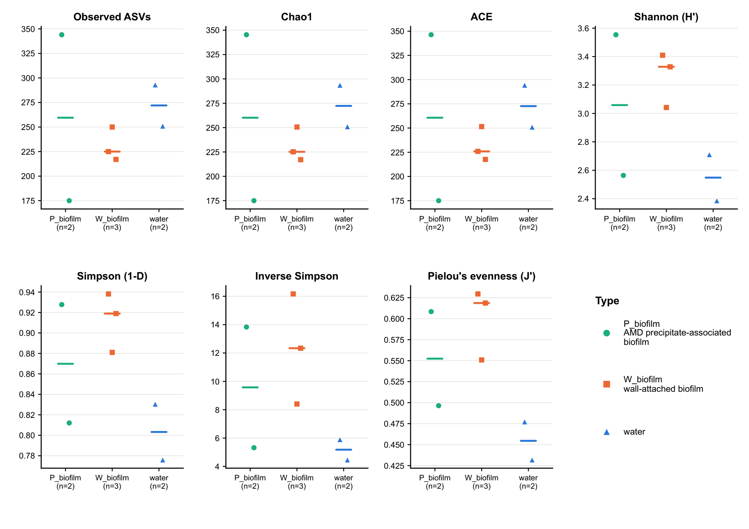

Supplementary Figure S4. Pairwise Bray–Curtis dissimilarity among Ilgwang AMD microbial communities. The heatmap shows pairwise Bray–Curtis dissimilarities calculated from the final 663-ASV table rarefied to 88,397 reads per sample using vegan::rrarefy (seed = 100). Rows and columns share the average-linkage hierarchical-clustering order, and values are printed in the corresponding cells. White indicates lower dissimilarity and dark blue indicates higher dissimilarity. The top and left annotation strips identify AMD precipitate-associated biofilm (P_biofilm), wall-attached biofilm (W_biofilm), and water. The mean within-Type dissimilarity was 0.484 and the mean between-Type dissimilarity was 0.654; between-Type means were 0.588 for precipitate-associated versus wall-attached biofilm, 0.656 for precipitate-associated biofilm versus water, and 0.719 for wall-attached biofilm versus water. These pairwise distances are summarized descriptively because distances from the same matrix are not statistically independent.
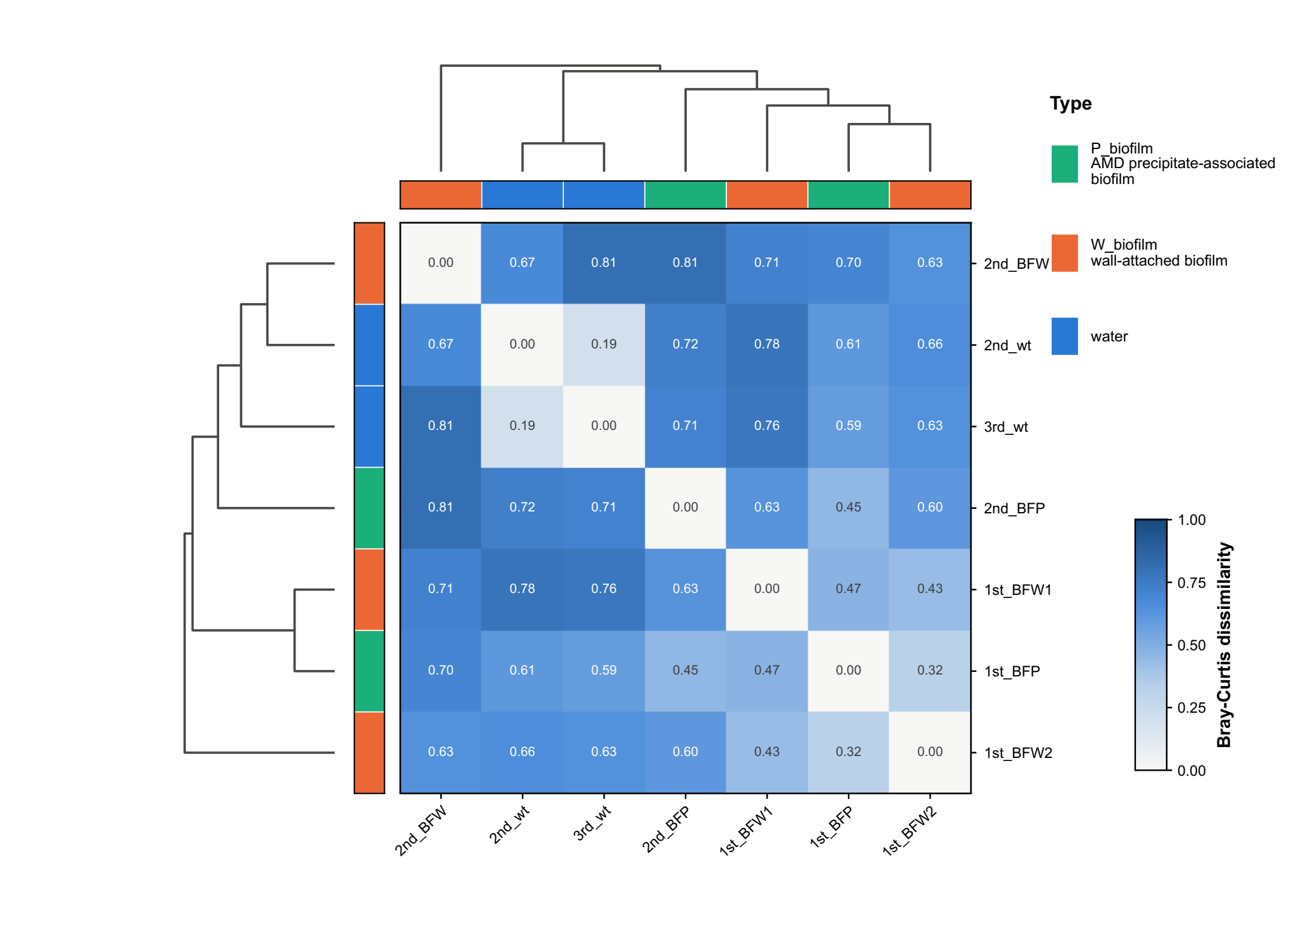

Supplementary Figure S5. Bacterial and archaeal read fractions across Ilgwang AMD samples. (a) Stacked bars show the percentage of Bacteria and Archaea reads within each sample; each bar therefore sums to 100%. Labels above the bars report the archaeal percentage. (b) For each domain separately, bars show the percentage of all domain-assigned reads distributed among the seven samples; Bacteria and Archaea each therefore sum to 100% across samples in this panel. Sample-label colors and symbols identify AMD precipitate-associated biofilm (P_biofilm), wall-attached biofilm (W_biofilm), and water. Counts were directly reaggregated from seqtab_final_long.csv joined by exact ASV sequence to the canonical SILVA SSU Ref NR99 release 144 taxonomy table (DADA2 assignTaxonomy; minBoot = 80): 610,601 Bacteria reads and 106,314 Archaea reads. Both panels are descriptive and use different denominators.
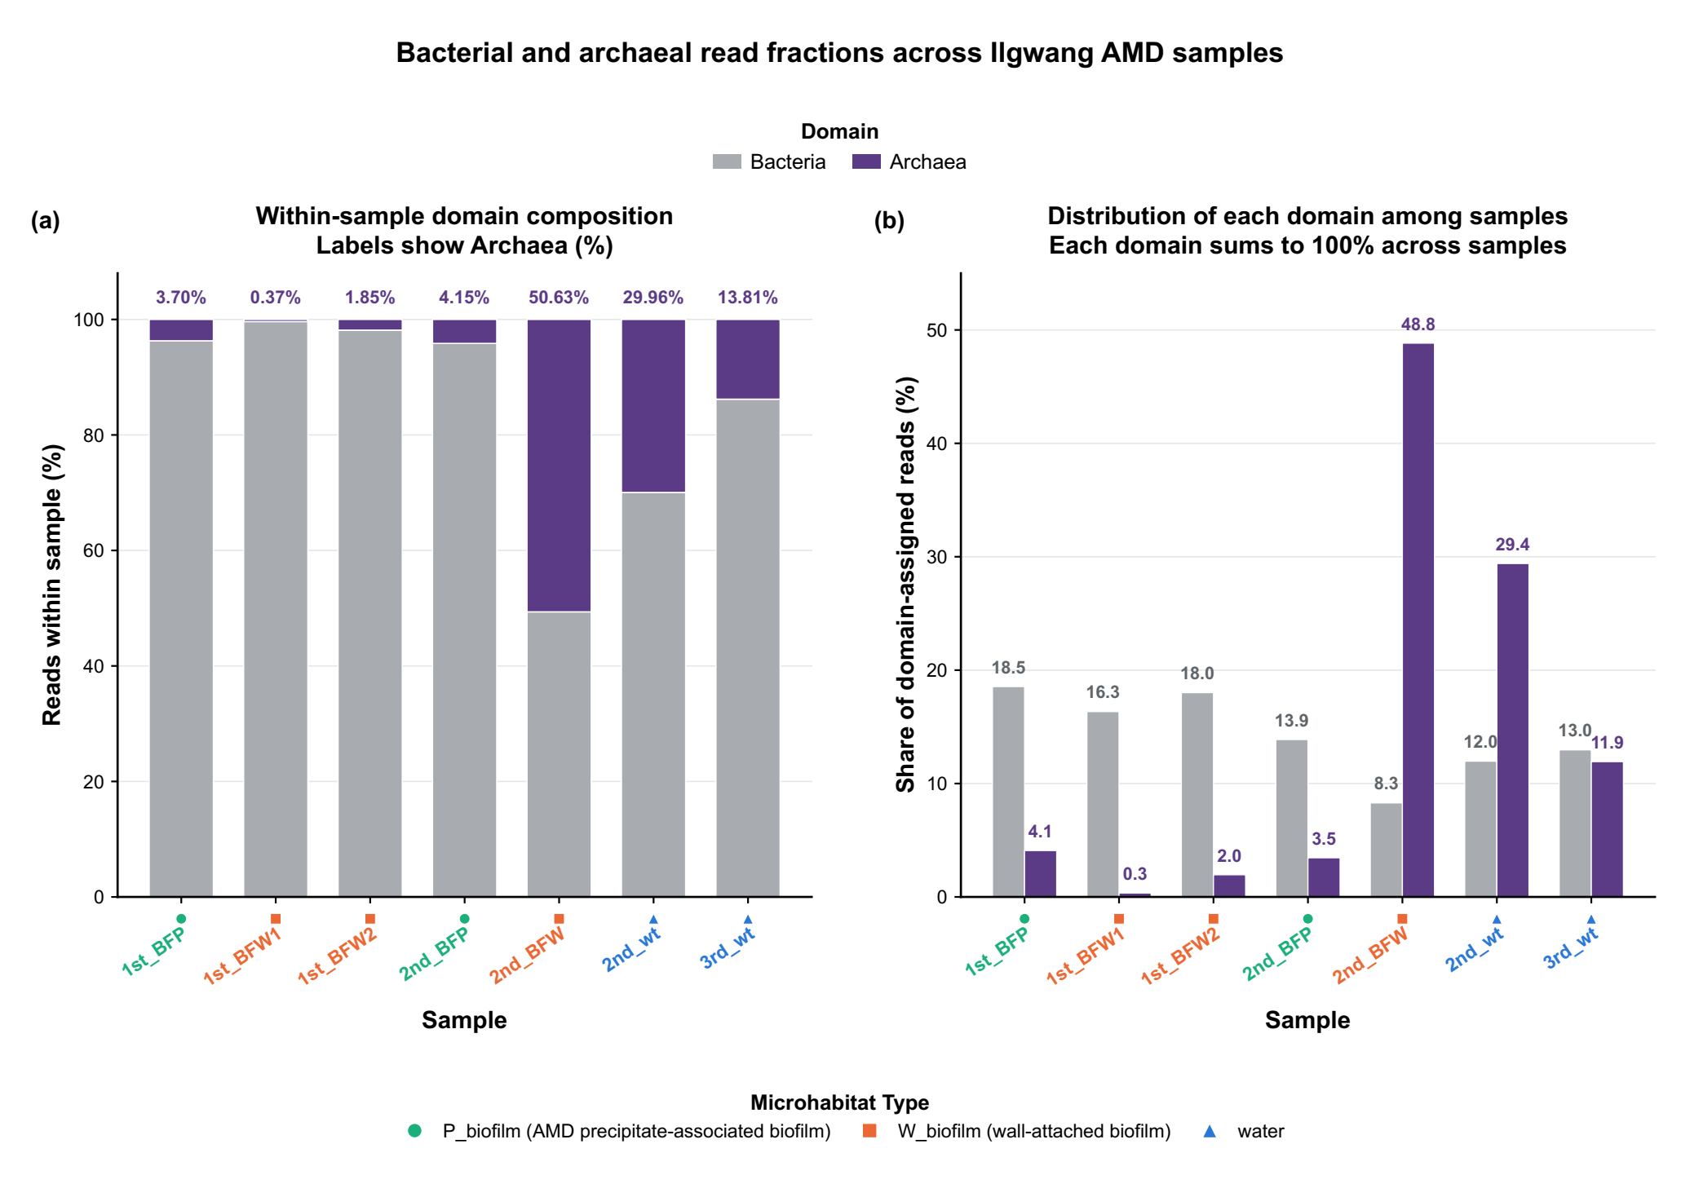

Supplementary Figure S6. Phylum-level composition of Ilgwang AMD microbial communities. Stacked bars show relative abundance of the eight most abundant confidently assigned phyla, ranked by dataset-wide mean, together with Unclassified and Others for each sample. Samples are arranged by AMD precipitate-associated biofilm (P_biofilm), wall-attached biofilm (W_biofilm), and water. ASVs were classified against SILVA release 144 using DADA2 assignTaxonomy with minBoot = 80. Others combines confidently assigned phyla outside the eight displayed categories, whereas Unclassified denotes ASVs without a confident phylum-level call at this threshold. Each sample bar sums to 100%; profiles are compositional and descriptive.
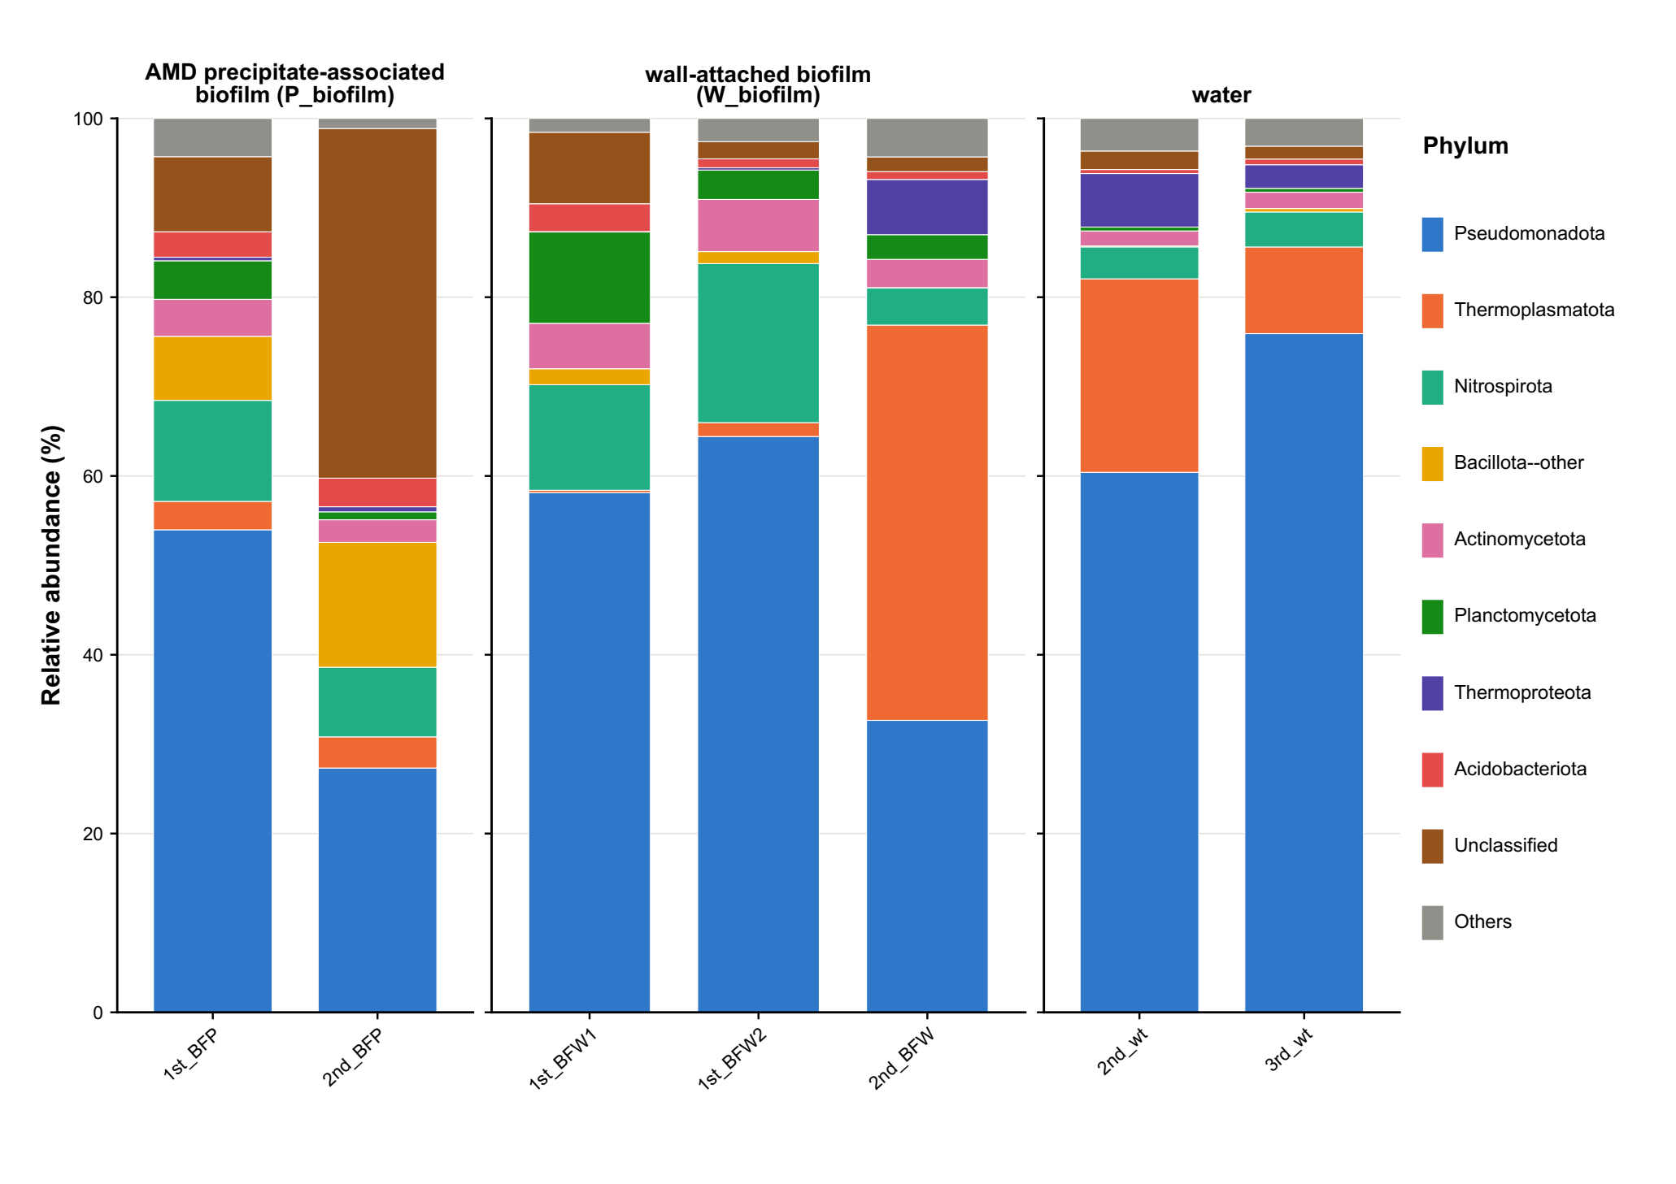

Supplementary Figure S7. Taxonomic resolution and genus-level bootstrap support of the 15 most abundant ASVs. Rows show the 15 ASVs with the highest pooled relative abundance. Aligned columns report ASV rank and identifier, genus assignment or nearest confidently assigned higher rank, pooled relative abundance (%), and bootstrap support at the genus-level classification step. Taxonomy was assigned with DADA2 and SILVA release 144; the dashed line marks minBoot = 80. Labels beginning with Unclassified show the nearest confidently assigned higher rank. ASV_1 accounted for 19.43% of pooled reads, had genus-level bootstrap support of 46%, and is consequently reported as Unclassified Gammaproteobacteria. The diagnostic V4 sequence match to Ferrovum does not establish Ferrovum membership.
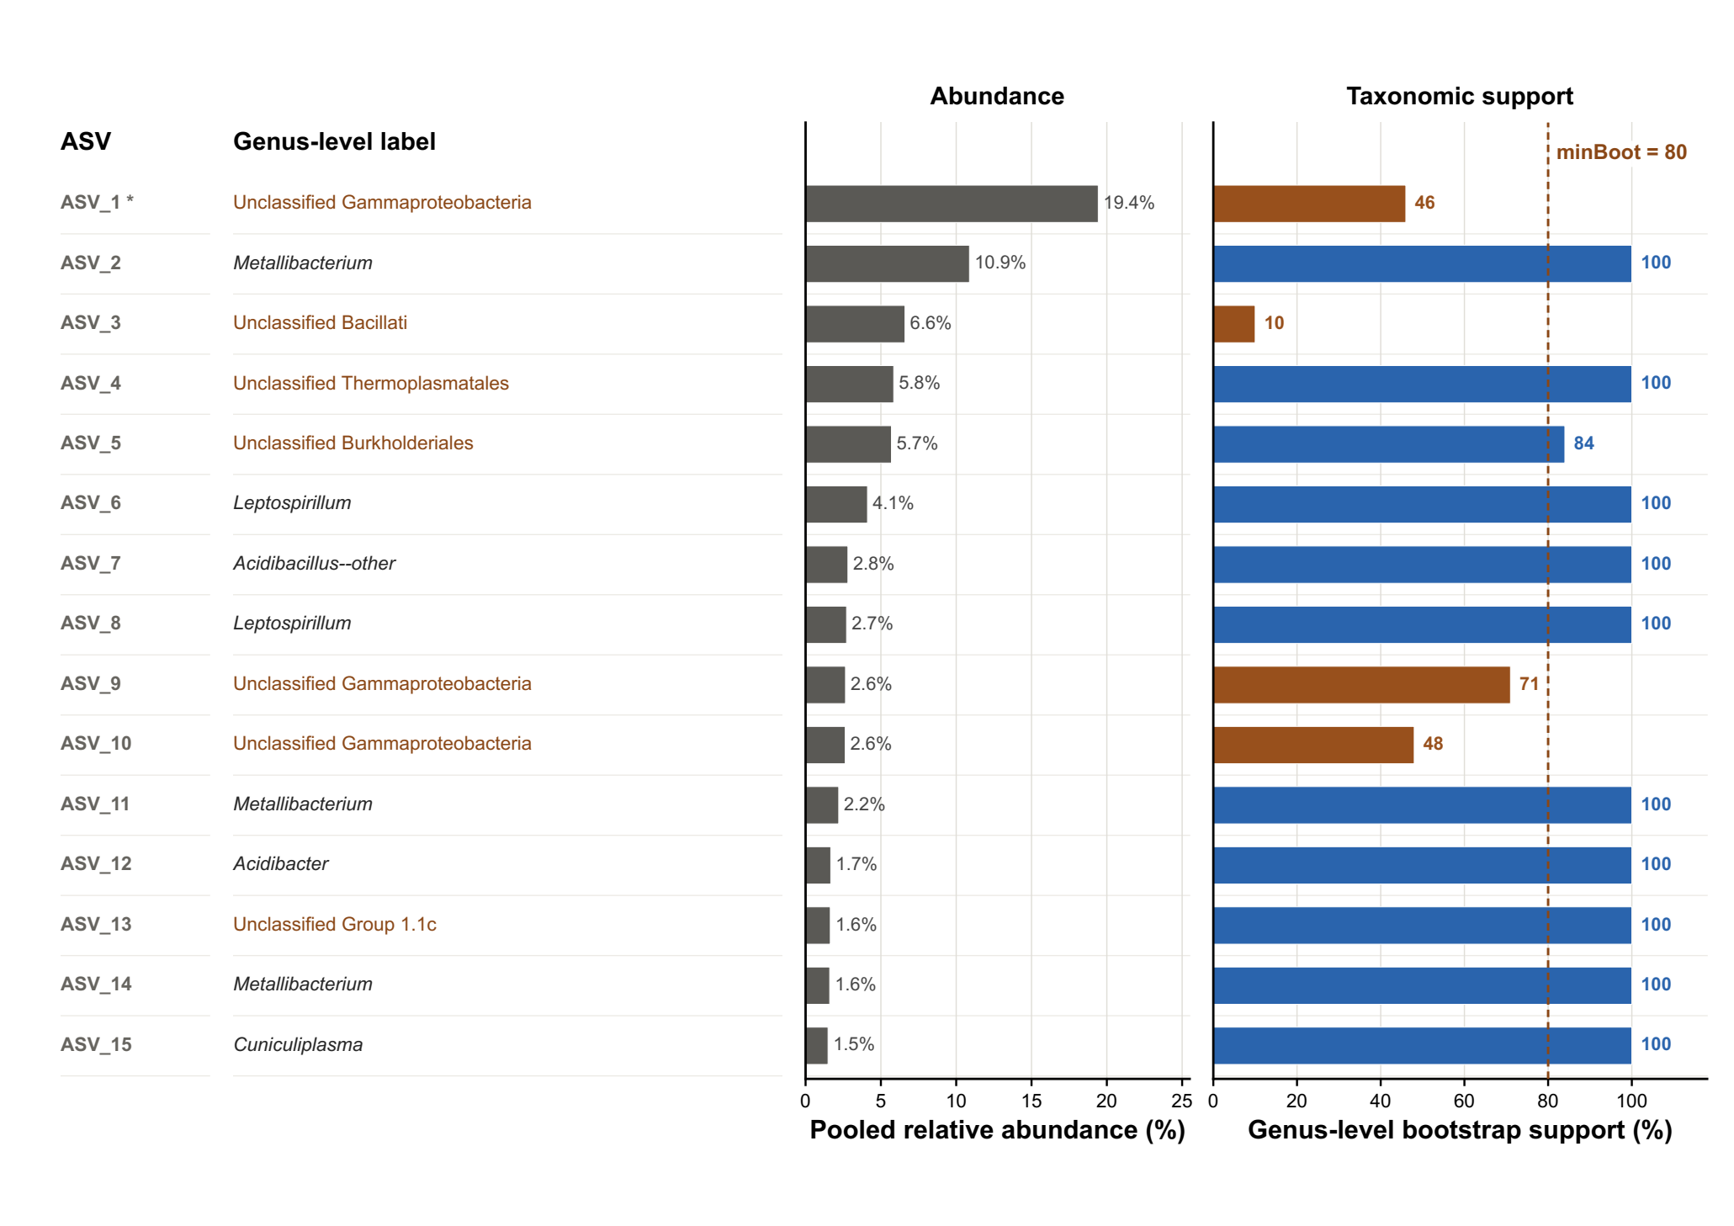

Supplementary Figure S8. Descriptive overlap of detected ASVs among the three microhabitat Types. An ASV was considered detected in a Type when at least one read occurred in at least one sample assigned to that Type, without abundance or prevalence threshold. Of the 663 ASVs, 102 were detected only in AMD precipitate-associated biofilm, 127 only in wall-attached biofilm, and 133 only in water. Eighty-four were detected only in the two biofilm Types, 24 only in AMD precipitate-associated biofilm and water, 31 only in wall-attached biofilm and water, and 162 (24.4%) in all three Types. Circle areas are schematic and not scaled to counts. These values describe sequence detection under the stated rule and do not estimate ecological occupancy or formal Type-specific cores.
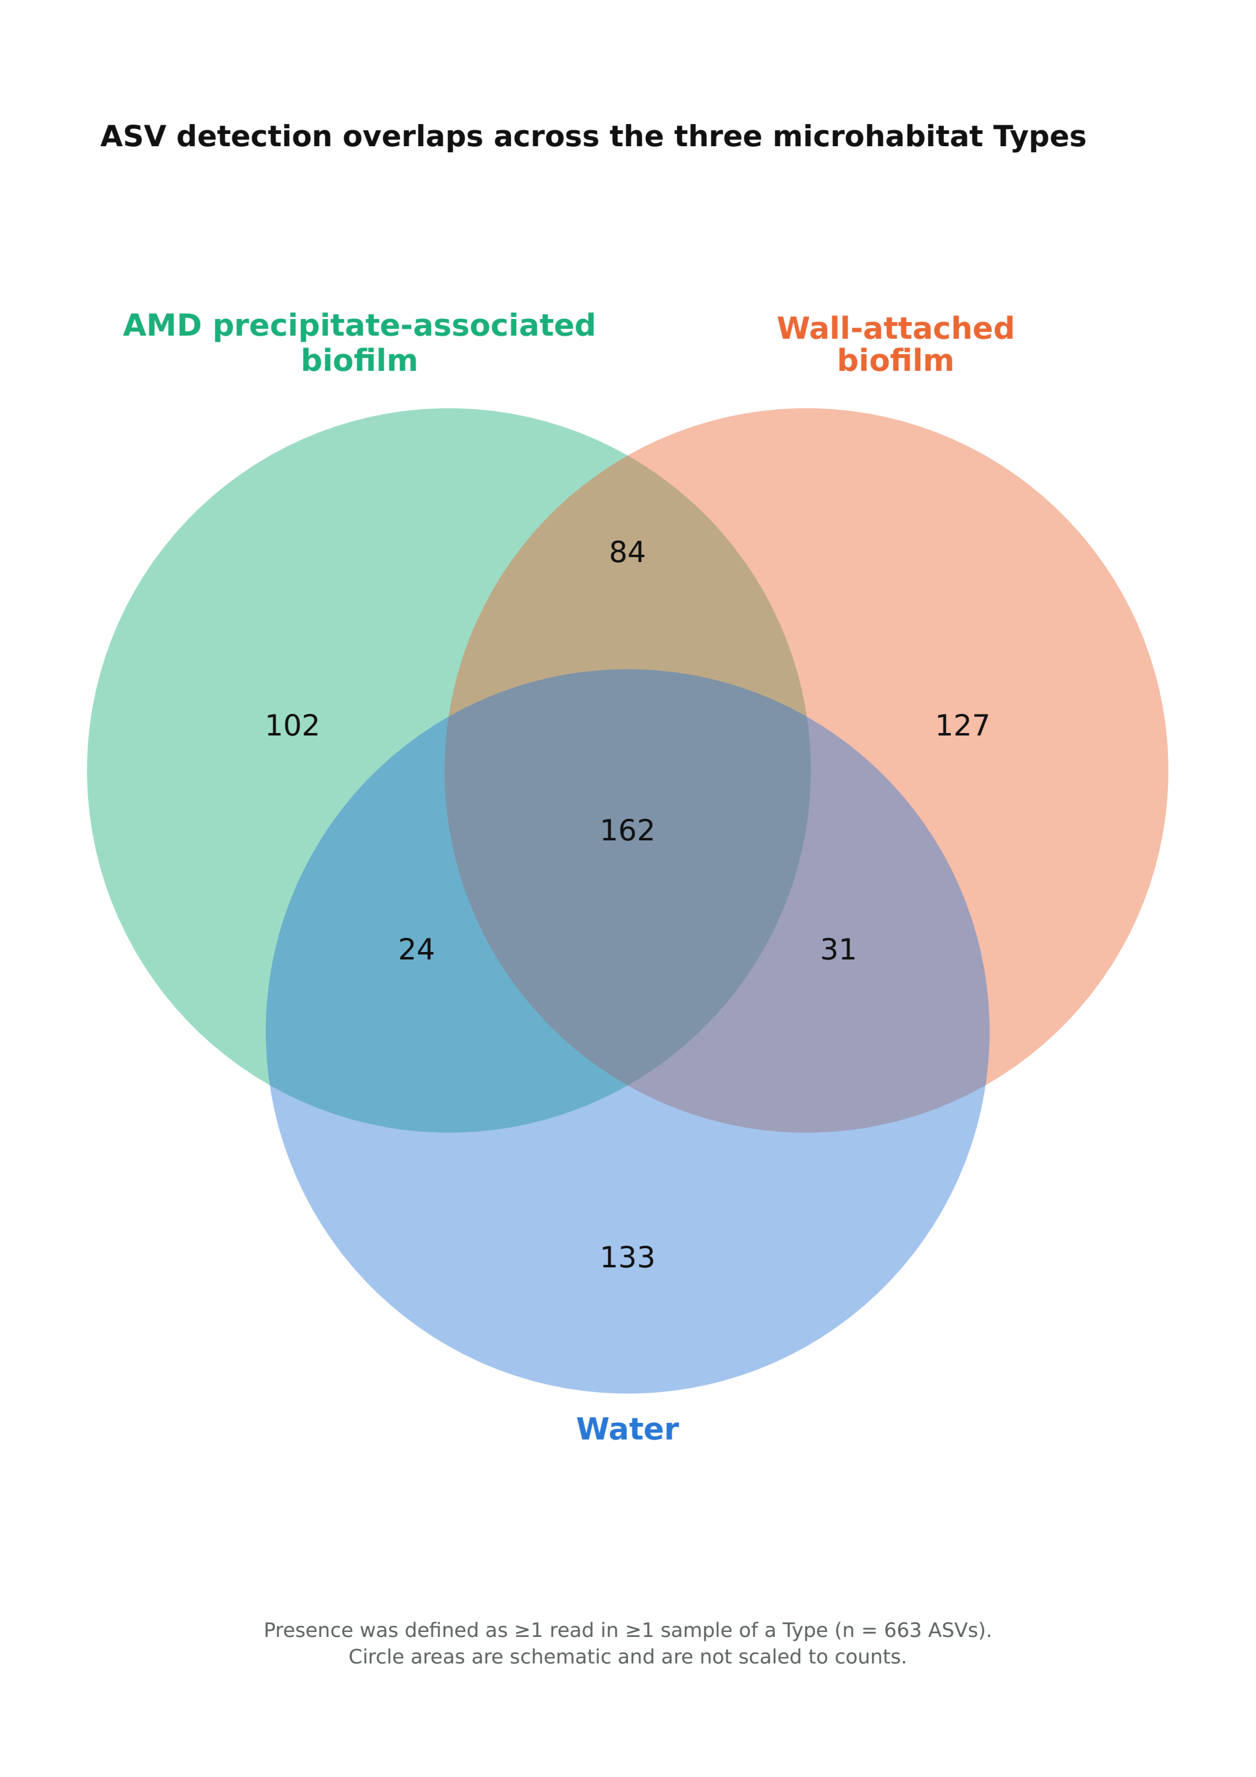

Supplementary Figure S9. a) Neighbor-joining phylogenetic tree based on 16S rRNA gene sequences showing the relationships between Ferrovum-related ASVs recovered from the Ilgwang acid mine drainage (AMD) site and representative Ferrovum reference sequences. ASVs identified in this study are shown in bold. Representative sequences of the Ferrovum phylogenetic groups described by Ullrich et al. (1) were included for comparison, and the tree was rooted using Nitrosomonas europaea ATCC 25978. Bootstrap values (>50%) based on 1,000 replicates are shown at branch nodes. The scale bar indicates 0.01 nucleotide substitutions per site. b) Heatmap of the relative abundances of Ferrovum-related ASVs identified from the Ilgwang AMD site. Color intensity represents the relative abundance (%) of each ASV in individual samples.
(a)
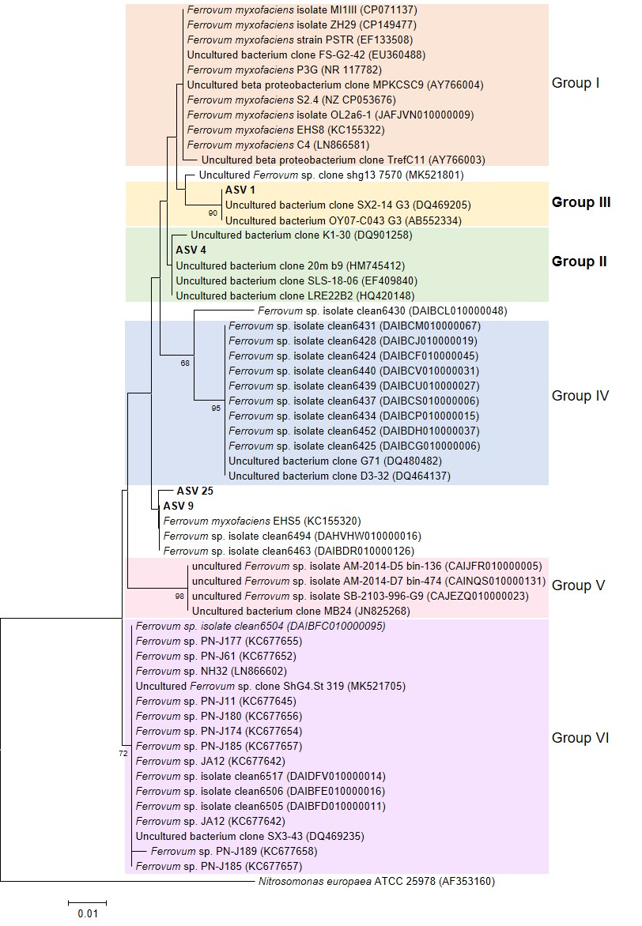
(b)
