Supplementary Information
Long-term spatiotemporal dynamics, hotspot persistence, and extreme AOD days over Bursa, Türkiye
Burak Caliskan
Table S1a. Spatial support of the annual common analysis mask
Table S1b. Sensitivity of the annual trend to the 15-, 18-, and 20-year common-mask criteria
Table S2a. Sensitivity of the regional trend to the minimum annual spatial-coverage criterion
Table S2b. Leave-one-year-out sensitivity of the regional trend
Table S3. Sensitivity of pixel-level trend results to the Mann-Kendall test formulation
Table S4a. Candidate minimum data-sufficient-year thresholds for the four-season common-pixel mask
Table S4b. Selected same-pixel seasonal comparison scenario
Table S4c. Frequency with which each season ranked highest or lowest in the harmonized 11-year series
Table S4d. Trend results based on season-specific fixed masks
Table S5. Annual 90th-percentile AOD thresholds used to define the relative high-AOD class
Table S6a. Daily regional sensitivity of the primary and supplementary QA/glint masks
Table S6b. Sensitivity of extreme aerosol-day results to the minimum daily spatial-coverage criterion
Table S7a. Annual extreme aerosol days and fixed-threshold exceedance days under the primary 30% daily spatial-coverage criterion
Table S7b. Trends in area-weighted spatial exceedance rates for the fixed AOD threshold
Table S7c. Trends in the annual proportion and raw number of days exceeding the period-wide p95 threshold
Fig. S1. Area-weighted annual AOD series and Theil-Sen trends for the fixed masks defined using minimum requirements of 15, 18, and 20 data-sufficient years
Fig. S2. Variation in the Theil-Sen slope and Hamed-Rao p value across the leave-one-year-out analyses, in which each study year was sequentially excluded
Fig. S3. Area-weighted seasonal MAIAC AOD series for winter, spring, summer, and autumn during the 11 years that could be compared using the same fixed pixel support
Fig. S4. Annual number of days exceeding the period-wide 95th-percentile AOD threshold under the minimum daily spatial-coverage criterion of 30%
Fig. S5. Daily regional mean MAIAC AOD over Bursa during 2003-2025. Each point represents a quality-screened daily regional mean AOD value satisfying the primary minimum spatial-coverage criterion of 30%

MAIAC data, quality control, and temporal composites
The MODIS/061/MCD19A2_GRANULES collection of the MCD19A2 Collection 6.1 MAIAC product available in the Google Earth Engine data catalogue was used. Values from the Optical_Depth_055 band were converted to dimensionless AOD by applying a scale factor of 0.001, and the range of 0-8 was retained to preserve physical interpretability. The primary quality mask included the following AOD_QA bit-field criteria: cloud-mask bits 0-2 = 001, land/water/snow bits 3-4 = 00, and AOD-quality bits 8-11 = 0000. The supplementary QA/glint sensitivity mask additionally required adjacency bits 5-7 = 000 and glint bit 12 = 0. This second mask was not treated as an independent product validation but as a consistency check assessing the influence of additional bit filters on regional mean AOD values derived from the same product.
Granules intersecting Bursa on the same calendar day were combined by calculating the arithmetic mean at the pixel level. Monthly means based on at least five valid days were assigned equal weight. Annual composites required at least 60 valid days and nine valid months, whereas seasonal composites required at least 15 valid days and all three valid months. All raster outputs were generated in the EPSG:32635 coordinate reference system at a nominal spatial resolution of 1 km.
Area weighting and trend sensitivity
For pixels partially intersecting the provincial boundary, the actual intersection area between each raster cell and the Bursa polygon was calculated, and regional means were weighted using these areas. The primary common analysis mask comprised pixels with at least 18 data-sufficient years during 2003-2025. Regional and pixel-level trend slopes were calculated against the actual calendar years using the Theil-Sen method. The Hamed-Rao test implemented in pyMannKendall 1.4.3 was used as the primary method for the pixel-level analysis. No fallback procedure was applied to the 19 pixels for which invalid p values were produced, and these pixels were excluded from the FDR test family. The Benjamini-Hochberg correction was applied at q=0.05.
Methodological dependence of the primary pixel-level results was examined using the original Mann-Kendall test and a Hamed-Rao implementation restricted to lag 1. Sensitivity of the regional annual trend was assessed using common-mask scenarios requiring at least 15, 18, or 20 data-sufficient years, minimum annual spatial-coverage thresholds, and leave-one-year-out analyses in which each year was sequentially excluded.
Seasonal spatial harmonization
For direct comparison among the four seasons, a common fixed mask was constructed using pixels that were data-sufficient in all four seasons within the same years. The scenario requiring at least six jointly valid years and annual fixed-mask coverage of at least 30% retained an area of 5,171.67 km² and 11 comparable years. For seasonal trend analyses, separate fixed masks were defined for each season using a minimum requirement of eight data-sufficient years per pixel and annual fixed-mask coverage of at least 30%. Threshold selection was based on a predefined balance between spatial representation and time-series length rather than on statistical significance outcomes.
High-AOD persistence and Getis-Ord Gi*
For each year, the 90th-percentile threshold of valid pixels within the common analysis mask was calculated, and pixels at or above this threshold were assigned to the relative high-AOD class. Persistence was defined as the proportion of valid years in which a pixel belonged to the high-AOD class. Local spatial clustering of long-term mean AOD was evaluated using the Getis-Ord Gi* statistic with Queen contiguity and an explicit self-weight of 1. Statistical significance was assessed using 999 two-sided random-label permutations with a fixed random-number seed of 20260719, and the resulting p values were adjusted using the Benjamini-Hochberg procedure.
Extreme aerosol days and fixed-threshold exceedance series
The primary daily series was restricted to days for which valid AOD observations covered at least 30% of the Bursa provincial area. The period-wide 95th percentile of this series was 0.251765 and was used as the extreme-aerosol-day threshold. The annual extreme-day rate was calculated by dividing the number of threshold-exceeding days by the annual number of valid days. Daily spatial-coverage thresholds of 20% and 50% were additionally evaluated as sensitivity scenarios.
For the area-weighted annual series of pixel-level exceedance rates for AOD>0.4, AOD>0.5, and AOD>0.7, the original Mann-Kendall test was used as the primary significance test because of the sparse, zero-inflated structure of the series. The Hamed-Rao test was reported as a methodological sensitivity analysis.
Table S1a. Spatial support of the annual common analysis mask
Minimum number of data-sufficient years | Fixed-mask area (km²) | Provincial area (%) | Number of pixels | Mean annual coverage (%) | Minimum annual coverage (%) | Period-mean AOD
15 | 9,484.16 | 87.31 | 9,683 | 94.89 | 59.81 | 0.115
18 | 9,037.54 | 83.2 | 9,219 | 96.12 | 62.58 | 0.116
20 | 8,508.35 | 78.33 | 8,669 | 97.07 | 66.11 | 0.116

Table S1b. Sensitivity of the annual trend to the 15-, 18-, and 20-year common-mask criteria
Minimum number of data-sufficient years | Theil-Sen slope (×10⁻³AOD year⁻¹) | Hamed-Rao p | Slope-based change (%) | Correlation with the 18-year series (r) | MAE relative to the 18-year series  (×10⁻³AOD) | Consistent significance decision
15 | -0.500 | 0.035 | -9.53 | 0.9996 | 0.480 | Yes
18 | -0.510 | 0.0345 | -9.68 | 1 | 0.000 | Yes
20 | -0.479 | 0.0345 | -9.05 | 0.9996 | 0.600 | Yes

Table S2a. Sensitivity of the regional trend to the minimum annual spatial-coverage criterion
Minimum annual coverage (%) | Years retained | Years excluded | Minimum coverage in retained series (%) | Theil-Sen slope (×10⁻³ AOD year⁻¹) | Hamed-Rao p | p<0.05
0 | 23 | - | 62.58 | -0.510 | 0.035 | Yes
70 | 22 | 2009 | 83.86 | -0.441 | 0.055 | No
80 | 22 | 2009 | 83.86 | -0.441 | 0.055 | No
85 | 21 | 2003; 2009 | 88.5 | -0.370 | 0.110 | No
90 | 20 | 2003; 2009; 2023 | 93.1 | -0.370 | 0.163 | No

Table S2b. Leave-one-year-out sensitivity of the regional trend
Excluded year | Spatial coverage of excluded year (%) | Theil-Sen slope (×10⁻³ AOD year⁻¹) | Hamed-Rao p | p<0.05 | Slope direction consistent with full series
2003 | 83.86 | -0.429 | 0.071 | No | Yes
2004 | 99.96 | -0.599 | 0.001 | Yes | Yes
2005 | 98.83 | -0.574 | 0.037 | Yes | Yes
2006 | 99.28 | -0.574 | 0.028 | Yes | Yes
2007 | 99.97 | -0.429 | 0.055 | No | Yes
2008 | 99.74 | -0.429 | 0.055 | No | Yes
2009 | 62.58 | -0.441 | 0.055 | No | Yes
2010 | 96.32 | -0.571 | 0.042 | Yes | Yes
2011 | 98.51 | -0.545 | 0.021 | Yes | Yes
2012 | 97.63 | -0.467 | 0.042 | Yes | Yes
2013 | 99.62 | -0.528 | 0.024 | Yes | Yes
2014 | 99.98 | -0.572 | 0.032 | Yes | Yes
2015 | 93.1 | -0.510 | 0.032 | Yes | Yes
2016 | 99.75 | -0.510 | 0.037 | Yes | Yes
2017 | 99.7 | -0.0510 | 0.048 | Yes | Yes
2018 | 98.23 | -0.572 | 0.013 | Yes | Yes
2019 | 99.87 | -0.572 | 0.028 | Yes | Yes
2020 | 99.9 | -0.467 | 0.063 | No | Yes
2021 | 97.67 | -0.453 | 0.055 | No | Yes
2022 | 97.8 | -0.482 | 0.048 | Yes | Yes
2023 | 88.5 | -0.528 | 0.055 | No | Yes
2024 | 99.98 | -0.528 | 0.055 | No | Yes
2025 | 99.91 | -0.305 | 0.102 | No | Yes

Table S3. Sensitivity of pixel-level trend results to the Mann-Kendall test formulation
Method | Pixels with valid p values | Pixels with invalid p values | Total FDR-significant pixels | Decreasing | Increasing
Default Hamed-Rao test (primary) | 9,200 | 19 | 1,550 | 1,539 | 11
Original Mann-Kendall test (sensitivity) | 9,219 | 0 | 1,120 | 1,111 | 9
Hamed-Rao lag-1 test (sensitivity) | 9,216 | 3 | 1,155 | 1,145 | 10

Table S4a. Candidate minimum data-sufficient-year thresholds for the four-season common-pixel mask
Minimum number of jointly valid years | Fixed-mask area (km²) | Proportion of annual common domain (%) | Number of pixels
6 | 5,171.67 | 57.22 | 5,260
8 | 3,230.90 | 35.75 | 3,297
10 | 1,520.99 | 16.83 | 1,559
12 | 496.82 | 5.5 | 515
15 | 34.48 | 0.38 | 37
18 | 0 | 0 | 0

Table S4b. Selected same-pixel seasonal comparison scenario
Selected minimum number of jointly valid years | Annual coverage threshold (%) | Years retained | Fixed-mask area (km²) | Proportion of annual common domain (%) | Minimum retained coverage (%)
6 | 30 | 11 | 5,171.67 | 57.22 | 37.1

Table S4c. Frequency with which each season ranked highest or lowest in the harmonized 11-year series
Season | Number of years ranked highest | Number of years ranked lowest
Winter | 0 | 9
Spring | 3 | 0
Summer | 7 | 0
Autumn | 1 | 2

Table S4d. Trend results based on season-specific fixed masks
Season | Number of years | Fixed-mask area (km²) | Mean AOD | Theil-Sen slope (×10⁻³ AOD year⁻¹) | Raw p | FDR-adjusted p
Winter | 13 | 4,509.29 | 0.088 | -0.615 | 0.246 | 0.493
Spring | 21 | 9,027.54 | 0.125 | 0.118 | 0.833 | 1
Summer | 23 | 9,037.54 | 0.139 | 0.001 | 1 | 1
Autumn | 23 | 9,037.54 | 0.108 | -0.594 | 0.170 | 0.493

Table S5. Annual 90th-percentile AOD thresholds used to define the relative high-AOD class
Year | Annual p90 AOD threshold
2003 | 0.144
2004 | 0.131
2005 | 0.141
2006 | 0.135
2007 | 0.146
2008 | 0.141
2009 | 0.139
2010 | 0.132
2011 | 0.129
2012 | 0.140
2013 | 0.125
2014 | 0.128
2015 | 0.137
2016 | 0.133
2017 | 0.132
2018 | 0.153
2019 | 0.137
2020 | 0.132
2021 | 0.128
2022 | 0.129
2023 | 0.132
2024 | 0.131
2025 | 0.118

Table S6a. Daily regional sensitivity of the primary and supplementary QA/glint masks
Mask/comparison | Coverage threshold (%) | Number of days | Mean AOD | Median AOD | p95 AOD | Pearson r | Supplementary - primary difference
Primary mask | 30 | 4,198 | 0.121 | 0.107 | 0.252 | - | -
Supplementary QA/glint mask | 30 | 4,197 | 0.121 | 0.107 | 0.252 | - | -
Matched primary-supplementary series | 30 | 4,197 | - | - | - | 1 | -0.006×10⁻³

Table S6b. Sensitivity of extreme aerosol-day results to the minimum daily spatial-coverage criterion
Daily coverage threshold (%) | Total number of days | Period-wide p95 AOD | Rate slope (percentage points year⁻¹) | Rate p | Count slope (days year⁻¹) | Count p
20 | 4,651 | 0.2592 | -0.032 | 0.673 | 0 | 0.812
30 | 4,198 | 0.252 | -0.005 | 1 | 0 | 0.852
50 | 3,406 | 0.238 | 0.065 | 0.580 | 0.143 | 0.241

Table S7a. Annual extreme aerosol days and fixed-threshold exceedance days under the primary 30% daily spatial-coverage criterion
Year | Valid days | Mean daily AOD | Days above p95 | Proportion above p95 (%) | Days with AOD>0.4 | Days with AOD>0.5 | Days with AOD>0.7
2003 | 177 | 0.131 | 11 | 6.21 | 0 | 0 | 0
2004 | 180 | 0.118 | 10 | 5.56 | 0 | 0 | 0
2005 | 158 | 0.120 | 4 | 2.53 | 0 | 0 | 0
2006 | 174 | 0.120 | 5 | 2.87 | 0 | 0 | 0
2007 | 208 | 0.133 | 14 | 6.73 | 1 | 0 | 0
2008 | 189 | 0.133 | 13 | 6.88 | 0 | 0 | 0
2009 | 176 | 0.122 | 6 | 3.41 | 0 | 0 | 0
2010 | 152 | 0.117 | 7 | 4.61 | 0 | 0 | 0
2011 | 189 | 0.112 | 6 | 3.17 | 0 | 0 | 0
2012 | 190 | 0.125 | 13 | 6.84 | 0 | 0 | 0
2013 | 202 | 0.114 | 8 | 3.96 | 1 | 0 | 0
2014 | 162 | 0.119 | 6 | 3.7 | 1 | 0 | 0
2015 | 177 | 0.121 | 10 | 5.65 | 0 | 0 | 0
2016 | 174 | 0.118 | 10 | 5.75 | 1 | 1 | 0
2017 | 185 | 0.118 | 14 | 7.57 | 0 | 0 | 0
2018 | 163 | 0.136 | 16 | 9.82 | 0 | 0 | 0
2019 | 192 | 0.122 | 7 | 3.65 | 1 | 0 | 0
2020 | 200 | 0.117 | 13 | 6.5 | 1 | 0 | 0
2021 | 179 | 0.117 | 5 | 2.79 | 0 | 0 | 0
2022 | 194 | 0.115 | 6 | 3.09 | 0 | 0 | 0
2023 | 167 | 0.117 | 9 | 5.39 | 0 | 0 | 0
2024 | 204 | 0.119 | 9 | 4.41 | 1 | 1 | 0
2025 | 206 | 0.109 | 8 | 3.88 | 0 | 0 | 0

Table S7b. Trends in area-weighted spatial exceedance rates for the fixed AOD threshold
Threshold | Period-mean exceedance area (%) | Theil-Sen slope (×10⁻³ percentage points year⁻¹) | Original MK raw p | Hamed-Rao sensitivity p | FDR-adjusted p | FDR-significant
AOD>0.4 | 0.389 | 1.365 | 0.916 | 0.916 | 1 | No
AOD>0.5 | 0.083 | 0.186 | 1 | 1 | 1 | No
AOD>0.7 | 0.017 | 0.131 | 0.185 | 0.001 | 0.556 | No

Table S7c. Trends in the annual proportion and raw number of days exceeding the period-wide p95 threshold
Indicator | Theil-Sen slope | Hamed-Rao p
Annual extreme aerosol-day rate | -0.005 percentage points year⁻¹ | 1
Annual number of extreme aerosol days | 0.000 days year⁻¹ | 0.852

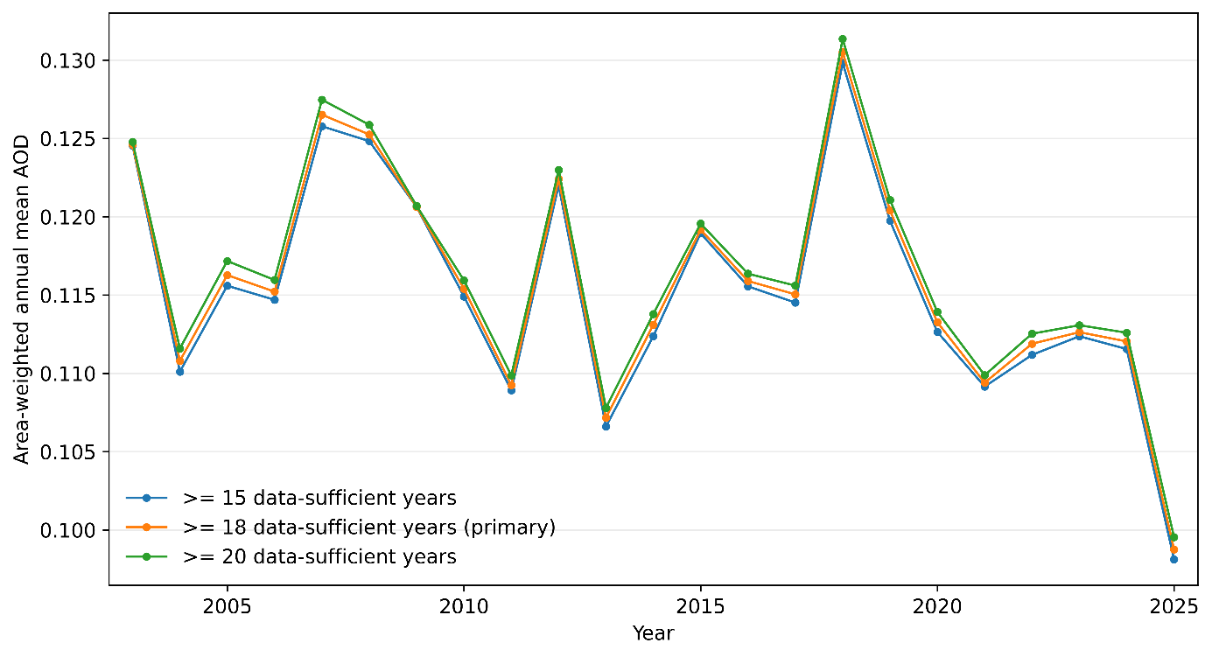
Fig. S1. Area-weighted annual AOD series and Theil-Sen trends for the fixed masks defined using minimum requirements of 15, 18, and 20 data-sufficient years
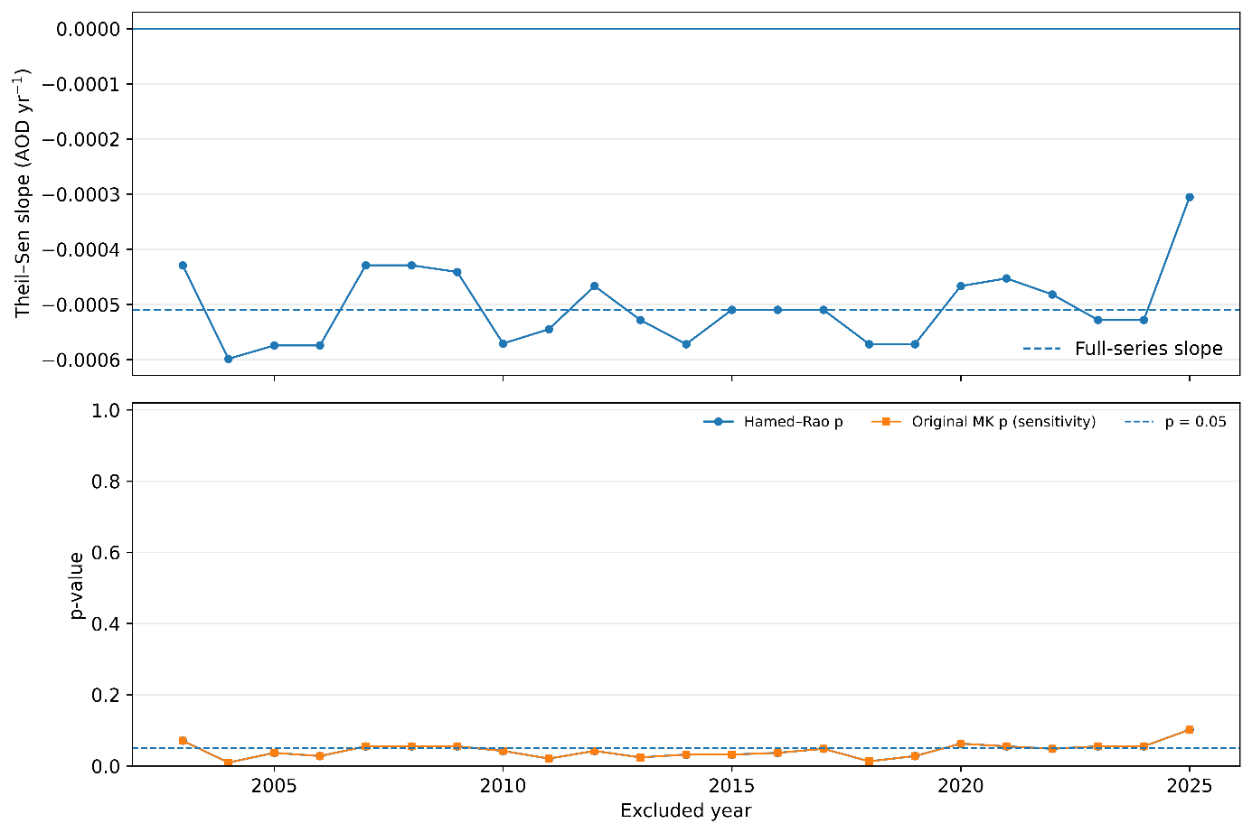
Fig. S2. Variation in the Theil-Sen slope and Hamed-Rao p value across the leave-one-year-out analyses, in which each study year was sequentially excluded

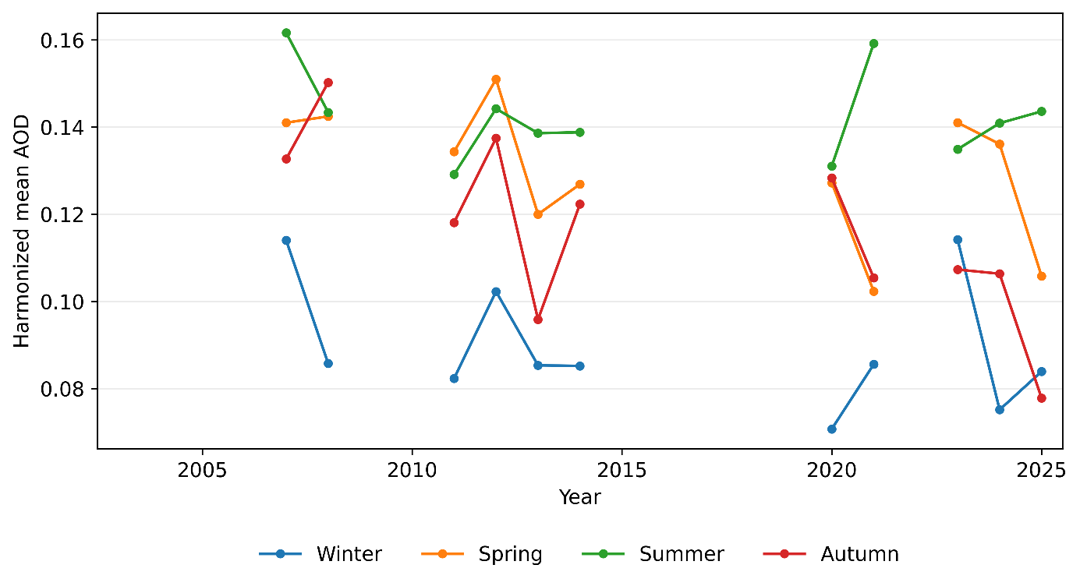
Fig. S3. Area-weighted seasonal MAIAC AOD series for winter, spring, summer, and autumn during the 11 years that could be compared using the same fixed pixel support
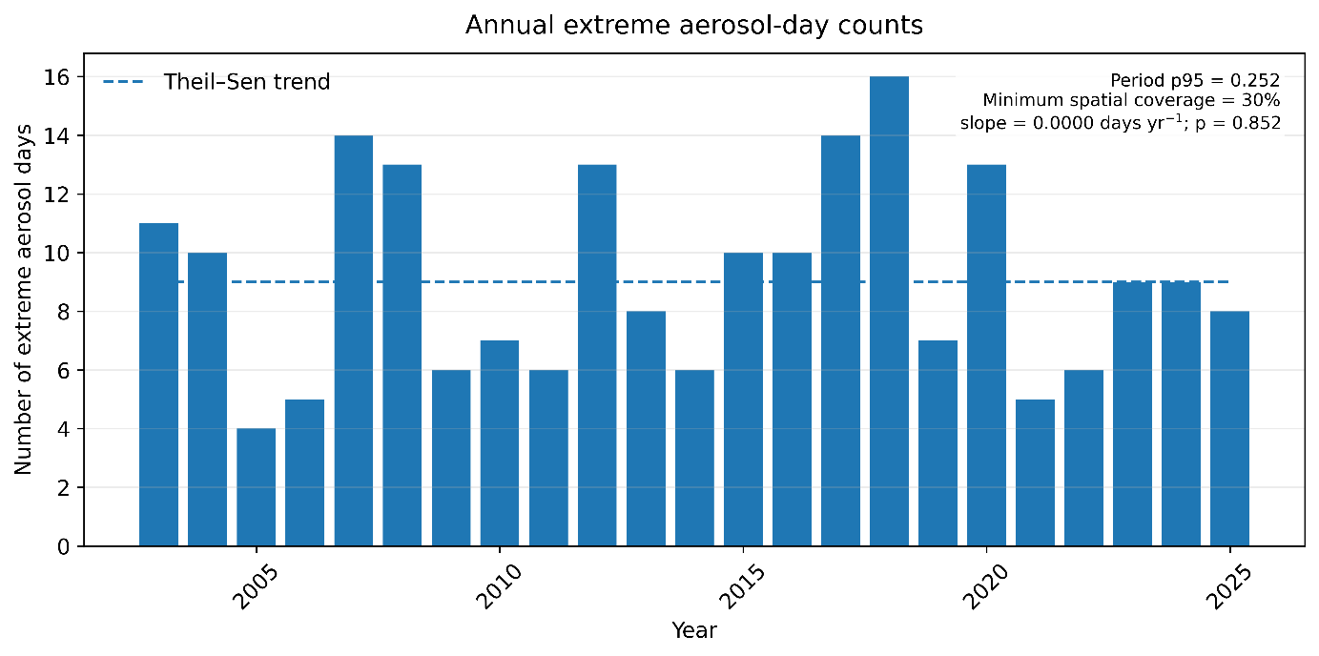
Fig. S4. Annual number of days exceeding the period-wide 95th-percentile AOD threshold under the minimum daily spatial-coverage criterion of 30%

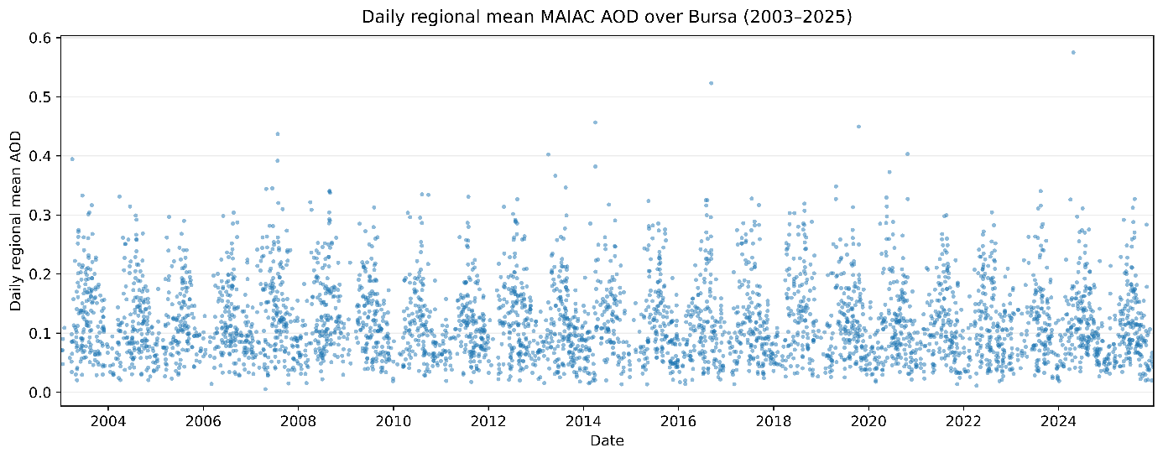
Fig. S5. Daily regional mean MAIAC AOD over Bursa during 2003-2025. Each point represents a quality-screened daily regional mean AOD value satisfying the primary minimum spatial-coverage criterion of 30%

