Metabolic syndrome prevalence and correlates among university and hospital staff in southwestern Uganda
Agapiti Hipoliti Chuwa^{1,2}, Peter Kangwagye³, David Collins Agaba², Ronald Ouma Omolo², and Richard Migisha,^{2*}
¹Department of Physiology, University of Dar es Salaam, Mbeya College of Health and Allied Sciences, P. O. Box 608, Mbeya, Tanzania.
²Department of Physiology, Mbarara University of Science and Technology, P. O. Box 1410, Mbarara, Uganda
³Department of Internal Medicine, Mbarara Regional Referral Hospital, P. O. Box 40, Mbarara, Uganda
*Correspondence: Email: rmigisha@must.ac.ug; Telephone: +256774394502.
Abstract
Background: Metabolic syndrome (MetS) represents a convergence of interrelated cardiometabolic abnormalities that substantially increases the risk of type 2 diabetes mellitus and cardiovascular disease. University and hospital staff may have distinct occupational and lifestyle exposures that contribute to cardiometabolic risk, yet evidence from Uganda remains limited. This study assessed the prevalence, component patterns, and correlates of MetS among university and hospital staff in southwestern Uganda.
Methods: We conducted an institution-based cross-sectional study among 231 university and hospital staff at Mbarara University of Science and Technology and Mbarara Regional Referral Hospital in Mbarara City, southwestern Uganda, during October 20, 2025–January 25, 2026. MetS was defined using modified harmonized Joint Interim Statement criteria as at least three of five cardiometabolic risk components: central obesity, elevated blood pressure, elevated triglycerides, reduced high-density lipoprotein cholesterol, and dysglycaemia. Dysglycaemia was defined as HbA1c ≥5.7% or being on glucose-lowering medication. We used modified Poisson regression with robust variance to estimate crude and adjusted prevalence ratios (aPRs) with 95% confidence intervals (CIs).
Results: 164 (71.0%) were university staff and 139 (60.2%) were male. Overall MetS prevalence was 29.4% (68/231; 95% CI: 23.6–35.8%). Reduced HDL-C, dysglycaemia, and central obesity were present in 150 (64.9%), 118 (51.1%), and 74 (32.0%) participants, respectively. In multivariable analysis, MetS prevalence was higher among females than males (aPR=3.01, 95% CI: 2.00–4.51), among participants aged 35–49 years (aPR=2.23, 95% CI: 1.10–4.52) and ≥50 years (aPR=2.72, 95% CI: 1.17–6.32) compared with those aged 18–34 years, and among current alcohol consumers compared with non-consumers (aPR=1.79, 95% CI: 1.22–2.62).
Conclusions: MetS affected nearly one-third of surveyed university and hospital staff in southwestern Uganda, and reduced HDL-C and dysglycaemia were the predominant abnormalities. Higher MetS prevalence was associated with female sex, older age, and current alcohol consumption. These findings indicate a substantial cardiometabolic risk burden in this institutional workforce and support consideration of workplace-based risk assessment and health-promotion strategies in similar settings.
Keywords: Metabolic syndrome, Health personnel, Occupational health, Prevalence, Uganda.
Introduction
Metabolic syndrome (MetS) is a constellation of interrelated cardiometabolic abnormalities, including central obesity, dyslipidaemia, elevated blood pressure, and dysglycaemia, that together increase the risk of type 2 diabetes mellitus, cardiovascular disease, chronic kidney disease, and premature death [1-3]. Although its additional predictive value beyond individual components remains debated, MetS provides a clinically useful framework for identifying clustering of modifiable cardiometabolic abnormalities and individuals who may benefit from early, multifaceted risk reduction [4, 5]. This concept is also reflected in the broader Cardiovascular-Kidney-Metabolic (CKM) framework, which emphasizes the interconnectedness of metabolic, cardiovascular, and renal disorders and the importance of early identification of shared risk factors [5].
Sub-Saharan Africa is undergoing a rapid epidemiological transition characterized by urbanization, socioeconomic change, dietary shifts toward energy-dense foods, and declining physical activity, contributing to a growing cardiometabolic disease burden [6]. Uganda reflects this broader transition, although reported MetS prevalence varies across populations and diagnostic frameworks. Previous studies found a relatively low MetS prevalence of 19.1% in a rural household-based population compared with higher prevalence rates among corporate employees in Kampala, where prevalence ranged from 22.8% to 28.4% depending on the criteria used [7, 8]. Population-based studies have also documented a substantial burden of individual cardiometabolic abnormalities among Ugandan adults, particularly reduced HDL-C, hypertension, and dysglycaemia [7, 9]. These findings suggest that cardiometabolic risk varies across population and occupational contexts.
Professional workforces, including university personnel and healthcare workers, may have distinct cardiometabolic risk profiles because of differences in age, sex composition, working hours, workplace environment, duration of employment, and health-related behaviors. Age is associated with progressive accumulation of visceral adiposity, insulin resistance, dyslipidaemia, and hypertension, while sex influences adipose distribution and lipid and glucose metabolism, contributing to differences in MetS risk [10]. Longer working hours and prolonged occupational exposure may influence cardiometabolic health through reduced opportunities for physical activity, disrupted recovery, and other behavioural or physiological pathways [11, 12]. Similarly, workplace type and years of employment may reflect differences in occupational demands and exposure patterns between academic and healthcare settings. Health-related behaviors, particularly alcohol consumption and smoking, may further contribute to cardiometabolic risk through effects on adiposity, blood pressure, glucose metabolism, and lipid profiles, while physical activity is generally associated with more favorable cardiometabolic health [13, 14]. Other occupational factors, including dietary patterns, sleep disruption, sedentary behavior, and psychological stress, may also contribute but were not directly assessed in the present study.
Restricting assessment to individuals who meet the diagnostic threshold for MetS may underestimate emerging cardiometabolic risk. Although one or two abnormalities do not satisfy the conventional MetS definition, their clustering may represent an evolving adverse metabolic profile associated with increased future risk of diabetes and cardiovascular events [15]. Characterising such subthreshold clustering may therefore provide complementary insight into cardiometabolic risk before the diagnostic threshold is reached. Evidence among professional employees in Uganda remains limited. We therefore conducted an institution-based cross-sectional study among university and hospital staff in Mbarara, southwestern Uganda, to: (i) estimate the prevalence of MetS using a modified Joint Interim Statement (JIS) definition; (ii) characterize sex-stratified patterns of individual MetS components; (iii) describe subthreshold metabolic clustering among participants with one or two MetS components; and (iv) identify independent correlates of MetS in this professional workforce.
Methods
Study design and setting
We conducted an institution-based cross-sectional study among staff of Mbarara University of Science and Technology (MUST) and Mbarara Regional Referral Hospital (MRRH) in Mbarara City, southwestern Uganda, from October 20, 2025, to January 25, 2026. MUST is a public university founded in 1989, and MRRH is its primary teaching hospital. MRRH is a 350-bed tertiary referral hospital serving a catchment population of more than four million people in southwestern Uganda. At study commencement, payroll records listed 906 staff members (666 at MUST and 240 at MRRH), who constituted the source population.
Study population and eligibility criteria
The study population comprised academic, clinical, administrative, and support staff working at MUST or MRRH. Eligible participants were full-time staff aged ≥18 years who had worked at either institution for at least 6 months and provided written informed consent. We excluded pregnant women because waist circumference, a key component of MetS, could not be reliably interpreted during pregnancy. We also excluded part-time staff and staff with less than 6 months of service because workplace characteristics would be difficult to interpret consistently in these groups. Participants identified their primary place of employment before data collection.
Sample size determination
The sample size was estimated using the Kish–Leslie formula for cross-sectional studies, assuming a MetS prevalence of 27.6% from a similar study in Ethiopia [16], a 95% confidence level, and a margin of error of 5%, yielding an initial sample size of 307. Because this exceeded 10% of the finite source population, a finite population correction was applied, resulting in a minimum sample size of 230 participants.
Participant selection and recruitment
The sample was proportionally allocated by institution, with 169 participants from MUST and 61 from MRRH. Within each institution, staff were further stratified by employment category to ensure representation of academic, clinical, administrative, and support staff. Participants were selected from institutional payroll lists using proportionate stratified random sampling without replacement; therefore, each eligible staff member could be selected only once.
Because some selected staff were expected to be ineligible, unavailable, or unwilling to participate, an additional reserve list was generated randomly within the same institution and employment strata. Reserve participants were approached only when a staff member from the primary list was ineligible or did not participate, thereby preserving the proportional allocation across institutions and staff categories.
Study variables and operational definitions
Primary outcome
The primary outcome was metabolic syndrome (MetS), defined using a modified harmonized Joint Interim Statement (JIS) definition. MetS was classified as the presence of ≥3 of five components: central obesity (waist circumference ≥94 cm in men or ≥80 cm in women); elevated blood pressure (systolic ≥130 mmHg, diastolic ≥85 mmHg, or antihypertensive treatment); elevated triglycerides (≥150 mg/dL [≥1.7 mmol/L] or pharmacological treatment); reduced HDL-C (<40 mg/dL [<1.0 mmol/L] in men or <50 mg/dL [<1.3 mmol/L] in women, or treatment); and dysglycaemia (HbA1c ≥5.7% or glucose-lowering medication). Because fasting plasma glucose was unavailable, HbA1c ≥5.7% was used as the glycaemic criterion and applied uniformly. Subthreshold clustering was defined as exactly one or two MetS components.
Explanatory variables
Sociodemographic and occupational characteristics included age (18–34, 35–49, and ≥50 years), sex, marital status (unmarried vs. married), primary workplace setting (university vs. hospital), institutional work experience (≤10 vs. ≥11 years), and daily working hours (≤8 vs. >8 hours/day).
Behavioural characteristics included alcohol consumption, smoking history, and physical activity. Alcohol consumption was defined as any self-reported intake during the preceding 30 days and categorised as non-consumption versus current consumption. Smoking history was categorised as non-smoker versus ever-smoker, defined as any history of cigarette or other tobacco use.
Family history of cardiometabolic disease was self-reported and defined as a reported history of hypertension, diabetes mellitus, stroke, or cardiovascular disease in a parent, sibling, or child.
Physical activity was assessed using the International Physical Activity Questionnaire-Short Form (IPAQ-SF) and categorised as low, moderate, or high according to the standard IPAQ scoring protocol [17, 18].
Physical, anthropometric, and biochemical measurements
Data were collected by a trained study team comprising a medical doctor and certified laboratory technologists. Physical and anthropometric measurements were obtained privately using standardized procedures. Blood pressure was measured using an automated digital sphygmomanometer (OMRON 3 Series) after 5 minutes of seated rest with back support. Two measurements were taken 5 minutes apart, and the mean was used for analysis. The device, cuff, battery, and display were checked daily for proper function before use. Waist circumference was measured at the midpoint between the lower costal margin and iliac crest at the end of normal expiration using a non-stretchable tape.
Participants were not required to fast. Approximately 5 mL of venous blood was collected aseptically. EDTA blood was used to measure HbA1c by high-performance liquid chromatography, while serum from gel-separator tubes was analysed for total cholesterol, HDL-C, LDL-C, and triglycerides using enzymatic colorimetric methods on an automated clinical chemistry analyser (Roche Cobas e402). The laboratory was accredited by the South African National Accreditation System (SANAS; Accreditation No. M0861). Current use of antihypertensive, glucose-lowering, and lipid-lowering medications was assessed by structured interview and, where available, verified from prescription records and incorporated into the corresponding MetS component definitions.
Statistical analysis
Categorical variables were summarized as frequencies and percentages. Continuous variables were summarized as means and standard deviations (SDs), medians and interquartile ranges (IQRs), or geometric means, as appropriate. Complete-case analysis was used for participants with complete outcome and covariate data.
MetS prevalence was estimated overall with 95% confidence intervals (CIs). Individual MetS components were described overall and stratified by sex. Component burden was categorized as 0, 1, 2, or ≥3 components, with ≥3 components corresponding to MetS. Subthreshold cardiometabolic clustering was defined as the presence of exactly one or two MetS components. Among participants with exactly two components, dual-component patterns were described overall and stratified by sex, age category, and workplace type.
Associations with MetS were assessed using modified Poisson regression with robust variance estimation, yielding crude prevalence ratios (cPRs), adjusted prevalence ratios (aPRs), and 95% CIs. Variables for multivariable adjustment were selected a priori based on clinical relevance, directed acyclic graph-informed considerations, and potential confounding. The final multivariable model included age category, sex, marital status, workplace type, daily work hours, institutional work experience, current alcohol consumption, and physical activity. Smoking history was not included in the multivariable model because the number of ever-smokers was small.
Sequential models were fitted to examine how adjustment for selected covariates influenced the prevalence-ratio estimates for current alcohol consumption and workplace type. A change of approximately 10% or greater from the crude estimate was considered evidence of meaningful confounding. Multicollinearity was assessed using generalized variance inflation factors. Model convergence, dispersion, and the number of MetS events relative to model parameters were also assessed.
Multiplicative interaction terms were assessed using robust Wald tests, including sex × workplace, sex × age, sex × alcohol, workplace × alcohol, alcohol × age, workplace × age, and workplace × daily work-hours interactions. Interaction terms were not retained in the primary model unless statistically supported and epidemiologically interpretable. All tests were two-sided, with p<0.05 considered statistically significant. Analyses were conducted using Stata version 17.0 (StataCorp, College Station, TX, USA).
Ethical considerations
The study was approved by the Mbarara University of Science and Technology Research and Ethics Committee (approval number MUST-2025-461). All participants provided written informed consent before enrolment.
Results
Participant recruitment flow
From a source population of 906 staff members, 250 were randomly selected and approached. Twelve staff members were ineligible, including six with less than six months of service, four part-time staff, and two pregnant women. Of the 238 eligible staff members, seven declined to participate because of competing work commitments (Figure 1). Overall, 231 participants were enrolled and included in the complete-case analysis. The participation rate among eligible staff was 97.1% (231/238), while 92.4% of all approached staff were included in the analysis.
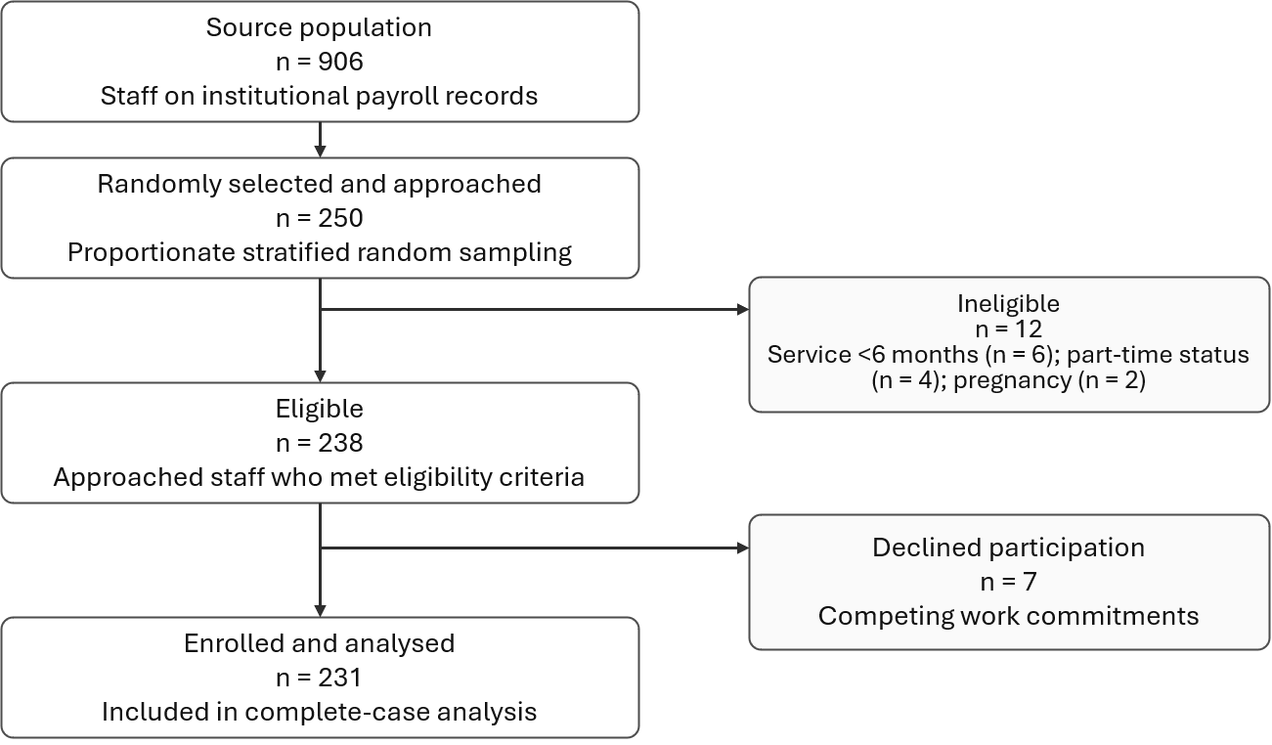
Figure 1. Participant recruitment and inclusion flow for the metabolic syndrome study among university and hospital staff in southwestern Uganda, October 2025–January 2026.
Participant characteristics
A total of 231 participants were included in the analysis. Of these, 139 (60.2%) were male, 164 (71.0%) were university staff, and 174 (75.3%) reported working more than 8 hours per day. The mean age was 41.1 years (SD, 9.3). Overall, 68 participants (29.4%) met the diagnostic criteria for MetS. Participants with MetS were older than those without MetS; among those with MetS, 43 (63.2%) were aged 35–49 years and 18 (26.5%) were aged ≥50 years, compared with 84 (51.5%) and 24 (14.7%), respectively, among those without MetS (p<0.001). Among participants with MetS, 42 (61.8%) were women and 26 (38.2%) were men (p<0.001). Compared with participants without MetS, those with MetS were more often married (82.4% vs 65.6%, p=0.017), more likely to report working >8 hours per day (85.3% vs 71.2%, p=0.035), more often university-based than hospital-based (80.9% vs 66.9%, p=0.048), and more likely to report a family history of cardiometabolic disease (51.5% vs 36.2%, p=0.045) (Table 1).
Table 1. Characteristics of study participants by metabolic syndrome status (N = 231)
Characteristic | Overall N=231 | No MetS N=163 | MetS present N=68 | p-value
Age category |  |  |  | <0.001
18–34 years | 62 (27%) | 55 (34%) | 7 (10%)
35–49 years | 127 (55%) | 84 (52%) | 43 (63%)
≥50 years | 42 (18%) | 24 (15%) | 18 (26%)
Sex |  |  |  | <0.001
Male | 139 (60%) | 113 (69%) | 26 (38%)
Female | 92 (40%) | 50 (31%) | 42 (62%)
Marital status |  |  |  | 0.017
Not married | 68 (29%) | 56 (34%) | 12 (18%)
Married | 163 (71%) | 107 (66%) | 56 (82%)
Workplace type |  |  |  | 0.048
Hospital | 67 (29%) | 54 (33%) | 13 (19%)
University | 164 (71%) | 109 (67%) | 55 (81%)
Staff category |  |  |  | 0.053
Academic | 103 (45%) | 73 (45%) | 30 (44%)
Admin/support | 61 (26%) | 36 (22%) | 25 (37%)
Clinical | 45 (19%) | 35 (21%) | 10 (15%)
Laboratory/technical | 22 (10%) | 19 (12%) | 3 (4%)
Daily work hours |  |  |  | 0.035
Standard (≤8 h/day) | 57 (25%) | 47 (29%) | 10 (15%)
Extended (>8 h/day) | 174 (75%) | 116 (71%) | 58 (85%)
Institutional work experience |  |  |  | 0.310
≤10 years | 175 (76%) | 127 (78%) | 48 (71%)
≥11 years | 56 (24%) | 36 (22%) | 20 (29%)
Alcohol consumption, past 30 days |  |  |  | 0.240
No | 154 (67%) | 113 (69%) | 41 (60%)
Yes | 77 (33%) | 50 (31%) | 27 (40%)
Smoking history |  |  |  | >0.99
No | 222 (96%) | 157 (96%) | 65 (96%)
Yes | 9 (4%) | 6 (4%) | 3 (4%)
Family history of cardiometabolic disease |  |  |  | 0.045
Negative history | 137 (59%) | 104 (64%) | 33 (49%)
Positive history | 94 (41%) | 59 (36%) | 35 (51%)
Physical activity level |  |  |  | 0.405
High | 110 (48%) | 81 (50%) | 29 (43%)
Moderate | 121 (52%) | 82 (50%) | 39 (57%)
Note. Values are n (%). Percentages in the Overall column use N=231 as denominator; percentages in MetS-status columns use the corresponding column denominators. p-values are from Pearson chi-square tests.
Prevalence of MetS, individual components, and subthreshold clustering

Prevalence of MetS components and component burden
Among the 231 participants, 68 participants met the modified diagnostic criteria for metabolic syndrome (MetS), giving a prevalence of 29.4% (95% CI: 23.6–35.8%).
Reduced HDL-C was the predominant MetS component, affecting 150 (64.9%), followed by dysglycaemia in 118 (51.1%). Central obesity and elevated triglycerides were present in 74 (32.0%) and 72 (31.2%) participants, respectively, while elevated blood pressure was the least frequent component, affecting 42 (18.2%). The sex pattern was notable: women had substantially higher prevalence estimates of central obesity than men (53.3% vs 18.0%) and reduced HDL-C (82.6% vs 53.2%), whereas elevated triglycerides were slightly more common among men than women (33.8% vs 27.2%) (Figure 2).
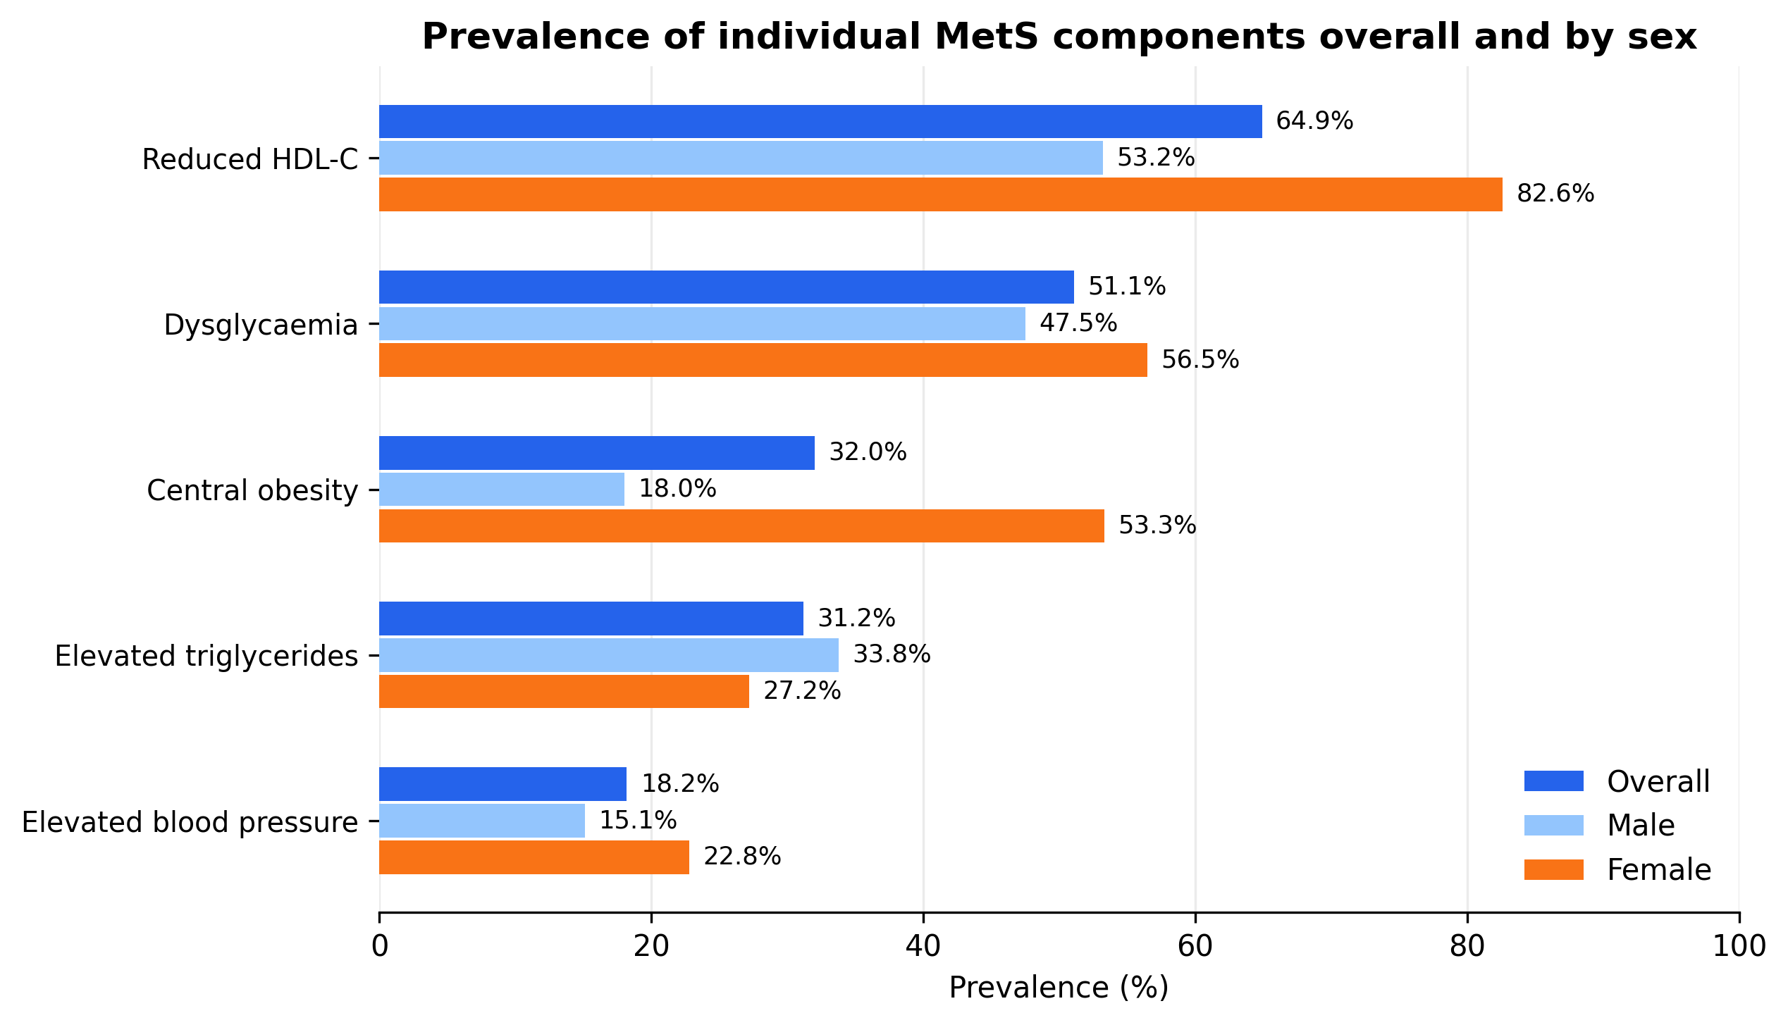
Figure 2. Prevalence of individual metabolic syndrome components overall and by sex among university and hospital staff in southwestern Uganda, October 2025–January 2026. Bars show the prevalence of each modified JIS component overall and stratified by sex.
Overall, 20 of 231 participants (8.7%) had no MetS components, 61 (26.4%) had one component, 82 (35.5%) had two components, and 68 (29.4%) had at least three components. Component burden was higher among women than men: 42 of 92 women (45.7%) had ≥3 components compared with 26 of 139 men (18.7%). Component burden also increased with age; ≥3 components were present in 7 of 62 participants aged 18–34 years (11.3%), 43 of 127 aged 35–49 years (33.9%), and 18 of 42 aged ≥50 years (42.9%) (Figure 3).
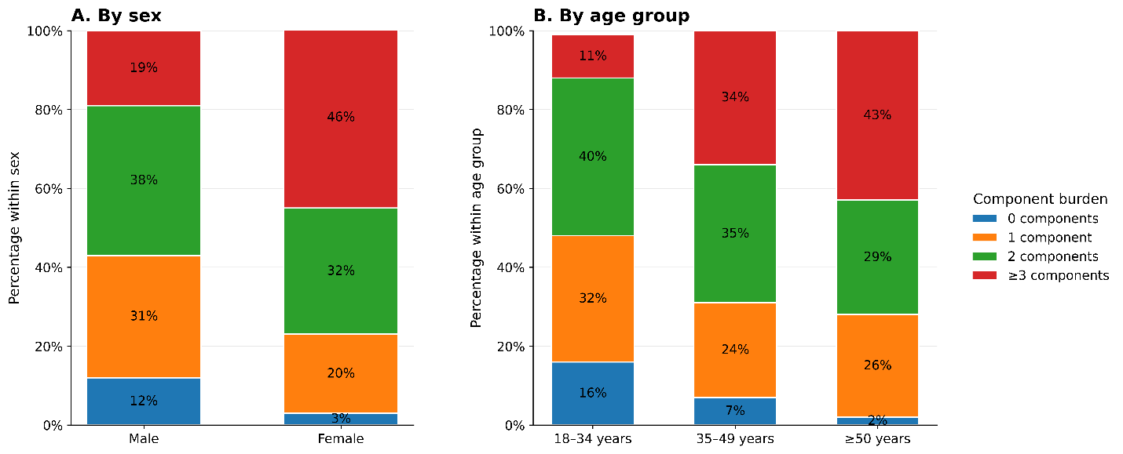
Figure 3. MetS component burden by sex and age group. Stacked bars show the percentage within each subgroup with 0, 1, 2, or ≥3 MetS components. The ≥3 components category corresponds to MetS.
Component burden also appeared higher among university than hospital staff: 55 of 164 university staff (33.5%) had ≥3 components compared with 13/67 hospital staff (19.4%). Conversely, having no MetS components was more common among hospital staff than university staff (13.4% vs 6.7%). The proportion with two components was similar across workplace groups, affecting 23/67 hospital staff (34.3%) and 59/164 university staff (36.0%) (Supplementary Table S2).
Subthreshold dual-component patterns
Among the 82 participants with exactly two MetS components, the most frequent dual-component pattern was reduced HDL-C plus dysglycaemia, observed in 27 participants (32.9%), followed by elevated triglycerides plus reduced HDL-C in 19 (23.2%). Central obesity plus reduced HDL-C and elevated triglycerides plus dysglycaemia were each present in 9 participants (11.0%). Patterns differed by sex. Among women with exactly two components, reduced HDL-C plus dysglycaemia was the dominant pattern, accounting for 12/29 dual-component profiles (41.4%), followed by central obesity plus reduced HDL-C in 6 (20.7%). Among men, reduced HDL-C plus dysglycaemia accounted for 15/53 profiles (28.3%), while elevated triglycerides plus reduced HDL-C accounted for 14 (26.4%) and elevated triglycerides plus dysglycaemia for 9 (17.0%) (Figure 4). Detailed age- and workplace-stratified patterns are provided in Supplementary Table S3.
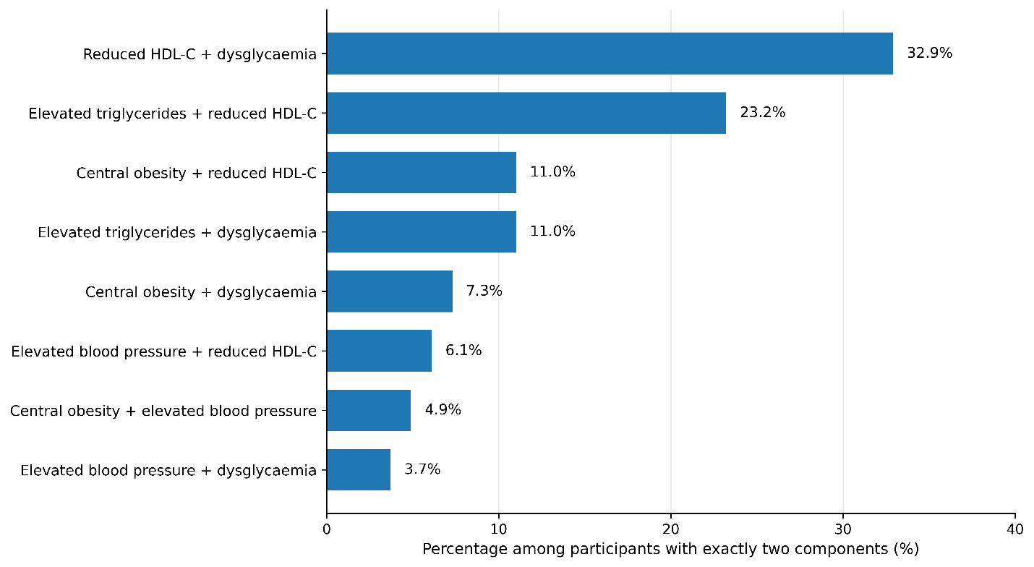
Figure 4. Dual-component patterns among participants with exactly two MetS components. Percentages are calculated among participants with exactly two components (n=82).
Correlates of metabolic syndrome
After adjustment for age, sex, marital status, workplace type, daily work hours, institutional work experience, current alcohol consumption, and physical activity, female sex, older age, and current alcohol consumption were independently associated with MetS (Table 3). Females had approximately three times the prevalence of MetS compared with males (aPR=3.01, 95% CI: 2.00–4.51; p<0.001). Compared with participants aged 18–34 years, MetS prevalence was higher among those aged 35–49 years (aPR=2.23, 95% CI: 1.10–4.52; p=0.026) and those aged ≥50 years (aPR=2.72, 95% CI: 1.17–6.32; p=0.020). Current alcohol consumption was not statistically significant in crude analysis (cPR=1.32, 95% CI: 0.88–1.97; p=0.179) but was associated with higher MetS prevalence after adjustment (aPR=1.79, 95% CI: 1.22–2.62; p=0.003).
Table 3. Correlates of metabolic syndrome among university and hospital staff, southwestern Uganda, October 2025–January 2026
Variable | Category | Crude PR (95% CI) | Crude p-value | Adjusted PR (95% CI) | Adjusted p-value
Age category | 18–34 years | Reference |  | Reference
 | 35–49 years | 3.00 (1.43–6.28) | 0.004 | 2.23 (1.10–4.52) | 0.026
 | ≥50 years | 3.80 (1.74–8.28) | <0.001 | 2.72 (1.17–6.32) | 0.020
Sex | Male | Reference |  | Reference
 | Female | 2.44 (1.62–3.69) | <0.001 | 3.01 (2.00–4.51) | <0.001
Marital status | Not married | Reference |  | Reference
 | Married | 1.95 (1.12–3.39) | 0.019 | 1.32 (0.80–2.19) | 0.274
Workplace type | Hospital | Reference |  | Reference
 | University | 1.73 (1.01–2.95) | 0.044 | 1.65 (0.93–2.93) | 0.085
Daily work hours | Standard, ≤8 h/day | Reference |  | Reference
 | Extended, >8 h/day | 1.90 (1.04–3.46) | 0.036 | 1.64 (0.96–2.79) | 0.072
Institutional work experience | ≤10 years | Reference |  | Reference
 | ≥11 years | 1.30 (0.85–1.99) | 0.225 | 0.98 (0.60–1.60) | 0.932
Alcohol consumption, past 30 days | No | Reference |  | Reference
 | Yes | 1.32 (0.88–1.97) | 0.179 | 1.79 (1.22–2.62) | 0.003
Physical activity level | High | Reference |  | Reference
 | Moderate | 1.22 (0.82–1.83) | 0.331 | 0.92 (0.59–1.43) | 0.715
Note. PR, prevalence ratio; CI, confidence interval. Prevalence ratios were estimated using modified Poisson regression with robust variance estimation. The adjusted model included age category, sex, marital status, workplace type, daily work hours, institutional work experience, alcohol consumption in the past 30 days, and physical activity level.
The primary model converged and showed no problematic multicollinearity (maximum adjusted GVIF=1.21) or overdispersion (Pearson dispersion ratio=0.67). With 68 MetS events and nine parameters, the events-per-parameter ratio was 7.56. Prespecified interaction terms were not statistically supported (all p>0.18) and were not retained.
Sequential adjustment showed that the alcohol–MetS estimate strengthened mainly after adjustment for sex, from a crude PR of 1.32 to 2.11 after sex adjustment and 1.79 in the full model. For workplace type, the crude university-versus-hospital estimate was 1.73; it was attenuated after age adjustment to 1.52 and remained imprecise in the full model (PR=1.65, 95% CI: 0.93–2.93) (Supplementary Table S4).
Discussion
In this cross-sectional study of university and hospital staff in southwestern Uganda, nearly one in three participants met the diagnostic criteria for MetS, and a substantially larger proportion had one or two metabolic abnormalities below the diagnostic threshold. Reduced HDL-C and dysglycaemia were the most common abnormalities, and older age, female sex, and current alcohol consumption were independent correlates of MetS. The predominance of lipid and glycaemic abnormalities suggests that workplace-based cardiometabolic screening should identify not only overt MetS, but also earlier metabolic changes that may precede clinically apparent disease.
The observed MetS prevalence is broadly consistent with the burden reported in occupational and urban adult populations in the region. In Kampala, a study among corporate employees reported MetS prevalence estimates of 22.8% using NCEP-ATP III criteria and 28.4% using IDF criteria; notably, most participants without MetS already had at least one metabolic abnormality[8]. Similar findings have been reported among public servants and healthcare workers in Ethiopia and Rwanda, with prevalence estimates ranging from 25.2% to 31.5% [16, 19]. At the continental level, pooled African estimates suggest that MetS affects approximately one-third of adults, with a similar estimate when JIS criteria are applied; the burden is also higher among women and in East Africa, patterns that are consistent with the present findings [20]. Earlier sub-Saharan African evidence has similarly shown higher MetS prevalence among women and urban populations [6]. Differences in age, sex distribution, population characteristics, sampling methods, and diagnostic criteria should nevertheless be considered when interpreting these comparisons.
The high prevalence of subthreshold clustering in this study adds important context beyond the conventional MetS classification. Among participants with exactly two components, the most frequent pattern was reduced HDL-C with dysglycaemia, followed by reduced HDL-C with elevated triglycerides. This suggests that many participants who did not meet the full diagnostic threshold for MetS already had multiple coexisting metabolic abnormalities. Cardiometabolic risk is therefore better understood as a continuum rather than a strictly binary condition, consistent with the broader Cardiovascular-Kidney-Metabolic framework, which emphasizes early identification of interconnected metabolic, cardiovascular, and renal risk [5, 15, 21, 22]. However, the cross-sectional design prevents determining whether these subthreshold patterns progress to MetS or subsequent cardiovascular or metabolic disease.
The component profile observed in this cohort is also notable. Reduced HDL-C was the most common metabolic abnormality, consistent with reports from Uganda and other African populations. In rural Uganda, for example, reduced HDL-C has been reported in more than half of adults [7], suggesting that this abnormality may be part of a broader regional lipid pattern in sub-Saharan Africa [23]. In the present study, reduced HDL-C was particularly frequent among women, which may partly explain the higher MetS prevalence observed in females. However, reduced HDL-C should not be interpreted in isolation as a direct surrogate for cardiovascular risk. Some African populations may have lower HDL-C alongside relatively low total and non-HDL cholesterol, and the relationship between HDL-C, adiposity, and cardiovascular outcomes may differ across populations [23]. In this study, reduced HDL-C is therefore best understood as an important component of the overall MetS phenotype, particularly because it commonly coexisted with dysglycaemia and central obesity. This pattern reinforces the value of identifying early metabolic abnormalities before the full syndrome is established.
Alongside reduced HDL-C, dysglycaemia was a prominent feature of the MetS profile in this study. HbA1c was used instead of fasting plasma glucose because fasting blood collection is often difficult to standardize in workplace studies, particularly where staff have variable schedules. HbA1c reflects average glycaemic exposure over the preceding 8–12 weeks and may therefore capture more sustained dysglycaemia than a single fasting glucose measurement. This distinction is relevant because a Ghanaian study reported higher MetS prevalence when HbA1c, rather than fasting plasma glucose, was used as the glycaemic criterion[24]. However, HbA1c is not without limitations. It may be affected by anaemia, haemoglobinopathies, malaria, iron deficiency, and other conditions that alter erythrocyte lifespan or haemoglobin characteristics. Evidence from the OPTIMAL multicentre observational study in Uganda suggests that HbA1c can remain useful for assessing glycaemic control in populations where such conditions are common [25]. Thus, HbA1c strengthened feasibility and reflected longer-term glycaemia in this study, while also limiting direct comparison with fasting glucose-based MetS studies.
MetS prevalence increased with age, consistent with the progressive accumulation of adiposity, insulin resistance, dysglycaemia, dyslipidaemia, and blood-pressure abnormalities over the life course [26]. With increasing age, changes in body composition, insulin sensitivity, lipid metabolism, blood pressure regulation, physical activity, and energy expenditure may increase the likelihood that multiple MetS components cluster in the same individual. For women, menopausal transition-related hormonal changes may additionally influence fat distribution and metabolic risk[27]. However, the cross-sectional design limits inference about temporal progression.
The higher prevalence of MetS among women also aligns with regional meta-analytic data and studies from sub-Saharan Africa [6]. These patterns may reflect a combination of biological, social, and behavioral influences that vary across settings and stages of adult life. Oestrogen influences adipose-tissue distribution, insulin sensitivity, hepatic lipid metabolism, and energy homeostasis. Declining oestrogen during the menopausal transition is associated with greater visceral adiposity and adverse metabolic changes [28, 29]. However, menopausal status, reproductive history, and detailed measures of adipose distribution were not collected, precluding direct attribution of the observed sex difference to these mechanisms.
The association between current alcohol consumption and MetS is biologically plausible but should be interpreted with caution. Alcohol may influence cardiometabolic risk through effects on hepatic fat accumulation, lipid metabolism, glucose regulation, inflammation, and adiposity[30, 31]. However, these effects vary by drinking frequency, amount consumed, drinking pattern, sex, diet, and body size. Because the present study assessed current alcohol use without detailed quantification of these dimensions, the observed association should be viewed as hypothesis-generating rather than causal.
These findings have several public health implications. First, they support integrating cardiometabolic risk assessment into occupational health services for university and hospital staff, particularly in resource-limited settings where preventive care is often underdeveloped. Second, the high frequency of subthreshold cardiometabolic risk clustering suggests that screening should not focus only on staff who already meet the MetS definition, but should also identify those with one or two metabolic abnormalities who may benefit from early counseling and risk reduction. Third, prevention efforts should be designed around low-cost, implementable workplace actions, such as periodic blood pressure and waist-circumference checks, scheduled glucose and lipid testing, brief lifestyle counseling, healthier food options within institutional settings, opportunities for physical activity during the workday, and support for reducing harmful alcohol use. Because MetS prevalence was higher among women, older staff, and current alcohol consumers in this study, these groups may warrant more proactive screening and tailored prevention support.
Limitations
This study has several limitations. First, the cross-sectional design precludes establishing temporality or causal relationships between the identified correlates and MetS. Second, the institution-based sample was drawn from two professional workplaces in southwestern Uganda, which may limit generalizability to other occupational groups, unemployed adults, rural populations, or the general population. The findings may also be affected by healthy-worker bias, since employed staff may differ from the broader adult population in health status, socioeconomic position, and access to health information. Third, behavioral exposures, including alcohol use and physical activity, were self-reported and may be affected by recall or social-desirability bias. Alcohol use was measured as current consumption and did not capture quantity, frequency, binge-drinking patterns, or duration of use, limiting interpretation of the observed association. Fourth, several relevant determinants of cardiometabolic risk, including diet, sedentary time, sleep, psychological stress, menopause status, and detailed occupational exposures, were not measured, leaving potential for residual confounding. Finally, dysglycaemia was assessed using HbA1c rather than fasting plasma glucose; although HbA1c offers the advantage of reflecting longer-term glycaemic exposure, this choice may affect comparability with studies that use fasting glucose-based MetS definitions. Despite these limitations, the study provides useful evidence on the burden and pattern of MetS among professional workers in Uganda, a population for which data remain limited.
Conclusion
Nearly one-third of university and hospital staff had metabolic syndrome (MetS), and an even larger proportion had subthreshold cardiometabolic risk clustering. Reduced HDL-C and dysglycaemia were the most frequent abnormalities, and older age, female sex, and current alcohol consumption were associated with higher MetS prevalence. These findings support consideration of workplace-based cardiometabolic screening and targeted prevention strategies and underscore the need for longitudinal studies to clarify the clinical and prognostic implications of subthreshold clustering and to evaluate feasible interventions in similar resource-limited professional settings.
List of abbreviations:
aPR: Adjusted Prevalence Ratio; BMI: Body Mass Index; CI: Confidence Interval; CKM: Cardiovascular-Kidney-Metabolic; cPR: Crude Prevalence Ratio; HbA1c: Glycated Hemoglobin; GVIF: Generalized variance inflation factor; HDL-C: High-Density Lipoprotein Cholesterol; HPLC: High-Performance Liquid Chromatography; IPAQ-SF: International Physical Activity Questionnaire-Short Form; IQR: Interquartile Range; JIS: Joint Interim Statement; LDL-C: Low-Density Lipoprotein Cholesterol; MetS: Metabolic Syndrome; MRRH: Mbarara Regional Referral Hospital; MUST: Mbarara University of Science and Technology; SANAS: South African National Accreditation System; SD: Standard Deviation.
Declarations
Ethics approval and consent to participate
Ethical approval for this study was obtained from the Research Ethics Committee of Mbarara University of Science and Technology (Reference No. MUST-2025-461). Written informed consent was obtained from all participants prior to enrolment in the study. All methods were carried out in accordance with relevant guidelines and regulations and in accordance with the ethical principles of the Declaration of Helsinki.
Clinical trial number
Not applicable.
Consent for publication
Not applicable.
Availability of data and materials
The datasets used and/or analysed during the current study are available from the corresponding author on reasonable request.
Competing interests
The authors declare that they have no competing interests.
Funding
This work was supported by the University of Dar es Salaam, Tanzania, through its academic and research support programme. The funder had no role in the design of the study; collection, analysis, and interpretation of data; or writing of the manuscript.
Authors’ Contributions
AHC designed the study, collected the data, performed the statistical analysis, and drafted the original and revised manuscript. PK supervised the study and provided clinical expertise and interpretation of findings. DCA contributed to study design, provided methodological input, and critically reviewed the manuscript for important intellectual content. ROO contributed to data interpretation, provided technical and academic input, and critically reviewed the manuscript for important intellectual content. RM conceived the study, participated in the study design, supervised the study, contributed to data curation, and participated in revising the manuscript. All authors read and approved the final manuscript.
Acknowledgements
The authors sincerely thank all university and hospital staff who participated in the study. We also thank the administrative management of Mbarara University of Science and Technology and Mbarara Regional Referral Hospital for permitting the conduct of the study within their institutions.
References
1. Islam MS, Wei P, Suzauddula M, Nime I, Feroz F, Acharjee M, Pan F: The interplay of factors in metabolic syndrome: understanding its roots and complexity. Molecular medicine (Cambridge, Mass) 2024, 30(1):279.
2. Adjei NK, Samkange-Zeeb F, Boakye D, Saleem M, Christianson L, Kebede MM, Heise TL, Brand T, Esan OB, Taylor-Robinson DC et al: Ethnic differences in metabolic syndrome in high-income countries: A systematic review and meta-analysis. Reviews in endocrine & metabolic disorders 2024, 25(4):727-750.
3. Noubiap JJ, Nansseu JR, Nyaga UF, Ndoadoumgue AL, Ngouo AT, Tounouga DN, Tianyi F-L, Foka AJ, Lontchi-Yimagou E, Nkeck JR et al: Worldwide trends in metabolic syndrome from 2000 to 2023: a systematic review and modelling analysis. Nature Communications 2025, 17(1):573.
4. van Namen M, Prendergast L, Peiris C: Supervised lifestyle intervention for people with metabolic syndrome improves outcomes and reduces individual risk factors of metabolic syndrome: A systematic review and meta-analysis. Metabolism - Clinical and Experimental 2019, 101.
5. Ndumele CE, Rangaswami J, Chow SL, Neeland IJ, Tuttle KR, Khan SS, Coresh J, Mathew RO, Baker-Smith CM, Carnethon MR et al: Cardiovascular-Kidney-Metabolic Health: A Presidential Advisory From the American Heart Association. Circulation 2023, 148(20):1606-1635.
6. Jaspers Faijer-Westerink H, Kengne AP, Meeks KAC, Agyemang C: Prevalence of metabolic syndrome in sub-Saharan Africa: A systematic review and meta-analysis. Nutrition, metabolism, and cardiovascular diseases: NMCD 2020, 30(4):547-565.
7. Ben-Yacov L, Ainembabazi P, Stark AH, Kizito S, Bahendeka S: Prevalence and sex-specific patterns of metabolic syndrome in rural Uganda. BMJ Nutrition, Prevention & Health 2020, 3(1):11.
8. Kyeyune JK, Mchiza ZJ-R, Bashir M, Ingabire PM, Githinji FW, Nakaggwa F, Busulwa IG, Nanyonga RC: Metabolic syndrome and its component factors among corporate company employees in Kampala Uganda. Research Square 2024:rs.3.rs-4907042.
9. Guwatudde D, Mutungi G, Wesonga R, Kajjura R, Kasule H, Muwonge J, Ssenono V, Bahendeka SK: The epidemiology of hypertension in Uganda: findings from the national non-communicable diseases risk factor survey. PloS one 2015, 10(9):e0138991.
10. Strauss M, Lavie CJ, Lippi G, Brzęk A, Vollenberg R, Sanchis-Gomar F, Leischik R: A systematic review of prevalence of metabolic syndrome in occupational groups - Does occupation matter in the global epidemic of metabolic syndrome? Progress in cardiovascular diseases 2022, 75:69-77.
11. Sooriyaarachchi P, Jayawardena R, Pavey T, King NA: Shift work and the risk for metabolic syndrome among healthcare workers: A systematic review and meta-analysis. Obesity Reviews 2022, 23(10):e13489.
12. Halling Ullberg O, Toivanen S, Tillander A, Bälter K: Workplace health promotion to facilitate physical activity among office workers in Sweden. Frontiers in Public Health 2023, 11.
13. Aminian O, Saraei M, Najieb Pour S, Eftekhari S: Association between type of physical activity and risk factors for cardiovascular disease, Islamic Republic of Iran. Eastern Mediterranean Health Journal 2021, 27(11):1061-1068.
14. Eftekhari S, Alipour F, Aminian O, Saraei M: The association between job stress and metabolic syndrome among medical university staff. Journal of Diabetes and Metabolic Disorders 2021, 20(1):321-327.
15. Guembe MJ, Fernandez-Lazaro CI, Sayon-Orea C, Toledo E, Moreno-Iribas C: Risk for cardiovascular disease associated with metabolic syndrome and its components: a 13-year prospective study in the RIVANA cohort. Cardiovascular Diabetology 2020, 19(1):195.
16. Geto Z, Challa F, Lejisa T, Getahun T, Sileshi M, Nagasa B, Tolcha Y, Daniel Y, Getnet M, Molla MD et al: Cardiometabolic syndrome and associated factors among Ethiopian public servants, Addis Ababa, Ethiopia. Scientific Reports 2021, 11:20635.
17. Craig C, Marshall A, SjÖStrÖM M, Bauman A, Booth M, Ainsworth B, Pratt M, Ekelund ULF, Yngve A, Sallis J et al: International Physical Activity Questionnaire: 12-Country Reliability and Validity. Medicine & Science in Sports & Exercise 2003, 35(8):1381-1395.
18. Sjostrom M, Ainsworth BE, Bauman A, Bull FC, Hamilton-Craig CR, Sallis JF: Guidelines for data processing analysis of the International Physical Activity Questionnaire (IPAQ) - Short and long forms. 2005.
19. Gafirita J, Musarurwa C, Tumusiime D, Rulisa S, Mukahigiro M, Bavuma CM, Ntaganda E, Twizelimana L, Nshimiyimana ML, Uwimana M et al: Prevalence of the Metabolic Syndrome and its Associated Factors among Hospital Workers at a Rwandan Provincial Hospital: A Cross-Sectional Study. Rwanda Journal of Medicine and Health Sciences 2025, 8(3):550-564.
20. Bowo-Ngandji A, Kenmoe S, Ebogo-Belobo JT, Kenfack-Momo R, Takuissu GR, Kengne-Ndé C, Mbaga DS, Tchatchouang S, Kenfack-Zanguim J, Lontuo Fogang R et al: Prevalence of the metabolic syndrome in African populations: A systematic review and meta-analysis. PloS one 2023, 18(7):e0289155.
21. Acierno C, Orio M, Schiavo L, Saracino A, Stabile E: From Metabolic Syndrome to Cardiovascular-Kidney-Metabolic Syndrome (CKM): A Clinical and Pathophysiological Continuum. Biomedicines 2026, 14(4).
22. Ding H, Jiang L, Zhao Y, Lee D, Chun B: Associations between cardiovascular-kidney-metabolic syndrome staging and risks of all-cause and cardiovascular mortality: a systematic review and meta-analysis. American Journal of Preventive Cardiology 2026, 25:101407.
23. Greiner R, Nyirenda M, Rodgers L, Asiki G, Banda L, Shields B, Hattersley A, Crampin A, Newton R, Jones A: Associations between low HDL, sex and cardiovascular risk markers are substantially different in sub-Saharan Africa and the UK: analysis of four population studies. BMJ Global Health 2021, 6(5):e005222.
24. Annani-Akollor ME, Laing EF, Osei H, Mensah E, Owiredu EW, Afranie BO, Anto EO: Prevalence of metabolic syndrome and the comparison of fasting plasma glucose and HbA1c as the glycaemic criterion for MetS definition in non-diabetic population in Ghana. Diabetology & Metabolic Syndrome 2019, 11:26.
25. Niwaha AJ, Rodgers LR, Greiner R, Balungi PA, Mwebaze R, McDonald TJ, Hattersley AT, Shields BM, Nyirenda MJ, Jones AG: HbA1c performs well in monitoring glucose control even in populations with high prevalence of medical conditions that may alter its reliability: the OPTIMAL observational multicenter study. BMJ Open Diabetes Research & Care 2021, 9(1).
26. Neeland IJ, Lim S, Tchernof A, Gastaldelli A, Rangaswami J, Ndumele CE, Powell-Wiley TM, Després J-P: Metabolic syndrome. Nature Reviews Disease Primers 2024, 10(1):77.
27. Uddenberg ER, Safwan N, Saadedine M, Hurtado MD, Faubion SS, Shufelt CL: Menopause transition and cardiovascular disease risk. Maturitas 2024, 185.
28. De Paoli M, Zakharia A, Werstuck GH: The Role of Estrogen in Insulin Resistance: A Review of Clinical and Preclinical Data. The American Journal of Pathology 2021, 191(9):1490-1498.
29. Yanachkova V: Menopause as a Metabolic Turning Point: Endocrine Mechanisms Linking Hormonal Transition and Obesity. In: Rethinking Obesity - Interdisciplinary Insights Into a Global Epidemic. edn. Edited by Păun DL. London: IntechOpen; 2026.
30. Martínez-Urbistondo D, Perez-Diaz-Del-Campo N, Landecho MF, Martínez JA: Alcohol Drinking Impacts on Adiposity and Steatotic Liver Disease: Concurrent Effects on Metabolic Pathways and Cardiovascular Risks. Current Obesity Reports 2024, 13(3):461-474.
31. Hashida R, Golabi P, Ong J, Kawaguchi T, Younossi ZM: Alcohol and Metabolic Syndrome Interaction. Clinics in Liver Disease 2024, 28(4):601-620.
Supplementary Tables
Supplementary Table S1. Individual metabolic syndrome components overall and by sex among university and hospital staff in southwestern Uganda, October 2025–January 2026.
Component | Overall  N=231 | Male  n=139 | Female  n=92 | Sex-difference  p-value
Reduced HDL-C | 150 (64.9%) | 74 (53.2%) | 76 (82.6%) | <0.001
Dysglycaemia | 118 (51.1%) | 66 (47.5%) | 52 (56.5%) | 0.226
Central obesity | 74 (32.0%) | 25 (18.0%) | 49 (53.3%) | <0.001
Elevated triglycerides | 72 (31.2%) | 47 (33.8%) | 25 (27.2%) | 0.357
Elevated blood pressure | 42 (18.2%) | 21 (15.1%) | 21 (22.8%) | 0.189
Note. Values are n (%). Sex-difference p-values are from Pearson chi-square tests. The five modified Joint Interim Statement components were central obesity, elevated blood pressure, elevated triglycerides, reduced HDL-C, and dysglycaemia. HDL-C, high-density lipoprotein cholesterol.
Supplementary Table S2. Metabolic syndrome component burden stratified by sex, age group, and workplace type among university and hospital staff in southwestern Uganda, October 2025–January 2026.
Stratifier | Category | n | 0 components | 1 component | 2 components | ≥3 components
Sex | Male | 139 | 17 (12.2%) | 43 (30.9%) | 53 (38.1%) | 26 (18.7%)
Sex | Female | 92 | 3 (3.3%) | 18 (19.6%) | 29 (31.5%) | 42 (45.7%)
Age group | 18–34 years | 62 | 10 (16.1%) | 20 (32.3%) | 25 (40.3%) | 7 (11.3%)
Age group | 35–49 years | 127 | 9 (7.1%) | 30 (23.6%) | 45 (35.4%) | 43 (33.9%)
Age group | ≥50 years | 42 | 1 (2.4%) | 11 (26.2%) | 12 (28.6%) | 18 (42.9%)
Workplace type | Hospital | 67 | 9 (13.4%) | 22 (32.8%) | 23 (34.3%) | 13 (19.4%)
Workplace type | University | 164 | 11 (6.7%) | 39 (23.8%) | 59 (36.0%) | 55 (33.5%)
Note. Values are n (% within each subgroup). Component burden was calculated from the five modified Joint Interim Statement components. The ≥3 components category corresponds to metabolic syndrome.
Supplementary Table S3. Dual-component patterns among participants with exactly two metabolic syndrome components, by age group and workplace type.
Stratum | Dual-component pattern | n (%)
Panel A. Dual-component patterns by age group
18–34 years (n=25) | Dysglycaemia + reduced HDL-C | 8 (32.0%)
 | Dysglycaemia + elevated triglycerides | 6 (24.0%)
 | Elevated triglycerides + reduced HDL-C | 5 (20.0%)
 | Central obesity + reduced HDL-C | 3 (12.0%)
 | Elevated blood pressure + reduced HDL-C | 2 (8.0%)
 | Dysglycaemia + elevated blood pressure | 1 (4.0%)
35–49 years (n=45) | Dysglycaemia + reduced HDL-C | 17 (37.8%)
 | Elevated triglycerides + reduced HDL-C | 12 (26.7%)
 | Central obesity + dysglycaemia | 4 (8.9%)
 | Central obesity + reduced HDL-C | 4 (8.9%)
 | Central obesity + elevated blood pressure | 3 (6.7%)
 | Dysglycaemia + elevated triglycerides | 2 (4.4%)
 | Elevated blood pressure + reduced HDL-C | 2 (4.4%)
 | Dysglycaemia + elevated blood pressure | 1 (2.2%)
≥50 years (n=12) | Central obesity + dysglycaemia | 2 (16.7%)
 | Central obesity + reduced HDL-C | 2 (16.7%)
 | Dysglycaemia + reduced HDL-C | 2 (16.7%)
 | Elevated triglycerides + reduced HDL-C | 2 (16.7%)
 | Central obesity + elevated blood pressure | 1 (8.3%)
 | Dysglycaemia + elevated blood pressure | 1 (8.3%)
 | Dysglycaemia + elevated triglycerides | 1 (8.3%)
 | Elevated blood pressure + reduced HDL-C | 1 (8.3%)
Panel B. Dual-component patterns by workplace type
Hospital (n=23) | Dysglycaemia + reduced HDL-C | 11 (47.8%)
 | Elevated triglycerides + reduced HDL-C | 4 (17.4%)
 | Central obesity + reduced HDL-C | 3 (13.0%)
 | Dysglycaemia + elevated triglycerides | 2 (8.7%)
 | Central obesity + dysglycaemia | 1 (4.3%)
 | Dysglycaemia + elevated blood pressure | 1 (4.3%)
 | Elevated blood pressure + reduced HDL-C | 1 (4.3%)
University (n=59) | Dysglycaemia + reduced HDL-C | 16 (27.1%)
 | Elevated triglycerides + reduced HDL-C | 15 (25.4%)
 | Dysglycaemia + elevated triglycerides | 7 (11.9%)
 | Central obesity + reduced HDL-C | 6 (10.2%)
 | Central obesity + dysglycaemia | 5 (8.5%)
 | Central obesity + elevated blood pressure | 4 (6.8%)
 | Elevated blood pressure + reduced HDL-C | 4 (6.8%)
 | Dysglycaemia + elevated blood pressure | 2 (3.4%)
Note. Restricted to participants with exactly two metabolic syndrome components. Percentages are calculated within each age group or workplace type stratum. Panel A and Panel B represent separate stratifications and should not be summed across panels. HDL-C, high-density lipoprotein cholesterol.
Supplementary Table S4. Sequential adjustment of current alcohol consumption and workplace type estimates in modified Poisson regression.
Exposure | Model | PR (95% CI) | p-value | % change  from crude
Current alcohol consumption | Model 1: crude | 1.32 (0.88–1.97) | 0.179 | 0.0
 | Model 2: + age | 1.18 (0.80–1.73) | 0.412 | −10.7
 | Model 3: + sex | 2.11 (1.45–3.08) | <0.001 | 60.4
 | Model 4: + age + sex | 1.84 (1.27–2.66) | 0.001 | 39.6
 | Model 5: + age + sex + workplace type | 1.77 (1.22–2.56) | 0.002 | 34.5
 | Model 6: full model | 1.79 (1.22–2.62) | 0.003 | 35.6
University workplace | Model 1: crude | 1.73 (1.01–2.95) | 0.044 | 0.0
 | Model 2: + age | 1.52 (0.90–2.57) | 0.114 | −11.8
 | Model 3: + sex | 1.77 (1.05–3.00) | 0.033 | 2.6
 | Model 4: + age + sex | 1.55 (0.93–2.60) | 0.092 | −10.1
 | Model 5: + daily work hours | 1.92 (1.14–3.24) | 0.014 | 11.2
 | Model 6: full model | 1.65 (0.93–2.93) | 0.085 | −4.3
Note. PR, prevalence ratio; CI, confidence interval; MetS, metabolic syndrome. Estimates were obtained from modified Poisson regression models with robust variance estimation. Percentage change was calculated relative to the crude prevalence ratio for each exposure. Current alcohol consumption was compared with non-consumption in the past 30 days. University workplace was compared with hospital workplace. The full model included age category, sex, marital status, workplace type, daily work hours, institutional work experience, current alcohol consumption, and physical activity level.

