Supplementary Material
for: Molecular and functional characterization of Bacillus thuringiensis strain VCRC-B669

Supplementary Table S1. Primers used in this study.
Gene | Primer name | Sequence (5’-3’) | Amplicon size (bp) | Tm (°C)
16S rRNA | 8F-W | AGA GTT TGA TCC TGG CTC AG | 1500 bp | 58
16S rRNA | 1492R-W | ACG GCT ACC TTG TTA CGA CTT | 1500 bp | 59
cry4A | sp-F | TCA AAG ATC ATT TCA AAA TTA CAT G | 459 bp | 56
cry4A | sp-R | CGG CTT GAT CTA TGT CAT AAT CTG T | 459 bp | 63
cry4B | sp-F | CGT TTT CAA GAC CTA ATA ATA TAA TAC C | 321 bp | 61
cry4B | sp-R | CGG CTT GAT CTA TGT CAT AAT CTG T | 321 bp | 63
cry10 | sp-F | TCA ATG CTC CAT CCA ATG | 348 bp | 52
cry10 | sp-R | CTT GTA TAG GCC TTC CTC CG | 348 bp | 60
cry11 | (UN)-F | CGC TTA CAG GAT GGA TAG G | 343 bp | 57
cry11 | (UN)-R | GCT GAA ACG GCA CGA ATA TAA TA | 343 bp | 59
cyt2 | (UN)-F | ATT ACA AAT TGC AAA TGG TAT TCC | 356 bp | 57
cyt2 | (UN)-R | TTT CAA CAT CCA CAG TAA TTT CAA ATG C | 356 bp | 63
pycA | F | GCG TTA GGT GGA AAC GAA AG | 550 bp | 58
pycA | R | CGC GTC CAA GTT TAT GGA AT | 550 bp | 56
ilvD | F | CGG GGC AAA CAT TAA GAG AA | 550 bp | 56
ilvD | R | GGT TCT GGT CGT TTC CAT TC | 550 bp | 58
rpoB | F1206 | ATC GAA ACG CCT GAA GGT CCA AAC AT | 1200 bp | 66
rpoB | R3202 | ACA CCC TTG TTA CCG TGA CGA CC | 1200 bp | 66

Supplementary Table S2. PCR amplification conditions for the genes analyzed in Bacillus thuringiensis VCRC-B669.
Gene | Initial denaturation | Cycles | Denaturation | Annealing | Extension | Final extension
16S rRNA | 2 min at 94 °C | 19 | 30 s at 94 °C | 1 min at 55 °C | 2 min at 72 °C | 8 min at 72 °C
cry4A | 3 min at 95 °C | 35 | 1 min at 95 °C | 1 min at 58 °C | 1 min at 72 °C | 5 min at 72 °C
cry4B | 3 min at 95 °C | 35 | 1 min at 95 °C | 1 min at 58 °C | 1 min at 72 °C | 5 min at 72 °C
cry10 | 4 min at 95 °C | 35 | 30 s at 95 °C | 30 s at 56 °C | 30 s at 72 °C | 2 min at 72 °C
cry11 | 5 min at 95 °C | 35 | 30 s at 95 °C | 30 s at 57 °C | 30 s at 72 °C | 1 min at 72 °C
cyt2 | 5 min at 95 °C | 35 | 30 s at 95 °C | 30 s at 61 °C | 30 s at 72 °C | 5 min at 72 °C
pycA | 3 min at 95 °C | 35 | 30 s at 95 °C | 30 s at 57 °C | 30 s at 72 °C | 5 min at 72 °C
ilvD | 3 min at 95 °C | 34 | 30 s at 95 °C | 30 s at 58 °C | 30 s at 72 °C | 5 min at 72 °C
rpoB | 3 min at 95 °C | 32 | 30 s at 95 °C | 30 s at 56 °C | 30 s at 72 °C | 2 min at 72 °C

Supplementary Figure S1. Morphological characteristics of Bacillus thuringiensis strain VCRC-B669.
(a) Colony morphology of strain VCRC-B669 grown on nutrient agar showing white to off-white, opaque colonies with an irregular to circular shape. (b) Gram-stained cells showing Gram-positive rod-shaped bacteria. (c) Spore-stained cells showing rod-shaped cells with centrally located oval endospores and apparent parasporal crystalline inclusions.
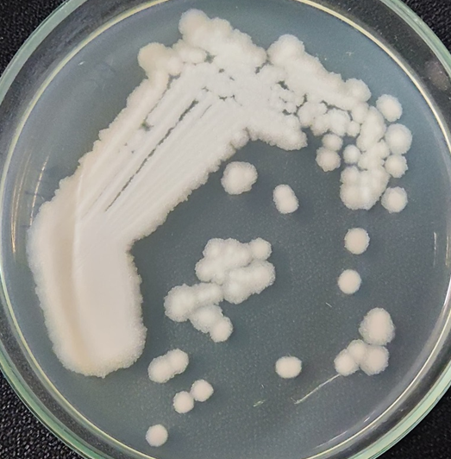
(a) Colony morphology

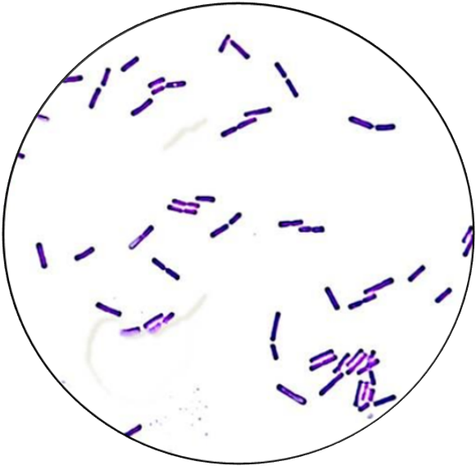
(b) Gram-stained cells

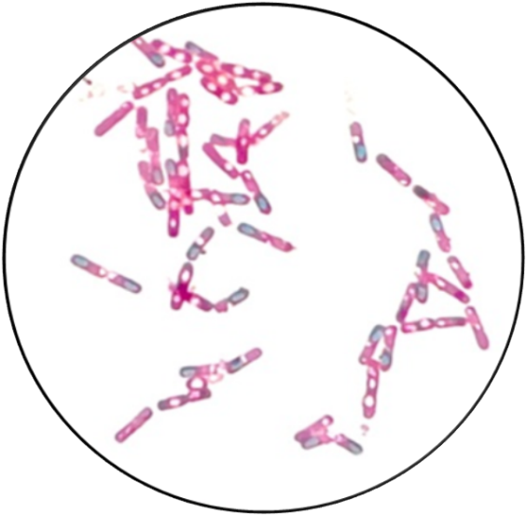
(c) Spore-stained cells showing endospores

