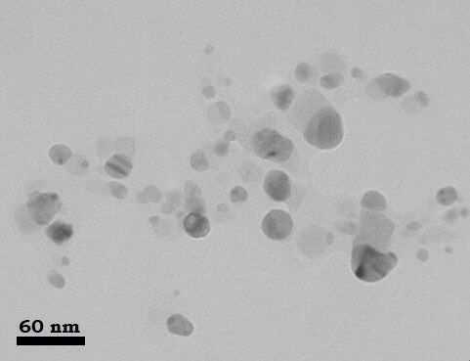
Fig. S1. TEM image of γ-alumina

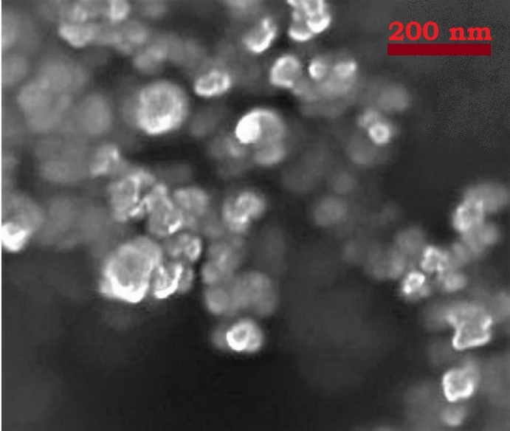
Fig. S2. SEM image of Super Activated Carbon

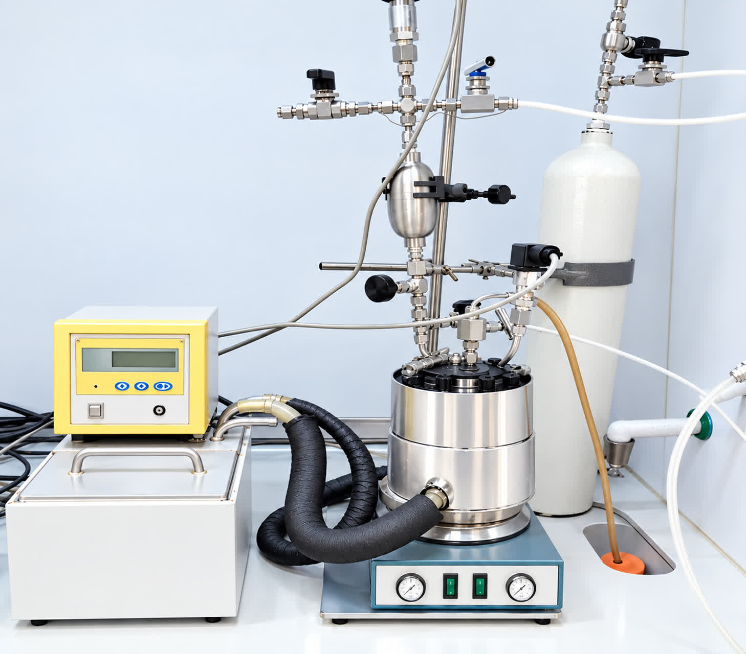

Fig. S3. Photograph of the laboratory apparatus employed in the experimental study of CO₂ absorption.

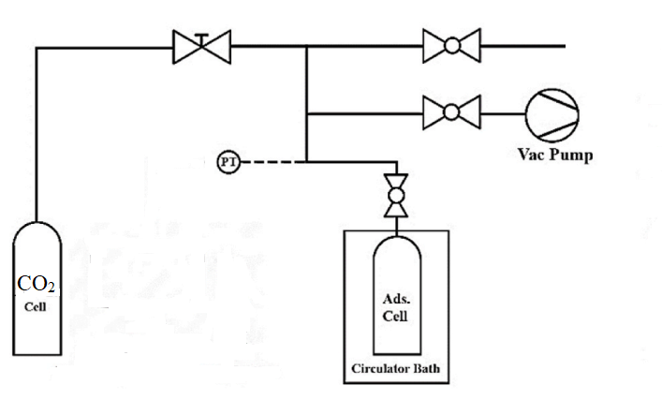

Fig. S4. Schematic diagram of adsorption set-up.

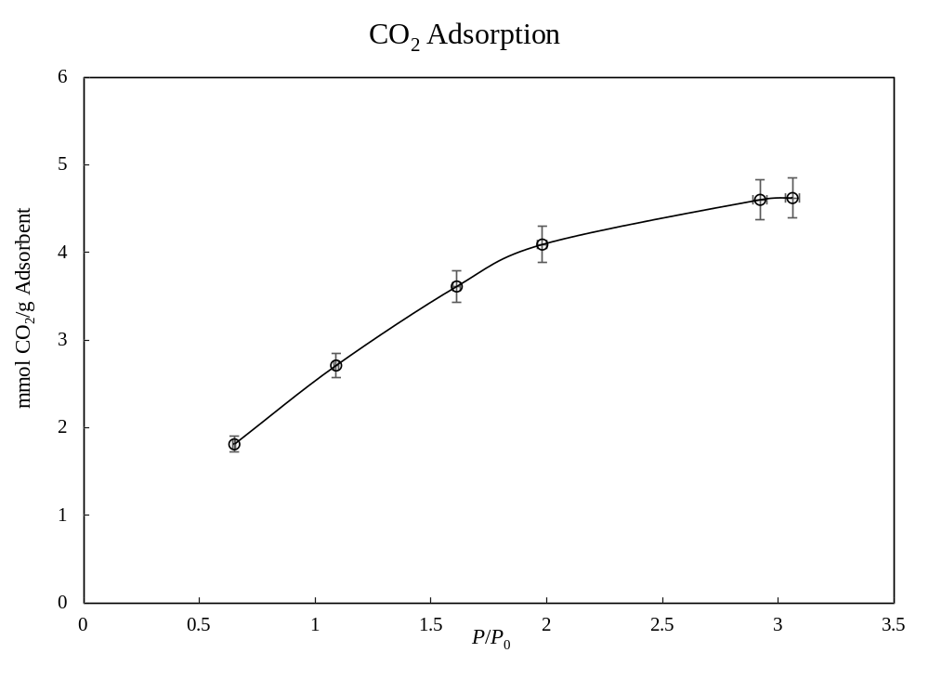

Fig. S5. CO₂ adsorption curve at isotherm 313.15 K.

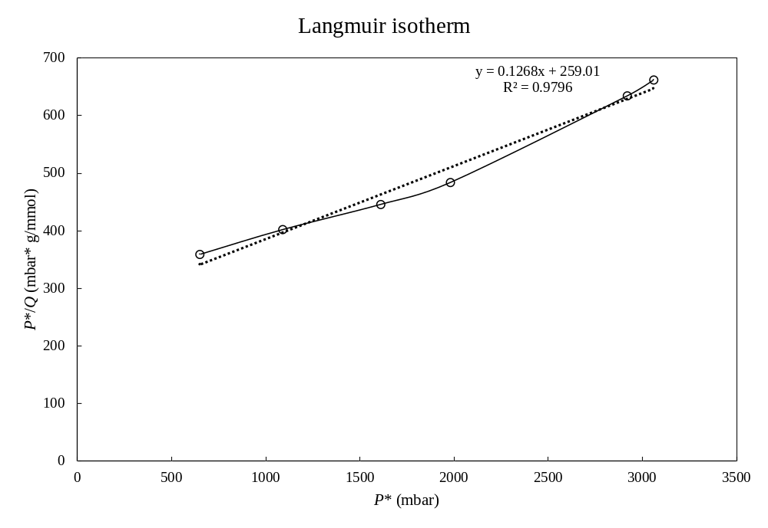

Fig. S6. Langmuir isotherm (T=313.15 K).

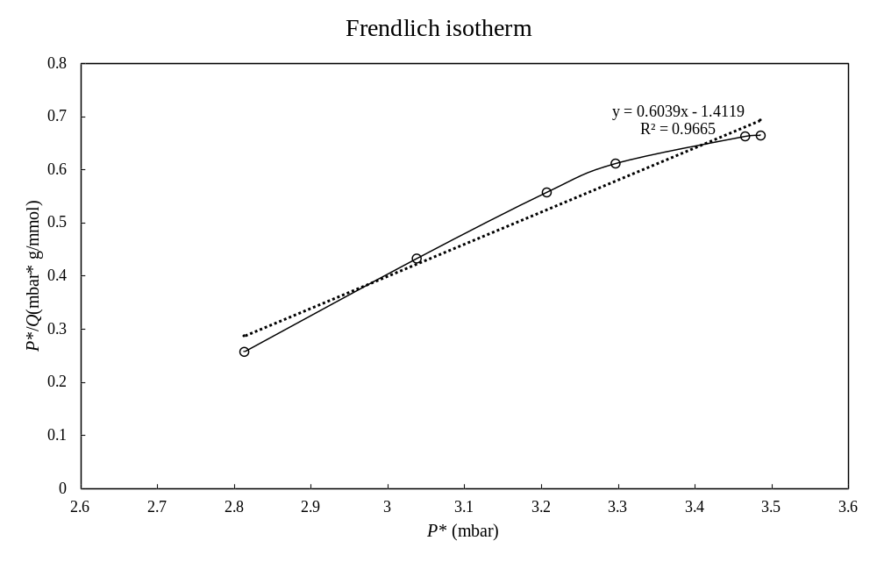

Fig. S7. Freundlich isotherm (T=313.15 K).

