Quantifying Controller Preference Reliability under Uncertainty in a Rotary Inverted Pendulum Benchmark
Yusuf Coşkun, Lale Özyılmaz, Muhammet Aydın
Supplementary Information
This file contains Supplementary Tables S1–S18 and Supplementary Figs. S13–S16. Tables S1–S10 provide the complete statistical-test outputs, model and controller specifications, uncertainty design, score normalization, Gaussian-process settings, residual-dependence calculations and CRI component values. The major revision adds Tables S11–S18 and Figs. S13–S16 to document initialization, tuning-fairness details, CRI dispersion-coefficient sensitivity, score-normalization sensitivity, command-delay sensitivity, dependence/tail-form sensitivity, fixed random seeds and regression/calibration diagnostics.
Supplementary Table S1. Complete paired statistical reporting for the controller-score comparisons.
(a) Omnibus Friedman tests for paired controller scores.
Context | N | Q | df | Asymptotic P | Kendall W
±10% | 2000 | 2906.8960 | 4 | 8.675e-629 | 0.363362
±15% | 2000 | 2891.6276 | 4 | 1.784e-625 | 0.361453
±20% | 2000 | 2881.1900 | 4 | 3.284e-623 | 0.360149
Overall | 2000 | 2895.7720 | 4 | 2.250e-626 | 0.361972
All Friedman tests use N = 2,000 matched scenario blocks and df = 4. The reported P values are asymptotic chi-square tail probabilities; values below double-precision representation were recomputed at high precision.
(b) Two-sided paired Wilcoxon signed-rank comparisons with Holm adjustment (family-wise α = 0.05).
Context | A | B | Median Δ(A−B) | Z | Holm-adjusted P | r_rb
±10% | PID | LQR | -0.296459 | -38.699771 | 1.255e-326 | -0.999099
±10% | PID | SMC | -0.038391 | -14.005401 | 5.778e-44 | -0.361573
±10% | PID | Fuzzy-SMC | -0.022108 | -5.441767 | 5.275e-8 | -0.140489
±10% | PID | ANFIS-SMC | -0.028145 | -7.895118 | 5.801e-15 | -0.203826
±10% | LQR | SMC | 0.247923 | 35.033121 | 4.933e-268 | 0.904439
±10% | LQR | Fuzzy-SMC | 0.264409 | 36.013470 | 4.634e-283 | 0.929748
±10% | LQR | ANFIS-SMC | 0.260692 | 35.664336 | 1.130e-277 | 0.920735
±10% | SMC | Fuzzy-SMC | 0.010642 | 14.290617 | 1.252e-45 | 0.368937
±10% | SMC | ANFIS-SMC | 0.005753 | 8.317734 | 2.690e-16 | 0.214737
±10% | Fuzzy-SMC | ANFIS-SMC | -0.006692 | -27.464316 | 2.812e-165 | -0.709037
±15% | PID | LQR | -0.298012 | -38.697139 | 1.389e-326 | -0.999031
±15% | PID | SMC | -0.038660 | -13.941675 | 1.414e-43 | -0.359928
±15% | PID | Fuzzy-SMC | -0.020054 | -4.952057 | 7.343e-7 | -0.127846
±15% | PID | ANFIS-SMC | -0.025976 | -7.390076 | 2.935e-13 | -0.190788
±15% | LQR | SMC | 0.248745 | 35.022978 | 7.040e-268 | 0.904177
±15% | LQR | Fuzzy-SMC | 0.270107 | 36.026479 | 2.899e-283 | 0.930084
±15% | LQR | ANFIS-SMC | 0.265910 | 35.676028 | 7.445e-278 | 0.921036
±15% | SMC | Fuzzy-SMC | 0.010291 | 14.256160 | 2.052e-45 | 0.368047
±15% | SMC | ANFIS-SMC | 0.005279 | 8.457419 | 8.201e-17 | 0.218343
±15% | Fuzzy-SMC | ANFIS-SMC | -0.006765 | -27.453669 | 3.769e-165 | -0.708763
Supplementary Table S1b (continued).
Context | A | B | Median Δ(A−B) | Z | Holm-adjusted P | r_rb
±20% | PID | LQR | -0.301514 | -38.694274 | 1.552e-326 | -0.998958
±20% | PID | SMC | -0.038066 | -13.855302 | 4.726e-43 | -0.357698
±20% | PID | Fuzzy-SMC | -0.018548 | -4.236559 | 2.270e-5 | -0.109374
±20% | PID | ANFIS-SMC | -0.024360 | -6.674888 | 4.948e-11 | -0.172324
±20% | LQR | SMC | 0.252377 | 34.999710 | 1.591e-267 | 0.903576
±20% | LQR | Fuzzy-SMC | 0.276233 | 36.041229 | 1.703e-283 | 0.930465
±20% | LQR | ANFIS-SMC | 0.270702 | 35.686829 | 5.062e-278 | 0.921315
±20% | SMC | Fuzzy-SMC | 0.010538 | 14.398981 | 2.626e-46 | 0.371734
±20% | SMC | ANFIS-SMC | 0.005810 | 8.738376 | 7.095e-18 | 0.225596
±20% | Fuzzy-SMC | ANFIS-SMC | -0.006742 | -27.363424 | 4.486e-164 | -0.706433
Overall | PID | LQR | -0.298151 | -38.697565 | 1.367e-326 | -0.999042
Overall | PID | SMC | -0.038576 | -13.936371 | 1.523e-43 | -0.359791
Overall | PID | Fuzzy-SMC | -0.019774 | -4.855230 | 1.202e-6 | -0.125346
Overall | PID | ANFIS-SMC | -0.025721 | -7.298398 | 5.824e-13 | -0.188421
Overall | LQR | SMC | 0.249172 | 35.028359 | 5.830e-268 | 0.904316
Overall | LQR | Fuzzy-SMC | 0.270900 | 36.038674 | 1.868e-283 | 0.930399
Overall | LQR | ANFIS-SMC | 0.266274 | 35.690894 | 4.378e-278 | 0.921420
Overall | SMC | Fuzzy-SMC | 0.010454 | 14.438819 | 1.474e-46 | 0.372763
Overall | SMC | ANFIS-SMC | 0.005337 | 8.627689 | 1.878e-17 | 0.222739
Overall | Fuzzy-SMC | ANFIS-SMC | -0.006635 | -27.666294 | 1.066e-167 | -0.714252
Interpretation note. Wilcoxon tests address block-wise paired score differences, whereas paired-bootstrap intervals for CRI differences address sampling uncertainty in the aggregate statistic CRI = median(J) + 0.5 IQR(J). The median of paired differences is not generally equal to the difference of marginal medians, and CRI additionally contains an IQR term. These quantities therefore address different estimands.
Supplementary Methods Tables
Supplementary Table S2. Nominal mechanical and motor parameters used in the nonlinear RIP model.
Symbol | Description | Value | Unit
m | Pendulum mass | 0.127 | kg
L | Rotary-arm length | 0.216 | m
Lp | Pendulum full length | 0.337 | m
l | Pendulum center-of-mass distance (Lₚ/2) | 0.1685 | m
Ja | Arm and motor inertia about vertical axis | 0.0028 | kg·m²
Jp | Pendulum inertia about center of mass | 1.202×10⁻³ | kg·m²
br | Arm viscous friction coefficient | 0.0024 | N·m·s/rad
bp | Pendulum viscous friction coefficient | 0.0024 | N·m·s/rad
g | Gravitational acceleration | 9.81 | m/s²
Ra | Armature resistance | 2.6 | Ω
La | Armature inductance (omitted from reduced electrical dynamics) | 1.8×10⁻⁴ | H
Kt | Motor torque constant | 7.68×10⁻³ | N·m/A
Ke | Back-EMF constant | 7.68×10⁻³ | V·s/rad
Kg | Gear ratio | 70 | –
ηm | Motor efficiency | 0.69 | –
ηg | Gearbox efficiency | 0.90 | –
Vₘₐₓ | Actuator voltage limit | 10 | V
Supplementary Table S3. Mamdani rule base for the normalized Fuzzy-SMC reaching-gain scheduler.
zₛ (rows) / zᵣ (columns) | Small | Medium | Large
Small | Small | Medium | Medium
Medium | Medium | Medium | Large
Large | Medium | Large | Large
Supplementary Table S4. Controller search variables, bounds and objective-evaluation budgets used for each genetic-algorithm seed.
Controller | Search variables and bounds | Independent parameters | Evaluations/seed
PID | Kp [10,200]; Ki [0,5]; Kd [0.5,20]; Kθ [-5,0]; Kθ̇ [-5,0] | 5 | 750
LQR | log₁₀(q₂) [0,4]; log₁₀(q₄) [-3,2]; q₁ = q₃ = 10⁻⁶, R=1 fixed | 2 | 300
SMC | η [0.01,10]; k [0,3]; ϕ [0.05,5] | 3 | 450
Fuzzy-SMC | ηₘₐₓ [0.01,10/0.87]; k [0,3]; ϕ [0.05,5] | 3 | 450
ANFIS-SMC | k [0,3]; ϕ [0.05,5]; ηₘₐₓ inherited from Fuzzy-SMC | 2 | 300
Supplementary Table S5. Selected controller parameters after nominal tuning with five seeds. Lower J_nom indicates better performance only under the nominal tuning objective.
Controller | Selected parameters | Best seed | Jₙₒₘ
PID | Kp=28.939881; Ki=4.298534; Kd=3.069876; Kθ=-0.195427; Kθ̇=-2.000034 | 5 | 0.584359912
LQR | q₁ = q₃ = 1.0×10⁻⁶; q₂ = 550.652990; q₄ = 1.143248×10⁻³; R=1 | 1 | 0.572361512
SMC | η=2.543346; k=0.150227; ϕ=3.807541 | 5 | 0.673176947
Fuzzy-SMC | ηₘₐₓ=6.881653; k=0.083102; ϕ=3.304549 | 4 | 0.655838093
ANFIS-SMC | ηₘₐₓ=6.881653 (inherited); k=0; ϕ=3.104867; 5×5 Gaussian-premise ANFIS with linear Sugeno consequents, 25 rules | 1 | 0.655372561
Supplementary Table S6. Nine-dimensional LHS scenario definition. The first four dimensions are mapped through the selected relative plant-uncertainty band; the final five dimensions define the composite disturbance.
LHS dimension | Quantity | Symbol / scale | Mapping or range
1 | Pendulum mass scale | m/m₀ | [1-b, 1+b]; b = 0.10, 0.15, 0.20
2 | Pendulum full-length scale | Lₚ/Lₚ,₀ | [1-b, 1+b]; b = 0.10, 0.15, 0.20
3 | Motor torque-constant scale | Kₜ/Kₜ,₀ | [1-b, 1+b]; b = 0.10, 0.15, 0.20
4 | Arm viscous-friction scale | bᵣ/bᵣ,₀ | [1-b, 1+b]; b = 0.10, 0.15, 0.20
5 | Sinusoidal torque amplitude | Asin | 0 to 0.15 N·m
6 | Sinusoidal frequency | ω | 2 to 5 rad/s
7 | Bias torque | τbias | -0.05 to 0.05 N·m
8 | Impulse torque amplitude | Aimp | -0.40 to 0.40 N·m
9 | Impulse onset time | timp | 1 to 3 s
Supplementary Table S7. Performance quantities, pooled-median normalization constants and base weights used in the continuous scenario score.
Metric | Engineering meaning | Normalization scale | Base weight
Pendulum RMS angle, α RMS | Regulation accuracy | 0.01921046 rad | 0.45
Rotary arm RMS angle, θ RMS | Sustained arm motion | 0.3035499 rad | 0.20
Applied voltage RMS, U RMS | Actuator effort | 0.7770046 V | 0.20
Chattering index, CI | Control signal roughness | 0.104855 | 0.15
Supplementary Table S8. Gaussian-process score-regression and outer out-of-fold assessment settings.
Quantity | Setting
Responses | Five continuous controller scores from equation (30), using the prespecified ±15% band
Predictors | Nine scenario descriptors defined in Supplementary Table S6
Marginal models | Five separately fitted Gaussian process regression models
Kernel | ARD squared exponential
Basis function | Constant
Response-noise SD | Estimated within each training fold; lower bound max[10⁻⁸, 10⁻⁶ SD(Jtrain)]
Input standardization | Estimated within each training fold only
Fitting and prediction | Exact
Outer OOF assessment | Five folds balanced by realization
Training / test size per fold | 1600 / 400 scenarios
Test realization composition | 200 scenarios from realization A + 200 from realization B per fold
Predictive intervals | Central 50%, 80%, 90%, and 95% intervals
Additional uncertainty adjustment | None; native GPR predictive standard deviations used
Supplementary Table S9. Residual-dependence estimation and probabilistic decision-integration settings.
Quantity | Setting
Dependence estimation | Five inner OOF folds within each outer training set; realization balance used when both realizations are present
Correlation input | Standardized inner OOF score residuals
Positive-definiteness safeguard | Symmetrization, eigenvalue floor 10⁻⁸, and renormalization to unit diagonal
Predictive integration | 20,000 antithetic Gaussian draws per scenario
Primary practical margin | 5% relative gap between the two lowest scores
Margin sensitivity | 2.5%, 7.5%, and 10%
Integration sensitivity | 5,000, 10,000, and 20,000 draws plus an independent integration seed
Non-unique-preference probability calibration | 10 equal-width probability bins over [0,1]
Independence sensitivity | Identity correlation matrix with the same marginal predictive means and standard deviations
Supplementary Table S10. Marginal scenario-score components underlying the Controller Robustness Index (CRI). For each controller and context, CRI = median(J) + 0.5×IQR(J); the reported components allow direct reconstruction of every aggregate CRI value.
Context | Controller | median(J) | IQR(J) | 0.5×IQR(J) | CRI | Rank
±10% | PID | 0.997691 | 0.393405 | 0.196703 | 1.194394 | 1
±10% | LQR | 1.331005 | 0.631959 | 0.315979 | 1.646985 | 5
±10% | SMC | 1.011454 | 0.434996 | 0.217498 | 1.228951 | 2
±10% | Fuzzy-SMC | 1.026342 | 0.423750 | 0.211875 | 1.238217 | 3
±10% | ANFIS-SMC | 1.032463 | 0.416281 | 0.208140 | 1.240603 | 4
±15% | PID | 0.995994 | 0.399193 | 0.199597 | 1.195591 | 1
±15% | LQR | 1.336014 | 0.647536 | 0.323768 | 1.659782 | 5
±15% | SMC | 1.006421 | 0.435585 | 0.217793 | 1.224214 | 2
±15% | Fuzzy-SMC | 1.021709 | 0.420706 | 0.210353 | 1.232062 | 3
±15% | ANFIS-SMC | 1.029743 | 0.414590 | 0.207295 | 1.237038 | 4
±20% | PID | 0.998138 | 0.409681 | 0.204841 | 1.202979 | 1
±20% | LQR | 1.336778 | 0.663674 | 0.331837 | 1.668615 | 5
±20% | SMC | 1.006447 | 0.437701 | 0.218851 | 1.225298 | 2
±20% | Fuzzy-SMC | 1.020554 | 0.416799 | 0.208399 | 1.228954 | 3
±20% | ANFIS-SMC | 1.027491 | 0.412214 | 0.206107 | 1.233598 | 4
Overall | PID | 0.996474 | 0.399836 | 0.199918 | 1.196392 | 1
Overall | LQR | 1.336202 | 0.648966 | 0.324483 | 1.660685 | 5
Overall | SMC | 1.006999 | 0.436301 | 0.218151 | 1.225149 | 2
Overall | Fuzzy-SMC | 1.022373 | 0.420855 | 0.210427 | 1.232800 | 3
Overall | ANFIS-SMC | 1.030051 | 0.415306 | 0.207653 | 1.237704 | 4
Note. “Overall” denotes the matched summary across the ±10%, ±15%, and ±20% uncertainty bands. The marginal CRI components are not interchangeable with the median of paired controller-to-controller score differences reported in Supplementary Table S1b.
Supplementary Table S11. Initial conditions and controller/estimator state initialization used in nominal and uncertainty simulations.
Quantity | Value / initialization | Purpose / note
Plant state x(0) | [0, 0.0994838, 0, 0]ᵀ = [0 rad, 5.7°, 0 rad/s, 0 rad/s]ᵀ | Common initial plant state for nominal and Monte Carlo simulations.
Estimator velocity states | θ̇_est(0)=0; α̇_est(0)=0 | No true angular velocity is supplied to any controller.
Estimator previous-angle states | Initialized to the current measured θ and α at the first sample | Prevents an artificial derivative impulse at initialization.
PID integral state | Iα(0)=0 | Conditional-integration anti-windup state is reset for every run.
Controller memory | Reset before each objective evaluation and each scenario/controller run | Prevents information leakage between evaluations or Monte Carlo blocks.
Simulation time | t0=0 s | Common start time for all controllers.
Supplementary Table S12. Tuning-fairness summary: search dimensionality, objective-evaluation allocation and interpretation.
Controller | Independent optimized variables | Evaluations / seed | Seeds | Total evaluations | Fairness note
PID | 5 | 750 | 5 | 3,750 | Largest search dimension; same 150 evaluations per independently tuned variable per seed.
LQR | 2 | 300 | 5 | 1,500 | Two logarithmic search variables; remaining weights fixed by protocol.
SMC | 3 | 450 | 5 | 2,250 | Three bounded controller parameters.
Fuzzy-SMC | 3 | 450 | 5 | 2,250 | Three bounded post-structure parameters; fuzzy rule base fixed.
ANFIS-SMC | 2 | 300 | 5 | 1,500 | ANFIS architecture selected separately; ηmax inherited from Fuzzy-SMC; k and ϕ tuned post-selection.
Interpretation note. The tuning protocol equalized objective-evaluation allocation per independently optimized parameter and used five seeds for every controller, but the architectures did not have identical search dimensionality, total optimization budgets, internal structure, or tuning flexibility. The study therefore compares the resulting fixed controller instances rather than claiming an intrinsic architecture-level ranking.
Major-revision analysis status. REV01 (CRI dispersion-coefficient sensitivity), REV02 (normalization-source/statistic sensitivity), REV03 (command-delay sensitivity), and REV04 (dependence/tail-form sensitivity) are complete; all associated integrity gates passed and the results are reported below.
Supplementary Table S13. Sensitivity of the overall Controller Robustness Index to the dispersion coefficient lambda.
The descriptive index was recomputed as CRI_lambda = median(J) + lambda IQR(J) for lambda = 0, 0.25, 0.50, 0.75 and 1.00. No controller was retuned and no scenario score was regenerated. The analysis used the archived 30,000 Monte Carlo records and the locked pooled-median normalization. All integrity gates passed: the pooled-median normalization was reproduced with a maximum absolute difference of 5.00 x 10^-16, and the lambda = 0.50 CRI values were reproduced with a maximum absolute difference of 4.89 x 10^-15.
lambda | PID | SMC | Fuzzy-SMC | ANFIS-SMC | LQR
0.00 | 0.996474 (rank 1) | 1.006999 (rank 2) | 1.022373 (rank 3) | 1.030051 (rank 4) | 1.336202 (rank 5)
0.25 | 1.096433 (rank 1) | 1.116074 (rank 2) | 1.127586 (rank 3) | 1.133877 (rank 4) | 1.498444 (rank 5)
0.50 | 1.196392 (rank 1) | 1.225149 (rank 2) | 1.232800 (rank 3) | 1.237704 (rank 4) | 1.660685 (rank 5)
0.75 | 1.296351 (rank 1) | 1.334225 (rank 2) | 1.338014 (rank 3) | 1.341530 (rank 4) | 1.822927 (rank 5)
1.00 | 1.396310 (rank 1) | 1.443300 (rank 3) | 1.443227 (rank 2) | 1.445357 (rank 4) | 1.985168 (rank 5)
Across lambda = 0–1, PID remained rank one and LQR rank five in the overall summary. The maximum gap from PID among the four leading controllers was 3.37–3.51%, so PID, SMC, Fuzzy-SMC and ANFIS-SMC all remained within the 5% practical margin. The LQR gap increased from 34.09% at lambda = 0 to 42.17% at lambda = 1. The overall SMC–Fuzzy-SMC crossover occurred at lambda = 0.9953. Band-specific crossovers occurred for Fuzzy-SMC versus ANFIS-SMC in the ±10% band (lambda = 0.8194), and for SMC versus Fuzzy-SMC (lambda = 0.6749) and SMC versus ANFIS-SMC (lambda = 0.8257) in the ±20% band. The full ±15% ordering was unchanged over the tested coefficient grid. These crossovers concern the ordering of near-tied aggregate summaries and do not change the practical conclusion that the four leading controllers remain inside the 5% relevance margin.
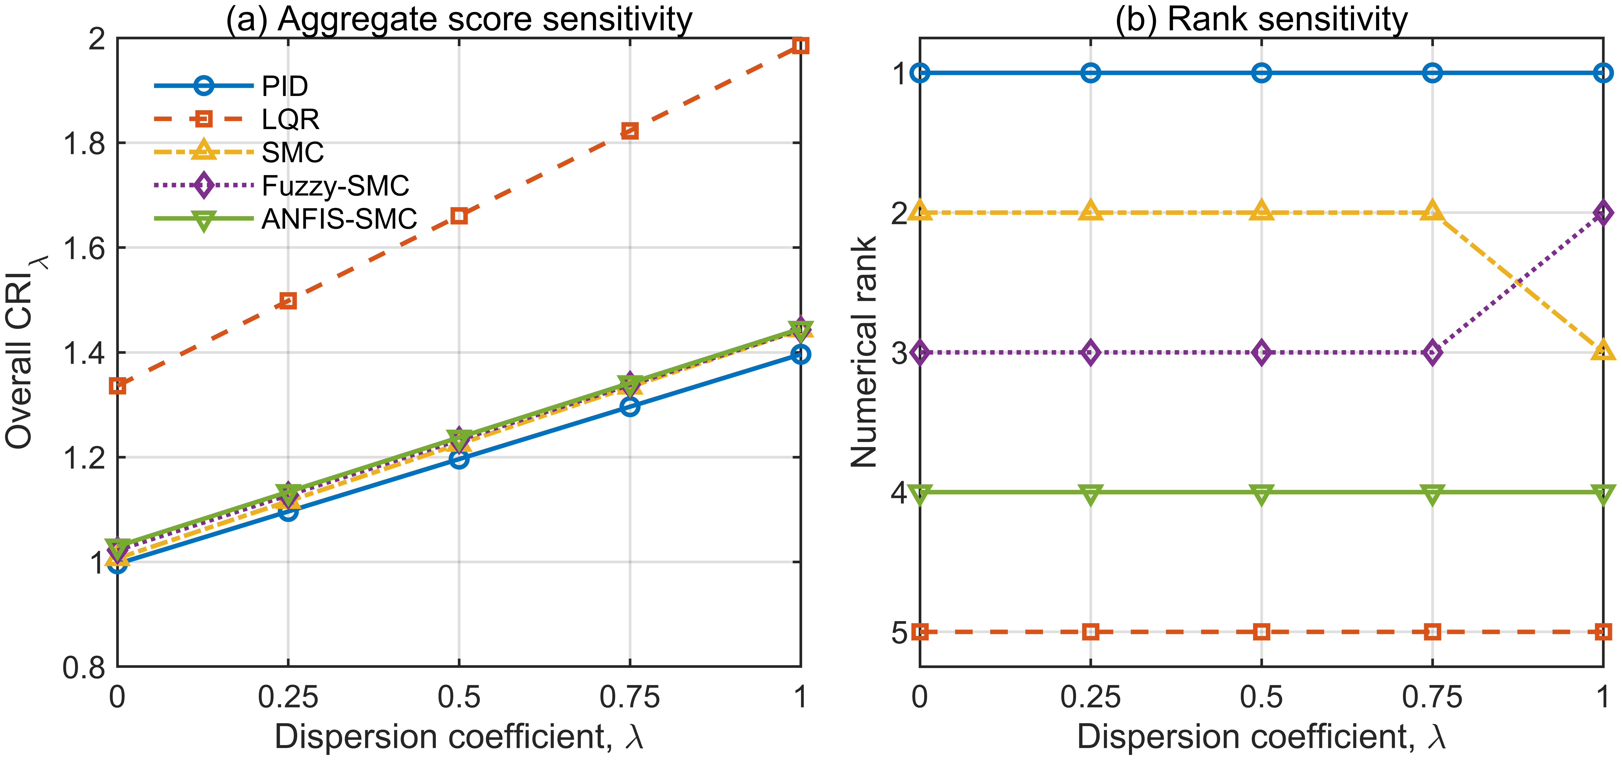
Supplementary Figure S13. CRI dispersion-coefficient sensitivity. (a) Overall CRI_lambda = median(J) + lambda IQR(J) for the five fixed controllers. (b) Corresponding numerical ranks. PID remains first and LQR fifth across the tested coefficient grid; the SMC and Fuzzy-SMC ranks exchange only at the upper end of the tested range.
Supplementary Table S14. Sensitivity of score normalization and resulting controller-separation summaries.
The four-metric score was recomputed from the archived Monte Carlo records using the locked pooled-median scales, realization-A medians, realization-B medians, and pooled means. Controller parameters, raw response metrics, metric weights, CRI coefficient (0.5), and the 5% practical margin were unchanged. No controller was retuned or resimulated. All integrity gates passed: 30,000 archived records and 2,000 paired scenarios were recovered; the locked pooled-median constants were reproduced to within 5.00 × 10⁻16, the locked CRI values to within 4.89 × 10⁻15, and the original ±15% non-unique-preference prevalence of 69.40% exactly.
Scheme | α RMS scale (rad) | θ RMS scale (rad) | U RMS scale (V) | CI scale
Pooled median | 0.01921046 | 0.3035499 | 0.7770046 | 0.1048550
Primary median | 0.01932930 | 0.3032586 | 0.7781787 | 0.1046900
Replication median | 0.01907615 | 0.3038087 | 0.7757040 | 0.1050032
Pooled mean | 0.02028225 | 0.4316228 | 0.8034544 | 0.1026227
Supplementary Table S14b. Overall CRI ordering and ±15% practical-separation prevalence under each normalization scheme.
Scheme | Overall rank order | Max gap among PID/SMC/Fuzzy/ANFIS (%) | LQR gap (%) | ±15% non-unique (%)
Pooled median | PID > SMC > Fuzzy-SMC > ANFIS-SMC > LQR | 3.453 | 38.808 | 69.40
Primary median | PID > SMC > Fuzzy-SMC > ANFIS-SMC > LQR | 3.424 | 38.820 | 69.50
Replication median | PID > SMC > Fuzzy-SMC > ANFIS-SMC > LQR | 3.422 | 38.856 | 69.35
Pooled mean | PID > SMC > Fuzzy-SMC > ANFIS-SMC > LQR | 6.709 | 30.431 | 67.50
Interpretation. The primary- and replication-median scales differed from the pooled-median scales by at most 0.70%, preserved the full overall rank order, kept the four leading aggregate CRIs within 3.43% of the minimum, and changed the ±15% non-unique-preference prevalence by at most 0.10 percentage point. Pooled-mean scaling was a stronger stress test: the rotary-arm RMS scale increased by 42.19%, the full numerical rank order still remained unchanged, and 67.50% of blocks remained non-unique, but the three SMC-family aggregate gaps from PID increased beyond 5% (SMC 5.73%, Fuzzy-SMC 6.34%, ANFIS-SMC 6.71%). Thus, the scenario-level conclusion that non-unique practical preference is common is not tied to the pooled-median constants, whereas aggregate four-controller membership in the 5% band is sensitive to the normalization statistic.
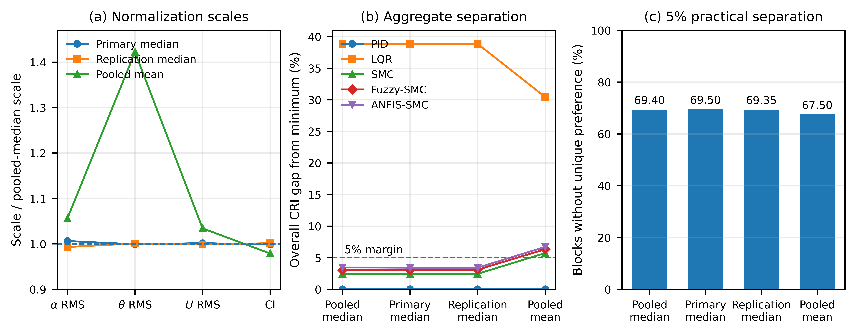
Supplementary Figure S14. Score-normalization sensitivity. (a) Normalization scales relative to the locked pooled-median scales. (b) Overall CRI percentage gaps from the minimum under each scaling scheme; the dashed line marks the 5% practical margin. (c) Fraction of ±15% scenario blocks without a unique practical preference at the 5% margin. Realization-specific median scaling closely reproduces the pooled-median results, whereas pooled-mean scaling provides a stronger stress test because the rotary-arm RMS scale is substantially larger.
Supplementary Table S15. Prescribed command-delay sensitivity in the pooled ±15% scenario domain.
Delay (ms) | All-five success | Overall CRI order | Max gap among PID/SMC/Fuzzy/ANFIS (%) | LQR gap (%) | No unique preference (%)
0 | 2000/2000 (100%) | PID > SMC > Fuzzy-SMC > ANFIS-SMC > LQR | 3.467 | 38.825 | 69.40
2 | 2000/2000 (100%) | PID > SMC > Fuzzy-SMC > ANFIS-SMC > LQR | 2.991 | 38.872 | 70.50
4 | 2000/2000 (100%) | PID > Fuzzy-SMC > SMC > ANFIS-SMC > LQR | 2.368 | 38.786 | 71.60
6 | 2000/2000 (100%) | PID > Fuzzy-SMC > SMC > ANFIS-SMC > LQR | 2.087 | 39.107 | 73.05
8 | 2000/2000 (100%) | PID > Fuzzy-SMC > ANFIS-SMC > SMC > LQR | 2.150 | 39.378 | 74.45
10 | 2000/2000 (100%) | PID > SMC > Fuzzy-SMC > ANFIS-SMC > LQR | 8.712 | 39.268 | 72.00
Supplementary Table S15b. Controller-specific CRI values across the command-delay envelope.
Delay (ms) | PID | SMC | Fuzzy-SMC | ANFIS-SMC | LQR
0 | 1.195591 | 1.224214 | 1.232062 | 1.237038 | 1.659782
2 | 1.196889 | 1.223729 | 1.227635 | 1.232684 | 1.662148
4 | 1.200435 | 1.224963 | 1.223392 | 1.228863 | 1.666039
6 | 1.201327 | 1.225415 | 1.220328 | 1.226393 | 1.671128
8 | 1.203177 | 1.229043 | 1.218958 | 1.222584 | 1.676960
10 | 1.208118 | 1.231653 | 1.296794 | 1.313368 | 1.682517
Protocol and integrity. The archived 0 ms ±15% baseline reproduced the locked CRI values with a maximum absolute error of 4.22 × 10⁻15 and reproduced the 69.40% non-unique-preference prevalence exactly. The delay-capable simulator reproduced six zero-delay sentinel scenarios across all five controllers with a maximum metric difference of 8.44 × 10⁻15. The five nonzero delays generated 50,000 new closed-loop simulations; all completed without MATLAB runtime exceptions. Delay was applied after the fixed controller command and before physical voltage saturation, with zero command prehistory and no retuning or delay compensation.
Interpretation. All five controllers remained successful in every tested scenario through 10 ms, so the full 2,000-block paired set was available at every delay. PID remained the minimum-CRI controller and LQR remained fifth, but the SMC-family ordering changed at 4–8 ms. The no-unique-preference fraction increased from 69.40% at 0 ms to 74.45% at 8 ms before decreasing to 72.00% at 10 ms. At 10 ms, the SMC gap from PID remained 1.95%, whereas the Fuzzy-SMC and ANFIS-SMC gaps increased to 7.34% and 8.71%. The tested range is a prescribed command-delay sensitivity envelope and must not be interpreted as an experimentally identified hardware-delay limit.
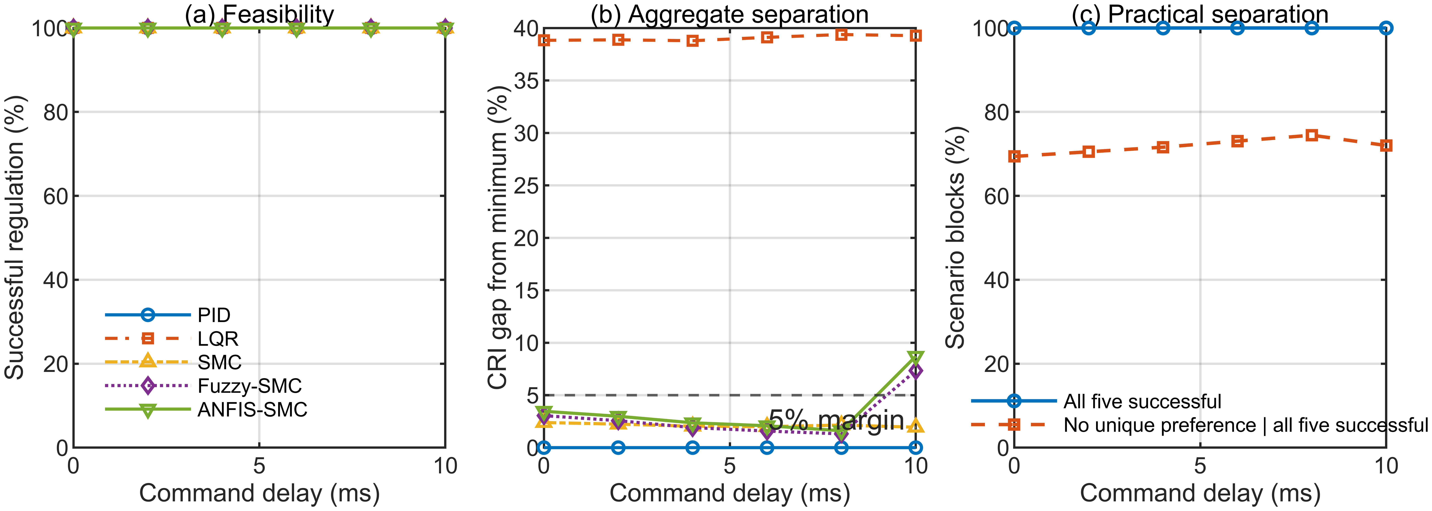
Supplementary Figure S15. Command-delay sensitivity in the pooled ±15% scenario domain. (a) Successful-regulation rate for each fixed controller. (b) Aggregate CRI percentage gaps from the minimum; the dashed line marks the 5% practical margin. (c) Fraction of scenario blocks in which all five controllers were successful and fraction without a unique 5% practical preference. The delay is a prescribed sampled-data command delay, not a measured hardware latency.
Supplementary Table S16. Dependence/tail-form sensitivity of the joint probabilistic decision analysis.
Dependence model | Mean P(no unique) | Mean |ΔP(no unique)| vs Gaussian | Max |ΔP(no unique)| vs Gaussian | Six-event MAP disagreement | Selective-decision disagreement | Mean L1 six-event change
Gaussian (locked) | 0.700419 | 0 | 0 | 0% | 0% | 0
t-copula ν=8 | 0.700486 | 0.003052 | 0.02220 | 0.05% | 0.05% | 0.006112
t-copula ν=4 | 0.700549 | 0.005999 | 0.04475 | 0.10% | 0.10% | 0.012038
Independent Gaussian | 0.687589 | 0.112250 | 0.42815 | 3.30% | 3.30% | 0.225095
Protocol and integrity. The sensitivity reused the 2,000 pooled ±15% OOF scenarios, the locked 5% practical margin, 20,000 draws per scenario, the original marginal GPR means/standard deviations, and the training-only fold-specific residual correlation matrices. No GPR was refitted and no plant/controller simulation was rerun. Student-t copulas with ν = 8 and ν = 4 were imposed as heavier-tail stress tests, with Gaussian marginals restored by probability-integral transformation. They were not fitted residual laws and do not test arbitrary nonlinear or scenario-dependent dependence. All integrity gates passed: five outer folds were recovered; all predictive marginals were finite; each fold-specific correlation matrix was positive definite (minimum eigenvalue 2.452 × 10⁻2); the archived independence-sensitivity fingerprint was reproduced with maximum absolute error 1.11 × 10⁻16; and locked Gaussian probabilities were reproduced exactly on the sentinel scenarios.
Interpretation. The locked Gaussian mean P(no unique) was 0.700419. The ν = 8 and ν = 4 t-copula sensitivities gave 0.700486 and 0.700549, with mean absolute probability changes of 0.003052 and 0.005999 and maxima of 0.02220 and 0.04475. Six-event MAP and selective-decision disagreement were only 0.05% and 0.10%. Selection coverage was 29.15% for the locked Gaussian model, 29.20% for ν = 8 and 29.25% for ν = 4; the selected controller was the exact simulated minimum in every selected block for all three dependence-aware representations. In contrast, the independent-Gaussian calculation produced a mean absolute P(no unique) change of 0.112250, a maximum change of 0.42815, 3.30% decision disagreement, and 25.85% selection coverage. The tested result is therefore far more sensitive to eliminating cross-controller dependence than to the two imposed heavier-tail forms, while broader nonlinear or scenario-dependent dependence remains untested.
Supplementary Figure S16. Dependence/tail-form sensitivity of the joint probability calculation. (a) Mean predicted probability of no unique practical preference under the locked Gaussian model, two heavier-tail Student-t copulas, and independence; the dashed line marks the true 69.40% simulated prevalence. (b) Mean absolute change in P(no unique) and in the six-event probability vector relative to the locked Gaussian calculation. (c) Six-event MAP and selective-decision disagreement relative to the locked Gaussian calculation. The Student-t copulas preserve the marginal Gaussian GPR predictions and use the locked fold-specific correlation matrices; they are imposed sensitivity models rather than fitted residual laws.
Supplementary Table S17. Principal random seeds and reproducibility streams used in the computational workflow.
Analysis component | Seed / stream definition | Use
Controller tuning | Five independent pseudorandom seeds: 1–5 | Common multi-seed nominal tuning and final parameter selection.
Primary LHS | 42001 | Nine-dimensional primary Latin-hypercube realization.
Primary measurement noise | 240000 + ScenarioID (240001–241000) | Two-channel Gaussian angle-noise realization shared across controllers and bands within each primary scenario.
Replication LHS | 52001 | Independent nine-dimensional replication Latin-hypercube realization.
Replication measurement noise | 340000 + ScenarioID (340001–341000) | Two-channel Gaussian angle-noise realization shared across controllers and bands within each replication scenario.
MC sample-convergence subset / bootstrap | 73101 / 73102 | Subset selection and bootstrap diagnostic in the Monte Carlo convergence audit.
Primary–replication comparison bootstrap | 83103 | Paired comparison/bootstrap diagnostic used when pooling the independent realizations.
CRI engineering-weight sensitivity | 94101 | Generation of the 5,000 priority-preserving and 5,000 unrestricted weight vectors.
CRI paired bootstrap | 95103 | 2,000 paired scenario-block bootstrap replicates.
GPR model fitting | 105101 + 100×outer-fold + controller index | Deterministic initialization of controller-specific GPR fits within the locked outer folds.
Joint dependence inner folds | 106101 + outer-fold | Source-balanced inner folds used to estimate training-only residual dependence.
Joint Gaussian integration | 106201 + ScenarioID | 20,000 antithetic Gaussian draws per held-out scenario.
Independent integration replication / convergence | 108101 + ScenarioID; 108201 + ScenarioID; 108301 + index | Independent-seed and draw-count sensitivity checks for the probabilistic integration.
Supplementary Table S18. Out-of-fold Gaussian-process regression and predictive-interval diagnostics in the pooled ±15% domain (N = 2,000 scenarios).
Controller | RMSE | MAE | R² | Std. residual mean | Std. residual SD | 50% coverage | 90% coverage | 95% coverage
PID | 0.018745 | 0.014955 | 0.995299 | -0.0036 | 1.0037 | 49.95% | 89.80% | 95.20%
LQR | 0.019209 | 0.014972 | 0.998400 | -0.0091 | 1.0102 | 52.20% | 89.55% | 94.10%
SMC | 0.024006 | 0.019040 | 0.992576 | -0.0036 | 1.0058 | 50.50% | 90.45% | 94.80%
Fuzzy-SMC | 0.020932 | 0.016469 | 0.993791 | -0.0011 | 1.0041 | 51.50% | 89.90% | 94.65%
ANFIS-SMC | 0.021006 | 0.016393 | 0.993581 | -0.0018 | 1.0047 | 52.15% | 89.80% | 94.30%
Note. Pooled empirical coverage across all five controllers was 51.26%, 80.76%, 89.90% and 94.61% at nominal 50%, 80%, 90% and 95% levels, respectively. The table reports controller-level 50%, 90% and 95% coverage together with point-prediction and standardized-residual diagnostics; the full 50/80/90/95% coverage tables and proper-score outputs remain in the archived computational package.

