GC-ToF-MS analysis of organic extract from Bauhinia galpinnii

Tentative name of Compound | R.T. (min) | Area %
3-Penten-2-one, (E)- | 2.86079 | 0.285
Pyrrole | 2.86945 | 27.131
Hydrazine, 1-methyl-1-(2-propynyl)- | 2.92249 | 3.252
Ether, dicyclopentyl | 2.96712 | 1.719
1, 3, 5-Cycloheptatriene | 3.04348 | 1.262
Succinic acid | 3.17985 | 0.284
Propanoic acid, 2-hydroxy-2-methyl-, ethyl ester | 3.22816 | 0.442
3-Tosyl sedoheptulose | 3.28679 | 5.826
Toluene | 3.36526 | 0.778
Fomepizole | 3.92823 | 0.536
Benzene, propoxy- | 4.12144 | 0.717
1H-Pyrrole, 3-methyl- | 4.47818 | 0.191
Ethylbenzene | 4.62305 | 0.133
Hexanal, 2-ethyl- | 4.69385 | 0.414
4-Cyclopentene-1, 3-dione | 5.13738 | 0.458
Styrene | 5.19073 | 0.214
Oxime-, methoxy-phenyl-_ | 5.35743 | 0.126
2(5H)-Furanone | 5.58928 | 0.151
Butyrolactone | 5.60003 | 0.106
4-Penten-2-one | 5.87477 | 0.128
2(5H)-Furanone, 5-methyl- | 5.99882 | 0.191
3-Hydroxy-4-methoxybenzaldehyde, TBDMS | 6.11537 | 0.225
Phenol | 6.57954 | 1.414
2-Heptanone, 4, 6-dimethyl- | 6.69871 | 0.116
Octanal | 6.87497 | 0.110
Ethanol, 2-[2-(ethenyloxy)ethoxy]- | 6.96944 | 0.137
4-Chlorobutanoic anhydride | 7.08805 | 0.169
2-Pyrrolidinone | 7.61702 | 0.255
Phenol, 3-methyl- | 7.68484 | 0.380
1, 2, 4-Triazine-3, 5(2H, 4H)-dione | 8.4213 | 0.104
Phenol, 4-ethyl- | 8.56345 | 0.135
Ethanone, 1-(4-methylphenyl)- | 8.786 | 0.114
2-Anilinopropanoic acid, TMS | 9.09065 | 0.106
1H-Pyrrole-2, 5-dione, 3-ethyl-4-methyl- | 9.11789 | 0.140
3, 4-Dihydroxymandelic acid, 4TMS derivative | 9.59208 | 1.370
Indole | 9.66651 | 0.214
Tetradecane | 10.3573 | 0.193
1H-Indole, 5-methyl- | 10.3693 | 0.223
Diphenyl ether | 10.4828 | 0.272
Hexadecane | 11.1229 | 0.255
3, 5-Heptanedione, 2, 2, 6, 6-tetramethyl- | 11.7121 | 0.108
Trimethylsilyl 23-acetoxy-3, 6, 9, 12, 15, 18, 21-heptaoxatricosan-1-oate | 12.1358 | 0.497
Myo-Inositol, 4-C-methyl- | 12.5179 | 0.127
3-Buten-2-one, 4-(4-hydroxy-2, 2, 6-trimethyl-7-oxabicyclo [4.1.0] hept-1-yl)- | 12.9119 | 0.370
Loliolide | 13.5757 | 0.189
Tetradecanoic acid | 13.588 | 0.169
6-Hydroxy-4, 4, 7a-trimethyl-5, 6, 7, 7a-tetrahydrobenzofuran-2(4H)-one | 13.9174 | 1.334
2-Cyclohexen-1-one, 4-hydroxy-3, 5, 6-trimethyl-4-(3-oxo-1-butenyl)- | 14.0386 | 0.123
3-Hexadecanol | 14.1853 | 0.927
2-Pentadecanone, 6, 10, 14-trimethyl- | 14.6419 | 2.091
1-Hexadecyn-3-ol, 3, 7, 11,15-tetramethyl- | 15.2272 | 0.169
Pentadecane | 15.4121 | 0.145
Hexadecanal, 2-methyl- | 15.5955 | 0.119
3-Methyl-2-(3, 7, 11-trimethyldodecyl) furan | 15.6637 | 0.108
2-Piperidinone, N-[4-bromo-n-butyl]- | 15.6799 | 0.167
3-Undecanol, 3-ethyl- | 16.1074 | 0.381
n-Hexadecanoic acid | 16.1796 | 0.593
Eicosane, 1-iodo- | 16.3777 | 0.303
s-Triazole, 3-acetamido- | 16.7467 | 0.100
Eicosane | 16.8132 | 0.492
2-Piperidinone, N-[4-bromo-n-butyl]- | 17.1078 | 0.129
Cyclohexanol, 1-propyl- | 17.907 | 0.337
Sulfurous acid, butyl isohexyl ester | 17.997 | 0.106
Tetrahydropyranyl ether of citronellol | 18.2798 | 0.227
Dodecane, 2, 6, 10-trimethyl- | 18.2893 | 0.149
1-Hexadecyn-3-ol, 3, 7, 11,15-tetramethyl- | 18.3557 | 0.450
Heptacosane | 18.6141 | 0.239
1-Hexadecyn-3-ol, 3, 7, 11,15-tetramethyl- | 18.886 | 0.989
Undecane, 3, 7-dimethyl- | 19.2544 | 0.126
Octadecane, 1-isocyanato- | 19.6414 | 0.106
Docosane | 19.81 | 0.277
Silane, dimethyl(hex-4-yn-3-yloxy) octadecyl- | 19.96 | 0.395
Tetracosane, 1-iodo- | 21.4053 | 0.131
Thiophene, 3-methyl-2-pentadecyl- | 21.442 | 0.231
Carbonic acid, octyl vinyl ester | 21.4623 | 0.113
4, 8, 12, 16-Tetramethylheptadecan-4-olide | 21.5547 | 0.783
Pentanoic acid, TBDMS derivative | 21.6191 | 0.214
Hexanedioic acid, bis(2-ethylhexyl) ester, | 21.8976 | 0.435
Tetracosane | 22.0051 | 0.111
Cyclohexane, 1, 3, 5-triphenyl- | 22.3626 | 0.114
2, 3-Dihydroxypropyl icosanoate, 2TMS derivative | 22.6484 | 1.405
Tetracosane | 22.7156 | 0.164
Octadecane, 2-methyl- | 22.9485 | 0.169
2, 3-Dihydroxypropyl icosanoate, 2TMS derivative | 23.7342 | 0.380
1-Heptacosanol | 23.7833 | 0.316
a-Tocospiro B | 24.7513 | 0.135
α-Amyrone | 29.6964 | 0.170
α-Amyrin | 30.1336 | 0.162
2-[(Trimethylsilyl)oxy] tetra decanoic acid, bis(trimethylsilyl) ester | 32.026 | 0.148
Mandelic acid, 2TBDMS derivative | 32.6989 | 0.221
Bold faceted data shows tentative compounds with high percentage area

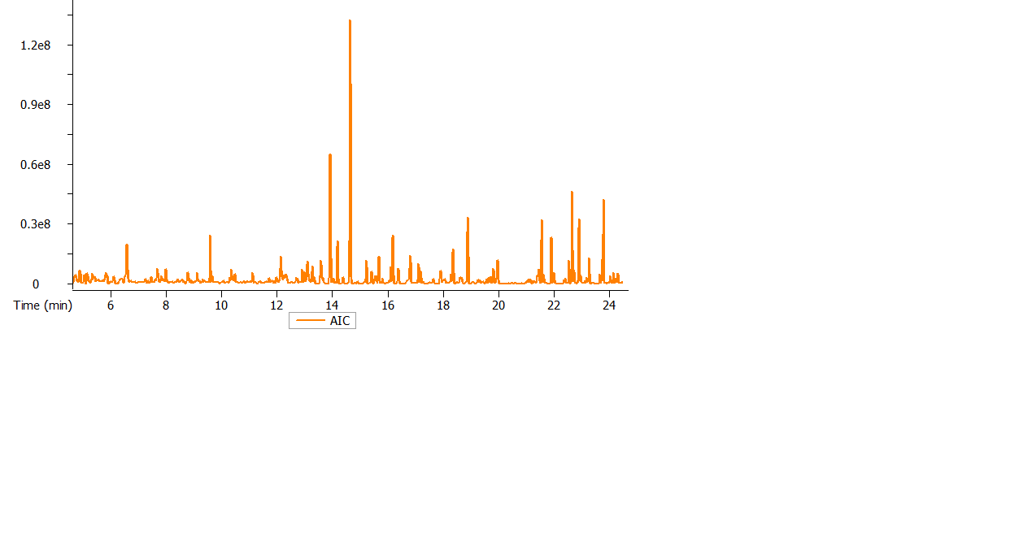

Chromatogram of compounds detected from Bauhinia galpinnii organic leaves extract.

GC-ToF-MS analysis of organic extract from Milletia grandis

Name | R.T. (min) | Area %
Conessine | 2.38547 | 0.414
3-Penten-2-one | 2.4351 | 0.698
Ethanone, 1-cyclopropyl- | 2.8598 | 0.582
Toluene | 2.95199 | 0.138
2-Pentyn-4-one | 3.10877 | 0.628
Hydroxymethyl 2-hydroxy-2-methylpropionate | 3.215 | 0.699
Hexanal | 3.64156 | 0.437
2-Cyclopenten-1-one | 4.2865 | 0.200
1H-Imidazole, 4, 5-dihydro-2, 4-dimethyl- | 4.6334 | 0.111
Hexanal, 2-ethyl- | 4.69227 | 0.399
Oxime-, methoxy-phenyl-_ | 5.35177 | 0.113
Hexanoic acid | 6.51299 | 0.118
Phenol | 6.58503 | 0.560
3-Hydroxy-4-methoxybenzaldehyde, TBDMS | 6.1148 | 0.116
3-Octanone, 4-methyl- | 6.23933 | 0.115
4-Oxohex-2-enal | 7.2548 | 0.165
2-Pyrrolidinone | 7.61984 | 0.138
Pyrazine, ethyl-, | 7.68979 | 0.114
Phenol, 2-methoxy- | 7.8342 | 0.115
n-Heptyl methylphosphonofluoridate | 8.23984 | 0.100
Octanoic acid | 8.55895 | 0.106
1-Propanone, 1-phenyl- | 8.59712 | 0.351
2-Dodecene, (E)- | 8.78039 | 0.683
Ethanone, 1-(4-methylphenyl)- | 8.78745 | 0.280
2-Cyclohexen-1-one, 3-methyl- | 8.81295 | 0.585
Acetic acid, [(1,1-dimethylethyl) thio]- | 8.84391 | 0.365
Dodecane | 8.84783 | 0.376
Benzaldehyde, 2, 5-dimethyl- | 9.06141 | 0.337
1H-Pyrrole-2, 5-dione, 3-ethyl-4-methyl- | 9.11772 | 0.367
1-Decanol | 9.57653 | 0.193
5-[(7-Chloro-4-quinolinyl) amino]-2-hydroxybenzoic acid, 3TMS derivative | 9.59443 | 0.714
Indole | 9.66938 | 0.154
1, 7-Octadien-3-ol, 2, 6-dimethyl- | 9.91251 | 0.180
Tetradecane | 10.3612 | 0.177
Dodecanal | 10.4403 | 0.299
Diphenyl ether | 10.4851 | 0.124
octadecanamide, N-(2, 6-dihydroxyphenyl)- | 10.7109 | 0.258
2, 6, 10-Trimethyltridecane | 10.8126 | 0.113
Hexadecane | 11.1221 | 0.533
4H-1-Benzopyran-4-one, 6, 7-dimethoxy-3-phenyl- | 11.2395 | 0.108
2(4H)-Benzofuranone, 5, 6, 7, 7a-tetrahydro-4, 4, 7a-trimethyl- (R)- | 11.5702 | 1.459
t-Butylhydroquinone | 11.5736 | 0.983
Cetene | 11.9193 | 0.124
4-(4-tert-Butylphenyl)-1, 3-thiazol-2-ylamine | 12.2566 | 1.974
2, 5-Cyclohexadien-1-one, 2,6-bis(1, 1-dimethylethyl)-4-ethylidene | 12.3381 | 0.101
2-Cyclohexen-1-one, 4-(3-hydroxy-1-butenyl)-3, 5, 5-trimethyl- | 12.4873 | 0.407
Tridecane | 12.698 | 0.135
7-Oxabicyclo [4.1.0] heptan-3-ol, 6-(3-hydroxy-1-butenyl)-1, 5,5-trimethyl- | 12.7266 | 0.236
Dodecyl acrylate | 12.8878 | 1.134
3-Buten-2-one, 4-(4-hydroxy-2, 2, 6-trimethyl-7-oxabicyclo [4.1.0] hept-1-yl)- | 12.9166 | 0.550
Pentadecane | 12.9363 | 0.428
Heptacosane | 13.0006 | 0.544
1, 4-Benzenediol, 2, 6-bis (1, 1-dimethylethyl)- | 13.2471 | 0.148
1-Undecene, 5-methyl- | 13.2824 | 0.133
Nonamethylene glycol | 13.3032 | 0.138
Cyclohexane, hexaethylidene- (isomer 1) | 13.3049 | 0.719
6-Hydroxy-4, 4, 7a-trimethyl-5, 6, 7, 7a-tetrahydrobenzofuran-2(4H)-one | 13.5748 | 0.232
Acetyl valeryl | 13.582 | 0.150
Loliolide | 13.9216 | 1.138
1-Tricosene | 14.0439 | 0.285
1-(2-Furyl)-N1, N1-dimethyl-1, 2-ethanediamine | 14.0653 | 0.435
1, 4-Benzenediol, 2, 6-bis (1, 1-dimethylethyl)- | 14.0845 | 0.239
2-Pentadecanone, 6, 10, 14-trimethyl- | 14.6461 | 1.692
2-Butyl-3-(4-ß-diethylaminoethoxybenzoyl) benzofuran | 14.5725 | 0.339
Neophytadiene | 14.5843 | 0.187
1, 2-Benzenedicarboxylic acid, bis(2-methylpropyl) ester | 14.9075 | 0.320
Oxirane, tetradecyl- | 15.1492 | 0.188
4-Tetradecylmorpholine | 15.2657 | 1.290
1H-Indene-4-acetic acid 6-(1, 1-dimethylethyl)-2, 3-dihydro-1,1-dimethyl- | 15.9284 | 0.174
Ethyl 2, 4-dioxovalerate | 15.9876 | 0.179
2-Bromotetradecane | 18.0034 | 0.132
2. 5-di-tert-Butyl-1, 4-benzoquinone | 18.156 | 0.852
4-Methyl-1, 6-heptadien-4-ol | 18.2854 | 0.244
Phytol | 18.4292 | 0.130
1, 7-Octadien-3-ol | 8.68714 | 0.137
2, 8, 9-Trioxa-5-aza-1-silabicyclo [3.3.3] undecane, 1-ethyl- | 18.7673 | 0.865
1-Hexadecyn-3-ol,3, 7,11, 15-tetramethyl- | 18.8926 | 0.298
Dodecanamide | 19.4303 | 0.163
2, 4-Imidazolidinedione, 5-methyl- | 20.1213 | 0.216
Hexadecanoic acid, 2-hydroxyethyl ester | 20.3381 | 0.162
1-Cyclohexyldimethylsilyloxy-3, 5-dimethylbenzene | 20.6131 | 0.920
4, 8, 12, 16-Tetramethylheptadecan-4-olide | 21.5603 | 0.415
1-Naphthalenethiol, S-heptafluorobutyryl- | 21.6249 | 0.313
9-Octadecenamide (Z)- | 21.6488 | 0.136
3-Hydroxypropyl palmitate, TMS derivative | 22.5378 | 0.289
Bis(2-ethylhexyl) phthalate | 22.9013 | 0.146
2, 3-Dihydroxypropyl icosanoate, 2TMS derivative | 23.7355 | 0.760
Benzene, 1, 2-dimethoxy-4-(1-propenyl)- | 24.0919 | 0.311
a-Tocospiro A | 24.6232 | 0.116
Benzene, 1, 2, 3-trimethoxy-5-(2-propenyl)- | 24.6758 | 0.183
a-Tocospiro A | 24.7541 | 0.155
((1R, 4S, 5R, 8S, 9R)-4-Isopropyl-6, 8, 9-trimethyl-3-oxabicyclo [3.3.1] non-6-en-1-yl) methanol | 27.7308 | 0.610
ß-Sitosterol | 28.8294 | 0.131
2, 2'-Methylenebis-(6-tert-butyl)-4-ethylphenol, O-pentafluoro propionyl- | 32.5189 | 1.273
Bold faceted data shows tentative compounds with high percentage area

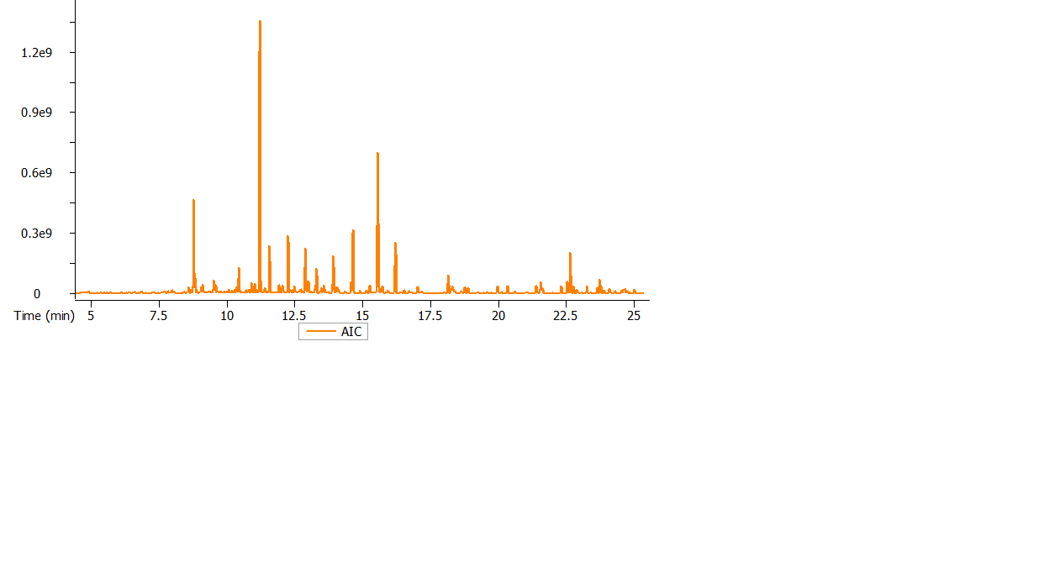
Chromatogram of compounds detected from Milletia grandis organic leaves extract.

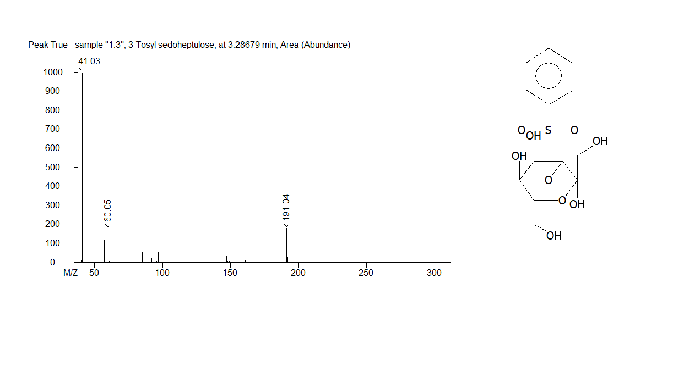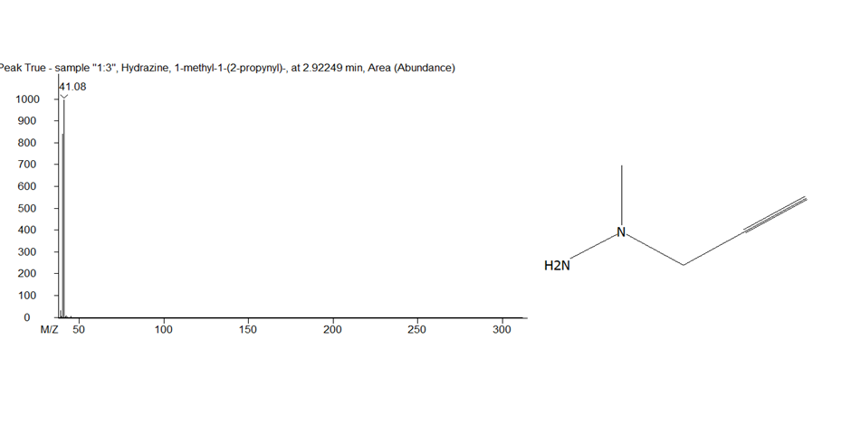

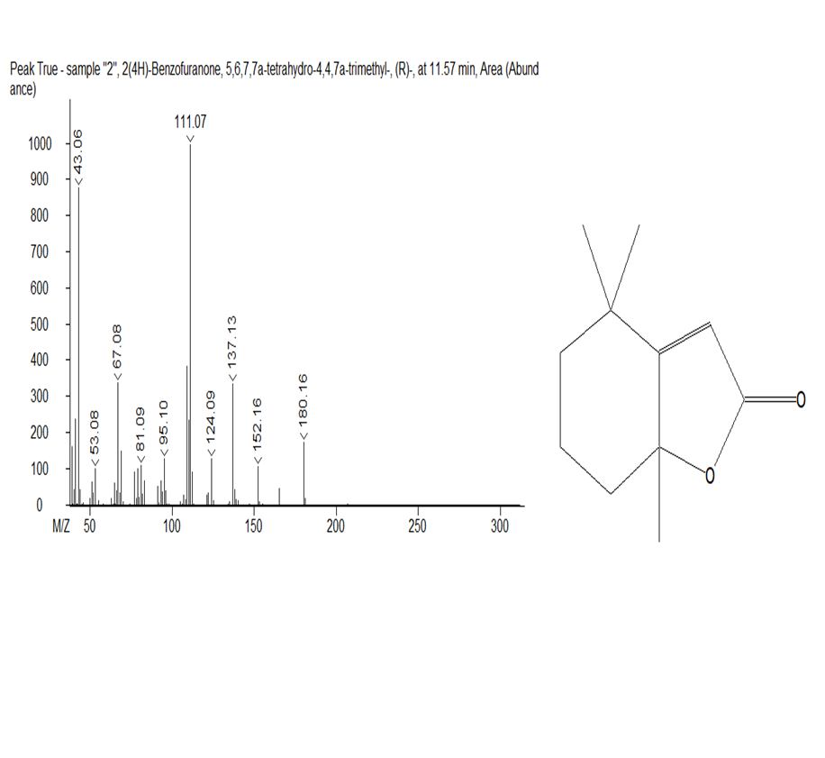
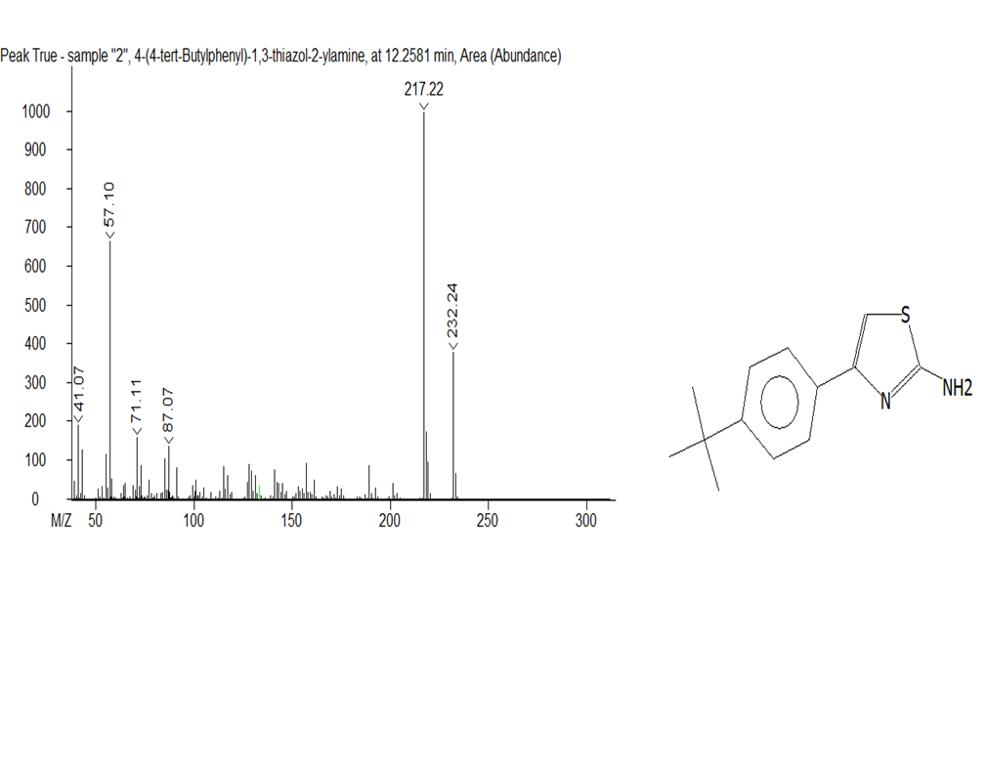

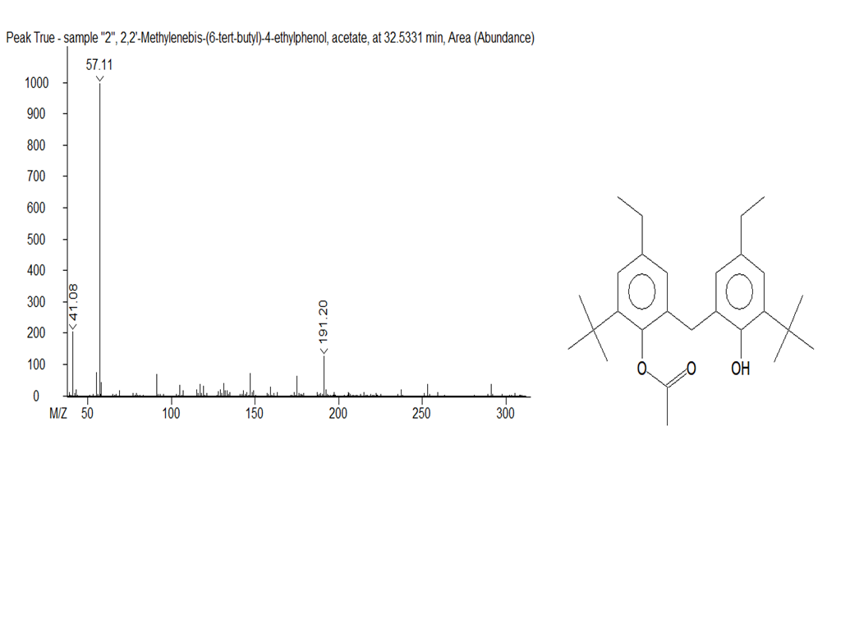
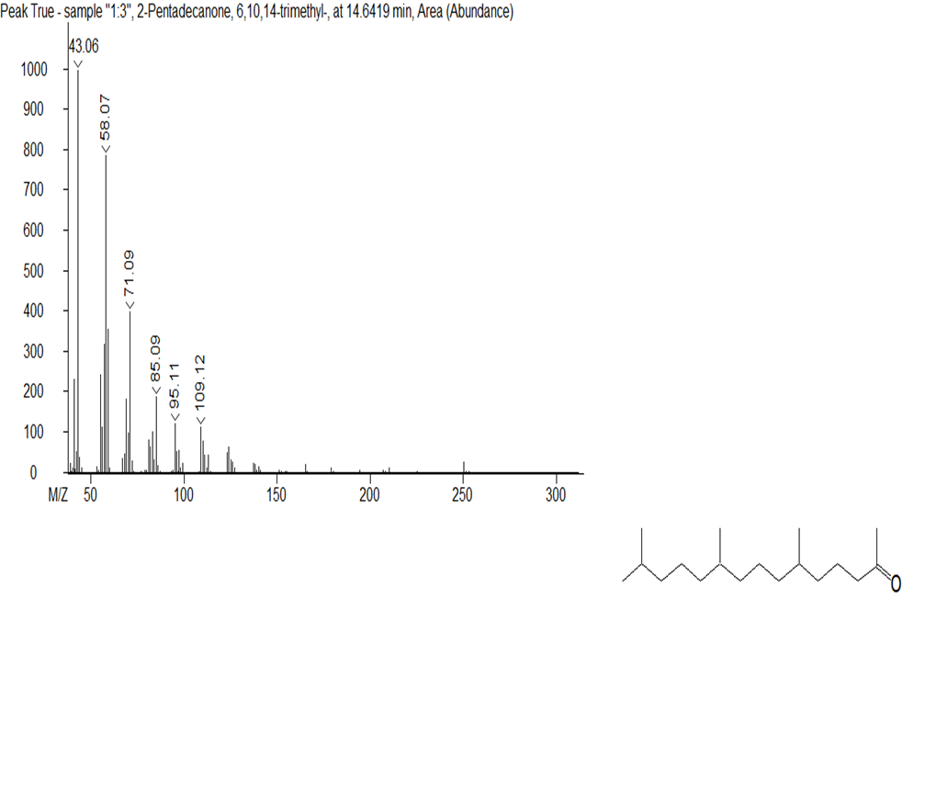

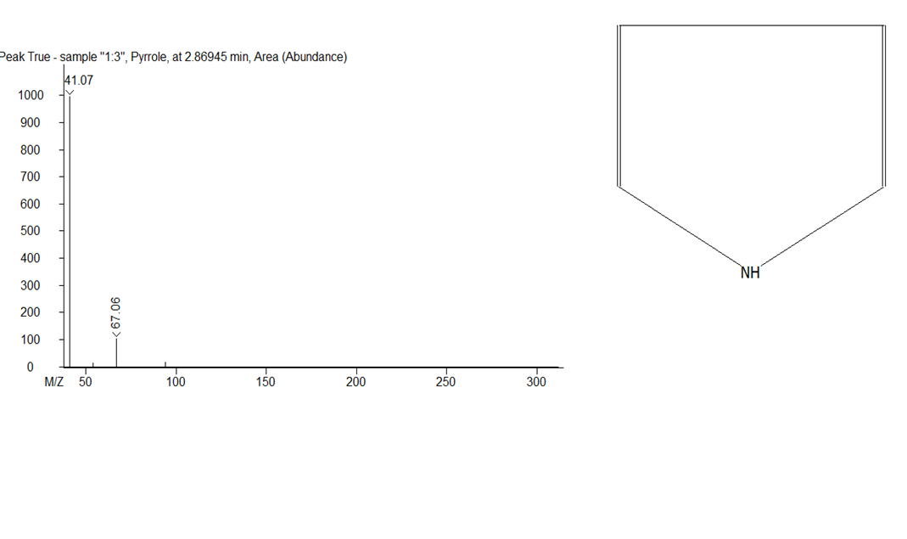
Compounds with higher percentage areas from both Bauhinia galpinii and Milletia grandis.

