Supplemental Figures
Figure S1. Methodology to setup homemade Styrofoam freezing container. Two pieces of 15 mL centrifuge tube Styrofoam holders were taped together to make a homemade freezing container.
Figure S2. 3-week-old 3D GBM organoids were frozen and successfully cultured post-thaw. A. Organoids were made in Matrigel, cultured for three weeks, and imaged before freezing and 2 weeks post-thaw. B. Post-thaw organoids were dissociated, and cell death was determined by flow cytometric analysis using Calcein AM (live) and DRAQ7 (dead) dye labeling. C. Cell viability was further confirmed using 3D CellTiter-Glo® cell viability assay. Intergroup comparisons were performed using ordinary one-way ANOVA followed by Tukey’s multiple comparisons. Data are presented as mean ± SD. Comparisons without asterisks are not statistically significant (p≥ 0.05). * p<0.05; n= 3 biological replicates.
Figure S3. Histological characteristics are preserved in pGBM001 MGO organoids post-thaw. A. Sections from never frozen and 10 days post-thaw cultured organoids were stained for H&E for histology. B. Sections were stained for proliferation marker pH-H3, stemness markers SOX2 and C. Nestin, and D. apoptotic marker Cleaved-Caspase3 (Cl-Casp3). Images were captured to show the organoid rim and organoid core niches. The number of positive cells per ROI in the organoid rim was quantified for (3 ROI quantified per datapoint from each of 3 independent MGO organoids per condition) E. pH-H3 and F. Cl-Casp3. Intergroup comparisons were performed using ordinary one-way ANOVA. Data are presented as mean ± SD. Comparisons without asterisks are not statistically significant (p≥ 0.05).

Figure S1.

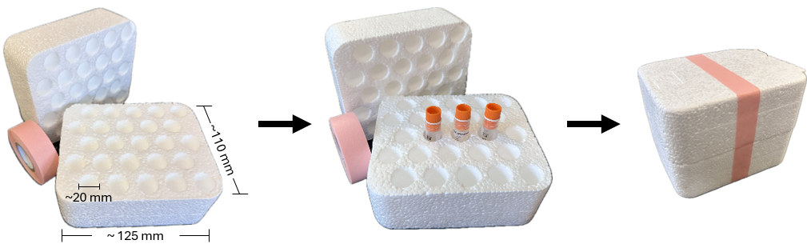

Figure S2.

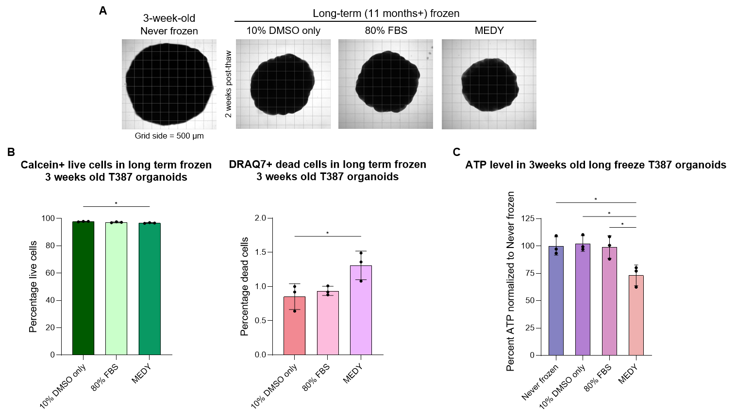

Figure S3.
