Supplementary Figure 1
Brightfield Images of human lung organoids pre-formed in a Kugelmeier plate on day 0 (A-C) after seeding in AD (A), AF (B) or SF (C) conditions and on d4 after seeding in SF conditions (D). 1500 organoids per condition were seeded and light microscopic analyses revealed even organoids under all conditions. Clumping occurred in SF on day 4. 4x (D), 10x and 20x (A-C) magnifications are depicted.

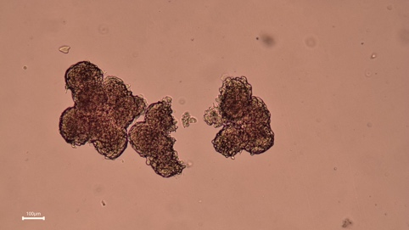
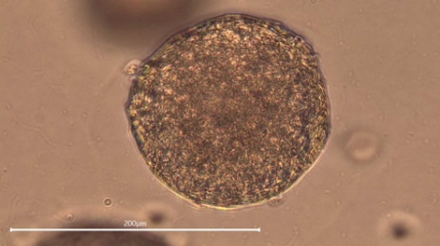
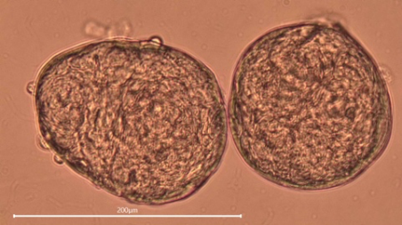
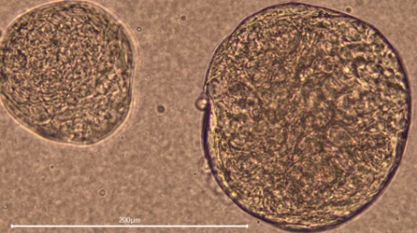
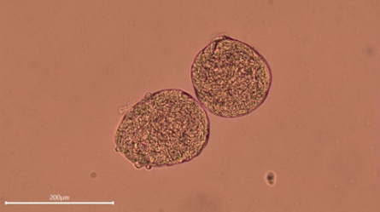
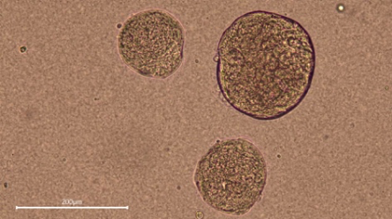
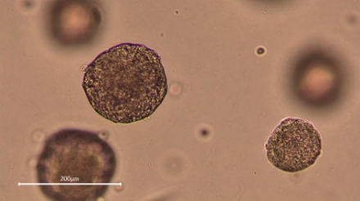
A

B

C

D

Supplementary Figure 2
Brightfield Images of human lung organoids pre-formed in a Kugelmeier plate on day 0 after EDTA treatment. Previously expanded in AD (A), AF (B) or SF (C) conditions. Light microscopic analyses revealed compact organoids without cavities under all conditions. 10x and 20x magnifications are depicted.

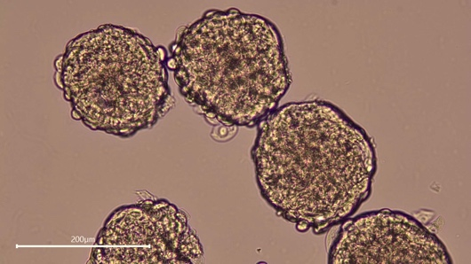
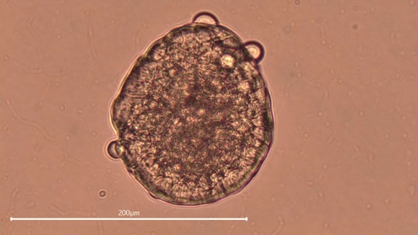
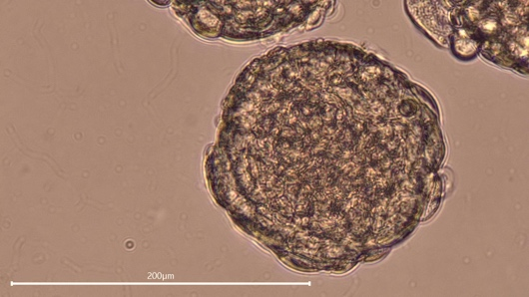
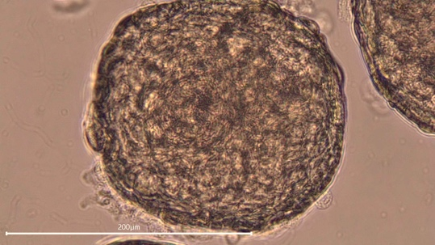
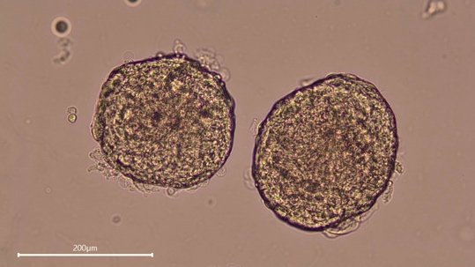
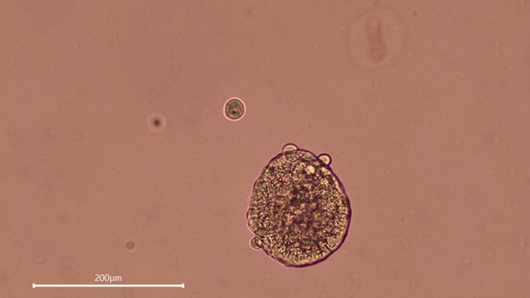
A

B

C

Supplementary Figure 3
KRT5-positive cells were quantified via 2D analysis on the Hoechst signal in AD (orange), AF (green) and SF (blue) systems in d0- and d13-differentiated conditions. Ratio of KRT5-positive cells of all nuclei are shown. All values are means ± SEM from n= 150 – 300 total cells (# of nuclei) counted. **P < 0.01; ****P < 0.0001. Statistically significant differences were determined by two-way ANOVA with Dunnett´s multi-comparison post-test.

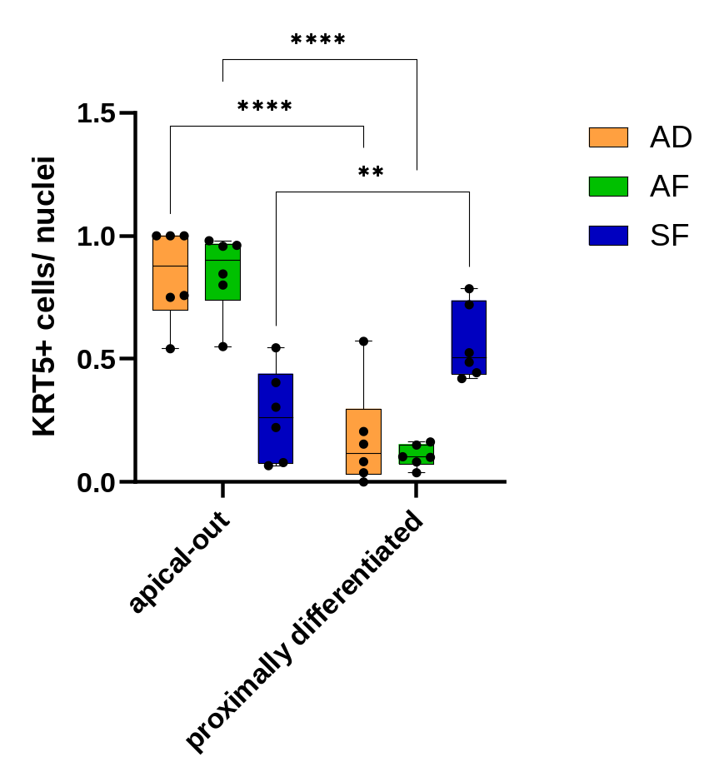

Text Supplementary Videos

Supplementary Video 1A
hAO proximally differentiated d13 in differentiation condition, expanded in animal derived scaffold, light microscope 20x
Supplementary Video 1B
hAO proximally differentiated d13 in differentiation condition, expanded in animal free scaffold, light microscope 20x
Supplementary Video 1C
hAO proximally differentiated d13 in differentiation condition, expanded in scaffold free condition, light microscope 20x
Supplementary Video 1D
hAO proximally differentiated d13 in differentiation condition, expanded in animal derived scaffold, stained with WGA for cilia (red), fluorescence labelled beads (green), live imaging confocal microscopy, 40xW
Supplementary Video 1E
hAO proximally differentiated d13 in differentiation condition, expanded in animal free scaffold, stained with WGA for cilia (red), fluorescence labelled beads (green), live imaging confocal microscopy, 40xW
Supplementary Video 1F
hAO proximally differentiated d13 in differentiation condition, expanded in scaffold free condition, stained with WGA for cilia (red), fluorescence labelled beads (green), live imaging confocal microscopy, 40xW
Supplementary Video 1G
hAO proximally differentiated d13 in differentiation condition, expanded in animal derived scaffold, Live-cell ciliary activity was evaluated by tracking fluorescently labeled beads in Harmony 4.7, with representative tracks indicated by arrows.
Supplementary Video 1H
hAO proximally differentiated d13 in differentiation condition, expanded in animal free scaffold, Live-cell ciliary activity was evaluated by tracking fluorescently labeled beads in Harmony 4.7, with representative tracks indicated by arrows.
Supplementary Video 1I
hAO proximally differentiated d13 in differentiation condition, expanded in scaffold free condition, Live-cell ciliary activity was evaluated by tracking fluorescently labeled beads in Harmony 4.7, with representative tracks indicated by arrows.

