Table S1. Prognostic Impact of Tumor Deposits by Lymph Node Status
Lymph Node Status | HR (95% CI) | P value | Interaction P value*
PN = 0 | 2.28 (0.81-6.42) | 0.119 | —
PN = 1-3 | 2.63 (1.36-5.08) | 0.004 | 0.843
PN ≥ 4 | 1.98 (1.15-3.38) | 0.013 | 0.746
*Interaction P value tests whether the prognostic effect of TD differs across lymph node strata (reference: PN = 0). P > 0.05 indicates no statistically significant interaction; the adverse point estimates were directionally consistent across PN strata.

Table S2. Calibration Performance of the Nomogram Model
Cohort | H-L χ² | H-L P Value | Brier Score
Training cohort | 8.663 | 0.372 | 0.095
Internal validation cohort | 3.468 | 0.902 | 0.098
External validation cohort | 2.395 | 0.967 | 0.086
Abbreviations: H-L, Hosmer-Lemeshow. The H–L test assesses goodness of fit, with P > 0.05 indicating no evidence of poor fit. Lower Brier scores indicate better overall probabilistic accuracy.

Table S3. Risk Stratification Based on Nomogram Score
Risk Group | Training Cohort | Internal Validation | External Validation
Low Risk | 9/374 (2.4%) | 6/152 (3.9%) | 1/93 (1.1%)
Intermediate | 23/288 (8.0%) | 14/137 (10.2%) | 6/123 (4.9%)
High Risk | 95/298 (31.9%) | 33/123 (26.8%) | 36/182 (19.8%)
P for trend | <0.001 | <0.001 | <0.001
Data presented as TD-positive cases/total cases (percentage).

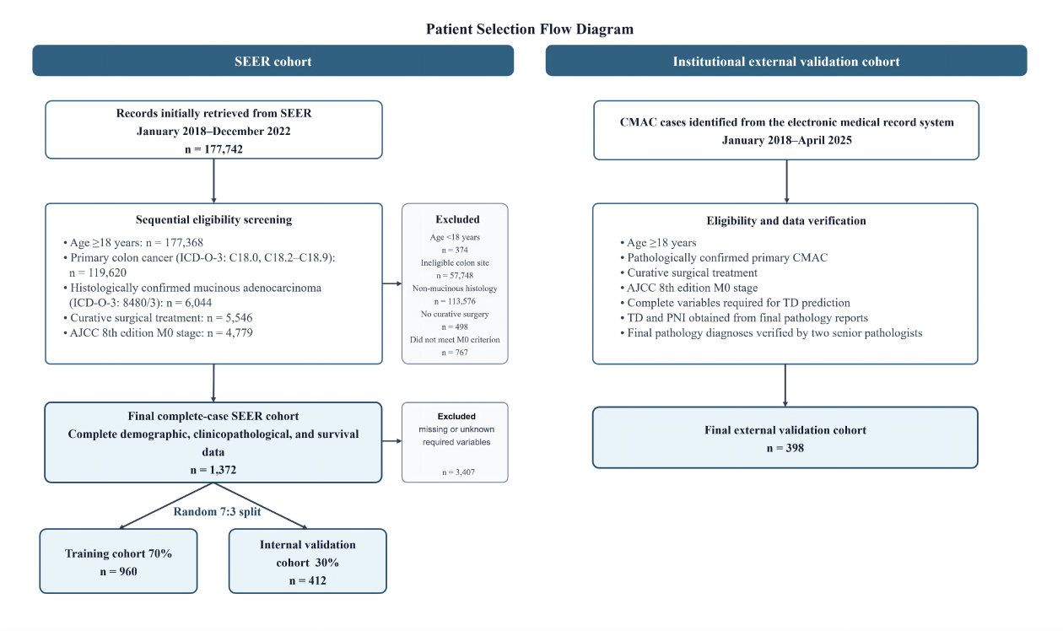
Figure S1. Flow diagram of patient selection for the SEER and institutional external validation cohorts.
The SEER cohort was selected according to the prespecified eligibility criteria and randomly divided into training and internal validation cohorts at a 7:3 ratio. The institutional cohort was identified from electronic medical records and used for external validation of the TD-prediction model.

