Supplementary Data

Hyaluronic Acid-Functionalized Polypyrrole Nanoparticles with Controlled Oxidation for Targeted Chemo-Photothermal Therapy of Prostate Cancer

Fatemeh Imani¹, Akbar Karkhaneh^{*1}, Nikoo Hossein-Khannazer^{2,3}, Reza Karimi-Soflou¹

- Department of Biomedical Engineering, Amirkabir University of Technology (Tehran Polytechnic), Iran
- Gastroenterology and Liver Diseases Research Center, Research Institute for Gastroenterology and Liver Diseases, School of Advanced Technologies in Medicine, Shahid Beheshti University of Medical Sciences, Tehran, Iran
- International Campus, Shahid Beheshti University of Medical sciences, Tehran,Iran.

* Corresponding author: Associate Professor, Department of Biomedical Engineering, Amirkabir University of Technology (Tehran Polytechnic); E-Mail: a.karkhaneh@aut.ac.ir, akbar.karkhaneh@gmail.com

Table S1. Electrical conductivity of nanoparticles

Sample | Electrical conductivity (σ, mS/m)
GP6 | 2.35
GP3 | 3.84
GP1 | 4.48
GPr | 10.03

Table S2. Water contact angle on different samples

Sample | Contact angle (θ°)
GP1 | 77.05 ± 4.92
GP3 | 75.2 ± 3.17
GP6 | 74.99 ± 3.05
GPr | 76.24 ± 4.46
GP1-HA | 66.87 ± 3.28
GPr-HA | 67.47 ± 3.02
Gelatin | 62.78 ± 2.13
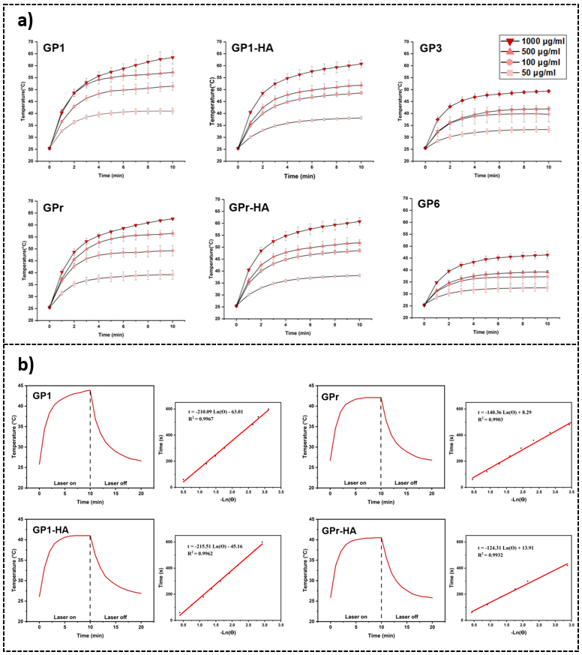
Figure S1. a) Temperature analysis of each sample at various concentrations upon irradiation with 808 nm laser, (b) Temperature changes of GP1, GPr, GP1-HA, and GPr-HA samples (100 μg/mL) during and after irradiation with an 808 nm laser (2 W/cm²), together with the linear fitting of time versus −lnθ obtained from the cooling period of each sample. The fitted slope was used to calculate the photothermal conversion efficiency.

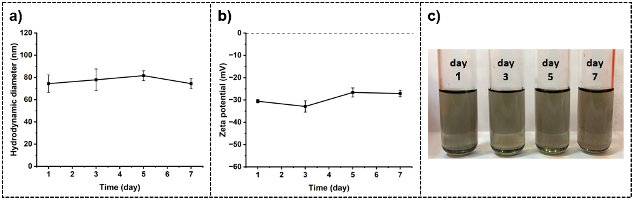
Figure S2. a) Hydrodynamic diameter, b) Zeta potential changes, and c) Photographs of GPr-HA sample dispersed in PBS buffer during one-week at room temperature.

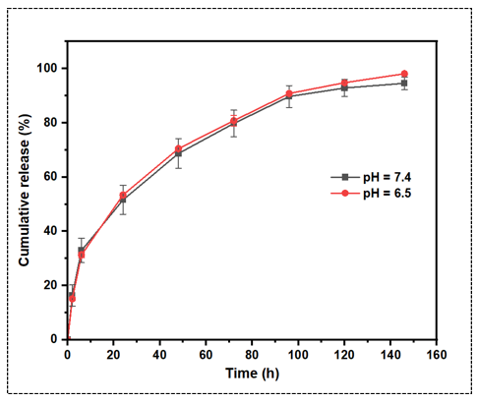
Figure S3. Cumulative Dox release under physiological and tumor microenvironment pH conditions

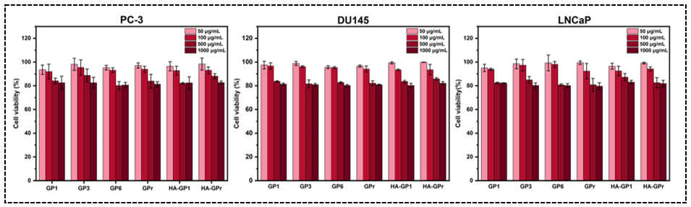
Figure S4. Cytotoxicity of GP samples against prostate cancer cell lines.

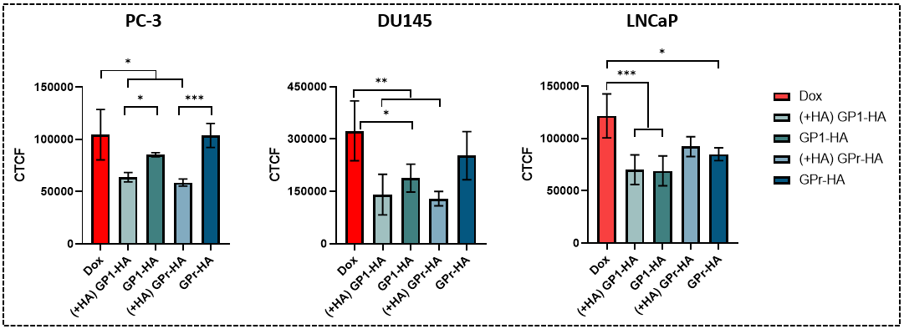
Figure S5. Corrected total cellular fluorescence (CTCF) of each cell line incubated with free Dox, GP1-HA, and GPr-HA before and after hyaluronic acid treatment.

Table S3. Exact p-values of the statistical comparisons between experimental groups
Figure | Cell line | Pairwise comparison | adjusted p-value | Significance
Fig. 4a | DU145 | GP1 vs. Free-Dox | <0.0001 | ****
Fig. 4a | DU145 | GP1-HA vs. Free-Dox | <0.0001 | ****
Fig. 4a | DU145 | GPr vs. GPr-HA | 0.0015 | **
Fig. 4a | DU145 | GPr vs. Free-Dox | <0.0001 | ****
Fig. 4a | DU145 | GPr-HA vs. Free-Dox | 0.0018 | **
Fig. 4a | PC-3 | GP1 vs. Free-Dox | <0.0001 | ****
Fig. 4a | PC-3 | GP1-HA vs. GPr-HA | 0.0003 | ***
Fig. 4a | PC-3 | GP1-HA vs. Free-Dox | <0.0001 | ****
Fig. 4a | PC-3 | GPr vs. GPr-HA | 0.0169 | *
Fig. 4a | PC-3 | GPr vs. Free-Dox | <0.0001 | ****
Fig. 4a | PC-3 | GPr-HA vs. Free-Dox | 0.0007 | ***
Fig. 4a | LNCaP | GP1 vs. Free-Dox | <0.0001 | ****
Fig. 4a | LNCaP | GP1-HA vs. Free-Dox | <0.0001 | ****
Fig. 4a | LNCaP | GPr vs. Free-Dox | <0.0001 | ****
Fig. 4a | LNCaP | GPr-HA vs. Free-Dox | <0.0001 | ****
Fig. 6a | DU145 | Dox@GPr-HA (50)  vs.  Dox@GPr-HA (50) +NIR | <0.0001 | ****
Fig. 6a | DU145 | Dox@GPr-HA (100)  vs.  Dox@GPr-HA (100) +NIR | 0.0086 | **
Fig. 6a | DU145 | GPr-HA (50) +NIR  vs.  Dox@GPr-HA (50) +NIR | <0.0001 | ****
Fig. 6a | DU145 | GPr-HA (100) +NIR  vs.  Dox@GPr-HA (100) +NIR | 0.0041 | **
Fig. 6a | PC-3 | Dox@GPr-HA (50)  vs.  Dox@GPr-HA (50) +NIR | <0.0001 | ****
Fig. 6a | PC-3 | Dox@GPr-HA (100)  vs.  Dox@GPr-HA (100) +NIR | 0.0011 | **
Fig. 6a | PC-3 | GPr-HA (50) +NIR  vs.  Dox@GPr-HA (50) +NIR | <0.0001 | ****
Fig. 6a | PC-3 | GPr-HA (100) +NIR  vs.  Dox@GPr-HA (100) +NIR | 0.0066 | **
Fig. 6a | LNCaP | Dox@GPr-HA (50)  vs.  GPr-HA (50) +NIR | 0.0003 | ***
Fig. 6a | LNCaP | Dox@GPr-HA (50)  vs.  Dox@GPr-HA (50) +NIR | <0.0001 | ****
Fig. 6a | LNCaP | Dox@GPr-HA (100)  vs.  GPr-HA (100) +NIR | 0.0003 | ***
Fig. 6a | LNCaP | Dox@GPr-HA (100)  vs.  Dox@GPr-HA (100) +NIR | <0.0001 | ****
Fig. 6a | LNCaP | GPr-HA (50) +NIR  vs.  Dox@GPr-HA (50) +NIR | <0.0001 | ****
Fig. 6a | LNCaP | GPr-HA (100) +NIR  vs.  Dox@GPr-HA (100) +NIR | <0.0001 | ****
Fig. S4 | DU145 | Dox vs. (+HA) GP1-HA | 0.0025 | **
Fig. S4 | DU145 | Dox vs. GP1-HA | 0.0305 | *
Fig. S4 | DU145 | Dox vs. (+HA) GPr-HA | 0.0014 | **
Fig. S4 | PC-3 | Dox vs. (+HA) GP1-HA | 0.0474 | *
Fig. S4 | PC-3 | Dox vs. (+HA) GPr-HA | 0.0250 | *
Fig. S4 | PC-3 | GP1-HA vs. (+HA) GP1-HA | 0.0415 | *
Fig. S4 | PC-3 | GPr-HA vs. (+HA) GPr-HA | 0.0005 | ***
Fig. S4 | LNCaP | Dox vs. (+HA) GP1-HA | 0.0008 | ***
Fig. S4 | LNCaP | Dox vs. GP1-HA | 0.0007 | ***
Fig. S4 | LNCaP | Dox vs. GPr-HA | 0.0189 | *

