Supplementary Information for

Disentangling climate variability in the subtropical and tropical Pacific

Ingo Richter¹, Malte F. Stuecker^{2,3}, Naoya Takahashi³, Niklas Schneider^{2,3}
¹Application Laboratory, Research Institute for Value-Added-Information Generation, Japan Agency for Marine-Earth Science and Technology, Yokohama, Japan
²Department of Oceanography, School of Ocean and Earth Science and Technology, University of Hawaiʻi at Mānoa, Honolulu, HI, USA
³International Pacific Research Center, School of Ocean and Earth Science and Technology, University of Hawaiʻi at Mānoa, Honolulu, HI, USA

npj Climate and Atmospheric Science

Corresponding author address:
Ingo Richter
Application Laboratory, JAMSTEC, 3173-25 Showa-machi, Kanazawa-ku, Yokohama, Kanagawa 236-0001, Japan
E-mail: richter@jamstec.go.jp

Supplementary Notes
1. Testing the robustness of the MCA-based Pacific Meridional Mode
We repeat the procedure for calculating the reference PMM-T index with some modifications to the input fields to probe its robustness. In the first test, we band-pass filter all input fields (SST and the 10m wind components) to retain periods in the intraseasonal to interannual range, from 3 to 60 months. The regression patterns of SST, wind and SLP (Supplementary Fig. 4b) show some differences to the original ones (Supplementary Fig. 4a). The equatorial SST anomalies are mostly absent, there are positive SST anomalies south of the equator, easterly wind anomalies over the eastern equatorial Pacific are absent, and the SLP pattern is shifted northward. All these changes make the patterns more similar to the ones obtained by regressing out ENSO variability via the CPCT index pair (Fig. 1d).
The absence of an equatorial SST signature in the band-pass filtered PMM suggests that these SSTs are mostly due to low-frequency variability in the input fields, particularly the SST field, as it is the one that dominates the first MCA mode. Motivated by this observation, we test the robustness of the MCA mode to swapping the first and second half of the SST record. Since the entire analysis period runs from 1950-2005, we split it into two 28-year blocks, namely 1950-1977 and 1978-2005. These two blocks are swapped, so that the years are arranged as follows: 1978, 1979, …, 2005, 1950, 1951, …, 1978. This procedure destroys the temporal coherence of the original data, except at the lowest frequency, i.e., the difference between the 28-year blocks. The resulting PMM pattern (Supplementary Fig. 4c) is rather similar to the band-pass filtered one. This suggests two things. First, it shows again that the wind input fields only make a modest contribution to the PMM pattern, as the pattern remains similar even if most of the SST-wind coherence is eliminated. Second, it suggests that the very low frequencies contribute to the PMM pattern. This is supported by Supplementary Fig. 5, which shows the difference between the 1978-2005 and 1950-1977 periods. In the mid and higher latitudes, the patterns are very different from the ones of the PMM (Fig. 1a) but in the tropics there is considerable agreement, including the southwestward slanted SST patterns that extends from Baja California to the equator, and the cold SSTs in the eastern equatorial Pacific, although they are exaggerated and extend too far westward. Since the data are linearly detrended before calculating the difference, we conclude that non-linear changes contribute to this pattern, possibly the 1970s climate shift (Meehl et al. 2009) or the two super-El Niños in the latter period (1982 and 1997).
As a further test, we repeated the MCA but with winds taken from a remote area in the South Atlantic and Southern Ocean (98W-0, 72-17S). The resulting pattern is highly correlated with the reference PMM pattern with pattern correlations ranging from 0.96 to 0.98 for SST and the 10m wind components. The PMM T index is correlated with the reference PMM T index at 0.92 (while the PMM W index is, of course, not correlated with the reference). The fact that winds from a completely different area do not have any major impact on the MCA SST pattern illustrates the potential of MCA to produce spurious coupled patterns.

2. Statistical significance of the PMM
Typically, a bootstrap approach is used to assess the significance of MCA modes, as explained in the Methods. Applying this test to the singular values of the reference SST mode yields a p-value < 0.001 (i.e., none of the 1000 permutations produces a singular value larger than that of the unscrambled time series). Applying the same test on the MCA with winds from the South Atlantic (Supplementary Fig. 4d) yields a p-value of 0.19. While this fails the 95% significance test, it is surprisingly high, given that the input winds are from a remote area that should have little relation to the target area. This suggests that the bootstrap test may be too permissive, which is further supported by sensitivity tests in which we take SST and winds from the tropical Pacific (130E-70W, 20S-20N), and do not regress out the CTI. Performing MCA on these data yields the familiar ENSO pattern as the first mode, with warm SST anomalies in the central and eastern equatorial Pacific and westerly wind anomalies to the west. The bootstrap approach suggests p < 0.001, as would be expected for this dominant pattern. When we replace the local winds with those from a remote region extending from the southeastern Pacific to the southwestern Indian Ocean (98W-60E, 72-35S), the p-value is still below 0.001, supporting the notion that this simple significance test is too permissive. Even if the remote winds were somehow significantly related to the tropical Pacific SST (which cannot be discounted, given ENSO’s global impacts), it is obvious that the MCA pattern cannot represent any two-way coupling between the tropical Pacific SST and the remote winds. A more stringent test should probably take into account the effective degrees of freedom of the input fields in both space and time.

3. Toward developing a new PMM index
As stated in the discussion of the main text, it would be desirable to have a physically based index of the PMM. The WES feedback, which is thought to underlie the PMM, is characterized by equatorward propagation. Consistently, idealized analyses have suggested that SST anomalies in the subtropics should propagate toward the equator on a time-scale of about 180-240 days³³. We examine the NCAR/NCAR Reanalysis SST data with respect to this propagation. After regressing out the CTI, the data are band-pass filtered in the 3-60 month range. The choice of this range is motivated by the 180-240 propagation time-scale, and by the role of the PMM in interannual ENSO variability.
Next, the data are masked to retain only values that lie in the area of high PMM-related variability. This is defined to be those points of the MCA SST pattern, whose values exceed 0.08 (arbitrary units), as shown in Supplementary Fig. 6a. After masking, we calculate the zonal average at each latitude, and then calculate the correlation of the time series at the northernmost latitude (24.8N) with the time series at all other latitudes (Supplementary Fig. 6b). The correlations are roughly symmetric about lag 0, but there is a tendency for slightly higher correlations at positive lags (i.e., the SSTs at 24.8N lead). This is most evident at 1.9N, where the highest correlation occurs at lag 1. Values at lags greater than 2 and less than -2 are not significant at the 95% level, and neither are values south of 9.5N. Overall, the correlation is too low and the lag between the time series at 24.8N and 1.9N too small to make a strong case for WES-related southwestward propagation, or to even form the basis of an index of the PMM. Likely, more sophisticated filtering and additional diagnostic tools will be needed to develop a new physically based PMM index. This is beyond the scope of the present study.

Supplementary Tables

Supplementary Table 1 | CMIP6 models used in this study.
Model name | Country/ Territory | Atmospheric model | Ocean model | # Years
ACCESS-CM2 | Australia | UM 10.6, GA 7.1 config | MOM5 | 500
ACCESS-ESM1-5 | Australia | UM 7.3 | MOM5 | 1000
AWI-CM-1-1-MR | Germany | ECHAM6.3.04p1 | FESOM 1.4 | 500
BCC-CSM2-MR | China | BCC_AGCM3_MR | MOM4 | 600
BCC-ESM1 | China | BCC_AGCM3_LR | MOM4 | 451
CAMS-CSM1-0 | China | ECHAM5_CAMS | MOM4 | 250
CanESM5 | Canada | CanAM5 | NEMO3.4.1 | 1000
CESM2-WACCM | USA | CAM6 | POP2 | 499
CESM2 | USA | CAM6 | POP2 | 1200
CIESM | China | CAM5 | POP2 | 500
CMCC-ESM2 | Italy | CAM5 | NEMO3.6 | 500
CNRM-CM6-1-HR | France | Arpege 6.3 | NEMO3.6 | 300
CNRM-CM6-1 | France | Arpege 6.3 | NEMO3.6 | 500
CNRM-ESM2-1 | France | Arpege 6.3 | NEMO3.6 | 500
E3SM-1-0 | USA | EAM v1.0 | MPAS-Ocean v6 | 500
E3SM-1-1 | USA | EAM v1.1 | MPAS-Ocean v6 | 165
EC-Earth3-Veg | European countries | IFS cy36r4 | NEMO3.6 | 500
EC-Earth3 | European countries | IFS cy36r4 | NEMO3.6 | 501
FGOALS-f3-L | China | FAMIL2.2 | LICOM3.0 | 561
FGOALS-g3 | China | GAMIL2 | LICOM3.0 | 700
FIO-ESM-2-0 | China | CAM5 | POP2 | 500
GISS-E2-1-G-CC | USA | GISS-E2.1 | GISS Ocean | 165
GISS-E2-1-G | USA | GISS-E2.1 | GISS Ocean | 851
GISS-E2-1-H | USA | GISS-E2.1 | HYCOM Ocean | 401
HadGEM3-GC31-LL | UK | MetUM-HadGEM3-GA7.1 | NEMO-HadGEM3-GO6.0 | 500
HadGEM3-GC31-MM | UK | MetUM-HadGEM3-GA7.1 | NEMO-HadGEM3-GO6.0 | 500
ICON-ESM-LR | Germany | ICON-A | ICON-O | 500
IITM-ESM | India | IITM-GFSv1 | MOM4.1 | 200
INM-CM5-0 | Russia | INM-AM5-0 | INM-OM5 | 1201
IPSL-CM6A-LR | France | LMDZ | NEMO-OPA | 1200
KACE-1-0-G | South Korea | MetUM-HadGEM3-GA7.1 | MOM4.1 | 150
KIOST-ESM | South Korea | GFDL-AM2.0 | MOM5 | 150
MCM-UA-1-0 | USA | R30L14 | MOM1.0 | 500
MIROC-ES2L | Japan | CCSR AGCM | COCO4.9 | 500
MIROC6 | Japan | CCSR AGCM | COCO4.9 | 800
MPI-ESM1-2-HR | Germany | ECHAM6.3 | MPIOM1.63 | 500
MRI-ESM2-0 | Japan | MRI-AGCM3.5 | MRI.COM4.4 | 401
NESM3 | China | ECHAM v6.3 | NEMO3.4 | 500
NorCPM1 | Norway | CAM-OSLO4.1 | MICOM1.1 | 500
NorESM1-F | Norway | CAM4 | MICOM | 200
NorESM2-LM | Norway | CAM-OSLO | MICOM | 501
SAM0-UNICON | Republic of Korea | CAM5.3 with UNICON | POP2 | 400
TaiESM1 | Taiwan | TaiAM1 | POP2 | 500
UKESM1-0-LL | UK | MetUM-HadGEM3-GA7.1 | NEMO-HadGEM3-GO6.0 | 750

Supplementary Figures

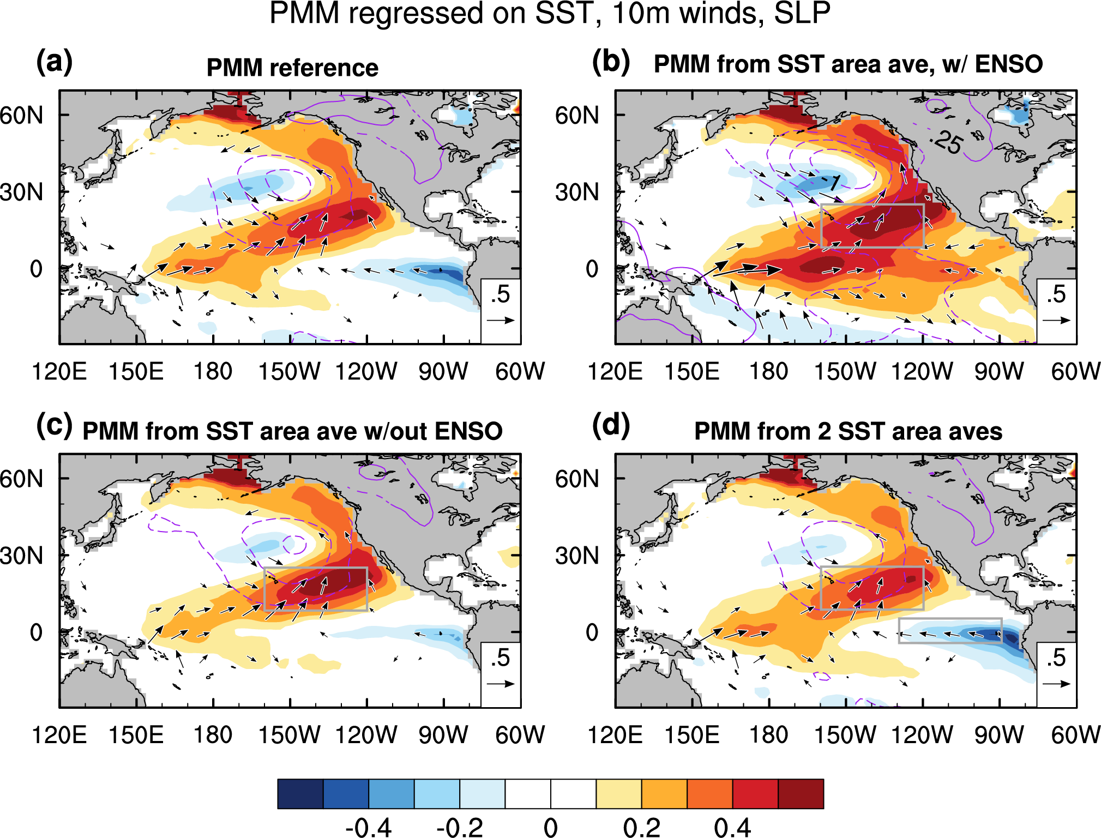

Supplementary Figure 1 | PMM reconstructed using simple area averages. a, b Repeated from Fig. 1a and Fig. 1c to facilitate comparison. c, Like Fig. 1c but with the ENSO signal regressed out. d, Similar to (c) but using the difference of two area averages as indicated by the two boxes. The grey box in the subtropics is used to calculate the area average of SST in (b) and (c). In (d), the additional grey box in the eastern equatorial Pacific is used to calculate the difference with the subtropical box, which yields the refined PMM index.

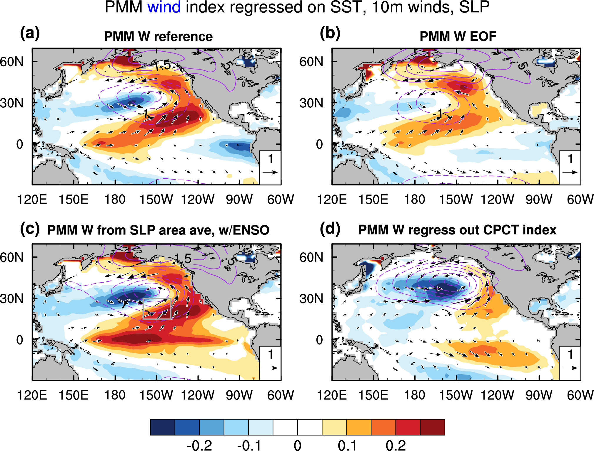

Supplementary Figure 2 | PMM wind indices. a, As in Fig. 1a, but for the PMM wind index instead of the PMM SST index. b, As in Fig. 1b, but for the EOF-based wind index, instead of the EOF-based SST index. c, Similar to (a), but for an index that is simply the area average of SLP anomalies in the grey box, and without removing ENSO variability beforehand. d, Like (a), but using a more thorough way of removing ENSO variability.

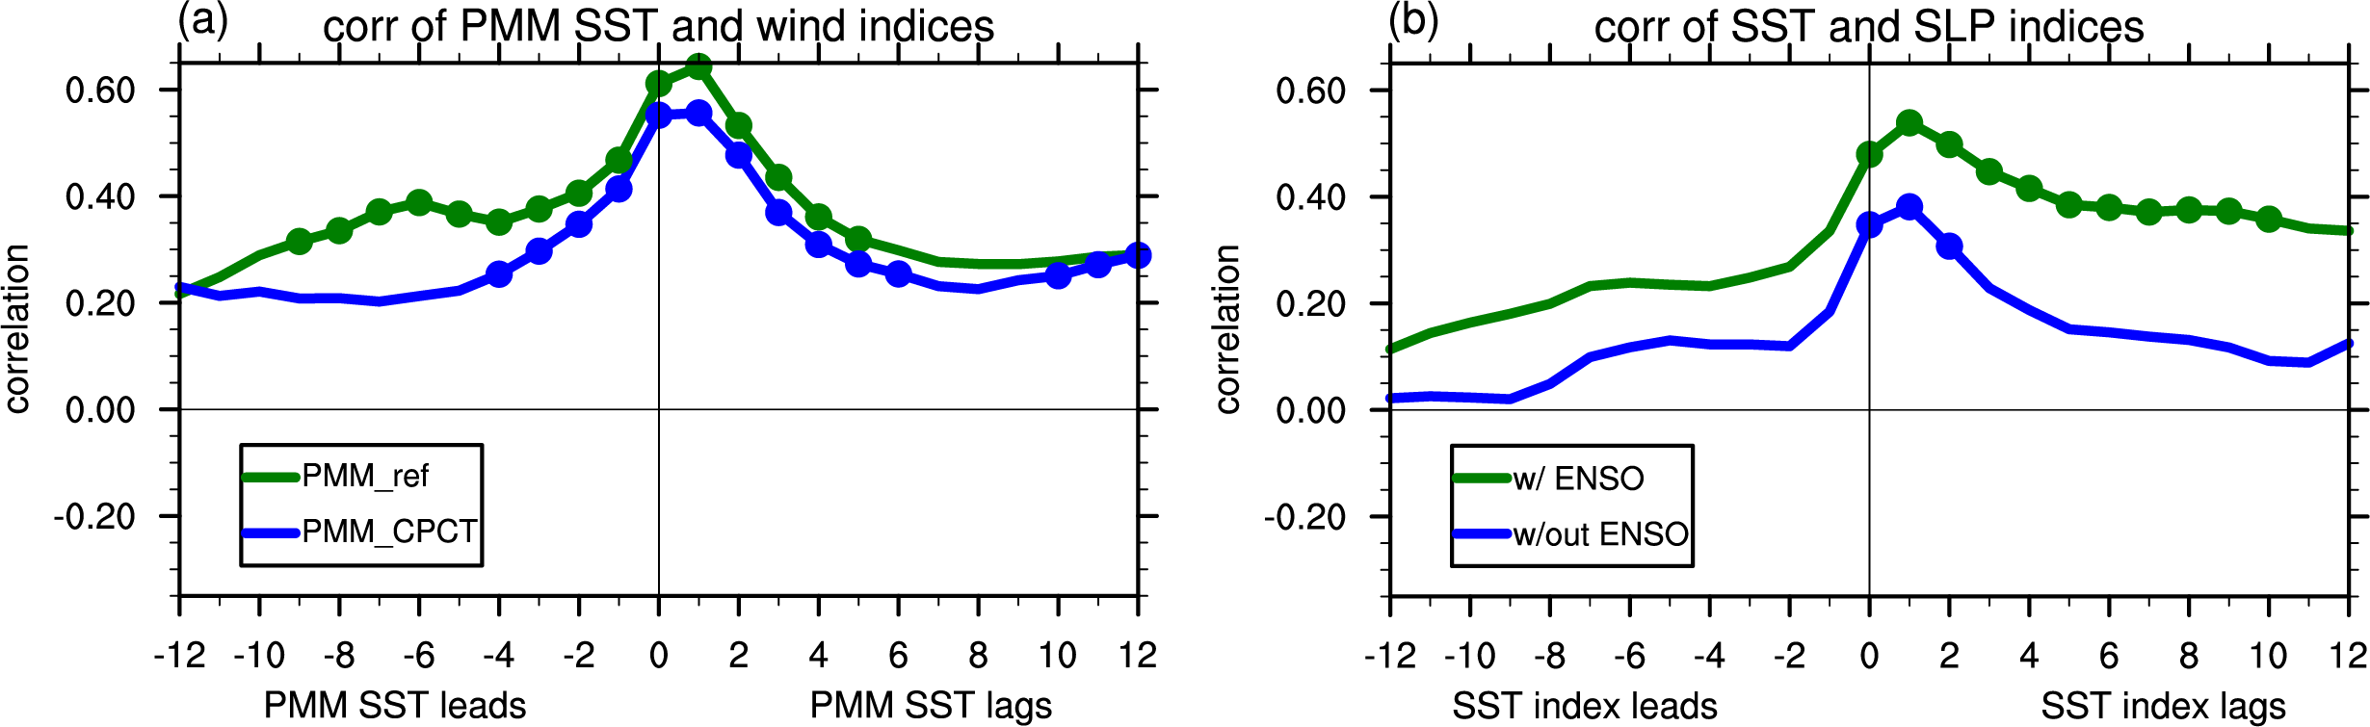

Supplementary Figure 3 | Relation between PMM-related SST and wind indices
a, Lagged regressions of the reference PMM SST and wind indices when the ENSO signal is removed by regressing out the CTI (green line) or the CPCT (blue line). Negative lags indicate that the PMM SST index leads the PMM wind index and vice versa. Values that are statistically significant at the 95% level, based on a two-tailed Student’s t-test, are marked by a filled circle. b, Similar to (a) but for simple area averages of SST (area shown in Fig. 1c) and SLP (area shown in Supplementary Fig. 2c) without ENSO removal (green line) and with CPCT removal (blue line).

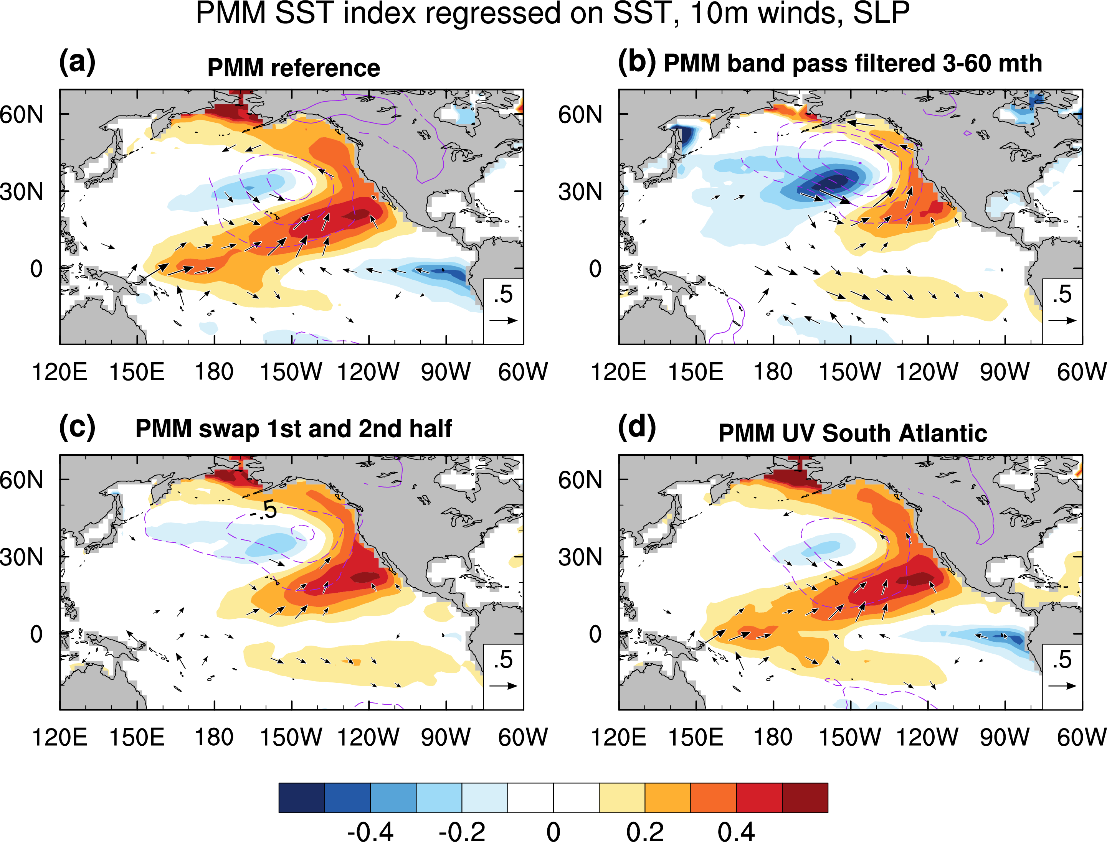
Supplementary Figure 4 | Sensitivity of the MCA-based PMM pattern. a, As in Fig. 1a, repeated for comparison. b, Similar to (a), but with band pass filtering applied to the input data sets prior to performing MCA. The band pass filter retains periods from 3 to 60 months. c, Similar to (a), but swaps the first and second half of the SST record prior to MCA. d, Similar to (a), but using winds from the South Atlantic and Southern Ocean (98W-0, 72-17S).

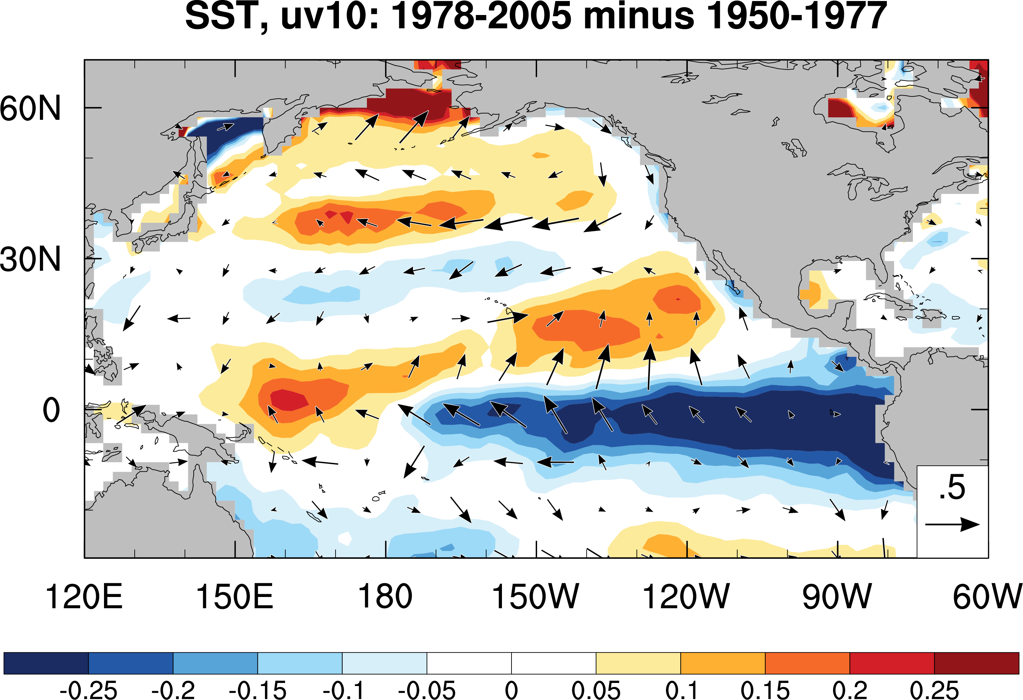

Supplementary Figure 5 | Pacific climate shift Difference between the period 1978-2005 and 1950-1977 for anomalous SST (shading; K) and 10m winds (vectors; reference 0.5 m/s). Data are from the NCEP/NCAR Reanalysis. Since the linear trends has been removed before the calculation, the differences suggest nonlinear changes, possibly related to the two super El Niños in 1982 and 1997, and to the so-called Pacific climate shift.

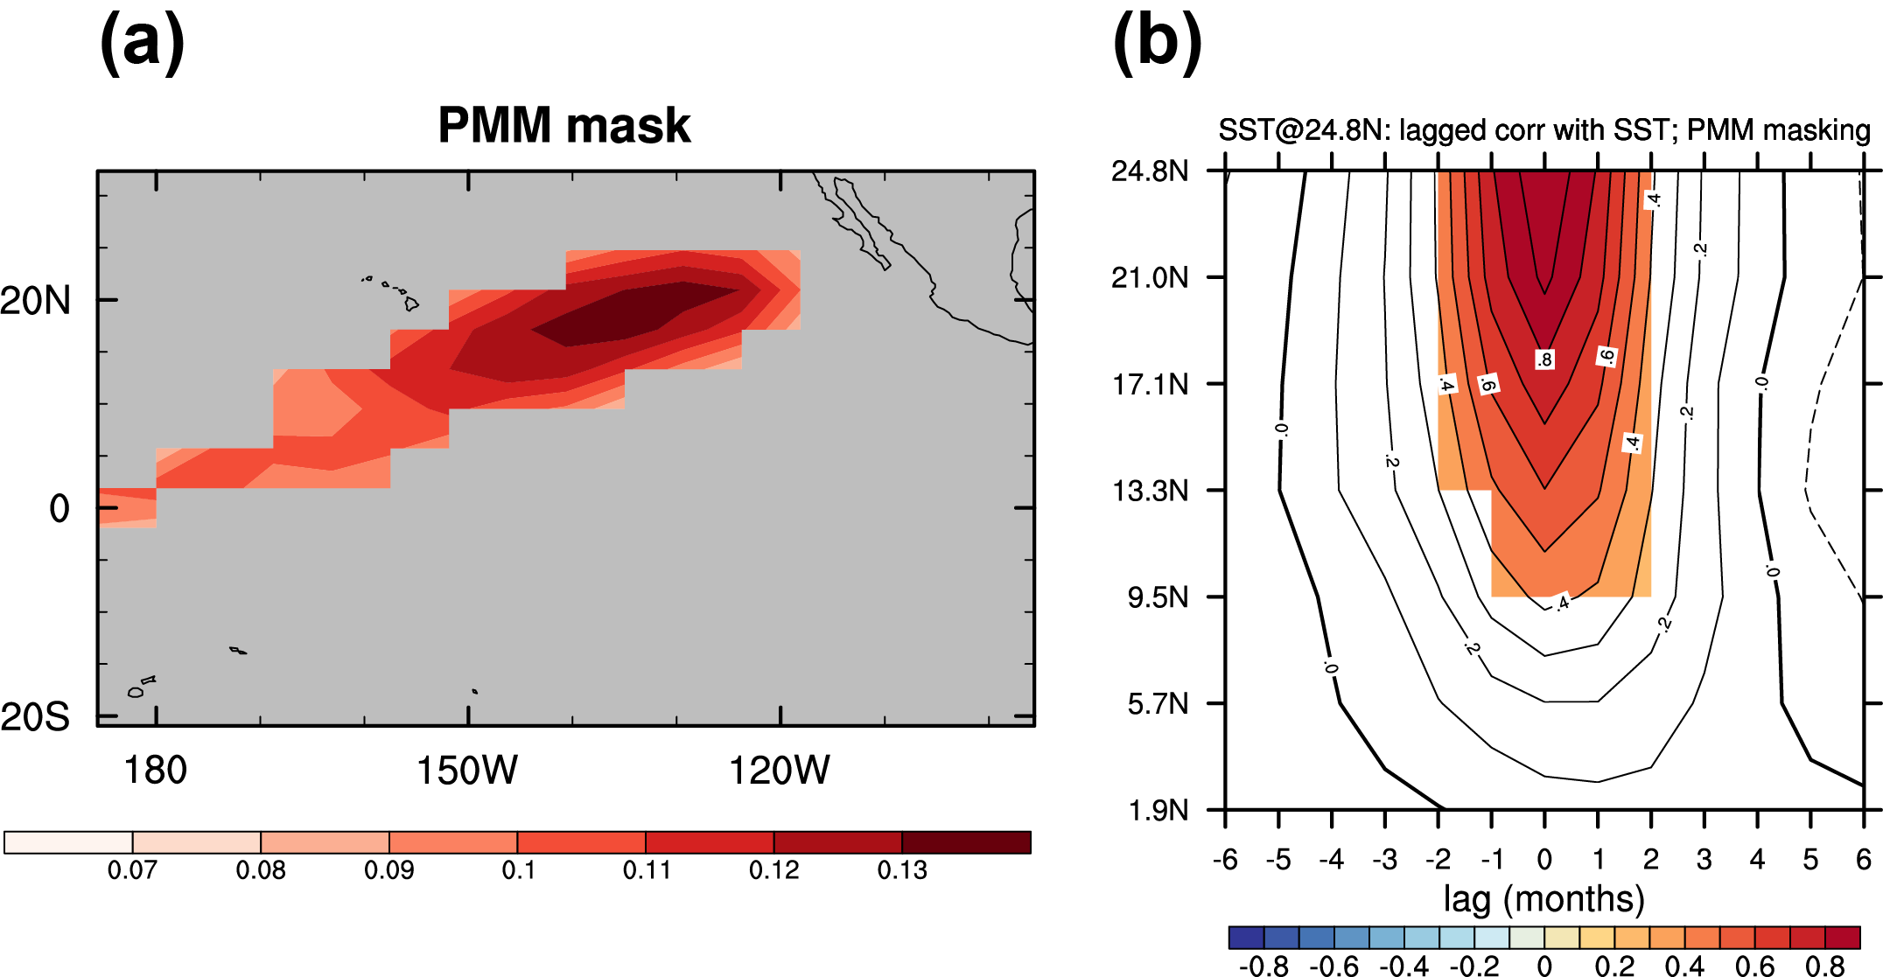

Supplementary Figure 6 | Assessing equatorward propagation of the PMM (a) Mask generated from the MCA SST pattern of the reference PMM. Values smaller than 0.08 are masked out. (b) Lagged correlations of SST anomalies at 24.8N with correlations at all latitudes. Positive lags indicate that the SST at 24.8N leads. For each latitude indicated on the y-axis, the SST are masked according to (a) and then zonally averaged. Prior to the correlation analysis, the data are band pass filtered in the 3-60 month range to focus on variability relevant to PMM propagation. The SST data are from the NCEP/NCAR reanalysis. The shading in (b) indicates correlations that pass the 95% significance test.

