Supporting Information S1 for
Sea coupling leads to a decrease in precipitation in East Asia under present day conditions that is partially alleviated in future simulations
Jing Peng*¹, Kai Li*^{1, 2}, Li Dan¹, Xiba Tang³, Zhongfeng Xu¹, Liwei Zou⁵, Hui Zheng¹, Taotao Zhang³

Contents of this file
Supplementary Table 1, Supplementary Figures 1, 2, 3, 4, 5, 6 and 7.
Introduction
The supporting information consists of supplemental figures.
Supplementary Figure1. Taylor diagram comparing the mean precipitation between simulations UNC (green) and CPL (red) with respect to the Tropical Rainfall Measuring Mission (TRMM) data during (1) June–July–August (summer) and (2) December–January–February (winter).
Supplementary Figure2. Spatial distributions of December–January–February (winter) climatology precipitation (mm day⁻¹) over the East Asia for the (a) observational Global Precipitation Climatology Project (GPCP), (b) CPL and (c) UNC during 1991-2014, and the differences between (d) CPL and UNC (CPL−UNC), (e) CPL and GPCP (CPL−GPCP), and (f) UNC and GPCP (UNC−GPCP).
Supplementary Figure3. The changes of mean precipitation after sea-coupling over the whole domain (red), the land (green) and ocean (blue) under present conditions during June-July-August (PJJA) and December-January-February (PDJF), as well as future conditions during June-July-August (FJJA) and December-January-February (FDJF). The black vertical lines represents ±1 standard deviation.
Supplementary Figure4. Spatial distributions of the differences between CPL and UCN for the historical (first row) and future (second row) periods and the changes for these differences between future and historical periods (bottom row) in the June–July–August (a–c) mean cloud fraction (%), (d–f) upward solar radiation (SWU, W m⁻²) and (g–i) downward longwave radiation (LWU, W m⁻²) in during (a, d, g) present day and (b, e, h) future conditions after sea coupling and (c, f, i) the differences between the future and present conditions are displayed in the bottom panel. The dotted areas indicate regions where the changes were statistically significant at the 95% confidence interval determined using Student’s t-test.
Supplementary Figure5. Spatial distributions of differences between CPL and UCN for the historical (first row) and future (second row) periods and the changes for these differences between future and historical periods (bottom row) in the June–July–August (a, g, n) downward solar radiation (SWD), (b, h, m) net solar radiation (SWN), (c, i, o) downward longwave radiation (LWD), (d, j, p) net longwave radiation, (e, k, q) sensible heat fluxes (SH) and (f, l, r) latent heat flux (LH) ) after sea coupling during present conditions (upper panel) and future conditions (middle panel). The differences between the future and present conditions are shown in the bottom panel. The gray shaded areas in first row and second row indicate regions where the changes were not statistically significant at the 95% confidence interval, determined using Student’s t-test.
Supplementary Figure6. The asymmetrical change in the thermal contrast between the land and sea (the area-weighted average temperature of the land between 0°–30°N minus the area-weighted average mean temperature of the ocean between 0°–30°N under present day conditions during June–July–August (JJA) and December–January–February (DJF) and under future conditions during June–July–August (JJA) and December–January–February (DJF). The black vertical lines represents ±1 SD. ‘P’ means the present conditions, and ‘F’ means the future conditions.
Supplementary Figure7. Changes in the mean latent heat fluxes (W m⁻²) after sea coupling over the whole sea (red), the offsea (green) and distant ocean (blue) under present day conditions during June–July–August (JJA) and December–January–February (DJF) and under future conditions during June–July–August (JJA) and December–January–February (DJF). ‘P’ means the present conditions, and ‘F’ means the future conditions.
The black vertical lines represents ±1 standard deviation.

Supplementary Table 1. June–July–August mean changes in the 2-m temperature, precipitation, upwelling longwave radiation, sensible heat fluxes and latent heat fluxes under present and future conditions after sea coupling. The percentages were calculated based on the changes attributed to sea coupling relative to the averages of each variable from simulation UNC.
Variable | Present |  |  |  |  |  | Future
Variable | Total domain |  | Land |  | Ocean |  | Total domain |  | Land |  | Ocean
Variable | Change | Change (%) | Change | Change (%) | Change | Change (%) | Change | Change (%) | Change | Change (%) | Change | Change (%)
Surface air temperature (°C) | −0.86±1.14** | −0.29±0.38 | −1.02±1.17** | −0.34±0.39 | −0.70±1.13** | −0.23±0.38 | −0.82±1.25** | −0.27±0.42 | −0.73±1.24** | −0.25±0.42 | −0.90±1.27** | −0.3±0.42
Precipitation (mm day⁻¹) | −0.080±0.40 | −0.78±4.23 | −0.13±0.28 | −1.47±2.39 | −0.032±0.77 | −0.03±7.20 | 0.054±0.30 | 0.66±3.23 | 0.014±0.25 | 0.21±2.82 | 0.09±0.61 | 1.25±6.25
Upwelling shortwave radiation at the surface(W m⁻²) | 0.82±0.32** | 2.45±0.96 | 1.46±0.67** | 3.23±1.48 | 0.20±0.18** | 0.89±0.84 | 0.04±0.13 | 0.12±0.74 | 0.33±0.54 | 0.71±1.17 | **−0.24±0.16 | −1.05±0.68
Surface sensible heat flux (W m⁻²) | −1.84±1.00** | −5.81±3.09 | −4.46±2.15** | −7.69±3.61 | 0.71±0.47** | 12.71±9.29 | −0.51±0.68** | −1.74±2.31 | −0.87±1.17** | −1.65±2.20 | −0.16±0.47 | −1.98±7.96
Surface latent heat flux (W m⁻²) | 3.69±3.64** | 3.36±3.35 | 6.91±3.31** | 6.32±3.07 | 0.57±5.84 | 0.71±5.17 | −0.16±3.37 | −0.07±2.94 | 1.53±1.74** | 1.31±1.50 | −1.80±6.58 | −1.28±5.79
Note: The double star simbols indicate the changes were statistically significant at the 95% confidence interval determined using Student’s t-test.

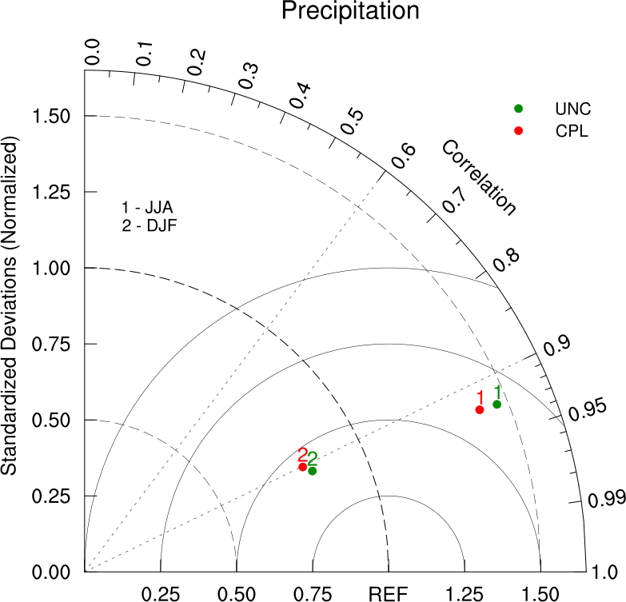
Supplementary Figure1. Taylor diagram comparing the mean precipitation between simulations UNC (green) and CPL (red) with respect to the Tropical Rainfall Measuring Mission (TRMM) data during (1) June–July–August (summer) and (2) December–January–February (winter).

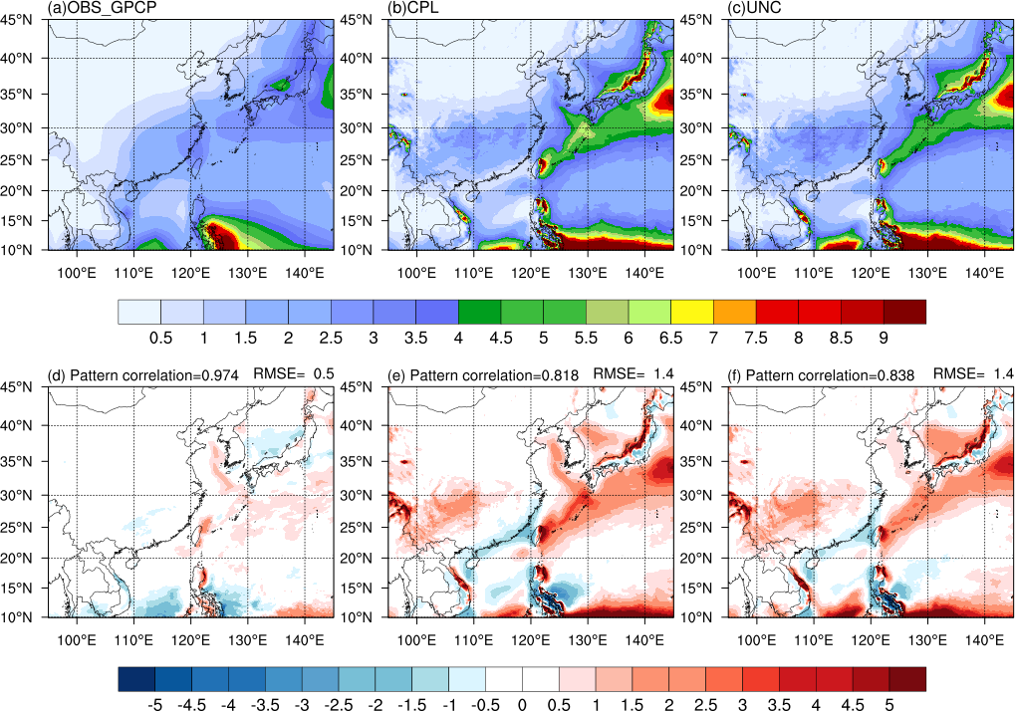
Supplementary Figure2. Spatial distributions of December–January–February (winter) climatology precipitation (mm day⁻¹) over the East Asia for the (a) observational Global Precipitation Climatology Project (GPCP), (b) CPL and (c) UNC during 1991-2014, and the differences between (d) CPL and UNC (CPL−UNC), (e) CPL and GPCP (CPL−GPCP), and (f) UNC and GPCP (UNC−GPCP).

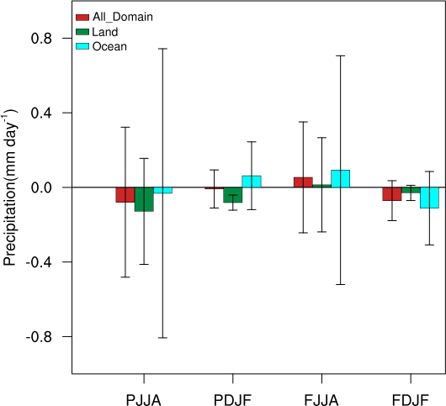
Supplementary Figure3. The changes of mean precipitation after sea-coupling over the whole domain (red), the land (green) and ocean (blue) under present conditions during June-July-August (PJJA) and December-January-February (PDJF), as well as future conditions during June-July-August (FJJA) and December-January-February (FDJF). The black vertical lines represents ±1 standard deviation.

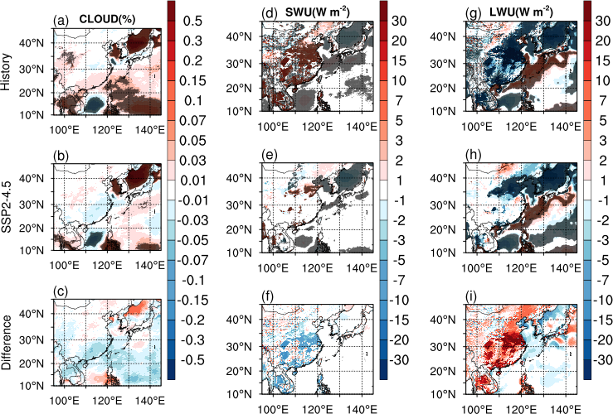
Supplementary Figure4. Spatial distributions of the differences between CPL and UCN for the historical (first row) and future (second row) periods and the changes for these differences between future and historical periods (bottom row) in the June–July–August (a–c) mean cloud fraction (%), (d–f) upward solar radiation (SWU, W m⁻²) and (g–i) downward longwave radiation (LWU, W m⁻²) in during (a, d, g) present day and (b, e, h) future conditions after sea coupling and (c, f, i) the differences between the future and present conditions are displayed in the bottom panel. The dotted areas indicate regions where the changes were statistically significant at the 95% confidence interval determined using Student’s t-test.

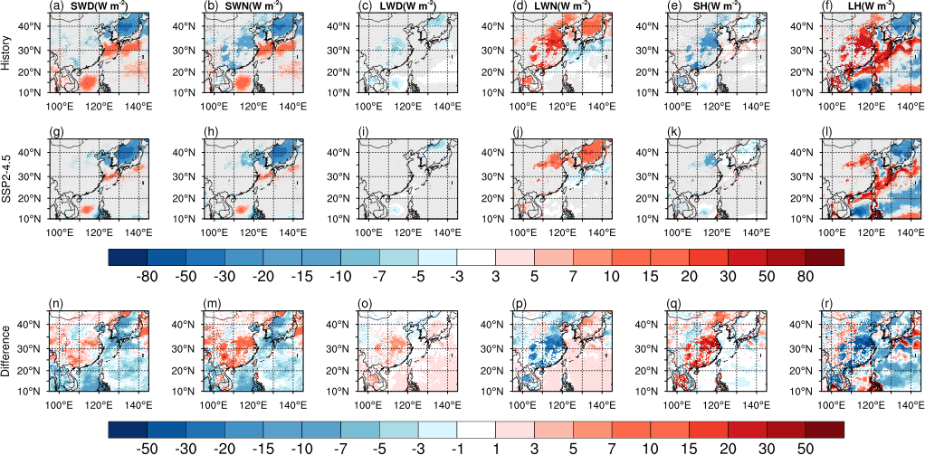
Supplementary Figure5. Spatial distributions of differences between CPL and UCN for the historical (first row) and future (second row) periods and the changes for these differences between future and historical periods (bottom row) in the June–July–August (a, g, n) downward solar radiation (SWD), (b, h, m) net solar radiation (SWN), (c, i, o) downward longwave radiation (LWD), (d, j, p) net longwave radiation, (e, k, q) sensible heat fluxes (SH) and (f, l, r) latent heat flux (LH) ) after sea coupling during present conditions (upper panel) and future conditions (middle panel). The differences between the future and present conditions are shown in the bottom panel. The gray shaded areas in first row and second row indicate regions where the changes were not statistically significant at the 95% confidence interval, determined using Student’s t-test.

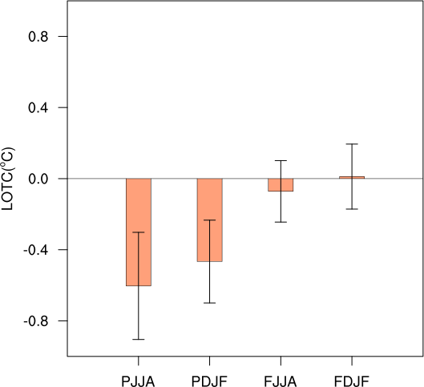
Supplementary Figure6. The asymmetrical change in the thermal contrast between the land and sea (the area-weighted average temperature of the land between 0°–30°N minus the area-weighted average mean temperature of the ocean between 0°–30°N under present day conditions during June–July–August (JJA) and December–January–February (DJF) and under future conditions during June–July–August (JJA) and December–January–February (DJF). The black vertical lines represents ±1 SD. ‘P’ means the present conditions, and ‘F’ means the future conditions.

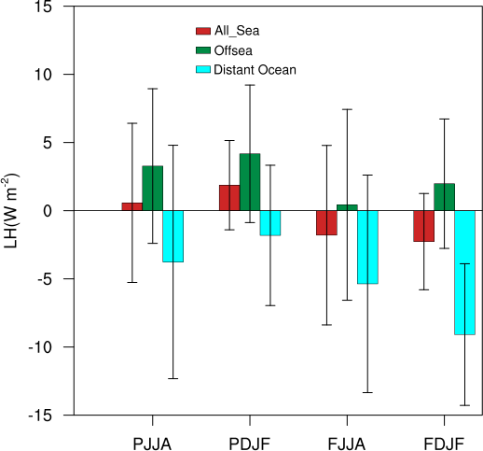
Supplementary Figure7. Changes in the mean latent heat fluxes (W m⁻²) after sea coupling over the whole sea (red), the offsea (green) and distant ocean (blue) under present day conditions during June–July–August (JJA) and December–January–February (DJF) and under future conditions during June–July–August (JJA) and December–January–February (DJF). ‘P’ means the present conditions, and ‘F’ means the future conditions.
The black vertical lines represents ±1 standard deviation.

*Corresponding author: Jing Peng, E-mail: pengjing@tea.ac.cn; *Kai Li, E-mail: likai@tea.ac.cn

