Supplementary Information
Mapping the seamless hourly surface visibility in China: a real-time retrieval framework using a machine-learning-based stacked ensemble model
Xutao Zhang¹, Ke Gui^{1, *}, Zhaoliang Zeng², Ye Fei³, Lei Li¹, Yu Zheng¹, Yue Peng¹, Yurun Liu⁴, Nanxuan Shang¹, Hengheng Zhao¹, Wenrui Yao¹, Hong Wang¹, Zhili Wang¹, Yaqiang Wang², Huizheng Che^{1,*}, Xiaoye Zhang¹
¹State Key Laboratory of Severe Weather & Key Laboratory of Atmospheric Chemistry of CMA, Chinese Academy of Meteorological Sciences, Beijing, 100081, China
² Institute of Artificial Intelligence for Meteorological, Chinese Academy of Meteorological Sciences,
Beijing, 100081, China
³ National Meteorological Information Center, Beijing, 100081, China
⁴ Plateau Atmospheric and Environment Key Laboratory of Sichuan Province, College of Atmosphere Sciences, Chengdu University of Information Technology, Chengdu, 610225, China
* Corresponding authors.
E-mail addresses: guik@cma.gov.cn (K. Gui) and chehz@cma.gov.cn (H. Che)

Supplementary Table 1. Key parameter information of the five base models used in this study.
Model | Parameters
MLP | Number of hidden layers | 7
MLP | Number of neurons per hidden layer | (32, 64, 128, 256, 256, 128, 32)
MLP | Activation function | ReLU
RF | Max depth | 26
RF | Estimators | 100
CatBoost | Estimators | 10000
CatBoost | Learning rate | 0.02
CatBoost | Max depth | 16
CatBoost | Growth policy | Depth wise
LightGBM | Estimators | 10000
LightGBM | Learning rate | 0.02
LightGBM | Max depth | 23
XGBoost | Estimators | 10000
XGBoost | Learning rate | 0.02
XGBoost | Max depth | 16

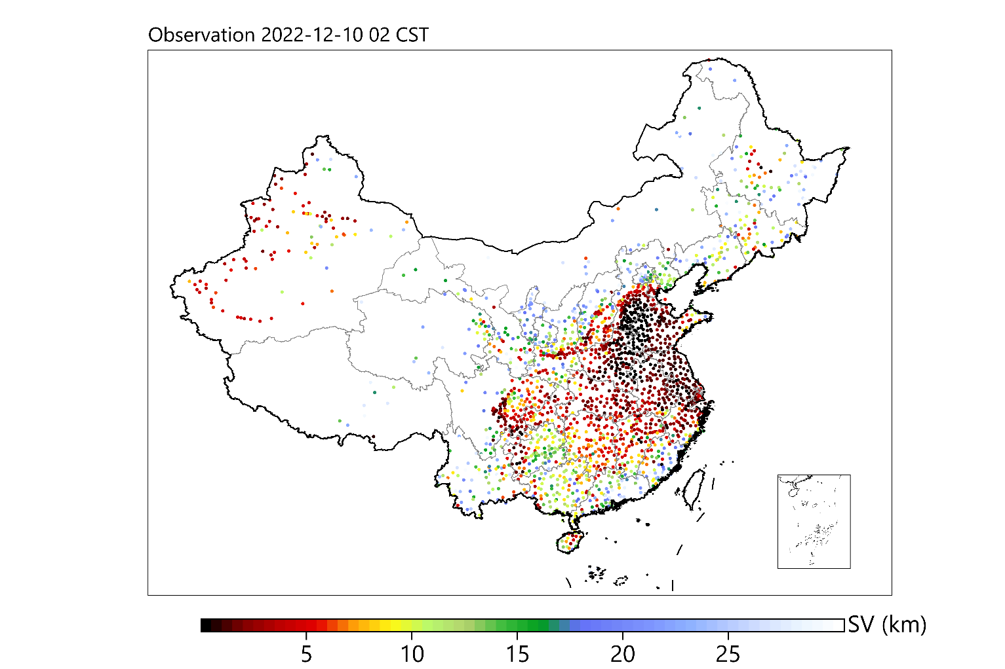
Supplementary Figure 1. Spatial distribution of observed surface visibility (SV) at 02:00 CST (China Standard Time) on December 10, 2022.

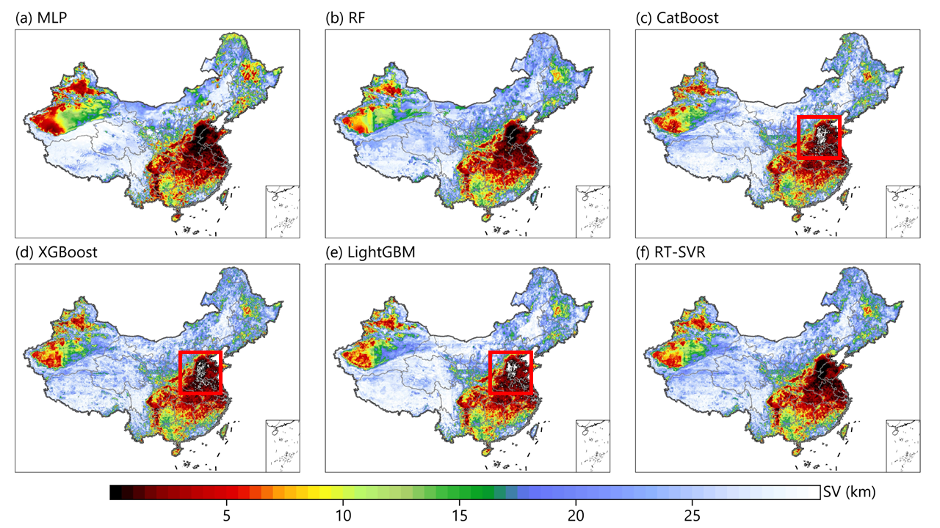
Supplementary Figure 2. Spatial distribution of estimated SV at 02:00 CST on December 10, 2022 from (a) MLP, (b) RF, (c) CatBoost, (d) XGBoost, (e) LightGBM, and (f) the RT-SVR model. Red boxes indicate regions of negative retrieval values.

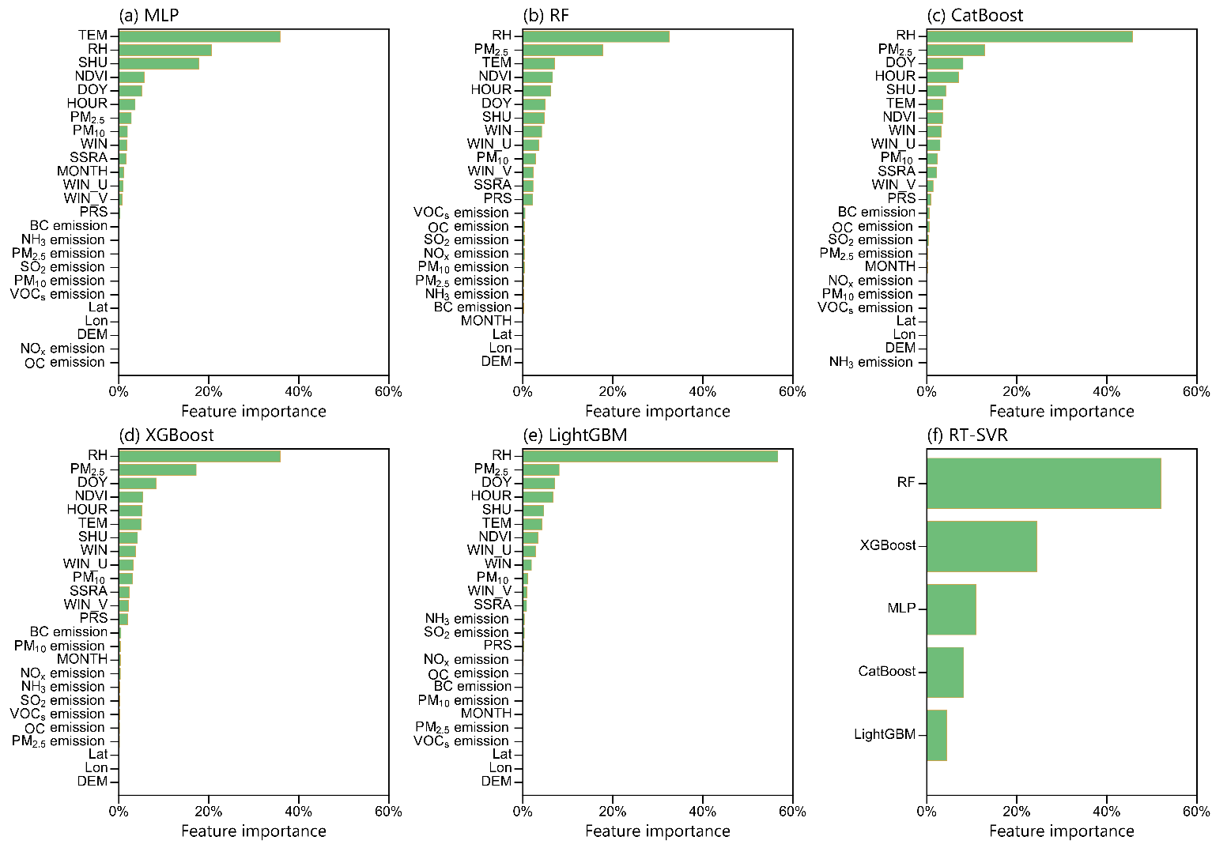
Supplementary Figure 3. Relative importance of features in the (a) MLP, (b) RF, (c) CatBoost, (d) XGBoost, and (e) LightGBM models. (f) Relative importance of each independent base model to the RT-SVR model. TEM: surface temperature at 2-m height; RH: surface relative humidity; SHU: specific humidity at 2-m height; WIN: wind speed at 10-m height; WIN_U: U wind component at 10-m height; WIN_V: V wind component at 10-m height; SSRA: downward shortwave radiation flux; PRS: surface pressure; DOY: day of year; Lat: latitude; Lon: longitude; DEM: elevation; NDVI: normalized difference vegetation index; SO₂: sulfur dioxide; OC: organic carbon; BC: black carbon; NO_{x}: nitrogen oxides; NH₃: ammonia; VOCs: volatile organic compounds.

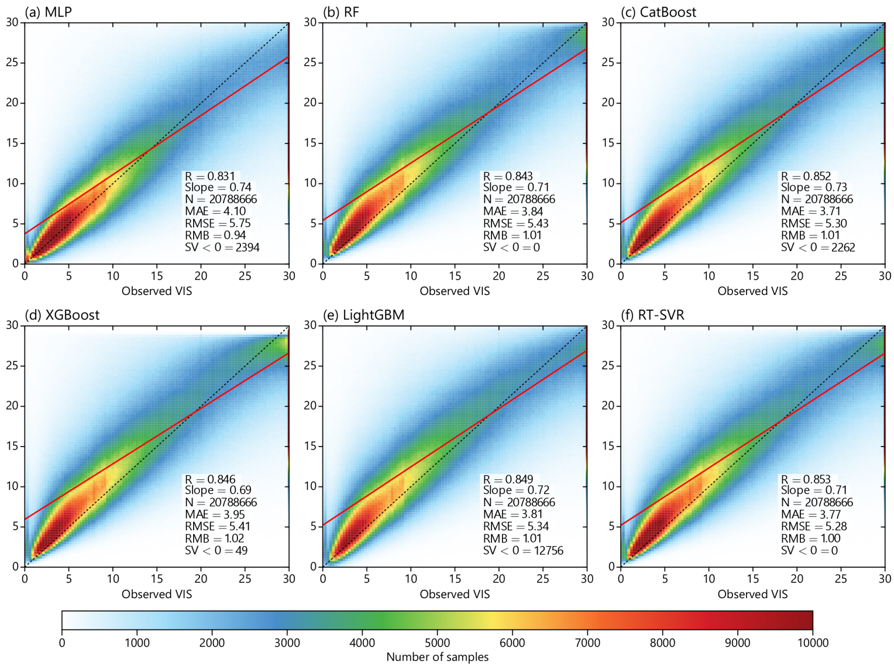
Supplementary Figure 4. Density scatterplot between observed SV and estimated SV across China for the hindcast-validation (HV) experiments in 2022 from (a) MLP, (b) RF, (c) CatBoost, (d) XGBoost, (e) LightGBM, and (f) RT-SVR. Results are based on hourly temporal resolution.

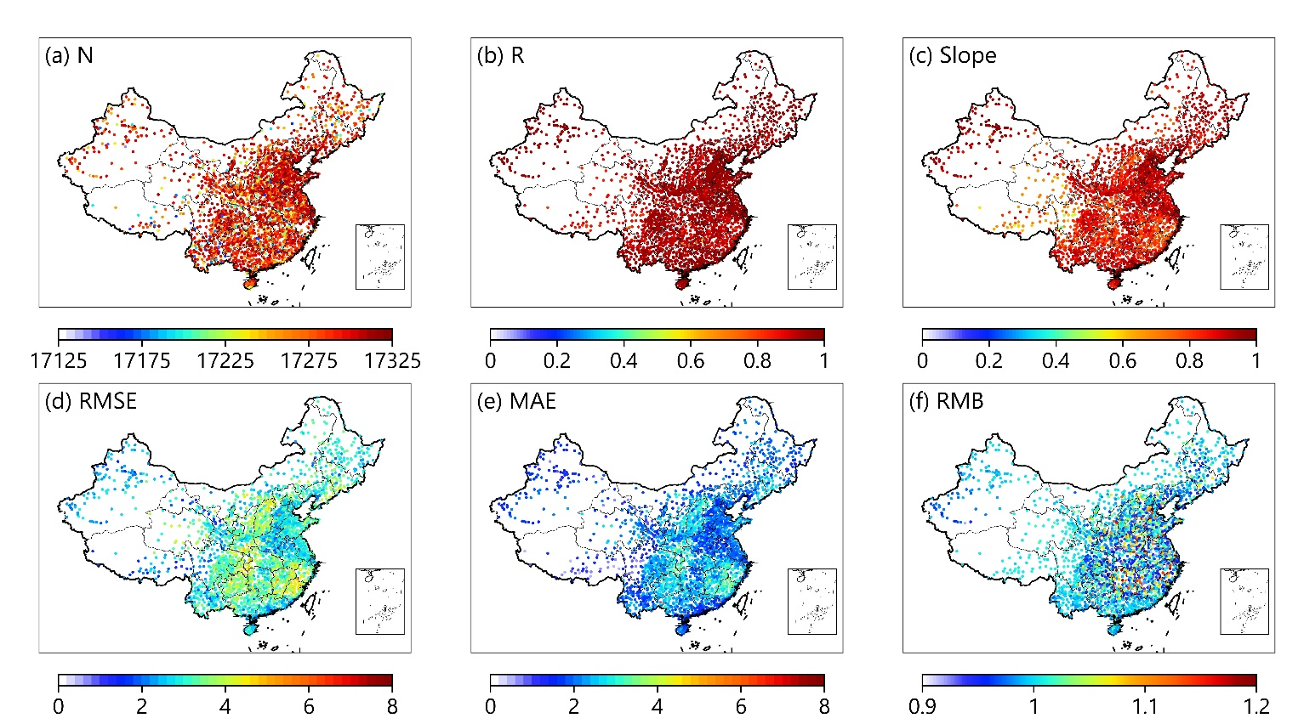
Supplementary Figure 5. Spatial distribution of statistical results for the 5-fold cross-validation (CV), including (a) number of sample matchups (N), (b) Pearson correlation coefficient (R), (c) slope, (d) root mean square error (RMSE), (e) mean absolute error (MAE), and (f) relative mean bias (RMB) at each SV site from 2020–2021 across China.

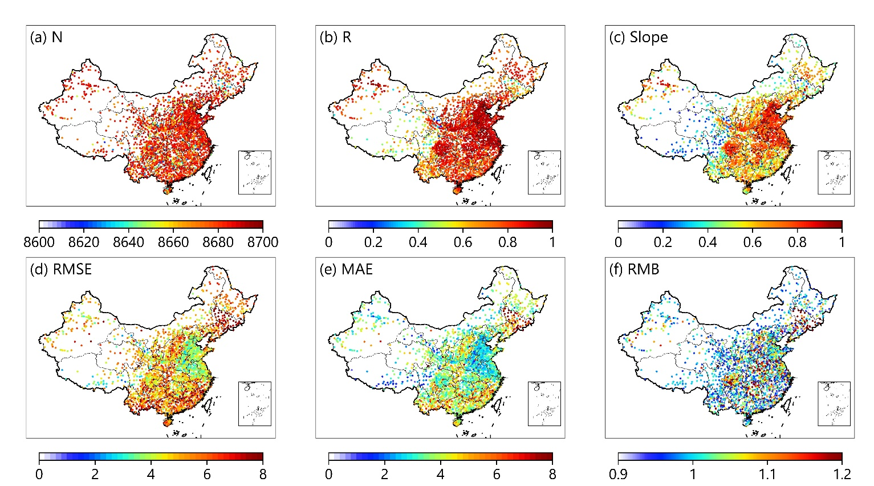
Supplementary Figure 6. Same as Supplementary Figure 5 but for the statistical results of the HV experiment in 2022.

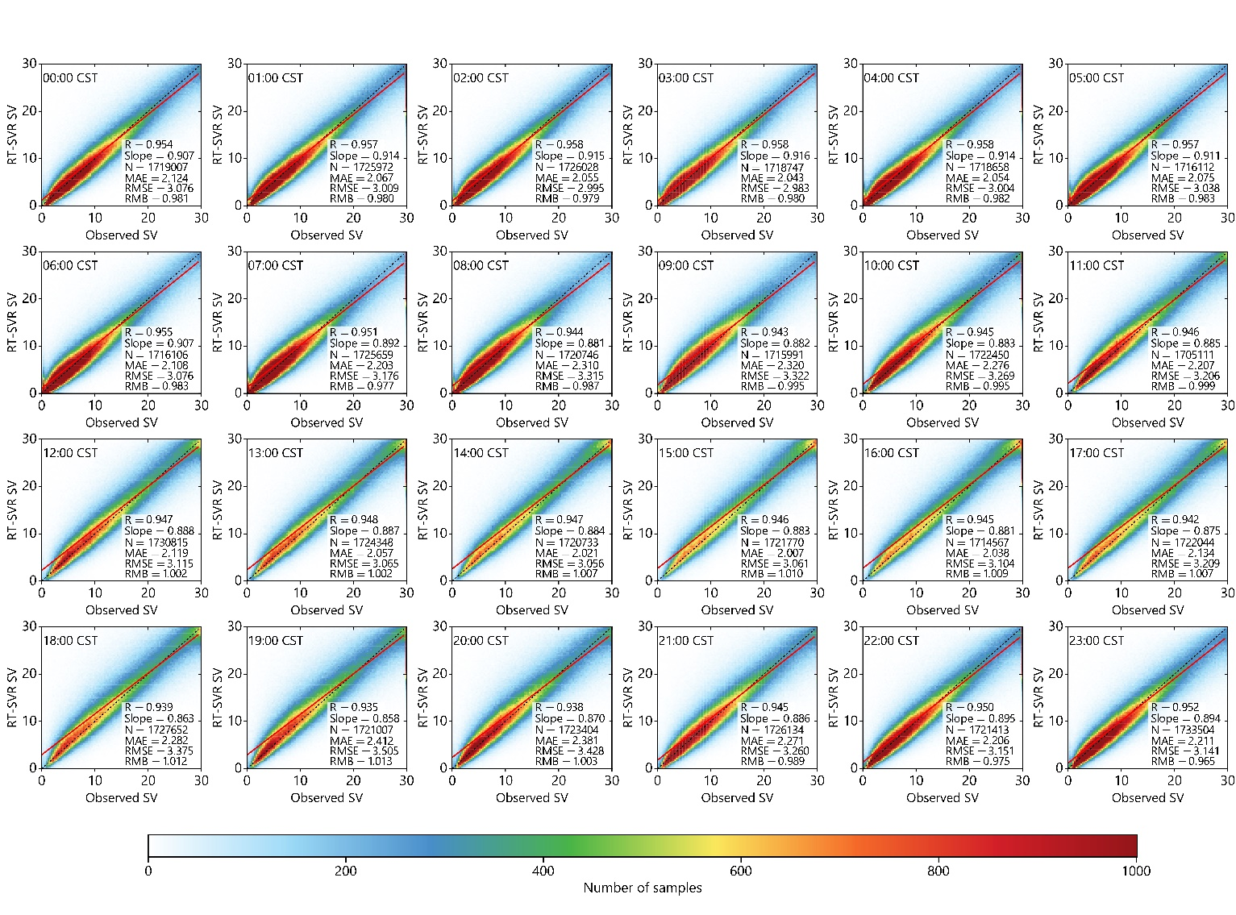
Supplementary Figure 7. Density scatterplots between observed hourly SV and estimated hourly SV across China for the sample-based 5-fold CV from 2020–2021. CV results are given on an hourly basis.

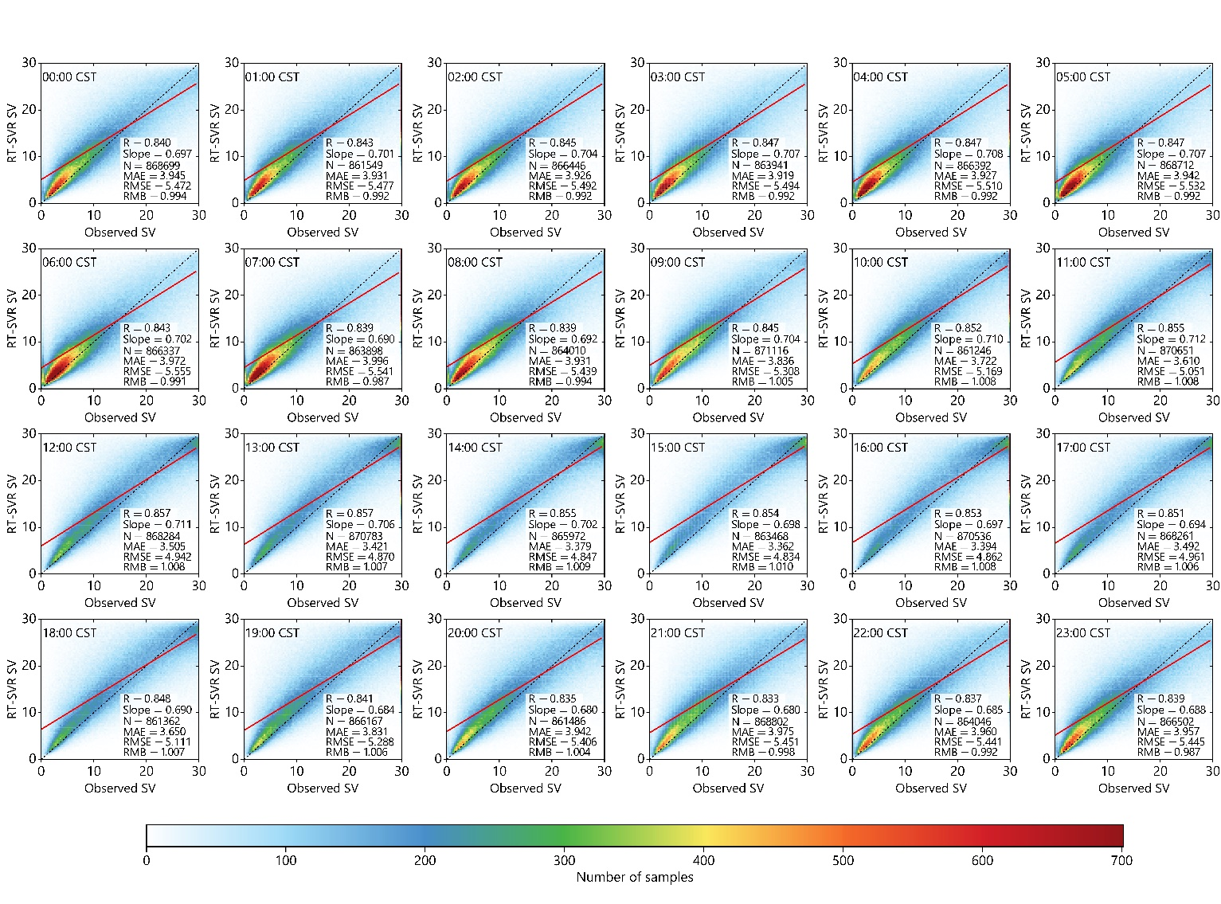
Supplementary Figure 8. Same as Supplementary Figure 7 but for the statistical results of the HV experiment in 2022.
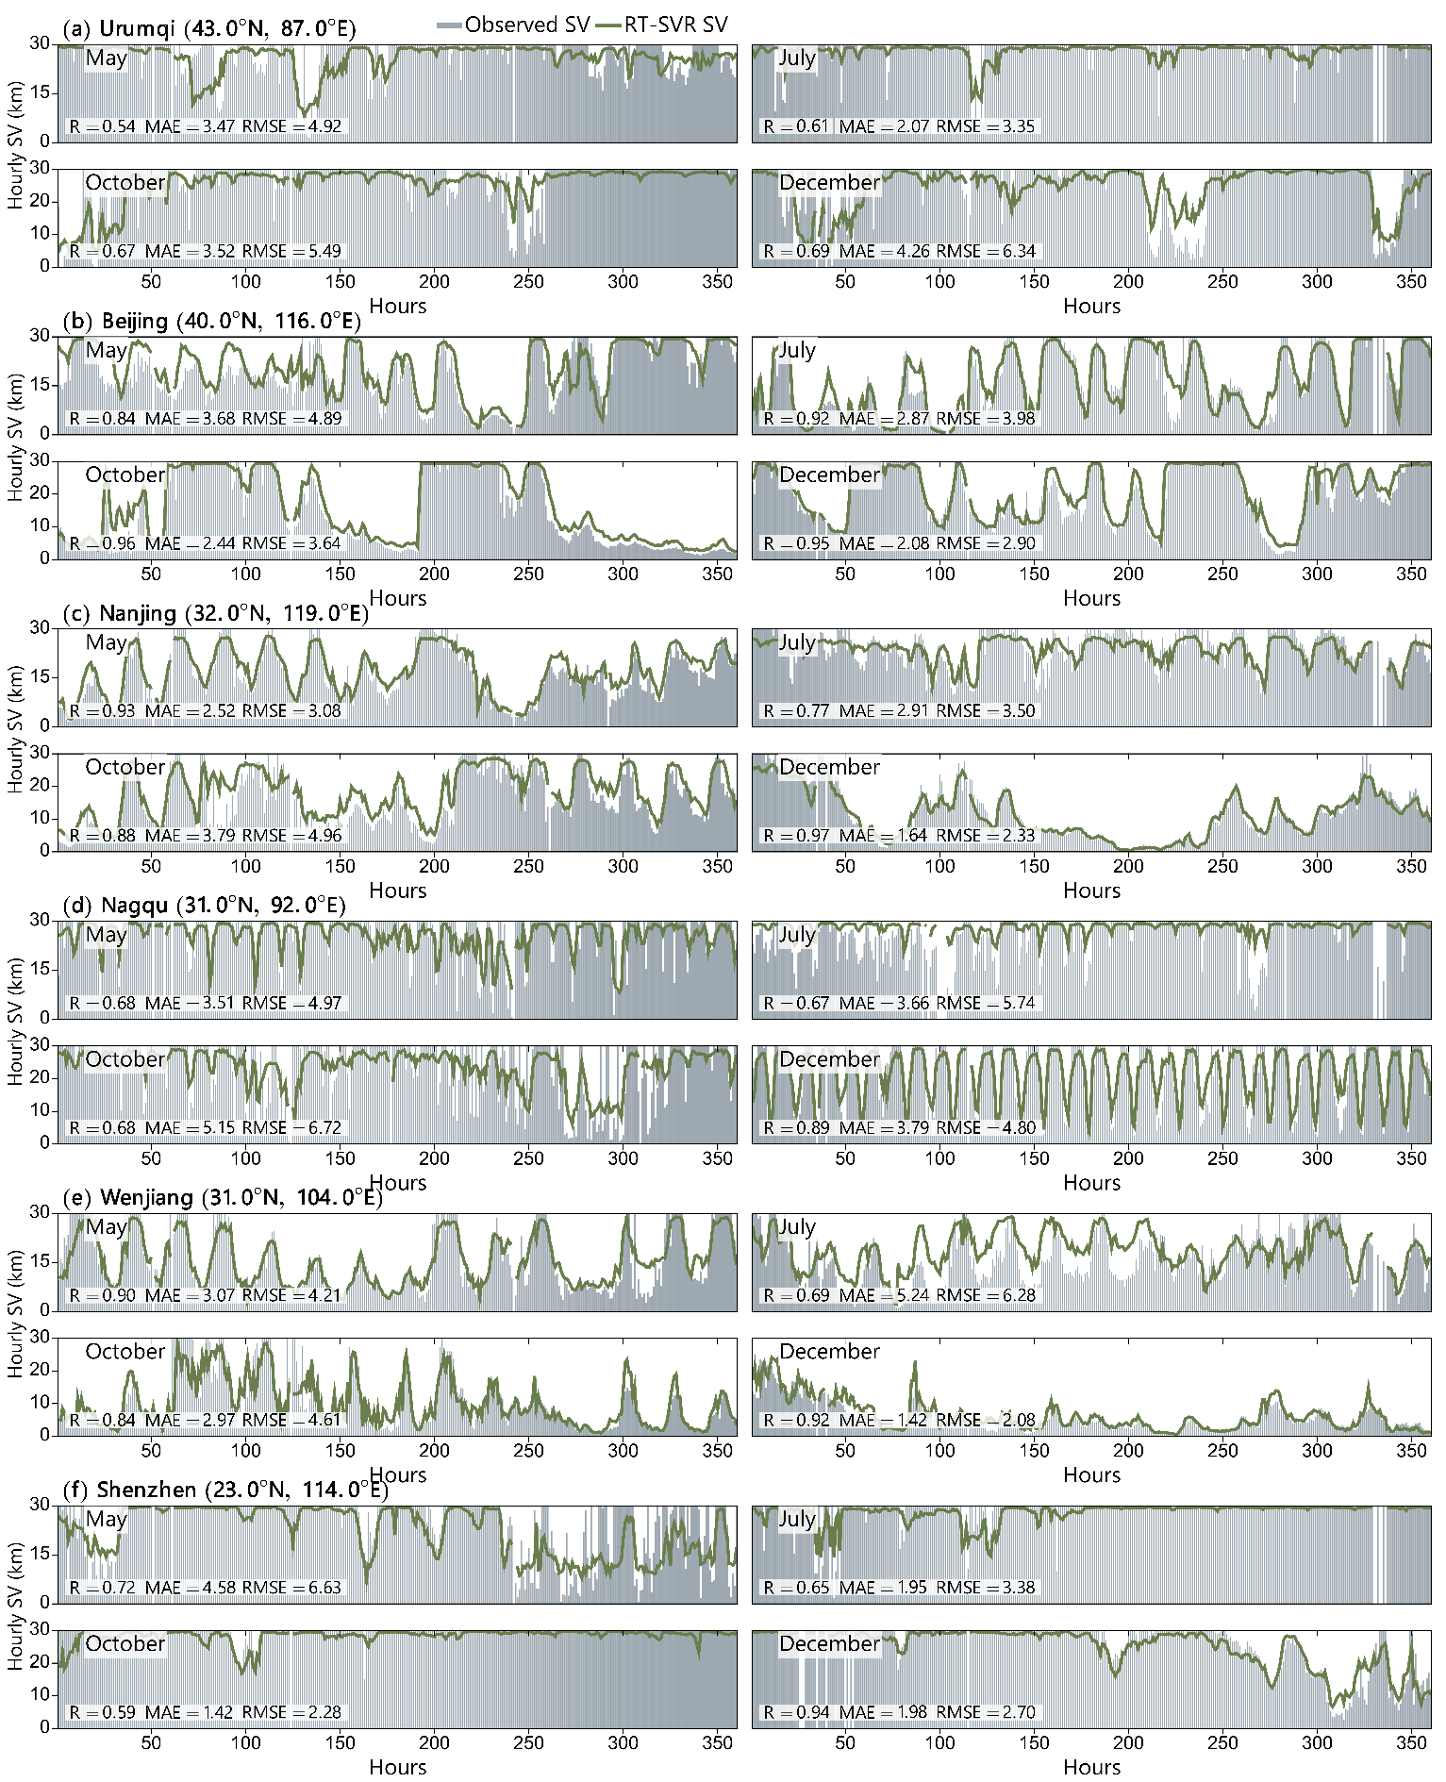
Supplementary Figure 9. Site-based performance of the RT-SVR model for the HV experiment in 2022. Comparison of hourly SV time series from the observations and the RT-SVR model at six different sites in China: (a) Urumqi, (b) Beijing, (c) Nanjing, (d) Nagqu, (e) Wenjiang, and (f) Shenzhen. Geographic locations of the six independent sites are shown in Fig. 3g. For clearer presentation, only the first 15 days of a specific month (May for spring; July for summer; October for autumn; December for winter) in each of the four seasons are shown here.
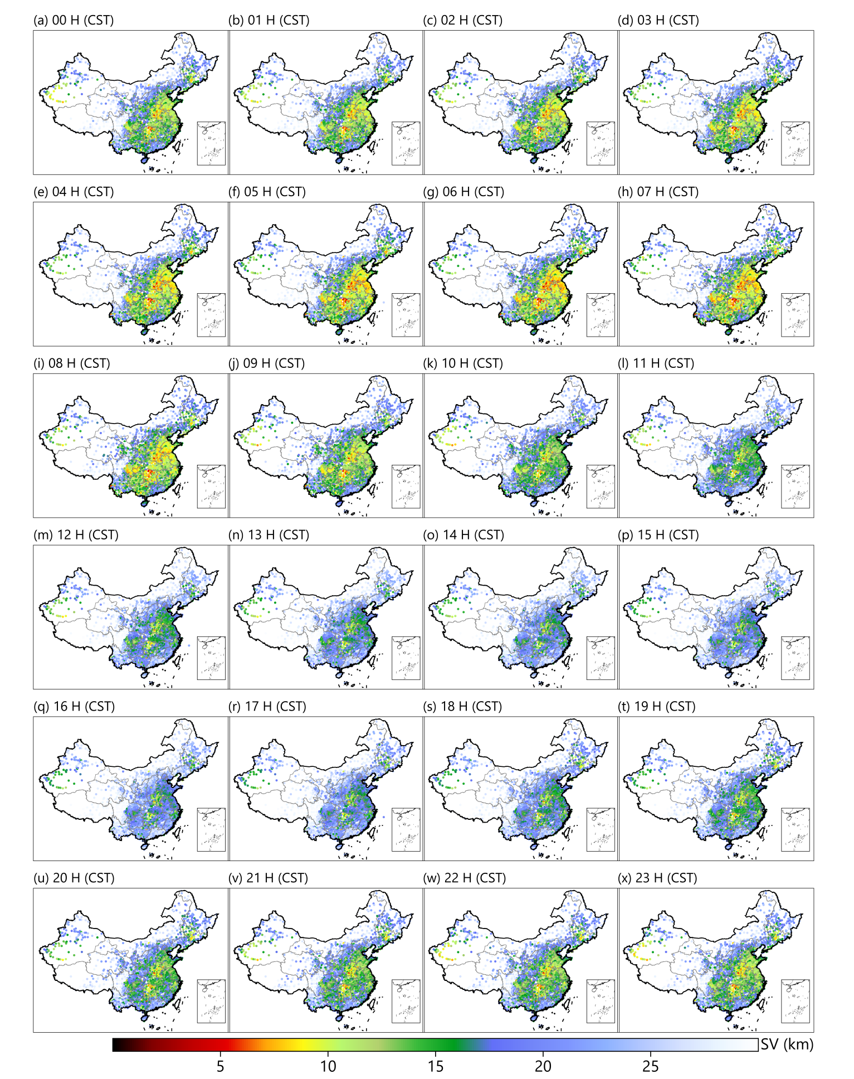
Supplementary Figure 10. Multiyear averaged hour-by-hour SV observation maps during 2020–2022.

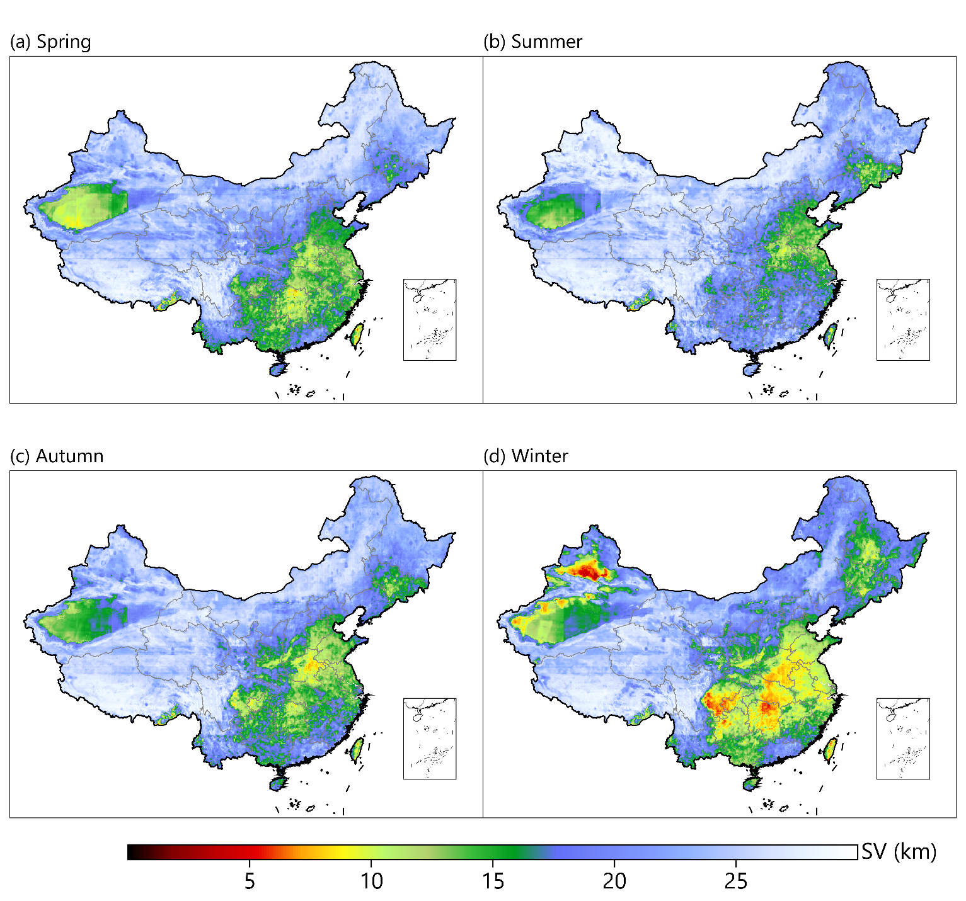
Supplementary Figure 11. Multiyear averaged seasonal SV maps retrieved from the RT-SVR model during 2020–2022.

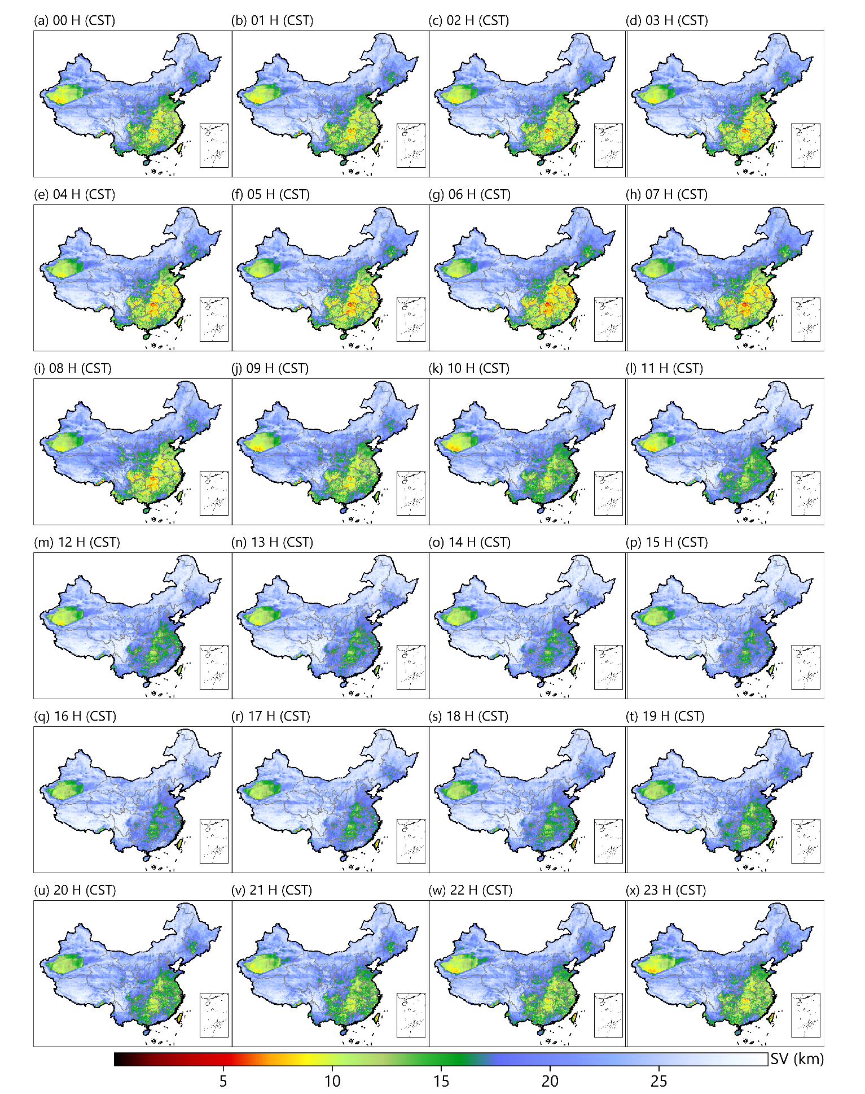

Supplementary Figure 12. Multiyear averaged hour-by-hour SV maps retrieved from the RT-SVR model during 2020–2022 in spring.

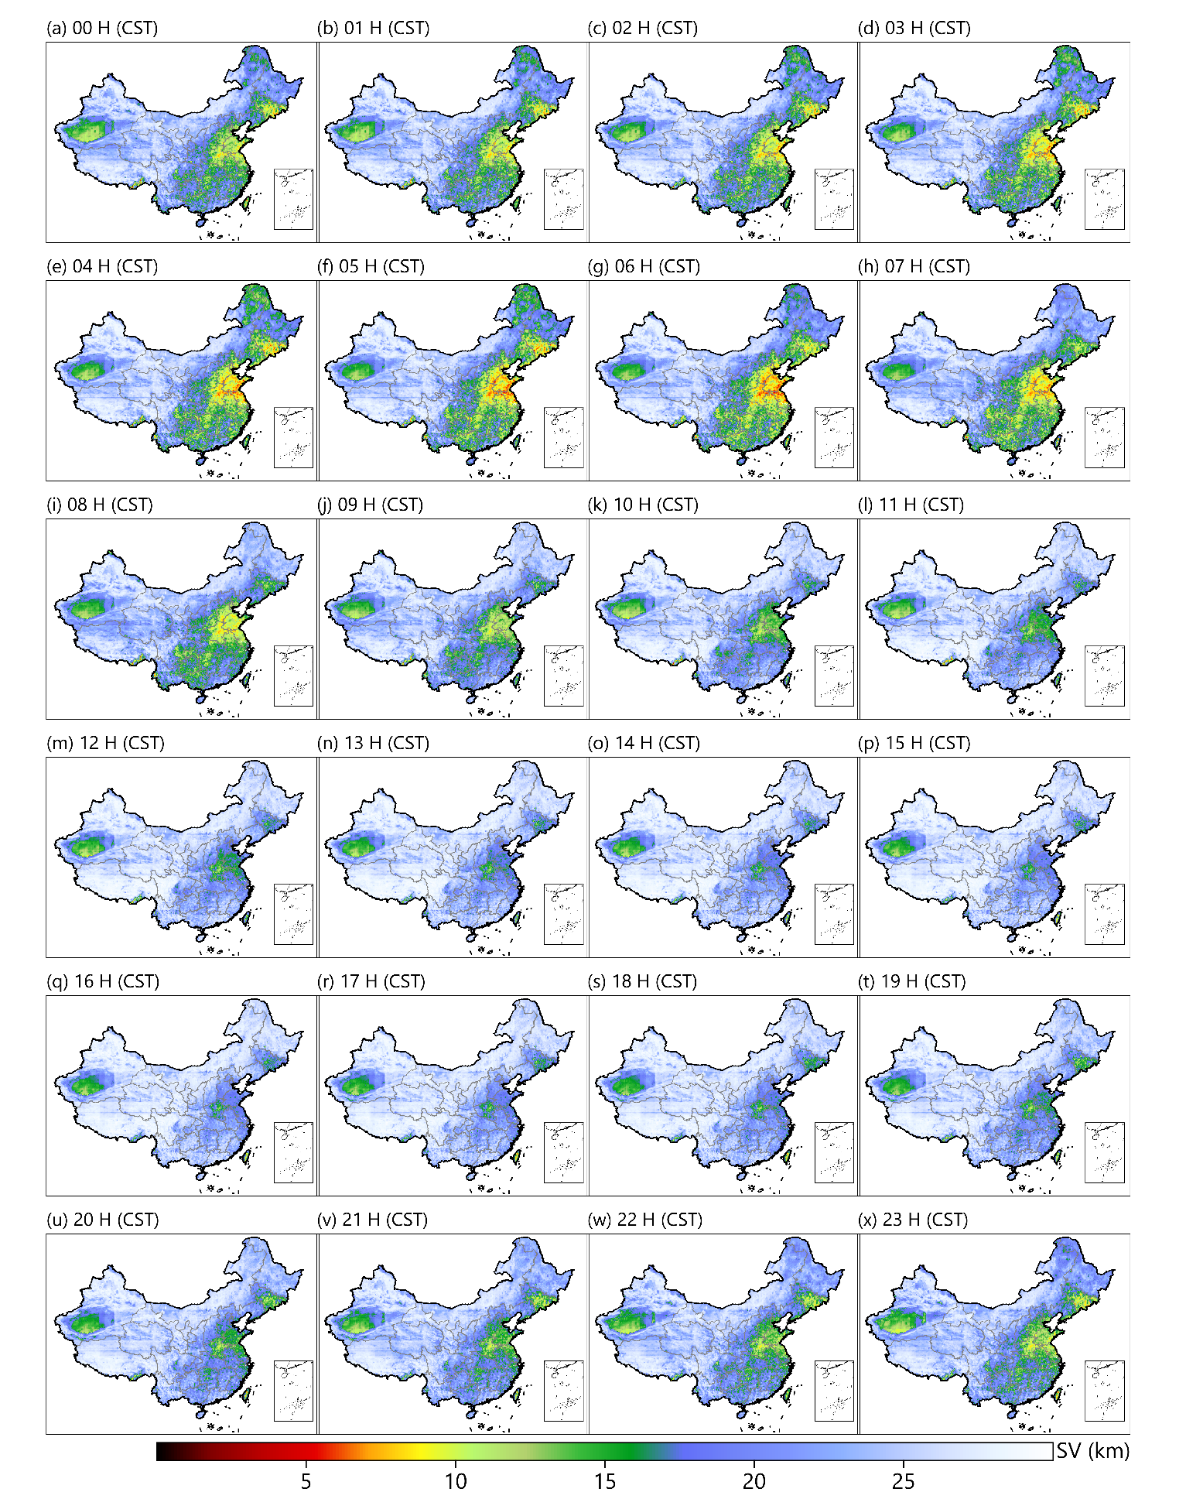
Supplementary Figure 13. Same as Supplementary Figure 12 but for summer.

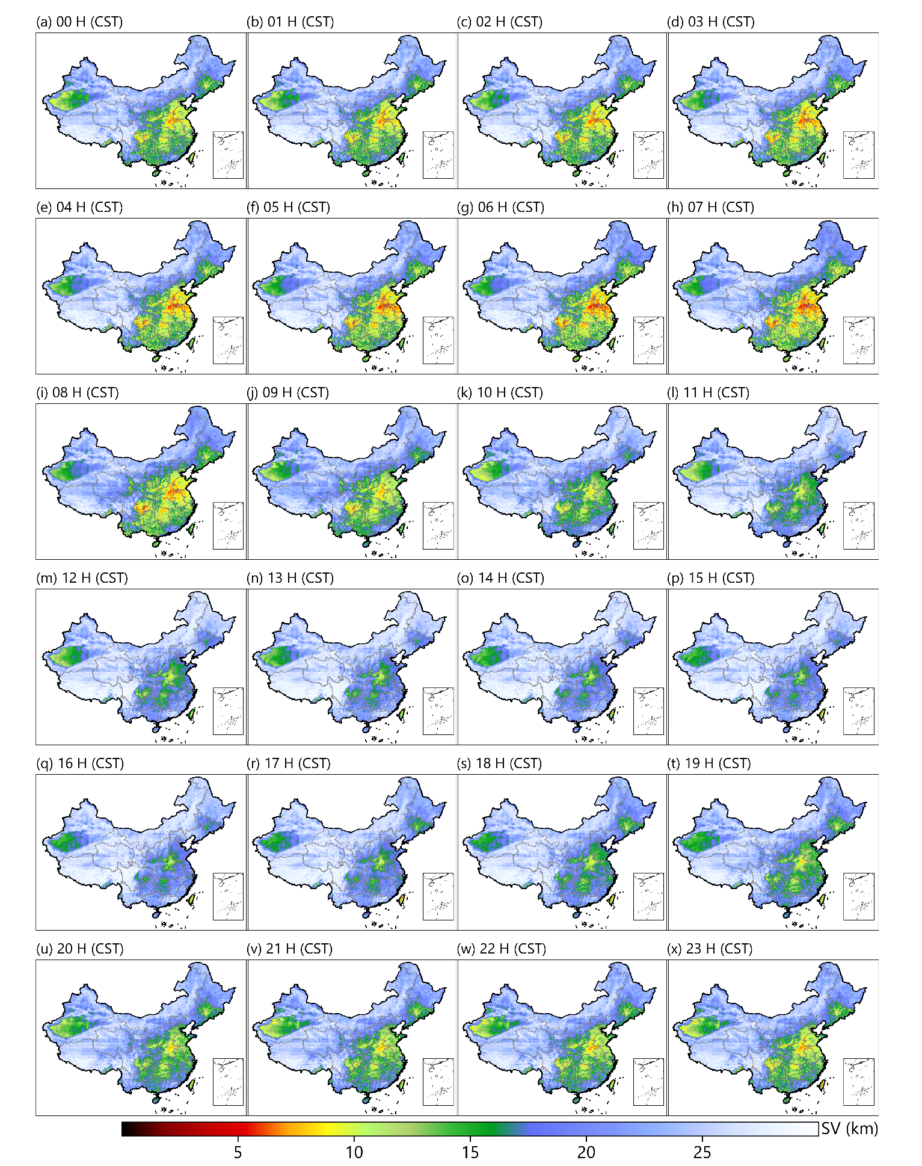
Supplementary Figure 14. Same as Supplementary Figure 12 but for autumn.

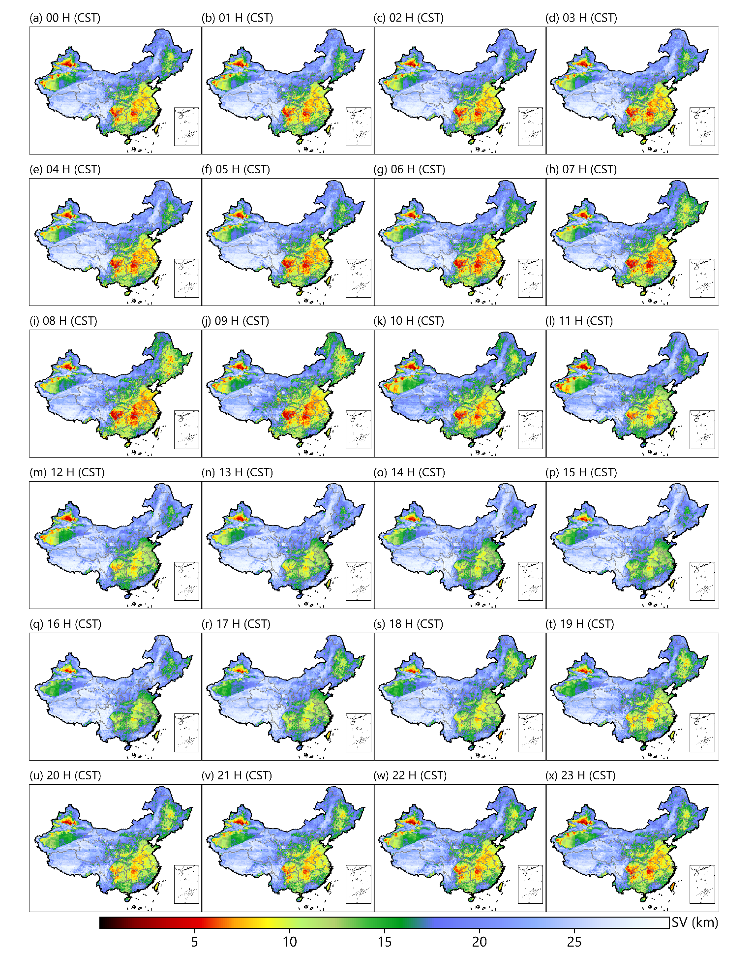
Supplementary Figure 15. Same as Supplementary Figure 12 but for winter.

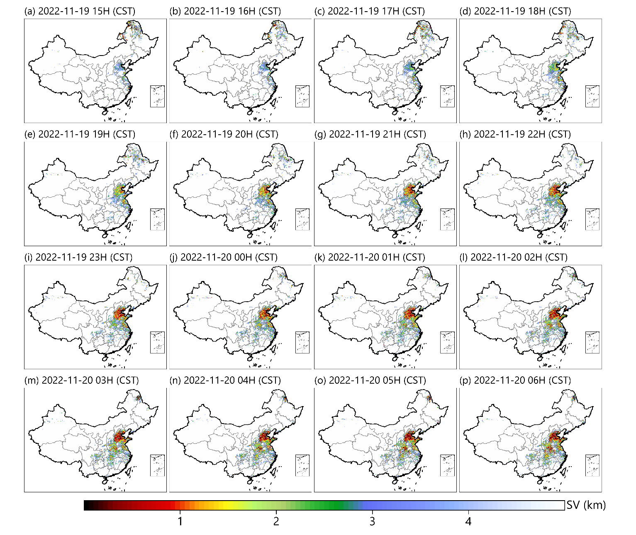
Supplementary Figure 16. Spatial distribution of the hourly seamless SV in China retrieved from the RT-SVR model from 15:00 CST on November 19, 2022 to 06:00 CST on November 20, 2022.
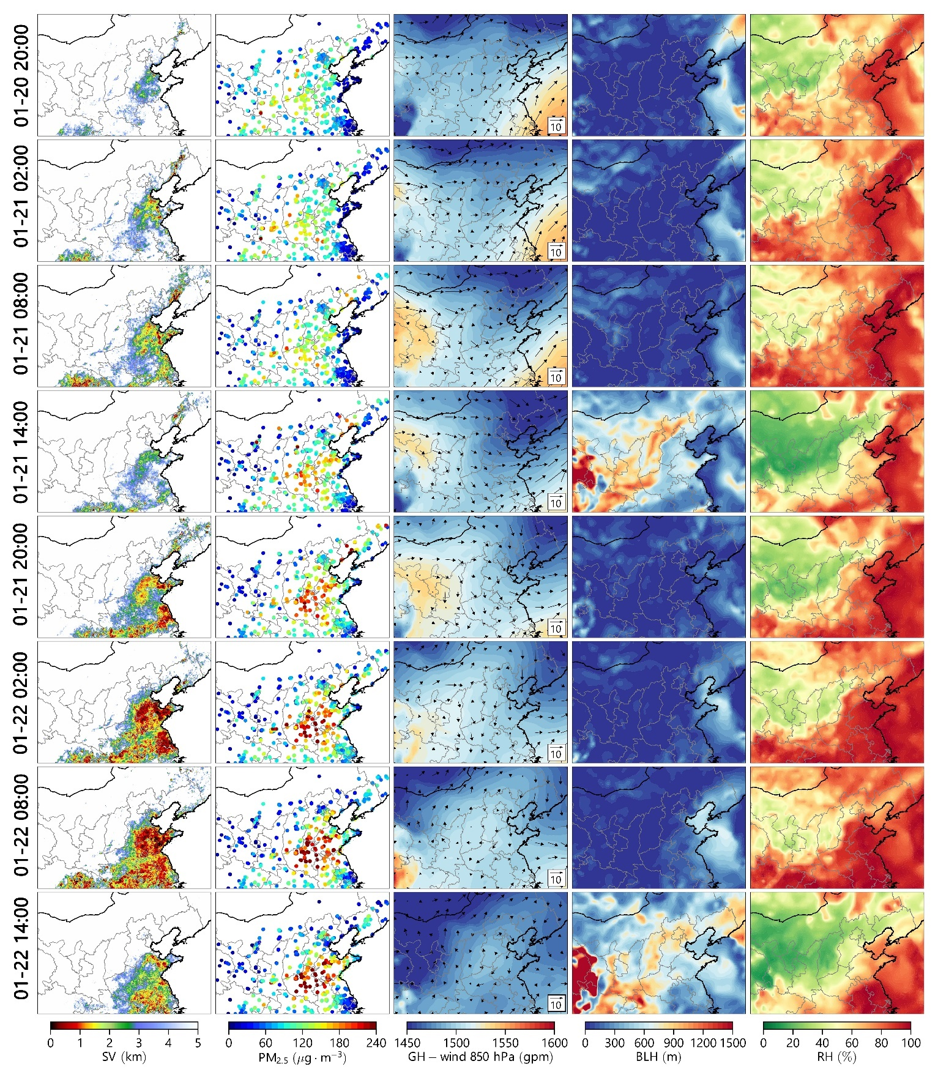
Supplementary Figure 17. Evolutionary maps of 6-hourly SV (first column), surface PM_{2.5} observations (second column), and meteorological fields (third column: GH and wind field at 850 hPa; fourth column: BLH; fifth column: RH) during a typical haze pollution event that occurred during January 20–22, 2021.

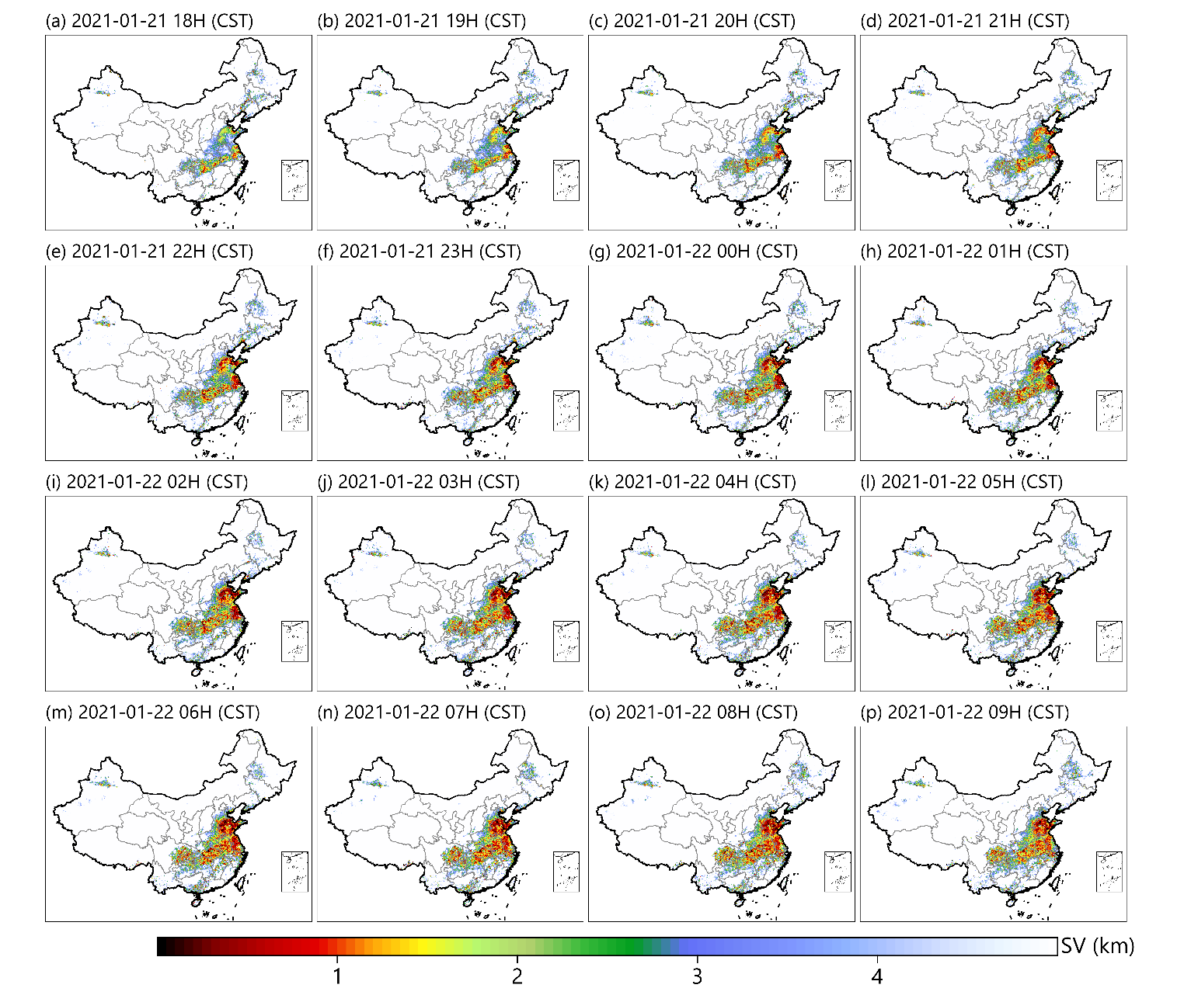
Supplementary Figure 18. Spatial distribution of the hourly seamless SV in China retrieved from the RT-SVR model from 18:00 CST on January 21, 2021 to 09:00 CST on January 22, 2021.
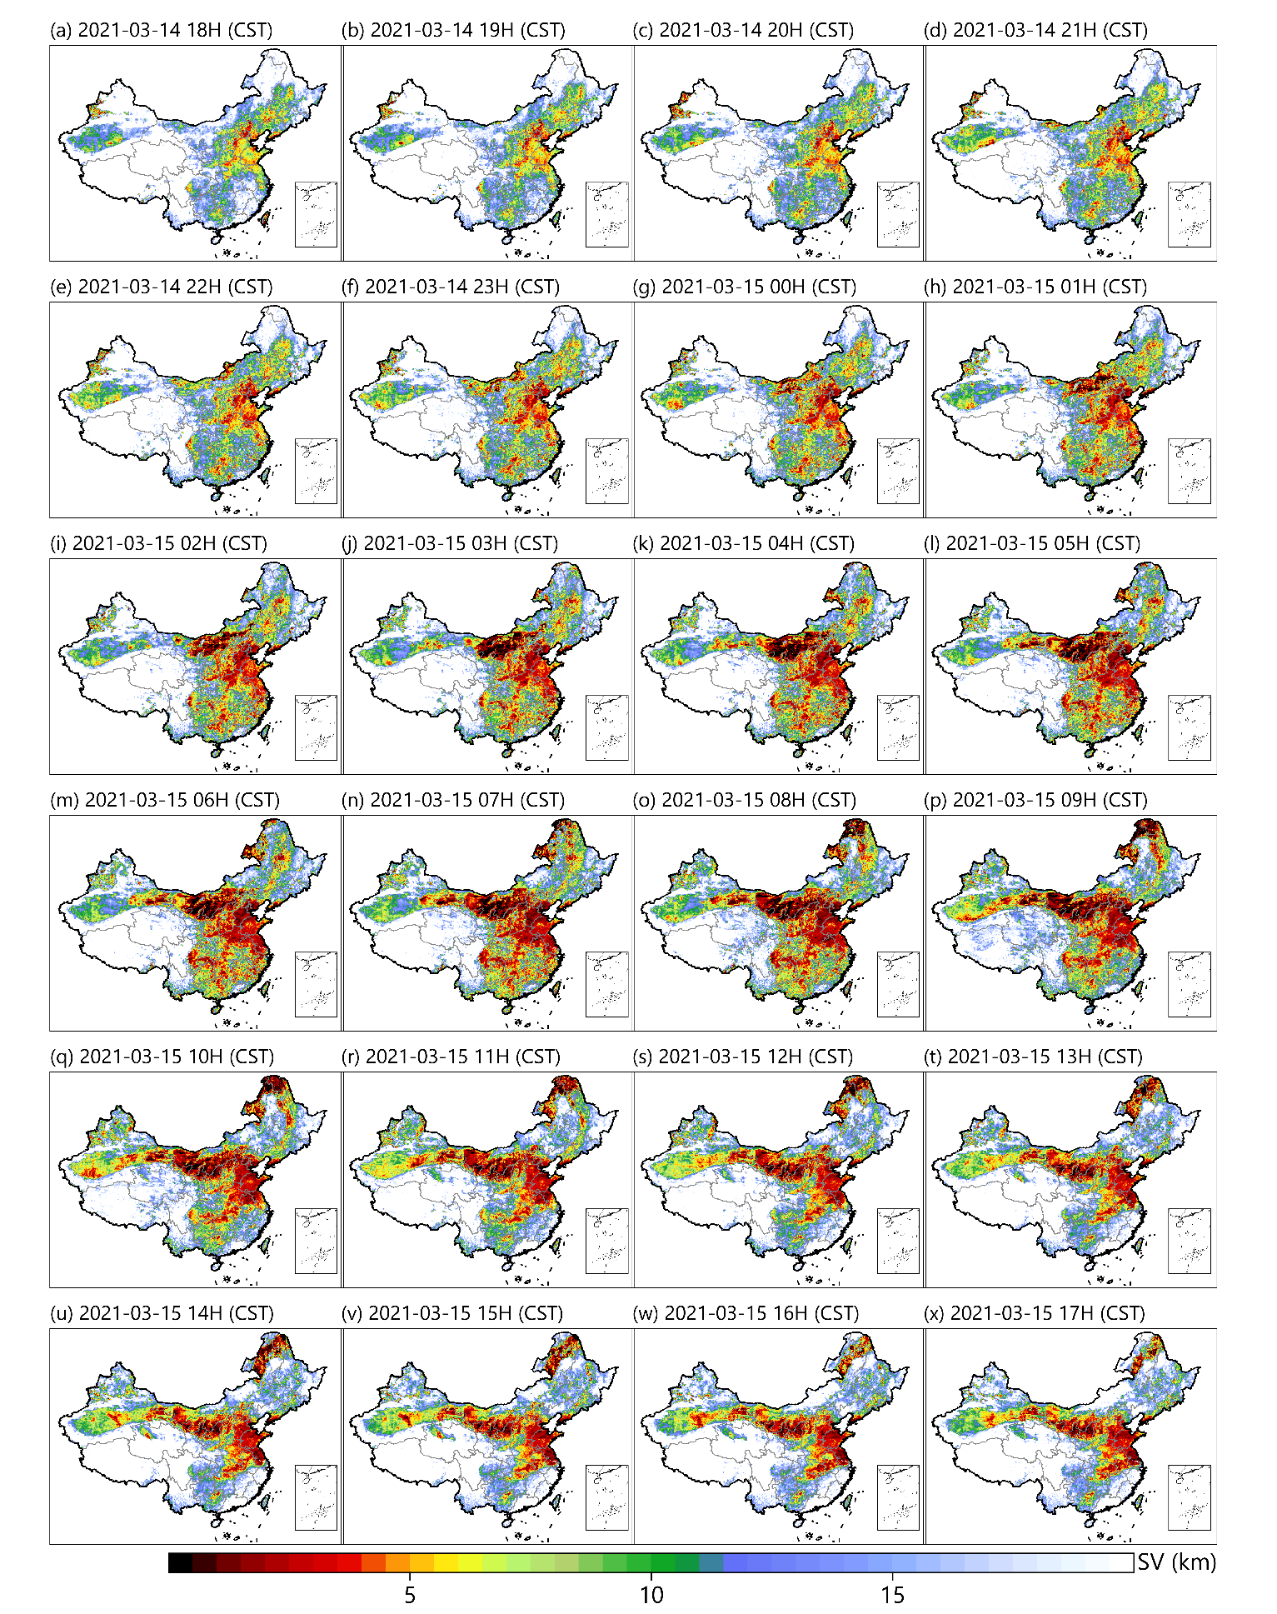
Supplementary Figure 19. Spatial distribution of the seamless diurnal cycle of the SV in China retrieved from the RT-SVR model during March 14–15, 2021.

