Supporting Information
Poleward Migration of Tropical Cyclones over the Western North Pacific in the CMIP6-HighResMIP Models Constrained by Observations
Zhuoying Li¹, and Wen Zhou^{1,2}
1 Key Laboratory of Polar Atmosphere-ocean-ice System for Weather and Climate, Ministry of Education, Department of Atmospheric and Oceanic Sciences & Institute of Atmospheric Sciences, Fudan University, Shanghai, China
2 Key Laboratory for Polar Science of the MNR, Polar Research Institute of China, Shanghai, China

Corresponding author: Wen Zhou (wen_zhou@fudan.edu.cn)

Contents of this file
Supplementary Tables 1 to 3
Supplementary Figures 1 to 14
Supplementary Reference 1 to 4
Supplementary Tables
Supplementary Table 1. Details of resolution and datasets in the CMIP6-HighResMIP models used in this study.
Model name | Resolution(km) | Datasets | Tracker | Reference
CMCC-CM2-VHR4 | 38.2 | highresSST-present  highresSST-future | TRACK | Cherchi et al. (2019)
CNRM-CM6-1-HR | 75.3 | highresSST-present  highresSST-future | TRACK  TempestExtremes | Voldoire., A. et al. (2019)
EC-Earth3P-HR | 54.2 | highresSST-present  highresSST-future | TRACK  TempestExtremes | Haarsma, R. et al. (2020)
HadGEM3-GC31-HM | 40.8 | highresSST-present  highresSST-future | TRACK  TempestExtremes | Roberts et al. (2019)

Supplementary Table 2. Correlation and RMSE between observations and models (MME_TRACK) under the new constrained detection method and without constraints (in brackets). ** represents the correlation is significant at the 95% confidence level.
 | Correlation | RMSE
Frequency | 0.98** (0.94**) | 0.46 (0.96)
Genesis latitude | 0.95** (-0.03) | 1.96 (7.54)

Supplementary Table 3. The storm intensity categories (Cat x) as measured by minimum mean sea level pressure (MSLP) ranges and the official Saffir - Simpson TC intensity scale.
Category | MSLP range (hPa) | maximum wind speed range (m s⁻¹)
0 | <994 | x<33
1 | 980≤x<994 | 33≤x<43
2 | 965≤x<980 | 43≤x<50
3 | 945≤x<965 | 50≤x<58
4 | 920≤x<945 | 58≤x<70
5 | 860≤x<920 | x≥70

Supplementary Figures
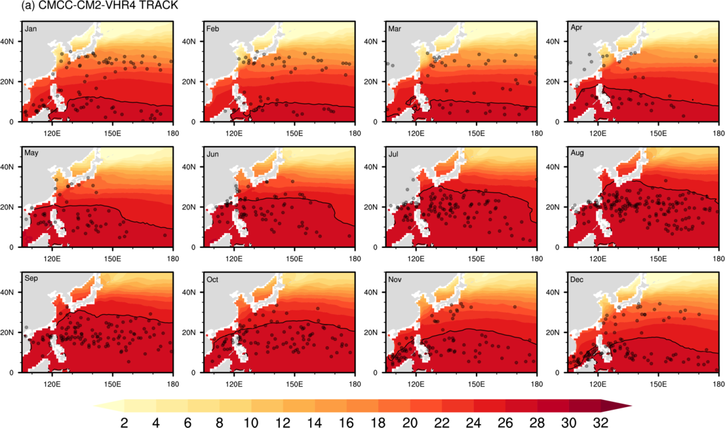
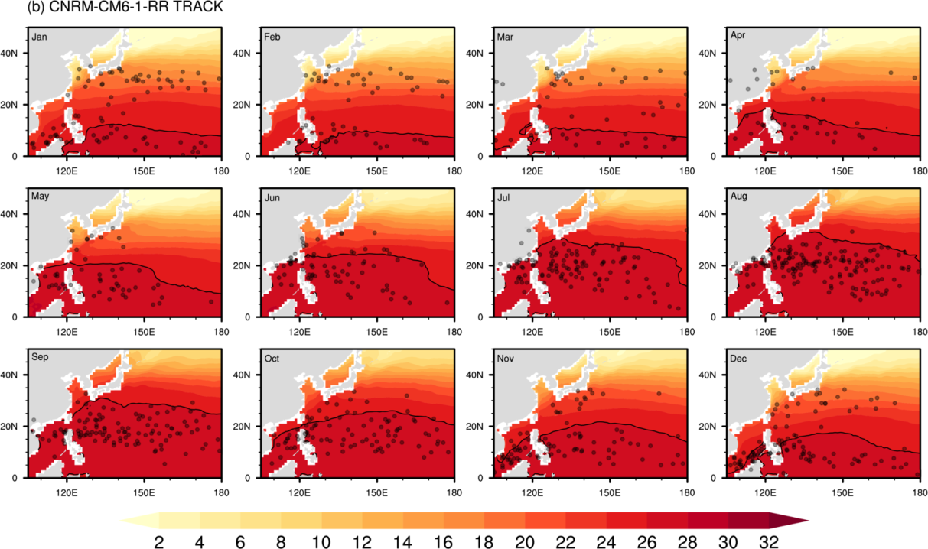
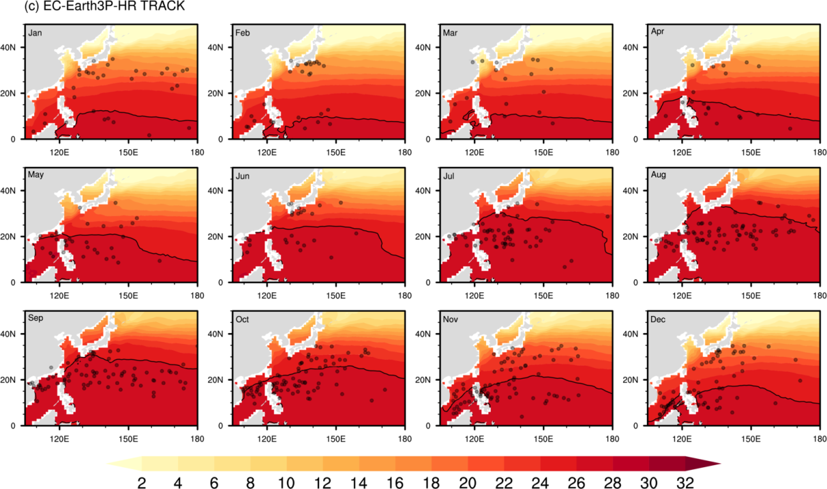
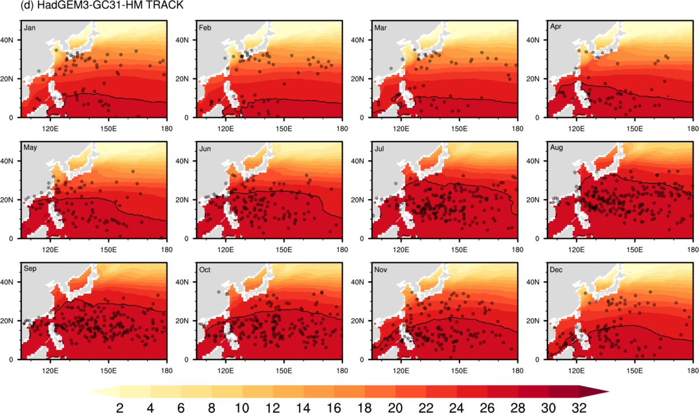
Supplementary Fig. 1 The monthly sea surface temperature (contours, ℃) and TC genesis position (black dots) over the WNP from 1980 to 2010 of (a) CMCC-CM2-VHR4, (b) CNRM-CM6-1-HR, (c) EC-Earth3P-HR, (d) HadGEM3-GC31-HM in the TRACK algorithm. Bold dark lines represent the 26℃isotherm.
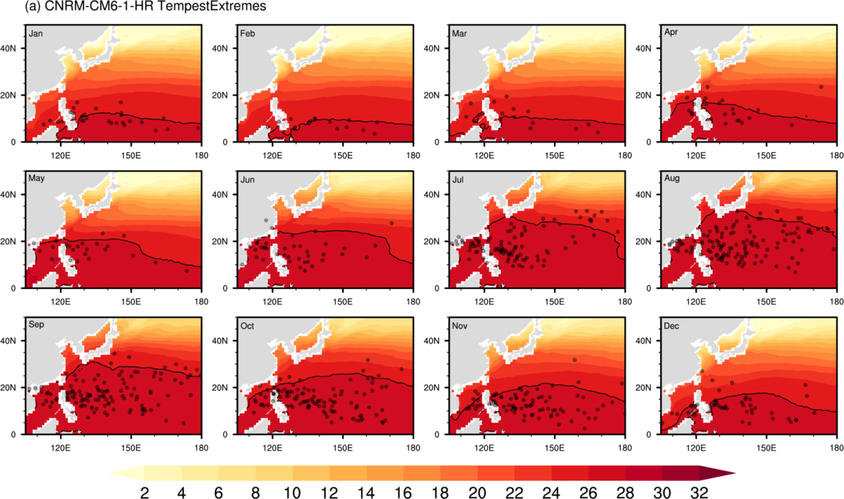
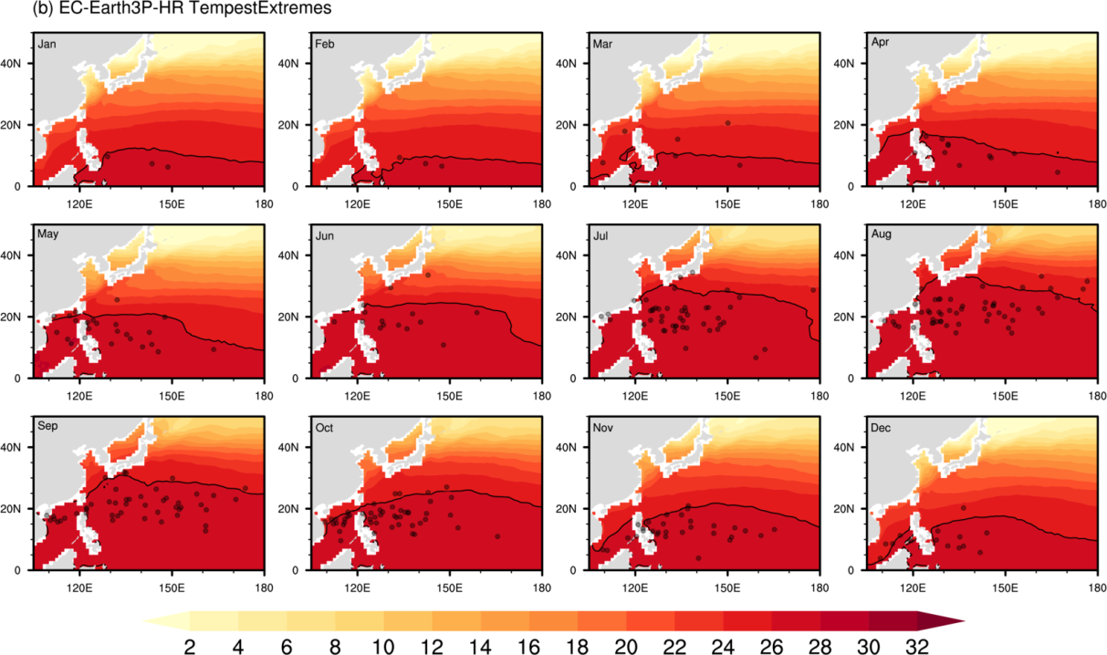
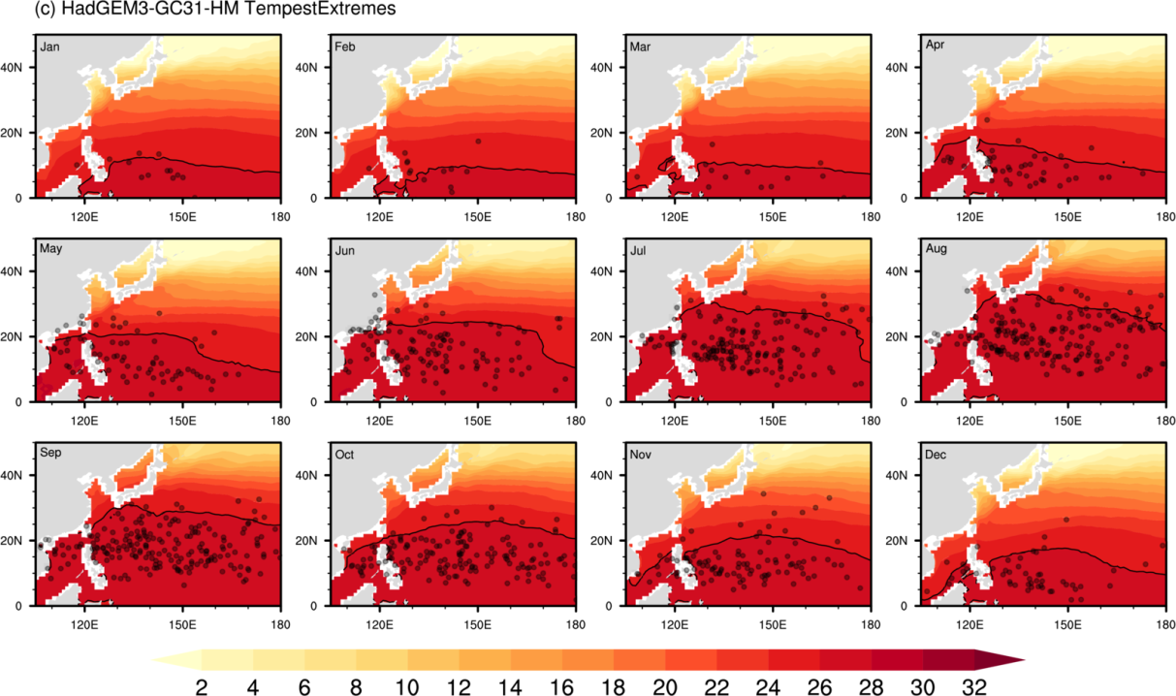
Supplementary Fig. 2 The same as Supplementary Figure 1, but for (a) CNRM-CM6-1-HR, (b) EC-Earth3P-HR, (c) HadGEM3-GC31-HM in the Tempext algorithm (black dots).
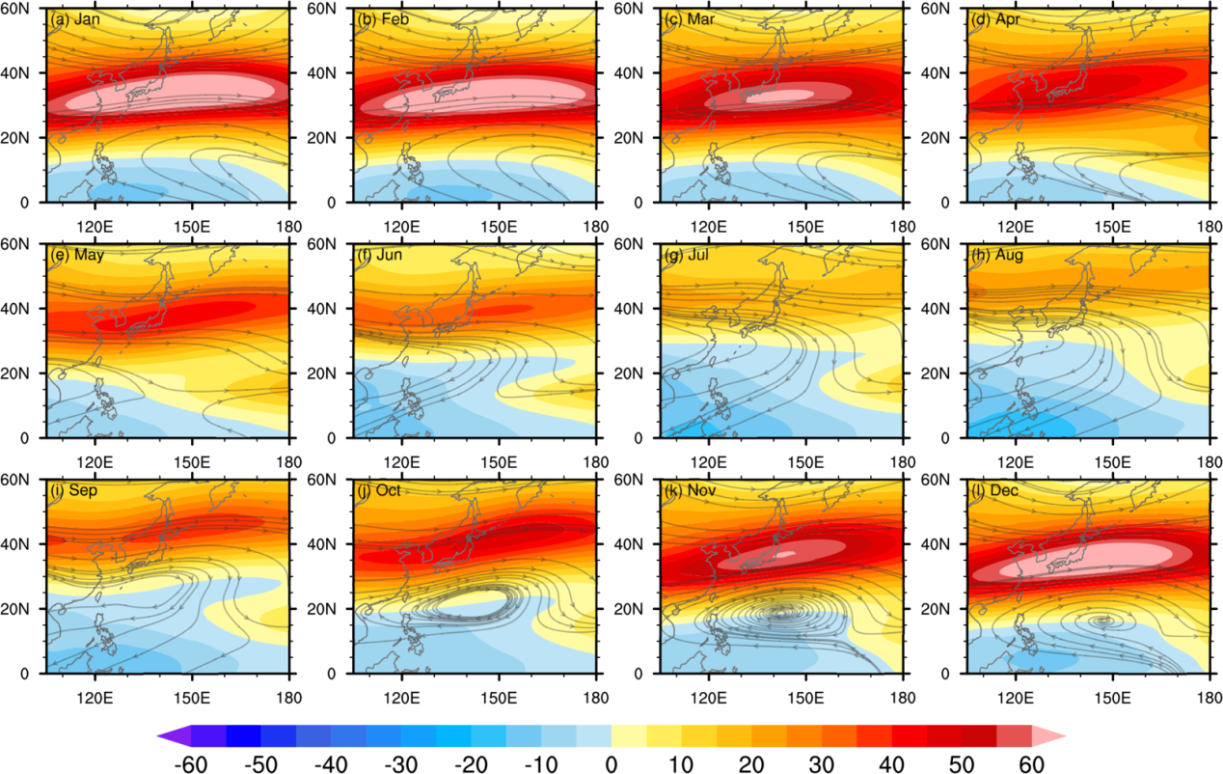
Supplementary Fig. 3 The climatological (1980–2010) monthly mean 200-hPa zonal MME wind (contours, m s⁻¹) and 200 hPa winds (streamline, m s⁻¹).
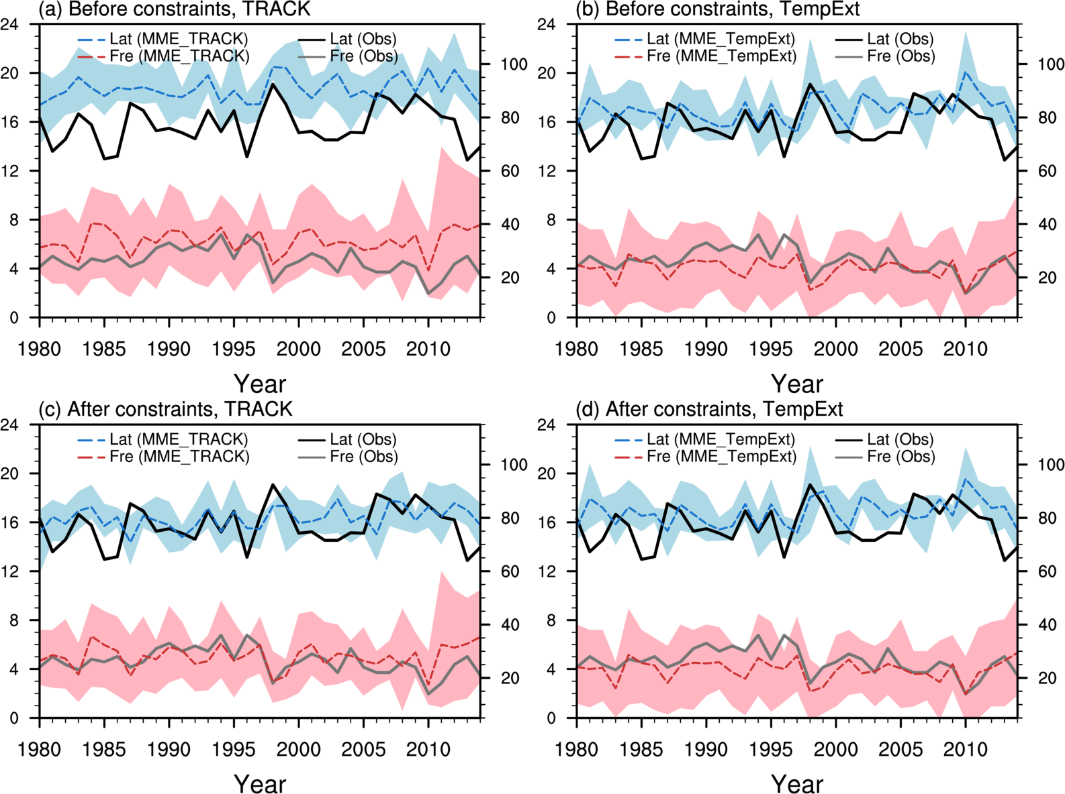
Supplementary Fig. 4 (a)-(b) Comparing the annual TC genesis latitude (blue) and frequency (red) from the HighResMIP models before constraints with observations over the WNP during 1980-2014. (c)-(d) The same as (a)-(b), but comparing from the HighResMIP models after constrains with observations. The solid lines represent observational genesis latitude and frequency. Blue and red dash lines represent the MME of genesis latitude and frequency, respectively. The filling curves represent the range of the TC genesis latitude (blue) and frequency (red) from models.
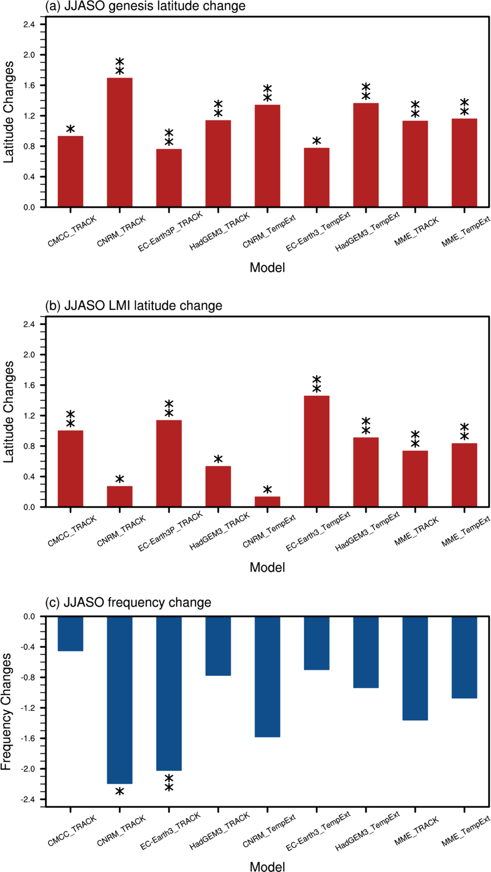
Supplementary Fig. 5 Future changes in JJASO TC (a) genesis latitude, (b) LMI latitude and (c) frequency for each model and their MMEs. * and ** represent 90 % and 95 % significance, respectively.
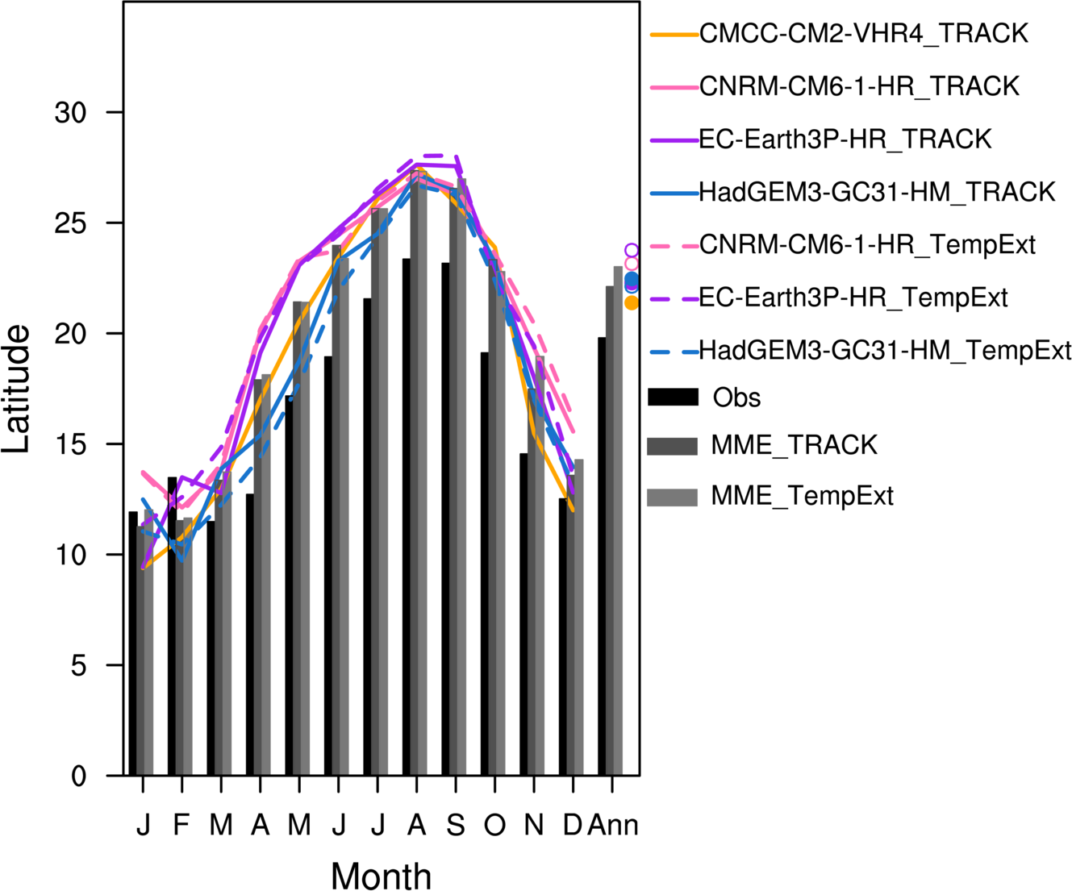
Supplementary Fig. 6 The climatological mean (1980-2010) annual cycle of TC TC LMI latitude over the WNP, from IBTRACS (black bars), the models using the TRACK tracker (solid lines) and the TempExt tracker (dashed lines), as well as their MMEs (gray bars). The rightmost column is the climatological mean (1980-2010) annual TC LMI latitude using the TRACK tracker (colored dots) and the TempExt tracker (colored circles).
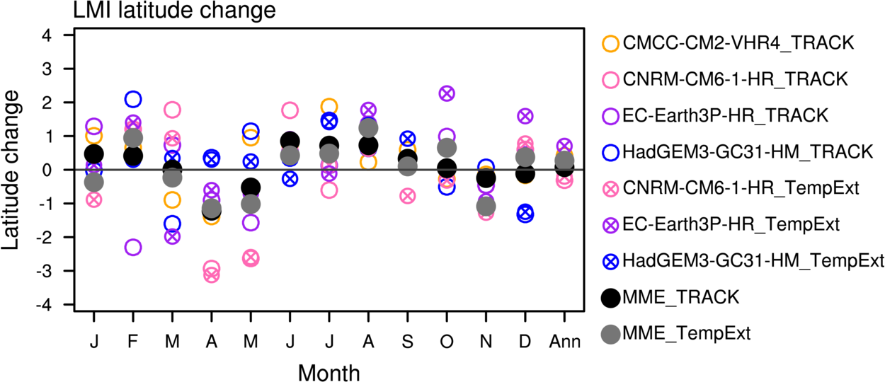
Supplementary Fig. 7 The same as Fig. 2a. Future changes in monthly and annual TC LMI latitude.
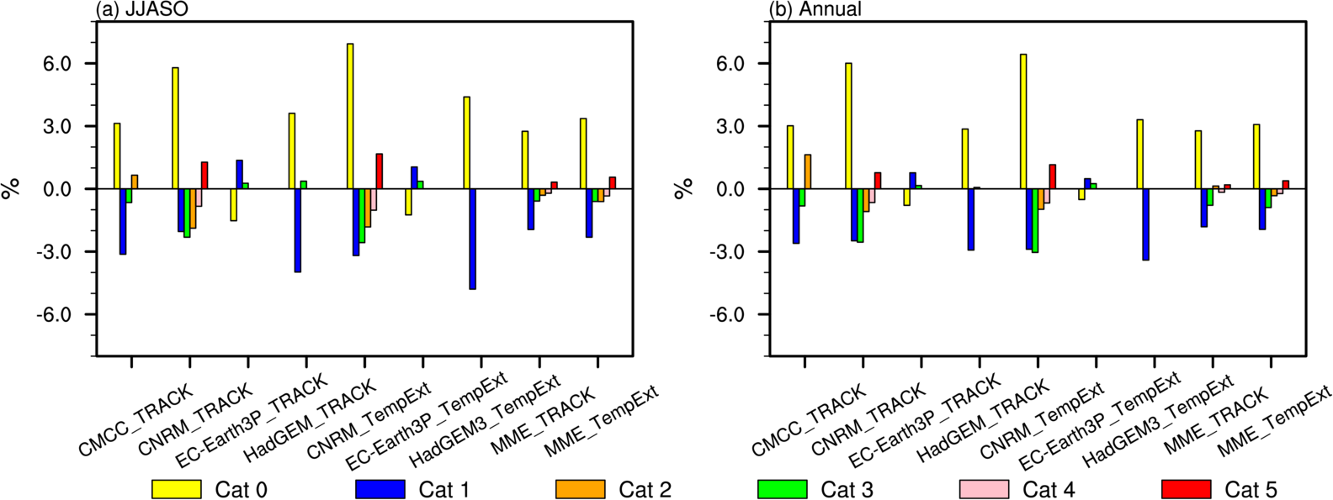
Supplementary Fig. 8 (a) Future proportion changes of JJASO TCs measured by the official Saffir - Simpson TC intensity scale. (b) the same as (a), but for annual TCs
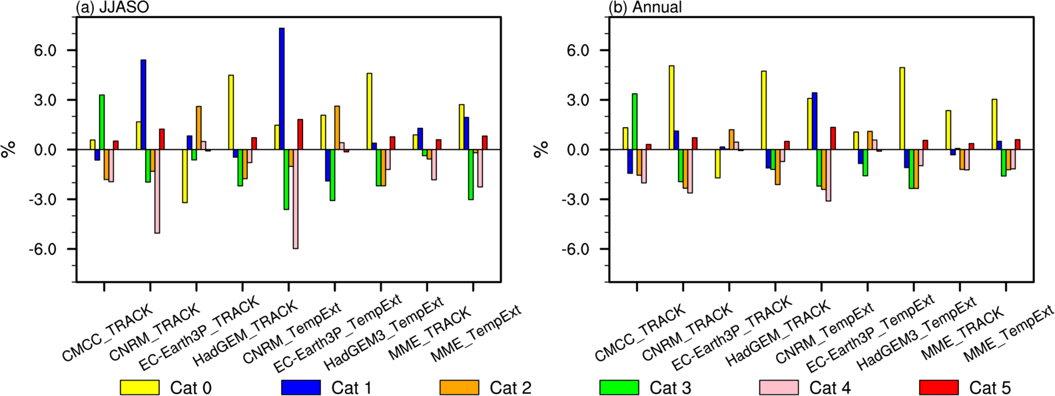
Supplementary Fig. 9 The same as Supplementary Figure 9, but measured by minimum mean sea level pressure (MSLP) ranges.
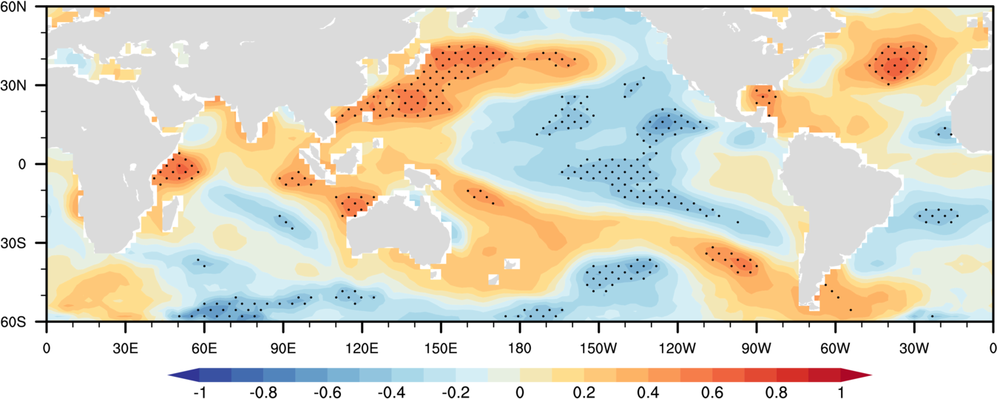
Supplementary Fig. 10 Correlation between JJASO SST and TC genesis latitude from 1980 to 2010. Black dots indicate trend values exceeding the 95% confidence level. The EWPC index is the difference between the two regions surrounded by the gray lines.
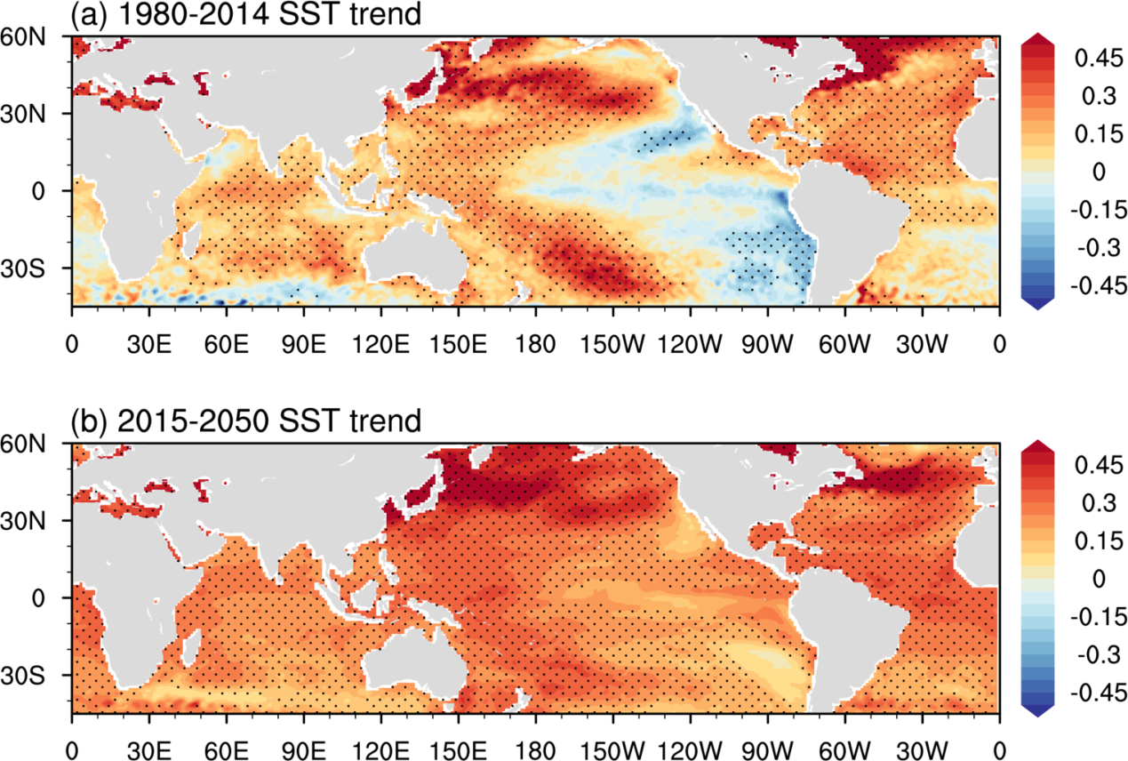
Supplementary Fig. 11 Linear trend of SST during (a) 1980-2014 and (b) 2015-2050 (unit: 10⁻¹℃). Black dots indicate trend values exceeding the 95% confidence level.
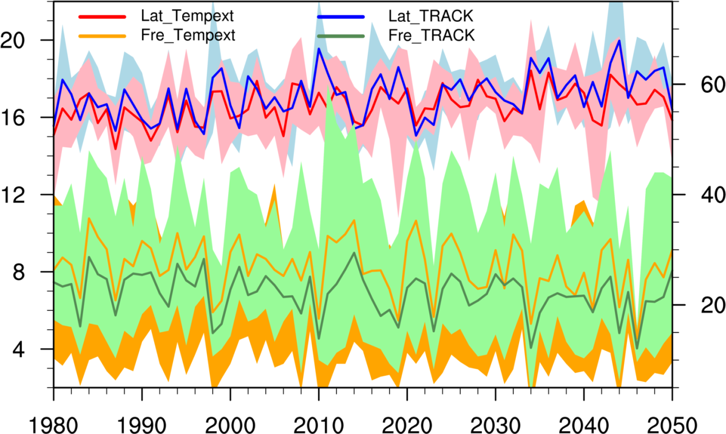
Supplementary Fig. 12 Time series of annual TC genesis latitude and frequency from 1980 to 2050 in CMIP6-HighResMIP models.
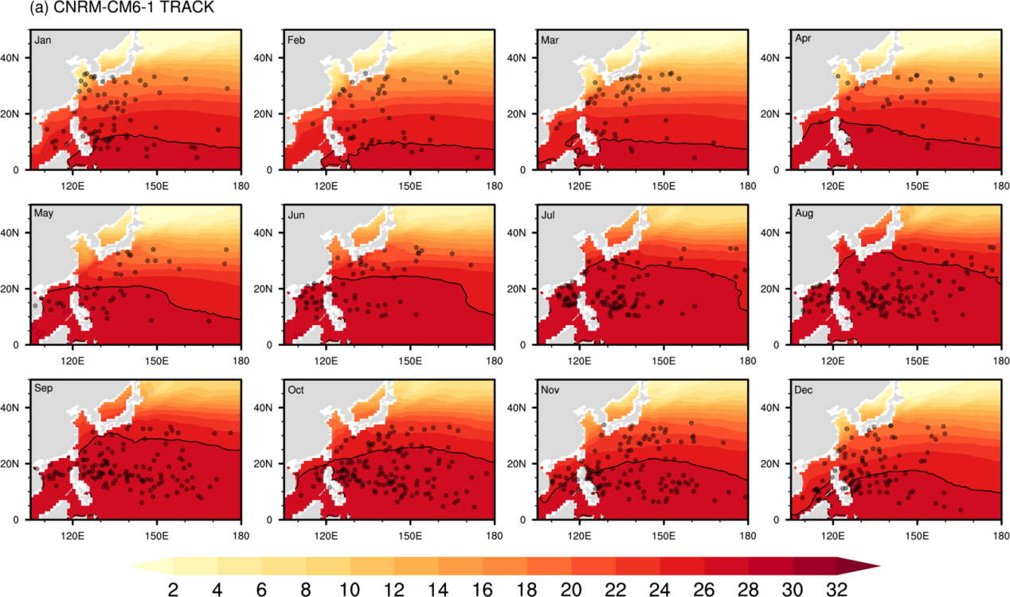
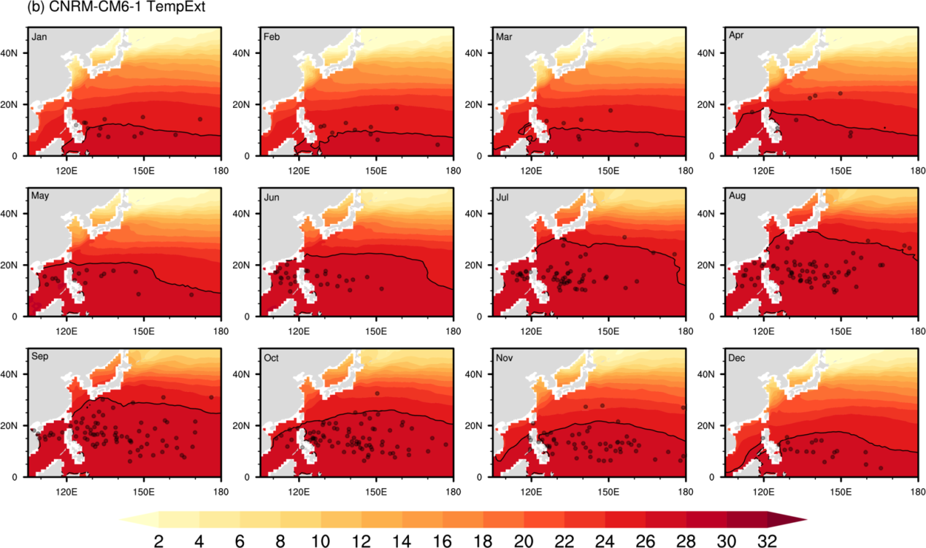
Supplementary Fig. 13 The monthly sea surface temperature (contours, ℃) and TC genesis position (black dots) over the WNP from 1980 to 2010 of CNRM-CM6-1 in the (a) TRACK algorithm and (b) the TempExt algorithm. Bold dark lines represent the 26℃isotherm.
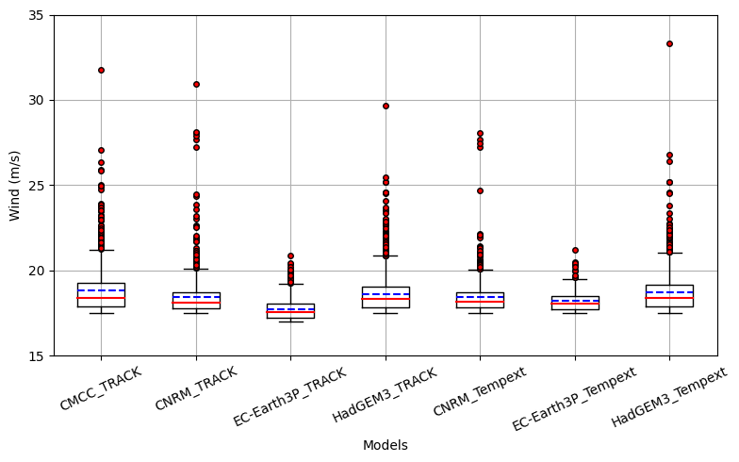
Supplementary Fig. 14 TC genesis wind speed over the WNP from each model (unit: m s⁻¹). The box indicates the range from the 25 th to 75 th percentile of the distributions, with the red solid line and blue dash line at the median and mean value respectively. The whiskers indicate the range of the distributions.

Supplementary References
- Cherchi, A. et al. Global mean climate and main patterns of variability in the CMCC-CM2 coupled model. J. Adv. Model. Earth Syst. 11, 1–25 (2019).
- Voldoire, A. et al. Evaluation of CMIP6 DECK experiments with CNRM-CM6-1. J. Adv. Model. Earth Syst. 11 (7), 2177–2213 (2019).
- Haarsma, R. J. et al. HighResMIP versions of EC-Earth: EC-Earth3P and ECEarth3P-HR. Description, model performance, data handling and validation. Geosci. Model. Dev. 13 (8), 3507–3527 (2020).
- Roberts, M. J. et al. Description of the resolution hierarchy of the global coupled HadGEM3-GC3.1 model as used in CMIP6 HighResMIP experiments. Geosci. Model. Dev. 12 (12), 4999–5028 (2019).

