From Cause to Consequence: Examining the Historic April 2024 Rainstorm in the United Arab Emirates Through the Lens of Climate Change

Diana Francis^{1*}, Ricardo Fonseca¹, Narendra Nelli¹, Charfeddine Cherif¹, Yesobu Yarragunta¹, George Zittis², Andries Jan de Vries³

¹ Environmental and Geophysical Sciences (ENGEOS) Lab, Earth Sciences Department, Khalifa University, Abu Dhabi, 127788, United Arab Emirates.
² Climate and Atmosphere Research Center (CARE-C), The Cyprus Institute, 2121, Nicosia, Cyprus.
³ Institute of Earth Surface Dynamics, University of Lausanne, Lausanne, Switzerland.
*Correspondence to: diana.francis@ku.ac.ae

Supplementary Material

Airport | Location | Elevation | Data Availability
1. Abu Dhabi (Zayed) Airport | 24.432972ºN, 54.651138ºE | 26.82 m | 01-1983 to present
2. Al Bateen Airport | 24.428333ºN, 54.458084ºN | 4.87 m | 01-1983 to present
3. Dubai Airport | 25.254997ºN, 55.364278ºE | 10.36 m | 01-1983 to present
4. Sharjah Airport | 25.328575ºN, 55.517150ºE | 33.83 m | 04-1976 to present
5. Al Maktoum Airport | 24.886110ºN, 55.172220ºE | 18.90 m | 06-2010 to present
6. Al Ain Airport | 24.261667ºN, 55.609167ºE | 264.87 m | 03-1994 to present
7. Ras Al Khaimah Airport | 25.613483ºN, 55.938817ºE | 31.08 m | 01-1983 to present
8. Fujairah Airport | 25.112225ºN, 56.323964ºE | 46.32 m | 09-1991 to present

Table S1: Airport Stations: List of stations in the United Arab Emirates (UAE) for which daily rainfall data are available. For each station, the location, elevation, and period over which data is availabl are provided.

Season | Source | Bias | 𝜇 | 𝜌 | 𝜂 | 𝛼
Spring | ERA-5 | -0.001 mm | ~0.0 | 0.066 | 0.748 | 0.950
Spring | CHIRPS | -0.022 mm | -0.005 | 0.070 | 0.587 | 0.959
Spring | MERRA-2 | 0.086 mm | 0.017 | 0.705 | 0.910 | 0.936
Spring | NCEP CFSR | -0.196 mm | -0.045 | 0.055 | ~0.0 | ~1.0
Spring | IMERG | 0.038 mm | 0.013 | 0.257 | 0.963 | 0.753
Summer | ERA-5 | -0.062 mm | -0.032 | -0.002 | 0.243 | 1.001
Summer | CHIRPS | -0.081 mm | -0.042 | 0.008 | 0.033 | ~1.0
Summer | MERRA-2 | 0.056 mm | 0.025 | 0.001 | 0.916 | 0.999
Summer | NCEP CFSR | -0.083 mm | -0.044 | -0.001 | ~0.0 | ~1.0
Summer | IMERG | -0.052 mm | -0.028 | 0.001 | 0.579 | 0.999
Autumn | ERA-5 | -0.029 mm | -0.013 | 0.070 | 0.515 | 0.964
Autumn | CHIRPS | -0.064 mm | -0.030 | 0.022 | 0.316 | 0.993
Autumn | MERRA-2 | 0.002 mm | 0.001 | 0.041 | 0.699 | 0.971
Autumn | NCEP CFSR | -0.086 mm | -0.040 | 0.038 | ~0.0 | ~1.0
Autumn | IMERG | ~0.0 mm | ~0.0 | 0.077 | 0.942 | 0.928
Winter | ERA-5 | 0.070 mm | 0.014 | 0.143 | 0.690 | 0.901
Winter | CHIRPS | 0.170 mm | 0.033 | 0.127 | 0.794 | 0.899
Winter | MERRA-2 | 0.169 mm | 0.0317 | 0.134 | 0.854 | 0.885
Winter | NCEP CFSR | -0.244 mm | -0.049 | 0.145 | ~0.0 | ~1.0
Winter | IMERG | -0.062 mm | -0.009 | 0.155 | 0.672 | 0.896

Table S2: Performance of reanalysis and satellite-derived products against in-situ observations: Daily precipitation rate bias (mm), normalized bias (𝜇), correlation (𝜌), variance similarity (𝜂) and normalized error variance (𝛼) with respect to ground-based observations at the eight airport stations listed in Table S1, for the ERA-5, MERRA-2, NCEP CFSR reanalysis and the satellite-derived CHIRPS and IMERG products for 1976-2024. For each dataset, the closest grid-point to the location of the station is selected for evaluation. The best performing product for each season, defined as the one which has the lowest normalized error variance 𝛼 that has to be smaller than 1 ($α$$<1$; i.e., the dataset must generate skillful forecasts) and for which the bias has to be not significant (i.e, the absolute value of the normalized bias 𝜇 is less than 0.5, $\left|μ\right|$$<0.5$), is highlighted in yellow.
`

CMIP6 Models | Spatial Resolution | Number of Realizations |  | Reference
CMIP6 Models | Spatial Resolution | Historical | Pre-Industrial | Reference
BCC-CSM2-MR | 1.125⁰ × 1.12149⁰ | 2 | 0 | [1]
CAMS-CSM1-0 | 1.125⁰ × 1.12149⁰ | 1 | 0 | [2]
CESM2 | 1.25⁰ × 0.942408⁰ | 10 | 1 | [3]
CESM2-WACCM | 1.25⁰ × 0.942408⁰ | 3 | 1 | [4]
CMCC-ESM2 | 1.25⁰ × 0.942408⁰ | 1 | 1 | [5]
CNRM-CM6-1-HR | 0.5⁰ × 0.499306⁰ | 1 | 1 | [6]
CMCC-CM2-HR4 | 1.25⁰ × 0.942408⁰ | 1 | 0 | [7]
CMCC-CM2-SR5 | 1.25⁰ × 0.942408⁰ | 11 | 1 | [7]
E3SM-1-0 | 1⁰ × 1⁰ | 5 | 1 | [8]
E3SM-2-0 | 1⁰ × 1⁰ | 21 | 1 | [9]
E3SM-2-0-NARRM | 1⁰ × 1⁰ | 5 | 1 | [10]
EC-Earth3 | 0.703125⁰ × 0.701754⁰ | 70 | 1 | [11]
EC-Earth3-AerChem | 0.703125⁰ × 0.701752⁰ | 3 | 1 | [12]
EC-Earth3-CC | 0.703125⁰ × 0.701752⁰ | 3 | 1 | [11]
EC-Earth3-Veg | 0.703125⁰ × 0.701754⁰ | 6 | 1 | [11]
FGOALS-f3-L | 1.25⁰ × 1⁰ | 3 | 0 | [13]
GFDL-CM4 | 1.25⁰ × 1⁰ | 1 | 1 | [14]
GFDL-ESM4 | 1.25⁰ × 1⁰ | 3 | 1 | [15]
INM-CM4-8 | 2⁰ × 1.5⁰ | 1 |  | [16]
INM-CM5-0 | 2⁰ × 1.5⁰ | 10 | 1 | [17]
MPI-ESM1-2-HR | 0.9375⁰ × 0.935062⁰ | 10 | 1 | [18]
MRI-ESM2-0 | 1.125⁰ × 1.12148⁰ | 11 | 1 | [19]
NorESM2-MM | 1.125⁰ × 0.942408⁰ | 3 | 1 | [20]
SAM0-UNICON | 1.25⁰ × 0.942408⁰ | 1 | 1 | [21]
TaiESM1 | 1.25⁰ × 0.94248⁰ | 1 | 1 | [22]

Table S3: CMIP6 Models: List of the 25 CMIP6 models considered in this study. For each model, the horizontal resolution, the number of available realizations for the present (actual climate) and pre-industrial (counterfactual climate) at the time of writing, and the reference manuscript, are given.

Season | Source | Bias | 𝜇 | 𝜌 | 𝜂 | 𝛼
SPRING | BCC-CSM2-MR | 0.041 mm | 0.011 | -0.001 | 0.517 | ~1.0
SPRING | CAMS-CSM1-0 | -0.018 mm | -0.005 | -0.002 | 0.799 | 1.002
SPRING | CESM2 | 0.418 mm | 0.115 | 0.003 | 0.387 | 0.999
SPRING | CESM2-WACCM | 0.360 mm | 0.096 | 0.001 | 0.614 | 0.999
SPRING | CMCC-ESM2 | 0.020 mm | 0.005 | -0.005 | 0.425 | 1.002
SPRING | CNRM-CM6-1-HR | 0.289 mm | 0.064 | -0.003 | 0.961 | 1.003
SPRING | CMCC-CM2-HR4 | 0.135 mm | 0.034 | -0.004 | 0.750 | 1.003
SPRING | CMCC-CM2-SR5 | 0.009 mm | 0.003 | 0.003 | 0.175 | 0.999
SPRING | E3SM-1-0 | 0.705 mm | 0.186 | -0.002 | 0.647 | 1.002
SPRING | EC-Earth3-CC | -0.029 mm | -0.008 | -0.001 | 0.392 | 1.001
SPRING | FGOALS-f3-L | 0.149 mm | 0.039 | 0.002 | 0.669 | 0.999
SPRING | GFDL-CM4 | 0.394 mm | 0.081 | 0.024 | 0.999 | 0.976
SPRING | GFDL-ESM4 | 0.286 mm | 0.072 | -0.001 | 0.792 | 1.001
SPRING | INM-CM4-8 | 0.132 mm | 0.036 | 0.001 | 0.482 | 0.999
SPRING | INM-CM5-0 | 0.174 mm | 0.049 | 0.009 | 0.269 | 0.998
SPRING | MPI-ESM1-2-HR | -0.045 mm | -0.012 | 0.006 | 0.205 | 0.999
SPRING | MRI-ESM2-0 | 0.366 mm | 0.101 | 0.006 | 0.375 | 0.998
SPRING | NorESM2-MM | 0.118 mm | 0.032 | 0.017 | 0.403 | 0.993
SPRING | SAM0-UNICON | -0.036 mm | -0.010 | ~0.0 | 0.327 | ~1.0
SPRING | TaiESM1 | 0.002 mm | ~0.0 | -0.003 | 0.511 | 1.001
SPRING | E3SM-2-0-NARRM | 0.613 mm | 0.165 | ~0.0 | 0.565 | ~1.0
SPRING | EC-Earth3-AerChem | -0.048 mm | -0.013 | -0.005 | 0.346 | 1.002
SPRING | E3SM-2-0 | 0.652 mm | 0.181 | 0.003 | 0.314 | 0.999
SPRING | EC-Earth3-Veg | -0.060 mm | -0.017 | -0.004 | 0.214 | 1.001
SPRING | EC-Earth3 | -0.044 mm | -0.012 | -0.010 | 0.084 | 1.001

Season | Source | Bias | 𝜇 | 𝜌 | 𝜂 | 𝛼
SUMMER | BCC-CSM2-MR | 0.050 mm | 0.029 | ~0.0 | 0.695 | ~1.0
SUMMER | CAMS-CSM1-0 | 0.085 mm | 0.047 | ~0.0 | 0.865 | ~1.0
SUMMER | CESM2 | 0.043 mm | 0.027 | 0.006 | 0.340 | 0.998
SUMMER | CESM2-WACCM | 0.037 mm | 0.023 | 0.026 | 0.505 | 0.987
SUMMER | CMCC-ESM2 | 0.077 mm | 0.042 | 0.030 | 0.911 | 0.972
SUMMER | CNRM-CM6-1-HR | 0.085 mm | 0.027 | -0.001 | 0.859 | 1.001
SUMMER | CMCC-CM2-HR4 | 0.451 mm | 0.140 | 0.001 | 0.850 | 0.999
SUMMER | CMCC-CM2-SR5 | 0.110 mm | 0.068 | 0.004 | 0.459 | 0.998
SUMMER | E3SM-1-0 | -0.009 mm | -0.006 | -0.005 | 0.355 | 1.002
SUMMER | EC-Earth3-CC | -0.049 mm | -0.031 | -0.001 | 0.211 | ~1.0
SUMMER | FGOALS-f3-L | 0.086 mm | 0.037 | -0.002 | 0.995 | 1.002
SUMMER | GFDL-CM4 | -0.056 mm | -0.036 | -0.001 | 0.034 | ~1.0
SUMMER | GFDL-ESM4 | -0.049 mm | -0.031 | -0.001 | 0.255 | ~1.0
SUMMER | INM-CM4-8 | 0.096 mm | 0.059 | 0.008 | 0.578 | 0.996
SUMMER | INM-CM5-0 | 0.055 mm | 0.035 | -0.016 | 0.168 | 1.003
SUMMER | MPI-ESM1-2-HR | 0.007 mm | 0.005 | 0.010 | 0.268 | 0.997
SUMMER | MRI-ESM2-0 | -0.050 mm | -0.032 | -0.004 | 0.056 | ~1.0
SUMMER | NorESM2-MM | 0.101 mm | 0.063 | ~0.0 | 0.444 | ~1.0
SUMMER | SAM0-UNICON | 0.056 mm | 0.021 | 0.003 | 0.957 | 0.997
SUMMER | TaiESM1 | 0.001 mm | 0.001 | -0.001 | 0.784 | 1.001
SUMMER | E3SM-2-0-NARRM | -0.031 mm | -0.020 | -0.003 | 0.226 | ~1.0
SUMMER | EC-Earth3-AerChem | -0.047 mm | -0.030 | -0.003 | 0.137 | ~1.0
SUMMER | E3SM-2-0 | -0.030 mm | -0.019 | -0.003 | 0.117 | ~1.0
SUMMER | EC-Earth3-Veg | -0.049 mm | -0.031 | -0.001 | 0.089 | ~1.0
SUMMER | EC-Earth3 | -0.051 mm | -0.032 | -0.007 | 0.028 | ~1.0

Season | Source | Bias | 𝜇 | 𝜌 | 𝜂 | 𝛼
AUTUMN | BCC-CSM2-MR | 0.135 mm | 0.062 | 0.008 | 0.945 | 0.993
AUTUMN | CAMS-CSM1-0 | 0.214 mm | 0.078 | -0.003 | 0.987 | 1.003
AUTUMN | CESM2 | 0.095 mm | 0.053 | -0.004 | 0.459 | 1.002
AUTUMN | CESM2-WACCM | 0.128 mm | 0.062 | -0.001 | 0.885 | 1.001
AUTUMN | CMCC-ESM2 | 0.009 mm | 0.005 | -0.002 | 0.672 | 1.002
AUTUMN | CNRM-CM6-1-HR | 0.455 mm | 0.106 | 0.007 | 0.749 | 0.995
AUTUMN | CMCC-CM2-HR4 | 0.227 mm | 0.092 | ~0.0 | ~1.0 | ~1.0
AUTUMN | CMCC-CM2-SR5 | 0.027 mm | 0.015 | 0.018 | 0.343 | 0.994
AUTUMN | E3SM-1-0 | 0.168 mm | 0.088 | -0.001 | 0.711 | 1.001
AUTUMN | EC-Earth3-CC | 0.043 mm | 0.023 | -0.001 | 0.677 | 1.001
AUTUMN | FGOALS-f3-L | 0.223 mm | 0.088 | -0.002 | ~1.0 | 1.002
AUTUMN | GFDL-CM4 | 0.162 mm | 0.056 | -0.002 | 0.968 | 1.002
AUTUMN | GFDL-ESM4 | 0.201 mm | 0.087 | -0.004 | -0.986 | 1.004
AUTUMN | INM-CM4-8 | 0.060 mm | 0.031 | -0.003 | 0.763 | 1.002
AUTUMN | INM-CM5-0 | 0.025 mm | 0.014 | -0.006 | 0.177 | 1.001
AUTUMN | MPI-ESM1-2-HR | 0.108 mm | 0.060 | -0.006 | 0.430 | 1.003
AUTUMN | MRI-ESM2-0 | 0.106 mm | 0.058 | 0.009 | 0.507 | 0.996
AUTUMN | NorESM2-MM | 0.068 mm | 0.037 | 0.003 | 0.521 | 0.998
AUTUMN | SAM0-UNICON | 0.100 mm | 0.028 | -0.001 | 0.855 | 1.001
AUTUMN | TaiESM1 | 0.086 mm | 0.032 | -0.002 | 0.998 | 1.002
AUTUMN | E3SM-2-0-NARRM | 0.178 mm | 0.093 | -0.005 | 0.690 | 1.003
AUTUMN | EC-Earth3-AerChem | 0.107 mm | 0.054 | ~0.0 | 0.798 | ~1.0
AUTUMN | E3SM-2-0 | 0.203 mm | 0.111 | 0.002 | 0.484 | 0.999
AUTUMN | EC-Earth3-Veg | 0.091 mm | 0.049 | 0.003 | 0.657 | 0.998
AUTUMN | EC-Earth3 | 0.070 mm | 0.040 | -0.001 | 0.232 | ~1.0

Season | Source | Bias | 𝜇 | 𝜌 | 𝜂 | 𝛼
WINTER | BCC-CSM2-MR | 0.158 mm | 0.037 | -0.005 | 0.651 | 1.004
WINTER | CAMS-CSM1-0 | 0.091 mm | 0.019 | 0.001 | 0.886 | 0.999
WINTER | CESM2 | 0.191 mm | 0.047 | 0.003 | 0.340 | 0.999
WINTER | CESM2-WACCM | 0.091 mm | 0.022 | -0.005 | 0.500 | 1.003
WINTER | CMCC-ESM2 | -0.120 mm | -0.030 | ~0.0 | 0.180 | ~1.0
WINTER | CNRM-CM6-1-HR | 0.282 mm | 0.057 | -0.005 | 0.946 | 1.005
WINTER | CMCC-CM2-HR4 | -0.061 mm | -0.015 | -0.003 | 0.490 | 1.001
WINTER | CMCC-CM2-SR5 | -0.114 mm | -0.028 | 0.005 | 0.080 | ~1.0
WINTER | E3SM-1-0 | 0.344 mm | 0.083 | 0.002 | 0.516 | 0.999
WINTER | EC-Earth3-CC | -0.004 mm | -0.001 | 0.003 | 0.315 | 0.999
WINTER | FGOALS-f3-L | 0.386 mm | 0.088 | -0.006 | 0.716 | 1.004
WINTER | GFDL-CM4 | 0.130 mm | 0.030 | 0.006 | 0.754 | 0.996
WINTER | GFDL-ESM4 | 0.092 mm | 0.022 | ~0.0 | 0.508 | ~1.0
WINTER | INM-CM4-8 | -0.074 mm | -0.018 | -0.004 | 0.318 | 1.001
WINTER | INM-CM5-0 | -0.011 mm | -0.003 | -0.004 | 0.178 | 1.001
WINTER | MPI-ESM1-2-HR | -0.066 mm | -0.016 | 0.005 | 0.170 | 0.999
WINTER | MRI-ESM2-0 | 0.367 mm | 0.089 | ~0.0 | 0.391 | ~1.0
WINTER | NorESM2-MM | 0.169 mm | 0.040 | ~0.0 | 0.545 | ~1.0
WINTER | SAM0-UNICON | -0.073 mm | -0.018 | 0.004 | 0.423 | 0.999
WINTER | TaiESM1 | -0.039 mm | -0.009 | 0.001 | 0.432 | ~1.0
WINTER | E3SM-2-0-NARRM | 0.259 mm | 0.063 | -0.005 | 0.382 | 1.002
WINTER | EC-Earth3-AerChem | 0.026 mm | 0.006 | 0.008 | 0.368 | 0.997
WINTER | E3SM-2-0 | 0.279 mm | 0.069 | ~0.0 | 0.219 | ~1.0
WINTER | EC-Earth3-Veg | -0.010 mm | -0.003 | -0.002 | 0.218 | ~1.0
WINTER | EC-Earth3 | 0.006 mm | 0.001 | -0.001 | 0.083 | ~1.0

Table S4: Performance of CMIP6 models against ground-based observations: As Table S2 but for the CMIP6 models given in Table S3 for the period 1976-2014. For each season, models for which the bias can be regarded as not significant (i.e, the absolute value of the normalized bias 𝜇 is less than 0.5, $\left|μ\right|$$<0.5$) and the forecasts can be regarded as skillful ($α$$<1$; i.e., the normalized error variance 𝛼 is less than 1), are highlighted in yellow and considered in the multi-model ensemble.

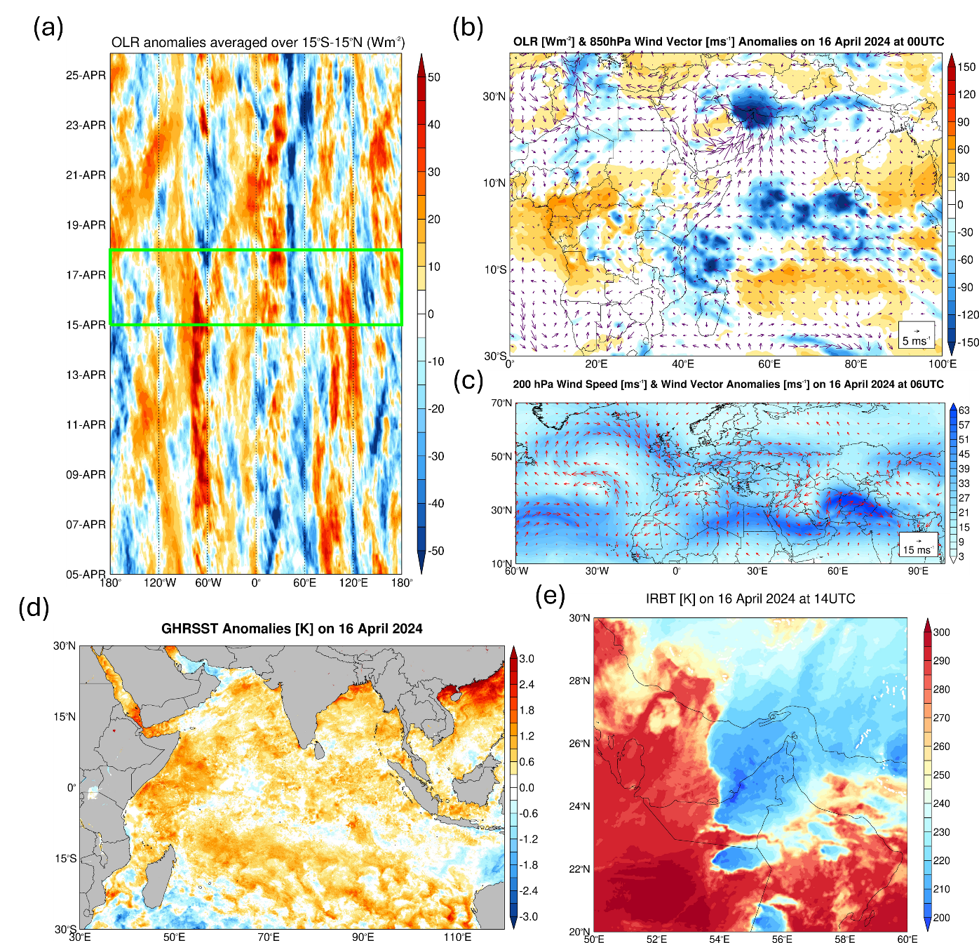
Figure S1: Large-Scale Drivers and Impacts of 16 April 2024 Historical Event: (a) 3-h anomalies of Outgoing Longwave Radiation (OLR; W m⁻²) from 05 to 25 April 2024 from ERA-5, computed with respect to the 1979-2023 3-h climatology. The green box highlights the study period, 15-17 April 2024. (b) OLR (shading; W m⁻²) and 850 hPa wind vectors (arrows; m s⁻¹) on 16 April 2024 at 00 UTC from ERA-5. (c) 200 hPa wind speed (shading; m s⁻¹) and wind vector anomalies (arrows; m s⁻¹) on 16 April 2024 at 06 UTC, with the anomalies computed with respect to the 1979-2023 climatology. (d) Sea Surface Temperature (SST) anomalies (K), with respect to 2003-2023 climatology, on 16 April 2024, as given by the GHRSST dataset. (e) Infrared Brightness Temperature (IRBT; K) at 14 UTC on 16 April 2024.

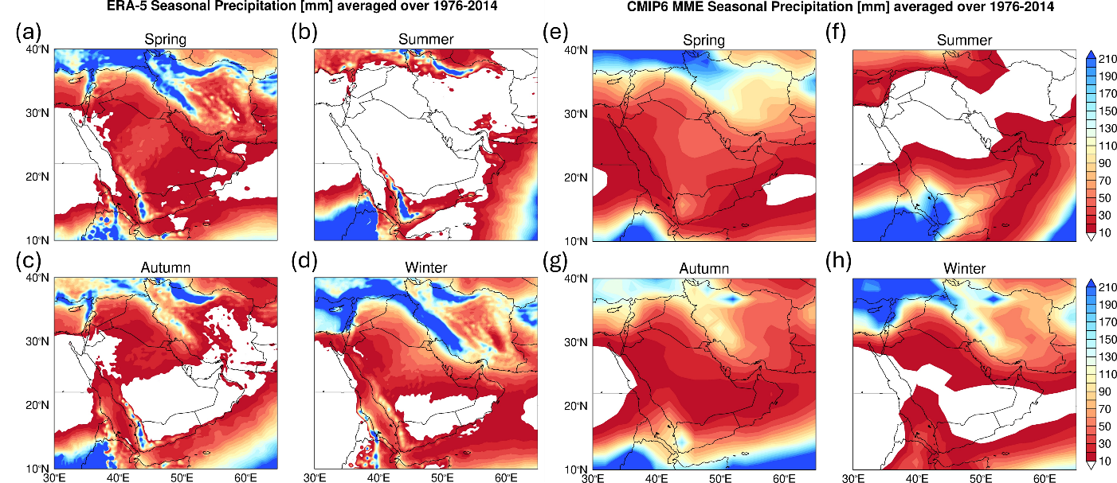
Figure S2: Seasonal accumulated precipitation in CMIP6 MME and ERA-5: Boreal (a) spring, (b) summer, (c) autumn and (d) winter accumulated precipitation (mm) from ERA-5 data averaged over 1976-2014. (e)-(h) are as (a)-(d) but for the CMIP6 MME, with the selected models for each season highlighted in yellow in Table S4.
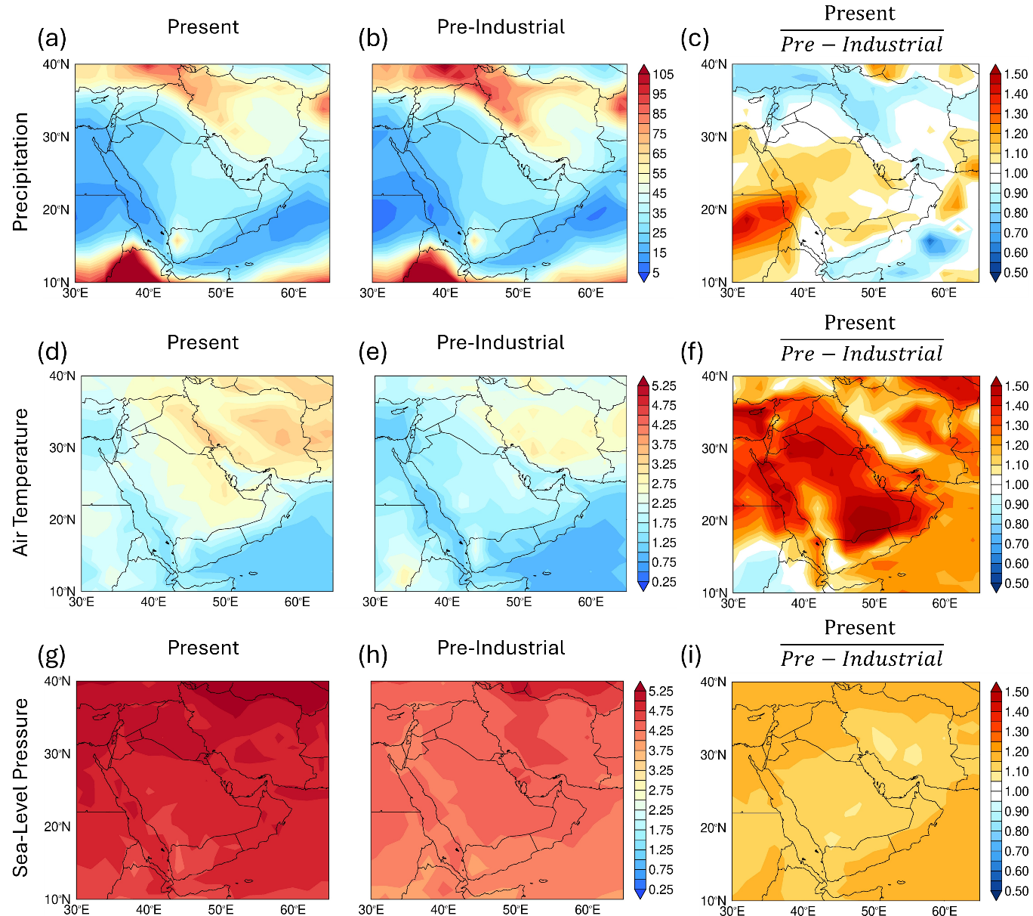
Figure S3: Change in Arabian Peninsula's Spring Climate Variability between Present and Pre-Industrial Simulations: Spring accumulated precipitation standard deviation (mm) for the 1976-2014 (a) present and (b) pre-industrial periods, and (c) ratio between the two (non-dimensional). (d)-(f) and (g)-(i) are as (a)-(c) but for the spring-averaged air temperature (K) and sea-level pressure (hPa), respectively.

References
[1] Wu, T., et al. BCC-CSM2-HR: a high-resolution version of the Beijing Climate Center Climate System Model. Geosci. Mod. Develop. 14, 2977-3006. https://doi.org/10.5194/gmd-14-2977-2021 (2021)
[2] Rong, et al. The CAMS Climate System Model and a Basic Evaluation of Its Climatology and Climate Variability Simulation. J. Meteorol. Res. 32, 839-861. https://doi.org/10.1007/s13351-018-8058-x (2019)
[3] Danabasoglu, G., et al. The Community Earth System Model Version 2 (CESM2). J. Adv. Mod. Earth Sys. 12, e2019MS001916. https://doi.org/10.1029/2019MS001916 (2020)
[4] Liang, Z., Rao, J., Guo, D. & Lu, Q. Simulation and projection of the sudden stratospheric warming events in different scenarios by CESM2-WACCM. Clim. Dyn. 59, 3741-3761. https://doi.org/10.1007/s00382-022-06293-2 (2022)
[5] Lovato, T., et al. CMIP6 simulations with the CMCC Earth System Model (CMCC-ESM2). J. Adv. Mod. Earth Sys. 14, e2021MS002814. https://doi.org/10.1029/2021MS002814 (2022)
[6] Voldoire, A., et al. Evaluation of CMIP6 DECK experiments with CNRM-CM6-1. J. Adv. Mod. Earth Sys. 11, 2177-2213. https://doi.org/10.1029/2019MS001683 (2019)
[7] Cherchi, A., et al. Global mean climate and main patterns of variability in the CMCC-CM2 coupled model. J. Adv. Mod. Earth Sys. 11, 185-209. https://doi.org/10.1029/2018MS001369 (2019)
[8] Golaz, J.-C., et al. The DOE E3SM coupled model version 1: Overview and evaluation at standard resolution. J. Adv. Mod. Earth Sys. 11, 2089-2129. https://doi.org/10.1029/2018MS001603 (2019)
[9] Golaz, J.-C., et al. The DOE E3SM Model version 2: Overview of the physical model and initial model evaluation. J. Adv. Mod. Earth Sys. 14, e2022MS003156. https://doi.org/10.1029/2022MS003156 (2022)
[10] Tang, Q., et al. The fully coupled regionally refined model of E3SM version 2: overview of the atmosphere, land, and river results. Geosci. Mod. Develop. 16, 3953-3995. https://doi.org/10.5194/gmd-16-3953-2023 (2023)
[11] Döscher, R., et al. The EC-Earth3 Earth system model for the Coupled Model Intercomparison Project 6. Geosci. Mod. Develop. 15, 2973–3020. https://doi.org/10.5194/gmd-15-2973-2022 (2022)
[12] van Noije, T., et al. EC-Earth3-AerChem: a global climate model with interactive aerosols and atmospheric chemistry participating in CMIP6. Geosci. Mod. Develop. 14, 5637–5668. https://doi.org/10.5194/gmd-14-5637-2021 (2021)
[13] He, B., et al. CAS FGOALS-f3-L Model Datasets for CMIP6 Historical Atmospheric Model Intercomparison Project Simulation. Adv. Atmos. Sci. 36, 771-778. https://doi.org/10.1007/s00376-019-9027-8 (2019)
[14] Held, I. M., et al. Structure and performance of GFDL’s CM4.0 climate model. J. Adv. Mod. Earth Sys. 11, 3691-3727. https://doi.org/10.1029/2019MS001829 (2019)
[15] Dunne, J. P., et al. The GFDL Earth System Model Version 4.1 (GFDL-ESM 4.1): Overall coupled model description and simulation characteristics. J. Adv. Mod. Earth Sys. 12, e2019MS002015. https://doi.org/10.1029/2019MS002015 (2020)
[16] Volodin, E. M., et al. Simulation of the modern climate using the INM-CM48 climate model. Russian J. Num. Analy. Math. Model. 33, 367-374. https://doi.org/10.1515/rnam-2018-0032 (2018)
[17] Volodin, E. & Gritsun, A. Simulation of observed climate changes in 1850-2014 with climate model INM-CM5. Earth Sys. Dyn. 9, 1235-1242. https://doi.org/10.5194/esd-9-1235-2018 (2018)
[18] Gutjahr, O., et al. Max Planck Institute Earth System Model (MPI-ESM1.2) for the High-Resolution Model Intercomparison Project (HighResMIP). Geosci. Mod. Develop. 12, 3241–3281. https://doi.org/10.5194/gmd-12-3241-2019 (2019)
[19] Yukimoto, S., et al. The Meteorological Research Institute Earth System Model Version 2.0, MRI-ESM2.0: Description and Basic Evaluation of the Physical Component. J. Meteorol. Soc. Japan Ser. II 97, 931-965. https://doi.org/10.2151/jmsj.2019-051 (2019)
[20] Seland, O., et al. Overview of the Norwegian Earth System Model (NorESM2) and key climate response of CMIP6 DECK, historical, and scenario simulations. Geosci. Mod. Develop. 13, 6165-6200. https://doi.org/10.5194/gmd-13-6165-2020 (2020)
[21] Park, S., Baek, E.-H., Kim, B.-M. & Kim, S.-J. Impact of detrained cumulus on climate simulated by the Community Atmosphere Model Version 5 with a unified convection scheme. J. Adv. Mod. Earth Sys. 9, 1399-1411. https://doi.org/10.1002/2016MS00877 (2017)

[22] Wang, Y.-C., et al. Performance of the Taiwan Earth System Model in simulating climate variability compared with observations and CMIP6 model simulations. J. Adv. Mod. Earth Sys. 13, e2020MS002353. https://doi.org/10.1029/2020MS002353 (2021).

