Supplementary Information for
Weakened Relationship Between the November Barents-Kara Sea Ice and January Arctic Oscillation after the Mid-1990s

Shuai Zheng¹, Peilong Yu^{1,2,3}, Bo Sun², Huijun Wang², Xiaopei Lin^{4,5}, Minghao Yang^{1,3}, Yudi Liu^{1,3}

¹ College of Meteorology and Oceanography, National University of Defense Technology, Changsha, China
² State Key Laboratory of Climate System Prediction and Risk Management/Key Laboratory of Meteorological Disaster, Ministry of Education/Collaborative Innovation Center on Forecast and Evaluation of Meteorological Disasters, Nanjing University of Information Science and Technology, Nanjing, China.
³ Key Laboratory of High Impact Weather (special), China Meteorological Administration, Changsha, China
⁴ Physical Oceanography Laboratory/Frontiers Science Center for Deep Ocean Multispheres and Earth System/Sanya Oceanographic Institution, Ocean University of China, Qingdao, China.
⁵ Laoshan Laboratory, Qingdao, China.

*Corresponding author:
Dr. Peilong Yu, yupeilong20@nudt.edu.cn

Contents of this file:
Supplementary Figures 1 to 11
Fig. S1 Relationship between autumn Arctic sea ice and December AO. Regression of SIC(%) in (a) November, (c) October and (e) September onto the December AO index during 1979-2015. (b), (d) and (f) show sliding correlation between the December AO index and the (b) November, (d) October, (f) September Barents-Kara SIC index, respectively. Black solid(dashed) lines in (e)-(h) indicate 95% (90%) confidence level according to the Student’s t test. Dotted areas in (a), (c) and (e) are statistically significant at the 90% confidence levels.
Fig. S2 Relationship between autumn Arctic sea ice and February AO.Same as Fig. S1, but for regressions onto the February AO index.
Fig. S3 Changes in atmospheric circulations at multiple levels in November associated with reduced November Barents-Kara SIC. Regressions of (a) geopotential height at 500 hPa (unit: 10⁻² gpm), (c) geopotential height at 850 hPa (unit: 10⁻² gpm) and (e) SLP (unit: 10⁻³ hPa) in November onto the November Barents-Kara SIC index during P1. (b), (d), (f) are same as (a), (c) and (e), respectively, but for during P2. The green contours in (a)-(f) denote the 90% confidence levels.
Fig. S4 Height-latitude cross sections for changes in geopotential heights and E-P fluxes associated with reduced November Barents-Kara SIC. Regressions of geopotential height (shaded, unit: 10⁻² gpm) and the Eliassen-Palm flux (vector, unit: 10⁸ m²·s⁻²) in (a) November, (b) December and (c) January onto the sign-reversed Barents-Kara SIC index during P1. (d), (e), (f) are the same as (a), (b) and (c), respectively, but for P2. Green contours denote the 90% confidence levels for the geopotential height anomalies. (b) and (c) share the same quiver key, while (e) and (f) share the same quiver key.

Fig. S5 Changes in atmospheric circulations at multiple levels in December associated with reduced November Barents-Kara SIC. Regressions of (a) geopotential height at 500 hPa (unit: 10⁻² gpm), (c) geopotential height at 850 hPa (unit: 10⁻² gpm) and (e) SLP (unit: 10⁻³ hPa) in December onto the November Barents-Kara SIC index during P1. (b), (d), (f) are same as (a), (c) and (e), respectively, but for during P2. The green contours in (a)-(f) denote the 90% confidence levels.
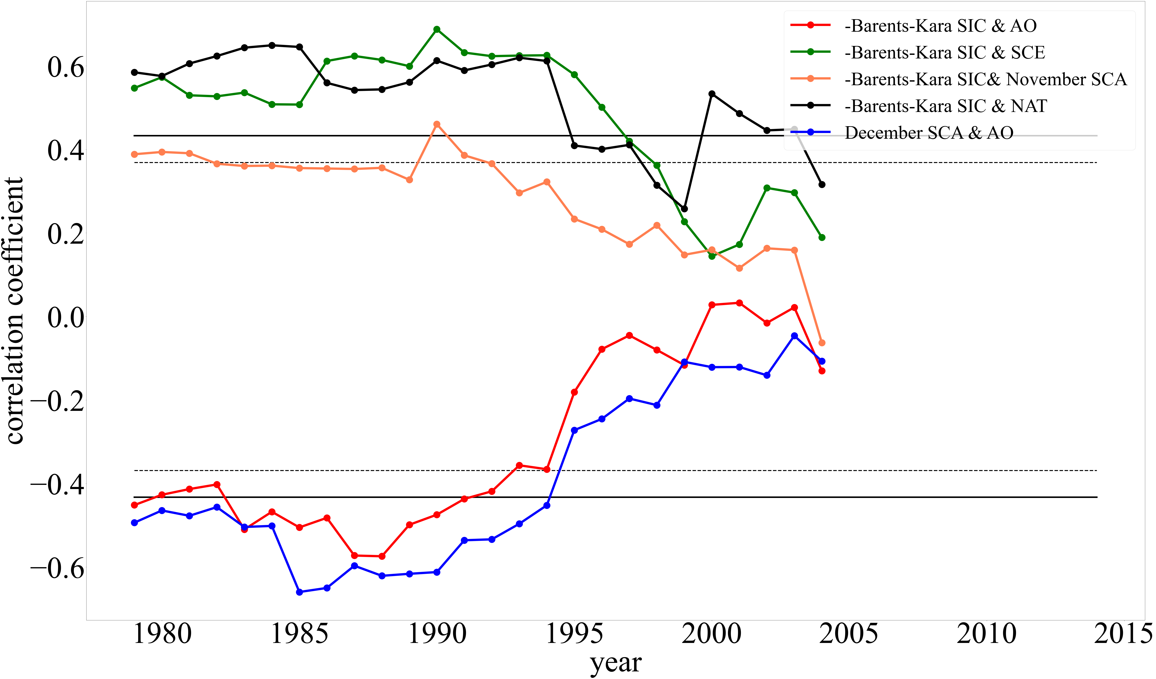
Fig. S6 Sliding correlations of the indexes used in this study. 21-year sliding correlations of the sign_reversed Barents-Kara SIC index, the NAT index, the SCE index, the November and December SCA index and the January AO index. Black solid(dashed) lines indicate 95% (90%) confidence levels.
Fig. S7 Changes of eddy vorticity flux and eddy heat flux associated with the NAT SST anomalies. Regressions of (a) eddy vorticity flux (EVF, unit: m∙day⁻¹), (c) eddy heat flux (EHF, unit: m∙day⁻¹) and (e) turbulent heat flux (THF, unit: W∙m⁻²) in November onto the NAT index during P1. (b), (d) and (f) are same as (a), (c) and (e), respectively, but for regressions during P2. The green contours in (a)-(f) denote the 90% confidence levels.
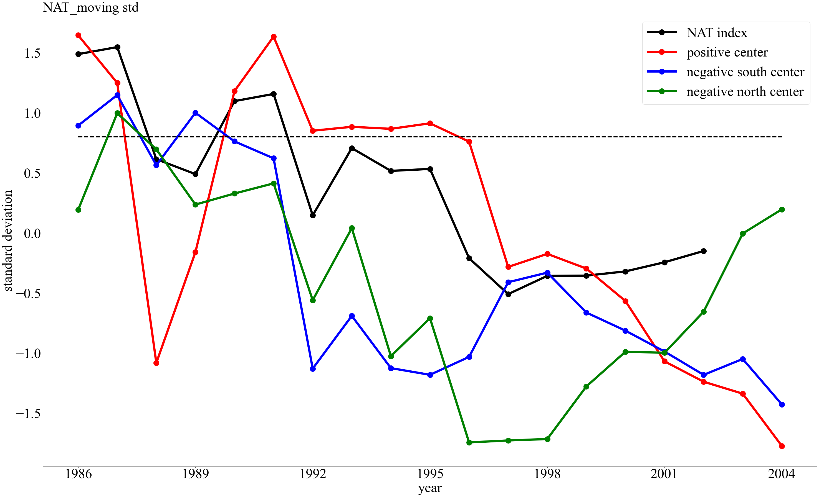
Fig. S8 Moving standard deviation of the NAT SST anomalies. The 15-year moving standard deviation of the NAT index (black solid line) and the three SST anomaly centers. Black dashed line denotes the 0.8 std.
Fig. S9 Half of the chosen AMIP models’ geopotential height changes associated with the NAT index. Regressions of 5 AMIP models’ geopotential height outputs (ACCESS-ESM1-5, EC-Earth3, HadGEM-GC31-MM, TaiESM1 and CNRM-CM6-1-HR) at 200 hPa onto the NAT index calculated by the models’ SST input datasets. Left panels show results in P1, while panels on the right show results in P2. Green contours denote the 90% confidence levels.
Fig. S10 Same as Fig. S9, but for the other 5 AMIP models (BCC-CSM2-MR, MIROC6, MRI-ESM2-0, NESM3 and SAM0-UNICON).

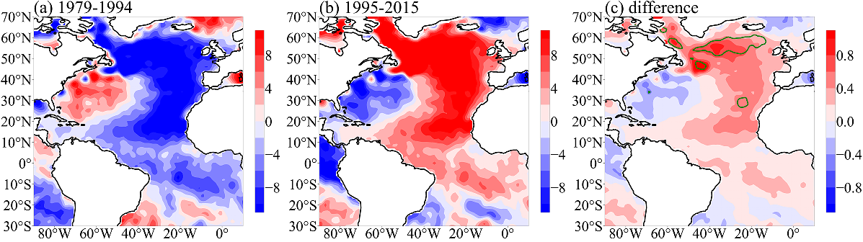
Fig. S11 Changes of SST background states after the mid-1990s. Climatology of Atlantic SST in (a) P1 and (b) P2. (c) shows their differences, with green contours denoting the 90% confidence levels.

