Supplementary Information

Ocean-Atmosphere Coupling Enhances Eurasian Cooling in Response to Historical Barents-Kara Sea-ice Loss

Mian Xu¹, Shichang Kang^{1, 2}*, James A. Screen³, Alexandre Audette⁴, Wenshou Tian⁵, Jiankai Zhang⁵, Hao Yu³ and Han Zhang⁶

- Key Laboratory of Cryospheric Science and Frozen Soil Engineering, Northwest Institute of Eco-Environment and Resources, Chinese Academy of Sciences, Lanzhou 730000, China
- University of Chinese Academy of Sciences, Beijing 100049, China
- Department of Mathematics and Statistics, University of Exeter, Exeter, UK
- Department of Earth and Planetary Sciences, University of California Santa Cruz, Santa Cruz, CA, USA
- College of Atmospheric Sciences, Lanzhou University, China
- School of Atmospheric Sciences, and Key Laboratory of Tropical Atmosphere-Ocean System, Ministry of Education, Sun Yat-Sen University, Zhuhai, China

*Corresponding author: Shichang Kang (shichang.kang@lzb.ac.cn)

Contents of this PDF file
Supplementary Notes
Supplementary Figure 1-4
Supplementary Table 1-3
Supplementary References

Supplementary Notes:
Atmospheric blocking detection
In this study, atmospheric block event is detected according to Woollings et al.¹, based on 500-hPa daily geopotential field (Z500). The detection procedures are as follows: Firstly, daily Z500 anomalies of 1979-2020 ERA-5 reanalysis data and each experiment are calculated at each grid as the deviation from the climatology of reanalysis and each experiment; Then, instantaneous blockings are detected where Z500 anomalies above the upper dectile of the Z500 anomalies distribution between 50°N-80°N from reanalysis and each simulation; Finally, additional constraints are applied on the detected instantaneous blocking to ensure its quasi-stationarity and persistency. That is, large-scale blocking should persist for a least 15° longitude and occur within 2.5° (latitude)×5° (longitude) of it; Also, this large-scale blocking should last for a least 5 days.

Supplementary Figures:
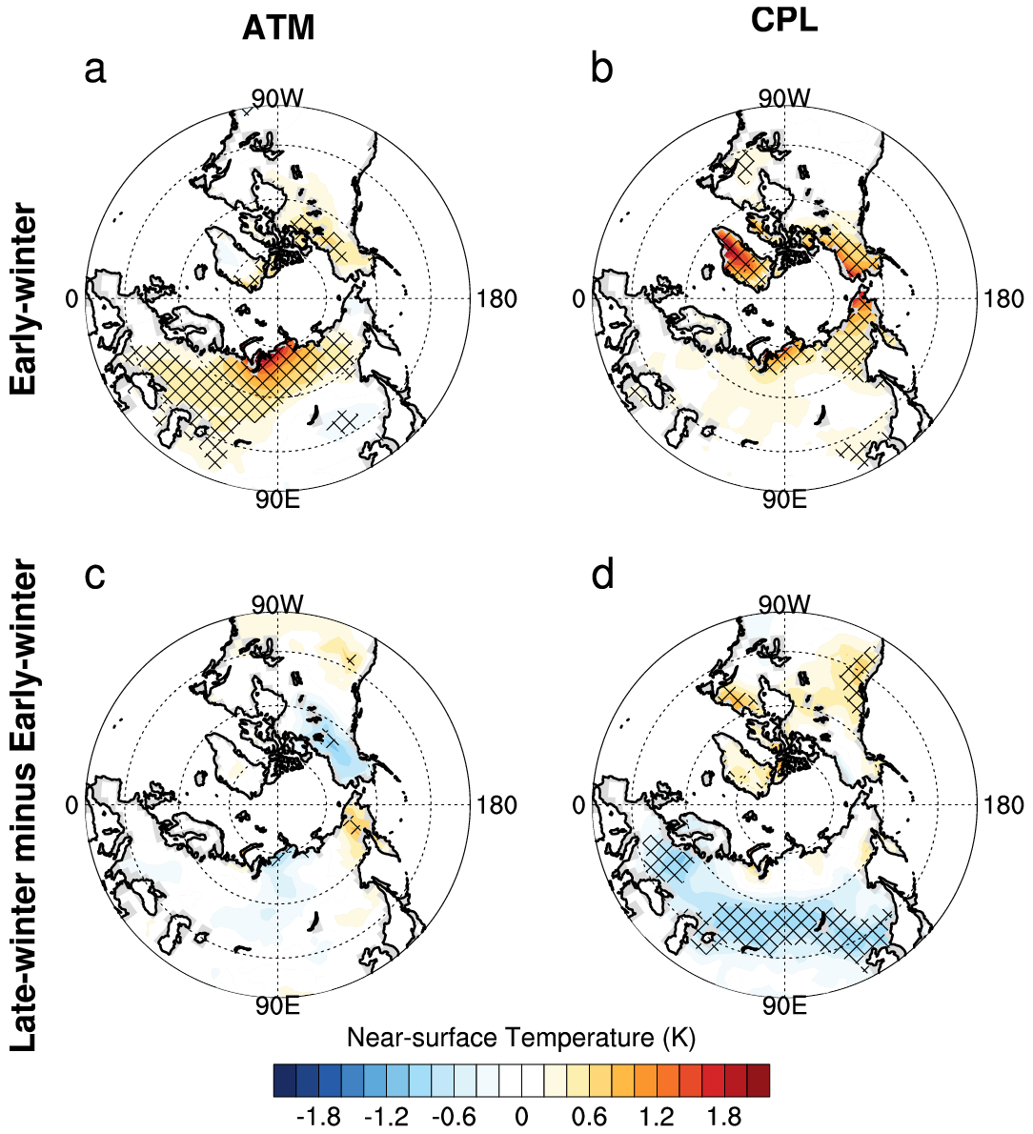
Figure S1. Simulated early-winter Eurasian near-surface temperature response to historical sea-ice loss. a 200-yr simulated differences of early-winter (November-December) T_{2m} between the historical the atmosphere-only historical BKS low- and high-SIC simulations (atm_lo minus atm_hi). b the same as a, but for the coupled historical BKS low- and high-SIC simulations (cpl_lo minus cpl_hi). Differences of the simulated T_{2m} responses to BKS sea-ice loss between the late-winter (January-February) and early-winter mean, derived from the c atmosphere-only and d coupled simulations, respectively. Cross-hatching denotes the statistical significance at the 95% confidence level according to bootstrap resampling.

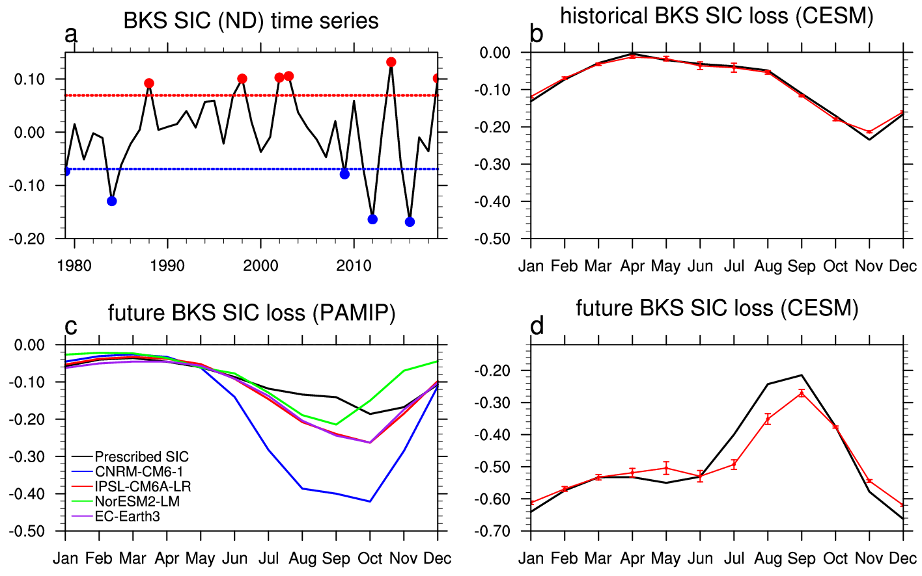
Figure S2. Selection of historical high- and low-SIC years and seasonal cycles of historical and future BKS SIC loss. a De-trended time series of 1979-2019 early-winter (November-December) BKS SIC (1), derived from PIOMAS reanalysis. Dashed blue/red line indicates the lower/upper threshold for the BKS low- and high-SIC years (1-time standard deviation) and the blue/red dots denote the selected BKS low- and high-SIC years according to this criterion. b Composited seasonal cycle of BKS SIC difference between historical BKS low- and high-SIC years (1; black) derived from PIOMAS reanalysis. Red line denotes the 200-yr simulated seasonal cycle of BKS SIC differences between the coupled BKS historical low- and high-SIC simulations (cpl_lo and cpl_hi). Red dots and vertical lines denote the mean, upper and lower boundary of 1-time standard deviation of BKS SIC differences between cpl_lo and cpl_hi runs, respectively. c Seasonal cycles of BKS SIC differences between PAMIP pa-futArcSIC-ext and pa-pdSIC-ext runs, derived from CNRM-CM6-1 (blue), IPSL-CM6A-LR (red), NorESM2-LM (green) and EC-Earth3 (purple). Black line denotes the prescribed seasonal cycle of BKS SIC differences between PAMIP pdSST-futArcSIC and pdSST-pdSIC runs. d the same as b, but for the coupled future and present-day BKS SIC simulations (cpl_fut and cpl_pd). Black line denotes the seasonal cycle of BKS SIC difference between SSP585 2080-2099 and historical 1980-1999, derived from 23 CMIP6 models (Supplementary Table 2).

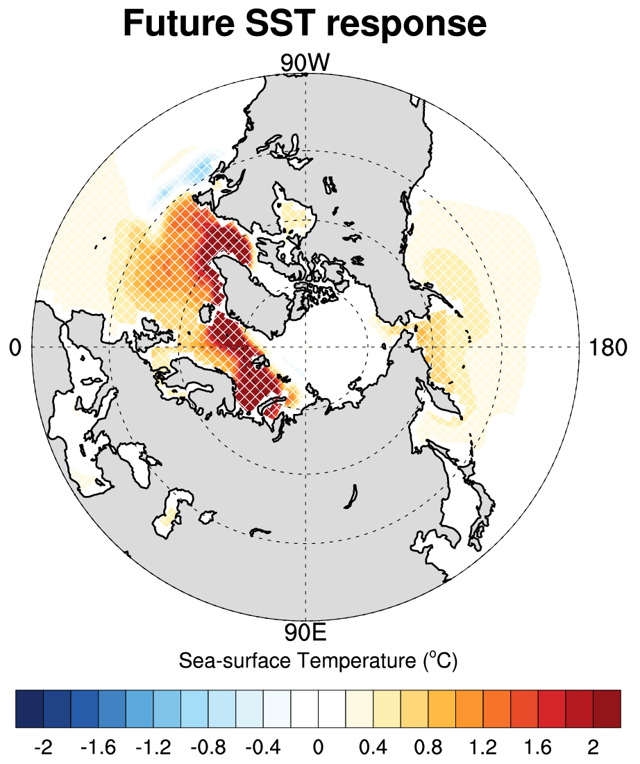
Figure S3. SST response to future sea-ice loss. 200-yr simulated differences of early-winter (November-December) SST between the coupled future and present-day BKS SIC simulations (cpl_fut minus cpl_pd). Cross-hatching denotes the statistical significance at the 95% confidence level according to bootstrap resampling.

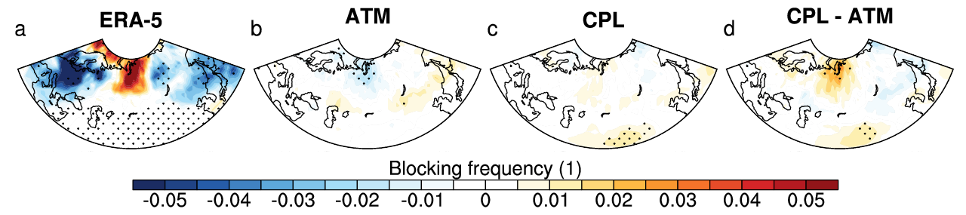
Figure S4. Atmospheric blocking response to historical sea-ice loss. a Regression map of early-winter (November-December) BKS SIC against late-winter (January-February) atmospheric blocking frequency (1) during 1979-2019, scaled by the early-winter BKS SIC difference between BKS low- and high-SIC years. b 200-yr simulated differences of late-winter atmospheric blocking frequency between the atmosphere-only historical BKS low- and high-SIC simulations (atm_lo minus atm_hi). c the same as b, but for the coupled historical BKS low- and high-SIC simulations (cpl_lo minus cpl_hi). d the differences between c and b (c minus b).
Supplementary Tables:
Table S1. CMIP6 models used in this study
Number | Model Name | Sea-ice component | Sea-ice resolution  (latitude × longitude)
1 | ACCESS-CM2 | CICE5.1.2 | 300 × 360
2 | ACCESS-ESM1-5 | CICE4.1 | 300 × 360
3 | CanESM5 | LIM2 | 291 × 360
4 | CESM2-WACCM | CICE5.1 | 384 × 320
5 | CNRM-CM6-1-HR | Gelato 6.1 | 1050 × 1442
6 | CNRM-CM6-1 | Gelato 6.1 | 294 × 362
7 | CNRM-ESM2-1 | Gelato 6.1 | 294 × 362
8 | E3SM-1-1 | MPAS-Seaice6.0 | 256 × 360
9 | EC-Earth3 | LIM3 | 292 × 362
10 | EC-Earth3-Veg | LIM3 | 292 × 362
11 | GFDL-CM4 | GFDL-SIM4p25 | 1080 × 1440
12 | GFDL-ESM4 | GFDL-SIM4p5 | 576 × 720
13 | HadGEM3-GC31-LL | CICE-HadGEM3-GSI8 | 330 × 360
14 | HadGEM3-GC31-MM | CICE-HadGEM3-GSI8 | 1205 × 1440
15 | MIROC6 | COCO4.9 | 256 × 360
16 | MIROC-ES2L | COCO4.9 | 256 × 360
17 | MPI-ESM1-2-HR | unnamed | 404 × 820
18 | MRI-ESM2-0 | MRI.COM4.4 | 363 × 360
19 | NESM3 | CICE4.1 | 384 × 320
20 | NorESM2-LM | CICE | 384 × 360
21 | NorESM2-MM | CICE | 384 × 360
22 | TaiESM1 | CICE4 | 384 × 320
23 | UKESM1-0-LL | CICE-HadGEM3-GSI8 | 330 × 360

Table S2. Simulation scheme of CESM1.2.0 experiments
Experiment Name | Simulation Length (yr) | SIC/SST Forcing | Ocean-atmosphere Coupling?
atm_hi | 203 | Prescribed historical BKS high-SIC | No
atm_lo | 203 | Prescribed historical BKS low-SIC | No
cpl_hi | 260 | Nudged historical BKS high-SIC | Yes
cpl_lo | 260 | Nudged historical BKS low-SIC | Yes
atm_pd | 203 | Prescribed CMIP6 MME 1980-1999 BKS SIC/SST | No
atm_fut | 203 | Prescribed CMIP6 SSP585 MME 2080-2099 BKS SIC/SST | No
cpl_pd | 260 | Nudged CMIP6 MME 1980-1999 BKS SIC/SIT | Yes
cpl_fut | 260 | Prescribed CMIP6 SSP585 MME 2080-2099 BKS SIC/SIT | Yes

Table S3. Ensemble size and horizontal resolution of PAMIP participant models
Model Name | Atmosphere-only | Long coupled | Horizontal resolution  (latitude × longitude)
EC-Earth3 | 100 | 300 | 256 × 512
IPSL-CM6A-LR | 200 | 300 | 143 × 144
NorESM2-LM | 200 | 100 | 96 × 144
CNRM-CM6-1 | 100 | 100 | 128 × 256

Supplementary References:
- Woollings, T., et al. Blocking and its response to climate change. Curr. Clim. Change Rep. 4, 287-300 (2018).

