Supplementary Information for
Arctic Cyclone Activity Changes Under a Warming Climate
Yue Chen^{1,2}, Yu Liang^{1,2,3}, Xianyao Chen^{1,2,3,4*}, and Haibo Bi⁵
¹ Frontier Science Center for Deep Ocean Multispheres and Earth System, Ocean University of China, Qingdao, China.
² Physical Oceanography Laboratory, Ocean University of China, Qingdao, China.
³ Key Laboratory of Transparent Arctic, Ocean University of China, Qingdao, China.
⁴ Laoshan Laboratory, Qingdao, China.
⁵ Key Laboratory of Ocean Observation and Forecasting and Key Laboratory of Ocean Circulation and Waves, Institute of Oceanology, Chinese Academy of Sciences, Qingdao, China.

*Corresponding author: Xianyao Chen (chenxy@ouc.edu.cn)

This file includes:
Supplementary Figures 1 to 4
Supplementary Tables 1

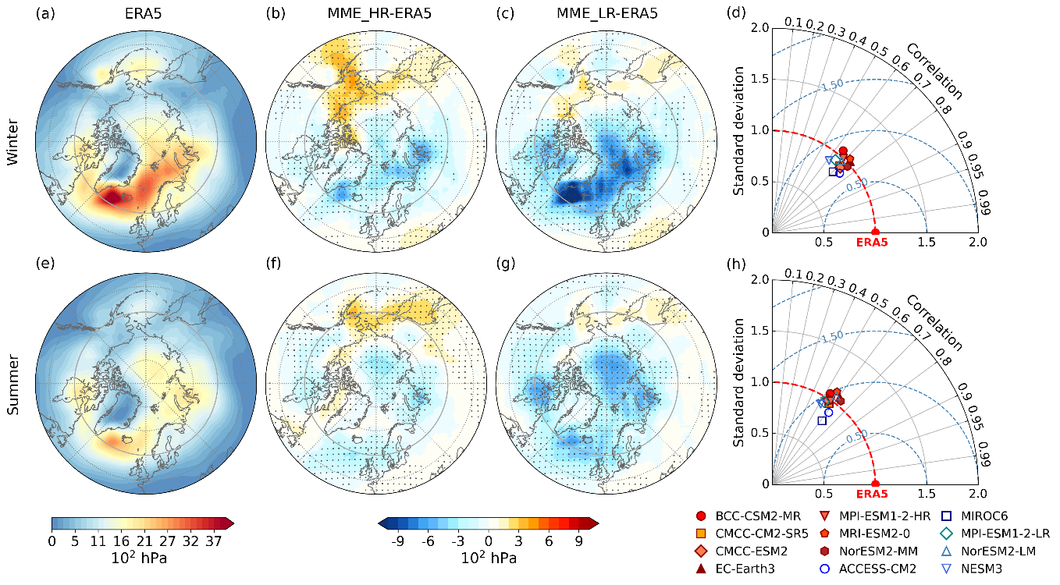

Supplementary Fig. 1 Comparison of Arctic cyclone activity index (CAI) between CMIP6 models and ERA5. a, Climatological mean CAI in ERA5 for winter during 1950–2014. b, Differences between the high-resolution multi-model ensembles (MME_HR) and ERA5. c, Same as b but for the low-resolution multi-model ensembles (MME_LR). d, Taylor diagram summarizes spatial correlation (radius), centered root-mean-square error (radial distance) and normalized standard deviation (distance from the origin) for individual models. Filled warm-colored symbols represent high-resolution models, and open cool-colored symbols denote low-resolution models. e–h, Same as a–d but for summer. Stippling in b, c, f, and g indicates that the differences are significant at the 95% confidence level.

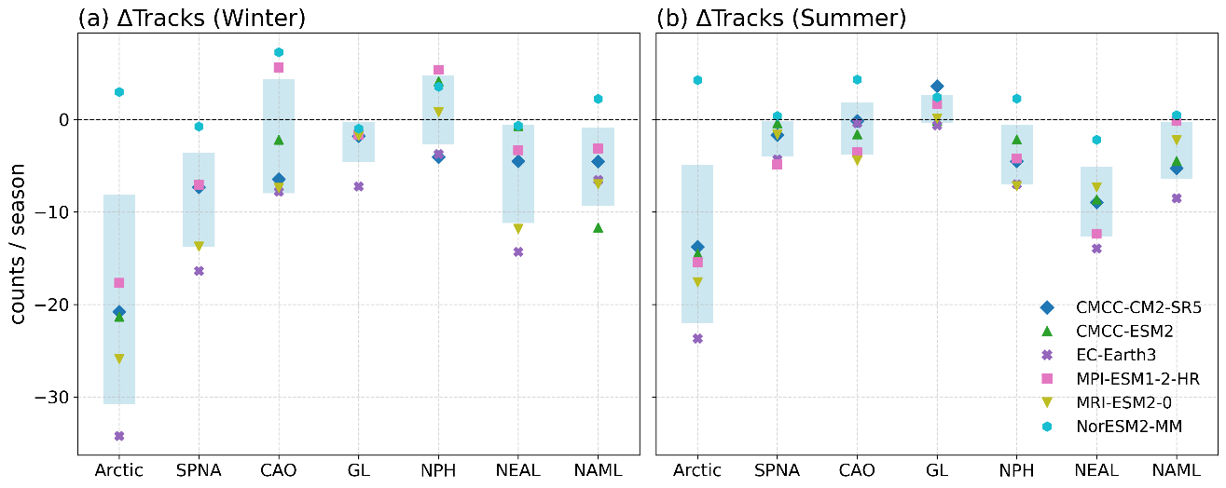

Supplementary Fig. 2 Inter-model differences in projected regional number of cyclone tracks between future (2071–2100) and historical (1985–2014) periods. a, Differences in seasonal cyclone tracks for each model in the seven sub-regions during winter. b, Same as a but for summer. Shading indicates the multi-model mean ± one standard deviation.

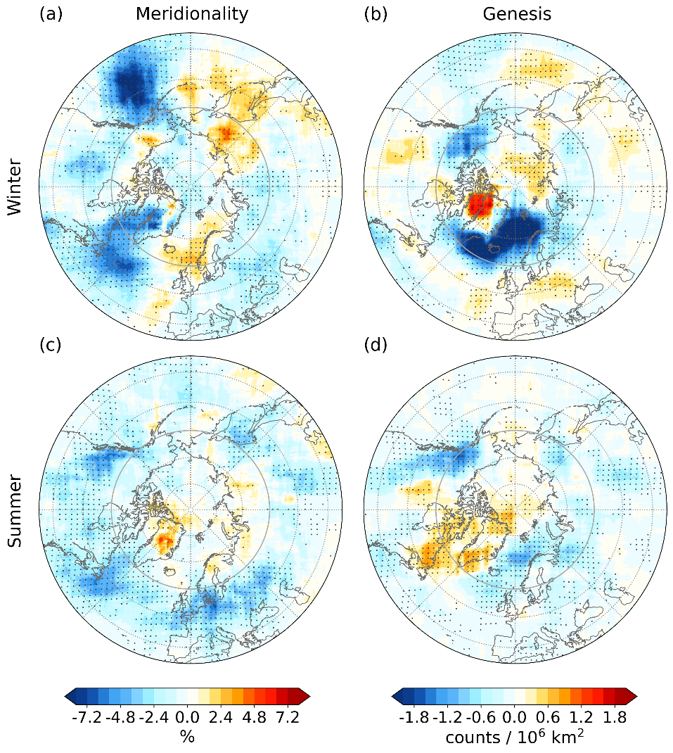

Supplementary Fig. 3 Projected changes in Arctic cyclone characteristics between future (2071–2100) and historical (1985–2014) periods. Differences in winter a meridionality and b genesis based on the multi-model mean of six selected high-resolution models. c–d, Same as a–b but for summer. Stippling indicates areas where the differences are significant at the 95% confidence level.

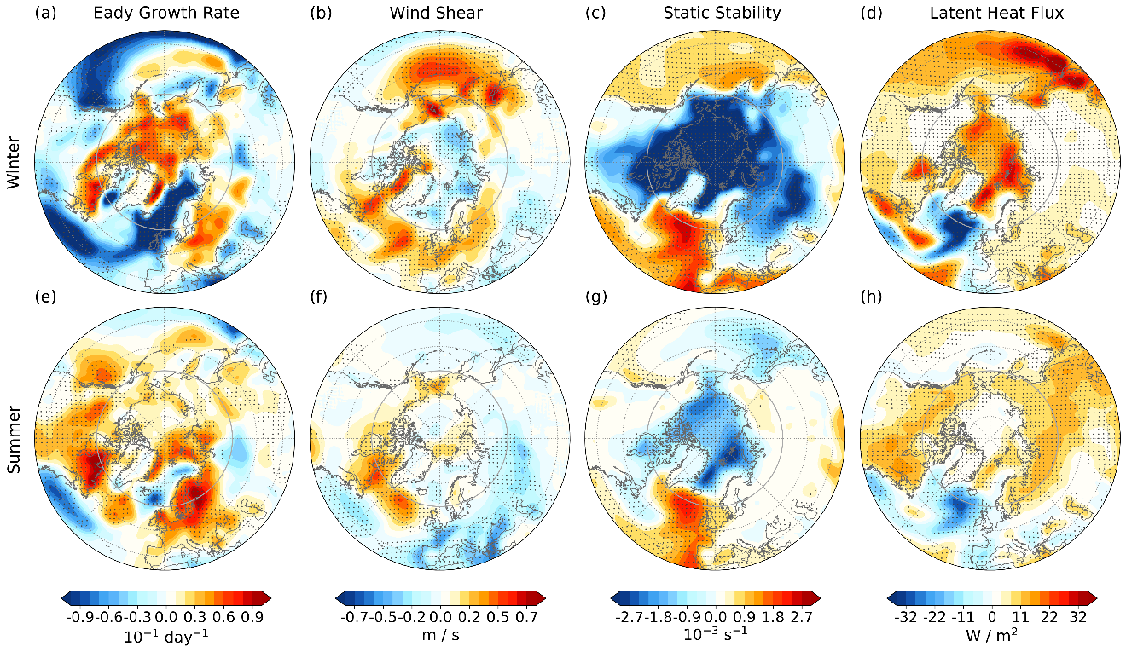

Supplementary Fig. 4 Projected changes in baroclinic instability over 1000–925 hPa and surface latent heat fluxes between future (2071–2100) and historical (1985–2014) periods. Differences in winter a 1000–925 hPa mean Eady Growth Rate (EGR), b vertical wind shear between 1000 and 925 hPa, c mean static stability over 1000–925 hPa, and d surface latent heat flux based on the multi-model mean of six selected high-resolution models. e–h, Same as a–d but for summer. Stippling indicates areas where the differences are significant at the 95% confidence level.

Supplementary Table 1 Information on the 12 Coupled Model Intercomparison Project Phase 6 (CMIP6) models used in this study.
Model | Institution/Nation | Atmospheric Resolution
Model | Institution/Nation | Horizontal | Vertical
ACCESS-CM2 | Commonwealth Scientific and Industrial Research Organization/Australia | N96; 192×144; 250 km | 85 levels
BCC-CSM2-MR | Beijing Climate Center/China | T106; 320×160; 100 km | 46 levels
CMCC-CM2-SR5 | Fondazione Centro Euro-Mediterraneo sui Cambiamenti Climatici (CMCC)/Italy | 288×192; 100 km | 30 levels
CMCC-ESM2 | CMCC/Italy | 288×192; 100 km | 30 levels
EC-Earth3 | EC-Earth Consortium/Europe | TL255; 512×256; 100 km | 91 levels
MIROC6 | MIROC/Japan | T85; 256×128; 250 km | 81 levels
MPI-ESM1-2-HR | Max Planck Institute for Meteorology/Germany | T127; 384×192; 100 km | 95 levels
MPI-ESM1-2-LR | Max Planck Institute for Meteorology/ Germany | T63; 192×96; 250 km | 47 levels
MRI-ESM2-0 | Meteorological Research Institute/Japan | TL159; 320×160; 100 km | 80 levels
NorESM2-MM | NorESM Climate Modeling Consortium/ Norway | 288×192; 100 km | 32 levels
NorESM2-LM | NorESM Climate Modeling Consortium/ Norway | 144×96; 250 km | 32 levels
NESM3 | Nanjing University of Information Science and Technology/China | T63; 192×96; 250 km | 47 levels

