Supplementary Information for
Beyond Global Mean Temperature: Increasing Asymmetry of Global Warming in Past and Future Climate Change
Qiuying Gan^{1,2#}, Jeremy Cheuk-Hin Leung^{1#}, Wenjie Dong², Yazhu Yang¹, Dingchi Zhao¹, Yi Li^{1*}, Renhe Zhang³, Banglin Zhang^{1,4,5*}
¹College of Meteorology and Oceanography, National University of Defense Technology, Changsha, China
²School of Atmospheric Sciences and Key Laboratory of Tropical Atmosphere-Ocean System Ministry of Education Sun Yat-Sen University, Southern Marine Science and Engineering Guangdong Laboratory (Zhuhai), Zhuhai, China
³Department of Atmospheric and Oceanic Sciences and Institute of Atmospheric Sciences, Fudan University, Shanghai, China
⁴College of Atmospheric Science, Lanzhou University, Lanzhou, People’s Republic of China
⁵Key Laboratory of High Impact Weather (Special), China Meteorological Administration, Changsha, China
# These authors contributed equally to this work.
Corresponding authors: Banglin Zhang (zhangbanglin24@nudt.edu.cn), Yi Li (liyiqxxy@163.com)

Contents of this file
Texts S1 to S8
Figures S1 to S8
Table S1 to S2
Reference

Introduction
This supporting information provides supplementary texts, figures, and tables cited in the main text.

Text S1. The asymmetry nature of global warming
In Fig. 1, we show a remarkable change in the shape of the global ΔT SPDF during 1900–2022, based on HadCRUT5. The global ΔT SPDF first followed a Gaussian-like symmetric distribution in the early 20th century, and progressively evolved into a right-skewed distribution in the latter period, particularly after the 1980s. Here, based on the BEST, GISTEMP, and NOAAGlobalTemp datasets, we also reveal a pronounced transformation in the global ΔT SPDF over the past century, characterized by both a shift in mean temperature and changes in its spatial symmetry.
Figs. S1–S3 illustrate the evolving global ΔT SPDFs from 1900 to 2022, with the overall shift towards higher temperatures reflecting widespread global warming. Notably, we observed a remarkable change in the shape of the global ΔT SPDFs over time. Fig. S1, which is based on BEST, shows that SPDFs transition from a left-skewed distribution in the early 20th century to a right-skewed distribution in the latter period, particularly after the 1980s. Fig. S2, based on GISTEMP, shows that SPDFs followed a near-Gaussian, symmetric distribution in the early 20th century, and it also evolved into a right-skewed distribution in the latter period, particularly after the 1980s. Similarly, Fig. S3, based on NOAAGlobalTemp, shows that the relatively symmetric ΔT SPDF before the mid-20th century progressively evolved into a right-skewed distribution in the latter period. The ${∆T}_{median}$ of the global ΔT SPDF significantly increases by 0.088°C/decade, 0.086°C/decade, 0.085°C/decade, which is slower than the increasing rate of ${∆T}_{mean}$ (0.097°C/decade for BEST, 0.095°C/decade for GISTEMP, 0.095°C/decade for NOAAGlobalTemp). These differences imply that the global ΔT change is spatially asymmetric, with increasing probability of global ΔT in the warm-side tails. The above pronounced changes demonstrate that the globe is undergoing a highly asymmetric warming process, driving a progressive shift of the global ΔT SPDFs towards a non-Gaussian, skewed, bimodal distribution, especially after the 1980s.

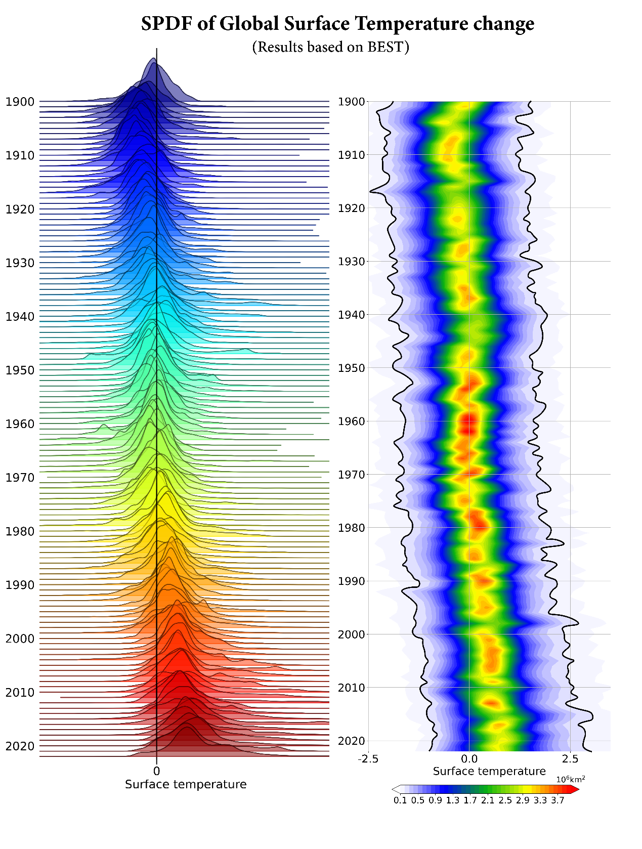
Figure S1 | Transformation of global ΔT SPDF due to asymmetry of global warming from 1900–2022 in the BEST dataset. SPDF of annual global ΔT (unit: 10⁶km²) from 1900 to 2022. Results based on BEST. Results show that the global ΔT SPDF has shifted to right-skewed asymmetric distributions, especially after the 1980s, consistent with Fig. 1.

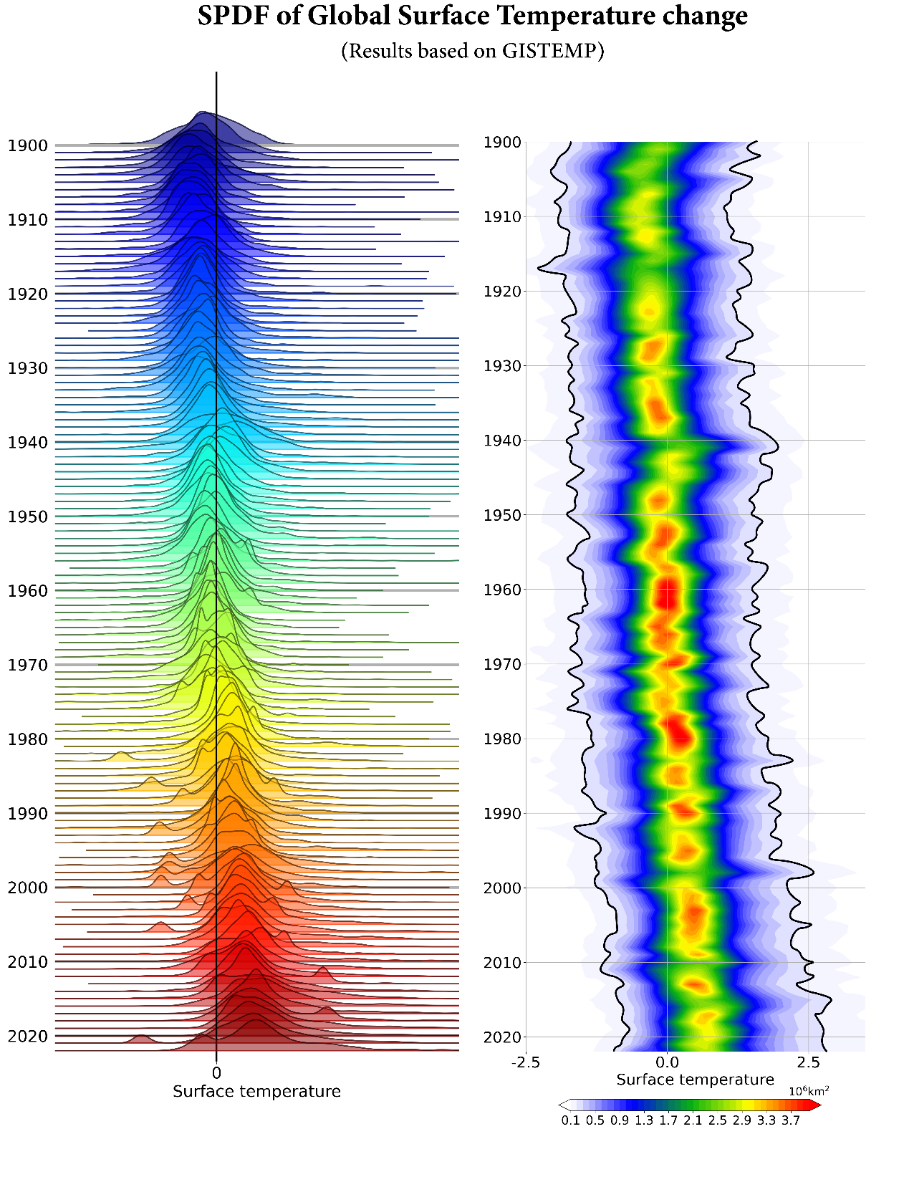
Figure S2 | Transformation of global ΔT SPDF due to asymmetry of global warming from 1900–2022 in the GISTEMP dataset. SPDF of annual global ΔT (unit: 10⁶km²) from 1900 to 2022. Results based on GISTEMP. Results show that the global ΔT SPDF has shifted from symmetric distributions to right-skewed asymmetric distributions, especially after the 1980s, consistent with Fig. 1.

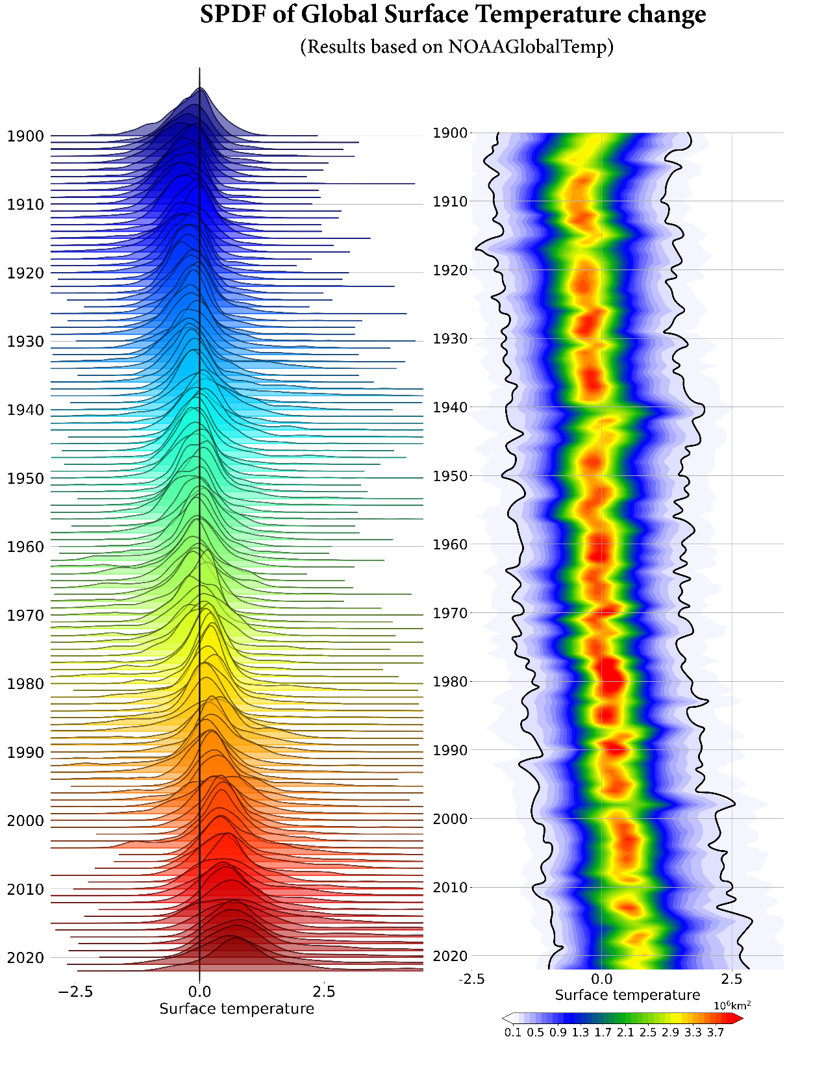
Figure S3 | Transformation of global ΔT SPDF due to asymmetry of global warming from 1900–2022 in the NOAAGlobalTemp dataset. SPDF of annual global ΔT (unit: 10⁶km²) from 1900 to 2022. Results based on NOAAGlobalTemp. Results show that the global ΔT SPDF has shifted from symmetric distributions to right-skewed asymmetric distributions, especially after the 1980s, consistent with Fig. 1.

Text S2. Changes in the occurrence of warming hot spots
Asymmetric warming is a complex phenomenon resulting from the coupling of multiple factors, which has been documented in numerous previous studies¹⁻⁵. However, there has been no quantitative study analyzing the contribution of different regions to this asymmetric warming on a global scale. Here, we quantitatively assess the key regions that primarily contribute to this global asymmetric warming by identifying regions where temperature evolution plays a pivotal role in driving the right-skewed distribution of global ΔT.
In Figs. 2a–2b, we demonstrate significant changes in the occurring probability of warming hot spots, which are responsible for the right-skewed distribution of the global ΔT distribution, based on HadCRUT5. Here, we show that consistent changes in the occurring probability of warming hot spots can also be derived from three other observational datasets, BEST, GISTEMP, and NOAAGlobalTemp (Fig. S4).
The results reveal, for all datasets, that the highest occurrence of warming hot spots predominantly occurs in the Arctic (60–90°N), where the climatological occurrence exceeds 50% during 1900–2022. This indicates that most Arctic regions endured temperature anomalies in the upper 80th percentile for more than half of the study period. Meanwhile, a relatively high occurring probability is also observed in regions including North America, central Eurasia, the Southern Ocean, etc. (Figs. S4a–c). This spatial distribution of the occurring probability of warming hot spots exhibits significant long-term trends. The largest increasing trends are mainly observed across most Arctic regions, eastern Europe, and central Asia (Figs. S4d–4f). These findings suggest that northern high-latitude regions are experiencing accelerating contributions to global warming asymmetry. It is also noted that a significant increase in warming hot spot occurrence is observed in Antarctica in BEST and GISTEMP, which is inconsistent with the results based on HadCRUT5 and NOAAGlobalTemp. However, these may be spurious trends due to incomplete observations in the early years^{6,7}, and should be interpreted with caution.

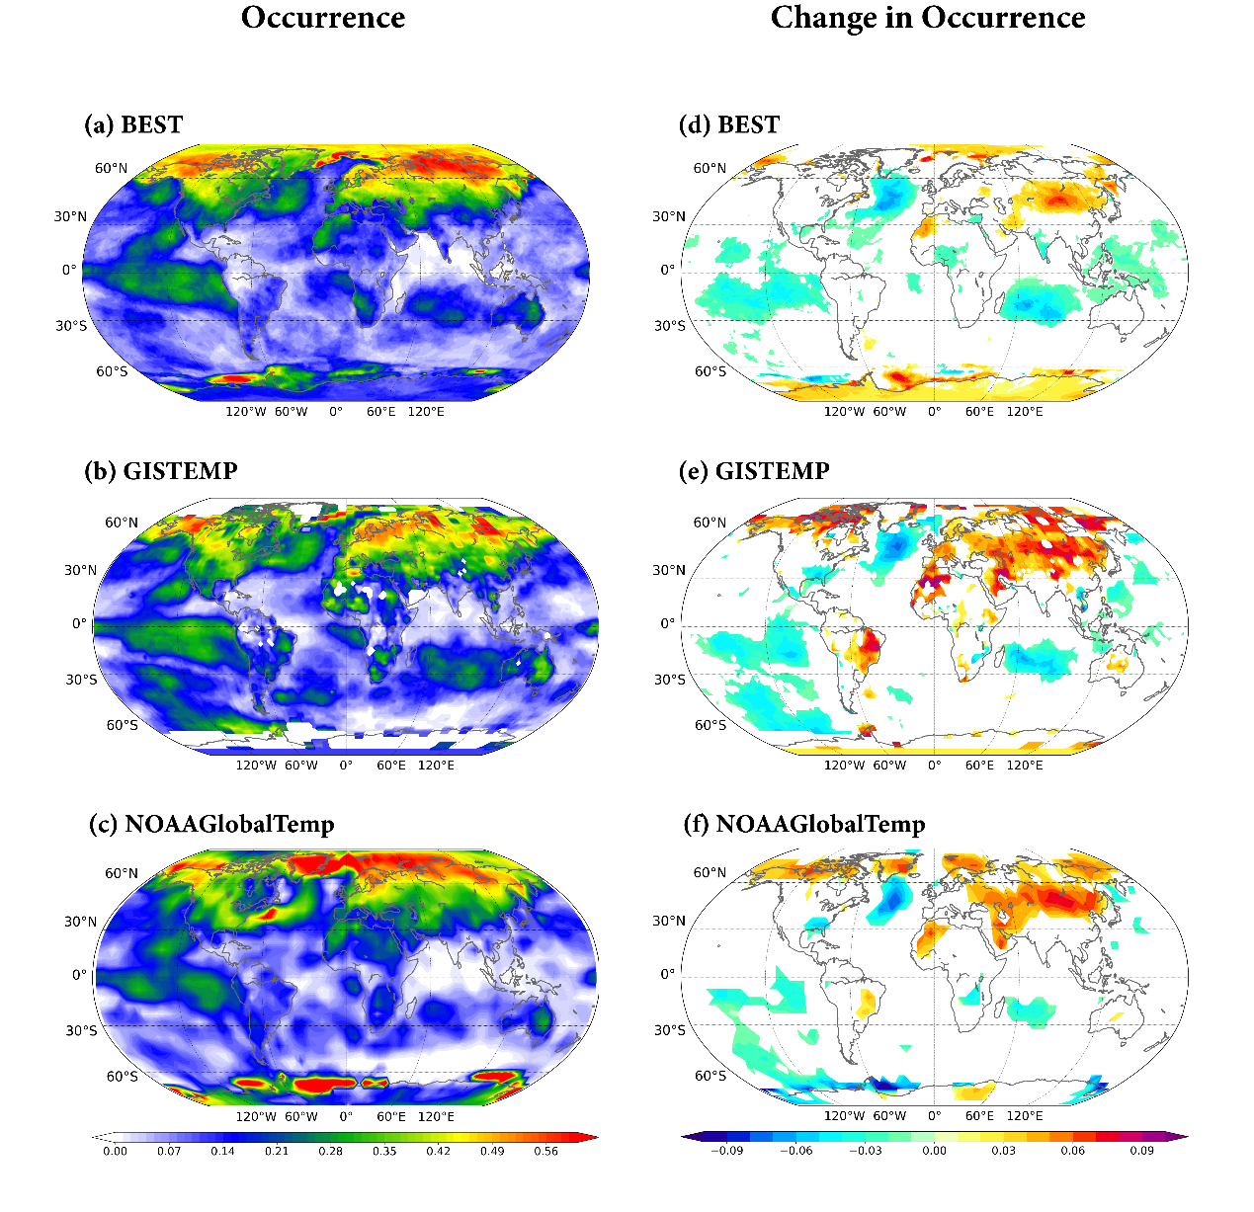
Figure S4 | Changes in the occurrence of global warming hot spots during 1900–2022. (a–c) The occurring probability of warming hot spots, i.e., grid points with ΔT exceeding the 80th percentile (T80) of the annual global ΔT SPDF (see Methods), during 1900–2022. (d–f) Long-term trend in the occurring probability (unit: /decade) of warming hot spots from 1900 to 2022. Only trend values at or above the 95% confidence level are shown. Results are based on the (a, d) BEST, (b, e) GISTEMP, (c, f) NOAAGlobalTemp datasets. Results show that the global warming asymmetry is mainly contributed by mid-high latitudes.

Text S3. Comparison between CMIP6 model-simulated historical changes in ${∆T}_{mean}$, ${∆T}_{median}$ and global warming asymmetry with observations.

The performances of CMIP6 models simulating historical changes in ${∆T}_{mean}$, ${∆T}_{median}$, and global warming asymmetry are evaluated. Figs. S5a–c present the time series of observed and simulated ${∆T}_{mean}$, ${∆T}_{median}$, and global warming asymmetry from 1900 to 2014, respectively. The results show that the multi-model ensemble mean (MME) of ${∆T}_{mean}$ exhibits high consistency with observations (r = 0.93), along with a relatively small inter-model spread. The long-term trend in MME (0.078 °C/decade) slightly underestimates the observed trend in ${∆T}_{mean}$ (0.087 °C/decade) by approximately 10.3% (Fig. S5a). Similarly, the variability of MME ${∆T}_{median}$ also agrees well with observations (r = 0.91), showing a narrow inter-model uncertainty range. However, the MME trend in global ${∆T}_{median}$ trend (0.066 °C/decade) is smaller than the observed trend (0.080 °C/decade) by 17.5%, indicating a larger bias compared to that of global${∆T}_{mean}$ (Fig. S5b).
In contrast, the MME of global warming asymmetry shows a rather low correlation with observations (r = 0.61), accompanied by a larger inter-model spread compared to those of global ${∆T}_{mean}$ and ${∆T}_{median}$. More notably, the MME trend in global warming asymmetry (0.44 °C³/decade) substantially overestimates the observed trend (0.19 °C³/decade), being more than twice the observation (Fig. S5c). The evaluation results suggest that although the CMIP6 models can reproduce the observed historical ${∆T}_{mean}$, they exhibit rather large uncertainties and biases in simulating the asymmetric nature of global warming, or the SPDF of $∆T$.

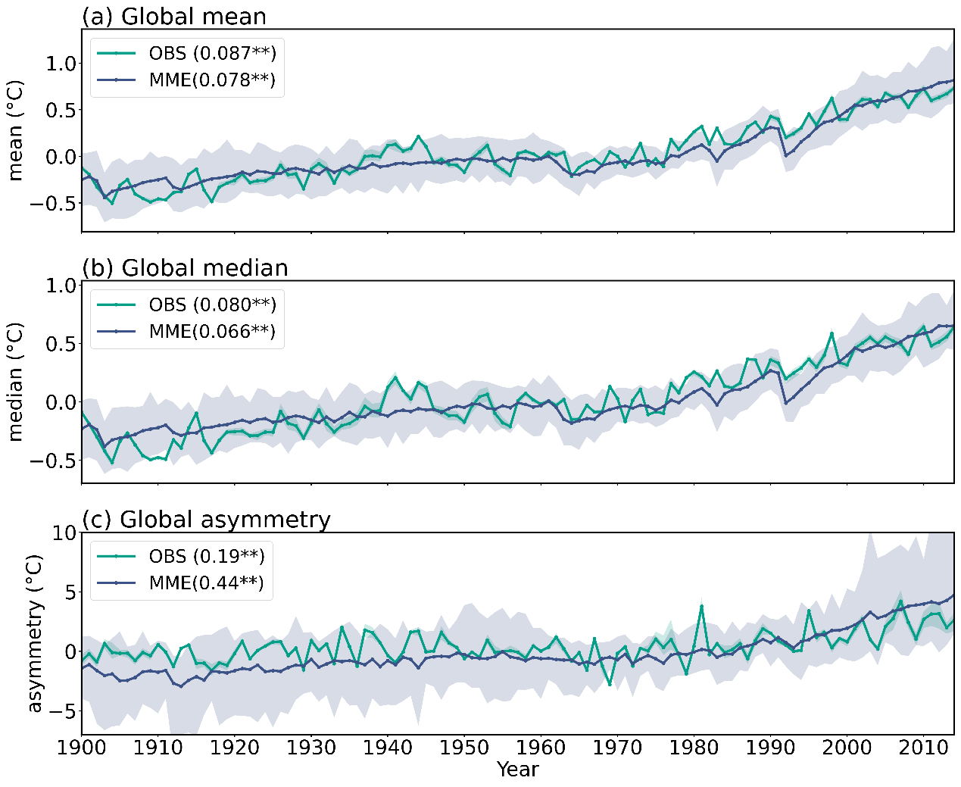
Figure S5 | Evaluation of CMIP6 model-simulated historical ${∆T}_{mean}$, ${∆T}_{median}$, and global warming asymmetry. Time series of (a) ${∆T}_{mean}$ (unit: °C), (b) ${∆T}_{median}$ (unit: °C), and (c) global warming asymmetry (unit: °C³) during 1900–2014, based on the consolidated 4-set mean observation (dark green) and the MME of CMIP6 models (dark blue). The shaded areas represent the spreads of the 5th to 95th percentiles. Asterisks (**) indicate that the linear trends (unit: °C/decade or °C³/decade) are statistically significant at the 99% confidence level. Results show that the climate models can well capture the historical changes of observed global ${∆T}_{mean}$ and global ${∆T}_{median}$, but substantially overestimate that of global warming asymmetry.

Text S4. Differences in historical changes of warming hot spots occurrence between well-performing and overestimating CMIP6 models

Identifying and understanding the origins of this bias is critical to enhance future climate change projections. In Fig. 3a and Text S3, we show that the CMIP6 models exhibit large uncertainties and biases in simulating the asymmetric nature of global warming. In order to understand the reasons leading to these uncertainties and biases, we categorize the 29 models into two groups based on their consistency with observed asymmetry trends: a well-performing subset (4 models) and an overestimating subset (25 models) (see Methods).
For the well-performing subset, the spatial pattern of the changes in warming hot spot occurrence shows reasonable agreement with observations, particularly in the Arctic, western Africa, North Atlantic, and southeastern Pacific, despite some discrepancies over central Eurasia and the northeastern Pacific (Fig. S6b). In contrast, the overestimating subset exhibits substantial deviations from observed spatial patterns, particularly in the Arctic, central Eurasia, and the global ocean (Fig. S6c). Comparing the two subsets, the overestimating subset primarily exaggerates the change in warming hot spot occurrence in eastern North America, Greenland, northern Eurasia, and marginal Antarctic seas relative to the well-performing subset (Fig. S6d).
These findings indicate that significant inter-model differences in the SPDF of simulated ΔT exist among the CMIP6 climate models. Among the 29 models, most models overestimate the global warming asymmetry, with systematic overestimations concentrated in eastern North America, Greenland, northern Eurasia, and Antarctic marginal seas. The results suggest that although climate models are generally able to capture the sources of global warming asymmetry, particularly the dominant contributions of northern high latitudes, there exists a widespread overestimation of regional warming asymmetry, as well as substantial inter-model discrepancies. This may be related to stronger spatial heterogeneity and heavier right-tailed distributions of $∆T$ in the polar regions. For example, models may produce more concentrated warming hotspots, stronger warming along sea-ice margins, or faster growth of spatial variance, which would lead to a larger contribution of these regions to global warming asymmetry. This finding implies the limitations regarding models’ ability to accurately simulate the spatial distribution of ΔT and its asymmetrical nature, which in turn affects the reliability of future climate projections.
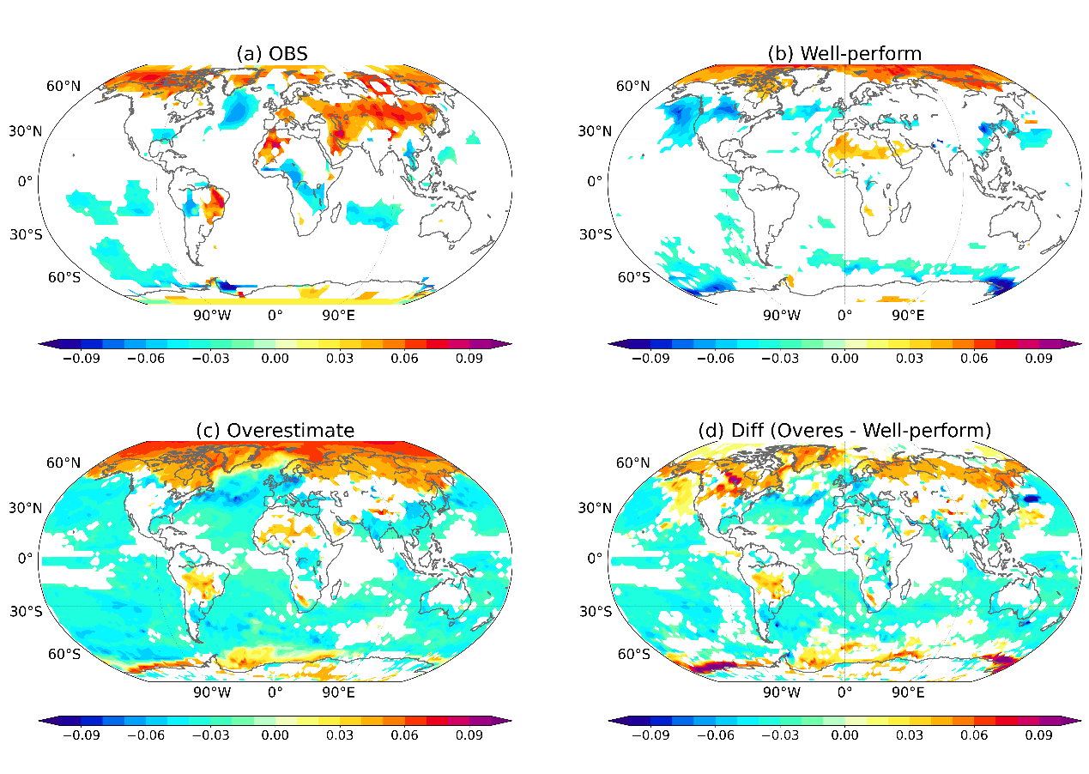
Figure S6 | Historical changes in warming hot spots occurrence simulated by well-performing and overestimating CMIP6 models. Changes in occurring probability (unit: /decade) of warming hot spots during 1900–2014 derived from (a) consolidated 4-set mean observation, (b) well-performing models, (c) overestimating models, and (d) the difference between overestimating models and well-performing models. Only the changes at or above the 95% confidence level are shown. Results show that compared with the well-performing subset, the overestimating subset tends to exaggerate the change in warming hot spot occurrence in eastern North America, Greenland, northern Eurasia, and marginal Antarctic seas.

Text S5. Regional contributions to global warming asymmetry between CMIP6 models and observations
To further diagnose the origin of the model's overestimation of global warming asymmetry, we examine the regional contributions derived from the MME relative to those estimated from observations (Fig. S7). Positive values indicate that the model-simulated contribution is larger than observations (i.e., models overestimate the contribution), whereas negative values indicate the opposite. The results show that the MME tends to attribute substantially larger contributions to global asymmetric warming from high-latitude regions, particularly the Arctic, compared with observations. This suggests that the model overestimation of global warming asymmetry is closely linked to exaggerated contributions from polar regions. Such biases may be related to processes associated with polar amplification, such as sea-ice-albedo feedback, cloud and turbulent heat-flux feedbacks, and changes in ocean heat transport ^{8,9}.
Besides, the interhemispheric asymmetry contrast pattern over the oceans may also play a role. As shown in Fig. S7, models tend to overestimate the contribution of Northern Hemisphere oceans while underestimating the contribution of Southern Hemisphere oceans. This hemispheric contrast resembles the over-amplified interhemispheric ocean warming contrast identified in previous studies^{10,11}, suggesting that biases in large-scale ocean–atmosphere coupling processes may also contribute to the model overestimation of global warming asymmetry.

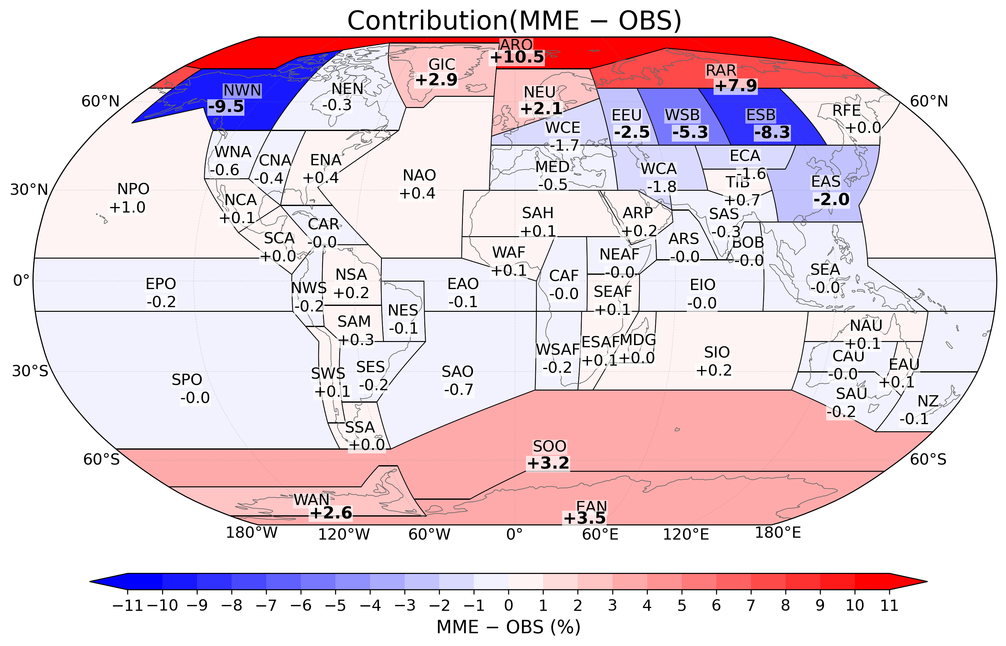
Figure S7 | Differences in regional contributions to global warming asymmetry between CMIP6 models and observations. Colors and numbers show the differences in contributions to the global asymmetry trend (MME − OBS) across AR6 regions. Positive values indicate that the model-simulated contribution is larger than observations (i.e., models overestimate the contribution), whereas negative values indicate the opposite.

Text S6. Schematic diagram presenting the three estimates of the global warming rate that are less sensitive to extreme values
In order to examine the sensitivity of ${∆T}_{mean}$ (Fig. S8a) to extreme values, we present three metrics for estimating the global warming rate that are less sensitive to outliers. The first metric, ${∆T}_{median}$, defines global surface warming rate as the change in the median of the global $∆T$ SPDFs (Fig. S8b). Compared to ${∆T}_{mean}$, this method yields a measure of global surface warming that is less sensitive to extreme values and outliers^{12,13}. The second metric, referred to as the global warming rate by SPDF shift, quantifies the warming rate based on the distance that the global ΔT SPDF shifts under climate change, by assuming that global ΔT is spatially uniform without changes in its SPDF shape. This assumption is designed to estimate the changes in global ΔT observed across the majority of regions, hence resulting in a global warming rate that is less sensitive to outliers (Fig. S8c, see Methods section for details). The third metric, referred to as global warming rate by Gaussian fit, quantifies the warming rate by fitting the observed global ΔT onto a Gaussian function and then comparing the mean value of the fitted distribution. This approach assumes the global ΔT always follows a symmetric Gaussian distribution, and the estimated changes in mean value of the fitted distribution exclude the asymmetry information of global surface warming (Fig. S8d, see Methods for details). The three global surface warming estimates introduced above are compared with ${∆T}_{mean}$, the conventional global warming rate measure used in the IPCC. Their differences demonstrate the degree to the ${∆T}_{mean}$ calculation is influenced by extreme values under global asymmetric warming. Our results show that the gap between ${∆T}_{mean}$, and the other three metrics has widened since 1900 (Fig. 4b) and will further increase nonlinearly with emission intensity in the future climate (Fig. 4d). This highlights the importance of recognizing the high sensitivity of ${∆T}_{mean}$ calculation to extreme values under the increasingly asymmetric global ΔT SPDF.

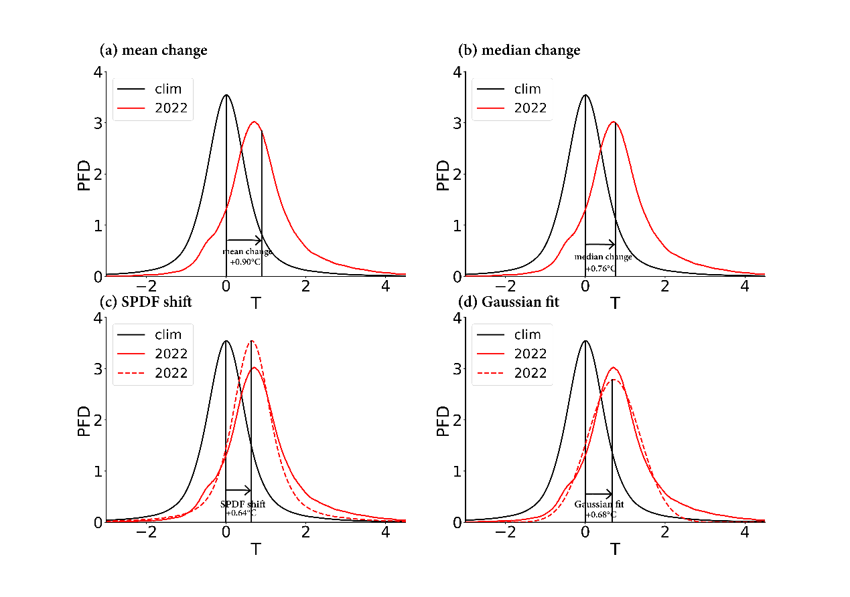
Figure S8 | Schematic diagram showing how different methods estimate the global warming rate. Global warming rate estimated by changes of global ΔT SPDF based on methods (a) ${∆T}_{mean}$, (b) ${∆T}_{median}$, (c) SPDF shift, and (d) Gaussian fit. The black curve denotes the climatological global ΔT SPDF. The red solid curve denotes the global ΔT SPDF observed in 2022. The red dashed curves in (c) and (d) denote the expected global ΔT SPDF under the corresponding assumptions of the two approaches (see Methods).

Text S7. Comparison of global surface warming calculated by different methods
Fig. S9 compares the observed global surface warming during 1900–2022 calculated using different methods, including ${∆T}_{mean}$, ${∆T}_{median}$, and global warming rate by SPDF shift and Gaussian fit, based on the BEST, GISTEMP, and NOAAGlobalTemp datasets, respectively. The comparison results reveal increasing discrepancies between ${∆T}_{mean}$ and the three approaches that are less sensitive to extreme values. The discrepancies range from 10.0% to 13.0% (BEST, Fig. S9a), 9.5% to 12.6% (GISTEMP, Fig. S9b), and 10.5% to 14.7% (NOAAGlobalTemp, Fig. S9c), respectively, during the period from 1900 to 2022. Notably, these differences nearly doubled after the 1980s, with discrepancies ranging from 17.6% to 23.8% (BEST, Fig. S9a), 22.2% to 30.6% (GISTEMP, Fig. S9b), and 19.1% to 25.7% (NOAAGlobalTemp, Fig. S9c), respectively. The results are consistent with those of Fig. 4b in the main text. These findings suggest a widening gap between ${∆T}_{mean}$ and metrics that are less sensitive to extreme values, implying the sensitivity of ${∆T}_{mean}$ to global asymmetric warming.

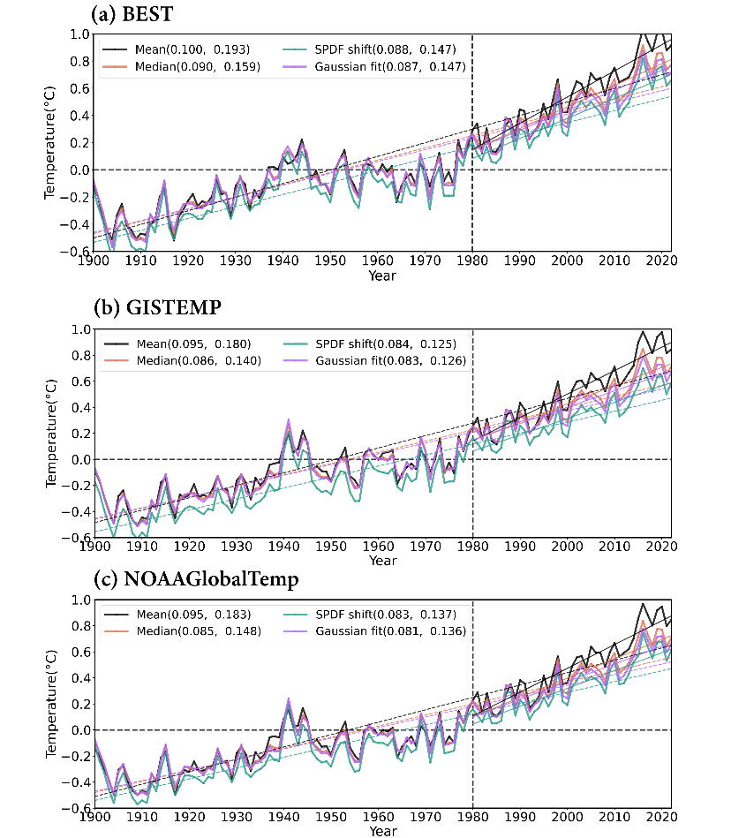
Figure S9 | Global surface warming during 1900–2022 calculated by different methods. Degree of global warming (unit: °C) obtained by different assessment methods (${∆T}_{mean}$, ${∆T}_{median}$, SPDF shift, and Gaussian fit, see Text S5 and Methods), based on the (a) BEST, (b) GISTEMP, (c) NOAAglobaltemp datasets during 1900–2022. Their linear trends (unit: °C /decade) from 1900–2022 and from 1980–2022 are denoted by dotted lines and solid lines, respectively, with the slope reflected in the label. All trends are statistically significant at the 99% confidence level. Results demonstrate a widening gap between ${∆T}_{mean}$ and metrics that are less sensitive to extreme values, implying the sensitivity of ${∆T}_{mean}$ to global asymmetric warming.

Text S8. CMIP6 models employed in this study
The CMIP6 model-simulated global ΔTs under the historical scenario (1850–2014) and different Shared Socioeconomic Pathways (SSP1-2.6, SSP2-4.5, and SSP5-8.5) are analyzed to figure out whether climate models reproduce this observed asymmetric warming and project its future evolution. For the historical scenario, we retained the results of 29 CMIP6 models. We also categorized the 29 models into two subsets according to their consistency with the observed asymmetry trends in Fig. 3a, including a well-performing subset of 4 models (MIROC-ES2L, CAMS-CSM1-0, GISS-E2-1-G, and MPI-ESM1-2-HR) and the remaining 25 models comprising the overestimating subset to analyze the main contributors to the model overestimation in global warming asymmetry. On this basis, we only retained the well-performing subset (MIROC-ES2L, CAMS-CSM1-0, GISS-E2-1-G, and MPI-ESM1-2-HR) to analyze the global $∆T$ SPDF and global warming asymmetry under SSP1-2.6, SSP2-4.5, and SSP5-8.5.

Table S1| The 29 CMIP6 models employed in this study.
Historical | SSP126 | SSP245 | SSP585
ACCESS-CM2 | CAMS-CSM1-0 | CAMS-CSM1-0 | CAMS-CSM1-0
ACCESS-ESM1-5 | GISS-E2-1-G | GISS-E2-1-G | GISS-E2-1-G
ACCESS-ESM1-5 | MIROC-ES2L | MIROC-ES2L | MIROC-ES2L
BCC-CSM2-MR | MPI-ESM1-2-HR | MPI-ESM1-2-HR | MPI-ESM1-2-HR
CAMS-CSM1-0
CanESM5
CanESM5-CanOE
CESM2
CESM2-WACCM
CIESM
CMCC-CM2-SR5
CNRM-CM6-1
CNRM-ESM2-1
FIO-ESM-2-0
GISS-E2-1-G
HadGEM3-GC31-LL
INM-CM4-8
INM-CM5-0
IPSL-CM6A-LR
KACE-1-0-G
KIOST-ESM
MCM-UA-1-0
MIROC6
MIROC-ES2L
MPI-ESM1-2-HR
MPI-ESM1-2-LR
MRI-ESM2-0
NESM3
NorESM2-LM

Text S9. Description of the IPCC AR6 Reference Regions
These regions form the fundamental geographical units for the systematic analysis of observed and projected climate change across the globe. This framework enhances climatic consistency within each region, thereby allowing for a more robust and coherent assessment of regional climate signals. The evaluation covers all major areas, including Africa, Asia, Australasia, Central and South America, North America, Europe, Small Islands, and the Polar Regions. Furthermore, larger and climatically complex areas are subdivided; for instance, Asia is analyzed through its sub-regions: East Asia, North Asia, South Asia, Southeast Asia, and Southwest Asia. Table S2 provides the acronyms and full names of these reference regions used throughout the assessment. Contributions of these reference regions to the increase of global ΔT asymmetry are also presented in Table S2.

Table S2| The reference regions defined in the IPCC AR6 reports
No. | Acronym | Full name | Contribution
1 | GIC | Greenland / Iceland | 2.30%
2 | NWN | North-Western North America | 14.88%
3 | NEN | North-Eastern North America | 7.18%
4 | WNA | Western North America | 0.59%
5 | CNA | Central North America | 0.47%
6 | ENA | Eastern North America | 0.36%
7 | NCA | Northern Central America | 0.07%
8 | SCA | Southern Central America | -0.01%
9 | CAR | Caribbean | -0.00%
10 | NWS | North-Western South America | 0.08%
11 | NSA | Northern South America | 0.01%
12 | NES | North-Eastern South America | 0.14%
13 | SAM | Southern South America | 0.00%
14 | SWS | South-Western South America | -0.05%
15 | SES | South-Eastern South America | 0.14%
16 | SSA | Southern South America | -0.04%
17 | NEU | Northern Europe | 1.13%
18 | WCE | Western and Central Europe | 2.85%
19 | EEU | Eastern Europe | 4.93%
20 | MED | Mediterranean | 0.74%
21 | SAH | Sahara | 0.73%
22 | WAF | Western Africa | -0.06%
23 | CAF | Central Africa | -0.00%
24 | NEAF | North-Eastern Africa | 0.04%
25 | SEAF | South-Eastern Africa | -0.03%
26 | WSAF | Western Southern Africa | 0.24%
27 | ESAF | Eastern Southern Africa | -0.02%
28 | MDG | Madagascar | -0.03%
29 | RAR | Russian Arctic | 17.80%
30 | WSB | West Siberia | 8.79%
31 | ESB | East Siberia | 10.41%
32 | RFE | Russian Far East | 3.80%
33 | WCA | West Central Asia | 2.48%
34 | ECA | East Central Asia | 1.68%
35 | TIB | Tibetan Plateau | 0.23%
36 | EAS | East Asia | 1.28%
37 | ARP | Arabian Peninsula | 0.11%
38 | SAS | South Asia | 0.02%
39 | SEA | South-East Asia | -0.07%
40 | NAU | Northern Australia | -0.01%
41 | CAU | Central Australia | 0.26%
42 | EAU | Eastern Australia | -0.01%
43 | SAU | Southern Australia | 0.07%
44 | NZ | New Zealand | 0.07%
45 | EAN | Eastern Antarctic | 0.08%
46 | WAN | Western Antarctic | 0.51%
47 | ARO | Arctic Ocean | 15.43%
48 | NPO | North Pacific Ocean | 0.06%
49 | EPO | Eastern Pacific Ocean | -0.42%
50 | SPO | Southern Pacific Ocean | -1.08%
51 | NAO | North Atlantic Ocean | -0.58%
52 | EAO | Eastern Atlantic Ocean | 0.08%
53 | SAO | Southern Atlantic Ocean | 0.27%
54 | ARS | Antarctic and Southern Ocean | 0.01%
55 | BOB | Bay of Bengal | -0.00%
56 | EIO | Eastern Indian Ocean | -0.00%
57 | SIO | Southern Indian Ocean | -0.29%
58 | SOO | Southern Ocean | 2.34%

References
1 Screen, J. A. & Simmonds, I. The central role of diminishing sea ice in recent Arctic temperature amplification. Nature 464, 1334-1337 (2010).
2 Hong, X., Lu, R. & Li, S. Amplified summer warming in Europe–West Asia and Northeast Asia after the mid-1990s. Environmental Research Letters 12, 094007 (2017).
3 Falvey, M. & Garreaud, R. D. Regional cooling in a warming world: Recent temperature trends in the southeast Pacific and along the west coast of subtropical South America (1979–2006). Journal of Geophysical Research: Atmospheres 114 (2009).
4 Allan, D. & Allan, R. P. Seasonal changes in the North Atlantic cold anomaly: The influence of cold surface waters from coastal Greenland and warming trends associated with variations in subarctic sea ice cover. Journal of Geophysical Research: Oceans 124, 9040-9052 (2019).
5 Kang, S. M. et al. Global impacts of recent Southern Ocean cooling. Proceedings of the National Academy of Sciences 120, e2300881120 (2023).
6 Rohde, R. A. & Hausfather, Z. The Berkeley Earth land/ocean temperature record. Earth System Science Data Discussions 2020, 1-16 (2020).
7 Hansen, J., Ruedy, R., Sato, M. & Lo, K. Global surface temperature change. Reviews of geophysics 48 (2010).
8 Hahn, L. C., Armour, K. C., Zelinka, M. D., Bitz, C. M. & Donohoe, A. Contributions to Polar Amplification in CMIP5 and CMIP6 Models. Frontiers in Earth Science 9, doi:10.3389/feart.2021.710036 (2021).
9 Chylek, P. et al. Annual Mean Arctic Amplification 1970–2020: Observed and Simulated by CMIP6 Climate Models. Geophysical Research Letters 49, doi:10.1029/2022gl099371 (2022).
10 He, C. et al. Climate models exaggerate greenhouse gas impact on recent interhemispheric temperature patterns and tropical climate. Nature Communications, doi:https://doi.org/10.1038/s41467-026-69783-5 (2026).
11 Friedman, A. R., Hwang, Y.-T., Chiang, J. C. & Frierson, D. M. Interhemispheric temperature asymmetry over the twentieth century and in future projections. Journal of Climate 26, 5419-5433 (2013).
12 Rousselet, G. A. & Wilcox, R. R. Reaction times and other skewed distributions: problems with the mean and the median. BioRxiv, 383935 (2018).
13 McCluskey, A. & Lalkhen, A. G. Statistics II: Central tendency and spread of data. Continuing Education in Anaesthesia, Critical Care Pain 7, 127-130 (2007).

