Supplementary Table 1. Hazard ratios from the Cox proportional hazard model for baseline values of imaging, molecular, clinical and demographic biomarkers.

 | Univariate analysis |  |  |  | Multivariate analysis
Variables | B | HR (exp(B)) | 95% CI for HR | P-value | B | HR | 95% CI for HR | P-value
CBF-SE | 0.840 | 2.317 | .796-6.748 | 0.123
CBF-GE | 0.586 | 1.797 | 1.060-3.047 | 0.030 | -0.536 | 0.585 | 0.110-3.116 | 0.530
CBV-SE | 0.752 | 2.121 | .758-5.728 | 0.138
CBV-GE | 0.568 | 1.765 | .989-3.150 | 0.133
tCho/hCre | 2.194 | 8.975 | 1.415-56.93 | 0.020 | 4.046 | 57.177 | 1.54-2123.4 | 0.028
tCho/NAA | 1.953 | 7.048 | .185-268.84 | 0.293
Vol-CE | 0.026 | 1.026 | 1.01-1.04 | 0.002 | 1.412 | 4.104 | 0.366-46.07 | 0.252
Vol-FLAIR | 0.020 | 1.020 | 1.01—1.03 | 0.000 | -0.276 | 0.759 | 0.153-3.761 | 0.735
KPS | -3.934 | 0.020 | .001-.706 | 0.032 | -2,251 | 0.105 | 0.001-7.514 | 0.301
Age | -0.071 | 0.932 | .880-.987 | 0.015 | -0.069 | 0.933 | 0.877-0.992 | 0.027

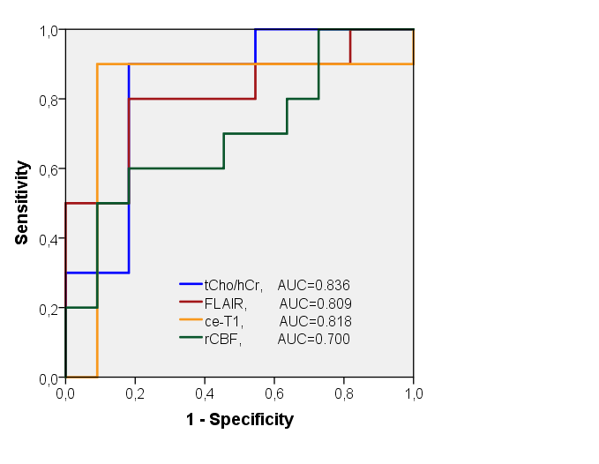

Supplementary Figure 1. Receiver operating characteristic (ROC) curves for tCho/hCr, FLAIR volume, ce-T1 volume and rCBF using baseline values. Area under curve (AUC) is indicated for each imaging biomarker.

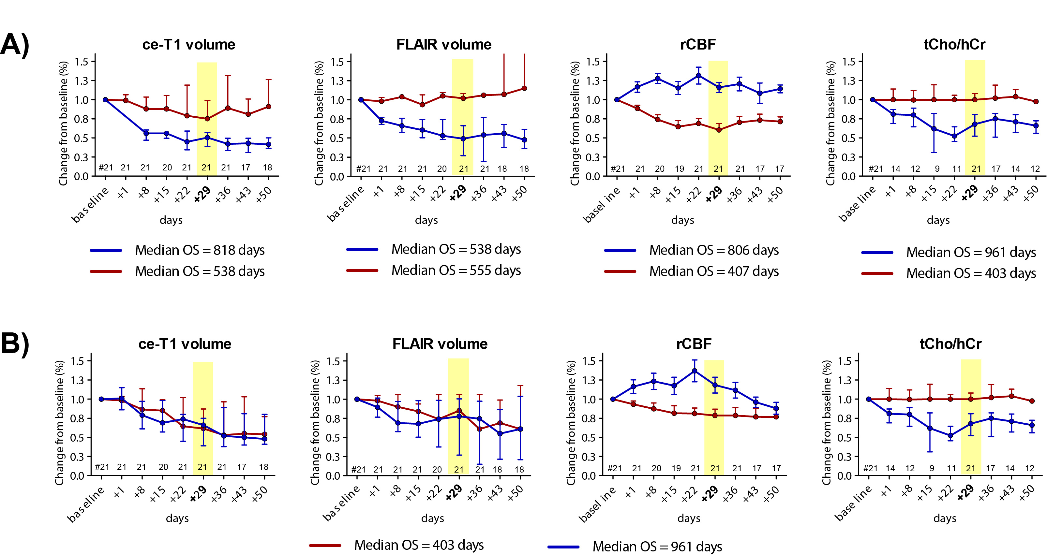

Supplementary Figure 2. Time courses of imaging biomarkers during combined antiangiogenic and radiochemotherapy. A) For each imaging biomarker the patients were split in two groups based on the relative change at day +29 as compared to the threshold derived from ROC analysis. For each imaging biomarker the median overall survival in each group was calculated. B) The patient groups obtained using tCho/hCr threshold were used to plot the time courses for all imaging biomarkers. The overall survival times calculated based on tCho/hCr patient groups are nearest to the true OS values, short OS = 405 days and long OS = 1009 days.

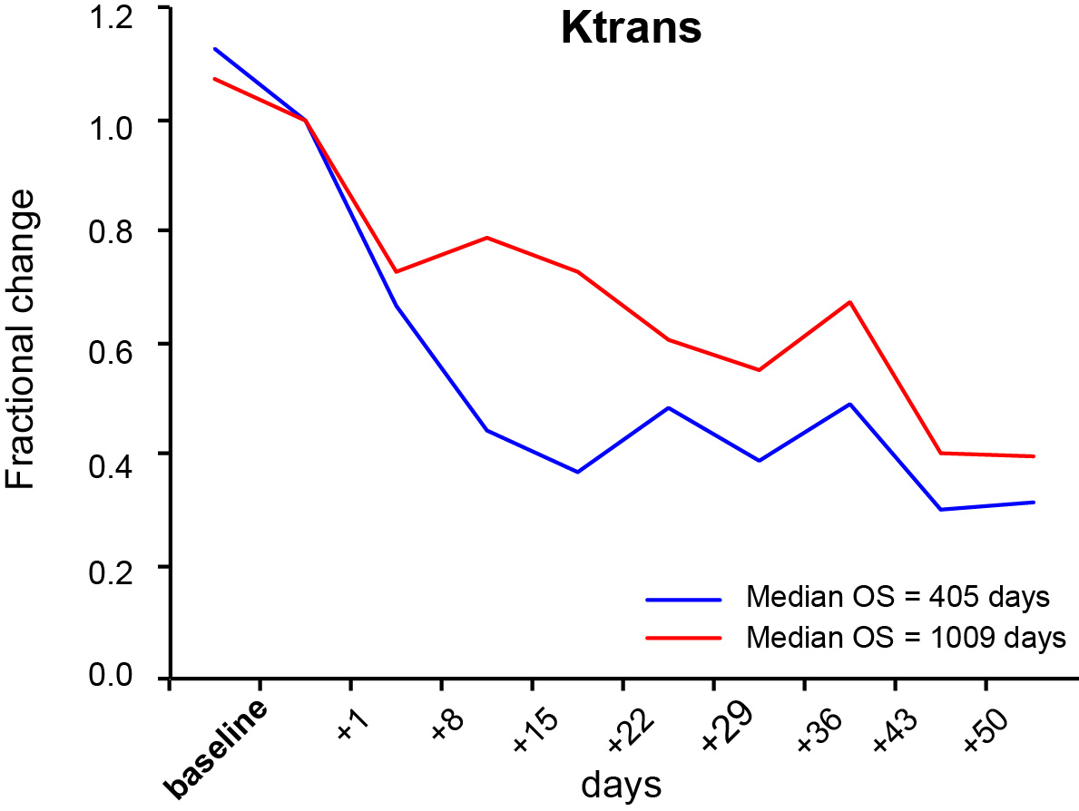

Supplementary Figure 3. Time courses of Ktrans derived from DCE measurements during combined antiangiogenic and radiochemotherapy. Time courses for the short OS (blue) group and long OS (red). There is more reduction in Ktrans for the short OS group.

