Supplemental Information

Triple negative breast cancer targeting and killing by EpCAM-directed, plasmonically active nanodrug systems

Samir V. Jenkins,¹ Zeid A. Nima,² Kieng B. Vang,² Ganesh Kannarpady,² Dmitry A. Nedosekin,³ Vladimir P. Zharov,³ Robert J. Griffin,¹ Alexandru S. Biris,² and
Ruud P.M. Dings¹

¹Department of Radiation Oncology and the ³Phillips Classic Laser and Nanomedicine Laboratories, University of Arkansas for Medical Sciences, Little Rock, AR, USA
²Center for Integrative Nanotechnology Sciences, University of Arkansas at Little Rock, Arkansas, Little Rock AR, USA

Corresponding Author: Ruud P.M. Dings, 4301 W. Markham, Mail Slot #771,
Little Rock, AR 72205. Email: rpmdings@uams.edu

Running title: EpCAM-directed, plasmonically active nanodrug systems

Keywords: targeted therapy, triple negative breast cancer, nanotherapy, doxorubicin, EpCAM, photoacoustic microscopy, surface-enhanced Raman spectroscopy and therapeutic index, rational design.

Conflict of Interest: The authors declare no conflicts of interest.
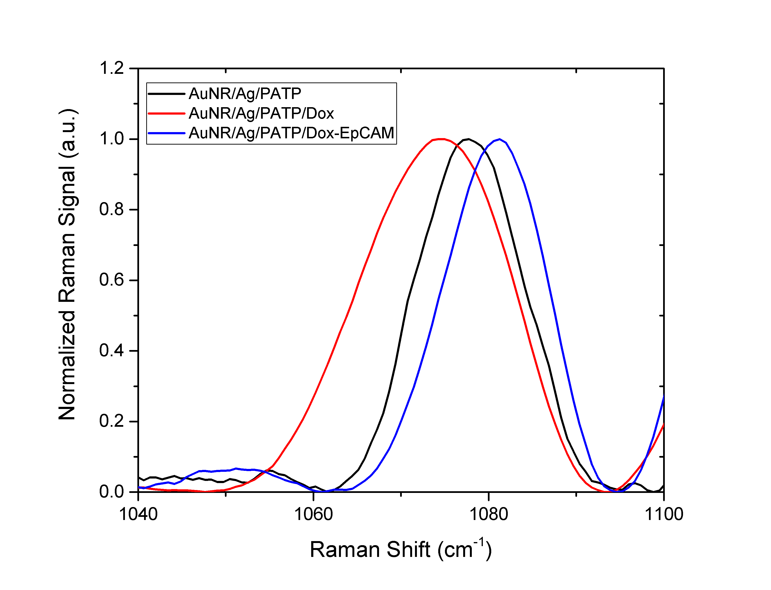

Figure SI-1. Raman spectra of individual particle preparations.

Figure SI-2. EpCAM antibody by itself does not cause cell viability inhibition.
The effects of EpCAM antibody on the viability of 4T1 cells. Please note at the ED₅₀ of AuNR/Ag/Dox-EpCAM (3 µg/ml) a total of 0.05 µg/ml EpCAM Ab is present. Data represent mean +/- SD.

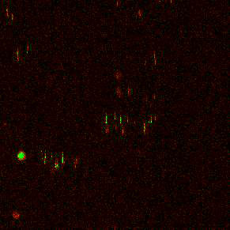
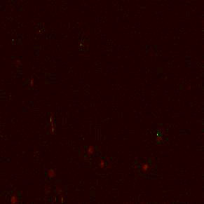
a
b
AuNR/Ag-EpCAM
AuNR/Ag

Figure SI-3. PA detection of targeted nanoparticles in TNBC. (a) Representative images of AuNR/Ag and AuNR/Ag-EpCAM particles on 4T1 tumor slections. Red = low intensity signal; Green = high intensity signal (b) Quantification of AuNR/Ag and AuNR/Ag-EpCAM PA signals on 4T1 tumor sections.

